UNDERSTANDING THE FLD (Hurst course Ch.9)

- The cyclic analyst who wishes to obtain maximum benefit from use of the FLD needs a greater understanding of its theoretical basis than has been presented in previous lessons.

- Because the FLD is derived from a Moving Average, a general discussion of the Moving Average will be the first step toward developing this greater understanding.

The discussion will be in the context of a daily price bar-chart, but bear in mind that it applies to weekly and monthly charts as well.

- A Moving Average is a time sequence of data points, each one of which is the average of a particular set of daily mean prices.

When plotted on the daily chart, this sequence of data points progresses in time in the same manner that the price data progresses in time.

However, while the shape of the Moving Average plot is generally similar to the shape of the price plot, it is considerably smoother.

The Moving Average is, in effect, a numerical filter that filters short waves out of the complex price movement.

- The number of price data points that are averaged together to form each
moving-average data point is called the span of the Moving Average.

The length of the span determines the nature of the filtering action of the Moving Average.

- A price wave with a period equal to the span of the Moving Average will be
almost completely filtered out of the Moving Average plot.

All shorter waves will be greatly reduced in amplitude.

All longer waves will be essentially unaffected and will sum to form the Moving Average plot itself.

- Recalling our definition of trend, we can see that the Moving Average represents the trend underlying the span wave (the wave whose period equals the span).

- In a set of harmonically related waves with proportional amplitudes (such as the nominal cyclic model), we can expect the shortest wave in a trend under consideration to dominate the short term movement of the trend.

And, when component wave amplitudes are normal, the Moving Average does indeed track the wave next longer than the span wave.

The overall direction of this tracking wave motion will, of course, be in accordance
with the sum of all longer waves.

- From the foregoing remarks it can be seen that if we are interested in examining the wave motion of a certain component wave in the complex price movement, we can do so by creating a Moving Average whose span is equal to 1/2 the period of the wave of interest.

Such a Moving Average is called a half-span Moving Average, and the wave on which it is based is called the base wave.

(Thus, for a given Moving Average, the span wave has a period equal to the span, and the base wave has a period equal to twice the span.)

- So that the properties of the half-span Moving Average will be completely
clear to you, let's go back over them again:

- The span of the half-span Moving Average is made equal to ½ the period of the wave of interest, the base wave (hence the name half-span).

- The span wave, which will be completely suppressed and will not appear in the Moving Average plot, therefore has a period equal to 1/2 the period of the base wave.

In the nominal cyclic model, the span wave is thus the wave next shorter than the base wave.

- All waves shorter than the span wave will be very greatly reduced in amplitude and will therefore not have much effect on the Moving Average plot.

- All waves longer than the span wave will be essentially unaffected and will sum to form the Moving Average plot itself.

The shortest wave in this sum will be the base wave, and the Moving Average plot will therefore track the base wave.

In this section we are particularly interested in the half-span Moving Average because it is from this Moving Average that the FLD for the base wave is derived.

This matter will be discussed further later on in the section.

• The first step in generating a Moving Average is to determine the span.
For a half-span Moving Average, this is done in the following manner:

- By means of an FPA, find the average period of the wave in which you are interested. (This wave will be the base wave.)

b. Divide this period by 2.
c. Round the result to the nearest odd whole number.

(Using an odd number for the span will cause the moving-average data points to
fall on grid lines instead of in between.)

- For a full-span Moving Average (in this case the wave in which you are
interested is the span wave), step b is omitted.

The average period of the span wave is simply rounded to the nearest odd whole number.

A full-span Moving Average would be used to filter out, or remove, the span wave
from the resulting plot.

(Of course, a full-span Moving Average for a given span wave is also a half-span Moving Average for the next longer wave.)

- The second step in generating a Moving Average is to add together the daily mean prices for a number of consecutive days equal to the span.

(For example, if the span is 15, add together the daily mean prices for 15 consecutive days.)

- The daily mean price can be determined by adding together the high and low prices for the day and dividing by 2.

Or, it can be obtained graphically from the chart by reading off the price at the center of the price bar (marked by a dot on CycliTec charts).

- Hypothetical daily price means must be included for weekend days and
holidays.

These hypothetical price means are determined graphically by drawing a straight line between the price means of the days on either side of the weekend or holiday.

The point at which this straight line crosses the grid line representing the weekend day or holiday determines the hypothetical mean price for that day.

(This process is called linear interpolation.)

- When the span of daily price means has been added together, divide the
sum by the number of data points used (the span).

The result is the average for this set of daily price means.

- Plot the moving-average data point thus obtained on the grid line that is at the exact center of the span of days whose daily price means were added together to obtain the average.

• The first span of days just dealt with can be taken at either the right end
or the left end of the total length of time for which the Moving Average is to be generated. In our discussion, we will start at the left side of the chart, working forward toward the most recent daily price bar.

- The next moving-average data point is obtained with much less effort.
First, step the span of days one day to the right (remember we have started at the left end of the price data).

But now, instead of adding together all of the daily price means in this span, make use of the sum obtained for the preceding data point.

- The new span of days contains the same days as the old span except for one day taken off of the left end and one new day added on at the right end.

Therefore, to obtain the sum for the new span, start with the old sum, subtract the daily price mean for the leftmost day in the old span, and add the daily price mean for the rightmost day in the new span.

The result is the sum for the new span.

- This sum is divided by the span, as before, and plotted on the grid line just to the right of the preceding moving-average data point.

(Check the location to make sure it is in the exact center of the new span of days.)

- This process of stepping to the right by one day and recalculating the average is repeated again and again until all the desired moving-average data points have been generated or until no more price data is available.
The resulting plot of moving-average data points may then be connected
together by a series of short straight lines or by a smooth curve.

- The generation of the Moving Average for a daily price bar-chart can be
summarized as follows:

- Determine the span in one of the following 2 ways —

a. For a half-span Moving Average, divide the period of the base wave by 2 and round the result to the nearest odd whole number.

- For a full-span Moving Average, merely round the period of the span wave to the nearest odd whole number.

- Determine the daily mean prices for all of the days in the overall time interval for which the Moving Average is to be generated (including weekend days and holidays, whose hypothetical mean prices are determined by linear interpolation).

- Starting at the left end of the overall time interval of interest and counting to the right, count off a number of consecutive days equal to the span.

- Add together the price means of this span of days.

- Divide this sum by the span.

- Plot the resulting moving-average data point on the grid line that is in the exact center of the span of days used to obtain the sum for step 5.

- Step the span to the right by one day.

From the sum for the last span, used to obtain the data point just plotted, subtract the price mean for the leftmost day in that span.

- To the result of step 7, add the price mean of the rightmost day in the new span (the first day to the right of the previous span).

- With the sum from step 8, repeat step 5. Then repeat steps 6 trough 9.

Now it is time for you to generate a Moving Average yourself as an exercise.

Turn to figure 9-1, a daily chart of EQF for 26 May 1972.

• Observe the FPA shown on the chart.

(With only the information available on this chart, there would be some question about the validity of the phasing diamonds at grid line 16.

However, examination of the chart issue just preceding this one indicates that these diamonds are valid.)

The average periods shown are based on the average period of the nominal 20-day wave rounded to one decimal place.

For the sake of this example, assume that you are interested in observing the price motion contributed by the 41.8-day wave.

Determine the span of a Moving Average that would filter out the 20.9-day wave and greatly reduce the amplitude of the 10.5-day wave and all shorter waves.

Do this before reading further.

- On the assumption that you wanted to track the 41.8-day wave, you would have used step la of the Moving Average procedure and divided 41.8 by 2 to get 20.9, then rounded this result to 21, the nearest odd whole number.
Or, knowing that you wanted to filter out the 20.9-day wave, you could have used step Ib and simply rounded 20.9 to 21.

In either case, you should have obtained 21 as the span for the Moving Average.

- Now look at table 9-1.

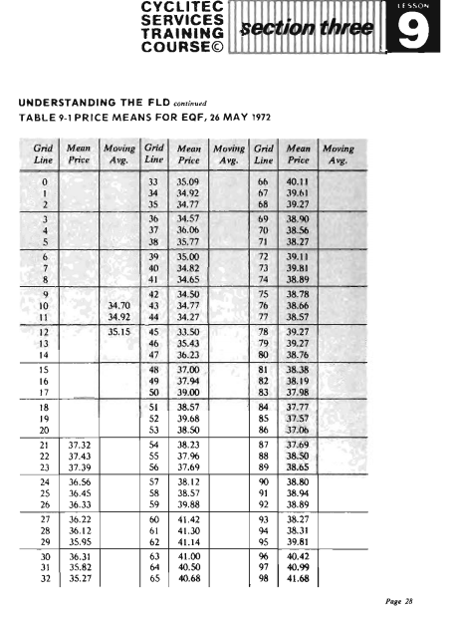

This table gives the price means for the chart of figure 9-1.

The prices were read to the nearest grid line and then estimated to one additional decimal place.

The table also has columns for entry of the moving-average data points once they have been calculated.

In order to give you some experience in reading price means from a chart, the first 21 price means (grid lines 0 through 20, working from left to right) have been omitted from the table.

Fill in these missing price means by reading from the chart the prices at the centers of the appropriate price bars, estimating the prices to two decimal places.

Obtain the prices for the weekend days by the linear interpolation method described in a preceding paragraph.

Before you begin, however, please read the following paragraph.

- The printing plates for CycliTec charts are made by a two-step process;
one step for the grid and one step for the price bars.

For this reason, there may be some very slight difference between the position of the price bars on your chart and the position of those on the chart from which the price values given in the table were taken.

Carefully examine the price bar at grid line 179. Is the center dot exactly halfway between 42.5 and 42.6?

If so, your prices should match those in the table exactly.

If not, mentally make the necessary slight adjustment as you read off the prices.

Go ahead and complete this task before reading further.

- Now, using the procedure described previously, calculate the first 10
moving-average data points, working from left to right.

The first 3 points have been entered in table 9-1 to help get you off on the right foot.
As you proceed, make a note of the sum of the price means for the first
moving-average data point and also for the tenth.

Go ahead and calculate these first 10 points before reading further.

• The correct sum for the first 21 price means is 728.77.

By the time you reached the tenth moving-average data point, this sum should have evolved to 759.43.

Your sums may differ by up to 5 or 6 in the last decimal place due to personal differences in estimating.

But except for such small differences, your sums should match those given.

- As you calculate this Moving Average, realize that because of the manner in which the sums are carried over from one span of price bars to the next, any error that is made will also be carried over.

If such an error is not detected, it will affect every subsequent data point.

For this reason, it is a good idea to check the sum every 10 or 20 data points by carefully adding the appropriate set of price means.

- The rest of the price means are given in the table, so if you adjust your sum for the moving-average data point at grid line 19 to be exactly 759.43, from this point on, your numbers will match those given in the text.

(Be sure to check your sum every 10 or 20 data points.)

- It is helpful to devise some system of check marking or numbering those price means that have been subtracted at one end of the span and those that have been added at the other. In this way you can keep track of the span as you step it down the column of price means.

- Now continue your Moving Average calculations and fill in the rest of the table before reading further.

- Check your results against those given in table 9-2.

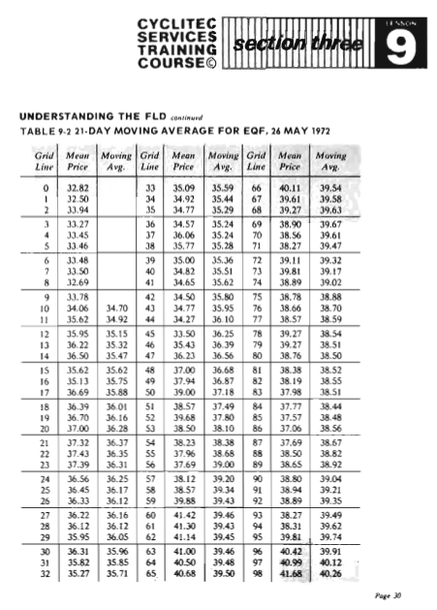

Then, using a colored pencil or pen, plot the moving-average data points on the chart of figure 9-1

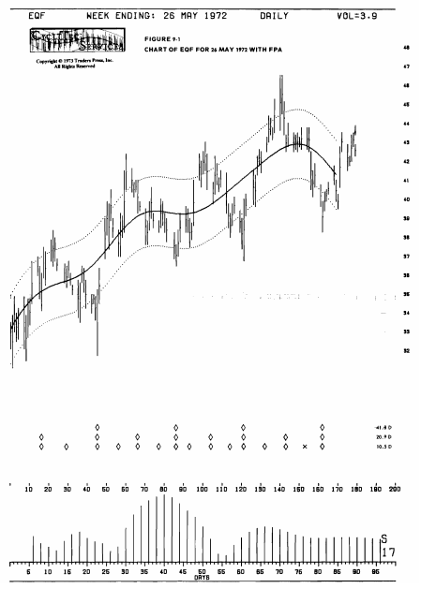
Do this before reading further.

- Notice that the Moving Average plot has the shape of a 40-day wave oscillating about the Dominancy Envelope centerline.

The upward crossings of the Moving Average with the Dominancy Envelope centerline are very nearly 40 days apart in every case (as are the downward crossings).

Also notice how the price waves shorter than 40 days tend to oscillate about the
Moving Average.

These observations fit in nicely with what you know about the Moving Average and about trend.

• You now understand quite well why there are no moving-average data points for the last ten price bars on the right of the chart or for the first ten on the left.

This is the lag of the Moving Average.

Here the word lag refers to an information lag, not a phase lag.

As you can see, the Moving Average wave is nicely in phase with the 40-day price wave.

• Now we come to the FLD, which is based on the 2 Moving Average characteristics that we have just observed:

- The shape of the half-span Moving Average wave is the same as, and in phase with, the shape of the base price wave.

- The last available moving-average data point lags the last available price bar by 1/2 span, or 1/4 cycle of the base wave.

- Look at figure 9-2. An idealized price wave is shown plotted out to time B.
A half-span Moving Average is also shown, somewhat reduced in amplitude for the sake of illustration.

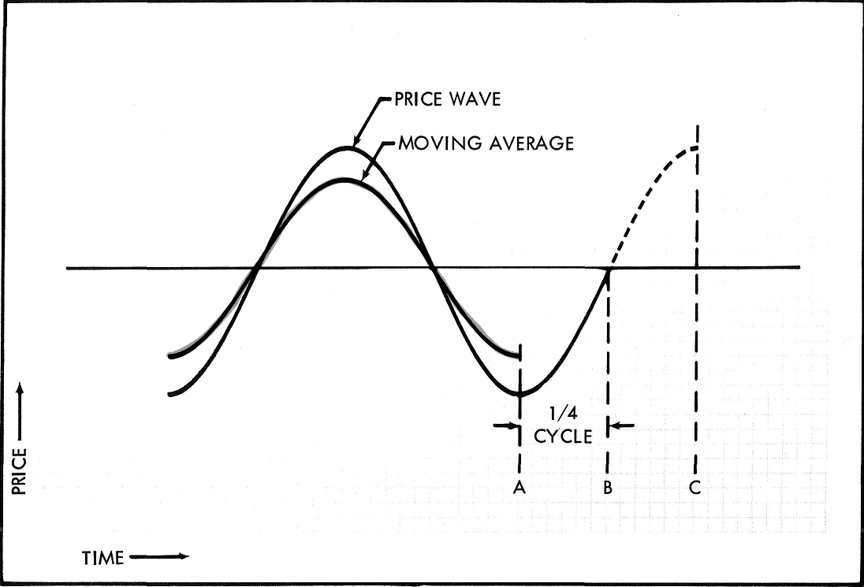

Figure 9-2 The Half-Span Moving Average of an idealized Wave

As you would expect, the Moving Average is only plotted to time A because of the 1/4 cycle information lag of moving-average data points with respect to price-wave data points.

- The Moving Average is just now forming its trough at A.

However, the price wave, which also formed its trough at A, is now at B and at a price that is already half way to the crest at C.

- So here we have a situation that allows us to make a specific, quantitative
forecast about price movement.

We know that the price change that took place between times A and B will again take place between times B and C.
The moment we see that the Moving Average is exactly at its trough, we can predict the price that will be reached at the next crest of the price wave.

- Of course, these are idealized waves. In the case of actual price movement, we could not be quite so positive.

We would have to say: When the half-span Moving Average is exactly at its trough, the base price wave is half way between the price low at its trough and the price high that is most likely to be reached at its next crest.

(And as you know, the price expectation at the crest will be altered by Underlying Trend conditions.)

- Now the question is:

How can we tell when the Moving Average is exactly at its trough?

The answer lies in the rate of change of the Moving Average price.

- Just before the trough, the Moving Average price is changing in the downward direction; the rate of change is negative.

Just after the trough, the Moving Average price is changing in the upward direction; the rate of change is positive.

Right at the trough, the rate changes from negative to positive and therefore must pass through zero.

That is, at the very center of the trough there will be a point at which there is no change in price from one moment to the next.

- Therefore, if we can locate the point in time at which the rate of change in
Moving Average price changes from negative to positive, then we have located the center of the trough.

- Now recall the manner in which you generated the movi ng average.

As you stepped the span along from one day to the next, you took the sum from
the previous span, subtracted the price mean for the leftmost day, and added the price mean for the next day on the right.

You then divided the resulting new sum by the span to get the new Moving Average price.

- If the price mean added to the right end is exactly the same as the price mean subtracted from the left end, the new sum will be exactly the same as the previous sum and there will be no change in the Moving Average price.

- If the price mean added to the right end is less than the price mean subtracted from the left end, the new sum will be less than the previous sum and the Moving Average price rate will be negative.

This will be the case when the Moving Average is approaching the trough.

- If the price mean added to the right end is greater than the one subtracted from the left, the new sum will be greater and the Moving Average price rate will be positive.

This will be the case when the Moving Average has passed the trough.

Now, with this concept in mind, look at figure 9-3.

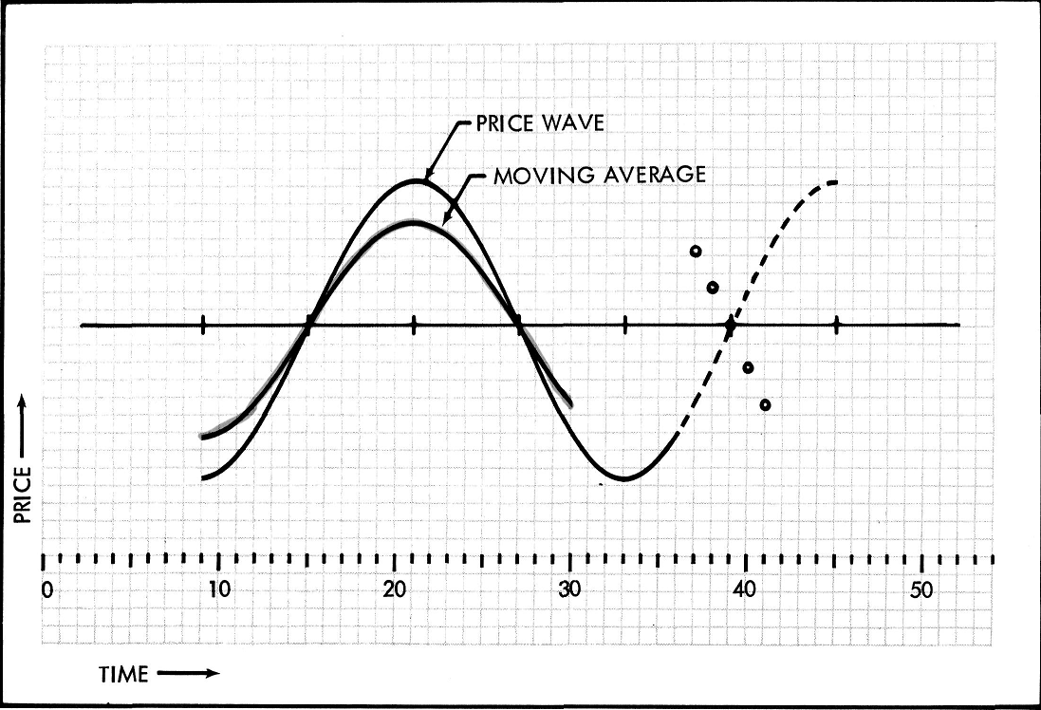

Figure 9-3 The Genesis of FLD

Here we again have an idealized price wave and Moving Average the same as in figure 9-2, but this time the Moving Average has not yet reached its trough.

The period of the price wave is 24 days, so the span of the half-span Moving Average is 12 days.

Imagine that grid line 36 represents today and that you would like to estimate the price that will be reached at the next crest of this price wave.

Also imagine that, as would be the case in a real-world situation, you do not know exactly on which day the trough of the Moving Average will occur.

- However, you do know that if the trough of the Moving Average is at grid line 30 (its last available data point), then the sum of tomorrow's span of price means will have to be greater than the sum of today's span of price means in order to change the Moving Average price rate from negative to positive.

For this to be true, tomorrow's price mean will have to be greater than the price mean that will be subtracted from the left end of today's span.

And you know that the price mean that will be subtracted is the one that is 12 days back, counting today.

- Now, if you go back 12 days (from today, grid line 36), find the mean price for the day, and then plot that price as a point on tomorrow's grid line, you have marked the tomorrow's mean price that if exceeded would result in a reversal of the rate of change of the Moving Average.
Furthermore, if tomorrow's mean price should indeed exceed this point, the point would also serve an additional function.

Because it is ¼ cycle from the moving-average data point that has now been
identified as the trough center, this plotted point would also be the halfway mark between the price at the last trough and the price at the next crest.

- The point is shown plotted on grid line 37 in figure 9-3.

It is too far above today's mean price for you to have much expectation that tomorrow's mean price will turn out to be that high.

Therefore, you might decide to plot similar points for the next several days.

Points for the next 4 days are shown plotted in figure 9-3.

Figure 9-3 The Genesis of FLD

And now you no doubt recognize the FLD.

Take your pencil and straightedge and connect these 5 points in sequence with short straight lines.

The resulting FLD line marks the boundary between those future price means that will produce a smaller span sum than that of the previous day and those future price means that will produce a larger span sum than that of the previous day.

- If the future price mean is below the line, it will be lower than the price mean that is subtracted from the left end of the previous day's span sum even though it may be higher than the previous day's price mean.

The new span sum will therefore be less than the previous day's span sum, and the new moving-average data point (plotted 1/4 cycle back) will be
lower than the previous one.

- If a future price mean falls right on the line, it will be exactly the same as the price mean that is subtracted from the left end of the previous day's span sum.

The new span sum will therefore be equal to the previous day's span sum, and the new moving-average data point will be exactly the same as the previous one.

- If the future price mean is above the line, it will be higher than the price
mean that is subtracted from the left end of the previous day's span sum
even though it may be lower than the previous day's price mean.

The new span sum will therefore be greater than the previous day's span sum, and the new moving-average data point will be higher than the previous one.

- From this reasoning, it follows that as long as price means are below the FLD line, the Moving Average (1/4 cycle in the past) is falling.
Also, whenever price means are above the FLD line, the Moving Average is rising.

- Therefore, when price means cross, or break, the FLD line as they are moving from below the line to above the line, the Moving Average (1/4 cycle in the past) is just changing from falling to rising and is right at the center of its trough.

- We then know that the price wave plot, which is 1/4 cycle further along in time than the Moving Average plot, is halfway between its trough (which occurred at the same grid line as the Moving Average trough) and its next crest.

- It is then a simple matter to obtain the most probable price at the next crest by taking the price rise from the trough to the FLD break and adding it to the price at the FLD break.

- (Realize that in general, the exact point of zero rate of change for the Moving Average will fall in between the discrete grid lines.

Thus the point at which price means cross the FLD line will generally be in between grid lines.

You have observed this in your dealings with FLD breaks in past analyses.)

- From the foregoing paragraphs, it can be seen that what we are really doing is using the half-span Moving Average (which tracks the base price wave and is in phase with it) to identify the time location of the trough of the price wave.

We are then measuring 1/4 cycle forward in time from the price wave trough to establish the time location of the half-way point in the price rise from trough to crest.

- Fortuitously, the FLD break simultaneously identifies the location of the wave trough and itself marks the half-way point in the price move from trough to crest.

- As you know, the price at the trough is taken to be the price low associated with the trough in the phasing analysis of the base wave, and this price low does not generally lie on the same grid line as the trough of the base wave (and the Moving Average).

- The very same reasoning just used for the price move from trough to crest
can also be applied to the move from crest to trough.

By now you should have a thorough understanding of the basic principles of the FLD; what it is, how it works, and why it works.

Study the foregoing discussion until you feel completely comfortable with the concept.

Now let's take up the matter of the multiple FLD break.

As indicated previously, a Moving Average is a somewhat imperfect filter in that some small percentage of the waves shorter than the span wave leak through and appear in the Moving Average plot.

The worst offender is the wave just shorter than the span wave, but any other shorter wave with abnormally high amplitude will also show up in the plot.

• Return to figure 9-1 on which you plotted the 21-day Moving Average for EQF. (Moving Averages are generally referred to by their span length.)
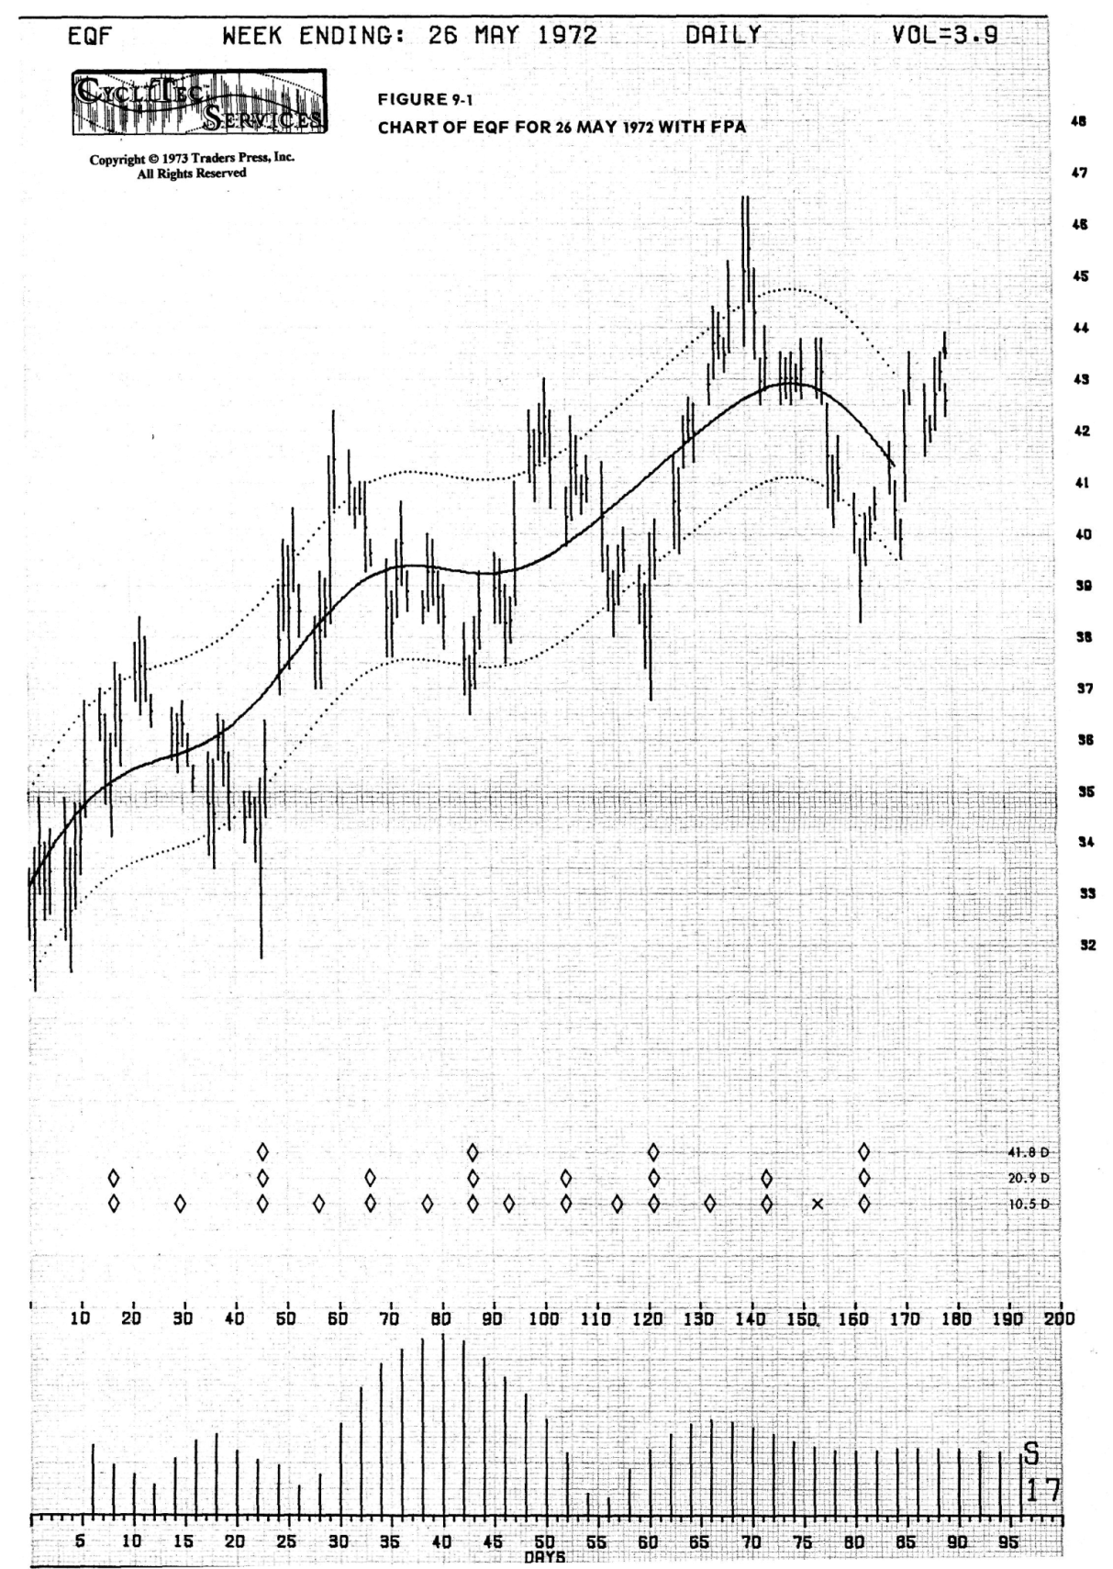

Carefully examine the Moving Average plot for distortions, or ripples, caused by waves shorter than 21 days.

- Notice that these distortions are most apparent at the troughs and crests of the Moving Average where the price rate of change of the base wave is low.

(As you know, this rate is zero at the center of each trough and crest.)
In between troughs and crests of the base wave, the price rate of the plot is high enough to largely obscure the remnants of the shorter waves that are leaking through the filter.

- From your new understanding of the FLD, you know that each time the
Moving Average plot changes direction there will be a corresponding price
break of the FLD exactly 1/4 cycle (of the base wave) further on.

- Now, as an exercise, start at the left side of the chart and search the
Moving Average plot for the points of rate reversal.

Realize that because of the ripples just discussed, there may be more than one point of rate reversal for any given trough or crest of the base wave.

Also realize that at any given trough or crest, there has to be an odd number of reversals; either 1, 3, or 5, not 2 or 4.

This is because the plot must ultimately leave the trough or crest area in the opposite direction from that of the approach.
(When Underlying Trend is very strong, there may be an even number of
closely spaced reversals; this condition will be discussed later.)

Record the results of your search in table 9-3 in the following manner.

In the column headed Reversal Grid Line, circle the number of the grid line on which the reversal point appears.

This will be the point for which the plot is moving in one direction on one side and in the opposite direction on the other side.

- For example, the first reversal point you would come to in your search
from left to right is the one at grid line 21.

On the left side of this point the plot is moving up; on the right side, the plot is moving down.

You would therefore circle the number 21 in the Reversal Grid Line column in
table 9-3.

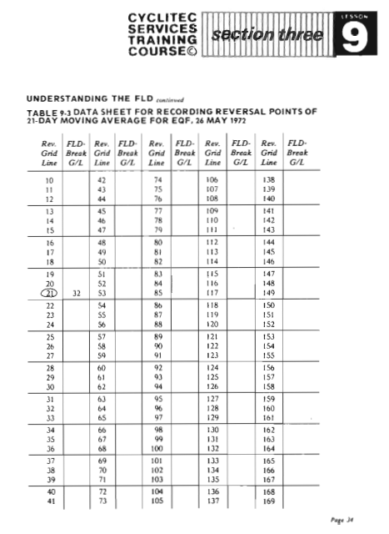

- Next, in the column headed FLD-Break Grid Line, write in the grid line number at which you would expect to find an FLD break as a result of each price reversal you have found in the Moving Average.

- You expect an FLD break to occur 1/4 cycle (10-1/2 grid lines) after each reversal point.

In our example with the reversal point at grid line 21, this would locate an FLD break halfway between grid lines 31 and 32.

- Because the reversal at grid line 21 is at a crest, the FLD break should be
in the downside direction.

Consequently, you would expect the price mean at grid line 31 to be above the FLD and the price mean at grid line 32 to be below the FLD.

You would therefore write 32 in the FLD-Break Grid Line column opposite the circled 21 in the Reversal Grid Line column.
The entries for this example have been made in table 9-3.

Go ahead and complete this task before reading further.

- Now turn to figure 9-4, which is the same chart as figure 9-1 but with the
half-span Moving Average and FLD for the 41.8-day wave added.

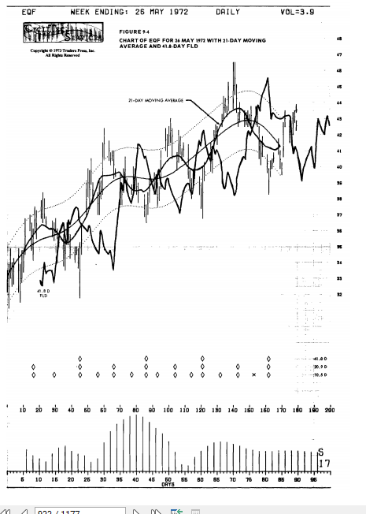

(The shift distance used for the FLD was 21 days.)

- First, check your plot of the Moving Average against that shown in the figure.

Because each color is printed on the chart with a separate impression of the press, there may be a slight registration error.

The red Moving Average plot should have points that fall exactly on price 35.8 at grid line 42 and exactly on price 42.3 at grid line 131.

The green FLD line should have points that fall exactly on price 33.5 at grid line 66 and exactly on price 43.0 at grid line 193.

If these points are slightly off on your copy of the figure, make appropriate allowances when checking your own work.

- Next, look for the FLD breaks that you forecast in the FLD-Break Grid Line column in table 9-3.

You should find that they are all indeed present.

- The correct reversal grid line numbers and associated FLD break forecasts are shown in the table on the following page.

- You undoubtedly noticed the triple FLD breaks occurring in association with the Moving Average crests in the vicinities of grid lines 21-27 and 60-69 and in association with the Moving Average troughs in the vicinities of grid lines 80-84 and 115-117.

- These multiple breaks are typical of those you have encountered in the past.

And now you understand exactly how and why they have occurred.
They are caused by the multiple reversals, or ripples, at the troughs or crests of the Moving Average; and these ripples are the result of the leakage of shorter waves through the Moving Average filter.

Reversal Grid Line | FLD-Break Grid Line | Reversal Grid Line | FLD-Break Grid Line
21 | 32 | 82 | 93
26 | 37 | 84 | 95
27 | 38 | 105 | 116
37 | 48 | 115 | 126
60 | 71 | 116 | 127
61 | 72 | 117 | 128
69 | 80 | 144 | 155
80 | 91 | 166 | 177

- When a multiple break occurs with an FLD that is being used to generate an Action Signal, the first break is taken as the Action Signal because at that time, of course, it is not known that there will be a multiple break.

- When a multiple break occurs with an FLD that is being used in past time to establish a price objective, the multiple break can be handled in any one of the following ways:

- Mentally smooth both the FLD and the price movement in the vicinity of the multiple break so that only one break is produced.

- Average the highest and lowest of the break prices and use this average as if it were the price at a single break.

- For the price objective, use a range of prices established by the highest and lowest of the break prices.

• For the triple break in the vicinity of grid lines 90-95 in figure 9-4, method a results in a break price of about 39.0 at about grid line 93.

Method b results in an average break price of about 38.9.

And method c would employ a break price range of about 38.6 to 39.2.

You can see that whichever method is used, the results are essentially the same for all practical purposes.

- Now let's consider the matter of the missed FLD break and the even number of multiple breaks.

- Turn to figure 9-5, which is a daily chart of HP for 23 November 1973.

The 40-day and 20-day waves have been phased as indicated by the 2 rows of diamonds.

- Using an FLD number of 21, plot on this chart (in green or blue) a 42.0-day FLD starting at grid line 70 and ending at grid line 150.

Do this before reading further.

- Now examine your results, and, in the light of your knowledge of the
relationship between an FLD and the associated half-span Moving Average, determine the grid lines at which you would expect to find reversals in direction of the half-span Moving Average based on the 42.0-day wave.

Write down your answers.

- You have no doubt noticed that while there was a double FLD break in the vicinity of the 42-day low at grid line 86, there was no break at all in the vicinity of the 42-day low at grid line 126.

- We know that a price mean falling on an FLD corresponds to a point of zero rate of change in the associated Moving Average.

It therefore seems reasonable to expect that the point of closest approach of price means to the FLD would (in a case such as this with very strong Underlying Trend) correspond to a point of minimum rate in the associated Moving Average.

- Based on this premise, at what grid line would you expect to find in the 21-day Moving Average a point of minimum rate associated with the 42-day low at grid line 126 ?

Write down your answer before reading further.

- Now, using table 9-4 to record the data, read off the price means from the chart of figure 9-5.

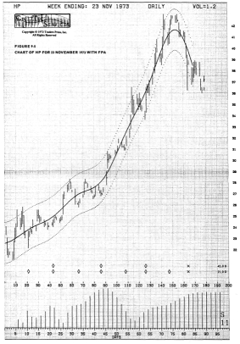

Start with grid line 40 and stop at grid line 150.

Read the price means to two decimal places or else the minor inflections you are expecting in the Moving Average may not be visible.

But first check the price-bar registration on your chart.

The center dot of the price bar grid line 8 should fall exactly on the 21.9 price Sine.

If it is slightly off in vertical registry, make an appropriate adjustment as you read off the price means so that you will be able to use checksums given later in the text.

Go ahead and record your price data now before reading further.

• From the price data you have just recorded, compute the 21-day Moving Average, again recording your results in table 9-4.

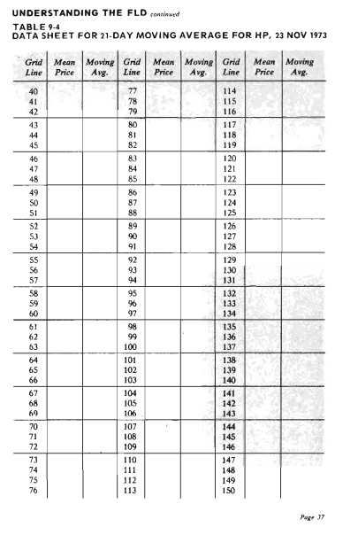

To assist you in this exercise, the checksums for every tenth grid line are given in the following table.

Realize that there will be variations of 1 or 2 in the second decimal place of price means due to personal differences in estimating.

If your span sum matches the checksum within 5 units in the last decimal place, your sum is probably all right.

Such a deviation is well within the requirements of our present application.

Grid Line | Check Sum | Grid Line | Check Sum
50 | 538.62 | 100 | 642.91
60 | 558.65 | 110 | 687.10
70 | 565.37 | 120 | 726.51
80 | 573.45 | 130 | 771.40
90 | 601.20 | 140 | 832.59

Complete the Moving Average calculations before reading further.

Before you plot the Moving Average, let's check your answers on the expectations resulting from examination of the FLD.

There was a downside break of the FLD between grid lines 76 and 77.

From this break, you would expect the 21-day Moving Average to have changed direction at grid line 66.

• There was an upside break of the FLD between grid lines 80 and 82, with
the price mean at grid line 81 falling right on the FLD.

This would lead you to expect a flattening of the Moving Average at grid lines 70 and 71 and a change in direction by grid line 72.

- The closest approach of the price means to the FLD in the vicinity of the 42-day low at grid line 126 occurs at grid line 126 itself.

You would therefore expect a slowdown in Moving Average rate at grid line 115.

- Now, see if these expectations are fulfilled by plotting the Moving Average (in red) on the chart of figure 9-5.

Do this before reading further.

- Upon examining your plot, you probably found that the Moving Average behaved exactly as expected.

If not check your plot against the one shown in figure 9-6.
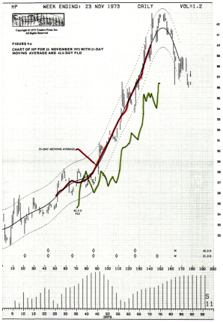

Perfect registration of the colors on your copy of figure 9-6 would be indicated by the following points.

The red Moving Average plot should have a leftmost point that falls exactly on grid line 50 and exactly halfway between price lines 25.6 and 25.7.

It should have a rightmost point that falls exactly on grid line 140 and exactly halfway between price lines 39.6 and 39.7.

The green FLD should have a point exactly on grid line 108 and price line 26.9 and another point exactly on grid line 136 and price line 34.9.

If the registration is slightly off, make appropriate allowances when checking your own work.

- It is important to realize that the double FLD break at grid lines 77-82 is in the same category as the multiple breaks encountered in figures 9-1 and 9-4.

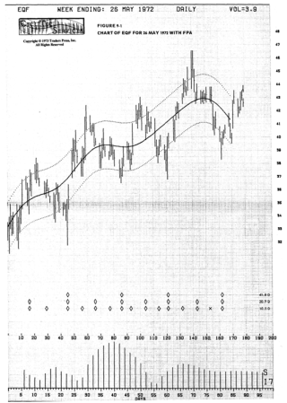

That is to say, it is due to Moving Average reversals that are caused by leakage of shorter waves through the Moving Average filter.

In figure 9-6 the high-amplitude shorter wave is quite visually apparent between grid lines 49 and 79.

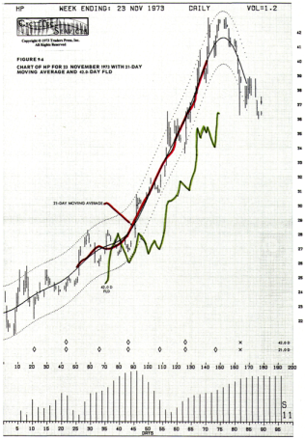

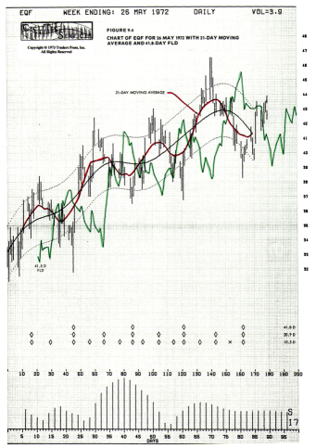

- If it were not for this leakage of the shorter wave, there would be no Moving Average reversal at all and therefore no FLD break.

- If the first break at grid line 77 had been encountered in real time (that is, when no price data was available beyond grid line 77), a price projection to a low of about 26.5 would have been made.

This would have lead to an expectation of very much the same price action that actually took place.

- However, by grid line 84 the second break would have occurred, much too close to the first break for the 2 of them to constitute the normal pair of FLD breaks straddling the 42-day low.

By grid line 91 the true nature of the double break would have been fully apparent and the phasing diamond for the 42-day low would have been placed at grid line 86 rather than 79.

- By the time of the next 42-day low at grid line 126, the upward pseudo-trend was very strong and even the high amplitude shorter waves did not produce an FLD break.

The slight inflection of the Moving Average in the vicinity of grid line 115 was again due to leakage from the shorter waves.
But of course it matched up well with the closest approach of price means to the FLD. exactly 1/4 cycle (of the base wave) later on.

- From the foregoing examples you can see that if you remember the Moving Average characteristics you have learned in this section and the relationship of the FLD to the Moving Average, you can properly interpret the FLD break in any of its manifestations.

You will thus be able to utilize the full power of the FLD break with complete confidence.

- Before we leave the subject of the FLD, a word on the calculation of the FLD number is in order.

- You have just seen from the manner in which the FLD is derived from the half-span Moving Average that the true FLD number is exactly equal to the span of the Moving Average, which is in turn 1/2 the period of the base wave.

(Realize that if the Moving Average is not actually going to be plotted, then there is no need to round the span to the nearest odd whole number.)

- You also recall that in earlier lessons the FLD number was calculated by
dividing the period of the base wave by 2 and then adding one.

- It is a good idea to add the one when the FLD is being used to generate an
Action Signal.

This provides added insurance that the anticipated price move is actually under way when the break occurs.

In early lessons, the one was added in all applications for the sake of consistency.

- Now that you have a thorough understanding of the FLD, you are in a
position to fully appreciate that the one should be added for Action Signal applications but may be omitted for all other applications.

