CHAPTER 6. SPECIAL SITUATIONS
USE ALL THE RULES (NOT JUST ONE OR TWO)

Chapter 6 MMTS Special Situations B

Look at chart #17. G.M General Motors (weekly).

This is a "classic" signal.

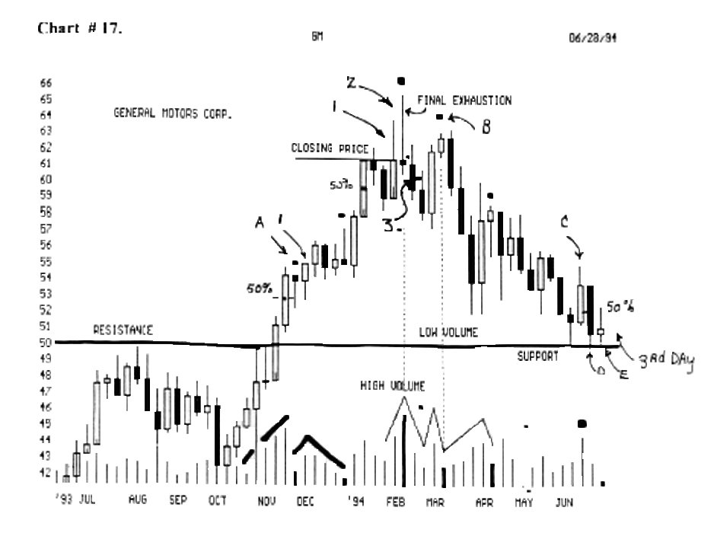
It fell below the 50 % line by 19 cents, but moved back up the 50 % line and closed the week back up at the high of the previous week.

We see (a) is a "reverse hammer" then the next week it fell to the 50 % line, then it ran back up and closed at ( 1 ) higher than the "hammer. "

This why we must make sure that it closes be-
Low 4/8ths (50 % Line) for the week (or for the day),
before we are comfortable with a short trade on this
stock.

Look at chart # 23. BA. (weekly). It fell 3 weeks to the 50 % line, then it ran up, then retraced back down to 50 % Line, then it bounced up, then fell back for a 2nd time with a "reverse hammer" forming a 4th higher low.

And since it didn't fall any lower than the 75 % line (5th lower low), it went on up to higher highs.

Look at chart # 24. Motorola, (weekly).

Look at the seven 50 % lines, and the influence they exert upon our stock's support / resistance.

The reverse rule is true.

If it can't make it up to the 50 % line by 19 cents or 39 cents, will have to fall back for support.

Look at the (triple bottom) 50 % Line.
It tried to touch the 50 % line, but it fell back 39 cents below the line.

Best entry position of final exhaustion price reversal pivots

Look at chart #18. F.R.E. (weekly).

It formed at (a) a "morning star" where we would have gone long on the close of this day.

But we would enter only 50 % of our position, since it has not moved higher than 25 % of the last down (black dot) week.

It is good that we didn't go in 100 %, because it fell at week (b), then it reversed and closed just above the 50 % line, so we would go in 100 %.

We never have any guarantee that it will clear the black candle, so we must enter cautiously, and give up some profit, for making sure that we are trading in the general trend.

Look at the Apr.,'94, "doji" reversal signal.

We should enter 50 % at the ( black dot ), then enter 100 %, as soon as it clears the 50 % line.

We don't always make as much profit by buying in segments or percentages of our capital base.

Page 57. (7 to 10 day - S) reversal rule.
(Most over looked rule) to consider every time you
enter a trade.

W.D. Gann said on page 57. "a daily movement may reverse trend and only run 7 to 10 days, then follow the main trend again."

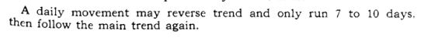

Look at chart # 5. G.E.T. Gaylord Entertainment

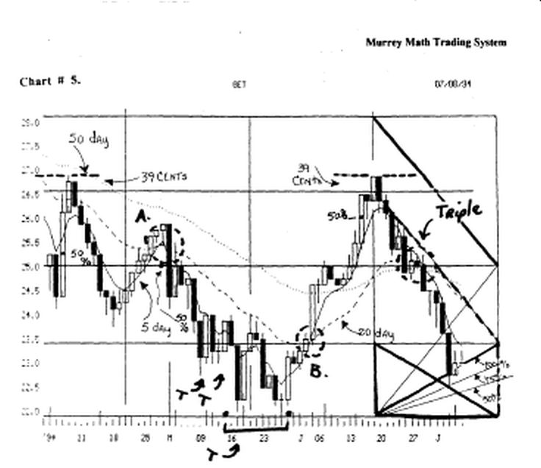

Look at the (t's) along the bottom of the chart.

It tried to reverse for 5 days, then it fell, then h reversed for 10 days, then it fell, then it reversed for 10 days, then it fell and formed a 10 week double bottom, then finally reversed and ran back up toward its old high at 27.00.

Look at chart # 14. Merck (weekly).

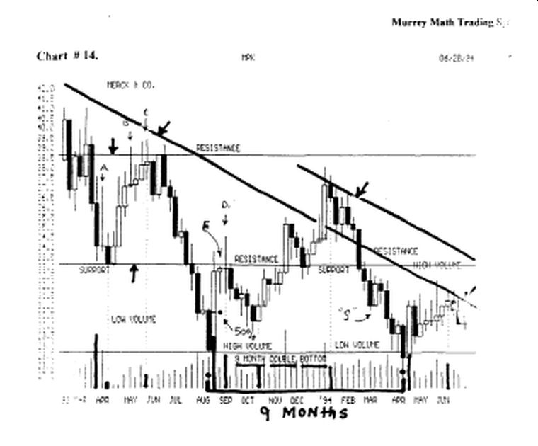

It fell from 38.4/8, back down to 28.1/8, then it reversed back up for 15 days, then it fell back down toward its old low, but couldn't get more than 39 cents below the 50 % line, over an 8 week time period, so it ran back up toward its (resistance) at 33.1/8.

Look at chart # 18. F.R.E.

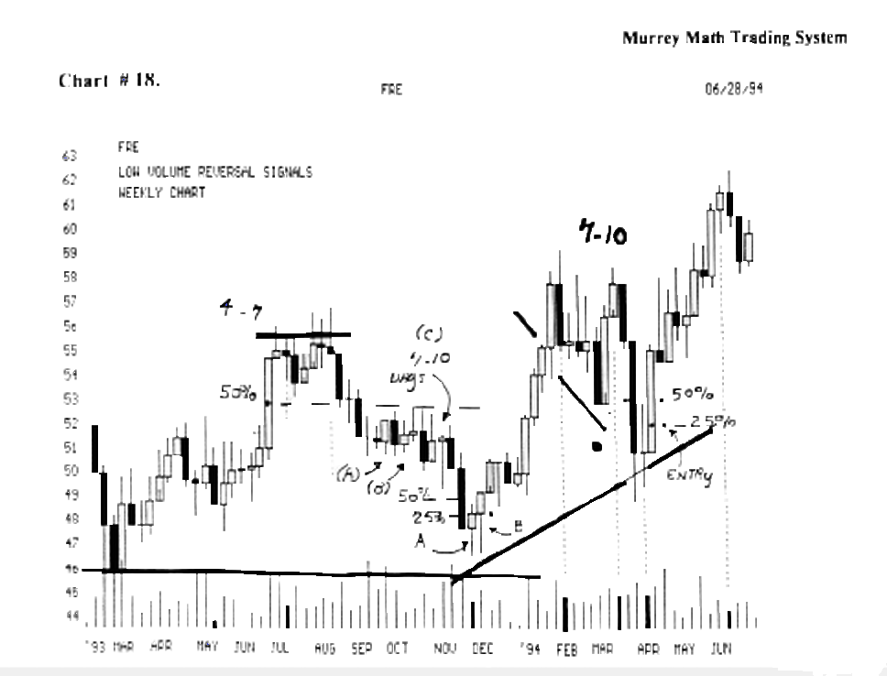
Find the (4 to 7 days) above the 50 % line. This market fell for a 3rd time after a 10 day reversal.
It reversed for 10 days at (a) and again at (b).
We must remember to watch the 50 % Line, and see if our stock can make it back up to its 50 % resistance Line.
Look at chart # 24. Motorola. ( weekly ). Find the (7 to 10) reversal days, that broke the trend, then continued on up to make higher highs.

We must always expect any stock or market to sell off, or reverse, then move up for 7 to 10 days, continue with its general trend

Look at chart # 27. Coca Cola, (weekly).

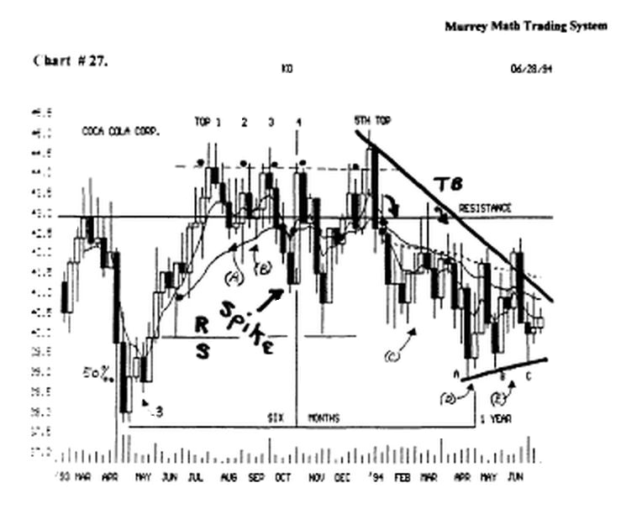
Find the 50 % line next to the final low in Apr.,'93, then it reversed for 10 days.

Then it fell the 3rd week, but, it didn't close more than 19 cents below the 50 % line, so it reversed and headed higher.

Find the (a) 10 days, (b) 10 days, (c) 3 weeks, (d) 10 days, and finally (e) it went up for 3 weeks, then fell back for support.

It formed a third higher low, which is an excellent place to enter a position.

Look at # chart 30. C.T.X.. ( weekly ).

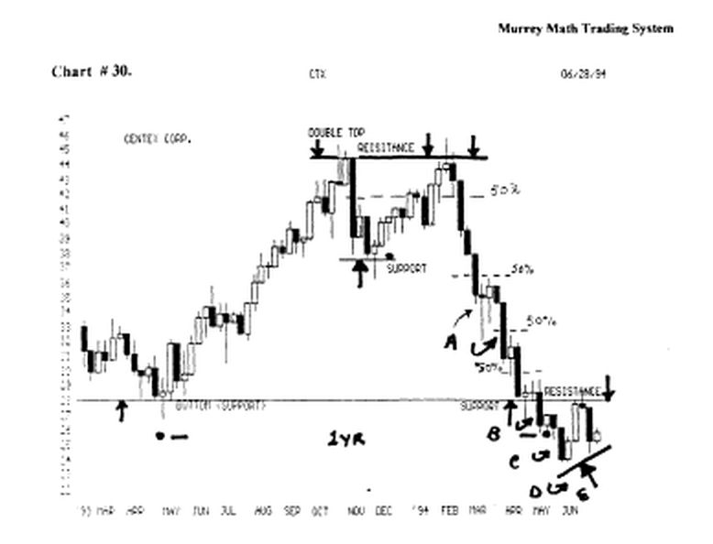

Find (a) 10 days, (b) 10 days, (c) 5 days, (d) 10 days.

It reversed 5 straight times. We would have been shell shocked

After seeing that this rule exists, and stocks don't always go straight up, is why this is the most neglected rule that tends to be over looked and least understood.

We would do well to close 50 % of our position, in a down market if our stock moves up for 7 to 10 days, then stalling out.

We would always protect our profits, and still stay in the market 50 %.

Short - legged "w" bottom reversal signal

Look at chart # 1. Disney. D.I.S. Find the (b) in Apr.,'94, and it formed a short-legged "w" and took off to the up side.
Look at chart #18 F.R.E. (weekly).

It formed a short legged "w" off its Nov.,'93, low.
Short - legged "w" triple bottom reversal signal Look at chart # 10. DJ.LA. 30 stocks. Find the lows (a, b, and c). It formed a double bottom at (a and b) then it didn't make a "w" but a "short - legged "W"".

This is an excellent buying opportunity.

And it moved back up to its (resistance) at 3,800.

Notice that it fell back to form a higher double bottom off the short leg of the "w" which was another great buying opportunity.

Look at chart # 22. DuPont. D.D.

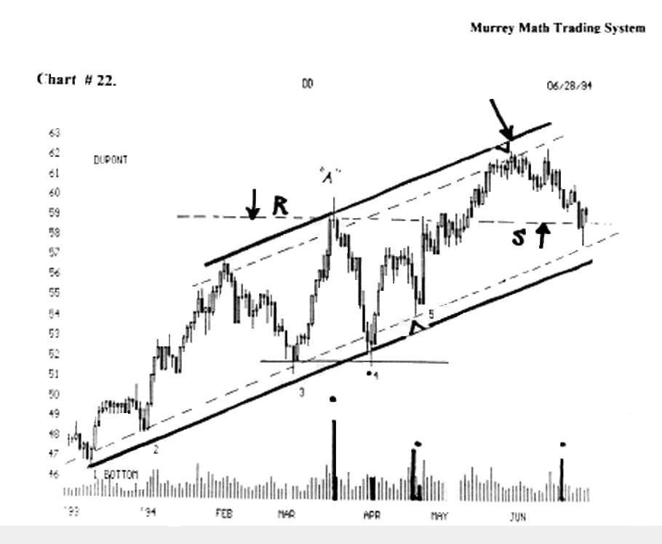

It formed a double bottom at (3 and 4).

Then at (5) it formed a short - legged "W" triple bottom. The momentum Lines in this upward trend are Babson lines. (see figure A).

We must consider whether or not these short legs are 37.5 %, 50.0 %, or 62.5 % retraces off the last high / low price pivots.

These would signal a greater opportunity to go with the reversal.

Secondary bottoms and tops

W.D. Gann said on page 33. "after the market makes final bottom and bas the first secondary reaction of importance, figure the percentage of that secondary reaction. Then watch for other reactions to run about the same. This is your yard, or measuring stick, for future movements."

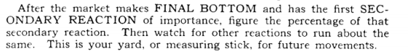

W.D. Gann said on page 35. "after the market has made final bottom in a bear campaign and the first rally takes place, then follows a secondary reaction, making a higher bottom, the half-way or 50 % point between the high of the first rally and the low on the secondary decline is very important from which to figure resistance levels.

The half-way point between the top of the first rally and the bottom of the secondary reaction is a strong support point."

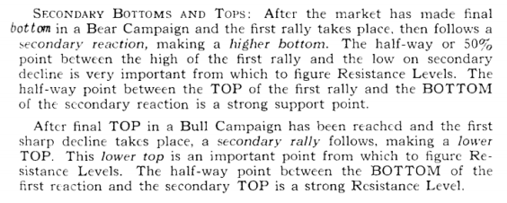

Look at chart # 10. D J.I.A. 30 stocks.

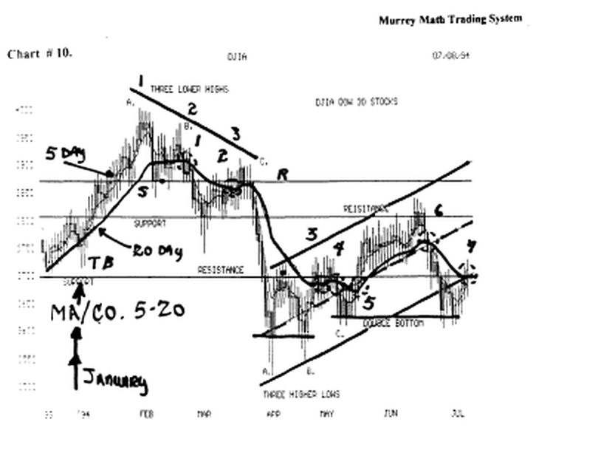
We see that the Dow 30 stocks fell to 3,515 and closed on the day up at 3,600. Its bounce reaction went back up to 3,700.

up to the first reaction, but couldn't drive through, so it fell back, not just 50 %, but almost 62.5 %, (Fibonacci maximum ratio retracement ) off its last high.

W.D. Gann always felt that the 50 % line was the most critical line for pivots of support or resistance for reversals, inside any 1/8th line.

Notice that the next run up at (c) was + 1.4/8 of the first reaction off its bottom.

It hit dd (resistance) and fell back to form a (double bottom) in July,'94, to support the market for higher prices.

Look at chart # 44. M.O. (Philip Morris),

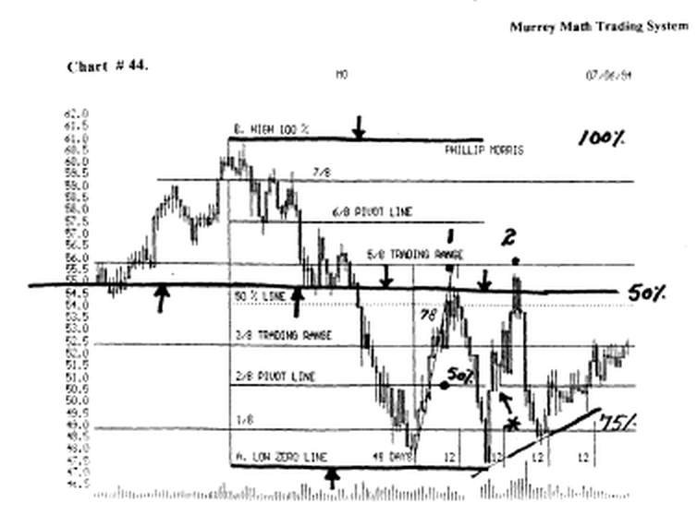

it made a low, then it reversed back up to 50 % off its low, then it fell back to its 2/8 line (50 %), but it did not hold there, so it fell all the way back down to form a double bottom..

Then it tried to reverse back up, and it broke above its first reaction off the bottom, but it couldn't close more than 39 cents above its 50 % line, and it formed a "tweezer top" and fell back fast, because it had run up fast on a 78° angle.

It fell at (2) and again, it couldn't hold at the 37.5 %, 50.0 %, or 62.5 % lines, so it had to fall back down to the 75 % line, which W.D. Gann said was the 2nd most important reversal point.

We must recognize that the pivot price was the 1/8th line, which is a weak line for reversals, but if it turns up here, after a -3/8.5 fall, we would expect it to move back up fast ). But it didn't.

Look at chart # 36. F.a.s.t.

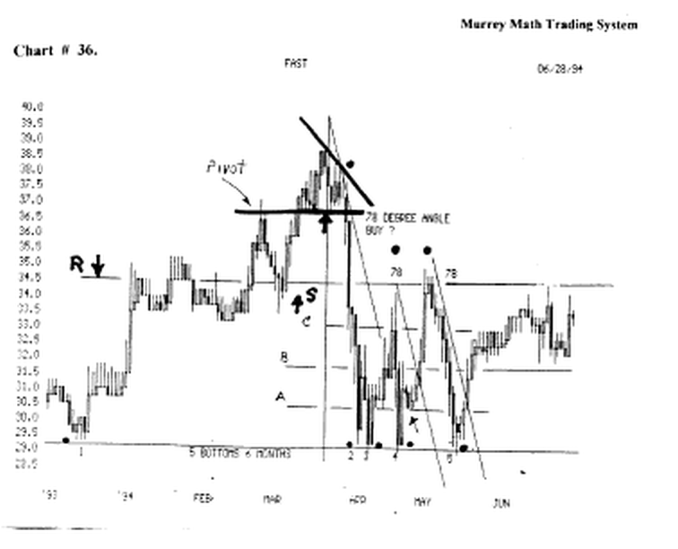

It fell to (2), then it reacted back up to close at (c), then it fell back to (3) which was a double bottom.

then it could only run up 37.5 %, then it fell back to (a) which was at a 25 % line, then it ran back up to form a double top at the 2nd (black dot).

Then, it fell back to form a 5th bottom, and it didn't
50 % line of these 2
even try and stop at the extremes.

5 bottoms, 6 months apart, is a great buy signal.

Look at chart # 26. M.D.T. (Medtronic).

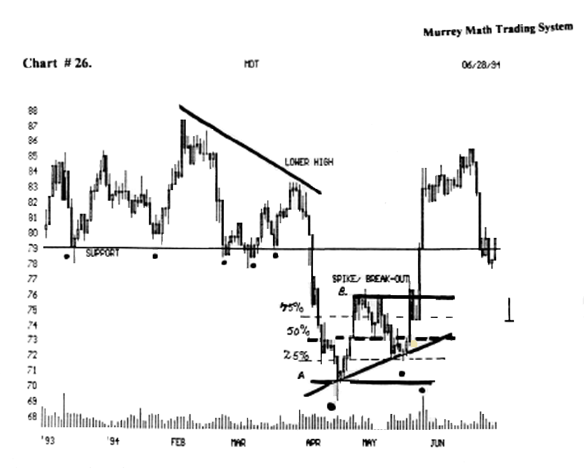

It formed 5 bottoms on its support line, but when it hit its down side angle, it reversed, and sold off hard, and fast, on the 6th tune, down to the support Line, so it had to fall all the way back down to 69. 1/2, where it reversed at (a).

It retraced from (a) to (b) then A fell back the first time to the 50 % Line, then it moved back up to the double top at (b), then it fell back 75 % of the move.

Then it reversed, on its 2/8 ths (25 %) Line, then it went back up to test its old highs at (b).

It tried to break out more than 39 cents above the "spike" break out price. But it couldn't, and it fell back down to the 75 % line for support.

The "grave stone" signaled a reverse back up would come soon: it came the next day.

The secondary support came in at May 20th,'94, when it formed a higher low (secondary support), with a small "morning star" (see black dot) right on the line, and it moved back up toward (b), which is the spike price point, it must close above, to get to higher levels, which it didn't the first day, then it reversed for 2 days, as I said before, it formed a "gravestone doji" and signaled a reversal soon.

Which it did. And it was strong, to the upside.

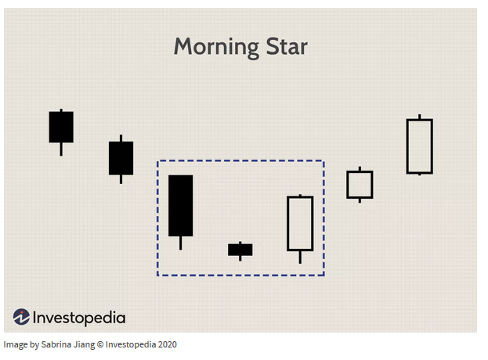

- A morning star is a visual pattern made up of a tall black candlestick, a smaller black or white candlestick with a short body and long wicks, and a third tall white candlestick.
- The middle candle of the morning star captures a moment of market indecision where the bears begin to give way to bulls. The third candle confirms the reversal and can mark a new uptrend.
- The opposite pattern to a morning star is the evening star, which signals a reversal of an uptrend into a downtrend.

Look at chart # 28. CCI. Citicorp.

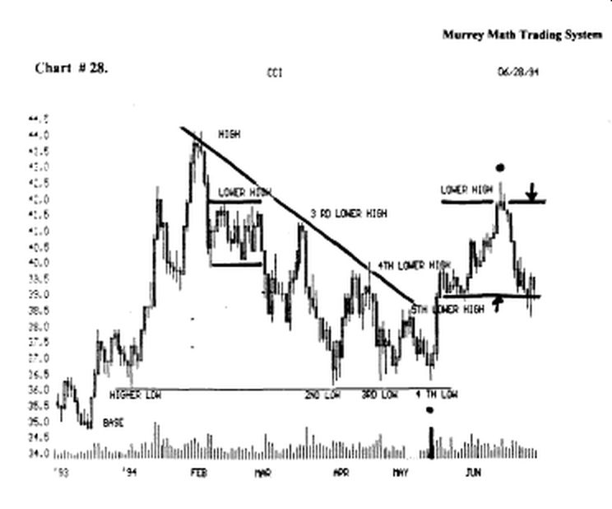
It topped out the first of Feb.,'94, then it fell back to the black line then retraced back up 50 % of its fall, but couldn't move any higher, so it fell back for support, but it kept falling, reversing, and going back up to test its downtrend line, and it formed (4) low bases.

Its first rally off its low was at (2nd low) and its upside reaction was its (4th lower high) on the down trend line, then it retreated again, back down for support, to form a 3rd bottom base, then we should watch for resistance, or support between the low of the (2nd bottom) and the high of (4th lower high), at 50 % of this distance, and it moved up, from its (3rd low), to form a (5th lower high) that was more than 50 % of these 2 extremes. It was like 62.5 %.

Then, it fell, to form a 4th bottom, which was better support, then it went up fast, back up to 42. 1/8, and stalled out on a (lower high) resistance line set up, back in Feb.,'94.

It signaled a final exhaustion, intraday reversal, (see black dot), "evening star" in the middle of July,'94.

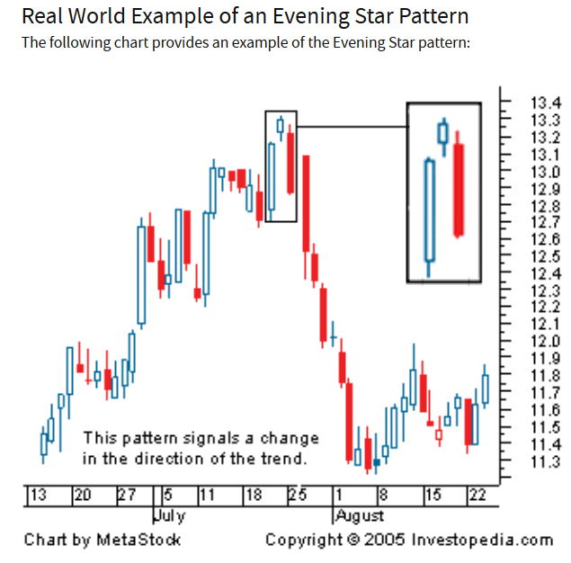

Then it fell all the way back down for support, on the black Line, which was 50 %, front (4th low) back up to (lower high), which is the best place to buy a rising stock.

Look at chart # 25. A.H.M.

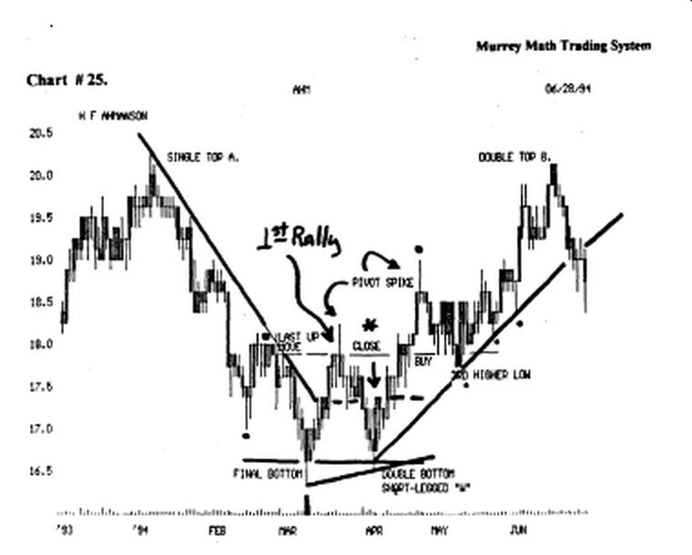
You will see that the 50 % point, from the first rally off a long down slide, and the first low of the secondary reaction, is very important, by starting at: final bottom, and marking the first pivot spike, at 18.00, and it had a strong, intraday reversal, and it went back down, off this first rally, to form a double bottom.

And then it made a secondary rally, (double bottom), then, it hit the 50 % line, of these 2 extremes, in just 1 trading day, (see the *), and it reversed for only 2 days, then it went on back up to test its old high, up against the high of the 1st rally, to try and break thru to higher prices.

It closed a cents above the line, but it took 3 days of stalling, to finally form a "rickshaw doji" to the left of (buy) and the next day, it moved up higher, to form a "final exhaustion" intraday reversal "evening star," sell signal, and it went back down, and formed a (3rd higher low), which is a great place to buy, and it moved up steadily, along the uptrend line.

Look at chart # 39. GDW.

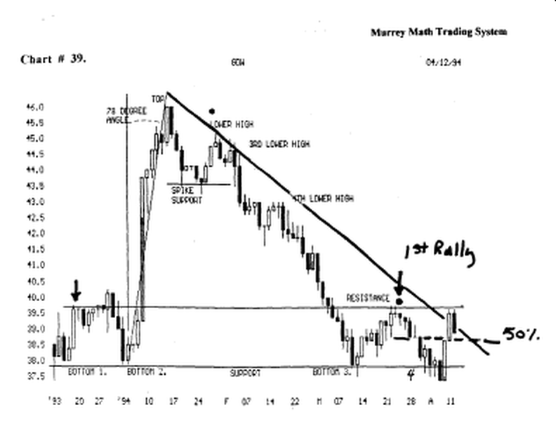

This stock has had its first rally off a "bear market fell" and its low formed a third lower bottom, along a long trend line, then it made a 1st rally, back up to the (see black dot) resistance line, and it fell back down to form a double bottom, and it reversed, and went back down, and stalled out on the downside, for a 4th low.

Finally based out below the line for 2 days, which is a sign that it was weaker, than it was stronger, and now, this "secondary reaction" went back up and closed just below its resistance Line, which is a weak sign, and that it wants to reverse, and fell back down toward the 50 % line, (dashed line), where it should get support, and reverse, and move back up, to test its (resistance) line, and sell, if it can't break thru to th upside.

Look at chart # 43. (MO) Philip Morris).

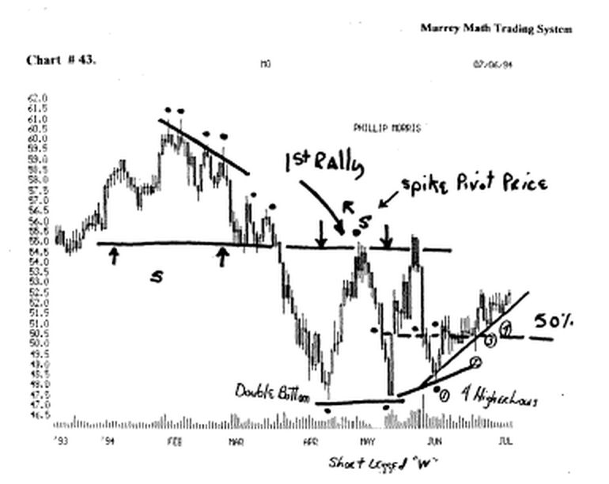
It fell hard, from 61.00 all the way down to 47.00, (see black dot), and then it made its 1st rally, back up to "S" (1st rally), and it reversed, and fell back down to form a double bottom, and now, the 50 % (dashed line) should give support, for our stock to reverse, and move back up, and test its high of its 1st rally. It couldn't hold, so it fell back down to form a second bottom, and we should watch for a reaction, when it comes back up against this 50 % Line.

It moved thru the 50 % Line, and moved back up to form a double top, and it closed above its 1st rally high, above the Line, but it couldn't close above the Line, 4 days in a row, so it reversed, and fell back down a stall out at (1), which formed a "short legged W" which is a great buy signal.

It moved up along this line 4 times, and each time, it moved higher, when it hit this up trend line.

Look at chart # 44. (MO). Philip Morris.

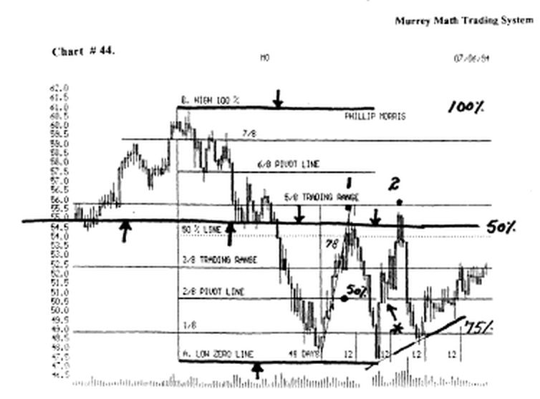

I have added the W.D. Gann # 1. rule, and that is to take the high and low extreme prices, and divide the difference by 8, and it should reverse, at the 25 %, 50 %, and 75 % Lines.

The 1st reverse rally, stalled out right on the 50 % line, just like he said, then it fell back down to the zero line, to form a double bottom, then it moved back up to the 3/8th Line, then reversed, for 2 days, (see *), which was the 50 % line, of the secondary rally Line, and it reversed, and moved back up to break thru the 50 % line, but it reversed sharply, at (2 with black dot), after only 3 days of extremely high volume selling, which was the signal, that the traders, were letting the "buy and hold" traders buy more, because it had closed above its previous rally back at (1).

(remember it must close more than 39 cents above a previous high or (kw), for at least 4 days in a row, before it may be expected to move up higher.

Secondary Tops

W.D. Gann said on page 35. "After final top in a bull campaign has been reached and the first sharp decline takes place, a secondary rally follows making a lower top. This lower top is an important point from which to figure resistance levels.

The half-way point between the bottom of the first reaction and the secondary top is a strong resistance level."

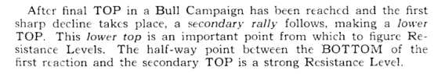

Look at chart # 38. Dell Computers.

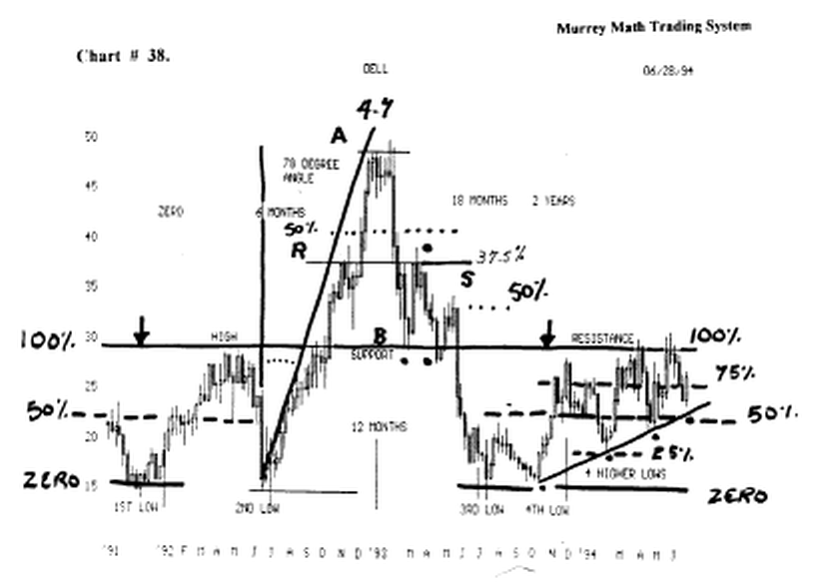

This stock moved up sharply, on a 78 ° angle, then it went sideways, for 6 days, (4 to 7 day mie), then it fell sharply, back down to its support Lines, from (A) to (B), at the (see black dot), and it reversed.

And it tried to go back up to its high, at (A), but we know that it stalled out on its first rally, only back up, at the (black dot), on me 37.5 % Line, in ApriL'93, and it fell back down to me (support Line).

And formed a double bottom, and reversed, and now we want to know if it can make it above the (50 % line), of this secondary rally, and it stalled right on me line, and fell back to the (support line), but it didn't even pay any notice, to the previous support.

And it tanked all the way back down to the same level, as the (2nd low), when it moved straight up, in 6 months, and it fell back down, exactly, to the very same price level, for a 1 year trading cycle of "zero profit" for the "buy and hold" traders, who used me "double bottom" buy rule, but didn't know the "78 ° " sell signal, against any stock that moves up too high too fast.

Look at the 1st rally off this vertical fall. h started on its (4th low), and couldn't make it back up to its (resistance line) by a few cents, which is a sell signal, and it fell back to its (dashed) (50 % Line), and reversed, but it couldn't move up past its 75 % line, and it had to fall back for support.

So it fell back down below the (50 % line), and formed a "short legged W" which is the 25 % line, between the zero line, (4th low) and the 100 % (resistance line), which W.D. Gann said was a great reversal price point.

Look back to December,'91. This stock established its base off its (1st low) and its (high), and then it reversed, and fell back down to form a (2nd low).

This stock is classic for cyclical time - price reversals such as:

a) 6 month time reversals,
b) 78 ° angle (speed too fast),
c) support off 4th bottom,
d) 4 to 7 day rule, and e) 25, 50, and 75 % reversals.

This stock made 14 reversals, that if you hk each one of them, you would have made a 700 % profit. But, if you had just made one trade down at 15.00, then you would have made 350 %, by just selling against the 78 ° rule.

Look at chart # 6. (MB) Nations Bank,

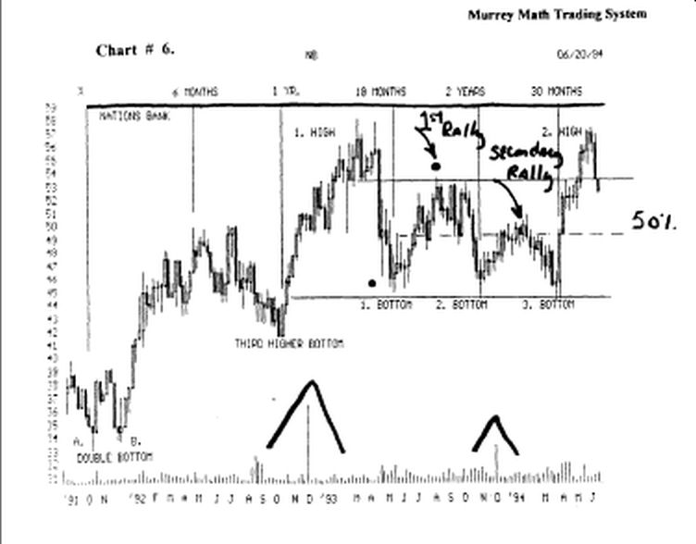

It made its 1st rally back up to test its old high, and it failed, and it reversed, and fell back down to form a (2. bottom) and then it made a secondary rally, and we are instructed, to watch for major resistance, on a 50 % line between (1. bottom) and the high of the 1st rally.

It reversed, and turned down, right on the secondary rally 50 % Line.

Short - Legged "M" tops (very few occur)

Look at chart # 29. Dollar General Stores.

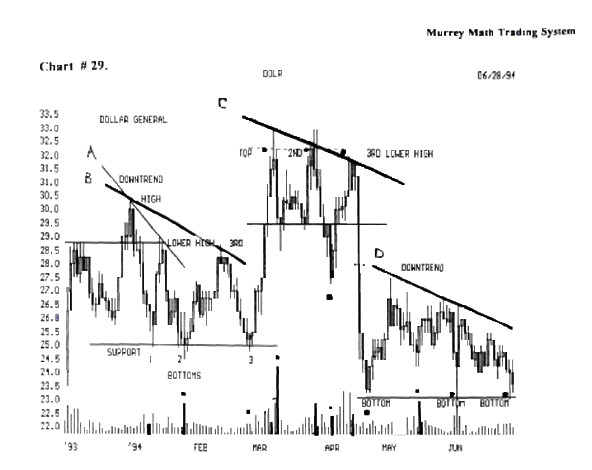

It is unusual to see this formation, but we must recognize that it happens, but it happens quite often at bottoms, when a market is trying, to decide, if it wants, to break out to higher highs, but this stock, is already on a higher high, and the "3" times rule, is in control here.

(the "3" times rule, states that you get 3 strikes and you are "out" just like in baseball, then it works the very same way, in me stock market reversals).

The (C) down trend Line, shows me 3rd time up, was weak, or a short legged "M."

The (black dot) at 26. 1/2, was the signal, that this stock was weak, for if it were really stable, it would have stalled on the support Line, and reversed, and moved back up to its old highs, but it really tanked down fast for 2 days, from 30.00, down to 27.00, and it reversed, fast, on some kind of news, back up to its (3rd lower high).

4 to 7 day Topping Out

Look at chart # 35. (HD) Home Depot.

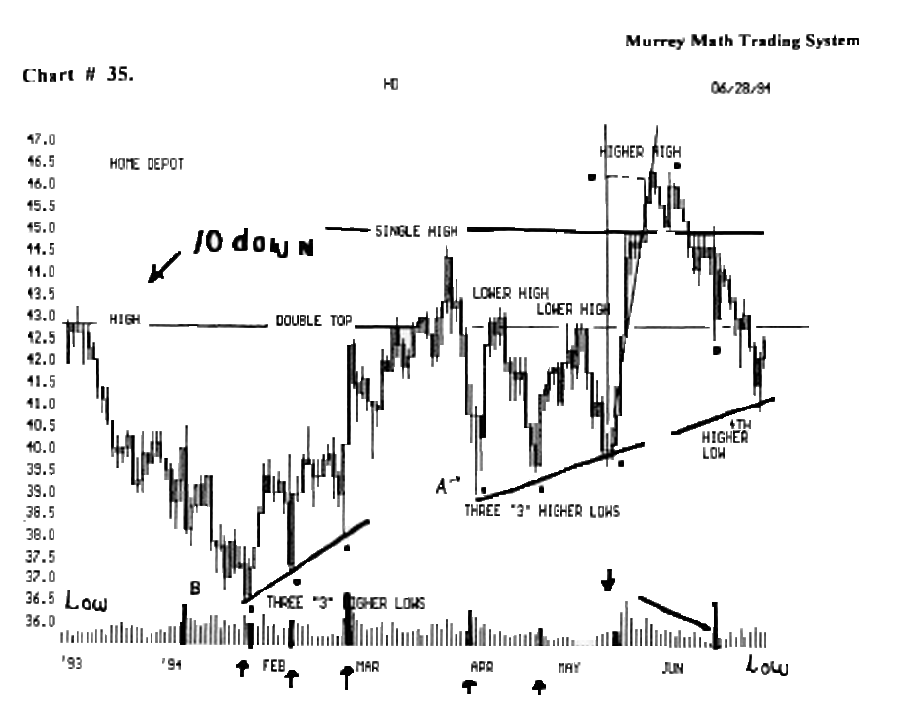

This is a normal topping out formation. This stock reaches an extreme high, then it goes back down for 2 or 3 days, then it moves back up, and on the 7 day, if it can't break out to higher highs, it will want to fall back down lower, for support.

Please, right here, just keep it simple, and start counting, as soon as it moves up to a new high, and stalls out, then reverses, for one day, and be ready to exit, to protect your profits.

Look at chart # 36. FAST.

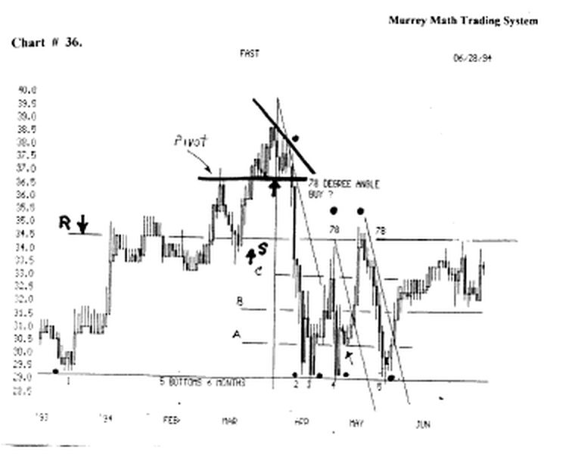

It reversed, consolidated, for 6 days, then, on the 7 th day it fell back down, fast, for support.

Look at chart # 38. Dell.

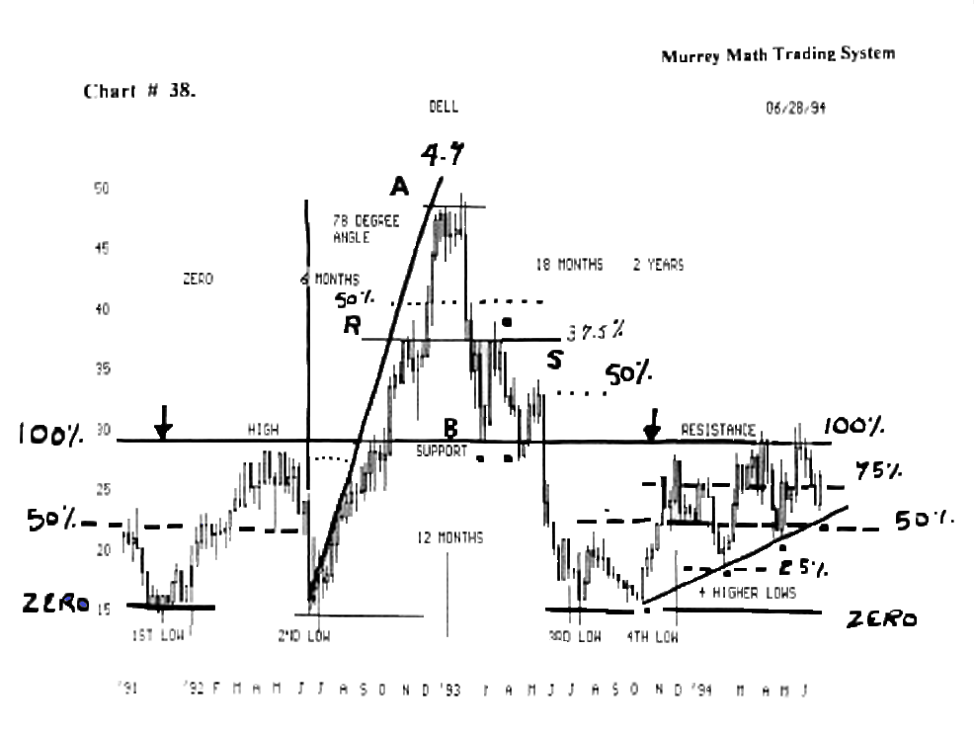

It has a classic case of the 4 to 7 day topping out. It changed its mind, every other day, until the Tth day, when it finally fell hard and fast.

Look at chart # 44. (MO). Philip Morris.

It topped out, and Consolidated for 6 days, and on the 7 th day, it really tanked, on some kind of "news."

Look at chart # 9. (FATN) First American Bank.

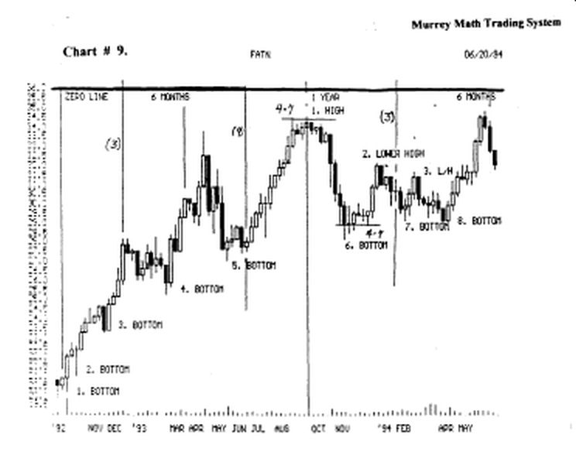

It Consolidated on a high for 7 days, then it reversed, and fell back down for support. Then it went sideways at (6. bottom) for 6 days, then it moved back up, but it could only make back up 50 %, from the high, and the base, at 28. 1/2.

W.D. Gann said on page 31. "You will always make the most money by following me main trend of the market, although to say that you must never trade against the trend means that you will miss a lot of intermediate moves which will make big profits.

Your rule must be: when you are trading against the trend, wait until one of the rules gives you a definite indication of a buying or selling point at bottom or top, where you can place stop loss orders.

One must reverse all the rules and reasons to set one's trading strategy toward trading the short side.
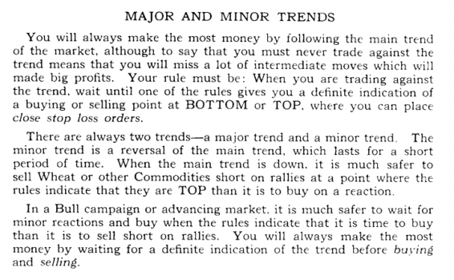

As you have seen, on a given number of charts, most stocks, and markets, want to stair step up, to a high, but, depending upon, how fast it moved up, it will retrace, (fall), and it will normally, fall more vertically, if it had just moved up too fast.

The "true traders," want to watch for a stock that is overbought, since it had already run up too fast, and bas made its 1st retrace, to get back up to its old high, and then we should watch for weakness, or failure, to move back up, to its most recent high.

Just ask yourself, right before you sell your position, for a large profit, why in the world did it ever move up that fast, in the first place ?

Look at chart # 38. Dell Computer.

This stock moved up too fast, then reversed, then it fell, just as sharply, back to its (support) Line, then it reversed, and tried to go back up, to its old high, but the same "news" that took it straight up, stalled out, with only a 37.5 % move up, then it reversed, which would be a great place, to short this stock.

Notice that the 37.5 % up move, was done in just one day, which didn't prove mat it had any follow thru, for the next day, (see black dot), it went up, for a short time, in the morning, then it closed the day lower. And it never tried to move up again, and test its 37.5 % line, so this was the best signal, that it is losing traders, willing to buy it back up (old high).

Warning: short selling should not be tried, until you have won 10 trades in one month, on the long side.

Spike Pivot Price

Look at chart # 3. Disney.

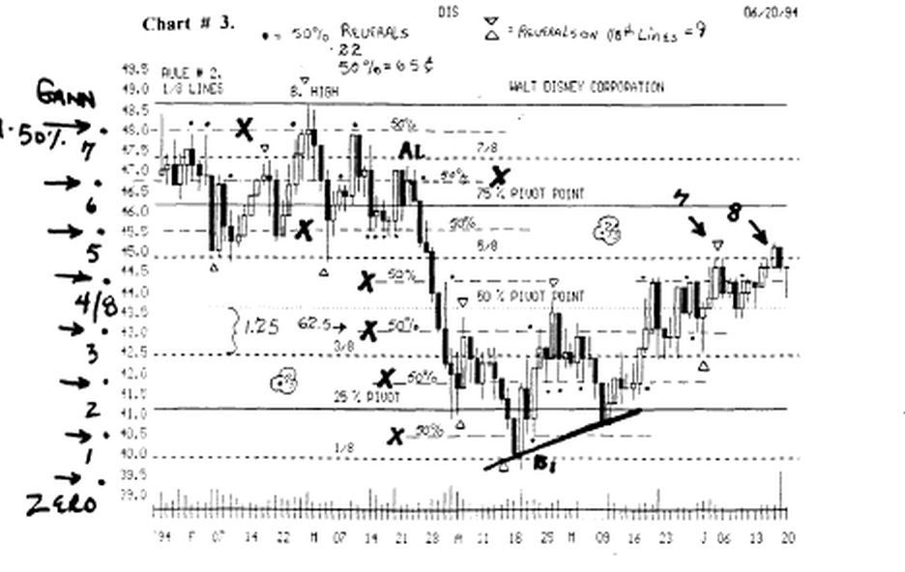

Find the 2 spike pivot points, (marked with a triangle above it).

These are critical resistance price points, when your stock, reverses off its low, and comes back up and tests this short term (pivot price).

You should not feel that it will move higher than the previous "spike pivot price," unless it closes more than 39 cents above the close of the spike, or it can close above the spike for 4 days in a row.

You see that it closed lower the next day, which was a reversal signal, so it fell back down to 41.00, which was higher than the last low, which was now, a buy signal, so we would go long again, and hope that the 3rd time up, it would break up to higher highs, above the 2nd spike pivot price.

It closed above the 2nd spike pivot price, on its 3rd try, and even closed the day, higher than 39 cents above the closing price of the previous spike, but just as before, it reversed fast, the next day, and closed, at the very same price, that it had opened the previous day, so it took 15 more trading days, to finally, close for good, above the spike pivot price.

Look at chart # 26. (MDT) Medtronic.

Here again, we see the spike pivot price, (B) off the 1st "bounce"

and it reversed, and fell back for support, the first time, it went up and tested it the 1st time.

It went down only to the 50 % Line, then it reversed, and made another run back up to test the (spike), and it closed above the Line, but, it reversed, and closed below the Line.

The next day, but you see 4e "gravestone" reverse signal, and it did, and moved up strong this time, to test its old highs, back in Feb.'93, which we know that we should always sell at least 50 % of our position, when it moves back up, 75 %, of the overall difference, between its high and its low. (it ran up a little higher and fell fast).

Look at chart #12. Munsingwear.

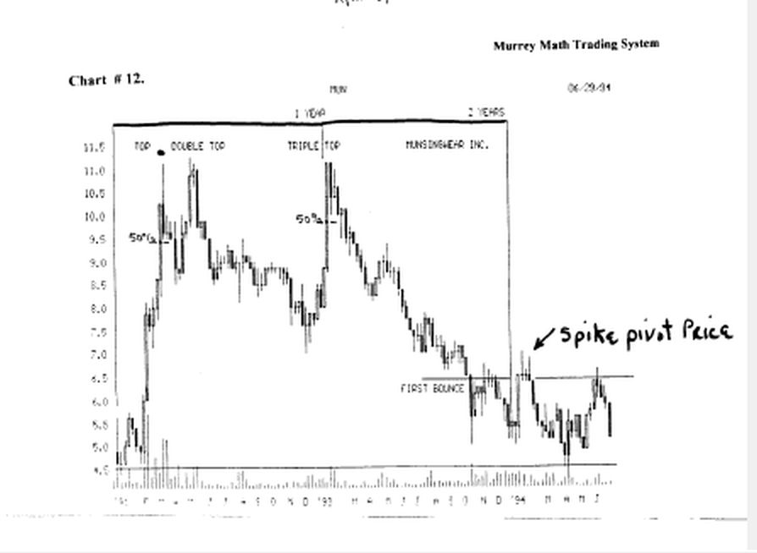

It fell sharply, for one year, back down to 5.00, where it made a double bottom, and then spiked back up, and at 6.50, it formed an "evening star doji" which was a reversal signal, to want to go back down soon, and it closed, on the line for 3 days in a row.

But couldn't hold, for the 4th day, so it fell back down even lower, to finally make a double bottom, back against its old low down at 4.50, which was the very same price it had been, exactly 2 years prior.

Then it based ont, and reversed, and went back up, to test the spike pivot price, and couldn't even close the day, once, above the Line, so it fell back down sharply toward its old 2 year low, for support, a 3rd time, which we know to be a great buy opportunity.

Ail we have to do, is look at the top of the page, to see that a triple top, is a great signal, that this stock is going to tank. ("3" times rule).

Look at chart # 25. (AHM).

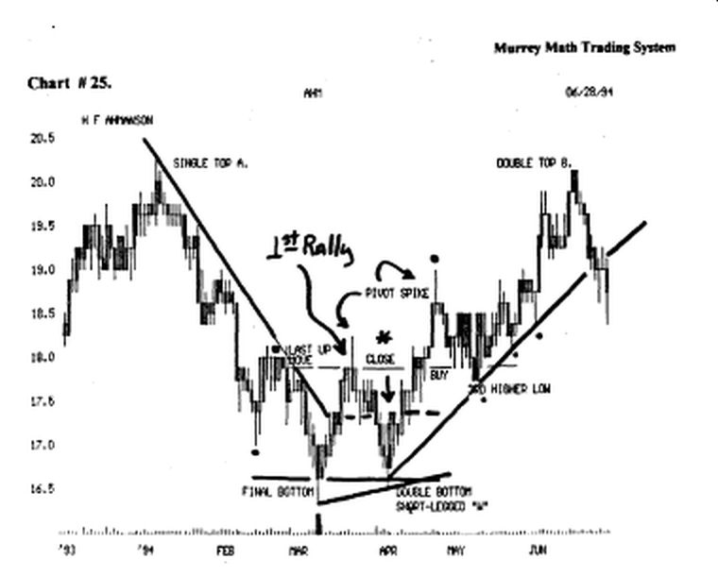

Its first rally, off its long down leg "bear market" bounced back up to form a spike pivot price, that if it went back down, would have 2 close above, one of 2 ways that we have already discussed.

So we saw that it retreated, and made a double bottom, and then reversed, and went back up sharply to test its spike pivot price, and on the second try, it closed above the closing price (of the 1st spike's closing price), on the 1st day, that it touched up equal to the 1st spike's closing price.

It closed the day equal to the spike's closing price, on the 2nd day.

It closed above the spike's closing price, on the 3rd trading day.

Then, on the 4m day's activity, it formed a "doji" "rickshaw man" where it fell below the spike's closing price, early in the trading day. Then it finished the day, back up above the spike's pivot price, on the 4m day.

The 5th day, no one was willing to sell any of our stock, and it just barely went up, which was the double sign, that the selling had quk, and we could expect a run to test its old high of 20.00.

Common sense tells us to just "eye bail" the high of 20.00 and the low of 16.50, and we would surmise, that if you we playing poker, which this is more aptly called "numbers" playing, just like the people who bet a dollar each day, for anyone with more assets, bets more.

And since they have more at risk, this country always legalizes, anything that is the most socially acceptable, if the group with the most assets, deems it to be acceptable in moderation, and is willing to put more at risk.

(just look at legalized drinking, and the number of poor people who get caught, versus those with more assets, who pay their way through the penalty).

But back to our poker hand, of betting that it will move back up to its old high, when we both know, from reading the 1st chapter, that W.D. Gann said that we should expect any stock, to get its greatest resistance, on the up side, at its 50 % line, in the total range of fluctuation, which it did.

And up at its 2nd spike pivot price, it formed a massive "shooting star" (see the black dot), which was at least 78 cents, so we knew that all of the smart traders had sold out of their poker hand, for they either made 50 %, of the run up, or they recouped 50 %, of their losses, and they didn't care, what the news was, or what it could do tomorrow.

They remembered that it had sold off sharply, after its sharp run up, on its 1st rally, so common sense told that if they sold out fast, on an intraday basis, then the 2nd level traders, would come in and back their position, and sell it off on the 3, 4, and 5th days, while the "buy and hold" traders, would just sit their, one more run, and say, "well, I waited this long, so I may as well wait a little longer, besides, it will come back some day, and since I didn't sell, on a high spike, because I didn't know any kind of a signal.

(plus I would have to pay my broker more money, than I would have made in profit, because I don't buy in 1,000 share lots, that I must be forced into a trading scheme, not System, that continually reinforces the wrong mind set, for the simple reason that you failed to buy 1,000 shares of stock to begin with).

There should be 2 laws of trading with a broker, and they are:

1) if the broker recommends the stock, and he doesn't force you to place a stop loss, then if you lose money, you don't have to pay any commission.

And 2) if you can't afford to buy 1,000 shares of stock, then you should not be allowed to buy it from him, until you have the money to play the game.

You would be more suited to buying mutual funds, which are 90 % easier to learn to trade, and you don't have to watch them but 5 minutes each day, and you don't have to have a broker, saying that he is keeping an eye on your stock, especially, if he has 40 clients, who have 5 different stocks.

Then just where do you think you are, on his priority list, when you have 300 shares of Chrysler, and he is out calling on institutional clients to get 10,000 share trades executed, while you are busy at work, earning a living, and you don't want to sell, because you can't double your money, on the trades you make, when if you simply look at these 326 charts, there are so few stocks that run up more than 4.5/8 before they reverse.

But, if you traded 1,000 share lots, and your stock moved up 2.00 points, you would automatically sell, with a $ 2,000.profit, and do business, with a discount broker, who charges you only $ 35.00 per trade.

If you learn to recognize, what the daily price action, is telling you, and sell every time you make $ 2,000. and go and find another stock that is low, and reversing, or
wait for this one, to go down, and then reverse, and just buy it back, and plan to sell it again, when it goes back up to your old price, where you sold it.

