CHAPTER 5 VOLUME AND DAILY ACTIVITY

W.D.Gann said on page 49. "study the volume of sales, the space and price movements, and the last most important time period."

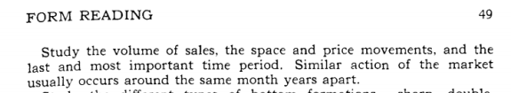

W.D. Gann said on page 62. "after considering the three important factors....formations, time, and resistance levels....the fourth and next very important factor is the volume of sales at tops and bottoms....the volume of sales is the real power behind all market and shows whether supply or demand is increasing or decreasing."

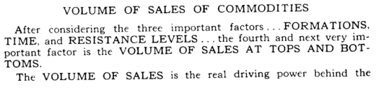
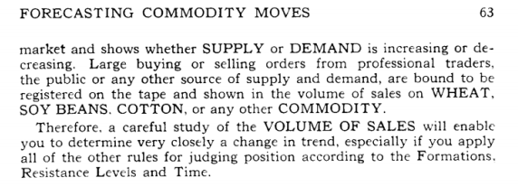

W.D. Gann outlined 4 different volume rules on page 63.

Rule # 1. "at the end of any prolonged bull campaign or rapid advance in any commodity, there is usually a large increase in the volume of sales, which marks the end of the campaign, at least temporarily.

Then, after a sharp decline on heavy volume of sales, when a secondary rally takes place, and the volume of sales decreases, it is an indication that wheat or any other commodity has made final top, and that the main trend will turn down."

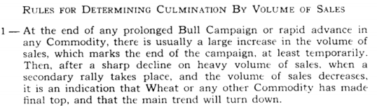

Rule # 2. "if wheat, soy beans, cotton, or other commodities hold after making a second lower top and get dull and narrow for some time, holding in a sideways movement, and then break out on increased volume, it is a sign of a further decline."

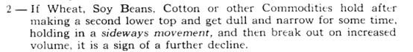

Rule # 3. "after a prolonged decline of several weeks, months, or several years, at the time wheat or other commodities are reaching bottom, the volume of trading should decrease and the range of fluctuation should narrow down.

This is one of the sure signs that liquidation is running its course and that the commodity is getting ready to show a change in trend."

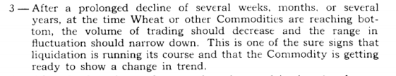

Rule # 4. "after the first sharp advance, when the trend is changing from a bear market to a bull market, the commodity will have a secondary reaction and make bottom, just the same as it had a secondary rally after the first sharp decline.

If the volume of sales decreases on the reaction and then the commodity moves up, advancing on heavier volume, it will be an indication of an indication of an advance to higher levels."

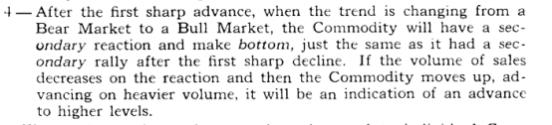

W.D. Gann said on page 63. "summary: sales increase near the top and decrease near the bottom, except in abnormal markets, like October and November 1929.

When there was a panicky decline in everything, when a large volume of sales occur at the bottom, making a sharp bottom from which a swift rally follows."

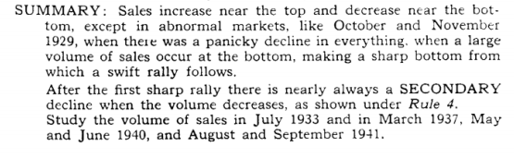
************************************************
We may read these 4 rules, and try and find just exactly, the same 4 sets of parameters to satisfy the law, but this does not always come out to be the case.

It is the intent of this book, to give logical volume signals, that are more in depth.

Because we combine the daily activity (Japanese candlesticks) with the volume, and guide your thinking, as you learn the momentum shifts, as recorded by volume for your stock for that particular day.

************************************************
I have observed that markets pivot and reverse trends on both high volume and low volume. We must treat these signals of equal importance, although I have found more high volume reversals than low volume reversals.
********************************************

High Volume Signal

Look at chart # 15. J.P.Morgan, (weekly).

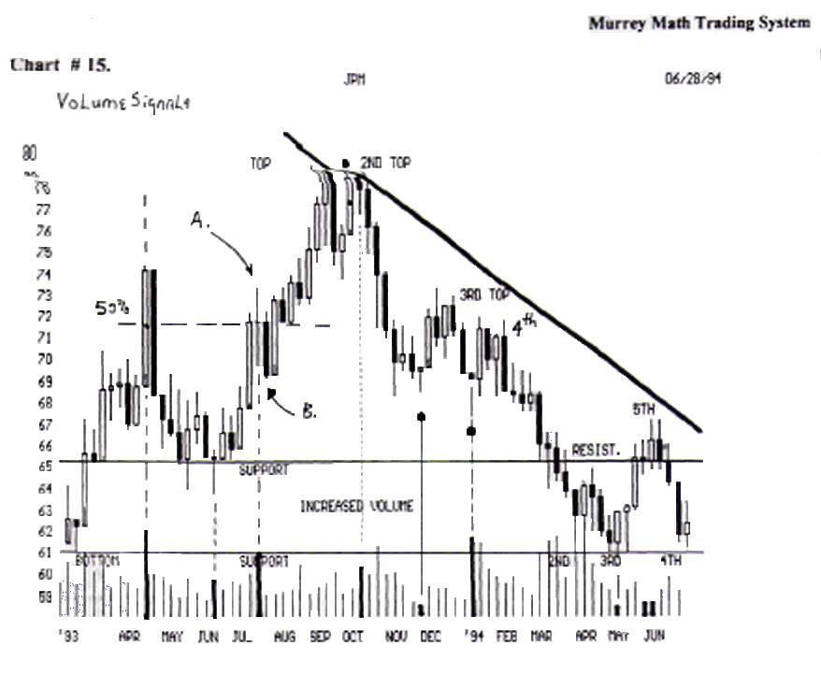

It topped out on its (2 top), high, on increased volume, with a (Japanese "hang man"), which was lower than the first high, so it was weaker at this top. Look at the low volume reversal in Dec.'93, and how it signaled an up move off its (Japanese Candlestick "morning star").

Then it fell back to 69. 4/8, with another (Japanese "morning star"), on extremely high volume, then it went up slowly on decreasing volume.

As the volume fell off, the stock fell. Let's look back to June,'93.

It formed a (Japanese "morning star"), on the support line, then ran up to 79.00. It reversed on twice as much volume as the week before.

The volume increased and the stock moved higher. It tried to reverse on high volume in the middle of August,'94, but the next week it broke out higher on lower volume, then it moved up on higher volume.

Look at chart #17. General Motors.

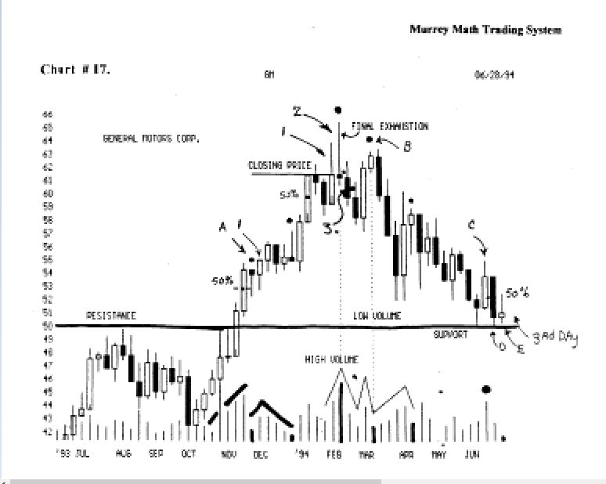

This is a weekly chart. this is a classic high volume reversal signal. Find the 2 week in February,'94.

Notice the extremely high volume on the day. It had moved up from a low of 42.00, back in October,'93.

After its 24. point run, it had its highest volume in 4 months.
The daily activity formed a final exhaustion reversal signal, (Japanese call it a "shooting star"), when it opened the day at 62. and ran up to 66.00.

Then sold off during the day, back down to close 1/8 below the open.

Volume decreased the next day and the stock fell.

Then it reversed to try and make a new high, 4 weeks later, but then it stalled out in March,'94, on very low volume (low volume reversal signal).

The next week it fell on increased volume (signal to exit this position).
--ft- basée! out back down at 50. (look back to Aug.'93).
W.D. Gann said that a top is resistance; then it becomes support in the future, after the price runs up through it, then falls back down to its old pivot price.

If it holds the (resistance) line it be an ideal place to go long again.

Notice (e), the volume dried up and the price stopped falling.
Look at the April,'94, reversal signal (black dot).

Notice that it tried to retrace back up to 64., but that week it stalled on very low volume and formed a (Japanese "hanging man"). This was a reversal signal.

It reversed and fell the next week on twice as much volume.

Look at chart # 22. DuPont (D.D).

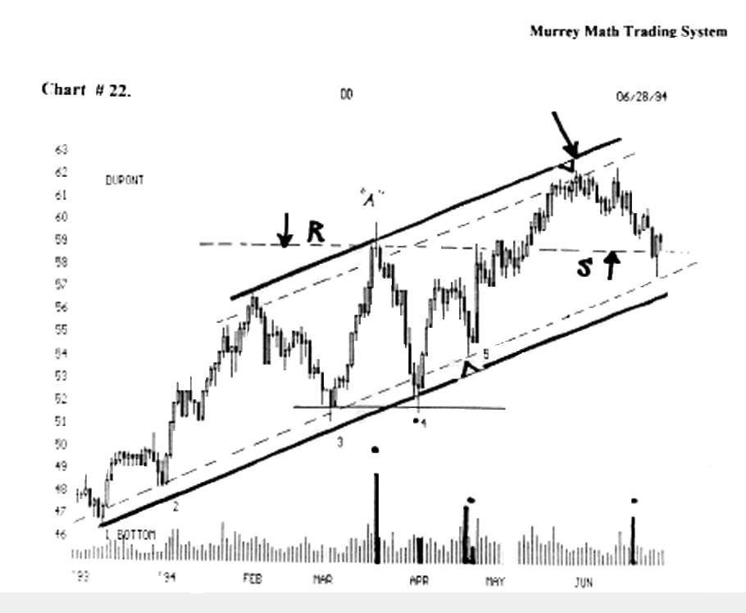

Note the black dot and extremely high volume in March,'94.

It had an exhaustion reversal that signaled a reverse was near.
It moved up on a 78 degree angle from the low back down at 52., and it fell back down to stop just above the 52. low.

It formed a double bottom on an up angled support line started back in December,'93.

Then, at (a), notice the very low volume the next day.

The price fell on very low volume meaning no buyers were willing to hold up the price of the stock.

Then, at (4), it reversed up on low volume.

It couldn't make it back up to the old high at (a), so it fell back to (5), where it reversed up on very low volume and stalled out at 62.50, then retreated to its old (r) resistance line, which became support.

It wants to hold at old resistance, and move back up to the old highs.

The last high volume signal pushed the stock-back up.
Look at chart # 29. Dollar General Stores. Traders love this stock. It is pushed in both directions by short term players.
If you had entered at 23.4/8 back in Dec.'93, and were a "buy and hold" trader, you would have lost 50 cents.

But, the volume signals help tell us when to enter and exit this stock.

Notice the extremely low volume in March,'94.

It shot up from 25. (3), that formed a (Japanese "shooting star"), at 32. 5/8, then the volume dried up, so it fell hard on extremely high volume.

This stock fell 32.00 to 29. 4/8, or 8 % in one day. The short term traders took their profits from down at 25..

The stock went back up to the (top) to its (2) high, then it got hit again with a high volume sell off. It dropped like a rock this time.

The faithful believed it was worth chasing higher, so they bought it up again in April,'94, on higher volume.

But the 3 lower high), stalled out short of the other two highs, (the traders were getting out early this time ), so the "3" rule came into effect.

If a stock can't break out to new highs the 3 time it will generally fall hard and fast. And it did.

Notice that it stalled out on its old support when it fell from 31.00 to 25.00 in one day's activity.

We would want to go long above 25. if it could close above 25. 3/8 for at least 4 days in a row or close above 25.4/8 on the day.

But we would make it prove to us that it was stable, by wanting to move sideways for 4 to 7 days, along 25. (support), and if it closed 40 cents below 25.00, we would close our long position.

Notice that after it (bottom) down at 23., in April,'94, it took 6 days to close above 25..

We would have gone long again, setting a tight stop 40 cents below 25.
.Since we had entered late, we would have to exit the first time it gave us a stall signal.

True traders would have entered at 23. 5/8, and sold 50 % of their position up and any price above 25.. Why?

Look back to (support 1, 2, 3), this was support, which is now major resistance.

And we don't know what will happen until it is too late.
We want to make a fast (mathematical) profit, and let 50
% of itride.

Look at chart # 35. Home Depot H.D.

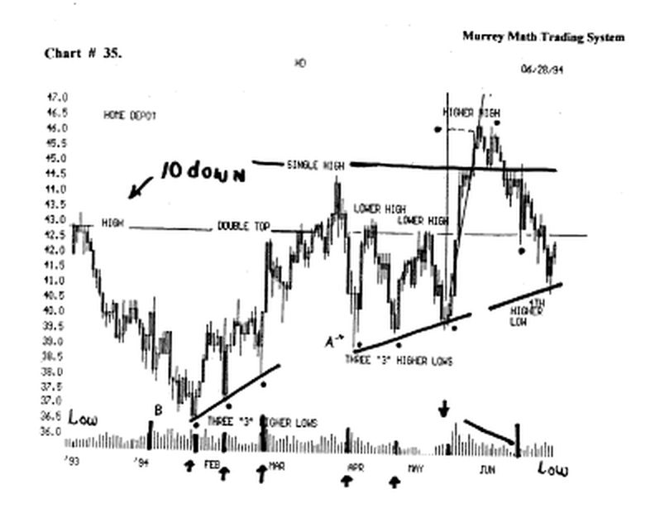
There are 6 volume reversal signals The first and last signal came on low volume.

Look at (a), which is a classic (Japanese "morning star" "doji"), reversal signal.

It opened the day at 41., went up to 41.1/8, then fell to 39..

Then, after lunch it reversed and ended the day at the same price that it had opened the day, back up at 41. on higher volume.

The next day it made an attempt to sell off again, but since it shouldn't go back down to the bottom of the previous day's wick, we knew that it had support above the previous day's low, and it would make it back up.

But we would put in our order to buy 3/8ths above the close of the "morning star," which is 41.375

************************************************
We must be on the positive side of the momentum.
It is better to give up some profit by getting the trend of the market by entering 3/8ths above the base line.
************************************************
If you enter too early, you will be "whip lashed."
Notice the 78 degree angle in May,'94. it reversed up on low volume.

Then after it topped out, it fell slowly on decreasing volume.

Look at chart # 57. I.B.M.

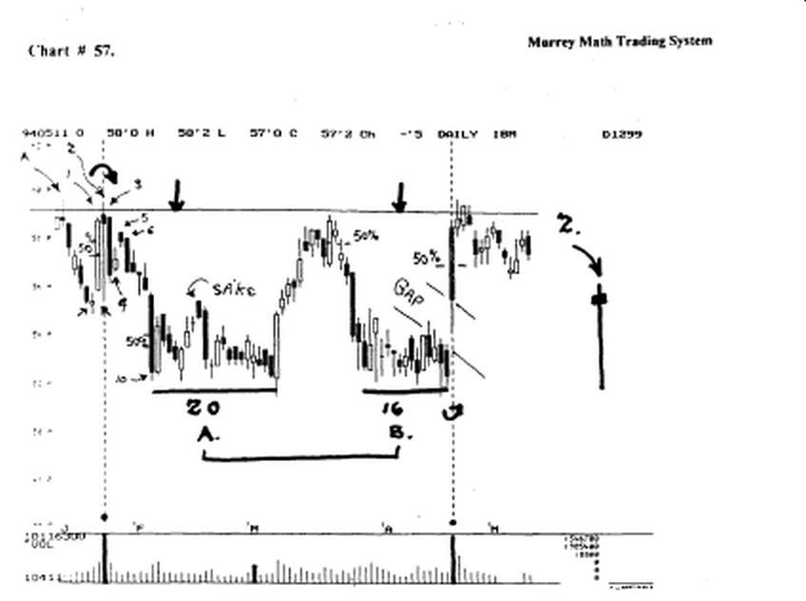

Notice the 9,000,000 share trading day in January,'94. I have drawn the day's activity to the right of the chart.

This is a classic (Japanese "hang man"), reversal signal, notice the day before.

It ran up 3 points from 56 to 59, on anticipation of a profitable earnings quarter.

It was rumored that Fidelity Mutual Fund had taken a large position in the stock.

The 9,000,000 share day was exciting trading.
it opened up ¹A point higher, thaï it moved up another % point, then tanked.

it fell from 59.3/8 all the way down to 55.50.

Then, it was bought back up to close almost at its open, but it closed just short of the close of the previous day.

This "hang man" said the upside had stalled out. it fell 3. points the next day on 40 % of the previous day's volume, no one was willing to support the profitable earnings report.

Then it fell all the way back down to 52.. it based out along 52. for 20 trading days, then it moved up again the 1 of March,'94, on twice the volume from the previous day.

It went back up to the old high, where we would sell 50 %, the 1 time it touched the old high.

When it couldn't hold the (50 %) line, we would have closed out the long position, and reversed and gone short.

Then in April,'94, 3 months later, another earnings report had the traders and "buy and hold" traders a little nervous, because it fell the two days prior to the report.

Then it gapped up 3. points on the day. It finished the day up over 6. points.

It was too late to enter a position, if we had net already been in a long position.

When it touched the old high, one should sell 50 % of their position.

Look at chart # I.B.M. 16. weekly chart.

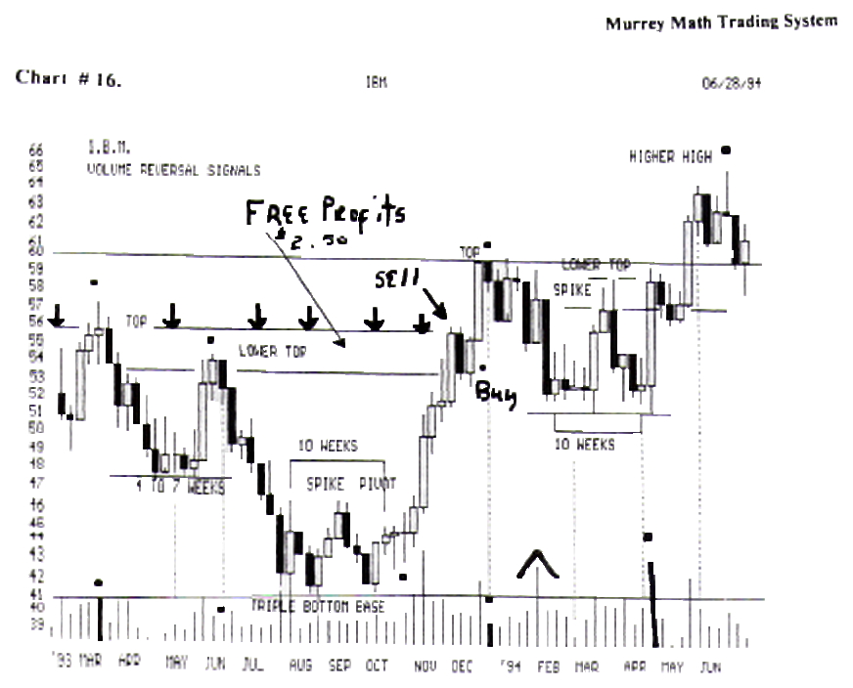

Notice the (4 to 7)week in May. It ran up the 6th week on high volume.

But It closed just below the spike (top) 56. 25, on extremely low volume and fell back to 41.375 with extremely low volume.

Then, it shot straight up on 5 times the volume. And it closed above the Lower top) on the week.

So we would sell 50 % of our position, as soon as it moves through the old high.

We don't have the answer, until it is over, and it has reversed, and the profit is eroded away, by our procrastination.

So, if we sell with a profit, we always end up with a profit.

Look, at the week of March,'93, it had a spinning top (Japanese "doji"), on higher volume.

It fell the next week on 1!/2 the volume.

Then in Dec.,'93, it stalled out at 59.375, with a small range of activity, on 1/3 the volume.

When a stock is on a high, it will take extra participation to push through to higher highs.

As the volume increased it fell back for support. The first week in Feb.,'94, it ran back up on 3 times the volume.

This signaled a buying opportunity. The "s" rule from page 57. (for an explanation of this rule look under Chapter 6. Special Situations).

Notice it fell in March,'93, on decreasing volume.

Then volume increased and it reversed and turned up. Then, in June,'93, the volume dried up, then the next week it fell, on increasing volume.

Then, it went sideways on increasing volume, and formed a "3" triple base of support.

Then in October,'93, it "engulfed" the previous week, then it formed a spinning top (looking for direction).

Then it formed a "hang man" saying that it wants to reverse and fall. (false signal).

The next week it did fall, but it reversed and formed a "doji" saying that it is getting ready to change direction, it did ! (to the upside).

it broke out to the up side on increasing volume.(Nov.).
it is critical to point out here, that the pivot day is the "3" (third) day of the turn.

We must wait until it drops above or below the pivot day, before we take a position, see the "3 day reversal signal (see Chapter 6. Special Situations).

Now, back to the last "doji" in Oct.,'93.
We can't go short until it closes below the close from two days prior.

It didn't fall, so we didn't react till it broke out to the upside.
Then, when it pushed above the (spike pivot).

We knew there was no more resistance and we stayed long, hoping it would run back up to its old high from June,'93. it did.
We would sell off 50 % when it ran above 54.00.

We stayed with our 50 % position until it touched the old high back in Mardi,'93.

We would have been ready for the Christmas "rally." It finished the month of December,'93, up at 59.3/8, on lower volume.

It finished Dec.,'93, on 2 times more volume. Then it stalled out on no activity, on lower volume.

Look at chart # 31. (COA)

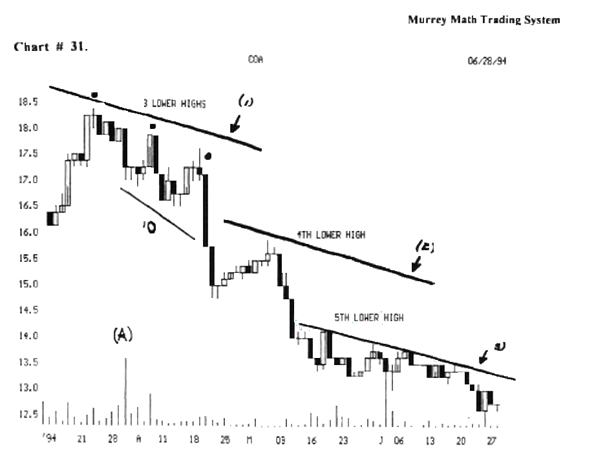

Look at (a), high volume sell off. It took 10 more trading days to react to this high volume signal.

We must gear down our expectations when the price is lower (14. range). The same reaction is taking place.

But most traders equate large volume with wide price swings. (50% of all moves are over on extremely high volume).

But every stock has a rhythm in proportion to its selling price, no matter how much volume is involved.

The Japanese Nikkei Dow runs at 10 times the price speed as the U.S. Dow 30 stocks.

So one has to adjust his expectations of how much and how far a stock will run, based on the current price.

When we learn, that profit as a percentage of its last low and high) is all we can ever expect to make in any non- news driven market.

We shall learn to make a profit percentage not dollars.

We may spend an inordinate amount of time trying to learn the different formations of volume.

But it is the common sense incorporation of the volume signals into our basic trading philosophy that keeps us on the correct side of our trades.

The amount of money made, shall not always be much, but, we want to expect to get out after a certain percentage of profit.

Please spend as much time as you need to see that volume reversal signals may be based on high volume or low volume at peaks or valleys.

Everyone must always remember the volume and daily activity of your stock for the last 3 days.

We must watch the daily trading action as expressed in shifts in volume.

If we make 18 % per trade, and we reinvest our profits, we shall double our money after just 5 trades.

We must sell 50 % of our position, when we make more than 18% profit.

This rule is true for stocks priced over 12.50.

But this isn't always true for inexpensively priced stocks.

The bid and ask spread is often too wide to always enter or exit, the trade with the profit margin we expect, in the shortest time.
It is important to go to chapter 6., Special Situations (secondary bottoms and tops).

Find W.D. Gann's comments on page 3. "after the market makes final bottom and has the first secondary reaction of importance, figure the percentage of that secondary reaction. Then watch for other reactions to run about the same. This is your yard, or measuring stick, for future movements."

This is a good rule, but news, and the speed of the fall, often signal how fast the reversal push the price of the stock back up.

If we think in terms of the Fibonacci ratios ( 37.5 % or 62.5 % ), then we must measure the extent of a move up or down against the last high-low difference.

So, we have to set our profit objectives against these Fibonacci ratios, rather than how much money you want to make.

Too many traders are "buy and hold" traders and they think in terms of holding a stock until they get a double.

But true traders are happy with a 37.5 % retracement or 18 % profit.

Then, we will double our money after just 5 trades.

When we trade 5 times, we less time owning the stock, so we are able to exit and put our money into a stock that is running up, not moving laterally, or falling back down to its moving average, because it ran up too fast.

If you refer back to the 8 Daily Rules To Address Each Stock or Market: you will remember that volume and daily activity, are (# 8), on the list of things to trade with, or against each trading day.

(remember to keep the last 3 days in your mind, so that you see the relationship, between your stock's price action, and many 1,000's of shares it takes to move a stock up or down).

Look at chart # 63. MA.S.

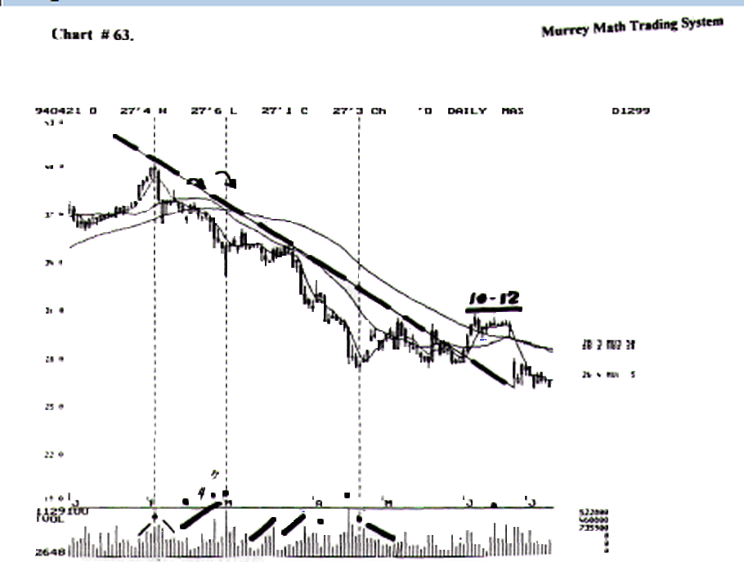

Look at the high in Feb.,'94. It had a narrow trading range on higher volume.
Then the next day it fell on higher volume.

This fast fall had to be news related because it fell on higher volume, than the day before.

Then the volume fell down 50 %, and couldn't move back up.
Then at (4) it stair stepped up, while it was falling. Then, in March,'94, it stair stepped up in price.

Then, on no volume, it topped out, then stair stepped up in volume again, and fell in price.

Then, the 3 trading day in April,'94, it had no volume, so it wanted to keep falling. So it fell on increased volume.

Then, down at 27.³/₄, it had extremely high volume, and reversed on lower volume.

Then, in late April,'94, it stair stepped (down on lower volume) as the price rose.

When a stock is on a high, then reverses, and falls, the volume should decrease, the first few days of the fall, unless, it falls on real bad news.

If it is real bad news, it will fall on higher volume, (faster, vertically, and at more points).

But if on the reversal day, (3rd day), the volume is higher than the top, (stall point), it is a signal that bad news has entered at the top and it will fall faster.

We see this to be the case on M.A.S. back in Feb.,'94. it had moved up from 36.00 in Jan.,'94, to 40..

Then, the news on the high, reversed the momentum of this stock. Then, 5 months later, it was back down at 26.

d) Descending Stairs

Look at chart # 69. BA.C.

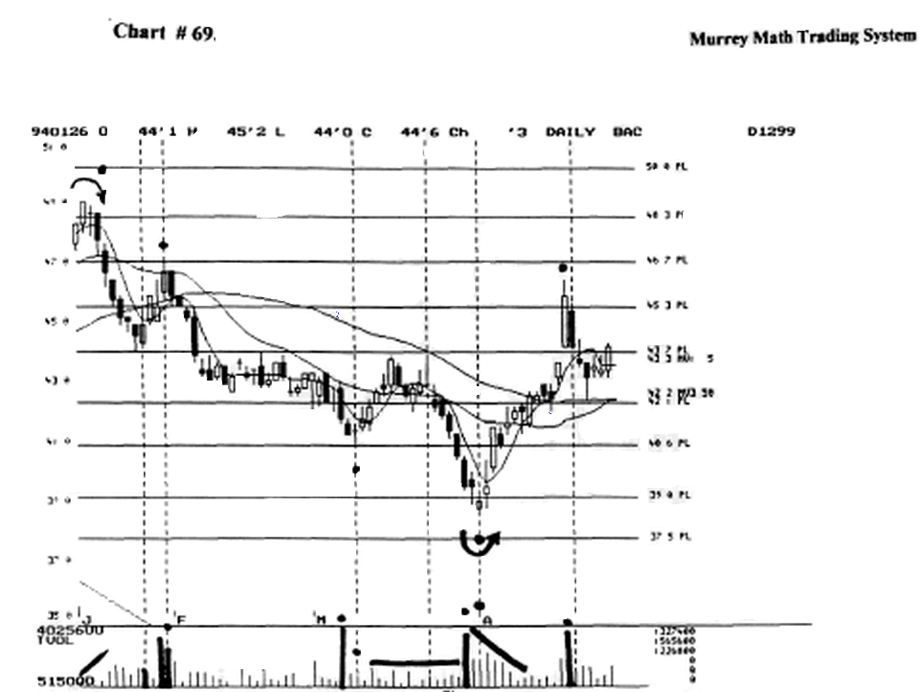

this stock fell from a high back in Jan.,'94, at 49.00, it fell back down 39.00, in April,'94.

Notice that it had no volume all through the month of March,'94. And the stock fell on no volume.

Then, it had extremely high volume after falling 6 days in a row

That we would expect it to keep falling, because of the extremely high volume.

it fell the next day cm 50 % of the previous day's volume.
Théo it had the same amount of volume and the price gapped down, but closed up ¹A for the day.

The next day it gapped up and reversed up on higher volume. This is our signal that this stock has reversed (short term).

Then, the volume stair stepped down as the sellers left, and the volume fell as the price moved up.

This bottom reversal, pivoted on lower volume.
The 3rd day pivot is called a (Japanese "3 island reversal"),

W.D.Gann called it a "gapped final exhaustion reversal" (page 321).

Always pay close attention to any day that has extremely high volume.

If it has a large price movement be careful, and ironically, if it has no price range movement be prepared for a reversal soon.

If a reversal doesn't come the next day, watch the "3" day.

Now, let's add where this price action occurs: a) high, b) low, or c) on a lateral move.

Ok, look at chart # 69. B.AC.

Look at last two days of Jan.,'94.

It reversed on low volume, then it had no volume the next day, and moved up 1. point, then it had more than 5 times the volume, and gapped down lower then moved up above the previous day's activity.

Then it sold off and closed below the previous day's close. The next day it gaped up and closed back up at 47.3/4, the (3 day).

The next day, (the black day, pivot day), it closed lower than the previous day's open, on lower volume, so no buyers stepped in to support the stock and it fell.

So any one, who bought the pivot, got whip lashed, but they could see the moving averages turn over and signal a reversal.

Look at chart # 69. B.A.C.

Then in March,'94, it had no price action, down at 41.3/8, on 20 times the action from the day before.

We know that it has dropped from 49.00 to 41.3/8, so we should be looking for a reversal soon.

The "3" day it had reversed and was moving up again.
Notice that it reversed on 1/10 volume, telling us that the sellers were gone. it formed a (Japanese "morning star"), reversal signal.

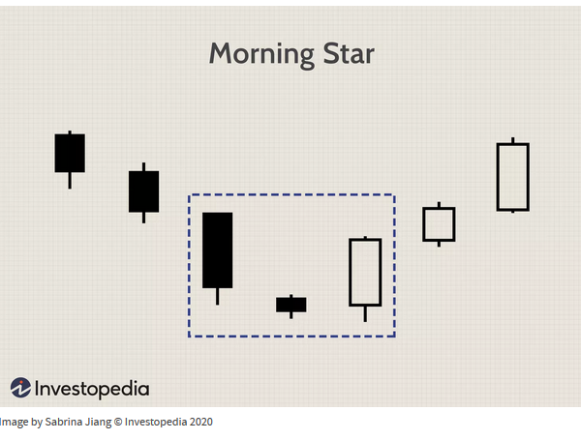

Look at chart # 69. B.A.C.

The last of Mardi,'94, it fell 1.00, on 10 times the volume.

Then the next day, it gave a buy signal, then gapped down, then gapped up then the next day, (3), on lower volume.

it had fallen from 44.00 back down to 38., when it had its "final exhaustion reversal," but again, it took "3" days to reverse its trend.

Look at chart # 69. B.A.C.

After the April,'94, reversal down at 38.3/4, it moved back up to the old high at 44., then it gapped up above the old high and started the day at 44.1/4.

Then it finished the day at 46. on twice as much volume.
This stock had run up from 39.3/4 to 46. just below, the old high back on the 1* trading day of Feb.,'94.

And it sold off just short of that old high. It had already made its run up, and it did it on high volume, against a previous high.
Then we must want to sell out 50 % of our position, against an old high.

News would be the only thing that would drive a stock up, after a 6. point move up.

Greed would cost us a lot of pure profits.

If we don't sell with a profit short term (18 % profit) it may fell back to support and we must wait to back up.

e) Up Chevron

Look at chart # 64. Medtronic.

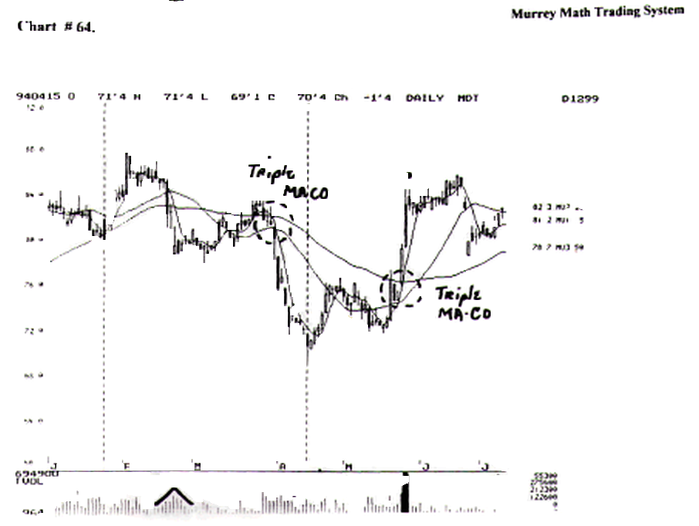
Notice that it fell on an increase in volume, then stalled out on higher volume, then it moved back up in price on decreasing volume.

Notice the extremely high volume and no price movement after it stalled out at 85.

The volume fell off to 10 % of the previous day's high activity, and the stock couldn't move up any higher.

Look at chart # 61. M.E.L.

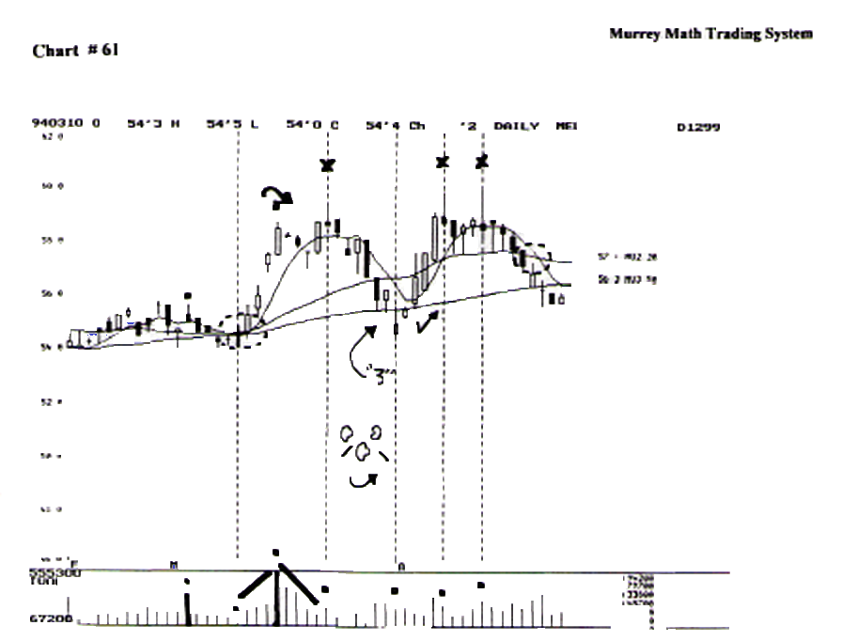

It moved laterally along for the month of Feb.,'94, thaï h had 100 % increase in its volume.

Then it reversed, and fell back to its base of 54.. then, it had no volume, then it made an up chevron, and the price moved up, and it topped out at 59., on extremely high volume.

Then it fell on decreasing volume.

Notice that there was no volume to support it, so it fell back to its old low for support, then on the trading day in April,'94, it reversed on a (Japanese "three island reversal").

Look at (x -1-2-3) and the daily activity. This stock opened the day higher.

Then closed back on a low for me day with a Japanese "shooting star."

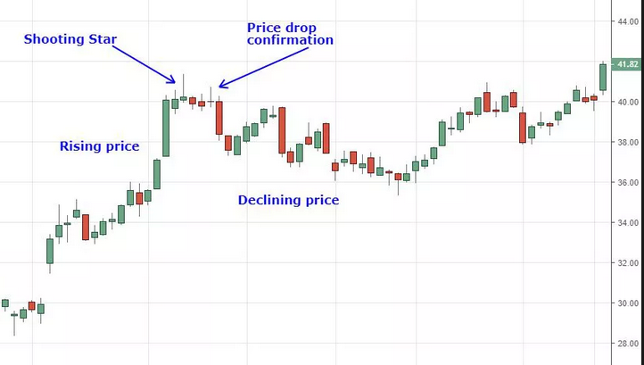

Signaling that this stock had topped out. Wfe had two higher volume signals and one lower volume reversal signal.

Notice that the "3" time it couldn't break through to the upside it fell back to its old support.

Look at chart # 65. Nations Bank.

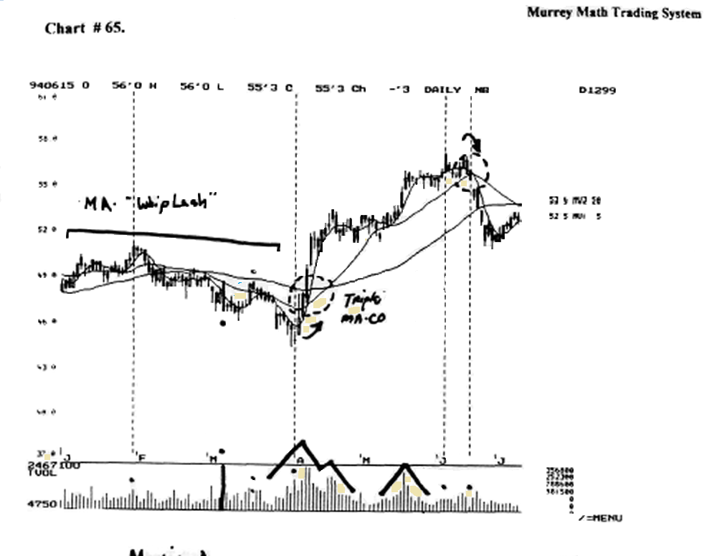

Find the May,'94, up chevron.

This chevron is not the classic move, because it didn't have any great follow through after the high volume day in the middle of May,'94.

But there is an up chevron, off the low of April,'94, down at 45..

Notice the "3" high volume days, where the traders tried to sell it off, but the small buyers supported it, and kept it moving laterally, then it moved up on lower volume.

f) Down Chevron

Look at chart # 62. Philip Morris. It formed a down chevron as it fell back down to me low at 48.

Then it reversed up on lower volume, as it moved up the volume increased.

It had one day that was a (Japanese "morning star") on very low volume. It increased volume and moved up.
Look at the four dashed vertical lines where it reversed.

It reversed twice on low volume and two times on higher volume.

g) Blips

Blips are extremes in volume that do one of two things: 1) move the stock, or 2) it does nothing.

Look at chart # 65. Nations Bank.

Find the Mardi,'94, high volume that made the stock move down 2. points on the day.

It took 8 more trading days to react down to 44..

Then, down at 44. it made a Japanese "inside reverse hammer" signaling that it would turn up.

Then it had another "blip" when it had an up chevron on extremely high volume, but it didn't move up off the volume.

It fell back down below its high volume day some 20 trading days later.

Look at chart # 61. M.E.L.

notice the high volume in March,'94. But there was not much price action movement as a result of the high volume.

Then 5 trading days later, it moved out to higher prices on no volume.

Look at chart #14. Merck, weekly chart.

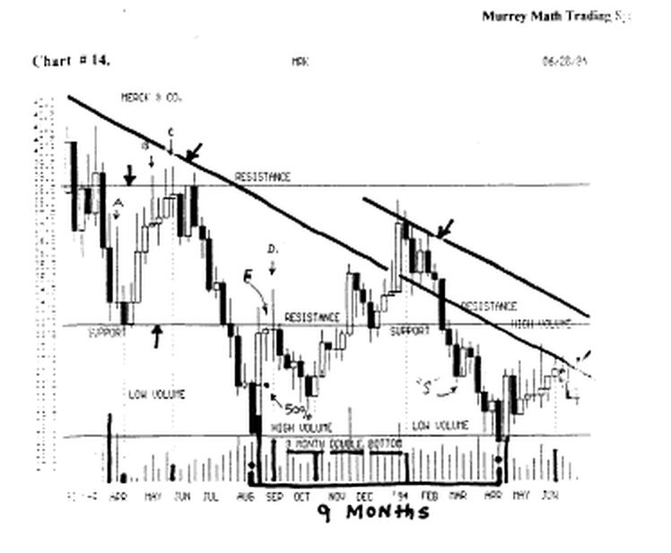
Find the 3. point fall in the last week in Mardi,'94, then it at (a) it formed a (Japanese "reverse hammer"), then it tell back down to the low of the 3 week in March,'94, for support, and it held down there for 3 weeks forming a (Japanese 'tweezer bottom") support level.

And it reversed and tried to go back up to its old highs at 41., but it couldn't break through the resistance line at 38.³/i.
This extremely high volume sell off was a blip, when it occurs, then the stock stalls out. Three weeks later it had no volume, then moved back up.

Then, it had a (Japanese "doji"), reversal signal, on lower volume. This chart is full of Japanese candlestick formations that are easy to read and react to, if you trade this stock. Refer to the section Learning to Read Japanese candlesticks.

Look at chart # 22. DuPont.

Find the extremely high volume in March,'94, on a high, and it formed a (Japanese "doji"), with the open and the close finishing the day at the same price.

Then, it stalled its down side reverse on lower volume, then reversed up after a "doji" where the open and the closed the day at the same price.

Just before 5, we had a "blip" when it fell 2. points on extremely high volume. Then it went nowhere on lower volume.

And at ( 5 ), it reversed up 5. points to its old high, but it closed just below the old high.

We would sell 50 % of our position, and wait to have it retrace or move laterally, ready to buy in again, when it breaks out after a set period of time.

On the 11 th day, it finally broke out to higher highs.

Notice the two up parallel lines that set the support and resistance lines (which Roger Babson called "moving momentum" ).

Notice the parallel dashed lines inside the major momentum lines.

Notice how it failed to make it up to the solid line, and it failed on the dashed (up line), in June,'94. It was weaker on the upside momentum pull, so it fell back to its (r) line and the (a) pivot day in March,'94.

It dropped below the line for one day, then ran back up and closed above the line for the day.

Look at chart # 35. Home Depot.
This is a perfect example of W.D. Gann's rules, and the reason we should learn the Japanese candlesticks, and that we must learn to pay close attention to volume reversal signals, that coincide with daily price action, the "blip" was at (b).

It moved down 2. points on high volume, then it reversed, and moved back up for the next 4 trading sessions.

Notice the extremely high volume in June,'94, when it sold off.
Then it reversed back up for one day, then went back down to the (Roger Babson "up momentum line").

It formed a 4 th higher low and started moving back up. to the (double top).

Look at the 78° angle formed off the "3" higher low in May,'94.

We should have sold 50 % of our position, when it stalled out on a (Japanese "tweezer top").

Then it fell back for 3 sessions, and tried to make a secondary run back up to the old high, and it couldn't make it back up to the old high, then it had a (Japanese "hangman"), and it fell back down to the "momentum line."

Notice the volume reversal signals. The last pivot ("3" higher lows), reversed the trend on low volume.

Look at chart #13. P.N.C.

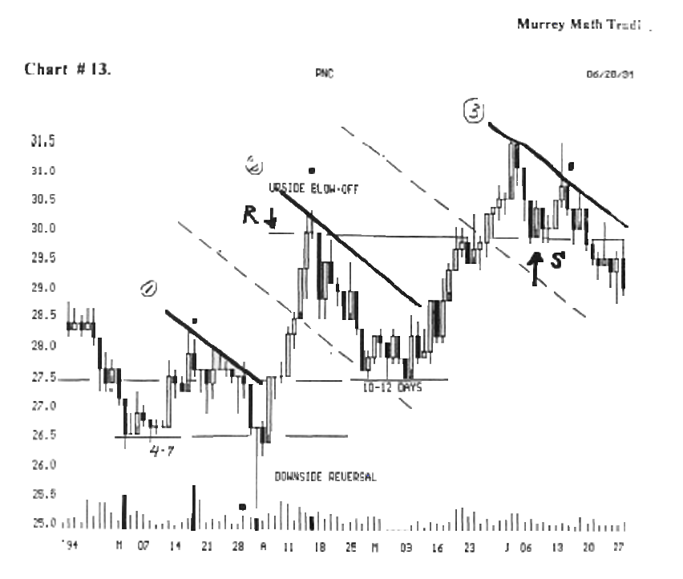

Find the upside blow off in April,'94.

It reversed on lower volume, and it was signaled by a (Japanese "shooting star").

The Shooting Star candlestick formation is viewed as a bearish reversal candlestick pattern that typically occurs at the top of uptrends.
Read more at: https://commodity.com/technical-analysis/shooting-star/

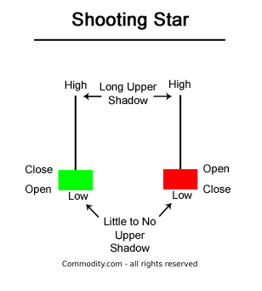

It fell back down to the support line.

It built a base (10 days ), then broke out to the old high. And it stalled out up on the (r) line for 5 days, then it broke out to higher highs.

Then it fell back down to the support line, (S), then it ran up against the "down side momentum line" and couldn't break out and fell on low volume.

In conclusion, we must incorporate these high/low volume signals, at highs and lows, or up against a previous high or low, so that we get the "feel" of when to enter or exit a trade.

This is only 10 % of our trading strategy; just as we consider moving averages to be just 10 percent of our strategy.

