CHAPTER.4. Buying and Selling (with and against previous lows and highs)

(Buying and Selling with and against previous tops and bottoms)

One may have read pages 39 thru 51, in W.D. Gann's book, How to Make Profits Trading in Commodities, and stopped, finally, thoroughly confused.

As we go through these different charts, we shall see the normal reactions that stocks make, as it tries to gain support or hits resistance m price as it travels thru tune.

Bottoms:

Single - see chart # 8. Federal Express (rare
reaction)
Double - see chart # 6. Nations Bank (normal
reaction)
Triple - see chart # 6. Nations Bank
Variation "w" + *V - see chart # 38. Dell Computer
Double "w" - see chart # 15. J. P. Morgan
5 spikes (rare: but more common on bottoms) - see
chart # 36. F.A.S.T.

Tops:

Single - see chart # 39. G.W.D.
Double - see chart # 7. Shoney's inc.
Triple - see chart # 29. Dollar General Stores
Variation *nT + "v" ( inverted ) see chart # 7.
Shoney's Inc.
Double "m" - see chart # 27. Coca Cola
5 spikes ( rare: but close together in time ) see chart
27. Coca Cola
Variations of these tops and bottoms - slanted up or slanted down
"3" is the beat signal to watch for reversals

Although you shall learn to read all of these different support and resistance reversal signals, the best tune to enter a position is on the 3"¹ up or down try.

The Japanese rice traders and W.D.Gann saw the
great significance of trading with or against "3" tries to break out above or bounce up off lows.

Look at chart # 2. Disney.
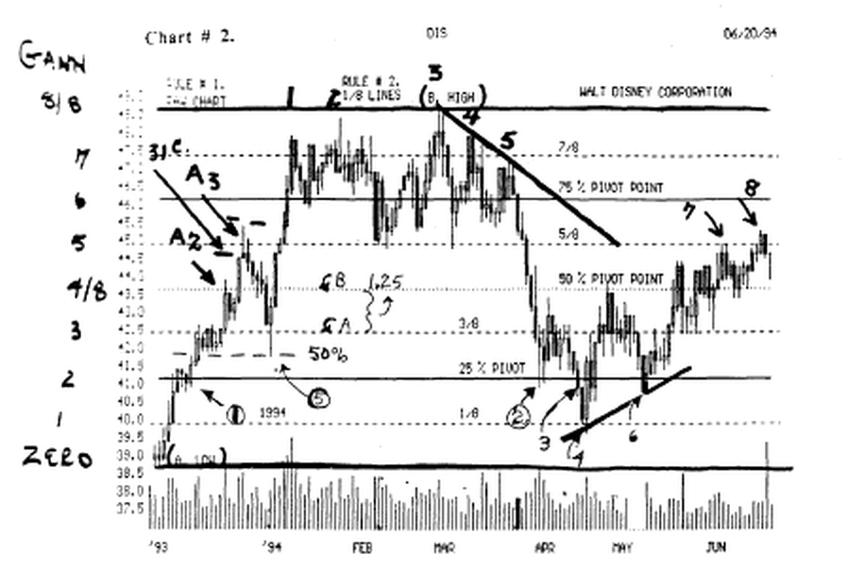
This is a totally confusing chart. No one would be able to tell just
exactly where it was going, without trading each whiplash.

Look at chart # 2. Disney.

Notice the 3*, 4*, and 5* lower high that culminated in the big fall after the 3^{rt} lower high.

Look at chart # 4. Disney.

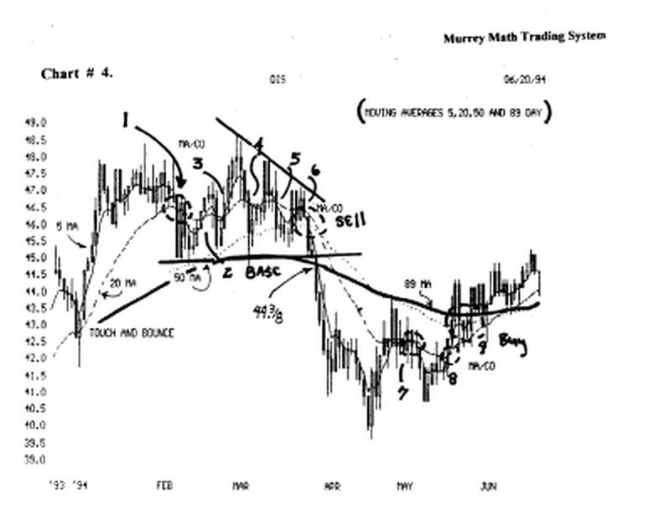

The moving average crossovers helped us see that this stock was rolling over to the down side, see (6), where the 5 day and 20 day fell below the 50 day moving average.

If we combine the "3rd lower high with the moving average cross-over, and we notice the Dow's higher volume on the fall.

Look at chart # 10. Dow 30 stocks, the "3*" tune rule works, even on indexes.

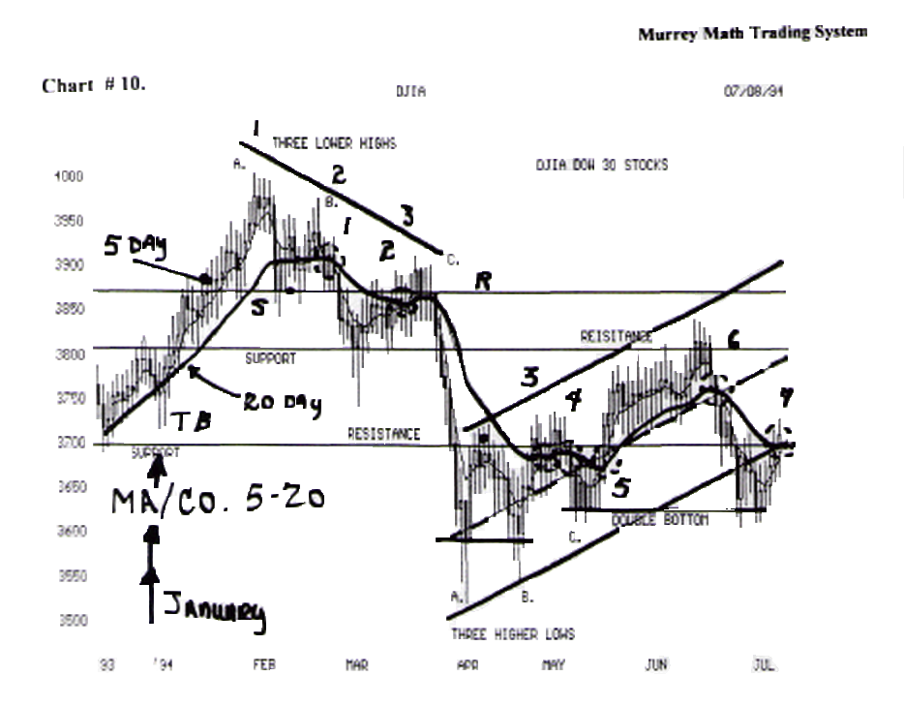

Find the (a, b, c) at the top, and the (a, b, c), on the low, when it reversed in April,'94.

The same thing happened again: when the moving averages crossed over at the top (2), on a 3^{rf} lower high, and at (5), we saw the moving averages cross over on the 3- higher lows.
One must study the movement of the Dow 30 stocks, because the momentum of the Dow will determine what your stock will do if the Dow reverses.

Plus, we must check with the momentum of the U.S. 30 Year Treasury Bond, to see where it is leading the U.S. stock market.
Plus, the U.S. Dollar will enter the formula at highs and Lows against the Japanese Yen.

Most "buy and hold" traders want to buy on tips and insider information.

Rather than looking at the momentum rhythm of the Dow 30, along with the weekly and daily chart of their stock.
As you go through these charts, look to see what happened to your stock after Feb.,'94.

Did all of these stocks continue to move up, or did they stall out or fall along with the general market momentum ?

Bottoms: single - see chart # 8. Federal Express Corp.

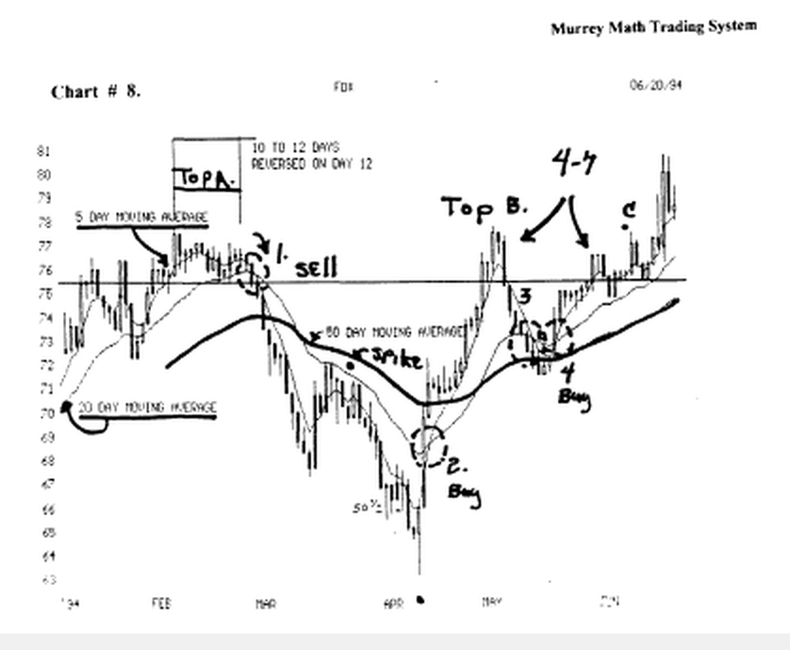

This is a classic single bottom reversal.

It moved down from its Feb.,'94, high, and tried to retrace in March,'94, at 67.4/8

Then it went up for 4 trading days (this is the **s" rule) that W.D. Gann described on page 57 - see section "s" rule. (this rule is the most over looked rule recognized by the fewest traders).

This stock had a very small day of activity in April,'94, then it fell from 65.00 to 63.00 on the day, then it reversed up and closed the day with a 1.00 point profit.

This is what W.D. Gann called a final exhaustion reversal, the (Japanese called it an "engulfing morning star").

The next day, its 5 day crossed up above its 20 day moving average and by may it was running up against its old high back in Feb.,'94

We would have sold 50 % of our position, and looked for a signal.

When it dropped below ( Line ), we would have gone short, if we take the Apnl,'94 low, and the May, '94 high, and divided this difference by 8, and multiplied the 1/8* by 3.

We may just "eye bail" it and see that it fell off its high just 37.5 % of this last move, where it found support, and reversed up toward the old high. We would buy on the reverse up, then sell 50 % when it hit the old high

The (4 to 7 day rule) is in effect at this time. (to the right). Find the 4 to 7 day rule.

When a stock breaks above its old high, it must close above the resistance Line for at least 4 to 7 days in a row, before it has the tune on its side, to prove that it will hold, then move higher.

And the reverse is true, when a stock is on a low.
It closed above the Line 3 days, then fell on the 4* day, then it moved back above the line on the 7^{lh}-day, then went up. then fell back to the line and on the 11¹" day ( 10 to 12 day rule), it broke out to higher highs.

Look at (4 to 7 rule) to the left at (top b). It ran up above the line in May,'94, and it looked like it would move up to new highs, but it couldn't close above the line for 4 days m a row, and so on the 4* day it formed a (Japanese "hangman")

Then on the 4* day it closed below the line.
If you look back to Feb.,'94, you will see that it closed m May,'94, just above that old top.

Just because a stock closes above an old high it does not mean that it will go on up to higher highs. That is why one must take a profit of at least 50 %, when it moves up to the old high.

There is no guarantee what it will do at its old resistance, but an 18 % profit in your pocket is worth twice as much as any paper profit.

It is hard to sell into a great rally, but if you sell every tune you make 18 % profit you won't care what it does tomorrow.

But, if you don't sell with a profit, the odds are 80 % that you will hold it, if it falls below the entry price.

Had you read W.D. Gann's book, you would have been curious why he could say that if wheat can't close 3 or 5 cents above an old high it would fall

I shall also say that since the May, 94, high didn't close 39 cents above the old high back in Feb.,'94, it should fall back to its support level.

This 39 cent signal is pure math just as 5 cents is a pure math reversal signal.

But again, it isn't the object of this chapter to justify why these two numbers are predetermined pivot price points, (read 19 or 39 Reversal signals).

W.D. Gann said on page 48. "single tops and bottoms: this top or bottom can be a sharp fast decline (advance)....followed by a quick rally from the bottom with no secondary reaction until it advances to higher levels."

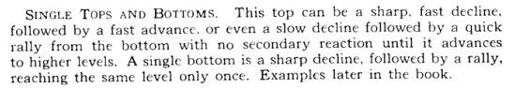

This stock fell from 78.00 to 63.00 in 2 months. Then it reversed vertically on news or earnings, or the reason why it fell so fast was false.

This is the kind of reaction that all buy and hold traders pray for, when they buy a stock.

Only 20 % of all stocks will reverse this fast, without a "secondary reaction."

You may see the "secondary reaction" back in Mardi.'94, when it fell from 78.00 back down to 67 00, when it had a "secondary reaction" and turned up and stalled out at 72.00, just below the old support back m January,'94.

True traders would have sold 50 % of their position up at 72.00, which was the old support, and the spike (pivot) price.
We would have made 12 % (and happy to make it in 3 trading sessions).

We would have wanted for a direction signal, it proved that it wanted to go higher, so we would stayed in our 50 % and bought it back on true momentum to the upside.

Again, we would have sold out 100 % back up at the old high, because we would have made too much money too soon, and we want to make just 18 % in the shortest period of time, and then set back and wait for direction and momentum.

Since this double top was 3 months in time, we would have been happy to make more than 18 % profit in 1 month.

Our goal is to secure 18 % on every trade.

Notice the "spike pivot price" at (the black dot) back in Mardi,'94

See the section special situations - spike pivot prices.
We should sell 50 % of our position against this price
level.

Stocks want to react to these last reaction price levels.

W.D. Gann said on page 46. "the rule is, old bottoms become tops and old tops become bottoms. What was at one time the ceiling later becomes the base, bottom or buying point. What was at one time the base or the bottom. after it is broken and the market rallies, becomes the ceiling top or selling point.

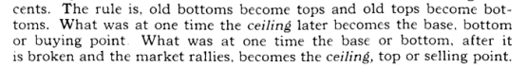

Look at chart # 10. DJ.IA. 30 stocks

Find the (5 day), price point.

The market moved up in Dec.,'93, to the top (resistance Line) at 3,875.0. Then it backed off for 3 days. Then it moved up through the resistance Line, to new highs up near 4,000.0. Then it fell back to the resistance Line, then bounced up toward the old high.

Then it fell back to the support Line, couldn't hold. then it fell back to the next lower support Line, reversed and tried to close (4 to 7 day rule) above the support line that now has become the resistance line.

But it closed above it for only 1 day, so it had to fell back for more support, and it fell back to 3,515.0, which would take us all the way down to last October's support line, then it ran back up and hit its head on the (resistance line), and couldn't make it the 1st try

So it fell back to form a double bottom, then it bounced off this support line and tried to break through the (resistance line), but it couldn't break through at (4), then it back for support just above the old double bottom, then it broke through, the "3-" time.

Then it ran back up to the old support from March,'94, which is now resistance, it couldn't close above the resistance Line (4 to 7 day rule), for 4 days in a row, so it couldn't break through the first time, and it fell back for support, down at the previous low, forming a (double bottom).

We must use the opens and the closes, not the high or low intra-day activity, as our support and resistance Lines, for the Dow 30 stocks.

We will not get the true "feel" of our support and resistance if we go off the theoretical highs or lows.

WD. Gann said on page 46. "secondary decline or higher bottom, after a bear campaign ends, whether it ends with a sharp severe decline, or declines slowly, making final bottom, there is usually a quick rally lasting anywhere from a few weeks to two months. Then the secondary reaction takes place, making a higher bottom, and this bottom is the safest place to buy...."

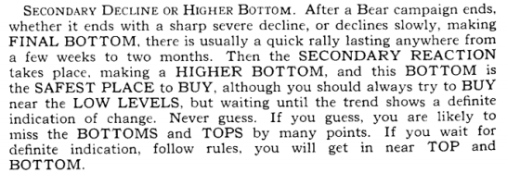

Look at chart # 14. Merck, (weekly).

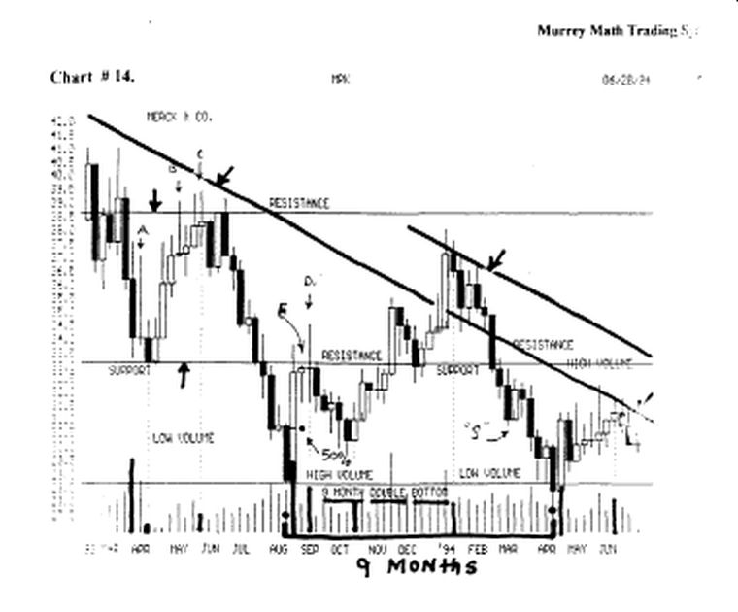

It had fallen from 38. 4/8, last May,'93, at (C) to a final low of 28. 1/8, in Aug.,'94. Then it made a quick rally, that lasted only 3 weeks(D). It formed a "rickshaw" "doji." Then it fell back toward the old low for 6 weeks. Then it reversed (this is the secondary reaction).

It made a higher bottom, which was the safest place to
buy at 30.1/2 in October,'93.

It ran back up to the 7/8* line (off the May,'93, high anddieAug.,'931ow).

If we look at the 1" up move off the final low of Aug.'93, we may get our sell signal from the (Japanese "hangman" at 33.00), the next week it made a classic "doji" "rickshaw man," which is a signal that it wants to reverse soon. And go back down for more support.

Notice that tins week the stock rose up as far as 34. 4/8, and had a low of 32.00, and it opened and closed on the same price, 33. (Monday and Friday same price).

This week had a 2.5 point swing and it closed on the same price, so it is easy to see that this stock was looking for direction.

It gave us its directional signal the "3e*" week which was the pivot price week, which was down. ("3 rule").
Look back up at 38.00, in May,'93, and look at the "rickshaw" "doji" signaling a reverse was coming soon.

It took "3" more weeks to stall out the up side move. Then it fell like a rock down to 28.4/8, for as final low.

Let's add another dimension to the "....then the secondary reaction takes place, making a higher bottom, and this bottom is the safest place to buy..." by trying to see if the "higher bottom" is on the 25 % line (pivot price).

Look at chart # 2. Disney.

We established the Gann 1/8- retracement lines off (a) 38.4/8, and the high nm up at (b) 48.4/8.

When we divided (a) and (b) by 8, then we have set the 25 % line, and if it reverses off the 25 % line, it is a stronger buying point.

It reversed at (2), then it reversed at (4), then it ran up to the 50 % line (pivot), and pivoted back down to (6), and fell 39 cents below the 25 % line, then it formed the "secondary reaction....making a higher bottom....the safest place to buy."

Please refer to the section special situations "short legged w."
Too many traders and buy and hold investors want to jump in 100 % on the last reaction to the anal down side, then may get whip lashed, because no one knows exactly where the final bottom is, unless it reverses against a previous low.

So, we should sell 50 % of our position on the 1* upward stall out, then watt for it to retrace, and get support to run back up to higher highs.

It finally stalled out down at (4), then it reversed up to 43 4/8, then this I" reaction was sold off back down to 39 cents below the 25 % Line.

Then it formed a "short legged w" and ran up strong to 19 cents above the 5/8* line.

Common sense gates that anyone may find any rule after some action has taken place, so we must prepare for an 18 % profit, and sell 50 % of our position, when we run up against old resistance, and don't care about what happens next.

Bottom: Double

Look at chart # 6. Nations Bank, (weekly) chart.

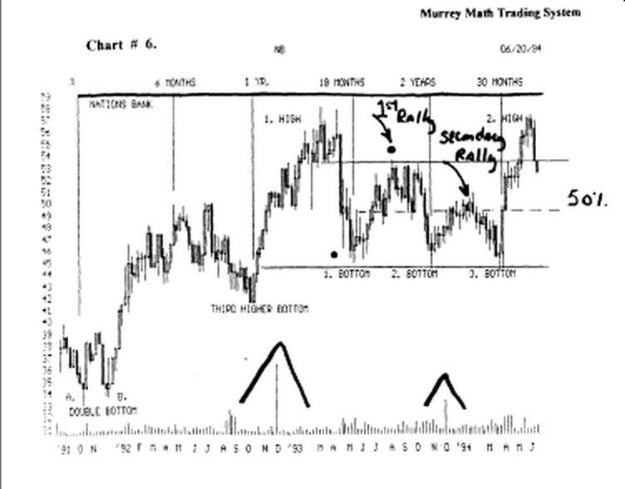

It finally stalled out down at 34.00.

It formed a double bottom, Oct.,'91, then it reversed back up to 50.00, then it dropped back down to 42.1/8, then it took off on a "3"¹" higher low (best place to buy) Oct.,'93.

Then it moved up to top out at 56.1/4, then it fell back to get support above the Oct.,'93 low, which is a positive sign, for another up run in the near future.

It formed another "3*" bottom and it ran back up to the old high at 56.1/4 and sold off again.

W.D. Gann said on page 49. ""w" bottom or double bottom. when wheat or other commodities decline and make bottom, then rallies for 2 or 3 weeks or more, declines and makes a bottom around the same level the second time, then advances and crosses the previous top, it has formed a "w" or double bottom."
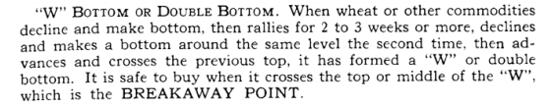

Look at chart # 6. Nations Bank.

This is exactly what happened. We just discussed it.
We must add the dimension of time between the width of each leg.

W.D. Gann said that "....the longer the period of time between any bottom, will result in a stronger reaction, when it breaks out."

Look at chart # 6. Nations Bank.

The time between the double bottom was 3 months (Oct. thru Dec.,'91).

But you will remember that the Dow 30 stocks ran up several hundred points, until the last of January,'92.
So Nations Bank moved up off its double bottom to 50.in July'92, then it reversed and fell back down to 41.

There it reversed in just one week in October/92 and ran back up to 56.25 in Aprif93 It reversed every 3 months against the change in the interest rates of bonds.

Look at bottoms 1, 2, 3 which were 6 months apart.
But the up run off these 3 bottoms were not as fast as the double bottom back in October'91.

The high off the flow of bottom 1., stalled out 62.5 % of the high from 56.1/4, in March,'93. And the low price, 46.00, April,'93, (1) was stalled out because the U.S. 30 Year Treasury Bond Market topped out Oct.'93).

Look at chart # 6. Nations Bank.

What did it do every October ? Right: it was setting on a low, and it reversed and ran up: except this past October,'93, when the bond market topped out and fell on increasing interest rates. We have set it to a 6 months' time cycle.

Bottoms: Triple

Look at chart # 6. Nations Bank, (weekly) chart.

It should have broken out stronger on the "3^" bottom, but the U.S.. 30 Year Treasury bond, topped out, and stalled out the up-move of all the bank stocks.

This was a great stock to trade against W.D. Gann's rules

Notice the extremely high volume week in Dec.,'92.

It tried to sell off, but "3" weeks later, it moved on up to new highs.

But 6 months later, it was selling 4.00 points lower than the big volume week, in Dec.,'92.

There was another high volume week in Dec.,'93, and again it was selling lower 3 months later, than the high volume day.

We should not think that high volume always means that new highs are near, or long term.

The buy and hold traders would have loved the high volume and the fact that it didn't fell, because it didn't move the stock much for the next few trading weeks.

Since we are looking at volume right now, look at the 4 high volume weeks in Aug.,'92.

It fell for 4 more weeks, then it finally stalled out on a (Japanese "engulfing pattern") in Oct.,'92.

This high volume "cluster rollover" signaled that the down side may be over.

If we count from the (a, b) low and the 50. high in July,'92, we find that the 50 % retracement (fell) comes at the (third higher bottom) in October,'92. (great buy).

W.D. Gann said that the greatest buying opportunity comes off a 50 % fall back in an up market. And it
was. (it moved all the way back up to 56.1/4.

Bottom: Double "w w" or 4 bottom

W.D. Gann said on page 49. "this formation shows First, second, third and fourth bottoms. The safest point to buy is at the breakaway point, or when wheat or other commodities crosses the middle point of the second "w"."

Look at chart # 36. F.A.S.T.

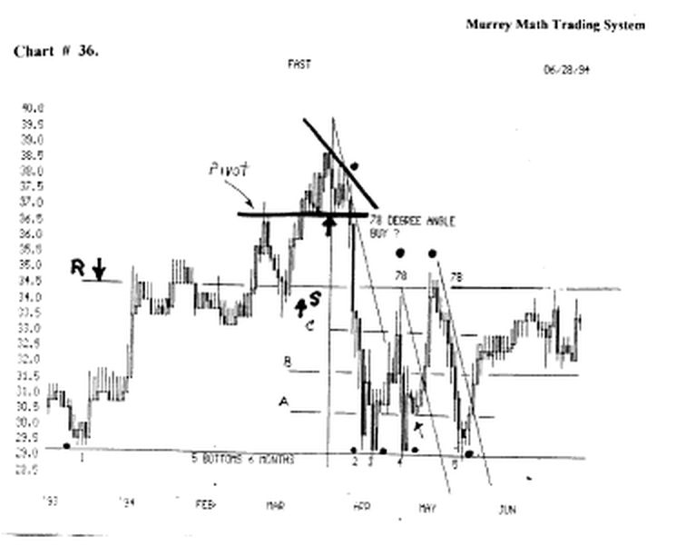

It is rare to find a stock that makes more than 4 bottoms, before it reverses, notice the "breakaway points" (a and b).

The break-away point is more accurately exactly where it clusters in its responses to any previous high or low. look again at (a and b).

We should buy (long),at (a), and watch for resistance at (b), and stay long as it moves through (b).

The last time it finally broke through the (b) resistance, the resistance became support in June,'94, and was a perfect time to buy and hold for it to go back up to the "spike" resistance Line

(34.4/8).

This resistance has been a factor since Jan.,'94.

Bottoms: 5 spikes (rare but more common on bottoms)

Look at chart # 36. F.A.S.T.

This stock made its 1st bottom in Dec.,'93. Then it stair stepped up to its high in Mardi,'94.

Then it fell on a 78° angle back down to its support line, at (S), but it didn't even stop, there and rest, for at least 1 day, because it "drove thru the line," and closed more than 78 cents lower.

ft fell all the way back down at the same level, as its previous low, way back at December,'93, some 4 months earlier.

It took 5 times to finally get the support to move back up, off this (5 bottoms - 6 months) bottom.

But l⁸ it has to get through the (r and s) line at 34. 3/8. Notice the fell on a 78 degree angle.

"Buy and hold" traders love this stock.

They would have bought at 29.3/8 and been smart up at 40.00, then, they would have made 4 excuses when it fell back down to its old low in just 12 trading days, that took it 4 months to move up.

Isn't it funny that we just take the low and the high and divide it by 2, we find the 50 % line to be major resistance.

(W.D. Gann said that: "the 50 % line is always major resistance to any low / high differential; especially if the time span is more than 3 months in tune.

After we started (take the low and the high), then set the l/S* retracements within these two differentials.

If we just happened to look at (b), we see that it is 50 % of the low and the 50 % line, which means that it is the 25 % line (which W.D.Gann said was the 2* most important pivot point for any stock to reverse).

Is this luck ? Who cares ?

But W.D. Gann said "it would happen more often than not."

We must learn the rules and trade instead of just sit there and wait till they double their money in one trade.

Let's make an 18 % profit on every trade.

TOPS:

Single - see chart # 39. G.D.W.

Double - see chart # 7. Shoney's Inc.

Triple - see chart # 29. Dollar General Stores

Variation "m" + inverted "v" - see chart # 7. Shoney's Inc.

Double "m" - see chart # 27. Coca Cola

5 spikes ( rare - very close in time ) - see chart # 27. Coca Cola
(these tops may be parallel or on a slanted angle)
Single

look at chart # 39. G.W.D.

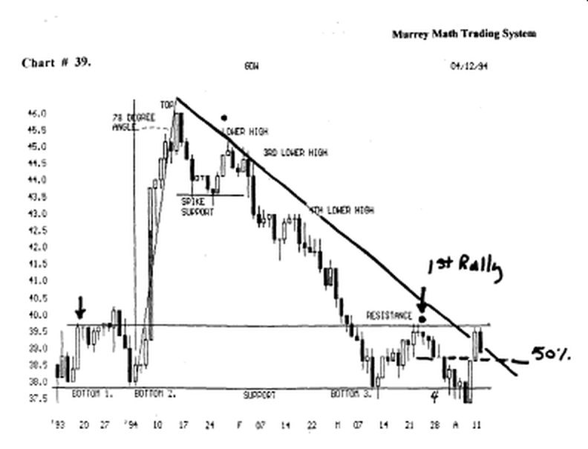

This is a classic example of a sharp single top, that moved up off a double bottom of 12 days ( width in time ).

Then topped out on a 78° angle, then fell back at the ( spike support ), for support, then it tried to make one last attempt back up to the old high, but it couldn't move back up higher than 50 % of the high ( 46.00 ) to low ( 43.50 ).

So, it as W.D.Gann said, "after the market makes its final top, it falls back, then retraces back up toward its old high, consider the 50 % line between these two extremes, and sell short if it can't hold above the 50 % Line."

This stock fell on a 45° angle (fast market), back down to its old low at 37.3/4 (2** low).

Then it retraced back up to its previous (resistance), at 39.3/4, march 22,'94, with a small "doji", then the next day it slipped back lower on a small "hangman" then it made a 2— "hangman" the next day.

Then, it fell back down 7 trading days later, just below the support level at 37.3/4, then it reversed 39 cents below the support line established in Dec.,'93, and moved back up to the (resistance) March 24, 1994.

Notice that it must close above the major "down trend Line" for more than "3" days in a row to help reverse the moving momentum of this stock.

The (4) low, is a classic example of how "break out" Systems don't work 25 % of the time.

The break out System wants you to go with the direction of the stock if it breaks above or below its major support.
But we must make sure that it has dropped more than 39 cents above or below the (resistance) or support line.

We must fall back to W.D. Gann's rule, "....always follow the trend."

Why do you want to wait till it has dropped from 46.00 back down to 37.1/4, to go short ?

It has already fallen 25 %, so the odds are greater that the down side is over now, because it is up against two previous lows, so it should want to stall out here. Maybe the "break-out theory" traders, created this weakness below the support Line.

We would want to wait and buy just above the support line on April 10, 1994.

Double Bottom

Look at chart # 7. Shoney's Inc. (weekly) chart.

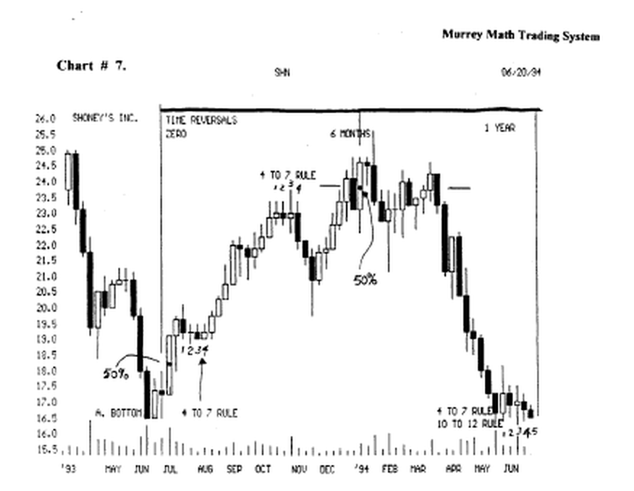

It formed a double bottom (from June,'93, to June,'94), which would be an ideal time to go long.

It will want to reverse if all its fundamental news is positive, but we should not enter unless it can hold above the support Line (16.4/8), using the (4 to 7) or (10 to 12) week support rule.

It looks like it wants to fall below the line. presently this stock is selling below the 1 year support line.

So if we want to buy this stock, we must wait until it can sell for 4 to 7 weeks (in a row) above this support Line, which now becomes the resistance line. we are looking for the "trend" but we must have entry and exit rules to help in our trading philosophy.

Look at chart # 10. DJ.I.A. 30 stocks.

Find the (a. and b.) low double bottom (April thru May,'94), and it moved up, then it fell back and made another double bottom, at © (May thru July,'94), that pushed the Dow back up to the (support line) in July,'94.

The Dow is currently up at 3,927.0, more than 200 points above this 2^{ad} set of double bottoms.

These support levels in the Dow help us determine when we shall enter a position on our individual stock.

If you had bought Exxon, G.E., I.B.M., A.T.T., Merck, or Walmart, would your stock fall after the Feb.,'94, (the all tune high in the Dow 30 Stock Index)

These are the 6 largest stocks in this country, so if they are that big, can't their power of how big they are make them immune to a general fall in the market, if their general fundamentals are favorable ?

Just call your broker and ask him to give you the price for each of these stocks in Jan.,'94, and then ask for the price of each of these 6 stocks down at 3,515.0 in April,'94 ?

month and their fundamentals were good, they should not have been hit hard just because the interest rates went up on good economic news.

If they went down with the Dow, then we should track the Dow 30 stocks, and their double bottoms, to establish our stock trading philosophy.

How many brokers will ask you not to enter a stock position, because the Dow is temporarily too high (over bought).

Then ask you to buy, when the news is bad and the Dow is way down on its lows.

We should always buy the bounce, and sell the bump. Triple Bottom

Look at chart # 29. Dollar General Stores.

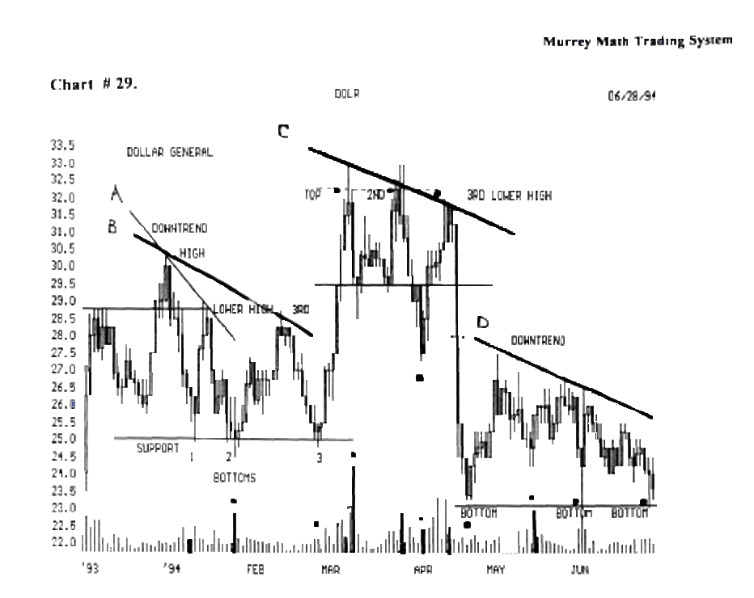

This stock reacted positively two times off triple bottoms.

If we look to the right, we see that it is forming another triple bottom.

It must break the (downtrend) line from May,'94, for (4 to 7 days in a row),to reverse the downtrend.

It also had a triple top, that signaled that it would fall, since the traders sold out of it short of the 2"¹ top.

But the "real sell signal" was set back at the (see black dot), down at 27.4/8, in April,'94, when it fell below the support line back up at 29. 4/8.

And didn't find support until it broke below the (lower high - 3—), back in Feb.,'94, and reversed.

Why did it reverse below two higher support Lines ?
If we take the 3rd low (25.00) and the high 33.00) and then divide the difference by 8.

Then multiply this 18th gann line by 5.

We see that this stock reversed at 62.5% off the top in
March,'94.

So we must look at previous support levels for support or resistance, and the Fibonacci ratios, within each high - low price extremes, to help us keep in touch with the moving momentum of our stock.

We must learn to get the rhythm.

Variation "m" + inverted «V

Look at chart # 49. shoney's Inc.

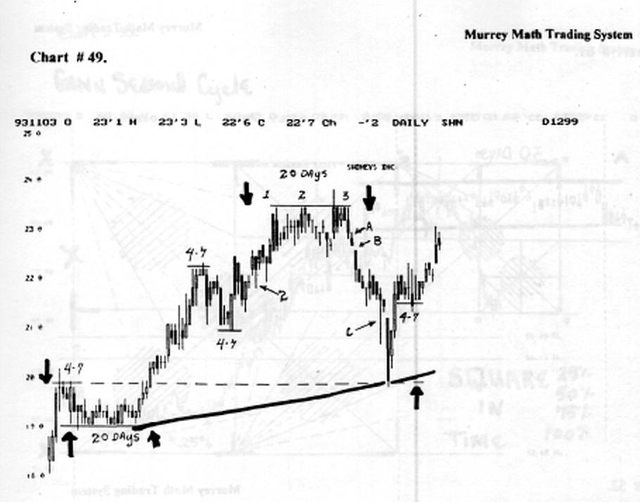

This stock formed an "m" top in Oct.,'93, then it back to old support at 20.00, then it reversed fast, and ran back up to 23.00, in Dec.,'93.

Then it formed and inverted "v" and started to fall. this formation is unusual, since we must not try and look past the strongest number "3" as the most ideal place to react to any stock's momentum.

Notice the low ( 19.00 ) and the high ( 23.50 ), then from this top, it fell back and found support at 75.0 % off its high.
Notice the (c) gap that occurred in Nov.,'93.

This was news related. ft gapped down then closed down at 20.00 (dashed support line ), and then the next day it gapped up again 50 cents, and closed the day at 21.00.

This reaction is a (Japanese "harami"). The "3°*" day, it closed above the gapped day, (c), and it had to close above this "gap" to allow this stock to move up toward the old high (triple top).

But, it must fill the (a and c) gap days to move back up to the old high.
It can't close above (a and b), at this time.

We would want to close our position up here if it didn't push up through this old gap.

Most stocks don't gap more than "3" times before they stall out, and slow down.

But commodities may gap for 6 to 7, or as many as 10, before it bas finished.

We must also look at ( 3 ) high, and low ( 20.00 ) in Nov.,'93, and that this stock stalled out at 7/8ths of this price extreme.
We should watch any stock that runs up + 7/8ths above its low.

If it can't keep moving up, it will fall fast off it.
Double "M"

Look at chart # 27. Coca Cola, (weekly) chart.

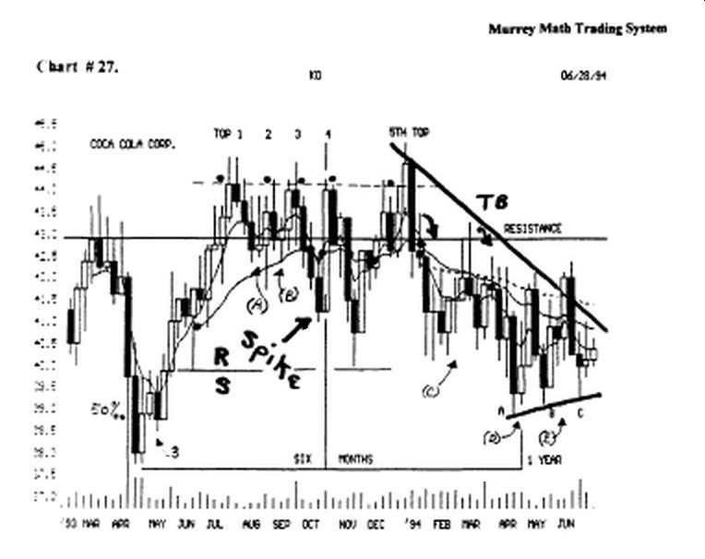

This stock formed a double "m" top, then fell below the spike pivot price down at 41.1/4.

This is critical that it couldn't hold at "spike" pivot price level, so it dropped to (r / s) line , then reversed on a (Japanese "engulfing pattern"), that closed above the previous week's high.

It tried to run back up to its (4th) top, then it fell back to the line (resistance), then it tried one more run up to the old high.
5 spikes

(rare: very close together in time when they occur)

Look at chart # 27. Coca Cola, (weekly) chart.

This stock tried a 5* time to break out to higher highs.

It even closed 39 cents above the line , but it couldn't above it but 1 week, so we knew that it was having trouble moving higher.

The next week, (5 ), it closed below the low of the previous week, (Japanese "dark cloud cover"), so we knew that the upside was over.

It couldn't move higher on 5 tries in 6 months in a row, so it fell ail the way back down to the (r and s) line, then it stalled here, and reversed back up, short term.

For it touched the (resistance) line two different weeks, but couldn't close above the line, se knew that it was weak, and wanted to fall back for more support, so it broke down below the (r and s) line, then found support just above 38.00 (the April,'93) low.

If we just look at the low ( 38.00 ) April,'93, and the high (44.4/8 ), and we divide this difference by 8, we see that fell 75 % off its July,'93, high.

W.D.Gann said 25 % was the 2- best buying opportunity), for any stock in an up market.

Notice that this stock reversed every 6 months.

Time isn't measured by 9 out-of 10 traders.

"Buy and Hold" traders don't even have a long term goal, of when to sell with a profit, so they rely upon low interest rates, and a growing economy to justify their long term trading philosophy.

