Murrey Math Trading System Watching Time Reversal Signals

CHAPTER3. Watching Time Reversal Signals

W.D. Gann said on page 33. "....the most important thing is the time period and when time overbalances or shows a change in trend, it is much more important than a percentage of prices."

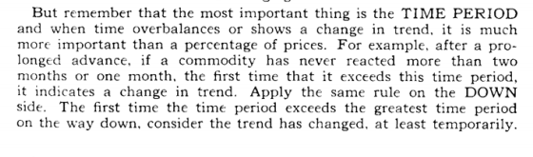

W.D. Gann said on page 34. "sometimes wheat, soy beans, or other commodities will hold for 3 to 7 days, or longer, making bottom or top, around these important resistance levels, and at other times may hold for several weeks around them, proving that buying or selling takes place around these levels."

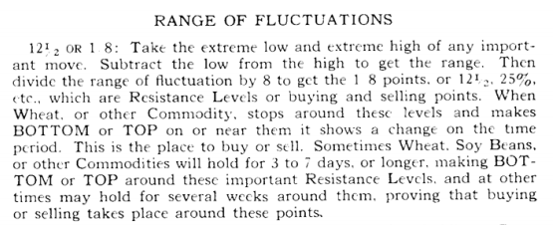

W.D Gann said on page 47. "give the market time to show the trend."

W.D. Gann said on page 48. "the market often spreads ont over quite a period of time, making a flat top lower than the extreme high of the move, and at the same time, making a flat bottom, moving in a narrow trading range....you must not judge that the trend bas definitely changed until it moves out of this flat range, crossing the tops to show up trend or breaking the bottoms to show a reversal and lower prices."

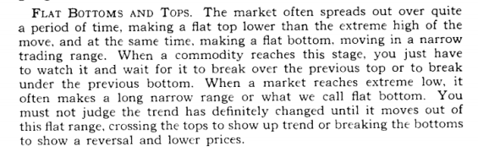

W.D. Gann said on page 56. "time is the most important factor of all and not until sufficient time has expired does any big move start up or down."

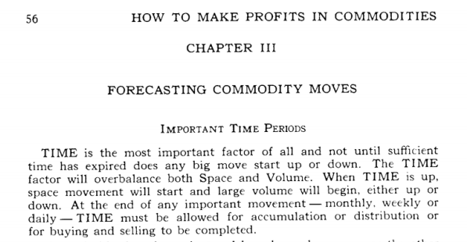

W.D. Gann said on page 57. "a daily movement may reverse trend and only run 7 to 1 days, then follow the main trend again."

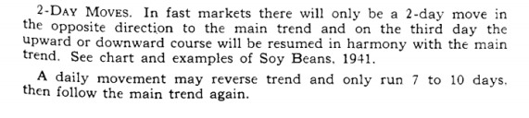
W.D. Gann said on page 57. "you should watch for top or bottom around the 49* to 52⁻ day,....because a period of 45 days is 1/8* of a year."
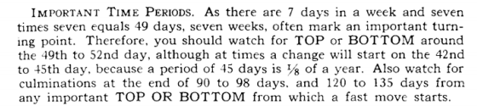
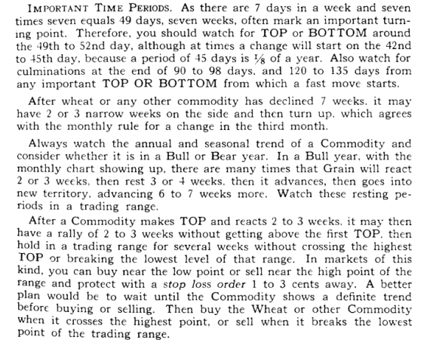

W.D. Gann said on page 53. "it is very important to watch for a change in trend 30 days from tops or bottoms....next watch for changes 60, 90, 120 days from tops or bottoms.... 180 or 6 months....the most important, and often marks changes for greater moves."

Consolidation time at highs:

(understand that these lateral time span rules shall hold
true on a daily basis or weekly basis)

1 ) 4 to 7 days - (W.D. Gann says 3 to 7 ) see:
Chart # 34. Uniysis
Chart # 7 Shoney's Inc. (weekly)
Chart» 9 FA.T.N.
Chart 13. P.N.C.

Chart # 16. I.BJV1. (weekly) Chart #18. F.R.E. (weekly) Chart #23. B.A. (weekly) Chart # 34. Uniysis Chart # 49 Shoney's

2) 10 to 12 days - (W.D. Gann dicta't comment)
See chart # 8. F.DA.
seechart#13.P.N.C.
see chart # 16. LB.IVL (weekly)
see chart # 34. Uniysis
see chart #58. Cotton
see chart # 63. JAJLS.
see chart # 72. W.F.C.

3) 20 days - see chart # 49. S.HN.

-see chart # 57. IB.M.
4) 30 days - see chart # F.A.T.N. (rare)

Please read the chapter special situations (reversal signals), to see that we must not sit and wait for these consolidations to take place.

And sometimes they do occur, and we must be patient, and wait for it to happen.

Stocks consolidate laterally in time, so that they may get direction, and this direction consolidation time varies at different times.

That is why one must not put all of one's investment capital into the first bounce, when a stock reverses.

It may reverse the very next day, ofFrts sharp bottom (see chart # 8. FJ) Jt.)» but this is unusual.

We must develop the patience to watch the 1" day our stock moves laterally.

Then we must start counting the lateral (sideways) consolidation in time: careful to get in early.

Look at chart # 51. F.A.T.N.

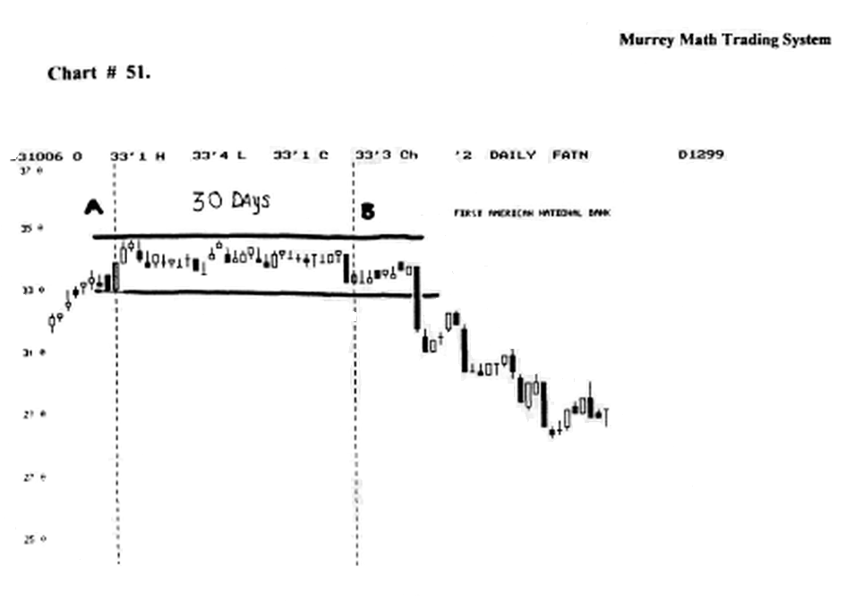

It is classic.

This stock had run up to new highs, on profitable earnings, and everyone had seen this stock turn around, and correct its balance sheet, against its bad real-estate loans in the late 1980's.

But, the traders were waiting for the interest rate direction to tell the stock where it was going.

The US. 30 Year Treasury Bond topped out October 18, 1993, but this stock couldn't wait till then, for its 30 days had been fulfilled a few days earlier.

It fell back to an old support line. (presently it is back up to this old high).

Look at chart # 34. DISNEY

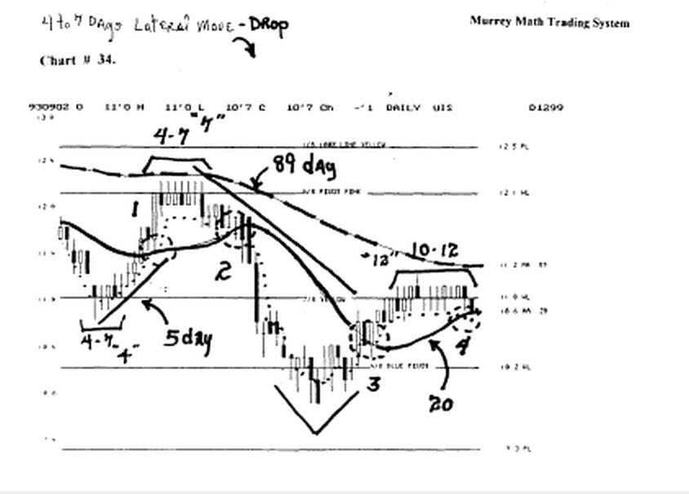

It is a classic chart.

it based out on the down side (4 days) then it ran up to 12.3/8, then it stalled out and rested, looking for direction.

it formed a classic (Japanese "tweezer top"), when it was bid up to the same price and closed the day down on the same price, until the 7th day, then it found its direction ! down !

It fell down through its old support from June,'93, and' settled at 10.3/8, then it tried to break the old (r / s) line, but it couldn't do it.
It moved laterally for 12 days, then it fell again.

This stock closed at the same price 12 days in a row, then it fell.

If a stock moves laterally, after making a new high, and it can't break out to higher highs, then the odds are increasing that it wants to rail for support.

The more days it moves laterally, and the faster it moved up, and the longer the run, the more extreme the reaction will be, when it reverses.

Consolidation rime at lows:

(it must be understood that these lateral consolidation times shall work on a daily basis or a weekly basis).

It must be understood that normal stocks will rarely move laterally for more than 30 days in a row.
Without making an up move and retracing back to its old
support line.

We must measure time off old lows.

1 ) 4 to 7 days - see:
chart # 7. Shoney's Inc.(weekly)
chart # 9. F.4.T.N.
chart» 13. P.M.C.
chart * 16. I.B.M. (weekly)

chart #23. B.A.( weekly ) chart 32. B.S.( weekly )

2) 10 to 12 days
chart # 8. Federal Express Corp. chart # 13.P.N.C. chart # 16.1.B.M. (weekly) chart # 33. A.S.A.
- 20 days
chart # 49. S.H.N.
chart #57. I.B.M.
charte # 44. M.O.
- 30 days
chart # 36. F.A.S.T.
- 3 months
- 4 months
chart # 37. F.M.C.. (weekly) chart # 41. EJX. (weekly)
7) 6 months
chart # 28. C.CJ.
charte* 33. AJSJL
chart # 36. Fw\^.T.(weekly)
chart # 45. Mo. (weekly)
chart #6. N.B. (weekly)
chart » 7. S.H.N.
8) 9 months
chart -: 14. M.R.K, (weekly)
chart # 18. F.R.E. (weekly)
9) 12 months
chart # 30. C.TJt.(weekly) [ it couldn't hold support ] chart # 38. Dell (weekly)
chart # 56. Lumber (weekly)
chart # 12. M.u.n.
10) 15 months
chart # 38. Dell (weekly)
11) 18 months
chart # 38. Dell (weekly)
12) 2 years - most traders are too short sighted to wait or study any stock on any basis further out into the future as 2 years.
t
But IB.M. seems to be on a 5 year and 10 year cycle.

W.D. Gann said that all stocks and commodities are reacting to its longest term, intermediate term, and its short term high and low differential price range.

There are time cycles that are not automatic in their time span, so we must look at the chart and find the individual time rhythm for what we are trading.

Look at chart # 55. Coffee. (weekly)

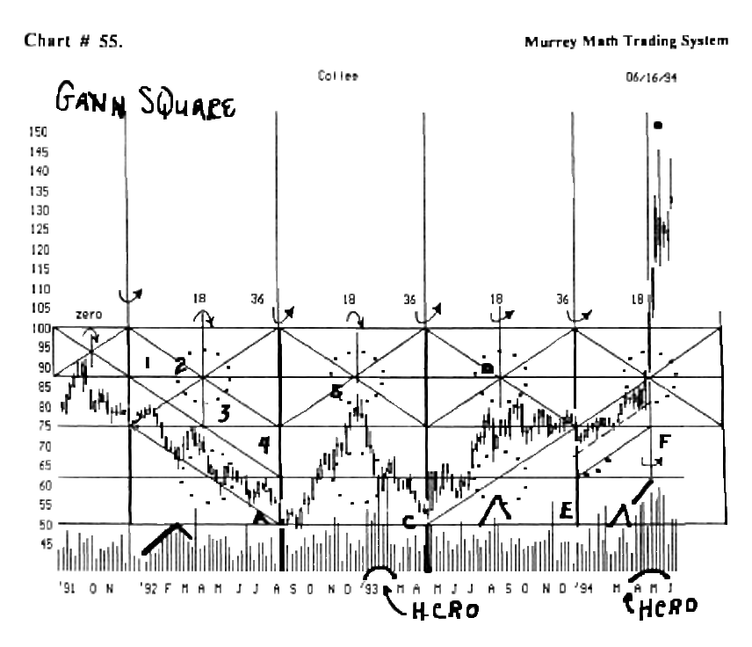

it is set on an 18 week time pivot price reversal.

I started "just looking" at the past 2 V* years of price action as it traded thru tune.

So, I saw the low of August,'92, then I saw the reaction in Dec.,'92, it had peaked out, then 18 weeks later it went back down to find a double base, again 18 weeks later.

If we run these 18 week pivots backward and forward off this cycle, we see that it broke out this past Apnl,'94, on extremely high volume.

You will see that it broke out at the end of this 18 week time - price pivot cycle.

Look at chart # 56. Lumber. (weekly).

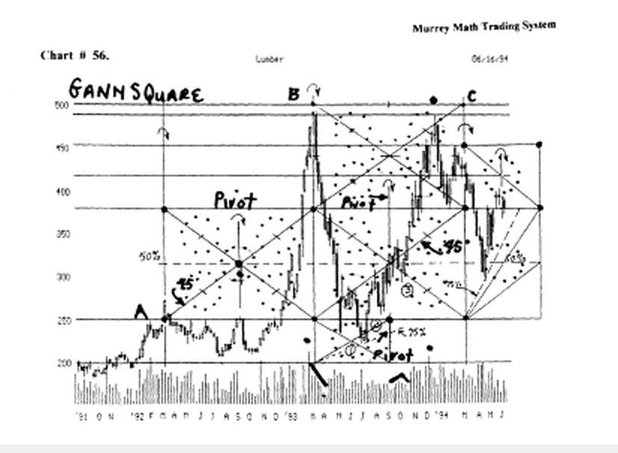

I have drawn the square in time for lumber.

The square in time was established by W.D. Gann through the use of the number 7. (at least his version was shown the trading world).

Gann describes how to do this in another book.

My way is based upon pure math and not the last reaction of a down move.

My way of setting the square in time for a stock or commodity doesn't always start on an extreme high or low, because the lowest low may be a final reaction to the rhythm, just below the line.

I know the exact price all stocks or commodities are trying to reach, and if they don't reach this perfect rhythm number, they will fall back for support.

Notice that I didn't set the starting point at (a) on a low; rather, I started on a high break out and it reversed at the (pivot) point, which is exactly 50 % of the square.

It ran up to almost 500.00, again at the end of this yearly cycle.

Then it fell sharply off the 78° angle, then it reversed down in July,'93, then it congested on the center (pivot) price and ran up again, but it met strong resistance along the diagonal angle off the (a) starting point.

Then, it fell back from its high, which was short of the March/93, then it made a reaction to make it back up to its Dec.,'93, high, and on the end of the cycle, it fell sharply.

Was this luck ⁹ Who cares ? We have enough rules to help us trade profitably.

But, the square in time helps us watch for natural pivot reactions, off the diagonal lines drawn off the upper and lower left side corners of a square.

Look at chart # 52. Cotton. (weekly).
Then, look at chart # 53. Cotton.
Then look at chart # 54. Cotton.

We have taken this commodity and viewed it from its larger square in time, down to its tradability off smaller squares, within each larger square.

It is based on (a) and (b).

Look at chart # 27. COCA COLA. (weekly).

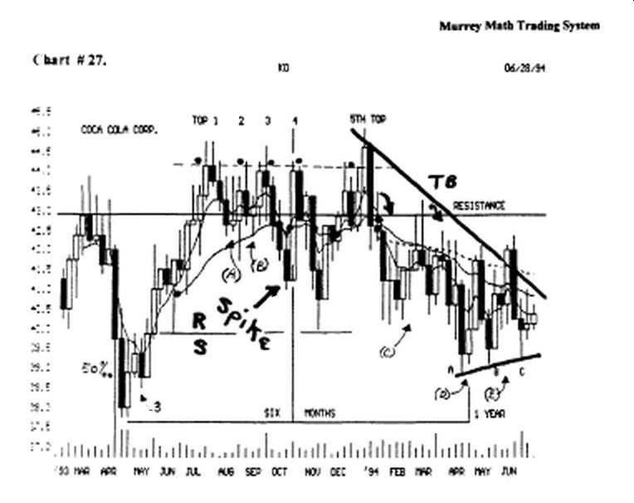

It based out in April,'93, and half way through the cycle, it pivoted up to try and break out to higher highs, then it fell back for support, and reversed at the end of the cycle, (a), then formed "3" higher lows and started moving back up to its (resistance) line.

Look at chart # 7. S.H.N. (weekly).

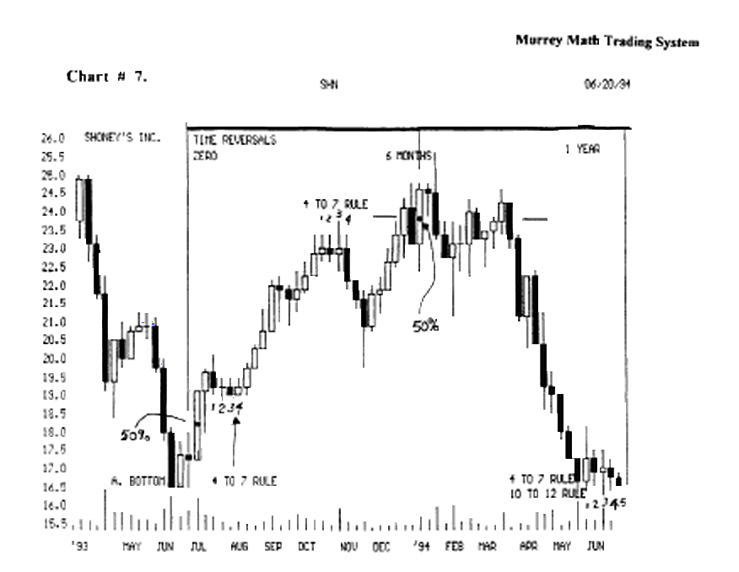

This stock is set on a 1 year time cycle.

If we set a box around this one year time span, we would see a square.

Time conversion ( consolidation ) W.D. Gann said on page 30. "a busy man or specialist should keep a weekly high and low chart on wheat, soy beans, cotton, or any commodity he is interested in."

W.D. Gann said later on down on page 30. "the more time period used in a chart, the more important it is for
determining a change in trend."

W.D Gann thought that the weekly chart was critical to looking at stocks or commodities, from which to form your trading strategy.

Always start from the weekly chart, back as far as "3" years of past history.

Then convert your time cycle reversals back to a daily basis on the short term, and you will be able to trade from a "fine tuned" momentum rhythm.

There is no guarantee that any stock will adhere to these time reversals.

We must learn to watch for every kind of reversal, and if that "first one" doesn't materialize, we set our parameters to watch for the next time span for consolidation, and the next reaction, and in some cases it may take as long as 3 years to find the support to initiate a reversal.

We shall never be able to always catch every bounce off its low, or will we be able to sell at every top, before it reverses back down to its previous support.

There are always news, politics, earnings reports, or weather, may ignite a fast reversal immediately.

So, watch your stock at least twice each day: the 1e hour, and the last 15 minutes of the trading day.

W.D. Gann said on page 15. "learn to follow the trend and you will make a success."

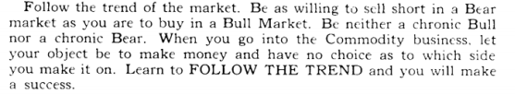

Someone must be scratching their heads and saying, "well ail these rules work after the fact. You are just looking for coincidences that occur regularly, \ don't think they will work when I trade."

This is the next phase to trading.

We must see the 1" signal that is reversing, then enter, and watch for the next signal that it stalling out, and to sell and take a profit.

Because, we see a shift in momentum, or that we have an 18 % profit, or that our stock has run up 37.5 % or 50 %, or 75 %, then we would want to sell 50 % of our position, because, just as you have already said, all these rules work after the fact."

Look at chart # 27. Coca Cola, (weekly).

You must trade this stock.

You may have been the best "entry position" trader in the world, when you entered your position down at 38.00, back in April,'93, then you became a buy and hold trader, and you watched it make 5 whip lash reversals in a row.

Then after one year they would have made S 1.00 after 365 days of talking about this stock.

But, if we had sold, when it made up to 44.3/4, we could have put 6.25, profit m our pocket.

But no, we waited 4 more times to get a break out to top our 6.25 profit, it fell the 5* time back down to almost a 90 % loss of ail our profits.

And if we had traded it ?

W. D. Gann said on page 39. "buy when the first rally from the extreme bottom exceeds in time the greatest rally in the preceding bear campaign." Classic rule.

Look at chart # 37. F.M.C.

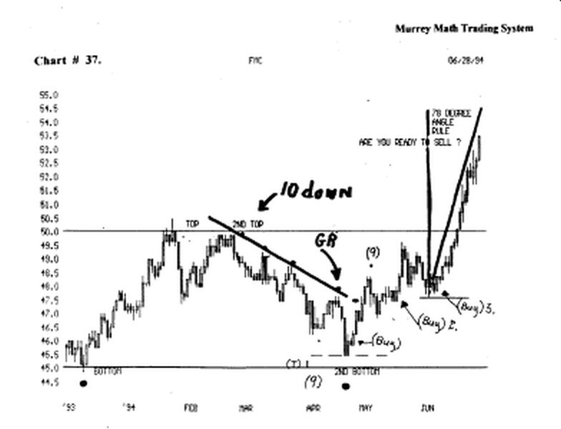

This rule is the safest place to enter, but we will always lose some bounce profit, if we don't "buy the bounce," (buy), 46.00, at ( 2* bottom ), in April,'94, and nde it back up to the (greatest rally),

Then sell 50 %, not enter here, because it may stall out here (gr).

But it went through the (gr) and all the "rule followers" were correct, but it reversed back down just below the (gr)line.
Then at (buy 2), this is the safest place to buy.

Then we would buy again at(buy 3),at the "3"*" tune up.

The point W.D. Gann was trying to make was simply this: we must make sure that our stock has the strength to break above and hold above this resistance line for (4 to 7 days in a row).
It held above it for only 3 days, then it fell back for support.
The time in the greatest rally in the bear campaign was 9
days.

If we count forward 9 days into the future, from the low, that signaled the end of the bear campaign, we would have been whip lashed because the tune (9) days in the rally, added to the low, found us up against a top

We must measure time into the future, against the bear market rally.

Look at chart # 46. Disney.

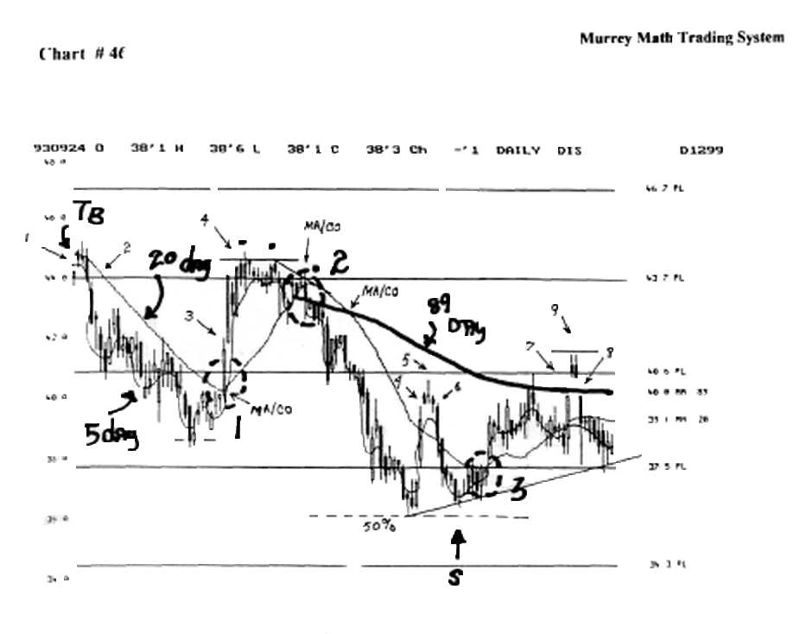

The greatest rally in the bear campaign was stalled out after 5 days up at (5), at 40.1/8.

Then at the (s), it stalled out and we start counting into the future, form this point.

Five days later, it moved above the resistance line (37.5), then it ran up and tested the old high at (5).

It touched the (40 5/8), Ime, then fell it is easy to see, from this one rule, that on the face of it, it may work in one back for support.

Instance, but we must use all our rules at the same time, to get the "true feel" for our stock, and we should start if one rule, then shift to the next rule as our stock moves in price, and through time.

WD. Gann said on page 47. "give the market time to show the trend."

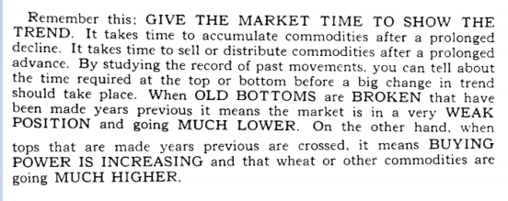

This means that if a slow market exists at low prices, count the days it consolidates or distributes. Look at our "consolidation time at lows" at the first of this chapter.

If it doesn't break out after the first reversal day, then we would shift our time counting to (4 to 7), then (10 to 12), then (20), then (30) days and so on, until it breaks out to the up side.

Watch volume at lows (for reversal signal)

We must look for a high or low volume signal to give us a clue to when a break out will occur.

The steeper a market falls, in theory, the higher the rebound bounce shall be.

But we must jump into the stock fast, for it will not go up (most of the time), more than 12.5 %, 25.0 %, or 37.5 %, retracement.

If it falls slowly, on a shallow downside angle, the rebound, is (usually), small, and slow.

We must look at volume first.

Many weeks in narrow range:

W.D. Gann said on page 51. 'When wheat or other commodities hold for 2 to 6 weeks or 10 to 13 weeks in a narrow range, then crosses tops or break bottoms of previous weeks, the trend has changed and you should go with it."

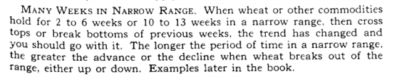

The commodities were traded 6 days a week, when he formed his trading strategy.

And now they are traded 5 days each week: we must adjust the time.

There are 2 trading calendars:

1 ) trading days only (consecutive)
2)or calendar year (including Saturday and Sunday).

We propose to you, that the best way to evaluate your trading strategy is by using the trading days calendar for stocks and commodities, but at the end of a yearly cycle (with commodities only), you may reset your cycle at the first of the next seasonal cycle each year.

Commodities are based on seasonal swings.

Since W.D. Gann saw market swings reacting in 2 to 6 weeks, and 10 to 13 week narrow ranges, we may set our standard moving averages to 5 week, 20 week, 50 weeks, or 89 weeks.

On a shorter term, we should set our daily moving averages at: 5 day, 20 day, 5.0 day, or 89 day.

We use the 5 day ( ma ) because we trade on a weekly basis.
We use the 20 day moving average because it 1/12 th of a year.

Then we use the 50 day (ma), which is almost a quarter of the year.

And lastly, the 89 day (ma) is long enough to measure slower shifts, but fast enough to trigger long term reversals.

Watching time reversal signals

W.D. Gann said on page 56. "in big upswings a reaction will often not last over 2 months, the third month being up, the same rule as in yearly cycle - 2 down and the third up."

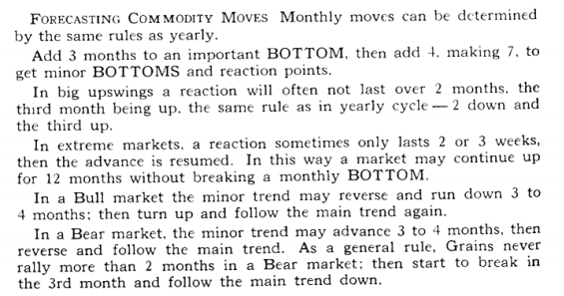

Look at chart # 56. Lumber. (weekly chart).

We just look at the weekly action of this commodity.

It popped up in March,'92, then it topped out in Mardi,'93, so we tried to find the square in time for this commodity.
We saw it reverse at (a), then it topped out near 500,at (b).

We set another square, into the future, and it reacted in Dec.,'93, to the uptrend line set back off the original square at (a), (c), then it finally fell at the end of the square, after it tried to retrace back up to its old high of Dec.,'93.

We know what W.D. Gann said about ....after a commodity has made an extended advance, and tops out, it will fall back, then want to retrace back up to final top, we should watch for the 37.5 %, 50 %, or 62.5 % retracement from the top back down to the (pivot), support line.

If we look at this last time up in Dec.,'93, it may well be a 62.5 %, retrace, so the "golden mean" is working on this lumber contract.

Let's look at the (a) 250.0 low, and (b) 500.0 high, and then the fall back down from the high in March,'93, to die final fall in May,'94, we may just "eye bail" it and decide that it retraced 62.5 % of this total retrace.

If we look at the May,'93, reverse, it is called a Japanese "piercing pattern").

This is where a commodity will drop sharp and fast, then gap down to start the week, then reverse fast, (on higher volume), and close the week above the 50 % line of the previous week's activity.

It did this, so it signaled a reverse, which is what it did.

So, we should look for this May,'94, retracement to stall ont at 37.5 %, 50.0 %, or 62.5 % of the difference between the Sept.,'93, high, and the May,'94, low around 295.0.

If we just "eye ball" this last stall - out to the up side it would be 50 % of the difference of the 2 extremes.

We must look at the long term high - low price extremes, and the short - term high - low extremes, to judge where momentum will slow down and reverse.

Do we really care how far any commodity runs, as long as we make 18 % profit on every trade ?

Notice the classic (Japanese "hangman"), the final week of March,'93, (high).

It signaled that a reverse was soon coming.

It had run up on a 78° angle, so we knew that it would reverse soon, and fall steeply, because war, or bankruptcy, is the only reason that anything should rise that fast: no contractor in the world can build enough houses fast enough to drive up the price of lumber to the general public, but panic buying is always greeted with panic selling after reality touches someone's profit objective.

Notice that it fell in May,'93, down past its old low of (a), (support), because it fell 9 weeks in a row, (the Japanese said that no commodity should run up or fall more than 10 trading days in a row - and this rule applies to [weekly] charts too).

So we would expect it to stall out after 9 or 10 weeks, or when it retraces back down to its old lows, after all, the contractors have been building more houses after the first "recovery" in the economy, started, when someone said that the recession was "officially" over, but the price of lumber fell back to its old low, and 2,000,000 more new homes were sold to America.

Does it make much sense to you how this could be ?

It just goes to show us that fundamentals don't matter when pame "buying" or "selling" takes over, that is why a trading philosophy based on the "golden mean" and the law of exact proportion, serve to predict when a commodity will stall out.

It looks like it stalled out on mathematical retracements, rather than any great economic news presented each week by all the "experts" who guide our fundamental trading philosophy.

Look at March,'93, and the fact it fell through the (a) old support line, the "break out" traders would sell it short, watching it go even lower.

It even fell below the (pivot) price line from Sept.,'92, so it was critical that it hold here, or it would be going even lower.

But, this was the final "blow off ' to the down side.

It gapped up the next week, then formed a reverse hammer, which meant that it wanted to go back down and test the old low, so it went side- ways for 5 weeks, then formed a smaller "doji" "shooting star" and it fell hard down through the March,'93, low in June,'93.

Then it formed a small reverse hammer on less than 1/2 the volume from the previous week, which signaled that it wanted to reverse back up soon, and it did, and it started its climb back up to (the 45° angle), set off the "square in time" and it backed off when it touched it the first time up, July,'93.

Then it fell back for support in late Aug.,'93, then it reversed back up, on a small "morning star" then it ran up fast, and high, in the center of the "x" in the square, then it fell back again, and wanted to get support on the "downside 45° angle" then it moved up fast on another "morning star" on higher volume, Oct.,'93, on a "3rd" higher low, plus it broke above the (50 % line).

Then it ran back up almost to its old high near 500, but it got hit hardest on the 45 degree angle, which was set way back off the 1st square, created in March,'92, through March,'93, which measures the moving momentum of this commodity, out into the future, which we see that it did numerous times.

Look at chart # 55. Coffee. (weekly).

We set the "square in time" for this commodity, by just looking at it and observing the seasonal action as it runs forward through time.

It started its cycle at (a), Aug.,'92, when it based out for 5 weeks, (4 to 7 week consolidation time period), then it reversed and broke out to the up side, then reversed 18 weeks later.

We followed this 18 week pivot "rhythm" and we notice that it reversed back in the past off this cycle, and it pivoted in the future off this cycle, and it exploded into higher ground right at the end of the (f), (5* 18 week cycle), on extremely high volume that had taken place the past 5 weeks.

Notice the "3" extremely high volume weeks, in January/94, and the fact that it couldn't move up that much volume, said that it was getting ready for a big move.

Then in March,'94, it formed an "upward chevron" and when the right side of the chevron had the volume falling as the price moved up, we could see the "sellers" leaving, all we needed was time, (the end of the square).

So that it would satisfy its consolidation period, then it exploded from 91 all the up to 105, in just one week, which was at the end of the 50 % (pivot) line in the 4 th square in time.

Isn't it curious how this commodity reversed every time on the 18 week cycle for 8 straight times, over the past 2 Vi years. (now there is one skeptic out there, who says that we started with the "break out" week, then reversed the 18 week cycle, and it hit enough times to prove our point.

Well, it is hard to prove very much to very many traders, because they think that some complicated formula will answer everything for us, but all we do is observe the obvious, when we set the "square in time," for any stock or commodity.

Plus, if this is luck, why did it run down along the 45° angle for 36 weeks, then it reversed, after a (4 to 7 week - 5 th week), Sept.,'92.
Then again, it ran up on a dashed line from (e), January,'94, for the enure 18 weeks, ull the end of the cycle, when it broke out fast at the end of the cycle, May,'94.

Notice the extremely high volume ( hcro ), Jan.'93.

Then it occurred again, April,'94. I call this a (hcro -high cluster roll over).

We have a cluster of extremely high volume, when a stock or commodity is getting ready to break out.

These high volume clusters occur more often when a stock is on a low, rather than on a high.

After a stock has made a big run up, every trader is happy to take a profit.

Conversely, when a stock is on a low, it must consolidate, and this consolidation, may take as many as 3 short jumps, at trying to move higher, before it finally starts moving up higher (see short legged "w" or double "w").

It doesn't have any standard formation, because each day is a new short term direction or the news changes daily, and the attitude isn't consistent with the fundamentals, which are calling for a change in direction.

Remember that all reversals don't always take place "right on schedule" just as we would hope they would, when we learn that it is a "great buy."

So, we must wait sometimes, or enter our position on a smaller amount, then we wouldn't have to learn too many rules, but our trading philosophy should be based on the ability to watch for the change in trend, and jump in, then, then watch for the next level of resistance, so we may take an 18 % profit.

W.D. Gann said on page # 57. "2- day moves In fast markets there will only be a 2 day move in the opposite direction to the main trend and on the third day the upward or downward course will be resumed in harmony with the main trend."

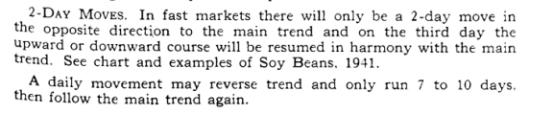

(remember that this rule also applies to a weekly chart).

Look at chart # 55. Coffee.

If we start up at (b), Dec.,'92, then we follow it down to the "high cluster roll over" at Feb.,'93, 60, h reversed and went up for 3 weeks.

Then fall back to its trend, which was down.

It based out (at c), Apr.,'93, and reversed up, then fall for 2 weeks, then it reversed up and made a new high, then it reversed up, and went up to the old high (b), then it fell for 2 weeks.

Then it reversed up and made a 2nd try to push up above (b), then it fell for 2 weeks, forming a "morning star" then it reversed.

And ran up in Oct.,'93, it fell from the 45° angle (from the smaller square), then it fell again for 2 weeks.

Then it ran back up at the end of the cycle, (e), then it fell for 2 weeks, right at the end of the cycle, then slide up along a diagonal line parallel to the square's 45° angle line, in the square just below it.

The last time it moved above the old high at (b), April,'94, it fell back for just one week.

Then it reversed, and moved up for 2 weeks, Apr.,'94, and on the "3*" week it broke above (b), "spike" pivot price, Dec.,'92, which was the end of the cycle (18 weeks).

This is a difficult mie to look for, and to trade, very often.
But we should try and look for reactions to a reverse, and be ready to take a profit of at least 18 % or sell 50 % of our position.

So we may be able to increase our capital base in the shortest period of time, regardless, when our stock or commodity stalls out, then reverses.

We can't read into the future, so we just take a profit short term, then we allow the "buy and hold" traders to wait and pray that it doubles soon.

Market (number of days) when it should reverse

W.D. Gann said on page 57. "a daily movement may reverse trend and only run 7 to 10 days, then follow the main trend again."

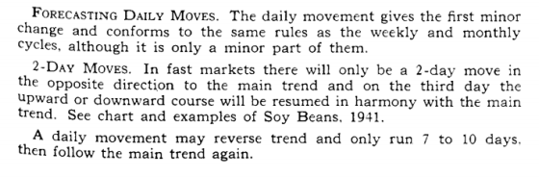

The Japanese in the 1750's, also said that no rice futures market should trade in one direction more than 10 trading days in a row. (this rule also works on a weekly chart.)

Look at chart # 54. Cotton. ( weekly ).

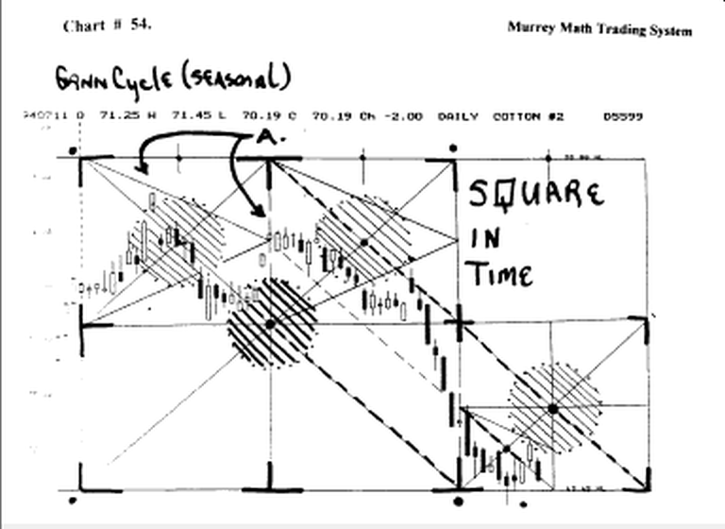

It gapped up in June, 94, then it fell for the next 10 trading days, then it reversed up for 2 days, then it reversed up for 2 days, then it fell back down to its old support level at 69.65.

If we find a current chart, we shall find that it couldn't hold support at 69 65, then it fell.

Look at chart # 9. F.A.T.N. ( weekly ).

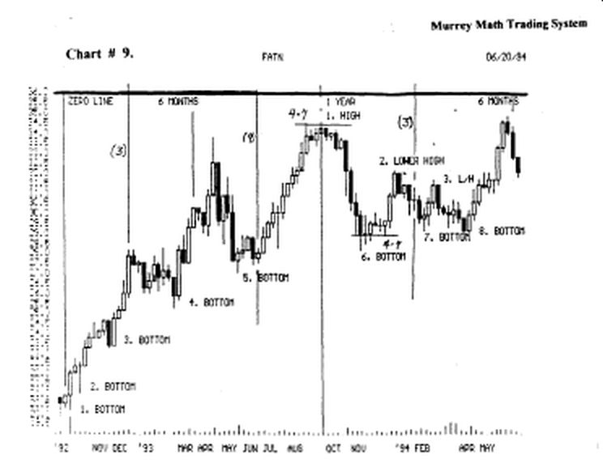

It ran up from its low. June,'93, for 12 weeks, then it moved laterally for 4 to 7 weeks, then it fell back, because it had moved up on a 78° angle.

Look at chart # 32. B.S. (weekly).

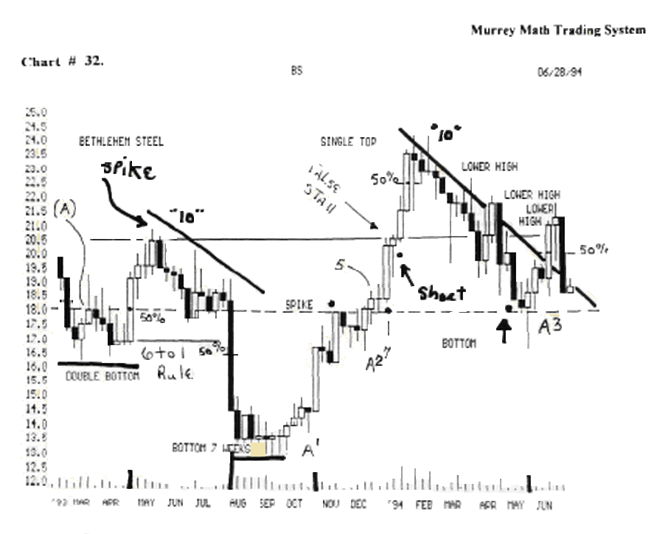
It fell for 10 weeks, then it reversed trend for (2 week rule), then it fell for 3 weeks, then it stalled out at the (spike) at 18.00, then it reversed up and tried to break above the (spike) pivot price, back in May,'93, it closed above the spike.

But it couldn't close above the Apr.,'94, high, 22.00, and it formed a "hangman" and the next week it fell all the way back to 19.00.

Look at chart # 33. ASA (weekly).

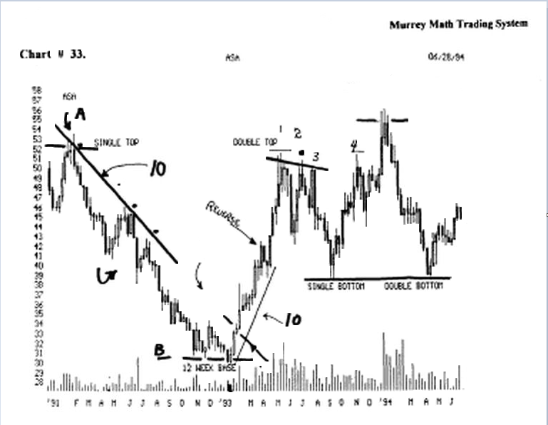

It fell for 11 weeks in a row, then it tried to reverse, and it did for 6 weeks, then it fell for just 1 week, then it reversed up for just 1 week, then it fell for 2 weeks.

Then it reversed up for 3 weeks, then it fell in July,'92, for 5 weeks, then it stalled, and reversed up for 1 week, then it fell and formed a 12 week base at 30.4/8, then it reversed up on lower volume, after its long sharp fall fromupat53.1/8.

It reversed up on a Harami" on lower volume, then it moved up for 11 weeks in a row, then it reversed down for "2 weeks" then it reversed up, Apr.,'93, for 5 straight weeks.

But notice that it ran up against an old high, in Jan.,'92, so it was time to sell 50 % of our position the 1st time it hits old resistance, especially, since it was 18 months ago, and it had run up on a 78° angle, so we would get ready to sell it short.

If we measure the fall back from the high, (a) 53.1/8, and the low, (b) 30.4/8, we would expect the single bottom to be no lower than the maximum "golden mean" number of 62.5 % fall back for support.

If we just "eye bail" it stall point at (single bottom), we see that it did stop there.

It reversed, and ran up above the old high, at 53.1/8, and ail the "break out" traders jumped on board, and lost big time, again.

We should have shorted it below 53.1/8, and watched the angle it fell on from its high, which was a 78° angle, so we would have expected a fast fall, and we would have started counting the weeks of the fall.

And we would expect it stall out after 10 weeks, or back down at the old support low, or 62.5 % of the high - low differential price levels.

It fell for 5 weeks, then it moved laterally for 5 weeks, (4 to 7 rule)

Then it dropped for 3 more weeks, then it formed a double bottom, and it reversed up, at Apr.,'94, which was a 6 month low, "double bottom."

Notice the long down trend Line, that started off the Jan.,'92, high, then we waited for its first try to move out of this down trend.

But it couldn't, so we must wart n'11 it breaks this down line and closes above this line for (4 to 7 days) (weeks in a row).

So, we would have entered 50 %, when it closed above the down trend Line, then entered 100 %, on the 4 the week.

When it reversed in Jan.,'93, it went up 50 % of the high - low differential, then it fell for 2 weeks, then it went on back up to the old high.

Look at chart H 38. Dell Computer, (weekly).

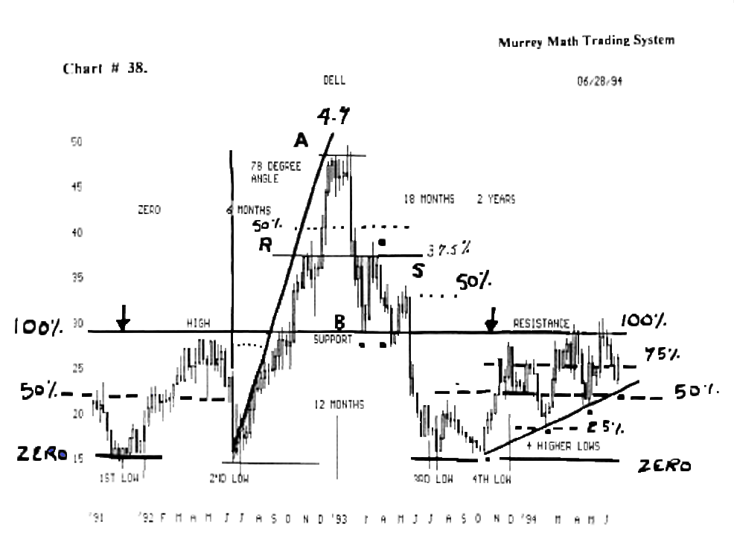

Look at this 10 week mn, that turned into 14 weeks, then it reversed for just 1 week, then it ran up for 3 more weeks.

Then it fell for one week, then it went up for 1 week, then it fell for 2 weeks, then it reversed on a "morning star" in Nov.,'92, then it went up for 5 more weeks.

Then it went laterally, for 4 weeks, (4 to 7 rule), then it formed a "hangman," a "Harami," then a "doji," then another "doji" then a "hangman" then it fell like a rock, back down to 37.5, (r), line.

It continued to fall back down to the (high-support) line and it held support here and reversed and ran back up 37.5 % of the differential between (a) 50.0, high, (b) low, 29.5/8, which we see that it reversed in March/93, on the 3/8 ths line.

It fell back and closed below the support line, which signaled that it was wanting to move lower, or not move back up to its old high.

Then, when we take the differential between (b) 29.5/8, and the high at (r) 37.5 %, we see that it reversed and
stalled up at the 50 % line.

Then it fell through the (b) support line and went all the way down to the old low, (2nd low), forming a "3rd" low, then it reversed up, (3rd low), and stalled after a 25 % pivot then it fell back down to form a (4 th low) in Oct 93. then it started to move up on a normal (33°) angle.

W.D. Gann said on page said on page 57 "after a
commodity makes top and reacts 2 to 3 weeks, it may then have a rally of 2 to 3 weeks without getting above the first top, then hold in a trading range, for several weeks without crossing the highest top or breaking the lowest level of that range.

In markets of this kind, you can buy near the low point or sell near or above the first top, then hold in a trading range, for several weeks without crossing the highest top or breaking the lowest level of that range.

In markets of this kind, you can buy near the low point or sell near the high point of the range and protect with a stop loss order 1 or 3 cents away."

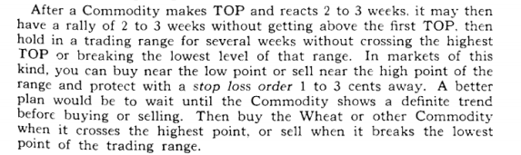

Look at chart # 33. ASA.

look at (double top), May/93, where it topped out up against a previous high, Feb..,'92, it reacted, and "reacts" by falling for 3 weeks.

Then it "rallied" back up for 3 weeks, unable to cross the old high, then it fell for 3 weeks, then it rallied for only 1 week, making a "3"¹" lower high, so it had to fall back for support.

It fell from its May,'93, high, (1), to its (single bottom), 37.5, Sept., '93, which was a 62.5 % fall from the Feb.,'92, high and the difference of the Jan.,'93, low.

So we would get ready to go long as soon as it pivoted in Sept., '93, then ran back up to (4), top, then it fell back for 2 weeks.

Then it reversed up to make a higher high, (5), but it couldn't close above the old high back at Feb.,'92, 53. 1/8, for (4 to 7 rule), then it couldn't hold the 5 th try, so à fell hard back down to make a double bottom at 37.4/8.

Watch for reversals after 5 (days, weeks, months, years) up markets

W.D. Gann said on page 59. "as a general rule when wheat or any commodity closes higher the 4th consecutive week, it will continue higher.

The 5th week is also very important for a change in trend and for fast moves up or down.

The 5 th is the day, week, month, or years of ascension and always marks fast moves up or down according to the major cycle that is running."

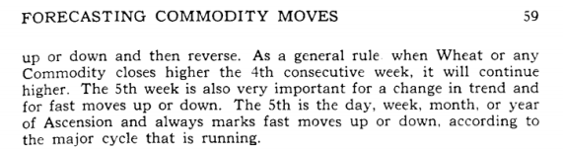

W.D. Gann said on page 57. "in rapid advances with big volume, a move will often run 6 to 7 weeks before a minor reversal in trend.... these are culmination moves up or down."

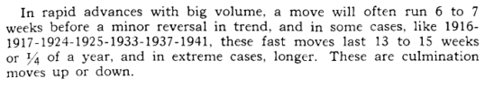

We must all be able to count to 5 or 6, or 7. The important thing to remember here, is that markets want to spin, stall, or pivot, off the number "3" and they lose momentum after 5, 6, or 7 weeks.

We can't expect anything to run up in price so high, so fast, without retracing and falling back for support, and get back closer to its 20 day moving average.

Unless you buy stock in "Bank Robbing Inc."

Will you hope to make profits faster than your stock can earn it.
If you ever get greedy, and want to wait one more day or just one more week.

Look at chart # chart 56. Lumber.

And look at what waiting one more week will do to the value of your portfolio, especially, if it is liimt down, and you are long a lumber contract.

It will make you appreciate an 18 % profit per trade. Watch for reversals in bear markets (down markets)

Too many traders hope that the market bas reversed before the final bottom, plus most "1"" bounces, are just that only a bounce, for no one knows how low it will finally go, so we just want to get in a trade short term.

W.D. Gann said on page 59. "rule for time of minor rallies in bear markets. These rules are reversed in a bear market. Rallies in a bear market last 2 to 4 weeks."

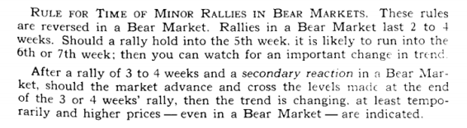

Look at chart # 30. C.T.X.

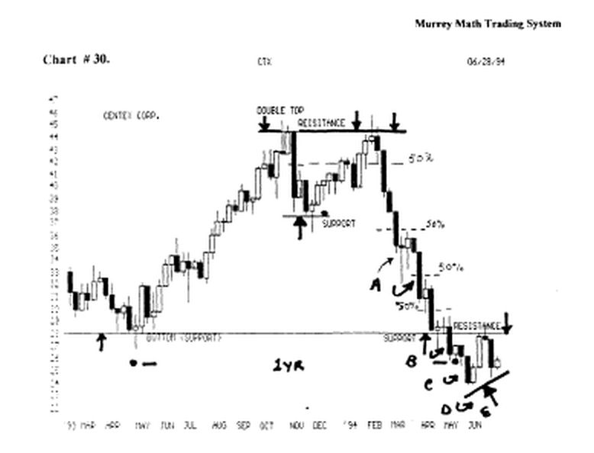

This stock was considered in a "bear market" when it couldn't hold the (support) line, at 37.4/8, in Dec.,'93.

In Feb.,'94, it didn't even hold there to make up its mind; there was no support, so it fell fast, but it did reverse back up at (a) for 2 weeks, then it fell and reversed at (b), for just one week, then it fell again.

Then reversed at (c) up for 2 weeks, then it fell again, and at (d) it went up for 1 week, then it fell again back down to (d) and it reversed up for 2 weeks, then it ran up against its old support Line, which now becomes resistance for this stock.

It couldn't break above the resistance the first time up to the line, so it back toward its old low wanting to get support.

Look at chart # 55. Coffee. (weekly).

Coffee topped out at 93.3/4. then it started a fall back down for support.

It wanted to turn up 4 times, and at ( 1 ), it turned up for 4 weeks, then it fell, (2), it turned up for 4 weeks.

Then it fell, (3), it turned up for 2 weeks, and at (4), it turned up for 4 weeks, then it settled out down at 50.00.

Divide the year by 8 ( time reversals )

W.D. Gann said on page 58. "divide the year by 8, which gives 1 '/z months or 45 days.

This is also 6 1/2 weeks, which shows why the 7 th week is always so important."

There are experts who run around trying to prove that W.D.Gann said that most break outs (off lows or highs) occur more often after 45 days, into the future.

But my first question is, "are you taking the calendar year and dividing it by 8, then applying this rule to a 5 day trading cycle, which don't match up ?"

This 45 day rule is not perfect, but anyone who even has the foresight to consider that time into the future will affect a pivot in a market, is far ahead of most traders, looking at just support / resistance lines to trade.

The simplest time cycle, in this trading world, is to just count 20 days past October 18, 1993, when the U.S. 30 year Treasury Bond Market topped out.

You will see the other markets pivot on this weekly cycle, in response to the U.S. Interest Rates, as reflected by the hearth of the U.S. Economy.

We should start our general observation of our stock or commodity, by just looking at a 2 or 3 year chart, (weekly basis), to see the kind of cycle it is running.
Is it running parallel to the U.S. Interest rates, is it on a fiscal year, or a calendar year, or is it trading on a seasonal "need" or an increased need, or a new product, or new technology break through ?

Look at chart # 55. Coffee. (weekly).
Look at chart # 56. Lumber. (weekly).
Look at chart # 52. Cotton. (weekly).
Look at chart # 6. Nations Bank, (weekly).
Look at chart # 7. Shoney's Inc. (weekly).
Look at chart # 9. F.A.T.N. (weekly).
Look at chart #12. Munsingwear. (weekly).

Look at chart # 44. Philip Morris. 12 day cycle
(look at chart # 45. Philip Morris) (weekly)

W.D. Gann said on page 58. "January 2nd and 7 th and
15 th and 21 st: watch these periods each year and note the high and low prices made. Until these high prices are crossed or low prices broken, consider the trend up or down."

WD. Gann said on page 58. "many times when commodities make low in the early part of January, this low will not be broken until the following July or august and sometimes not during the entire year. "This same rule applies in bear markets or when the main trend is down. High prices made in the early part of January are often high for the entire year."

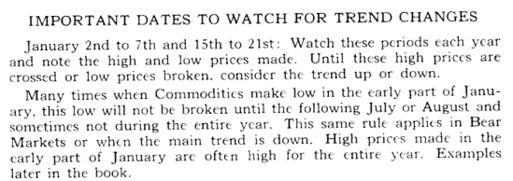

This is also called the "January effect" on Wall Street. They say that if the market starts off the year on a positive note, it will carry over for the rest of the year.

But if it can't open the trading year on an upswing, then the rest of the year will be negative. So, we must watch the 2nd, 7th; then 15th through 21st of the month to see if there is positive carry through for the "January effect."

Look at chart #10. DJ.I.A.
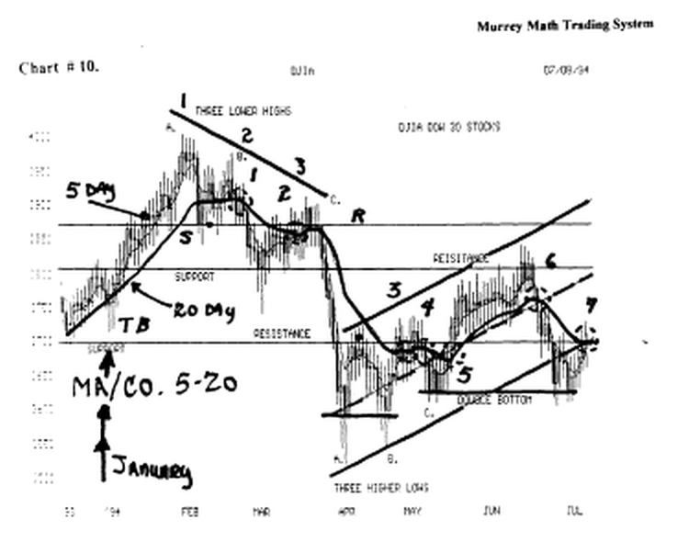

It opened the new year on Gann's "January" rule, and you will see that it moved up, then it got ahead of itself, and it fell back for support. This rule worked for just one month. When it fell below the (s) line we would know that it wanted to fall lower for support.

And it really sold off, because all the news on the economy was good, so the interest rates were rising, so the bonds sold off, taking the stocks down with them.

It finally based out down at (a.) back down at an old low from last October.

Every rule is a starting point for direction or momentum.
After we know our simple mies, we must start trading. We can't be guided by 1 rule, and forget all the rest. that corne into play, simultaneously.

That is why, after I explain a rule, I continue to show other applicable rules that are also affecting it.

