CHAPTER 2. SETTING UP MOVING AVERAGES

Please look at chart # 4. Disney.

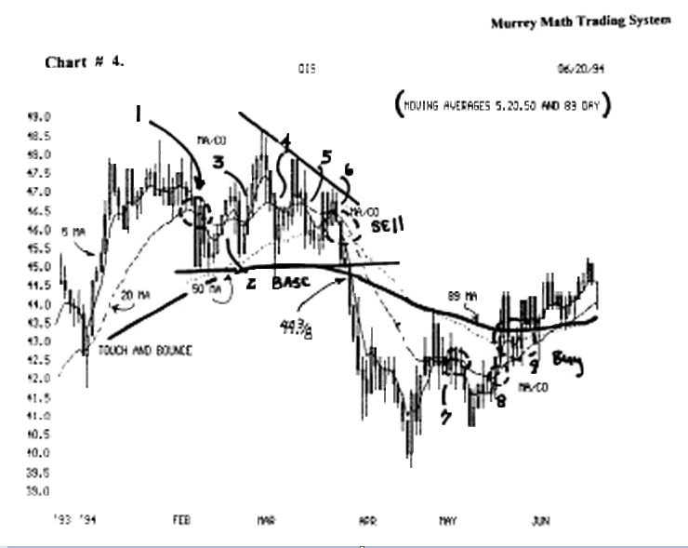

We included the 4 most common moving averages to signal when a trend reversal is near.

The 4 most common moving averages are:

1) 5 day (weekly),
2) 20 day (monthly),
3) 50 day (intermediate term),
and 4) 89 day Long term).

The roll-over of one of these averages signals a reversal. We must be aware of all 4 averages, daily.

The 5 day signals a short term reversal, and how far it falls below the adjacent average is sell a signal.

And, if it falls below more than one of the averages, and how long it stays below an average, is telling us that the trend bas reversed, and is more severe.

It helps signal us to take a profit, rather than to watch h fall back down to where we entered our position.

One never knows how far above or below one of the averages our stock will run.

But we must continue to monitor its moving average crossovers, that would signal a stall ont of its current direction, or a reverse.

These 4 different averages, signal momentum reversals, against different time frames. These time frames are one month, or 3 months time ranges.

Please don't take these 4 averages as gospel, and don't spend an inordinate amount of time adjusting, or fine running, these signals.

We don't want to get into a lengthy debate over which kind of moving average is better than another.

The most common averages are:

1) simple average of close,
2) weighted,
3) and the exponential moving average.

The exponential moving average shifts the weighing to the last 82 % of the days you are averaging.

And it will keep the latest days' activity more responsive to its average movement.

It is not my goal to argue one average against another, but the exponential has much credibility.

signal when a trend reversal is near.

The 4 most common moving averages are: 1) 5 day (weekly), 2) 20 day (monthly), 3) 50 day (intermediate term), and 4) 89 day Long term).

The roll-over of one of these averages signals a reversal. We must be aware of ail 4 averages, daily.

The 5 day signals a short term reversal, and how far it falls below the adjacent average is sell a signal.

And, if it falls below more than one of the averages, and how long it stays below an average, is telling us that the trend bas reversed, and is more severe.

It helps signal us to take a profit, rather than to watch it fall back down to where we entered our position.

One never knows how far above or below one of the averages our stock will run.

But we must continue to monitor its moving average crossovers, that would signal a stall out of its current direction, or a reverse.

These 4 different averages, signal momentum reversals, against different time frames. These time frames are one month, or 3 months time ranges.

Please don't take these 4 averages as gospel, and don't spend an inordinate amount of time adjusting, or fine running, these signals.

We don't want to get into a lengthy debate over which kind of moving average is better than another.

The most common averages are:

1) simple average of close,
2) weighted,
3) and the exponential moving average.

The exponential moving average shifts the weighing to the last 82 % of the days you are averaging.

And it will keep the latest days' activity more responsive to its average movement.

It is not my goal to argue one average against another, but the exponential has much credibility.

I feel that there is more to life than splitting hairs, over which average is more profitable, or more accurate, in its signaling.
All stocks have a fiscal calendar, of reporting their company's progress, and are required to report every quarter, during that fiscal year.

Since we have a year composed of 52 weeks, and ail markets close for Saturday and Sunday, and since WD. Gann said to always watch the weekly change in price for your stock, it would make sense to watch your stock's moving action based on a 5 day, then a 20 day (month) time period, to catch short term whip lashes.

This longer term averages should not be strung out exponentially longer, against the 20 day (ma).

So the longer term averages might work better at 50 and 89 days, which are 10 weeks and 18 weeks in length.

Anyone who watches a 50 day - 200 day average is trading too long term, to help themselves catch the fast computer generated reverses that our market runs through now.

Please remember that our S&P 500 Index, traveled only 12.5 % last year. And we had 6 major reversals during that period of time.

So, a 50-200 day moving average, would signal a reversal, just about the time, it is time to reverse.

W.D. Gann also said on page 33."the time period, and when time overbalances, or shows a change in trend, it is much more important than a percentage of prices."

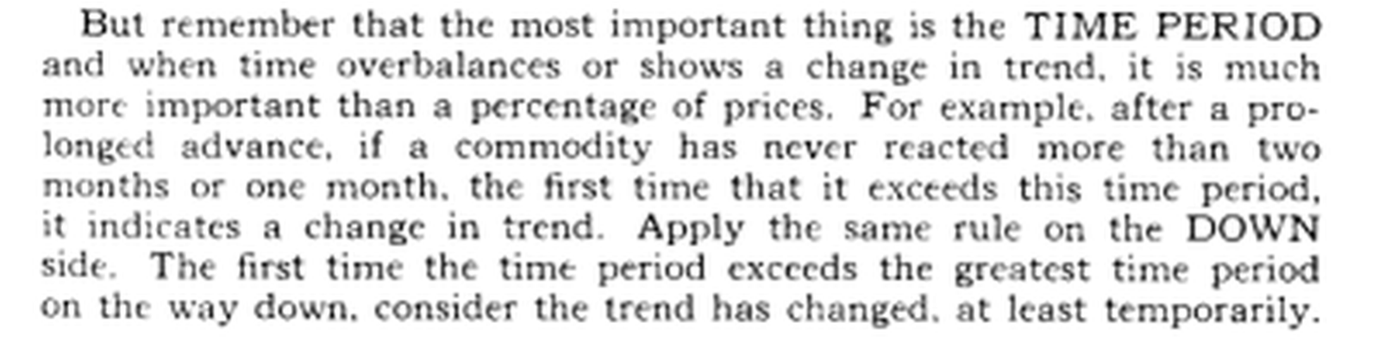

Gann recognized the fact, that an average price, will move ahead of itself, or fall below its average through time.

So, we should consider these 4 averages, as our stock moves to the right in time.

Please look at chart # 4. Disney.(D.I.S.)

We may see 9 moving average crossovers, that signal a direction reversal of this stock.

Reversals 3, 4, and 5, signaled a major direction reversal, and it was confirmed by a strong fall back down to 40.0, in the middle of April,'94.

Please notice that the price dropped below the 89 day moving average, at a price of 44. 3/8.

It is very simplistic, to agree, that if your stock was selling up at 48.4/8, and then it fell down to below its 89 day moving average, then we should recognize, one of two things:

a) it has based out, and will turn back up,
or b) it will continue to fall, to a lower low.

The slanted diagonal line signaled 3 straight times that this stock was being sold each time it retraced and wanted to move back up to its previous high but each time it moved up, the smart people sold it aïï, and drove it lower.

It is important to remember that the price of 44.3/8, is the cross over price to signal the change in the long term trend for this stock.

Moving averages need to be included in our 64 rules to winning trades. We don't trade reactions to moving averages more than a 10 percent influence of our evaluation, as to what we should do (to buy - sell - or hold), because all moving averages are always late indicating a change in direction

The moving averages measure changes of trends through time: (pure and simple).

Now, look at the last of March,'94, when the triple moving average cross-over occurred at (6), the stock fell fast.

Then at (8), it ran up again when the 5 day crossed the 20, and then just past (9), it had ail of the moving averages parallel in an upward trend.

The 5 day was above the 20, the 20 above the 50, and the 50 day above the 89 day moving averages.

But, just when these 4 averages were parallel in an upward trend, we would deduct from our trading rules, that it was ready to stall out and move laterally or fall back to 43. 3/8.

It has already run down from 48. 4/8 to 39. 5/8, then back up to 50 % of this 9. 00 point move.

It should stall out at 50 % or 62. 5 % or after 4. 5 or 5. 0 points.

If we take the high in March'94 and the low in Apnl'94, then we look at the high in Apnl'94, and it looks to be about 37. 5 % of the difference between these two extremes.

The best moving average crossovers entry or exit signals, come at tops and bottoms, and after consolidations where a stock can't break an old high or won't fall anymore on an extended low.

Remember the time factor:

a) how long it has sat on a low,
or b) the time between me last low, or how many feeble attempts it has tried to make to move, off its low, are just as important as the moving average crossovers

But, the longer the time span,(3, 6, or 9 months), the more evident a change in mind set, will reverse the stock (short term). And we shall discuss this trading strategy, in more detail later on in this book.

One cannot assume one simple statement to be profitable in every case, and that is, to buy, when one average crosses above a longer average.

There are more variables to be considered, simultaneously, to make a credible market prediction.

Please look at chart # 4. Disney, and (2, 3, 4, 5, 6).

Almost all of these positive moving average crossovers were a loser, if you went long or short this stock.

You got whiplashed, if you were a long term trader of this stock, since January,'94.

Number (6) and (8) were real winners. If we take into consideration that this stock tried to a) break above 48. 00 5 different times and it failed, and the amount of time it had moved laterally was almost b) one quarter ( 3 months ), so when it c) fell on a 3"¹ lower high and we recognized a triple moving average at ( 6 ), we knew that the sentiment was favoring a fall. It fell hard.

Everyone who bought Disney, back in February '94, saw it base out laterally for almost two months, trying to work itself into higher levels.

But the 3 higher lows signaled that it was being sold at lower highs, when it tried to move higher.

And, if we look at a bond market chart for the month of march '94, we see mat when the bonds fell below 110.15 on march 18, 1994, Disney fell until the bonds made a bottom off its low of 103.12 on April 5, 1994 (there is a correlation).

Then, Disney tried to rally up with the bonds when the bonds held on a double bottom later in Apr.,'94, Disney had come off its lows of 39. 5/8 back up to 43 3/8.

Then, the first trading day of May '94, the bonds fell sharply from up at 106.25 back down to 100.78, where it held and Disney followed it down and then held, when the bond market stalled.

Bonds rose on the 13* of May '94, and Disney (8) movedupoffitslowof41. OQtowani45. 00.

There are certain times when the stocks will break away from the cost of borrowing money as expressed in the interest rates or measured by the asset value of the U.S. 30 Year Treasury Bond.

But currently, the bonds and the Dow 30 stocks are closely linked with every significant pivot of the bonds.

If we look back to February '93, we see that bonds fell from 117.97 back down to 103.12, so the Dow 30 stocks fell from 3, 984 on the same day that the bonds were selling at 117.97, and it settled out down at 3, 593 on the same day bonds settled at 103.12.

Rising interest rates and value of me U.S. Dollar against the 4 major world currencies, will affect our Dow 30 stocks, and the momentum of our stock, if it is one of the top 100 U.S. companies.

It is not the intent of this book to prove the linking validity of watching market reactions to the interest rates, but one should not buy any stock without looking at the chart patterns of me bond market and the Dow 30 stocks, before you commit large amounts of capital in a stock.

The greatest stocks in the world don't go up as high or as fast in a recession or a depression.

It is only logical, to assume, that traders will accept a profit of 12. 5 % to 18. 75 % in any market.

And anyone will pay any price when ail the markets are on the rise, because of parue buying.

Remember that traders anticipate good economic news, and buy early, and drive the prices up vertically, in a short period of time.

Then traders watch their fast runs move laterally consolidating, or it falls back at least 37. 5 % of the just completed up run.

So our stocks shall move up too fast on the "herd mentality" to buy into good news.

But since 90 % of ail traders are "buy and bold traders," they sit and calmly watch their profits erode over time.

Let's look at chart # 4. Disney, and the touch and bounce.

This is when the daily price comes down (or up to) to the moving average or the (ma) comes down to (or up to) another moving average, and touches and reverses off the moving average.

This is a key reversal signal.

Let's look at chart # 4. Disney,

and study (2, 3, 4, 5) -are- catied-Wn/? lashes. Traders should learn that markets trading in a narrow range, should be bought as soon as it reverses, not just because the moving averages cross positive, because we will be in the trade too late in the rally, and will be trading to make a certain amount of profit rather than getting in sync with the momentum of our stock.

We should go to me section that talks about "Buy the Bounce" and "Sell the Bump," for a better entry.

Look at chart # 5, Gaylord Entertainment.

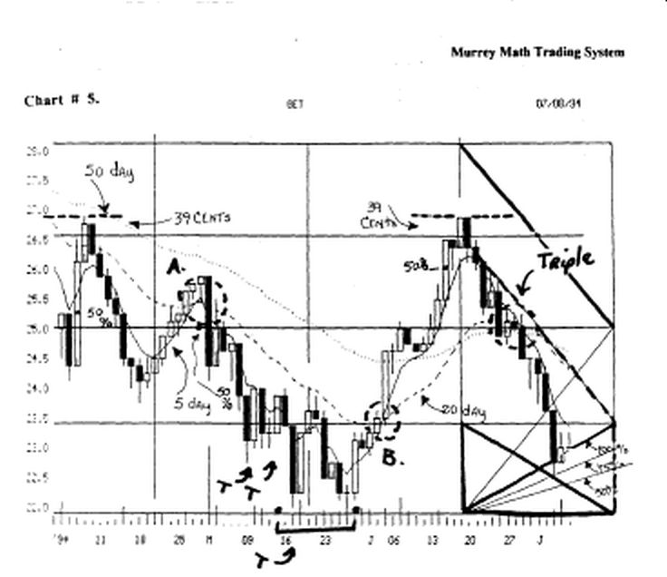

We had a touch and bounce, then it ran back up a second time to ( a ) and me 5 day touched the 20 day at 25. 5/8, then it reversed and fell to 22. 3/8.

It formed a double bottom at 22. 3/8, and at (b), the 5 day crossed the 20 day and ran back up to the old high.

We would use our rule to sell 50 % of our stock at the previous old high from April 10, 1994.

h couldn't close more than 39 cents above the line, so we know that it wants to fall back to its 50 day moving average.

We saw a triple average cross-over.at 26.00. Then it fell back down to its old low, but it reversed at 22.75, so we would go long again.

Look at chart # 8. Federal Express.

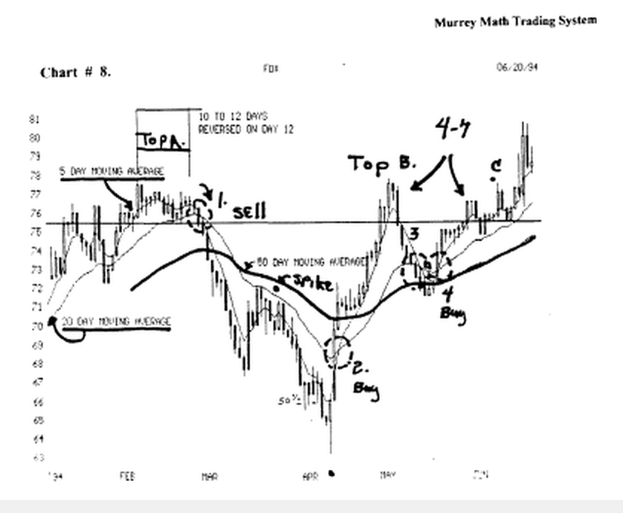

Late in Jan.'94. it made a touch and bounce, then it reversed up to 78. 00. then k reversed, and the 5 day crossed the 20 day at ( 1 ) sell.

It fell below the 50 day and finally stalled the downside at 63. 5/8. Then, at (2), the 5 day crossed above the 20 day and this signal would have netted a 9. 00 profit. Again, we would sell 50 % of our position up at 78. 00.

It reversed and the 5 day fell below the 20 day, but it held above the 50 day moving average, which would
been a whip lash.

Then, at (4), we would have gone long again, and sold 50 % again up at 78. 00, where we see the black dot.

When it didn't fall below the horizontal line at 75. 50, we would have gone long.

Look at chart #10. DJ.I.A.

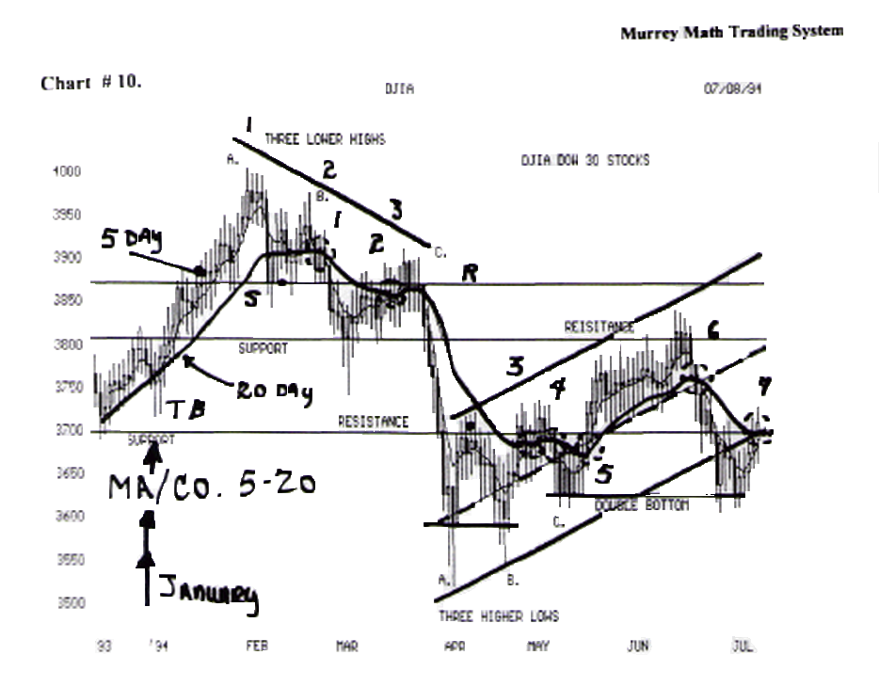

Dow 30 stocks, it had a touch and bounce, then it ran up to its ail time high. at (1), the 5 day dropped below the 20 day moving average; it closed on the support Line.

It reversed up to (2), and made a touch and bounce, and couldn't break above the down trend of the 20 day moving average.

It made a weak attempt to move back up to its old high at (c). at (3 and 4), we were whip lashed.

Then at (5), we have a 5 day cross-over the 20 day moving average at the same time we are getting a 3^{ri} higher low.

This is a great buying position. We would have sold out when the market ran up to the horizontal line (resistance).

Then at (6), we would expect a sell-off. Then at (7), we would have entered again for another run up to the resistance line.

Look at chart # 34. Uniysis. The 5 day moved above the 20 day moving average in late June,'93. when the price ran up to 12.125 and it touched the 89 day moving average, it went sideways for 7 days (4 to 7 day rule), then at (2) it fell back down below the 20 day at
o j/₄

Then it reversed moved up at (3 ) and broke above the
20 day moving average.

But it stalled on the support (horizontal line), in late august, then it went sideways for 12 days (to 12 day rule), and fell back at (4) below 20 day moving average.

Look at chart # 46. Disney.

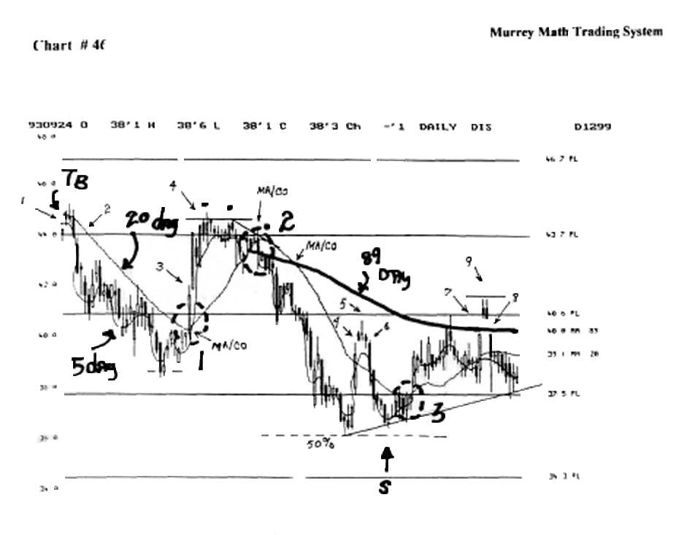
It fell in Mardi,'93, from a 20 day 5 day ( negative ) touch and bounce, then it fell back down to 38. 5/8.

It crossed back positive at #(2), up to the old high, where we would sell 50 % of our position, it moved sideways for 12 days then it fell, and at (2) to the negative, and at the same time it fell below the 89 day moving average.

Then. at (3), it turned positive off a second higher low, but it couldn't break above the 89 day moving average and it fell back again to 37. 50.

Look at chart # 47. Comex Gold.

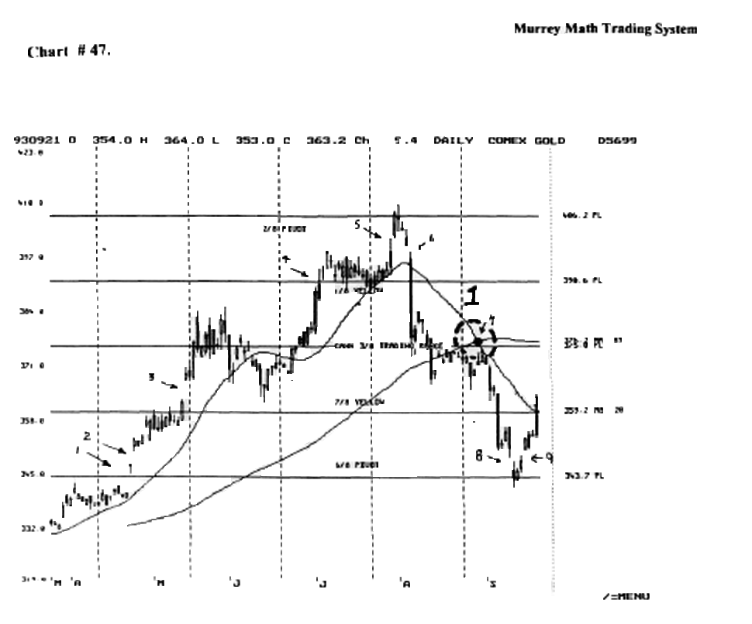

Please find (6) It fell almost 18.00 points in day. If we see a vertical fall this extreme, we want to go long on the next up move, m the future.

No one ever knows that any stock will fall this fast this soon, so we know that this is a signal that major players are selling out fast.

Then at (1), the 20 day crossed to the downside below me 89 day.

It went all the way down to 343.70 for support, then it gapped up, wanting-to run back up to the old high at 406.25.
Look at chart # 58. at Cotton. (1), 4 week moving average, fell below the 19 week, while it was below the 38 day moving week average.

It made a touch and bounce, at (2) and it fell back to make a double bottom, and it turned up at (3), with the 5 and the 20 moving above the 89 week (mov. aver.).

Then at (4), the 4 week fell below the 19 week, and then it fell below the 38 week moving average.

Look at chart # 71. Bankers Trust.

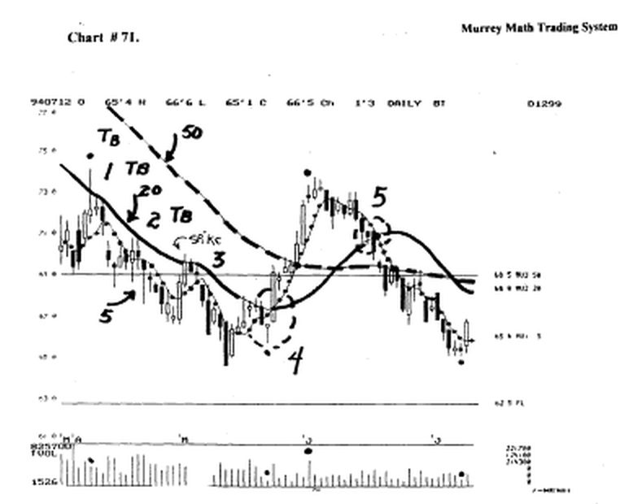

There were 3 touch and bounce reversals. Then it crossed at (4), positive above the 20 day moving average.

It crossed above the 89 day moving average and met the old high of 72. 4/8 in April,'94.

Then, at (5) it fell below the 20 day and then it fell below the 50 day moving average.

It went back down to its last low of 64. ³/4. It wants to reverse back up to its last high.

Let's try and set some standard 4 moving average expectations.

The ideal situation is to have all 4 averages moving up on a 22.5 degree angle, with me 5 on top of the 20, and the 20 above the 50, and finally the 50 above the 89 day moving average.

5/20/50/89 day moving averages
5 day
20 day
50 day

89 day: stay long and enjoy the profits.

20/5/50/89 day moving averages 20 day 5 day

50day
89 day - we are experiencing a short term sell off in an up market.

So we should buy (long) en dips, where the price of the stock makes a touch and bounce off the 20 day moving average.

50/20/5/89 day moving averages
50 day
20 day
5 day

89 day - this signals that this market bas rolled over to the down side for the intermediate time period. and we should only buy into this stock short terra, on bounces off the 89 day moving average.

50/20/5/89 day moving average
20 day
5 day

89 day: this signals that this market bas rolled over to the down side for the intermediate time period, and we should only buy into this stock short term.

50/20/89/5 day moving average
20 day
89 day

5 day: this signals a fast vertical fall, so one should buy only on pivots, and we should sell against any upside support or when it moves back up to the next moving average.

50/89/20/5 day moving average
89 day
20 day

5 day: this is a market that should be bought only short term. We would take a profit anytime it moves back up to old support or the next higher moving average.

89/50/20/5 day moving average 50 day 20 day

5 day: this is a full blown bear market. We should buy in against some old low (from 6 to 12 months earlier), or against the 5 day running back up to the 20 day moving average. (see charts # 4 A. and 4 B). We will see that it formed a double bottom. then moved up from a low of 37.5, up to 53. 1/8, where it politely reversed, and headed back down to 50.0.

If it falls vertically, it wants to reverse vertically, short term. (we must get in and out quick). (fast market falls are 45° angles or steeper).

If it falls on a 33.5° angle, it will have to consolidate, so we shouldn't expect it to turn up too fast.

If it falls on a 22.5° angle, this is an orderly downturn for any market. So, we could expect a nice upturn, after it bottoms out.

There are many more combinations of these 4 sets of averages, but we won't take the time to bore you with another example.

We shall interject one alternative set of (4 averages) to our current weekly set of 5, 20, 50, and 89 days). And they are: 4, 8, 16, 32, 64 moving day averages.

This is a simple set of averages, that run in direct parallel proportion, to the number of days, traded in the bond markets, each quarter, of each trading year.

We set our "Square in Time" off each quarter of the U.S. 30 Year Treasury Bond Market.

We start over each quarter, and match our stock's daily activity parallel to the same averages for the bond market.

Please substitute the moving average cross over combinations that you just read about on page 5., with these new moving averages, that match up with the "natural rhythm" for the bond market.

Please look at chart # 4 A. Disney (D.I.S.).

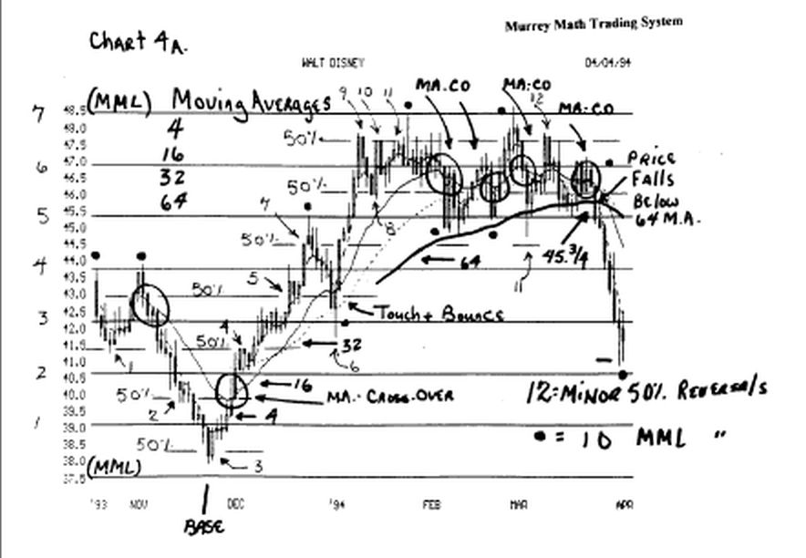

These moving averages are: 4, 16, 32, and 64.

This average parallels the averages for the U.S. 30 Year Treasury Bonds.

It may be necessary to explain to new traders out there, that, if the interest rates rise, then the asset value of the bonds goes down, and if the value of the U.S. bonds go down, then, in this market, presently, your stock will tend to move in tandem with the asset value of the bonds, (there always exceptions to any general rule.

So, please find out how much debt that your stock has, in proportion to their working capital, and this will give a strong clue to how predictable it is to reversing, with the rise or fall in the interest rates.

Please find the price (45.3/4), which is the exact price, where the daily price fell below the 64 day moving average.

This sell signal is 1.3/8 points higher, than the sell signal, under the weekly sell signal, which would save us a considerable amount of our capital.

Please look at chart # 4. Disney-, and chart # 4A. Disney~, and we see a difference between the 4 - 16, and 5-20 moving averages, back down at Dec.,'93, and we see that the 4 - 16 made a MA.-CO., but the 5 - 20 MA.-CO. made a touch and bounce.

A "touch and Bounce" is simply when a moving average goes up or down, and gets close to an adjacent average, higher, or lower, but it doesn't break through it, which is a great orne to buy or sell your stock, for it has either dropped down for support, or it has run up against resistance, and wants to fall.

It is therefore, crucial to understand that just because the daily price, breaks through to the down side, or up through, on a daily or weekly basis, we can't expect a true trend reversal, urml the moving average confirms the reversal in the trend, by staying above or below, the adjacent average for at least 3 weeks in a row.

Please look at the 4 moving average reversals up at the high, from Jan.,'94, through the middle of March,'94.

So, it is just common sense, to assume that we can't rely on moving average crossovers, at highs, or lows, when a stock is moving laterally.

Since no one knew which way they wanted to take this stock, the moving average was unable to confirm any directional signal that would not have to be reversed 4 times in a row.

This market confusion, is what frustrates so many traders, and brokers, who by the sheer fact that they just don't know exactly what it will do, that they simply, sit down and "buy and hold" and watch it, and pray that it goes their way into the future.

Look at chart # 4C. Disney.

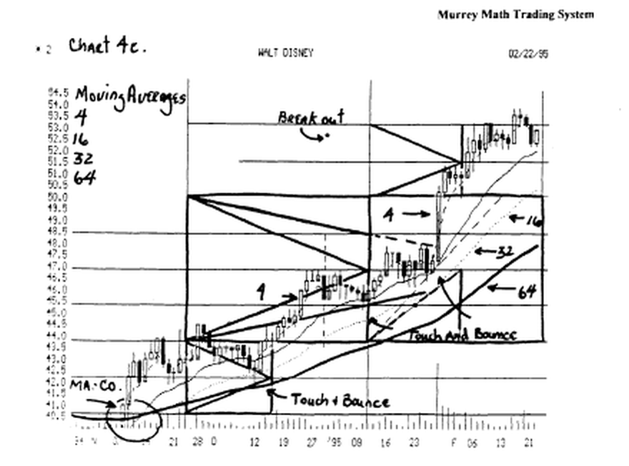

In the lower left side of the chart, it made a double cross over (16 and 32) above the 64, while the 4 day was already above the 64 Day MA.

Since then, it has made 3 touch and bounces, which were buy signals each time, (since it has gotten ahead of itself, it should want to fall back to 50.0, and build support (over time - 10 to 12 trading days) then it will let ume catch up with rcs fast move up in price, then it will want to move up higher, as the company comes out with additional good news, to justify, a higher price.
Look at chart # 4B.Disney.

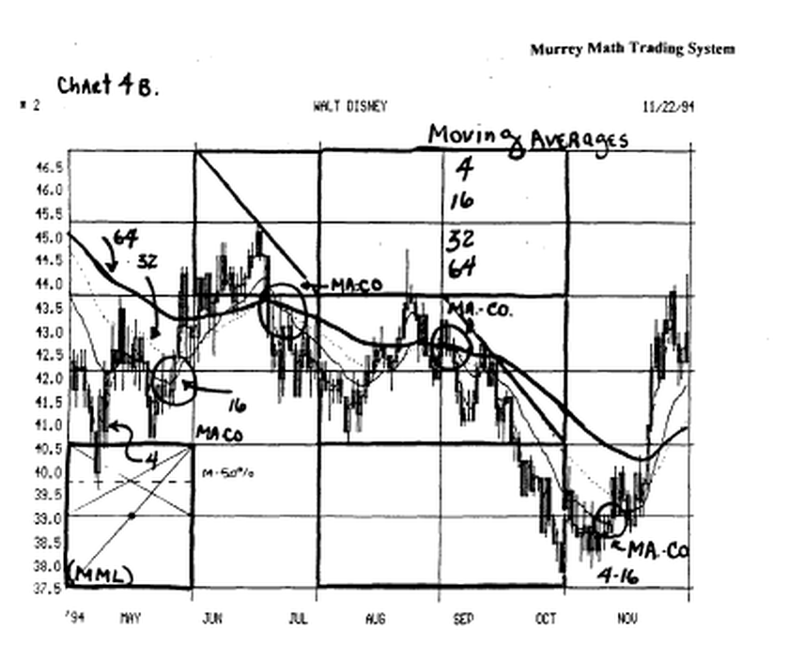

These 4 moving averages signaled a reversal m the trend of this stock, but it was always late. So, we should use these averages, for confirmation, of what we want to believe, is the general direction of our stock. Hopefully you will see enough "trend" common sense strategy, by just observing what you see.

Besides, we don't want to give any more than 10 % weighed value to where we enter a position, except when a stock is very over bought or oversold, then it helps let us know that the trend is reversing.

Please remember that moving averages may be used on a weekly trend as well as the daily averages. If we use weekly charts, we should change our averages to
1)4 week,
2) 20 week,
3) 50 week, and 89 week moving averages.

And we should adjust our averages to the last two major lows, then divide this time span by 2, till we get the shortest time period to get the "momentum reel" of our stock.

This is not a science, but just a very over bought or oversold, it lets us know the trend is reversing.

Please remember that moving averages may be used on a weekly trend as well as the daily averages.

If we use weekly charts, we should change our averages to:

1) 4 week,
2) 20 week,
3) 50 week, and 89 week moving averages.

And we should adjust our averages to the last two major lows, then divide this time span by 2, till we get the shortest time period to get the "momentum feel" of our stock.

This is not a science, but just a momentum tool, to help us recognize, when our stock will reverse, ultimately, save us profits, quicker.

We must "buy the bounce" and stay in, when the stock moves up through the momentum of the next higher moving average.

Or, we should sell, when it runs up, with enough profit, to allow us to sell, and make more than 1.5 points, with at least 1,000 shares, so that we may be able to make a higher amount of profit than we do, the amount of money we pay, just to enter and exit the trade.

This is just another tool to help us recognize when our stock will reverse, and save us profits.

