FLAG !!!!!
Scoobydoo:
Hi Harsh,
In the green box you've marked, he's just saying that if B didn't break the previous important level (as A did) then the subsequent FL formed wouldn't be as important. Basically saying the most important FL's are the one's that occur right after breaking the last important FL
josh1125
Very well explained scooby...that's exactly what I got from pedini's diagram. Once you've mastered this simple yet powerful diagram, you would be surprised how things really come together.
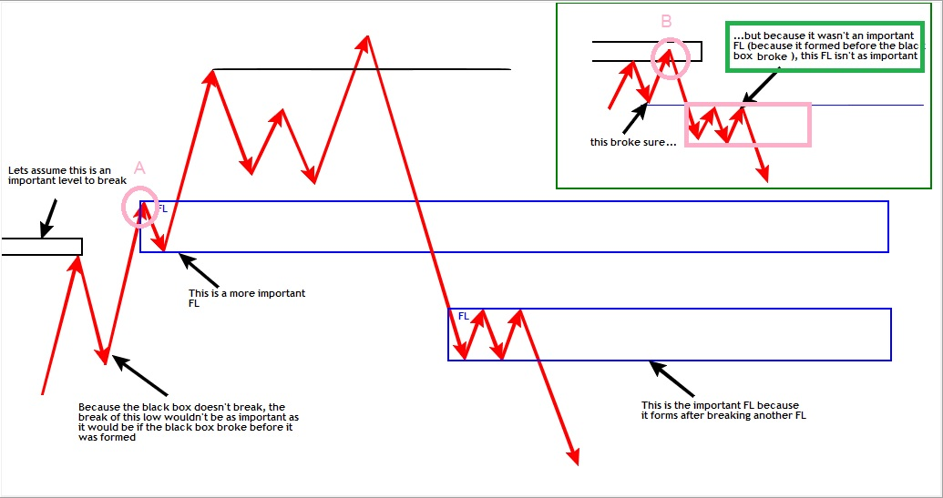

http://readthemarket.com/index.php/forum/journals/2033-josh1125-rtm-journey?start=150
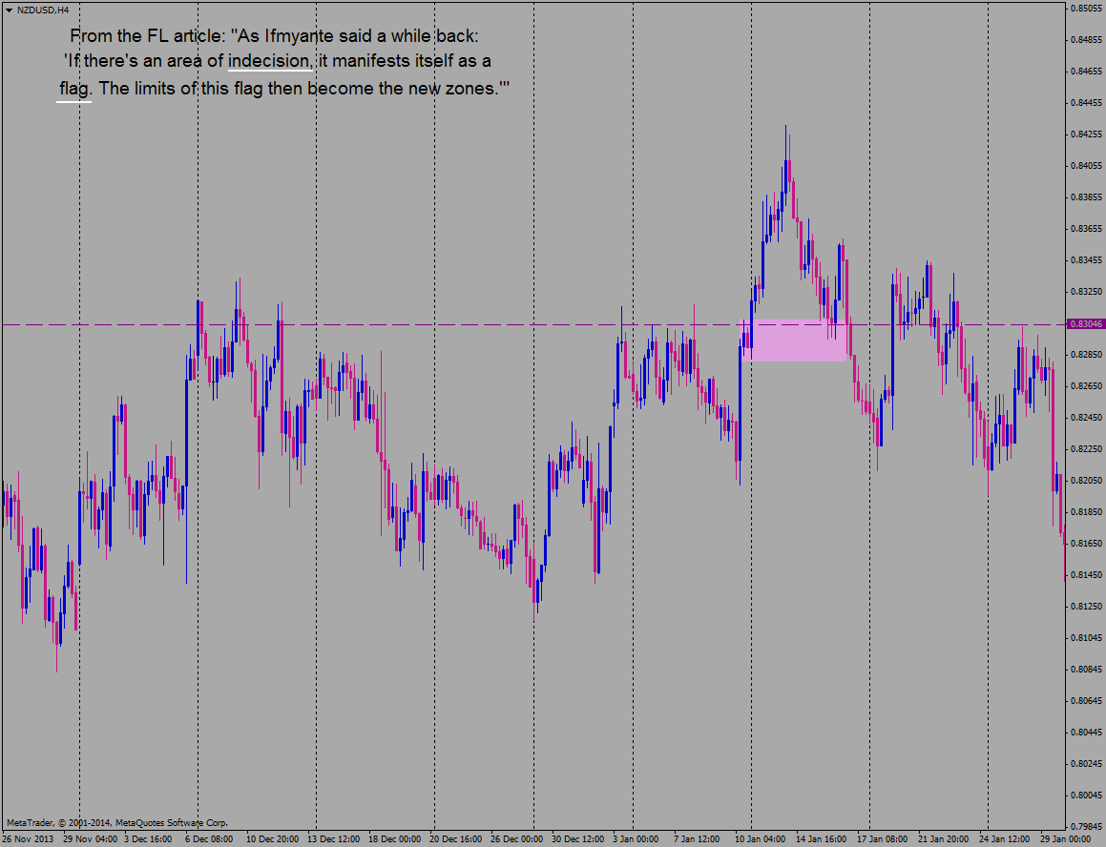
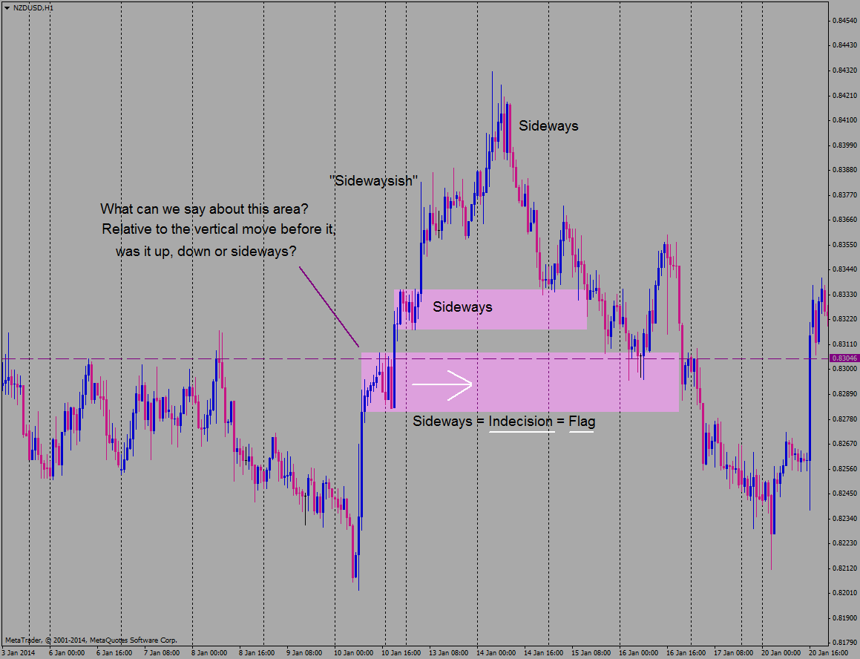
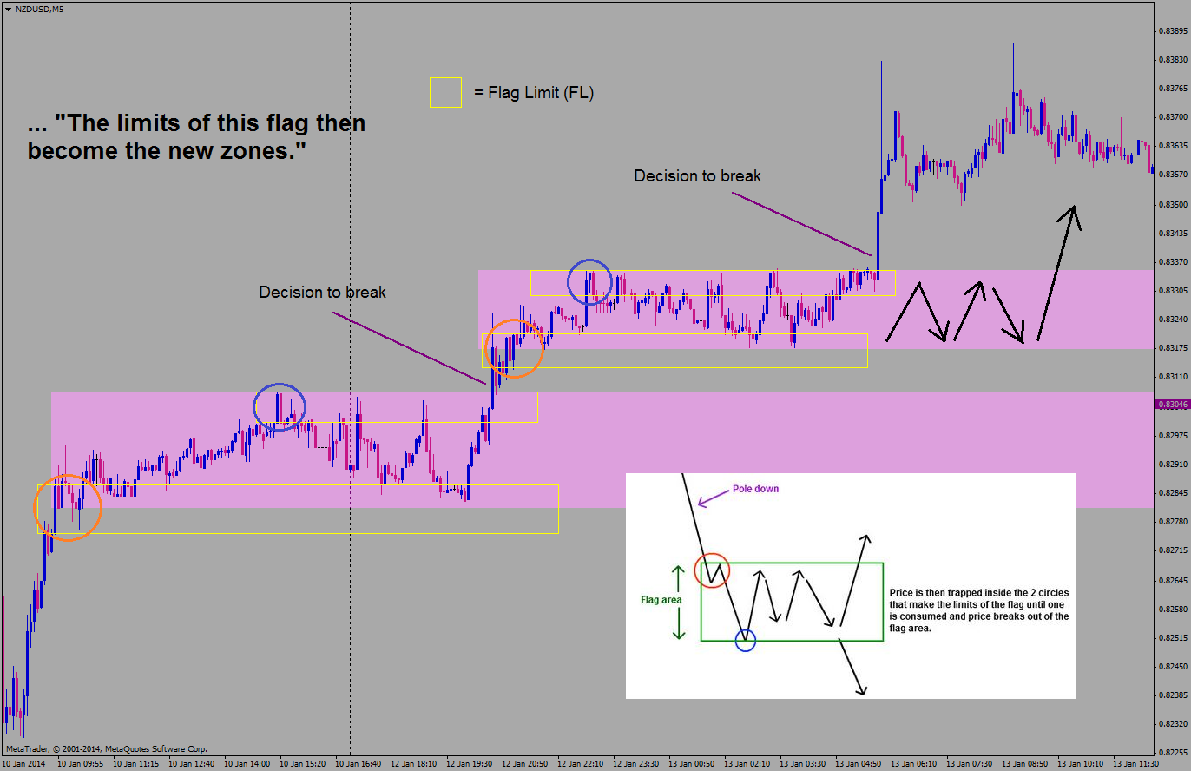
1.FTR => FTB
https://www.youtube.com/watch?v=95hbUsuTbVk
de la minutul 1:33 pretul face engulf la un supply dupa care face un ftr
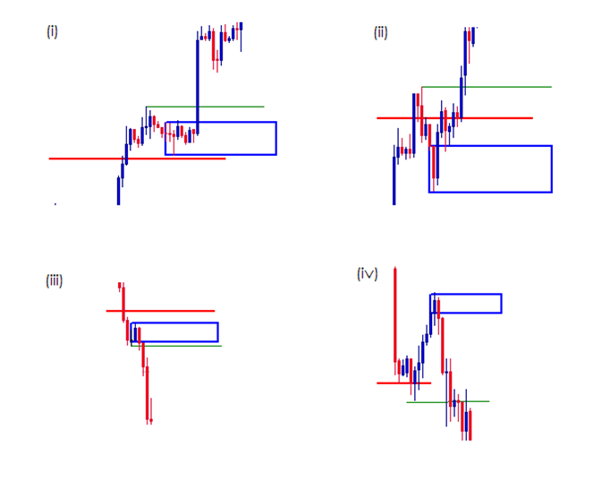
If studied properly, you will come to a point where everything gyrating around FTR,
Price engulfed important level and FTR becomes FL
FTR overlaps each other become compression
FL engulfed price retrace to FL becomes QM
Pole and a drop and compression to FL become can can
3 drive - it another form of compression
Thats the meaning IF say they are not pattern traders. Pattern trading is basic. His work is beyond that.
http://www.forexfactory.com/showthread.php?t=420159&page=41

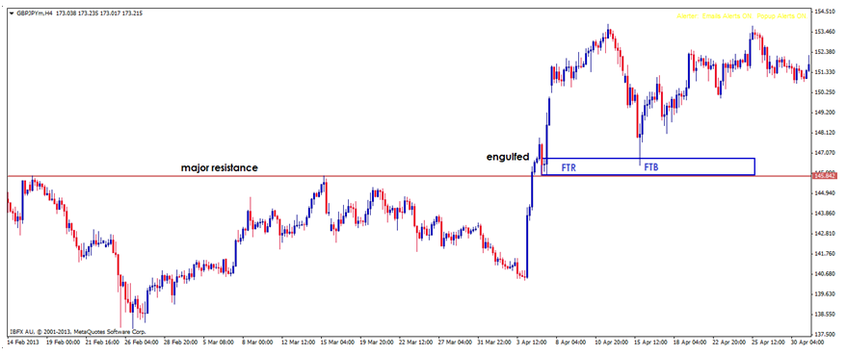

2.QUASIMODO! TREBUIE SA FIE IN ZONA DE SD
After you have gotten used to QMs, H&S, ect.. you may not see them as patterns any more.. you might just simply see them as pull back configurations. The pull back being the H/L or L/H on QM or the right shoulder of H&S. When price is reversing at the top/bottom it usually has to pull back because it is reacting to a level that opposes the reversal and consumes it. Then due to this reaction, price has to pull back to a level where the buyers and sellers will continue the turn. This is either an SR level or a SD level.
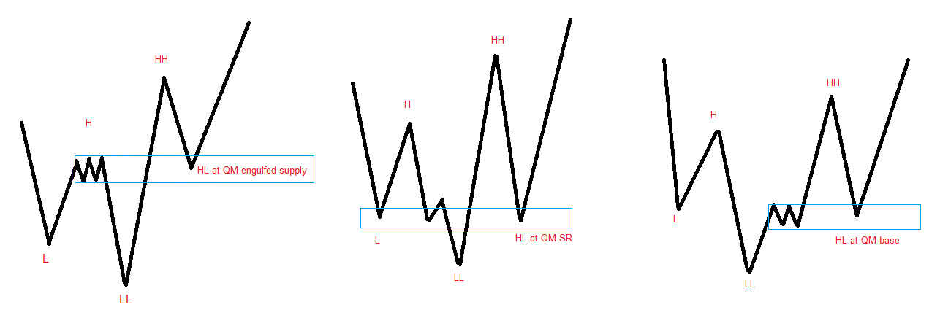
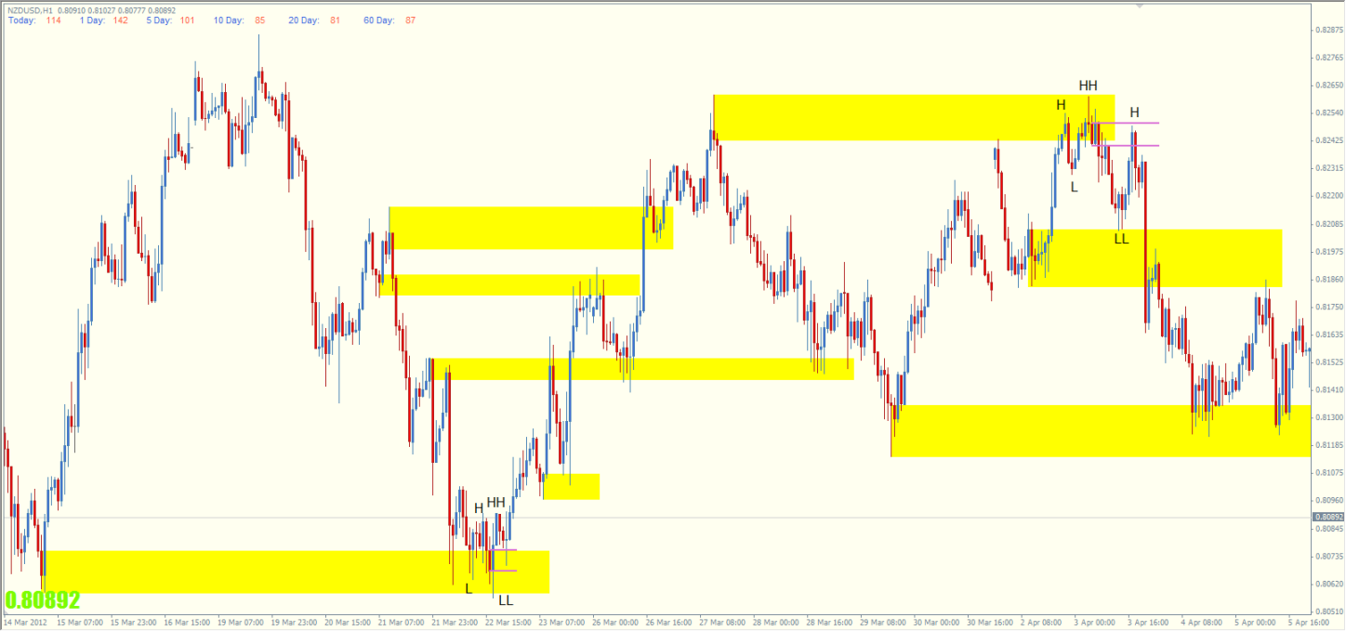

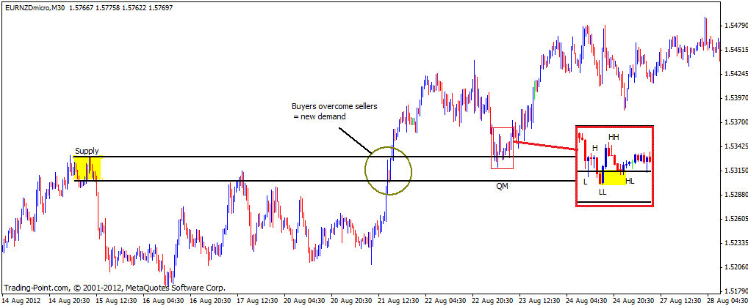

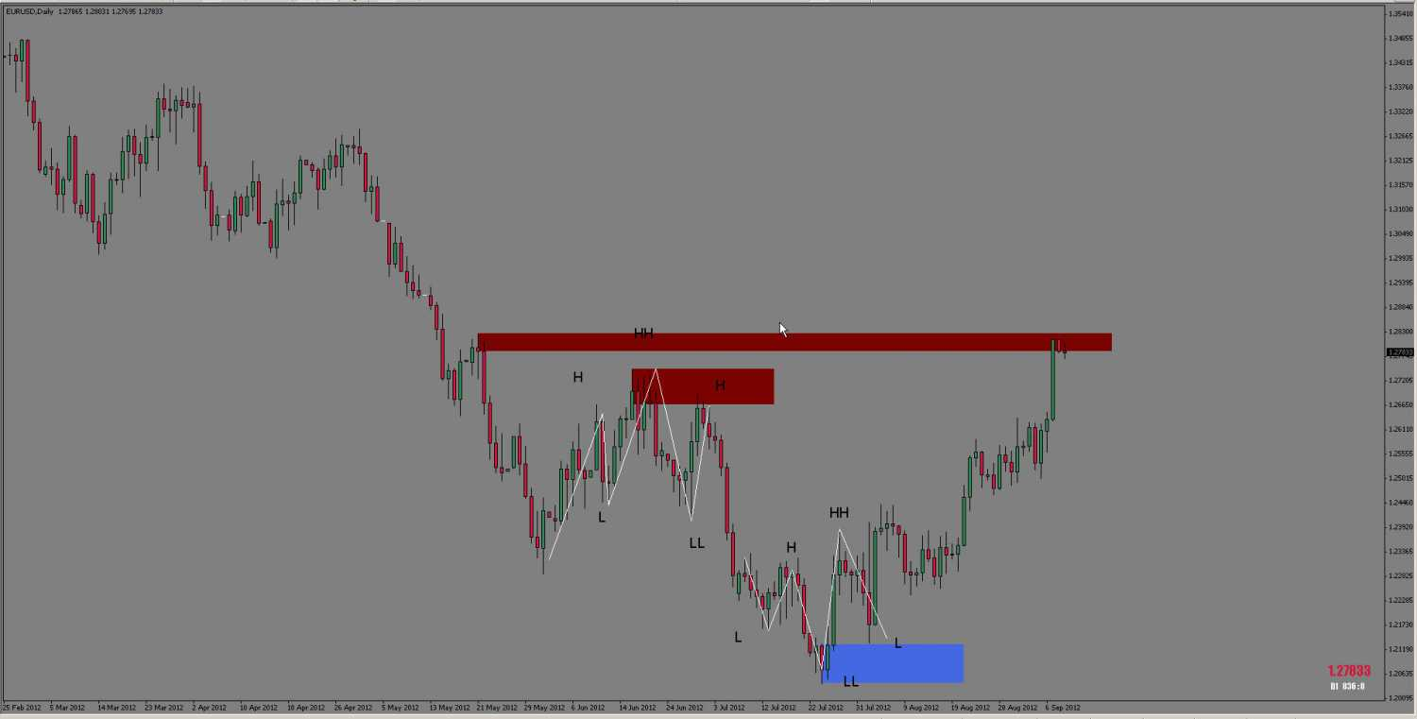

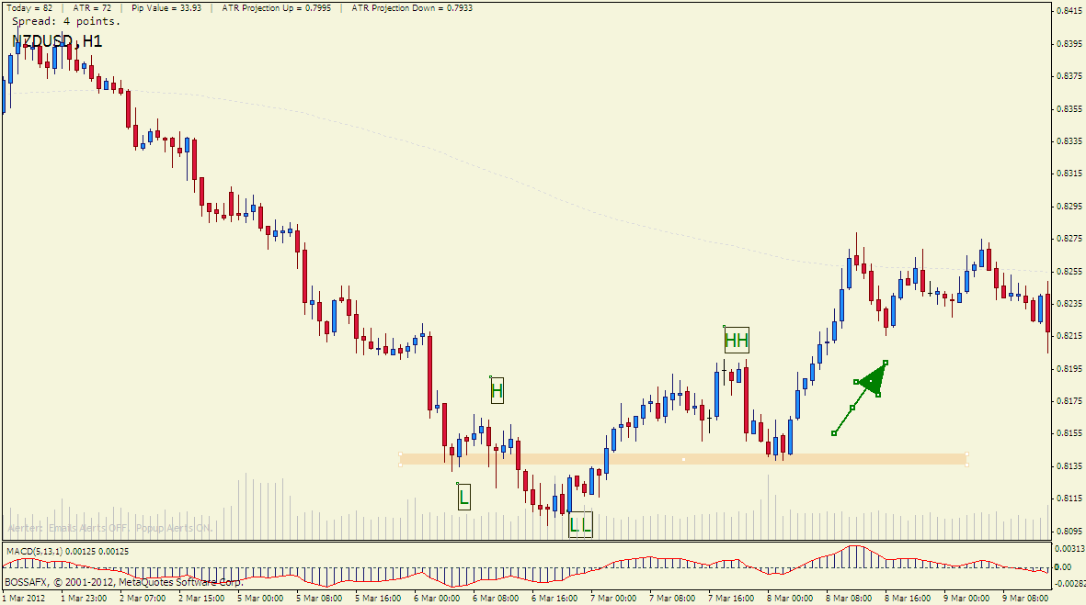

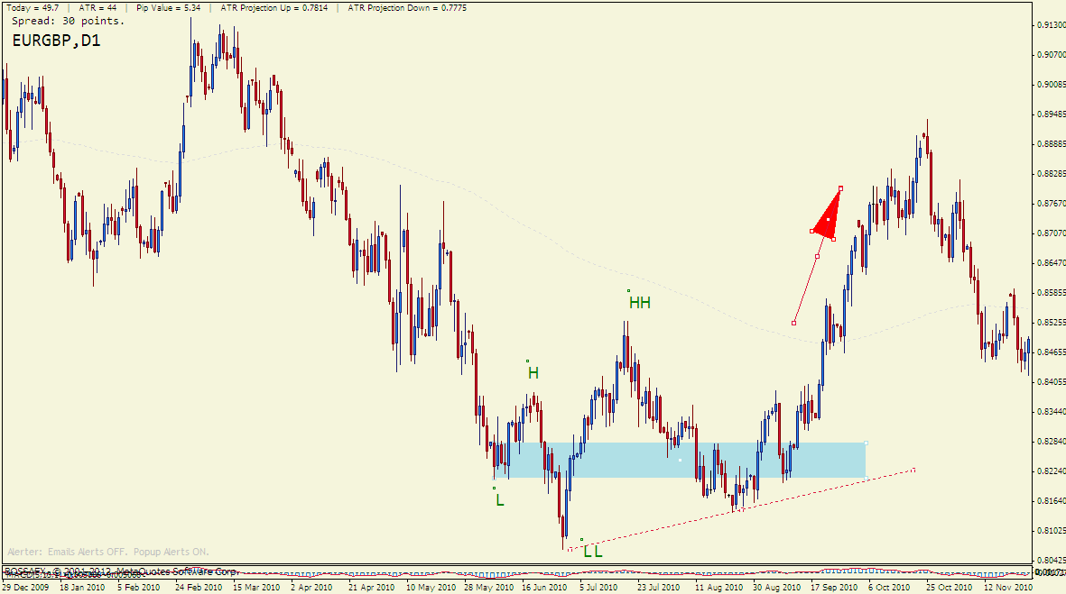

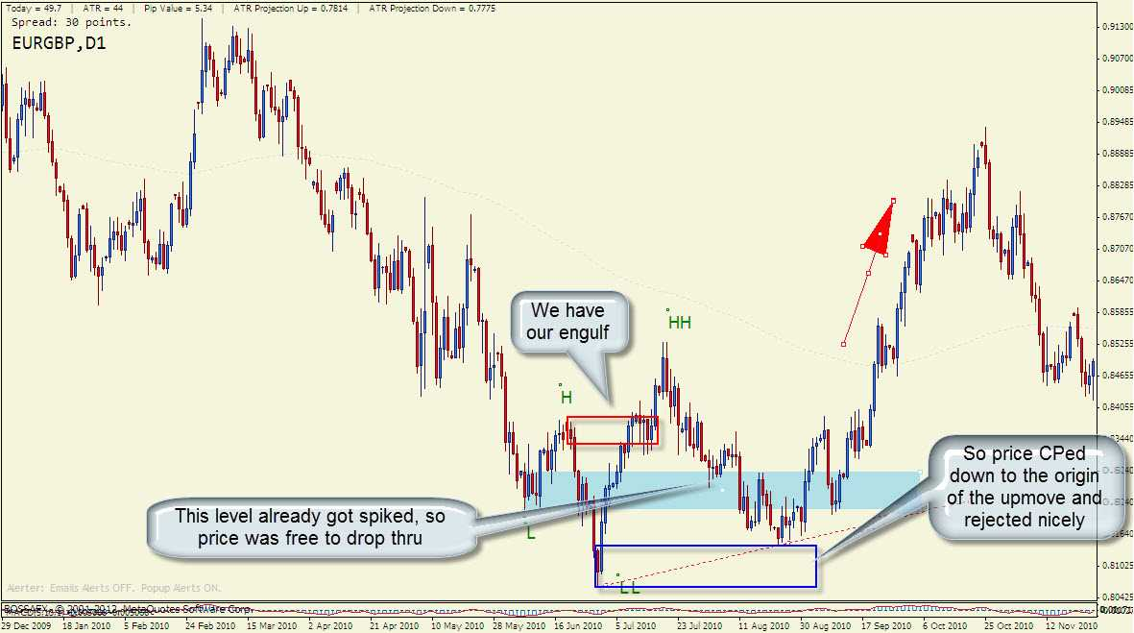

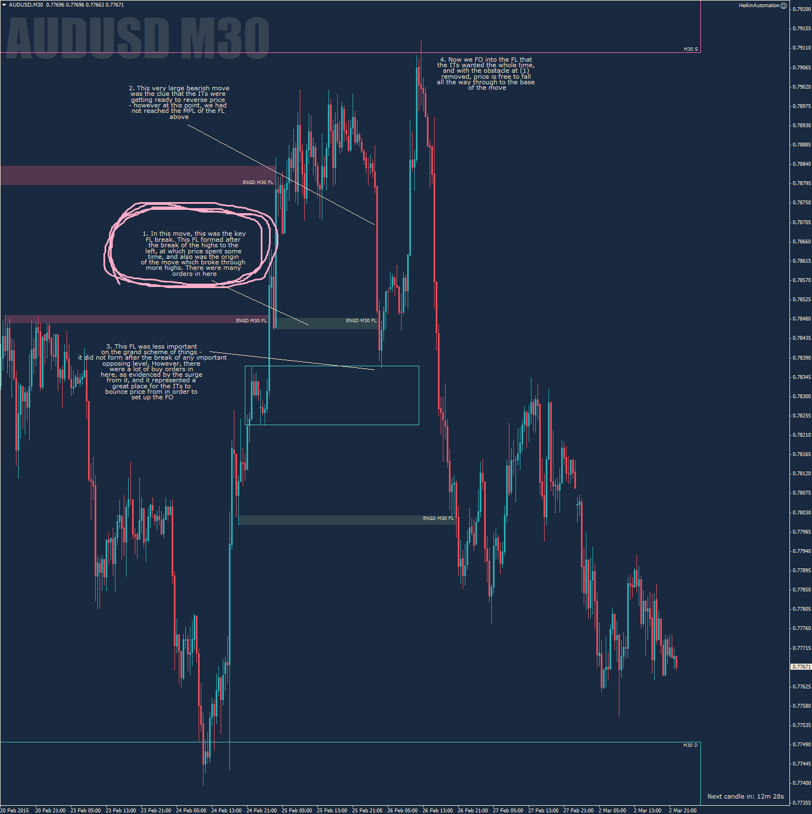
ENGULF:
So I've been doing quite a bit of reading in the Engulf thread, and I'm going to spend some time combining concepts. In the following chart, I've marked zones, and engulfs of highs. Just trying to identify the engulfs, and the origin of the engulfs. I've circled these engulf origins, which are the areas price should bounce at.
http://readthemarket.com/index.php/forum/journals/2033-josh1125-rtm-journey?start=50

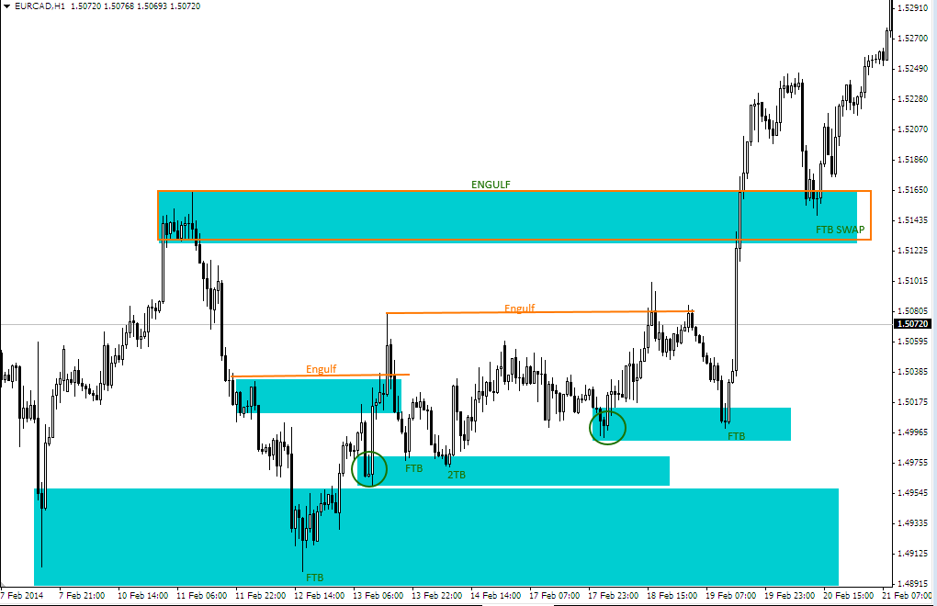

EXEMPLE: http://readthemarket.com/index.php/forum/journals/1577-les-paul-s-journal?start=275
FAKEOUT VS ENGULF!!!!
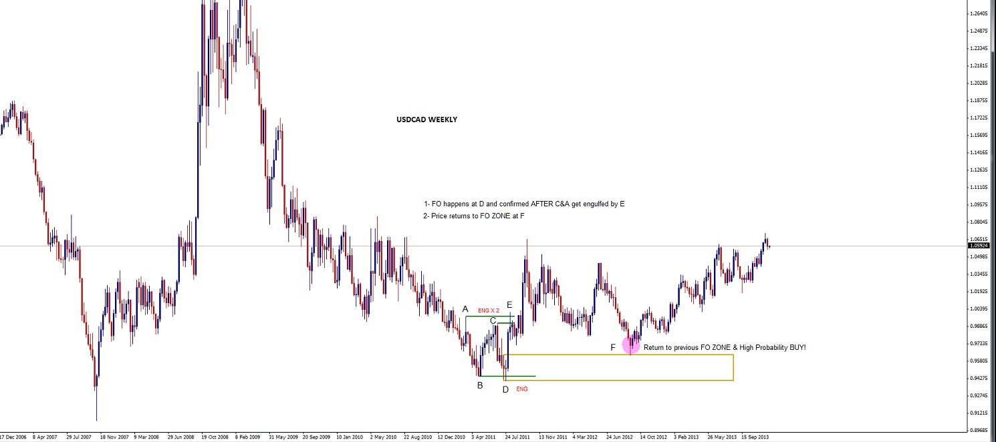
Also something I forgot to mention above:

D will keep its definition of engulf up until C/A get engulfed, so trading the return to C would still be on the table as long as it is respected... I hope that's not too confusing :blink:
http://readthemarket.com/index.php/forum/homework-rooms/1953-engulf-or-a-fakeout?limitstart=0
DECI NU TREBUIE SA STIM DACA ESTE ENGULF SAU FAKE FIINDCA ORICUM PUTEM TRANZACTIONA
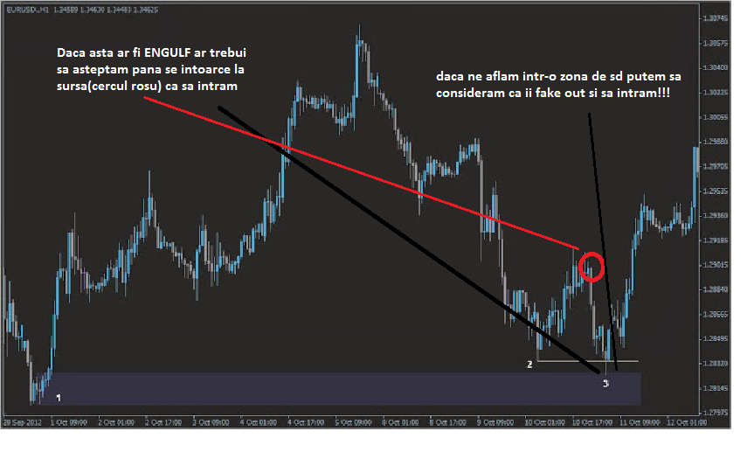

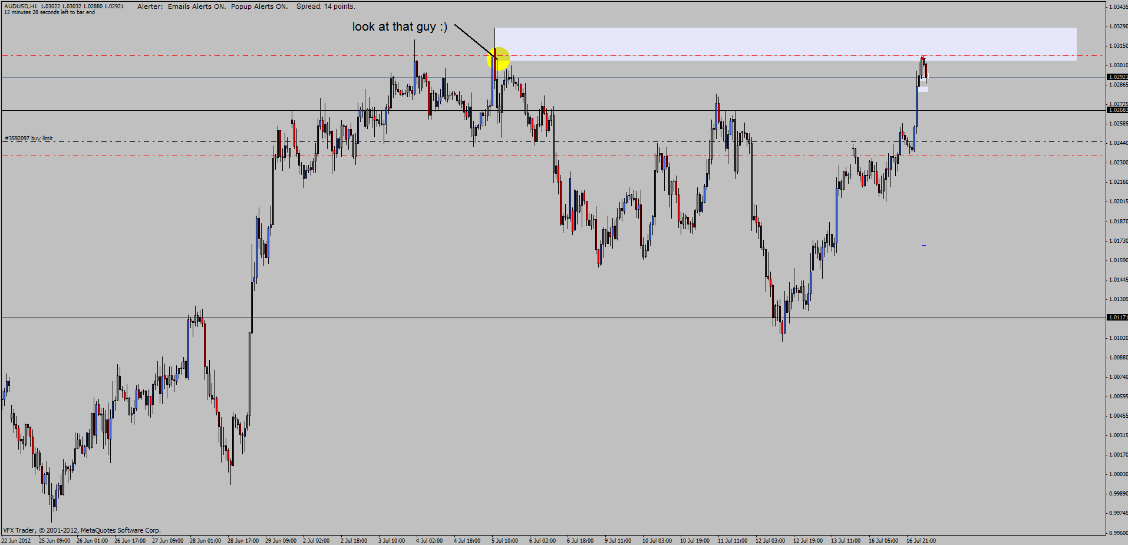

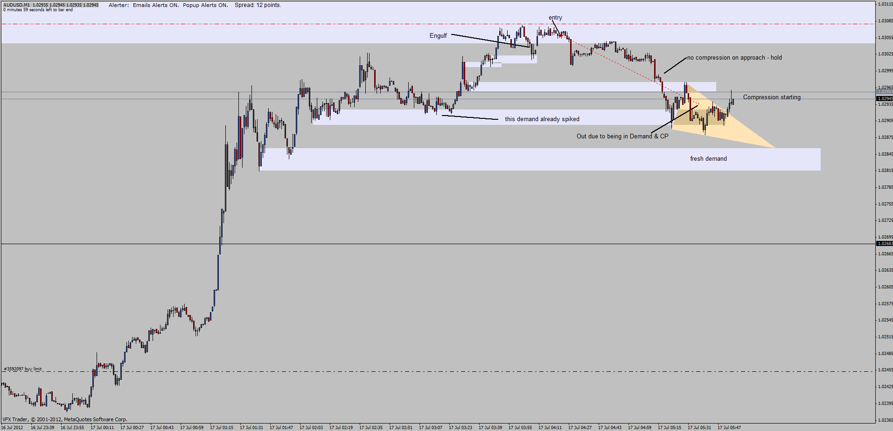
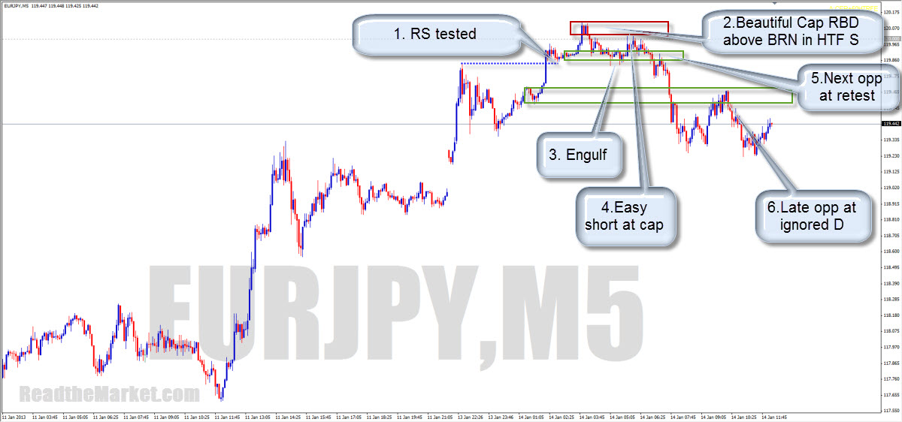

I just read the request and went straight to the charts to draw up the answer.

Suddenly an alarm started ringing in my mind, and I was reminded of a chat I had the other day with a couple of my oldest trading friends. I had mentioned a concept, and one of them asked me to explain it. I knew full well that I had explained it before, so was taken aback to be asked about it as if it were a brand new idea.
It was an extremely important lesson, and one I thought would've been instinctive to everyone by now.

I got to thinking again that a lesson served up on a silver platter in a free website may indeed have little perceived value

So, before I answer this request, I want you guys to work it out as best you can.
In doing it, I want you to consider:
Flags/Poles
FTR (actualy the same as above)
Support/Resistance breaks (I hope you noticed by now that FTR is the precise science of this!)
PAZ (Same thing again!)

If you can tie all of these things together with the engulf, you have the unified theory of market dynamics, and you'll be astonished at how simple the market is to read. You'll actually be able to boil it down to; If X, then Y

I do hope you all have a go at doing this - It seems that the best lessons are the ones we work out for ourselves
All the info you need to get the answers is already here in the site - so go and put it together
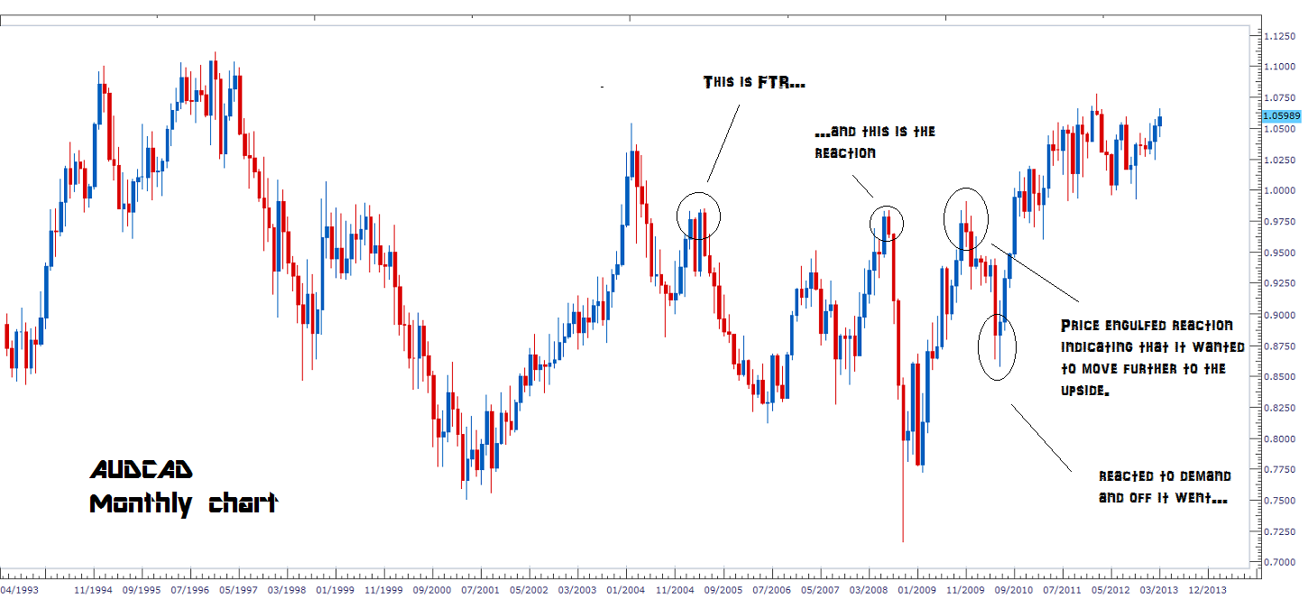
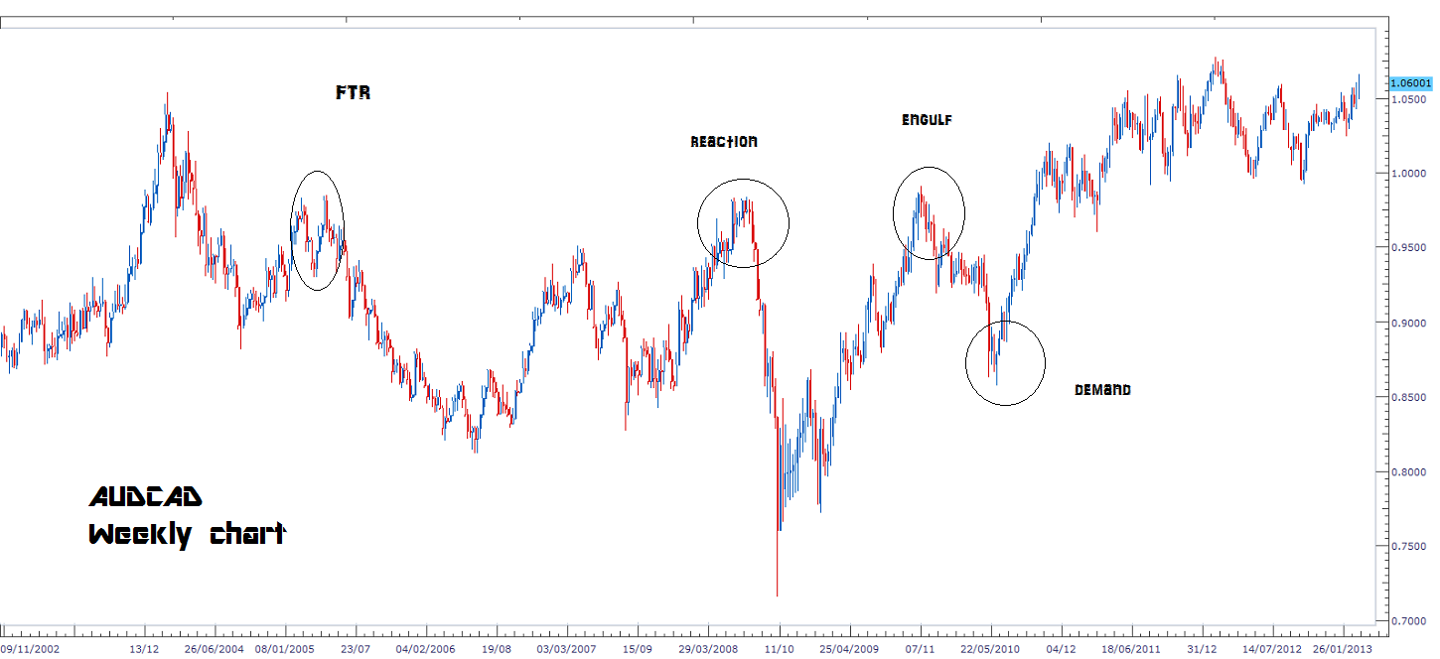
FAKEOUT: 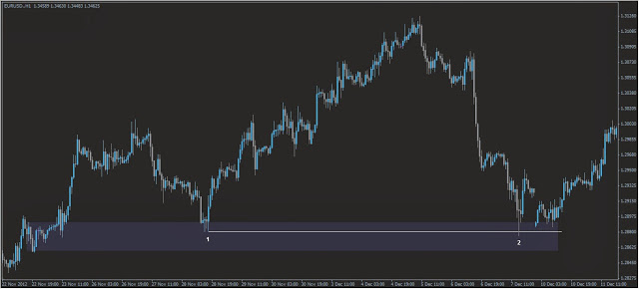
Sau FTB la FO

