Dmitry Sapegin
9 years ago

Market Profile trading methods
Main abbreviations:
- POC (point of control) - maximum profile value
- VAL (volume area low) - at least 70% of the value area
- VAH (volume area hi) - maximum 70% of the value area
- НVL (hi volume level) - maximum volume level

The values ​​(number) of points are optimized for the S & P500 futures, for other instruments their values ​​are used, depending on the intraday volatility.

1a. In a falling market, when the current session opens below yesterday's VAL, enter a short position from VAL and again from POC, with a stop above VAH (+ 1.5 pips).
1b. In a growing market, when the current session opens above yesterday's VAH, enter a long position from VAH and again from POC, with a stop below VAL (- 1.5 points).
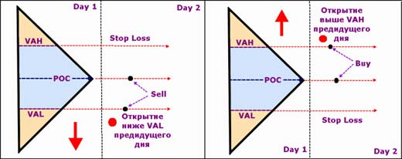

2a. In a falling market, when the current session opens inside VAL, open a short position from the previous day's VAH (- 2 points) with a stop at the POC or HVL level of the day before last (+ 1.5 points).
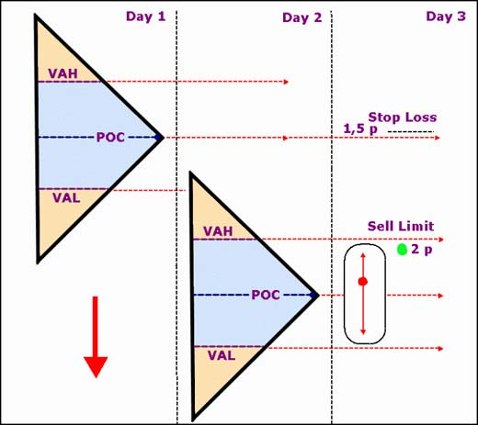

2b. In a growing market, when the current session opens inside VAL, open a long position from the previous day's VAL (+ 2 points) with a stop at the POC or HVL level of the day before last (-1.5 points).
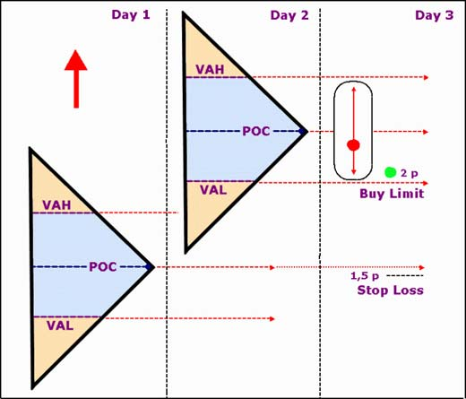

3a. In a falling market, when the current session opens above yesterday's VAH, but below yesterday's VAL, open a short position at the level of the day before yesterday's VAL and again at the level of the day before yesterday's HVL with a stop at the day before yesterday's VAH (+ 1.5 points). If the price has reached the level of hitting the stop and remains higher, we change the direction of trade.
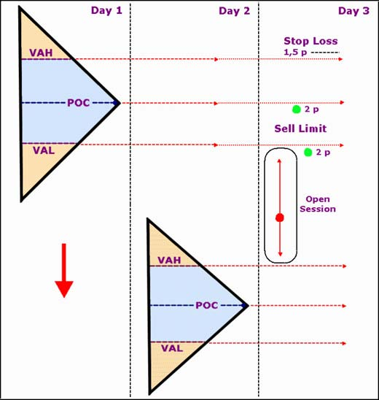

3b. In a growing market, when the current session opens below yesterday's VAL, but above yesterday's VAH, open a long position at the level of the day before yesterday's VAH and again at the level of the day before yesterday's HVL with a stop at the day before yesterday's VAL (- 1.5 points). If the price has reached the level of hitting the stop and remains below, we change the direction of trade.
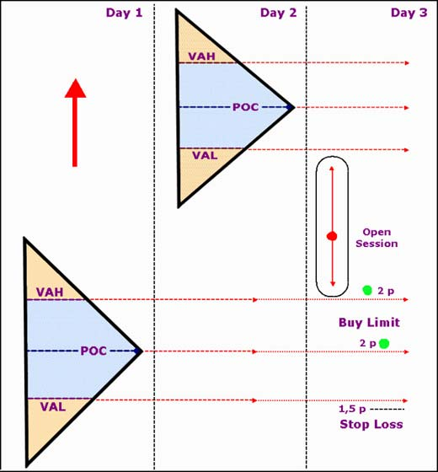

4a. In a falling market, when the current session opens above yesterday's VAL, but below the day before yesterday's POC, open a short position at the level of the day before yesterday's VAH and again at the level of the day before yesterday's POC, with a stop 1.5 pips above the day before yesterday's high. If the price has reached the level of hitting the stop and remains higher, we change the direction of trade.
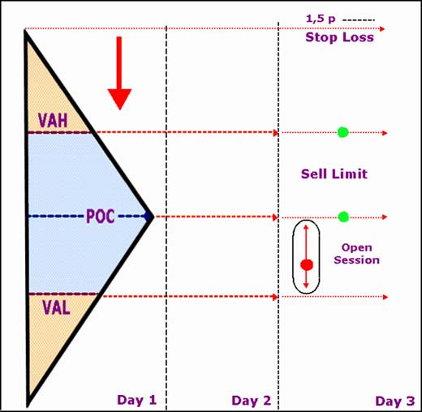

4b. In a rising market, when the current session opens below yesterday's VAL but above yesterday's POC, go long at the level of the day before yesterday's VAH and again at the level of yesterday's POC, with a stop 1.5 pips below yesterday's low.
If the price has reached the level of hitting the stop and remains below, we change the direction of trade.
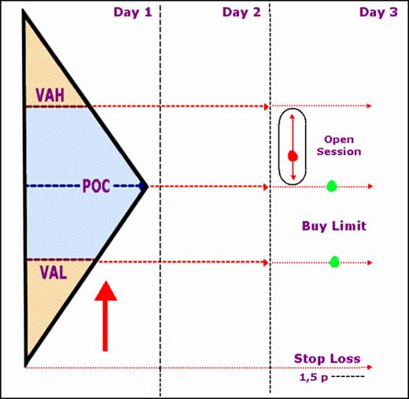

In all cases, the feet must be set taking into account the previous VAL, VAH and POC.
This technique was developed for the Market Profile, but can just as well be used with the Volume Profile.
Do not forget that the market is changing and it is necessary to take into account the current phase of the market (bullish, bearish or sideways), as well as market volatility.

