My target in trades
Sell example. Basically I ask myself who is making money the last few days. Exactly these retail traders will get their stops hit and they will transform into liquidity providers for the big banks. I observe their trading in HTFs. When i see a stop run into liquidity pool, i check for price exhaustion. Price exhaustion produces thin move, which is visible on LTF. It usually gets filled very fast. This is the confirmation of the price turn. Then i wait to see if price will do lower low, breaking recent LTF low as additional confirmation.
After all of this i start looking for shorts on rallies (on LTF). Again, in order for price to continue down the recent gap above has to be filled (on LTF). Gap is an area where thin move occurred. Thin move is a price range where price shoot hard in one direction without much resistance. Price doesn’t turn in the thin move range. Price turns at liquidity areas, where a lot of buying and selling occurred. Some people call them ranges, consolidations, etc... And target is the next liquidity area.
I trade liquidity zones (where a lot of buying/selling (accumulation) occurred). These are precise levels which are guarded by the big pockets. I spend most of my time to find these levels based of recent market structure.
I don’t trade "trends". I don’t believe in them, because there is too much manipulation... So i focus on swings.
Weekly and monthly i don’t look anymore. I still believe you can apply same concepts on them depending what trader are you, but problem is the human factor.
Whenever we enter a trade, we always trade a range. Think about it. That’s why it is critical to define your range. No matter the TF.
Sell its top and buy its bottom.
my entry and PA TFs: 5min, 15min, 30min
my analysis TF: H1, H4, Daily
My target in trades (sell example):
1. Enter around London Open with very tight SL
2. Try to sell the top of the daily candle
3. Anticipate range expansion to the downside
4. Wait until market gives me profits

Please understand! We are not trying to predict where the market will go!
1. We anticipate daily range expansion in one direction.
2. Try to get the high or low of the day
3. Wait patiently for market to give us profits
We need only 2 things to find a good spot:
1. Liquidity pools (Where are the stops located?)
2. Space in trade direction
Do not over complicate. It's simple.
Three phases of price movement we anticipate:
1. Manipulation (stop hunt)
2. Accumulation (ITs accumulate positions. We too!)
3. Distribution (ride price for profits)

Do your homework:
1. Take an empty chart (TF doesn’t matter for this exercise)
2. Imagine you have a position running from the top of a swing high.
3. Where would you put it after next swing? Where would you trail it on the way down?
4. Imagine when looking at daily charts where people put stops / where they trail them. Do they use previous highs/lows? Previous weekly highs/lows?
5. Where would you feel safe if you have to trail it.
6. There are always liquidity pools above and below market. Which ones are stronger??
7. In which direction market would naturally go?
8. What is price looking for?
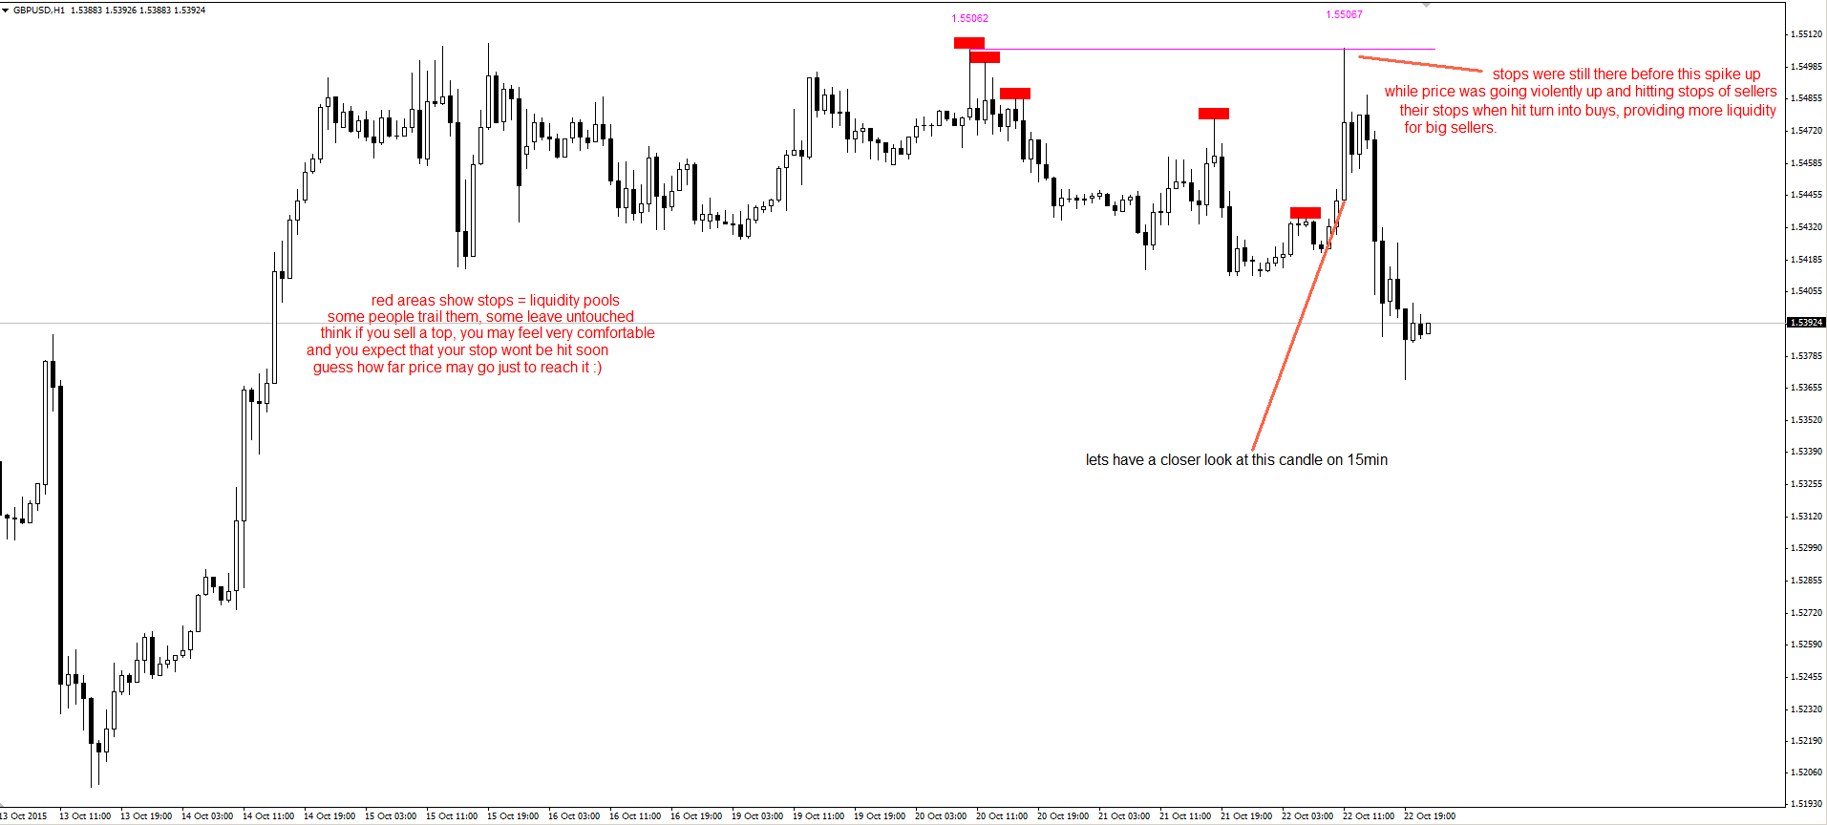

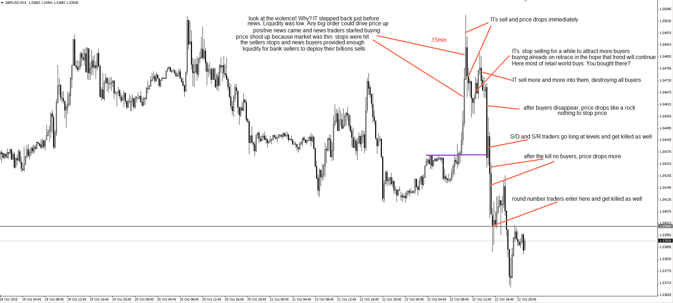

After you find these areas it’s easy. Market will always push price to the less liquid side of the market, which is basically where price moved fast and parabolic. These moves create liquidity gaps, which are being filled with the time. Market tends to fill most recent gaps. Got that?
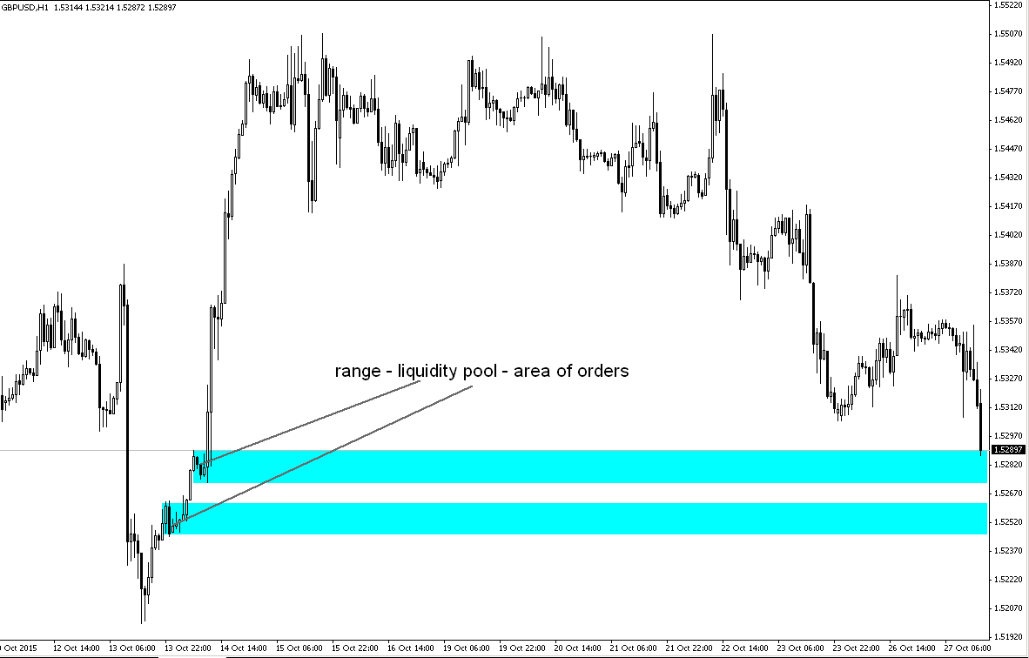

1. I knew the area is good.
2. I expected the price to go to 5380.
3. I understand the concept of liquidity pools and gaps
4. I take only trades which give me at least 5R. Nothing less.
5. I try to take trades which no one will. Those are the trades which work out. Always.
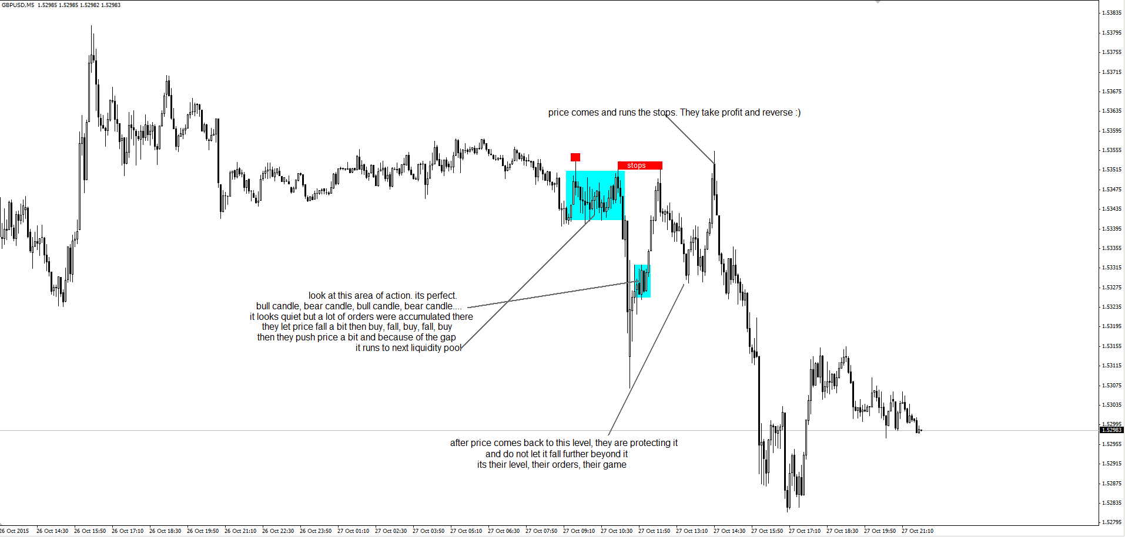
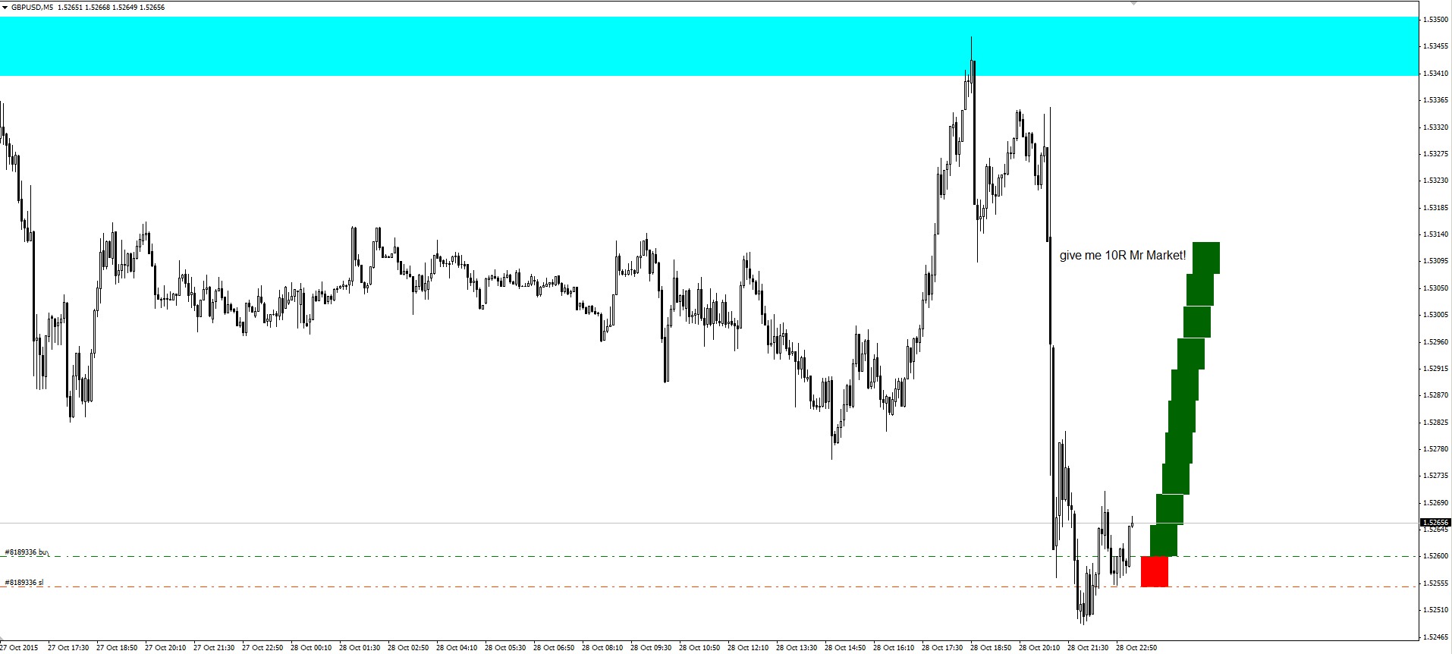
Your style is to wait till it bottoms out and then buy on the first higher bottom after isn't it. Opposite that for top. The 1.5255 buy area is a resistance price based on a previous bottom , correct? And time is involved also , correct?
Yes. I need some confirmation that price turned + some price structure to enter low risk on LTF and trail my stop as price fills the little recent gaps to the downside on the way up. These little retraces need to have specific structure in order to confirm the direction. Successful trades have similar behaviors. (As described above: more vs less liquidity areas). Yes, buy area is previous accumulation of orders area. If big buyers accumulated there, they will protect that level and use it to rebuy into falling price. Time of day I use too, but not always. Try to trade London open, New York open and London close. Around these times liquidity injection happens and price turns often. Before red news too.
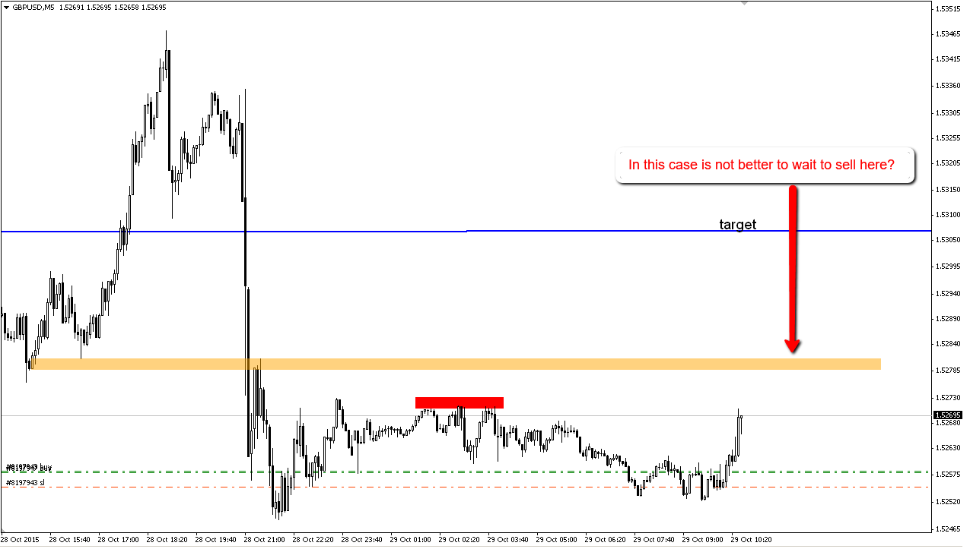
If too risky if you sell in the middle and you have so thin move above, which with high probability will get filled, before the price moves further down. It’s the nature of the market. We have higher odds for long, because we got 3 scenarios.
1. Price fills gap above and continues down
2. Price fills gap and continues up
3. Price continues down
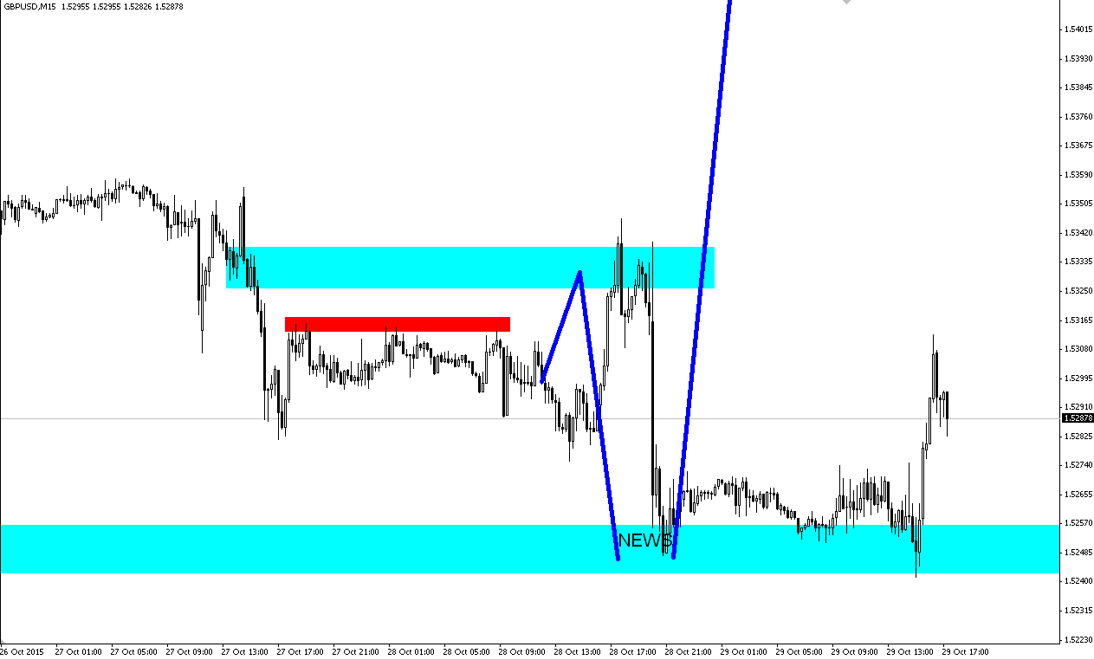

@TRD or anyone who probably know, I have reading back all of your post and researching stuff here and there,
I (think I) have better understanding how market works now
I have a clarify few things if you would be kind to answer
1. I see you trading only GBPUSD few days back, do you have any reason why? is it some kind of fundamental issue like the UK about to raise rate or longer TF technical?
2. I don’t think you have ever mentioned it, do you consider how many times liquidity pool retested in the past?
3. I see that you’re using ADR too, is it for fading strong moves? like GBPUSD move yesterday was bigger than your ADR and you enter short at liquidity pool above
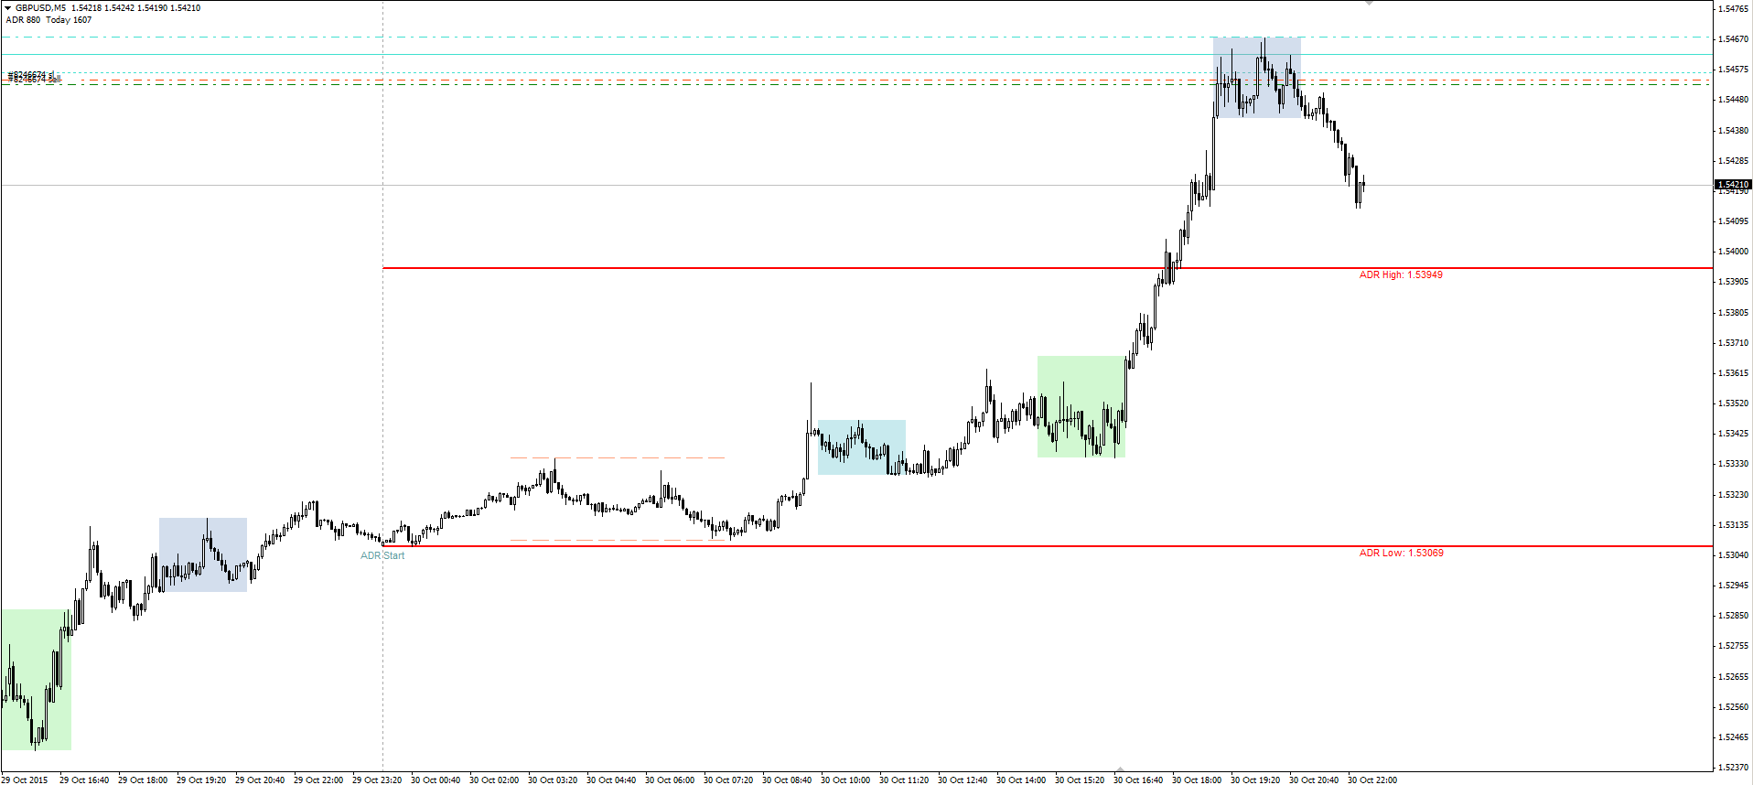
4. EU show big move on FOMC, can it be considered as showing liquidity gap too?
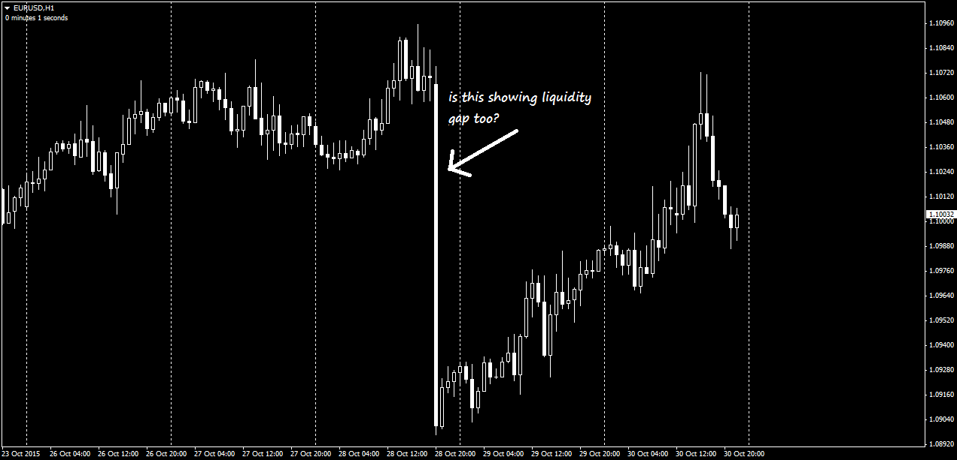
You obviously will succeed because you do some homework, which appears to be very hard for most of the readers.
Answer to Q1: Basically i look at USDX at start of the day. If it is bullish, i want to sell EU or GU, buy AU, sell UC, buy ND etc.
Do decide which to sell (EU or GU) i look at EG. If EG is bearish i sell the EU. If EG bullish i sell the GU. Got that?
Trading is not exact math, so there can be deviations.
Answer to Q2:
Are you talking about first or second or third retest? It may come 1 time or n times. Its all about how it will return and what kind of price structure will create.
Answer to Q3: Yes after price passes it is more likely that many intraday traders TP and reverse the price. Plus it was London close.
Answer to Q4: Ofc. Any strong more without a retrace leaves a gap open which will be filled sooner or later.
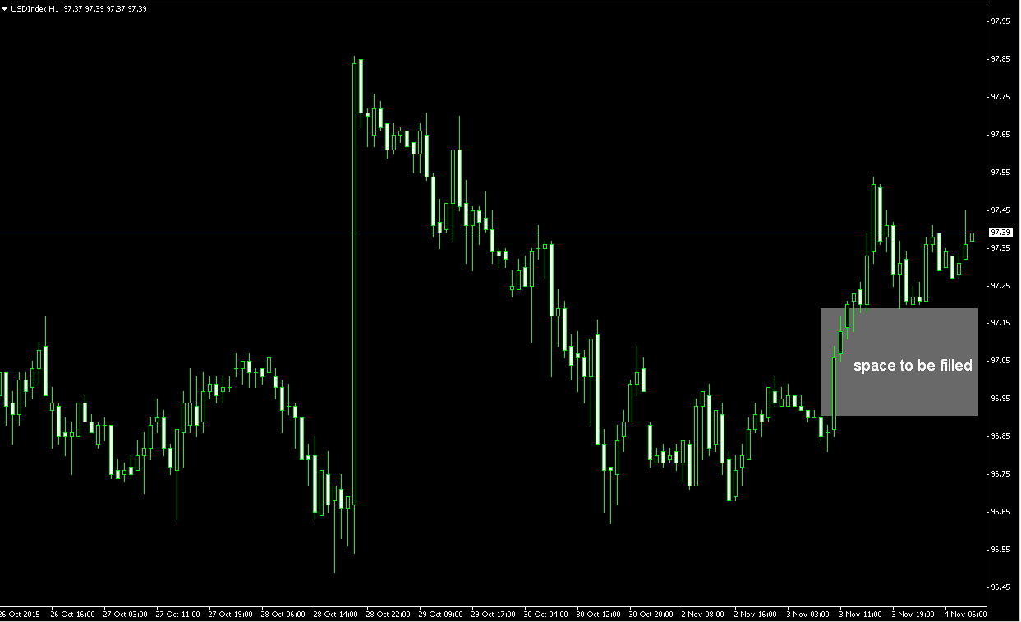
I will be careful with selling the EU/GU because if this obvious gap to be filled on the dollar

What kind of market condition is this?
A c c u m u l a t i o n
Very good answer. You see candles are next to each other, typical range. Banks accumulate during these quiet times. Then in no time manipulation occurs. Learn this market condition. It’s the most important!

Gaps are always filled. Some faster than others. All you have to do is trade in the direction of the gap fill at times where market is pushed harder. That happens usually after manipulation. we trade only after manipulation to be safe. Sometimes right after, sometimes after new HL/LH is made after it.
Accumulation is when the liquidity is high. A lot of transactions happening at that point. In PA is reflected as range. I bet you think volume is low during ranges
Distribution is when we have lack of liquidity. At that stage price runs like mad. Single bank order can push price miles away. Or price may drop violently, because nobody is buying. Not because sellers came in. ITs are not trading while price runs. Thats why it runs LOL
Your job is to know which gaps are open and mark them on your charts. Take GU as example. Above these gaps there is accumulation of price. There are the most orders located. And above these areas are the stops. Now there are a lot of sellers sitting comfortably above 4280, 4400, 4580 and 4680.
These guys are very sure GU HAS to continue going lower for them to make more profits. But many don’t know that liquidity gaps (also real gaps) are holes in price. Price doesn’t need a big push to go through them...
So relax, sit down, prepare your money and wait in the bushes until the time comes
……………………………………………………………………………………………………………………………………………………………..
I read your post and i could agree with you....... , maybe someone could not understand what I’m doing IF he looks only at my trades i post and that’s it. BUT if one look at what TRD did explained as rules/theory/principles + my trades, then maybe that one could understand more.
It’s just a matter of deep looking into things. My2cents.
SO...let me explain briefly my 'work', maybe someone would benefit from this after all.
1. We look at Asia range (i look also where my pink line is - NY midnight 5GMT)
2. We look for hunting above or below the Asia range, in order to take our long or short position. It may be look that we don’t care about the trend but we do care, that’s why you need to look and understand what dollar index is doing (trend of the day): IF its short then you look to long EU GU and vice versa, if dollarx is long you look to short EU GU; And here you look to take the best of these two looking again at dollar index and EG, as last one will dictate the rhythm between EU and GU (for more info look for correlations).
3. We established that short EU is in play, then we should look to short ABOVE the Asia high and AFTER we have seen several highs being hunted - AND THAT SHOULD HAPPEN ABOVE YESTERDAY or BEFORE YESTERDAY HIGHS. We wait for the price to develop down and on confirmation (sometimes without it) we enter short.
4. We take partial profit at the other range of Asia or at a significant support resistance level and let the other part run.
Rinse and repeat.
I may take several shorts and longs at a level i found above or below Asia, as i don’t fire as a sniper as TRD does, but i rather spread my bullets over an area, covering myself in case that hunting is not really over and will still continue: that lead to an advantage and a disadvantage:
ADVANTAGE: you can get the pick of the trend and ride it all down but in this case you haven’t loaded on full your position.
DISADVANTAGE: you can get caught in loading lots of positions and at some moment you need either to take loss or to hedge and deal with a hedge position further. But i have lot of experience in this area and such conditions are met rarely...but when i have them it’s giving me pain...a lot!
In such event i can lose even one week of profits. And if someone wants to enter into this strategy, he might be prepared to not lose more than you can do in one week or 2 tops!
But from a friend to another friend - I DO NOT RECOMMEND DOING THAT!
STICK WITH TRD SNIPER TRADING: one entry one loss or gain at a time. Wait for another right moment to entry and do it continuously and steady. Day in day out.
NEVER GIVE UP NEVER SURRENDER
EDIT: forgot to mention the most important part: screen time i spent is almost countless. My back and butt only know about that, same as my eyes. Prepare yourself with some eye drops, a good and confortable office chair as this screen time will never ever can be replaced by any explanation or someone else insight. From there come experience and intuitive guts.
Hope that helps!
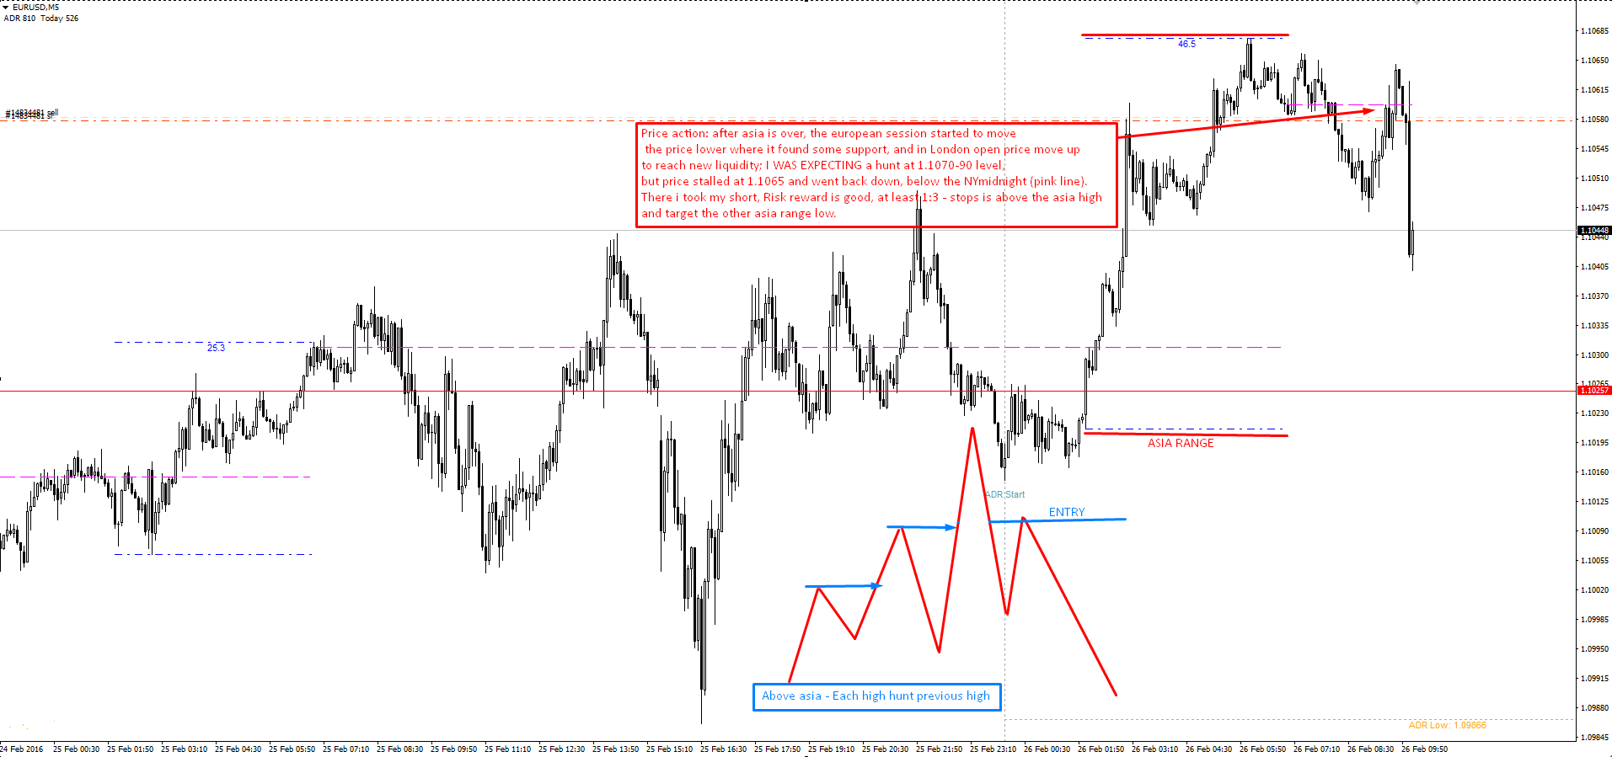
He he, everybody is different.
If i tell you that i spent less than 10 years, what would you think? This guy must be a genius or he was born a trader .
Now read carefully! There are phases/stages you have to go through:
1. Few years of losing real money
2. Few years of break even or barely winning real money
3. Few years of profitability where you can barely feed you and your family
4. Few years of profitability where you start making bigger money and feeling comfortable
5. Few years of profitability where you make loads of money, buy houses, sports cars, private jets, etc...
We are all at one of these stages 1-5.
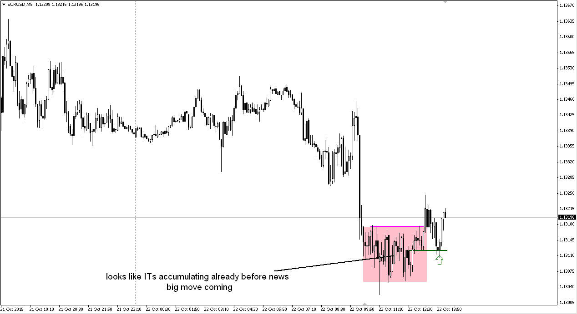
Usually accumulation happens in all ranges. There is liquidity concentrated.
But this chart represents more. See in the range how price comes slowly up and shoots back down faster, comes slow up and shoots back down faster. The result it big black candles. There banks buy in these candles to fill their orders. When you see such a candles in the down move, you know move is finished and accumulation in opposite direction happens. Before i traded stops i called them exhaustion candles.
Sometimes a stop hunt of the whole range happens, which amplifies the move in opposite direction, but not every time. If broken on wrong side they make sure that price comes back in the range. They protect locations where they bought last time.
As soon as banks are done with accumulation, they let the price break other side of the range and enjoy profits until the next range.

This is not a support and resistance trading. Market is driven by orders. What we try to is, what banks plan?
1. Who is moving the market? Banks (i know there are more entities)
2. What they want to do? Deploy zillions of orders
3. How to achieve that? By finding liquidity
4. How to find liquidity? By checking what retailers do.
5. What retailers do? Macd, MA, fibs, classical S and R, double/triple tops/bottoms, H&S, flags, candle patterns.......
6. Why is that important? Because retailers use stops. And theirs stops is Liquidity. Stops are limit orders.
7. What are banks doing? Hunt stops and protect areas where they traded last time
8. Where they traded last time? They bought when market falling last time
9. Why they did that? Because it's another way to use liquidity, using the market orders.
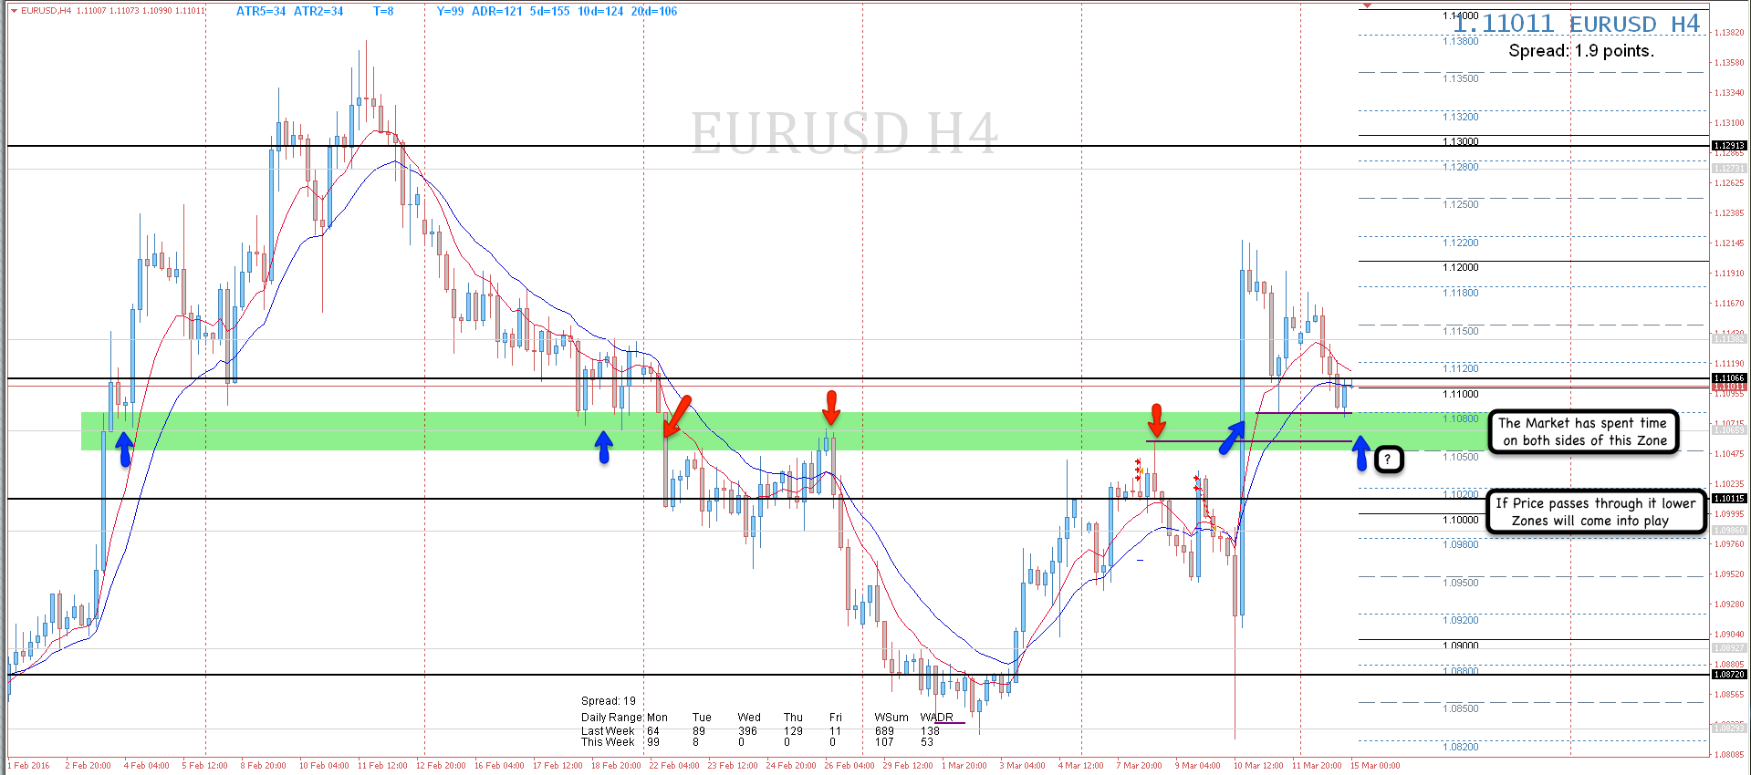
As you can see there is only one zone where price shouldn't breach. It's the 0980 level. Otherwise they will experience a drawdown. Everything above are sell stops, sell limit orders and future sell market orders, which will be triggered as price reaches the gap below 1080. Its their food.
***********************************************************************************
I said many times that wicks consume stops, so not many above\ below them. stops are below and above bodies of candles which have small to no wicks. because trading happens in the bodies. these candle bodies represent ranges on ltf, which can be hunted. this is were the wick comes from.
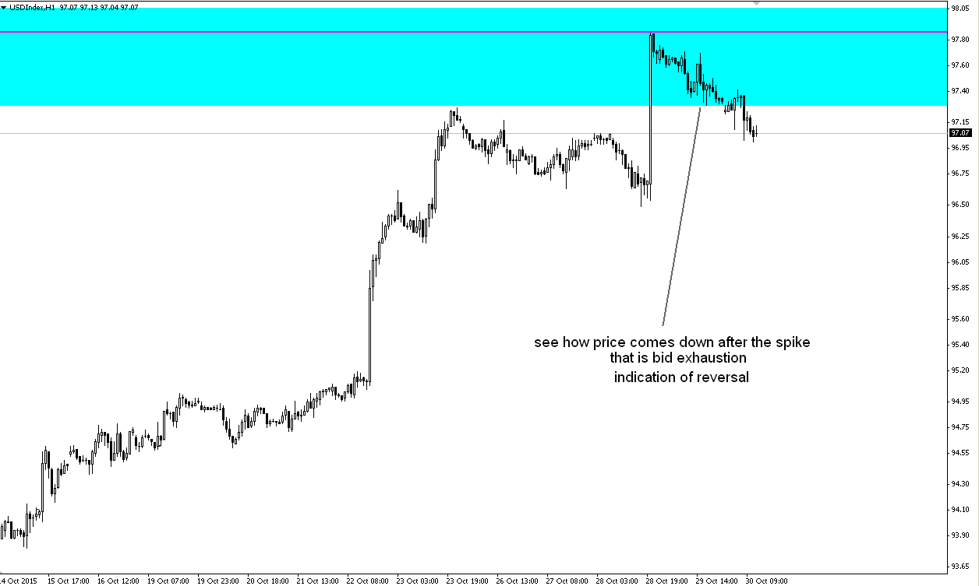

Wicks represent a thin move, which has thin liquidity, where price shoot and came back fast. If you push price through thin liquidity price may even jump to the level. Thin moves create liquidity gap, which are getting filled pretty fast. Why? Because after price jumps up and someone sells in a thin move, price would jump back down, because there is nothing to stop it. But why it comes down? Because it hits a liquidity pool.
Wicks are created by bank traders to hit stops and reverse price.
Sorry i guess that didnt answer your question. I dont want to confuse people here. Bulk of the trading is in the candle bodies. there is also the liquidity. So significant levels are made by healthy swing points. And healthy swing points are where price stayed for some time in order to build liq pool. Looks like a range on the chart.
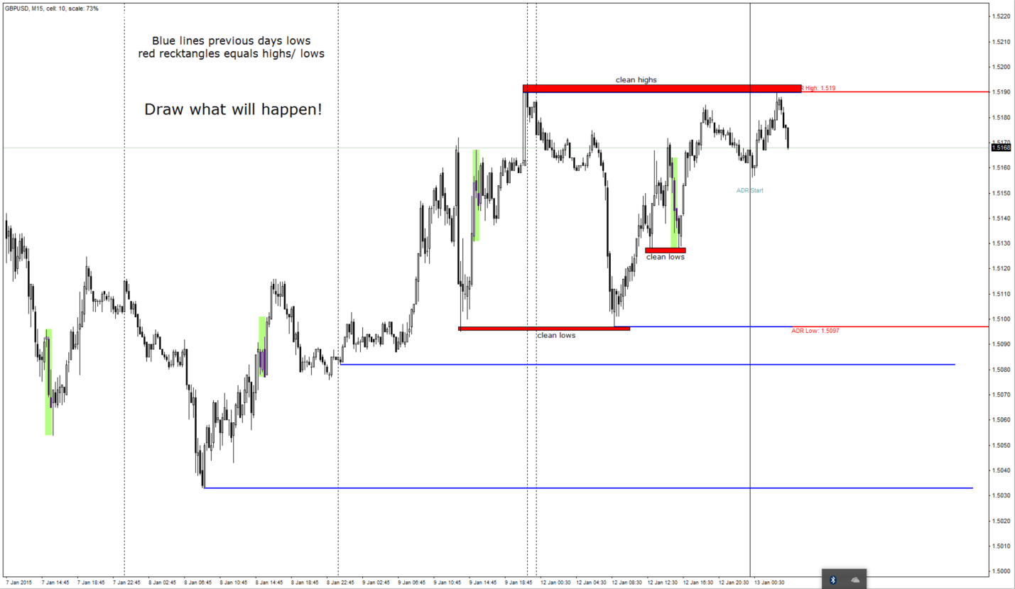
Biggest stops amount is accumulated on the range extremes. The red zone in the middle i created to fool you. It is a real hunt zone, but its minor and reaction is not expected to be big. So we know, that in order for price to move in one direction, some zone has to be hunted. That gives the price fuel. Why you think price will go straight to 5100 ?
Read my comment above. You are right that the biggest stops are accumulated at 5100, but how will price get there???
Just falling means traders take profit. Rarely heavy selling without stop hunt above.
You don’t need to know "who is allowing their Stops and Profits be wiped out?" We don’t care. We only care about what they do. Ofc if you are curious i can explain you off the thread.
TRD

Hi go5. I have generally 3 different ways to exit the market and all are based on market variables. Same as Jan teaches, you have to understand the left side of the chart and combined with how price is printed on the right. Very slow and very fast price movement tend to create liquidity gap, which opened the way for our trade to run. So when i see liquidity gap structures: 1. Very fast (quick parabolic moves without retrace or revisit) 2. Very slow (condensed/compressed moves), i i tend to let it run. If i see healthy trend on the left i try to exit as quick as possible at next recent high. That was exit number 1). 2) and 3) are explained in the screenshot


