Phasing Analysis is a procedure for isolating the wave components (cycles) present in a complex, composite wave (the price of a tradable entity).
It consists of a series of methods whereby wave trough positions are estimated. - JM Hurst

Lesson No. 3
- Review
- Intro
- The Cyclic Model Concept Revisited
- The Periodogram Concept
- The Price movement Periodogram and Initial Cyclic Model

- Some Features of Cyclitec Stock and Commodity Charts

- Trough Location by FLD's in Past Time

- Introduction to Phasing Analysis

- Entering a Phasing Analysis

- Extending a Phasing Analysis

- Completing a Phasing Analysis

- Considerations Affecting Phasing Analysis

- Extracting Information from a Phasing Analysis
- Conclusion

MC,
je trouve excellent que tu bosses mes graphes !
a) cela prouve que cela intéresse quelqu'un
b) ton attitude active me permet :
- d'être contrôlé
- de modifier des formulations ambigues
- de préciser des points laissés dans l'ombre
- de clarifier ma pensée
- de souligner les contradictions ou les erreurs
Pour pouvoir juger un tel graphe, il faut en fait connaître le méthodologie que j'utilise pour effectuer MA PHASING ANALYSIS.
Sur le graphique en question tu as 3 éléments distincts :
- les cours
- le modèle théorique
- les composants cycliques des cours extraits par la méthode de la différence entre 2 moyennes mobiles centrées dont le rapport des durées choisies est 2 à 1:
Exemple :
- les valeurs journalières composant la courbe violette représentant le composant cyclique de 9 Ans ont été calculées de la façon suivante
Moyenne mobile centrée 4.5 Ans (1152 Trading Days) - Moyenne mobile centrée 9 Ans (2304 Trading Days)
Le principe de Sommation nous apprend que les variations des cours (Price motion)d'un indice, d'une action etc résultents de la somme des cycles individuels à l'oeuvre au sein de cet indice ou de cette action.
Si on attribue à chaque cycle une " force" positive ou négative, tout le monde comprendra bien que pour qu'un cycle soit haussier, il faut que la somme des "forces" positives soit supérieures à celles des "forces " négatives.
Et inversemment.
Donc quand tu fais ton Analyse des Phases (Phasing Analysis), c'est à dire quand tu détermines la position et l'orientation respective des cycles les uns par rapport aux autres, tu ne peux pas avoir par exemple les cours du CAC 40 qui monteraient alors que tous les cycles seraient baissiers.
Le "modèle théorique" (mon baromètre) est très basique et parfaitement représenté par le tableau déjà présenté à de nombreuses reprises.
Pour faire bref les cycles idéaux montent pendant la première partie de leur vie, et baissent pendant la deuxième partie.
La question essentielle, c'est ils montent à partir d'où ?
A partir de leur dernier plus bas, d'où la question majeure :
Où est le dernier plus bas du cycle que j'examine ?
Comme l'immense majorité des indices ( et naturellement des actions qui les composent) ont fait 2 plus bas majeurs, visibles à l'oeil nu sur les graphiques, en Mars 2003 et en Mars 2009, je cprends ces 2 plus bas comme pivot intangibles de ma Phasing Analysis.
Mars 2003 et Mars 2009 sont des plus bas du cycle de 18 Mois.
C'est ma première contrainte.
6 ans = 4 X 18 mois
Y at-il un cycle de 6ans, de 3 ans c'est un autre débat
A partir de là je m'efforce d'appliquer le modèle théorique avec un point de départ tel que le modèle théorique présente le moins de divergences possibles par rapport à la réalité des cours et à l'orientation "réelle" des cycles que tu vois sur les graphiques.
C'est là où il peut exister des diférences d'appréciations.
Parfois il peut même être utile d'avoir 2 phasing différents (alternatifs diraient les Elliottistes ! ) et de vérifier ensuite lequel évolue de la "meilleure" façon.

I sometimes refer to phasing analysis as cycle phasing.
It is basically an analysis process performed by the software to generate a current cyclic model - a model that defines the wavelength and phase of all cycles between 5 days and 18 years currently active in the market price data.
As a result of phasing analysis the software is able to speculate as to when the troughs and peaks of various cycles are likely to occur.
Cyclic Analysis : The means by which cyclic concepts are used to produce transaction-decision information. - JM Hurst
Well that’s what it’s all about, isn’t it ?
Cyclic Analysis is based (fairly obviously) on the cyclic concepts Hurst mentions.
In other words, it is the analysis of stock market price movement, assuming the validity of cyclic theory.

It is very interesting to see how THT handles phasing of different periods of data.

The reality seems to be that if THT is presented with a lot of data (such as your 23 year example) then the phasing is quite simply not correct (much as I take pride in THT, I am not offended if anyone points out that the phasing is wrong!). It would be interesting to see what THT did with phasing based on the nominal model, because I think it is at a bit of a disadvantage here with the initial cyclic model.

The reason I say this is that it is performing a spectral analysis over a very large data sample (following discussion about this in other topics I am going to look at reducing the amount of data used for this analysis, but at present it analyses the entire data sample), and the principle of variation is no doubt very active over that time frame.

It is nevertheless disappointing that it produces phasing that is so clearly wrong.
Presumably the phasing between 1986 and 2000 was convincing enough to make THT not consider the 9-year cycle between 2000 and 2009 as a nominal 9-year cycle!

I know that is because THT allows only a certain variation in the cycles (65%-150%), which gives rise to problems such as this.

However if it allows greater variation the result is often fairly catastrophic (you can play around with this, and see what works best by changing the analysis settings in the menu Tools| Analysis Settings).

The 9 year analysis is more encouraging, as that phasing seems reasonable.
I am hoping that when I get the commonality model working, issues such as this will be resolved by reference to the commonality model, but in the meantime I would like to propose a "process" that could be adopted with THT.

I am going to make a video about this, because in my own personal testing of THT this is a process that I have found has some validity.
First of all I think it's important to acknowledge the limitations of THT with regard to phasing, which in practice means that THT is only as good as the data presented to it, and that has much to do with the analysis period that you select.

I am also hoping that one day this forum will develop into a place where fellow Hurst analysts can discuss issues to do with phasing, such as whether October 2000 was a trough of the nominal 18-year cycle, and that discussion can provide an informal "commonality model".
Here is the "process" that I would recommend with THT:
- Perform an analysis (as you have done) over as much data as you have.
Use this analysis for a "big picture" view of the cyclic model. In your example the bigger picture is that there was a prominent trough (perhaps the nominal 18-year cycle) in October 2000.
You don't show what happened before this date, but I'm assuming that it makes some sense.
There was also a prominent trough in July 2006, and so in some ways the only question is whether that trough was an early 9-year trough, or a late 54-month trough.
THT has taken the option of calling that an early 9-year trough, but that results in phasing problems later (in particular it "downgrades" the March 2009 trough which is a problem)
- Then I would refer to this forum, and other places where Hurst analysts exchange ideas, and ask whether others would concur that October 2000 was a prominent trough (whether it was an 18-year trough or a 9-year trough is really an academic debate as far as I'm concerned - it is not likely to affect your trading over the next few months).
Hopefully the commonality model will come to your assistance here, and confirm or invalidate that trough.

- Knowing that THT isn't great at phasing the longer term charts, I would then change the analysis period to have THT analyse only the price movement since that last major trough.
You will need to have THT find that trough again of course, so I would make the analysis period from early 2000, which is exactly what you have done - did you do this for the same reasoning I am presenting here?

- And that analysis is very interesting: it indicates that the July 2006 is in fact a 54-month trough, not an early 9-year trough as indicated in the earlier phasing.
I would feel more confident of this phasing, because it uses an analysis based on the more recent data, and is more likely to reflect the current state of the cyclic model.

- And finally that brings us to the whole purpose of performing an analysis with THT - what is happening now?
I think it is reasonable that the trough in early March this year is a trough of the nominal 18-month cycle, and the phasing since that trough seems reasonable.
The only thing that THT might have wrong at this point is the underlying trend, because it is possible that the March trough was in fact not merely an 18-month trough, but a 54-month trough, or even a 9-year trough.
Nevertheless THT is probably going to give a good idea as to where price is going in the short term.
In summary I am working to keep improving THT, particularly with regard to analyses over long data series, but I think that working with the process outlined above, one could arrive at a phasing analysis one is fairly confident with.
I welcome any comments about the process I've suggested above.
SentientDavid

I agree that the "principle of variation" can be a predominant factor - and it seems intuitively correct that the shorter the cycle period, the more important current phasing becomes (or, conversely, the more obsolete past phasing may be).

I think Profit Magic discussed that subject somewhat.
I have another issue though. I have not been able to decide whether the nominal or Initial cyclical analysis provides a better near-term forecast. I try to run each concurrently and they can have vastly different projections.
-claudio
no9

Initially I ran an analysis on data (DJ30) going back to 1928, a laborious process I do not recommend. This analysis produced phasing which was quiet clearly incorrect.
After a good deal of experimentaion I selected the 1932 low and then analysed from 240 bars back, 6 times my selected trading cycle of 40 days.
This approach appeared to have THT lock into the cycles at the correct place on the chart and in my inexperienced opinion produced a good analysis.
Moving forwards I now select what in my view is a major low, count back 240 bars and analyse from that point. It seems to be working for me so far.
[EDIT] I tried this method using both the nominal and initial models, the outcome on the DJ30 from 1928-1932 were uncannily similar.

In no way do I intend my comments to be critical of David’s work. I am trying to be helpful with general observations of the phasing based on experience.
Long-term (longer than about 6-8y of data)
David, Eva (and others) have discovered that THT is not good with phasing long data series. I (and others) have found the same thing.

To make THT phase ‘correctly’ I (we) have to shorten the period of data given to THT to a point where the weekly analysis matches my (our) ‘hand charting’ analysis.
I am wondering if THT’s reliance on ‘daily’ is creating an issue with the long-term data?

When I apply Hurst’s concepts to a new market I look on the yearly chart for nominal 18y cycles.

Once I find them ‘daily’ has no influence.

These nominal 18y lows are FIXED. I then move on to the 9y nominal and so on.
If there is a long-term phasing uncertainty then the shorter timeframe(s) sometimes can assist.

I always got the sense that Hurst worked with the longer timeframes and then moved on to daily.
Mid-term (3-6y of data)
THT seems ‘okay’?!
Short-term (any amount of data)
With the daily it seems that the shorter cycles (<=10d) cannot be totally relied upon.
Now I want to quantify these qualitative observations. I have benchmarking ready to go but there still seems to be a fair bit of ‘change’ occurring with THT.

I am keen to keep the phasing as the focus.

Hopefully v40 will be ‘stable’ for a while and we can get back to the engine room so that the phasing can be improved and perhaps resolved.

In my humble opinion even thinking about trading from the current version of THT is DANGEROUS and at best totally inappropriate.
Cheers, Dennis

I think that John's process is a good way of getting the most out of THT, and getting the best phasing analysis.

I know that going back 240 bars came from a discussion we had over email, but I'd like to suggest that it is no longer necessary to go back so far.

There used to be a big problem with the left edge of the chart because THT wouldn't phase that area, but in version 28 I changed that. Read about it here.

What that change does is in fact a "double-edged sword" because on the one hand it makes the phasing on the left edge of a chart less of a problem, but on the other hand if the left edge of your chart (by which I mean analysis period) is chosen poorly, then there is the vulnerability to incorrect phasing.

Let me give an example. Here is a chart where I have chosen the analysis period to start just before a torugh that I know (from looking at the full chart) is a fairly important trough:

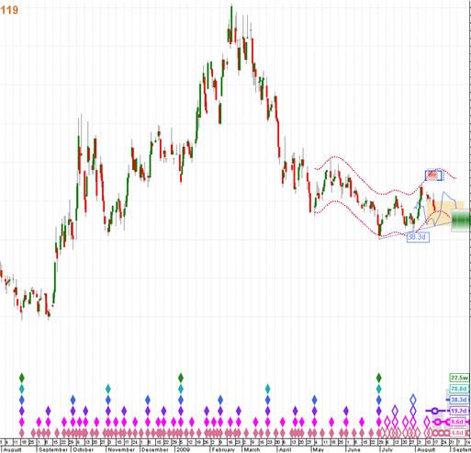
Phasing if Analysis Period start is chosen correctly
Now here is exactly the same chart, but I have chosen the start of the analysis to be arbitrarily after this major trough:

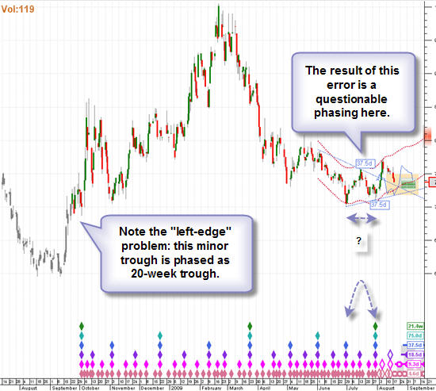
Phasing if Analysis Period start is random
Notice that THT is now no longer afraid to call the trough that it finds on the 3rd of October a trough of the 20-week cycle.

And this has the result of some fairly questionable phasing decisions later.

This is what I mean by the double-edged sword of changing the way in which THT handles the left edge of the chart.

If your choice of analysis period start is a good one, then it works in your favour, if not then it doesn't.
And so that is why I recommend using either a long-term analysis, or perhaps general opinion from experienced Hurst analysts to choose the start of the analysis period a little before a major trough.

It is also for this reason that I am seriously considering removing the option to "Step forward Last and First bars" during back-testing because the unfortunate side-effect of doing that is exactly what I've illustrated above - if the first bar of the analysis period is moving forward, then it is effectively being placed arbitrarily, and the phasing analysis will also change arbitrarily.

I know several testers are using this stepping forward option, and would like to hear from you before I remove the option if you feel that it is useful despite this downside.
With regard to the discussion around using the nominal or initial cyclic model, I would like to put forward my understanding of what works.

First of all I think it's important to understand the difference between using the 2 models, which is this:
- The nominal model is a perfectly harmonic model, and should represent the average cycle lengths that are at work in financial markets (although I have no proof of this, the model is Hurst's model and is the result of the work that he did).
If THT is using the nominal model, and indeed those cycles are active in the market over the time analysed, then the result should be a phasing analysis that "looks right".

- On the other hand the Initial Cyclic Model is not necessarily perfectly harmonic, and is built on the basis of cycles that are actually found in the data from the spectral analysis that THT performs.
This sounds as if it should be better than the nominal model, but in fact there are inherent problems in the spectral analysis (such as the result of harmonics) that means that is not always the case.
And so I would suggest first of all performing an analysis with the nominal model. If that analysis "looks good", then there is probably no need to use the Initial Cyclic Model (and ofter the ICM in fact gives the same analysis in these situations, because it is finding the nominal cycles in the data).

If on the other hand the nominal model analysis doesn't look right, then I'd suggest using the Initial Cyclic Model, because the fact that the Nominal model doesn't look right is an indication that perhaps the nominal cycles are not really correct for the particular instrument you are analysing.

Here is an example.

In Chapter 6 of the Cycles Course, Hurst discusses how the variation of cycle lengths in Gold is much greater than the variation of cycle lengths found in equities.

And so here is a phasing analysis of a gold-based index (which pretty much moves in sync with the gold price). This is the nominal model analysis:

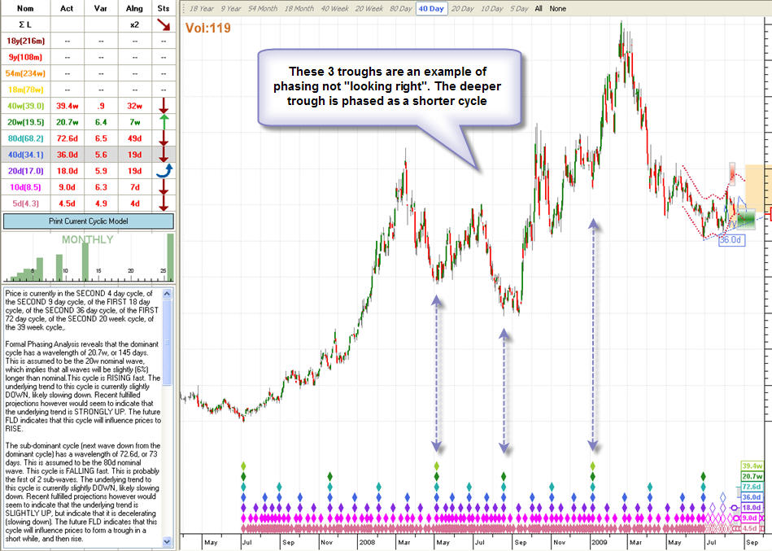
Gold Nominal model analysis doesn't look right
Here you can see what I mean by the phasing analysis not looking right - the 2 x 40-week troughs which have a deeper, more obvious 20-week trough between them.

In this situation I would recommend using the ICM, because it is possible that the cycles active in this instrument are not actually nominal. Here is the ICM analysis:
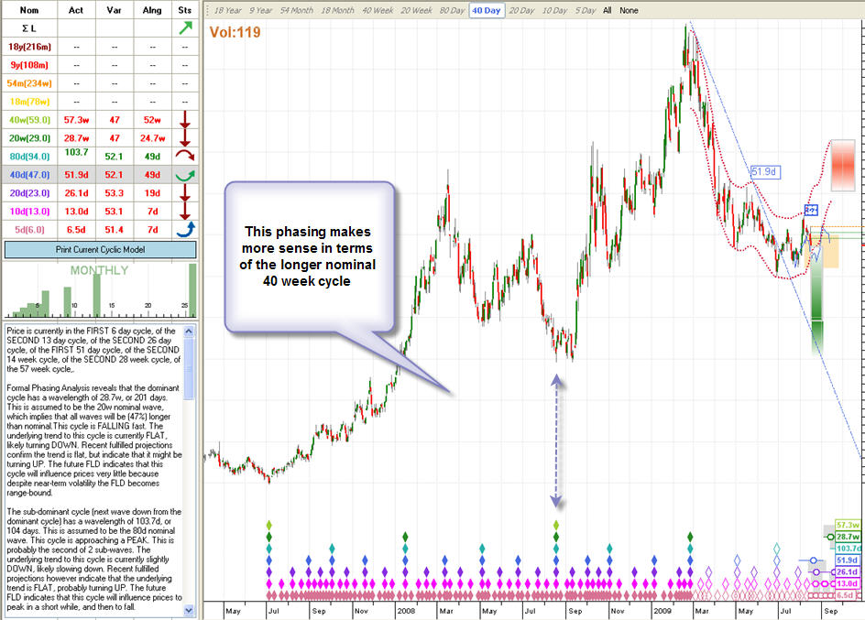
Gold ICM analysis different (and better ?)
I think you can see here that the phasing "looks better".

And from the current cyclic model table on the left you can see why - THT has found the actual cycles present in the data to be much longer than nominal (in fact about 50% longer).
I find this encouraging because it illustrates Hurst's point about gold - that the cycles have a greater variation from nominal than other instruments.
And so I would recommend being critical of THT's phasing analysis using the nominal model, and if looks dodgy, see if the ICM looks better.
All of this makes me realise that THT will never be a "black box".

To get the most out of it you need to apply your own knowledge of Hurst's techniques.

Left to its own devices THT will make mistakes, but I hope that as a tool in the hands of someone who knows at least the basics, it will perform well.

And certainly our recent discussions have indicated that there are t2 things that you need to do correctly to help THT do its job correctly:
- Choose an appropriate start point for the analysis.
- Know when to use the ICM as opposed to the Nominal model.

I'm not sure what the repercussions to code-writing might be, but here is a suggestion for the THT engine phasing process:
Instead of the phasing engine performing a "left-end" start to the analysis of all cycles, suppose that cycles are evaluated for a chosen number of cycles looking back from the present.

As an example, a maximum of 6 cycles could be set as the analysis range for each different cycle.

That means that more data would enable longer cycles to be evaluated, but shorter cycles would not make use of data beyond my arbitrarily chosen 6 cycle limit.

In other words, the program would step further into the past data as the cycle periods to be evaluated are increased (from days to weeks to multi-year cycles).
I am behind the curve of fully understanding what you have done without the benefit of Hurst's cycle course, but hope that makes sense.

In principle what you suggest is a good idea, and in fact I am working on doing something similar to this, however in practice it is more complicated because THT only manages to resolve phasing issues by looking at the shorter cycles, and seeing how well they phase, which is an important part of Hurst's approach.

That is why it is not an easy thing for me to do, but I am working on a way of doing the phasing which is similar to your idea of only going back a certain number of cycles.

I will only have it ready in a few weeks, because it is a fairly big change and I am very wary of negatively affecting the aspects of THT's phasing which are working!

How THT does Phasing Analysis by SentientDavid » Tue Aug 04, 2009
THT performs phasing analysis using Hurst's described process.

This has always been very important to me. I have read many books about Cyclic analysis, including work by Millard, Ehlers and others.
When I started working with Hurst's Cycles Course I was immediately struck by the difference of approach - the phasing analysis was not a purely mathematical approach, but a pattern recognition "fuzzy logic" approach.

Hurst describes phasing analysis at times as "an art", and many times mentions that two people will come up with different phasing analyses, because of the "art" in the process.

And so instead of using the purely mathematical approach of finding troughs present in moving averages, THT replicates to some extent a visual pattern recognition process.

Of course it uses mathematical processes (it's computer software after all...) but it uses those processes to support a logical process that mimics Hurst's own process.

Let me explain the process in detail.
Building an Initial Cyclic Model
The first thing THT does is to build an "Initial Cyclic Model", as proposed by Hurst. Hurst's approach was to find prominent troughs from his periodograms, and build an initial cyclic model that was close to the nominal model, and which "harmonised" as well as possible - in other words each wave is as close to a perfect 2x or 3x harmonic of its adjacent waves.

THT does exactly the same thing - but first it has to generate the periodograms.

It took me a long time to work out how Hurst generated those periodograms, and I'm not sure whether THT uses the identical process, but I followed a trail of clues that Hurst left in his book "The Profit Magic of Stock Transaction Timing", particularly in chapter 11 which describes the "Lanczos" method.

I managed to obtain the original paper written by Lanczos in the 1960's, and with the assistance of John Smith, retired Professor of Nuclear Chemistry from John Hopkins Baltimore University (who spent many long hours explaining things to me in the hot Italian summer last year), THT now performs a version of spectral analysis on the data (it is a form of Fourier Analysis).

Having performed the spectral analysis, THT generates a "periodogram", the peaks of which provide evidence of a particular cycle in the data.

Then THT compares these peaks to the nominal model, and constructs the most likely cyclic model based on the harmonics of the cycles found, exactly as Hurst proposed in his Cycles Course.

THT then uses this initial cyclic model as it moves on to perform a phasing analysis entry.

(See my topic about the new option in THT to use the nominal or initial cyclic model as the basis for phasing analysis).
Rating troughs
Before I get into the meat of this topic I need to explain how THT "rates" troughs.

This is a crucial element of the phasing process, and something one takes for granted when doing a phasing analysis manually. It turned out to be a fairly complicated business...

Here is how THT rates each and every trough found in the data:
- First of all THT finds the "isolation" of the trough.
This means how many bars it takes for the low price of the trough to be exceeded. If a low price is exceeded to the left (in the past) of the trough, that has a different impact than if it is exceeded to right.
Further to this the isolation is calculated according to the cycle presently being considered, and so the isolation of the same trough is different when considering the 18 month cycle than it is when considering the 20 day cycle.
- Then THT calculates something it calls the "strength" of the trough - this is a figure proportional to the distance from an upper channel of a particular cycle to the trough.
So again this figure is different depending on the cycle one is considering.

- Then a trough is given a rating dependant on how it relates to other troughs around it!
This is a process of virtually "drawing a line" from the trough to every other trough in the data.
The angle and length of this line gives THT a further "rating" value for the trough.
This figure is not dependant upon the cycle one is considering.
That is how THT "rates" each and every trough (defined by having a higher low price on each side) in the data.

But knowing the strength a particular trough is only a part of the rating process.

A much more important part is relating the troughs to one another.

THT does this by creating a "cyclic model" of one or more cycles.

For each cycle in the model, THT creates a list of all the troughs that it thinks might be troughs of that particular cycle.

Then it rates that model, using this process:
- THT "draws a line" between adjacent troughs, and then calculates the area of price below that line between the troughs.
The more price action there is below the line, the lower the rating of this pair of troughs.

- THT generates a dummy FLD line, and tests to see whether these troughs behave correctly with this FLD line (in other words the troughs are below the line, and price crosses roughly midway between the intervening peak)

- Then a dummy VTL line is drawn (using 3 consecutive troughs because VTL's imply things to do with one cycle up) and a similar test is performed, this time evaluating whether the crossing of the VTL proved to be correct in terms of the longer cycle.

- Then a harmonic rating is determined: this is a very useful value for comparing different models.
A model with a high harmonic rating is one with a much greater average strength across all its even troughs than its odd troughs (or vice versa).
A model that has similar strengths is not as highly rated because the longer cycle is not so clearly evident, and there is probably an extra trough, or a missing trough somewhere in the model.
- 2 final ratings are calculated:
  - a regularity measure, which indicates how regular the cycles in the model are,
  - and a nominal variance measure, which indicates how close to nominal the model is.
This rating process is used throughout the phasing analysis process, and lies at the heart of resolving ambiguous phasing situations.
I should also mention that THT builds its own weekly data from the daily data it works with, and uses troughs found in the weekly data initially, then moves on to the daily data as it works its way down in the phasing analysis extension.

Re: How THT does Phasing Analysis by SentientDavid » Tue Aug 04, 2009
Phasing Analysis Entry
Phasing analysis entry starts with identifying the most obvious troughs of the dominant cycle.

The dominant cycle is the longest cycle apparent in the data you are working with

(I have sometimes thought this term is a bit misleading because it implies that this cycle "dominates" over all the others, which I suppose in some ways it does ... but it is possible to have a shorter cycle which is more "dominant" in this sense).

THT starts the phasing analysis entry by finding an "entry root" which is the most prominent trough in the data.

The “entry root” is usually, but not always, the lowest price in the data range.

It might not be the lowest trough if the rating of the trough (described above) is higher for one or another reason.
Having found an entry root, THT searches forwards and backwards from that trough, looking for troughs within range (of 65% - 150% of nominal or initial cyclic model length), which could be troughs of the same cycle.

This is the same process used by Hurst.

Instead of trying to resolve ambiguities at this level THT instead builds many different models (rather in the way Hurst would place diamonds with crosses in them).

In the event of no troughs being found in an area where one is expected, THT will insert a "straddled" trough using the most prominent trough it can find.
Having found all possible cyclic models at the dominant cycle level THT sorts them (using a process which considers the ratings of each model as described above), and passes only the top 10 models on.

This 10 is an arbitrary number, but I found when experimenting with this that it is only the top few models that really count.

The process would be speeded up by passing only 3 or 5 models on, but there are some conditions in which a poorly rated model jumps to the top because of what happens in phasing analysis extension, so I settled on 10 as a suitable compromise.
Phasing Analysis Extension
This is the process of working down from the dominant cycle all the way to the 5-day cycle (in fact if the dominant cycle is longer than 18 months THT only works down to the 10-day cycle, and uses a simplified, less accurate process on the 5-day cycle).
THT performs phasing analysis extension (as proposed by Hurst)

- by first transferring the troughs from one cycle up, -
- and then building cyclic models using those troughs, looking for all possible troughs between those "inherited" troughs.

It does this for each of the models passed on from one level up.

Often the lower level phasing helps to resolve ambiguities one level up, which is why THT follows this process, and doesn't simply resolve those ambiguities at the higher level.

This is also one of the reasons why the weekly charts on THT plot the final phasing analysis - because ambiguities and mistakes are resolved by the daily data analysis, so why present a phasing analysis that THT knows is incorrect because of the lower level phasing ?
THT builds cyclic models for each cycle, and combines them with the models it has inherited, resulting eventually in many hundreds (or even thousands) of cyclic models.

Before moving on to the next cycle it sorts all of these models (this is the most time consuming part of the process), and passes on the top 10 only.
Phasing Analysis Completion
Finally THT performs phasing analysis completion - it works back UP the cycles, resolving ambiguities thanks to the lower level phasing, and actually extending beyond the dominant cycle to find evidence of longer cycles (it uses a rough estimate of Sigma L to do this... as proposed by Hurst...)
Building the "Future Model"
During phasing analysis up to this point THT has only worked as far (to the right on the chart) as the last trough of the dominant cycle.

This means there is an area that can be as long, or sometimes longer that the dominant cycle at the right of the chart that hasn't been phased.

THT phases this area separately because it requires a slightly different, more complicated approach which is more time consuming.

This part of the phasing analysis is actually given a name: the "future model", and handled almost as a separate entity by THT.

It is presented by means of hollow diamonds, and THT in fact stores up to 5 different versions of this phasing so that you can compare them.

The reason for this is because this is the part of the phasing that is critical - this is the phasing that mostly influences trading decisions, and is where you will most probably want to "double-check" what THT is doing.

To some extent it doesn't really matter if a trough of a particular cycle is misplaced several cycles in the past, but here it does matter.
The reason this part of the phasing is more complicated is because THT has to be very careful about the rating of troughs here (it uses a modified rating system to handle troughs near the right edge of the chart), and because there are no troughs to the right it is much harder to actually perform the phasing.

Consider the manual process of phasing

- when there is a trough to the left and one to the right, you can pretty easily guess the position of the trough in between,

- but of course on the right edge you cannot, and there is a great danger that you decide a particular trough is a trough of a certain cycle, but that decision proves later to be premature.
THT uses a principle of the "burdening" of troughs to protect against making premature phasing decisions.

A trough is "burdened" if owing to the principle of harmony the placing of a particular trough implies the simultaneous placing of a longer cycle trough in the same place.

I described this in more detail here.
Phasing Analysis Extraction
Having completed the phasing analysis, THT extracts all of the cyclic model information, and stores it in the "current cyclic model".
Updating Analysis
If you save a chart in a workspace, THT stores the basic cyclic model information (it doesn't store all 5 future models as a matter of interest, because this resulted in very large workspace files, and is unnecessary in my opinion).
If you reopen that chart, with the same data, THT will load the analysis, but will not have available the 5 options of the future model, it will only present the best-rated of those models (which is the one you work with by default anyway).
If you reopen the chart with updated data (in other words another day or a few days have been added to the data) then THT makes a decision as to whether to update the future model only, or the entire phasing analysis.

Most of the time it will only update the future model (which is why very long data series can be used, as you'll only have to sit through the full analysis every few weeks or months).

THT will always update the future model if there is new data, because new data will change the future model substantially in some cases, until the phasing is correct.

The only times that THT will update the full analysis is if the new price information indicates that perhaps the phasing is incorrect (such as an overdue trough that hasn't happened, or price has fallen below a recent major trough which might be incorrectly phased).

For this reason it is recommended that you create charts which you update on a regular basis - that results in a better phasing analysis in most case than if you simply created a new chart every day, and performed a fresh analysis.
This is also why there are some small discrepancies between an updated analysis and a fresh analysis (that's a subject for a separate post).
Of course there is lot more to THT's analysis (including FLD's, VTL's, Channels, FLD patterns, etc.), which I will cover in a future topic.

I hope this post helps to explain the phasing analysis aspect of what THT does.

Re: Nominal and Current Cyclic Model
by PJS » Fri Jul 24, 2009 8:18 am
David,
I think I may have found the reference you were after when you said:
"Hurst suggests that after 2 times the length of a cycle if a trough has not been found, then one can place a tentative trough at the average cycle length distance from the last trough."
Lesson 5 Page 33 of the Cyclitec Course.
Quote : "The question arises of how long such a wave should be carried with and overdue phase designation if no proof of the expected trough is forthcoming. A good rule of thumb for these situations is that if proof of a trough has not been obtained by the time the trough of the next shorter wave is due, then it should be assumed that a trough of the wave did occur at a time given by adding the average period of the wave to the time of the last known trough. The phase reference is then shifted to this new trough location, and the wave status is adjusted accordingly."
Is this what you were thinking of?
Pete
PJS

Re: Nominal and Current Cyclic Model
by SentientDavid » Fri Jul 24, 2009 3:25 pm
Yes, that is exactly the paragraph I was referring to - it inspired me to have THT insert additional troughs at the right edge of the chart even if there is no evidence of one, so long as 2x (or 3x for the 18 month cycle) the average wavelength has passed. THT follows this practice exactly as suggested by Hurst.

Re: Nominal and Current Cyclic Model
by Dennis » Fri Jul 24, 2009 9:55 pm
Hi David,
I am confused.
Lesson 5, p33: "by the time the trough of the next shorter wave is due"
In other words you put an open diamond in when one and a half of that cycle has elapsed "by adding the average period of the wave" even if you can’t see the low expressing in price – if I am interpreting Hurst’s words correctly.
You said: “so long as 2x (or 3x for the 18 month cycle) the average wavelength has passed”.
My confusion comes when I read Hurst as 1.5 and I read you as 2 (or 3)!
On another but related matter, Hurst says "by adding the average period of the wave". Does he mean the ‘Nominal’? What does THT use?
Cheers,
Dennis
Dennis

Re: Nominal and Current Cyclic Model
by PJS » Fri Jul 24, 2009 10:20 pm
Hi David and Dennis,
I take the "average period of the wave" to be the "circle" you would put on a chart, being the average of the cycle phased(the current cyclic model ACTUAL cycle length).
More on this is in the Cyclitec Course Lesson 6 page 8.
Quote:
"When a trough is overdue for a given wave and there is no price low in the vicinity that is strong enough to be considered as a possible location for the trough, then the wave phase is listed in the current cyclic model as elasped time from the last known trough (this will be longer than the average period) and the wave status is listed as bottoming. This phase reference and status are continued until the point is reached when the elapsed time is equal to one and one-half times the average wave period. At this point a phasing diamond (with and X in it) is arbitrarily placed one average wave period from the last known trough and is now used as the new phase reference. The wave status is changed to topping, in keeping with the new wave phase."
So Dennis, I would take that as 1.5 times the average ACTUAL cycle length, as you posted on.
Regards
Pete
PJS

Re: Nominal and Current Cyclic Model
by SentientDavid » Sat Jul 25, 2009 4:11 pm
Hi Dennis and Pete. My apologies - I was rushing and didn't think about this properly. You are absolutely right that Hurst says one should insert a trough after 1.5 times the average cycle length. THT was using 2x, but I have changed that back to 1.5 (version 29) because I would like you to test it for yourselves and feed back to me. Here is some background to the reason why I made it 2:
When developing the phasing process I coined a term for myself that THT uses behind the scenes, but it would be useful for you to understand it. I described some troughs as "burdened" and others as not. A burdened trough is a trough that due to the principle of harmony also marks the trough of a longer cycle. So in other words a 20 day cycle trough will be burdened if it is the second trough since the last 40 day trough (because it carries the "burden" of the next 40 day trough). Now what I noticed when initially testing the phasing analysis of THT was that if I placed a trough after 1 and a half cycles had passed then that positioning would often be premature ... for instance imagine a situation where the next 5-day cycle is due for a trough, but it is a heavily burdened trough, because it is the last 5 day cycle in the 18-month cycle ... all of a sudden placing that innocent and not very important 5-day trough has huge implications - particularly if you are placing a "dummy" trough, in other words a trough that is not actually on a trough in the price. This bothered me - I would fairly often get very premature long-cycle troughs because of this. And so I changed the "dummy" trough placement to 2x.
It took this discussion on the forum to jog my memory (I actually thought Hurst had said 2x, and had forgotten I'd changed it!). In my defence I did do this almost 2 years ago... I have changed it back now, and encourage you to have a look at how often it is a problem. If it doesn't seem to be a problem then I'll leave it there at 1.5. It sounds like a small thing, but I think you'll find it makes a difference. On the other hand so much else has changed in the phasing analysis engine since then that perhaps it will make a negligible difference.

Version 29 - Using the Initial Cyclic Model
by SentientDavid » Thu Jul 30, 2009 7:40 pm
With version 29 you have the option to perform a phasing analysis based on the Initial Cyclic Model as opposed to the Nominal Model. This needs a bit of explanation, so here goes...
Hurst suggested using the periodograms on his Cyclitec charts to build an Initial Cyclic Model, which is then used as the starting point for a Formal Phasing Analysis. THT does build an Initial Cyclic Model, using the periodograms it generates, but in the early days of developing THT I found that performing phasing analysis based on the ICM sometimes gave very odd results, and so what THT has been doing up until version 29 is using the ICM as an indication to expect, or allow waves that are not perfectly nominal, but THT still used the nominal model as the basis from which to build the phasing analysis. What I have done with version 29 is enable THT to perform the entire phasing analysis based on the Initial Cyclic Model. The reason this now works, whereas previously it didn't is two-fold: I have improved the phasing engine substantially, and I have improved the logic THT uses in creating the Initial Cyclic Model. I have made this an option in THT so that Beta Testers can try both and work out which process provides better analyses.
What does it mean to "base the phasing analysis on a model"?
Phasing analysis is performed by working from the dominant cycle down through shorter cycles to the nominal 5-day cycle. At each level THT identifies the most likely troughs of that cycle, and uses a method to determine the likeliness of that trough being a trough of that particular cycle. I will cover this subject in a separate topic, but for now I should explain that THT uses an ideal model to "rate" each series of troughs, and to make decisions about what combination of troughs is the correct one. If THT is using the Nominal model to make these decisions then the closer the distance between two troughs is to the true nominal length of that cycle, the more likely THT is to choose those troughs. On the other hand if it is using the Initial Cyclic Model to make the decisions, then it will choose troughs that are separated by the cycle lengh given by the ICM. This is likely, I believe, to result in a more accurate phasing because the cycle lengths of the Initial Cyclic Model are determined from the spectral analysis performed by THT on the actual data, and should be more representative of the actual cycles active in the data.
How to change between Nominal and Initial Cyclic Models
By default THT still uses the Nominal Model. This is so that none of your phasing analyses change suddenly. You will see a new button in the toolbar:
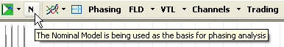
Nominal Model/Initial Cyclic Model toggle button
v29_1.jpg (10.08 KiB) Viewed 72 times
If the letter N is showing, THT is basing the phasing analysis on the Nominal Model. If the letter I is showing, THT is using the Initial Cyclic model.
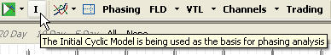
Initial Cyclic Model will be used for phasing analysis
v29_5.jpg (10.49 KiB) Viewed 72 times
I would recommend while testing the accuracy of the models that rather than constantly alternating between models you save a "nominal" workspace, and a separate "initial model" workspace. In this way consistent trading histories can be built up using each model.
The Initial Cyclic Model is not perfectly harmonic
Whereas the Nominal model is perfectly harmonic (each cycle wavelength is exactly 2 or 3 times the length of the cycle one shorter), the Initial Cyclic Model is not perfectly harmonic. This is because THT uses the actual cycle lengths found by spectral analysis in the data - if a wavelength is not fond, then it will use the closest wavelength actually found, which is not always perfectly harmonic (the reasons for this have to do with the limitations of spectral analysis - the subject of a separate post). This results in the ICM phasing analysis being a little more variable than a nominal model phasing analysis.
A sample comparison between Nominal and ICM analysis
The best way to understand the difference is through an example. I am going to use the ideal data that first alerted me to the opportunity of doing this, in the forum discussion here(thanks to Dennis who made the data available for download in that forum). This data is "ideal" in that it consists of only one 40-day wave. If THT uses the nominal model to analyse this data, this is the cyclic model it builds:
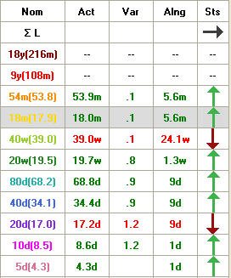
Current Cyclic Model based on Nominal Model
v29_2.jpg (31.42 KiB) Viewed 72 times
Note the numbers in brackets - they give the actual length of each cycle that the model is built upon, and here you will recognise them as the lengths of Hurst's Nominal model.
Also note that the true length of a nominal 40-day cycle is in fact 34.1 days. Because we know that the actual length of the one and only cycle in this data is 40 days, the question arises: why does THT find a cycle of 34.4 days? The answer to that has to do with the phasing analysis process of starting with the dominant cycle, in this case the 18 month cycle. THT looks for cycles close to the nominal length of 546 days (17.9 months, or 34.1 x 16). Because we are working with ideal data, THT finds a great trough (of the same "strength" as every other trough actually) at 560 days, and assumes that this is the nominal 18 month cycle. It works its way down through the cycles, and ends up with a phasing that looks like this:
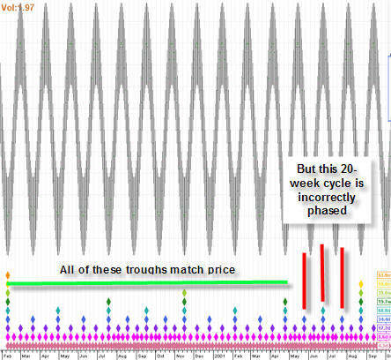
Phasing Analysis based on Nominal Model
v29_3.jpg (49.78 KiB) Viewed 72 times
Note that things look fairly good for the first 3 20 week cycles, but the last 20-week cycle has phasing which is quite obviously wrong. This is the issue raised by Dennis in this forum discussion. The reason is because THT is working to the Nominal Model, which tells it that the 18 month cycle should be close to 546 days.
Now let's take a look at the same data analysed with the Initial Cyclic Model. Here is the resultant Current Cyclic Model:
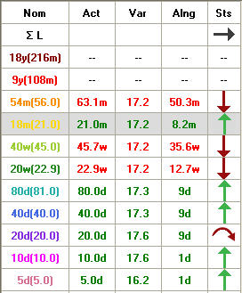
Current Cyclic Model based on Initial Cyclic Model
v29_4.jpg (33.67 KiB) Viewed 72 times
Notice the numbers in brackets after the nominal cycle length - these are the wavelengths found in the ICM, and you will see that they are more appropriate to the data we are working with - the nominal 40-day cycle is in fact 40 days long! Notice also that the harmonicity of the ICM is not as good as the Nominal Model. Notice also the Variance column (which is variance from nominal, regardless of the model used as the basis for analysis), and you will see that all cycles found are approximately 17% longer than nominal. Now let's take a look at the phasing analysis that results from using the ICM:
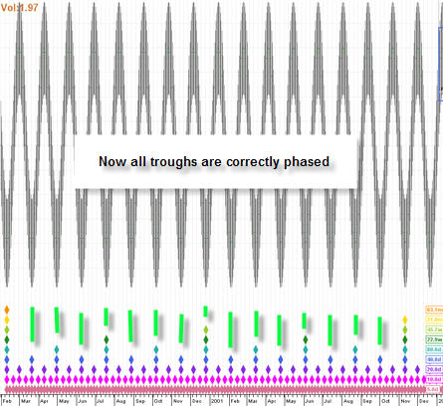
Phasing Analysis based on Initial Cyclic Model
v29_6.jpg (47.25 KiB) Viewed 72 times
You will see that all the troughs are correctly phased.
And so in summary
Using the Initial Cyclic Model to perform phasing analysis is closer to Hurst's theory and is what Hurst was doing in the Cycles Course. I abandoned the use of the ICM because I found it unreliable, but I'm very excited to re-introduce it into THT because I believe it will result in more accurate phasing analyses. Please test this on your data, and compare the phasing analysis using the Nominal Model to the Initial Cyclic Model, and let's see which works best and where I can improve on the ICM.
Using the ICM by default on new charts
You can switch between NM and ICM as explained above, but you can also change the default model used whenever you open a new chart by setting this option in the Options - Analysis tab:
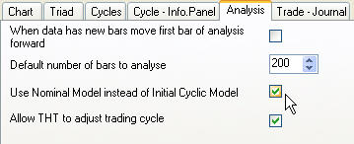
New Analysis Options
v29_7.jpg (14.29 KiB) Viewed 72 times
You will also see there several new options which relate to this forum discussion, as well as a setting that will prevent THT from changing your trading cycle, as per this forum discussion.
Finally, while we're talking about options, I have included this new option:
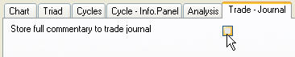
Trading Journal Option
v29_8.jpg (6.67 KiB) Viewed 72 times
This stores all the commentary found on the Trading tab to the Trading Journal every time an analysis is performed. I have made it optional because if you are backtesting you will find that your Trading Journal quickly becomes a very big file. This is in response to this forum discussion.

Re: Version 29 - Using the Initial Cyclic Model
by SentientDavid » Fri Jul 31, 2009 5:03 pm
Hi Pete.
What I mean by saying that the harmonicity of the ICM is not as good as that of the Nominal Model is that the cycle wavelengths of the ICM are not perfect 2, or 3 times the shorter wavelengths (not perfect harmonics), whereas the nominal model, because it is artificially constructed has a better harmonic wave structure. So in the example I gave, if you compare the ratios between the wavelengths, you will get this:
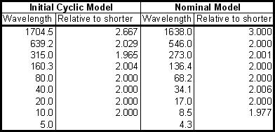
Comparison of harmonic ratios
v29_9.jpg (21.62 KiB) Viewed 52 times
The most that the Nominal Model varies from the ideal of 2 or 3 from one wave to the next is by 0.023, and that's between the 4.3 and 8.5 day cycles, however the ICM varies by as much as 0.333 in the longer waves. That's what I mean by the Initial Cyclic Model not having a harmonicity as perfect as the Nominal Model. It might seem like a small difference, but remember that here we're looking at ideal data. I've found that working with real data, the "error" between cycles can be quite a lot larger.

