Murrey Math Trading System Setting up Murrey Math Lines

Chapter One Part II B : Setting up Murrey Math Lines

Look at chart # 85A.. Chrysler. (C) (daily).

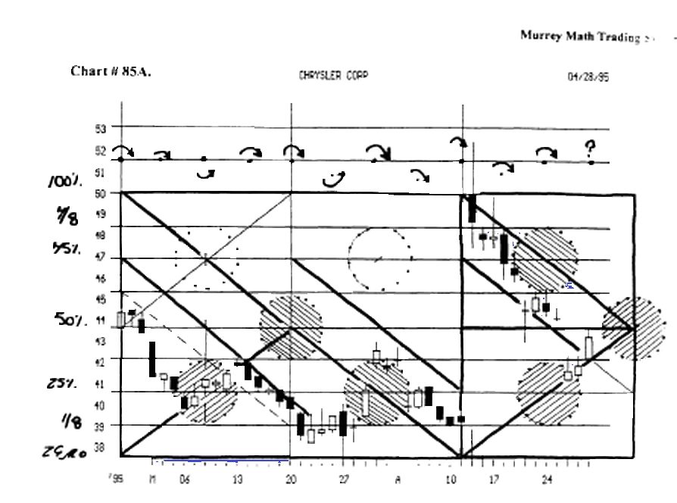
You may be thoroughly confused, but here is an explanation, that will clear up any confusion you might have, at this time

For the "perfectness" of this System, allows you to shift a 5/8 th Line to become a 1/8 th line, and now, they will art and react the very same.

Let's make up a stock and call it "Chrysler." And let's say that it is presently selling for 50, and its last high was 56.1/4, and its last low was 43.3/4.

Now. do you see the inherent problem ?

This stock was up to, and met major resistance on the 50 % Line in the 12.5 % section of (50.0 to 62.5) and it fell down through 50, but it found support at 43.3/4, which was the major support Line for the 12.5 % section between 50. and 37.5.

So, how do we play the rules that W.D. Gann set up, when we have a stock trading:

- near the major 50 % Line between 50. and 100.,
- m the lower 50.0 % of the next higher 12.5 %,
- down ni the upper 50 % of the next lower 12.5 %

We must first work through this dilemma, by first looking at it, from as current price of 50.

This signals us to be aware of the fact that it has previously run up through 50., and that it now has the potential to go up to only 62.5, and no more, because, we should never expert any stock to move up any higher than the next 12.5 % from the next lower one that it is next to.

It is currently setting on 50., so we must think that this stock might trade up as high as 62.5, and back down as low as 37.5. But our stock reversed up at 56.1/4 (50 % line) and it found support down at 43.3/4 (50 % Line).

Remember, we are using Gann's rules, but we are attaching them to our M.M.L. Lines, which in this case are actually pure math Lines that we have adjusted, because this stock has traded 100 % on Gann Lines, which are M.M.L Lines at the same time.

Let's set these lines on paper, so we might visualize, what we have just discussed.

56.25 100.0 % line 4/8 th 8/8 th
54.68 37.5 % line 3/8 th 7/8 th
53.12 25.0 % line 2/8 th 6/8 th
51.56 12.5 % line l/8th 5/8 th

50.00 50.0 % line 0/8 the 4/8 the
48.43 87.5 % line 7/8 the 3/8 the
46.87 75.0 %Line6/8th 2/8 m
45.31 62.5 %line5/8th 1/8 the
43.75 50.0 % line 4/8 the 0/8 the

Notice that 4/8 the = 8/8 the Line,
then the 2/8 the = 6/8 the line,
then the 50 % line = 4/8 the line,
then the 6/8 the line = 2/8 the line,
then the 50 % Line = the zero Line.

The only lines of contention, might be how one would trade the 1/8 th and 7/8 th lines the same as the 3/8 th and 5/8 th lines. But, we should be able to see, that since this stock is trading right on the major 50 % line, so, it will want to make up its mind 12.5 % on either side of this major, and minor 50 % line, so we may easily see how they are equal in their trading influence, although they are, in fact, different Lines.

Now, we may be expected to look at the current price of any stock, or market, and set each horizontal line (part of "Square in Time"), off its current low price, and how far above, (which means how many even numbers of MML. Lines it has traveled), and by above we mean above either a zero, 2/8th, 4/8th, or 6/8th, or 8/8th line.

So, the rule is to always set your horizontal Lines against your stock's current price-action, so that you have at least 2, 4, or 8 MML Lines above its low reverse, that is always set on even numbers (as we just explained in the previous paragraph).
««»»»«»»»«»»»»»«»«**«**»»»»*******»*»*»»*«»«**««
(exception: stock trading in narrow range rotating near major (MML) Line. You may use only 1 line above and below). (see chart # 179. Microsoft Corp.).

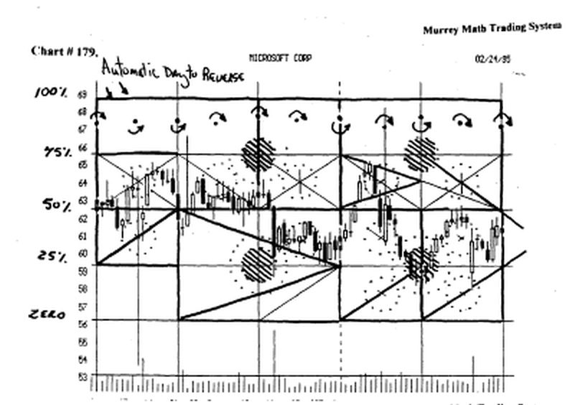

There is always the common sense rule that says occasionally, a major stock will get stuck in a narrow trading range, so we should remember to always trade on square at a time, before we get too far out ahead of ourselves, for we know that we can never, ever expect a stock to trade any higher or lower, on a short term basis, than the square it is currently trading in, and the next larger or smaller square.

lu slow markets, (see chart #111 Coca Cola K.O.)

that trade in a narrow range, we may keep our squares down to a minimum of 1 small square of 1.5625 M.M.L Line.

Using W.D. Gann's rule, we recognize, how long a stock will run laterally, before it breaks out, up or down. We would find out 2 things:

- when are the earnings coming out, and
- what is the general trend of the Dow 30 Stocks, when the earnings are reported.

These 2 factors will may be accelerated or nullified if they are antagonistic to one another, or parallel, when the earnings reports, are made public, or when the overall market goes against the direction of its earnings reports.

Now, before you raise your hand, let's solve the obvious question of how to figure out how to set our vertical Lines, against its current price-action.

Let's go back to Gann's simplest # 1. rule: take the extreme high and low...., so let's just do that.

And when we do, we must make sure that this total range shall be inside at least 4 vertical Lines, or 8 vertical Lines, that encompass the total high / low range of our stock's price action.
************************************************
Now, let's not "knit pick" this "eye-ball" rule.

If a stock trades just 39 cents above or below any even vertical M.MX. Line, then we should not get too "excited" about this feeble attempt to "break out" into a new direction.

But contrarily, if a stock moves just 19 cents, into an odd number vertical line, should immediately add 2 Lines to make sure that the number of vertical Lines count up and down, above or below its current price, to 2, 4, or 8 MML Lines, and making sure that they take in all the trading action (high and low), making sure that we always start on an even numbered Murrey Math Line.

We set up these Murrey Math Lines starting at 100, with a square of 100. (vertical) and 100 to the right, to make a "Square in Time."

We then found the 1/8 th M.M.L Lines to be: 12.5, 25.0, 37.5, 50.0, 62.5, 75.0, 87.5, and 100.

But, the Murrey Math Trading System, doesn't stop here. We need to divide this 12.5 by 8, as we did earlier, and found it to be 1.5625. We know that, even these minor 1/8 in lines, react exactly, at this minor price-action, as 12.5 would be expected to exert the same pressure on a stock that was trying to get to 100.

The Appropriate Color for each 1/8 th Line are: (M.M.L. Line) 12.5 to zero (1.5625)
12.5 8/8 th Line 100.0% Line Blue 10.93 7/8 in Line 87.5 % Line Yellow 9.37 6/8 th Line 75.0 % Line Pink 7.81 5/8 th Line 62.5 % Line Green

The Appropriate Color for each 1/8 th Line are: (M.M.L. Line) 100.0 to 87.5 (1.5625)

100.0 8/8 th Line 100 0 % Line Blue
98.43 7/8 th Line 87.5 % Line Yellow
96.87 6/8 th Line 75.0% Line Pink
95.31 5/8 th Line 62.5 % Line Green
9375 4/8 th Line 50.0% Line Blue
92.18 3/8 th Line 90.62 2/8 th Line 89 06 1/8 th Line 8750 Zero Line
37.5 % Line Green 25.0 % Line Pink 12.5 % Line Yellow
Blue
«••«•«•••«••••«••«••••«•••a*»*»»********
Now, you are able to start with any stock that is currently trading at 80.00 (see chart #111. Marsh Mc Cellar (M.M.C.) and work off the major M.M.L. Line, then back track to the intermediate 8/8 th division (12.5 %) from 87.5 down to 75.0, then divide this 12.5 % division, into its equal 8/8 ths division of minor M.M.L. Lines.

But, to make our trades more accurate, when we enter or exit, we must divide each 1.5625 into' its 1/8 th percentage of each:

1 £625, which is .1953125 (1/8 th)
1/8 th of 1.5625 = .1953125 (overshoot)
2/8 th of 1.5625 = .39 (pivot)
3/8 th of 1.5625 = .59 (enthusiasm)
4/8 th of 1 .5625 = .78 (minor 59 % Line)
5/8 th of 1 .5625 = .97 (enthusiasm)
6/8 th of 1.5625 = 1.17(pivot)
7/8 th of 1.5625 = 1.36 (overshoot)
8/8 th of 1.5625 = 1.5625

It is critical that you learn these lines down to an increment as small as 19 or 39 cents.

See the Quick Reference Sheet for stocks that give you 19 cents and 39 cents reversal signals:

Then you will know the exact rhythm for your stock, (that is trading above 12.5) at all times. (Stocks trading below 12.5 point, must be traded within four separate trading ranges, inside their zero to 12.5 (100%) range).

We shall address the 4 divisions later, under the section: Stocks trading Below 12.0 to Zero.

We need to make one small point about a small argument, between 2 "fundamental traders" as they were in a quandary, over the fact that all of my mathematical numbers, don't always match up to either 1/64, 1/32, or 1/16, or 1/8, or 1/4, etc., of a whole number.

I calmly said, "Just take the closest 1/8 th of any number, and keep on trading, and don't forget to take a profit, when it runs up." (enough said).
There are numerous exact observations that may help us determine, if 19 cents, or 39 cents, is really significant enough, for us to enter or exit a trade, based on such an insignificant amount such as 19 or 39 cents.

Remember now, that we are speaking only for stocks that trade above 12.5 in price, when we make these applications at this time, and they are:

W.D.Gann said on page 71. "1861 - Last Low in June, 55c; holding 5c above the double Bottoms, indicating strength and getting support just under 56c. The 100 % advance on the base of 28 was an important buying point 1863 - wheat crossed $ 1.00 per bushel, made high at 112, and later in the year broke back under $ 1.00 again. Declined to 80 c, which was the last low before the big advance started. This was 5c under the half-way point of 170."

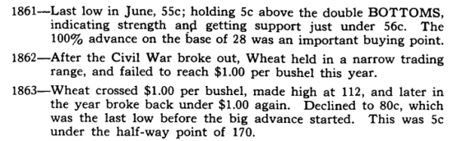

We have just ask you to divide 1.5625 by 8, as a part of a perfect fractal, so you must divide 1.5625 by 8, and we get. 1953125.

Now, when we divide 19.53125 by 8, we get 2.441414, or 1/8 th of 19.53125.

2.4 cents = 1/8 th of the next higher square Fractal.

But, W.D. Gann said that we should always watch for pivots (reverses) at 25, 50, and 75 % lines, within a high/'low range of fluctuation.

Gann told us that if wheat did this or that on a 5c (5 cent) move up or down. and could or could not hold, then, if wheat was selling for under S 1.00 per bushel, then he knew what I know, but he just refused to tell us mathematically, so we could relate, what he said to what was "really" going on.

Or, sadly enough, Gann really didn't carry his logic of what he knew, to its automate fractal, and divide each perfect 12.5 % (1/8 th) by itself.
After all, his mentor, Fibonacci, (1124 a.d. Italy) had seen it, (the "classic 12.5 multiplier), and recorded his findings, for the whole world to see, after he had learned the obvious, from the Egyptians; who had learned it from the Mayan Indians, from Central America.

The problem with "buy and hold" investors, or "fundamentalists" or "liberals" is that they always skew the obvious, to an ahrmstic truism, that once you generalize the truth, it loses its relevance, to what you are trying to do: and that is to be precise enough, to always make a profit.

Since 50 % of all Americans possess an I.Q. of (between 90 - 110) and Charles Murray, just presented a book, stating that 120,000,000 million Americans have this level! of I.Q., and a moron is down at 70 - 80, then the average person you "greet" on the street, is closer to dumb, than they are to smart, since I.Q. is set on a bell curve, (no matter what your race).

Please, if you have to ask what a "bell curve" in statistics is, please move to the back of the room, and feel good, that I have found a trading system, that allows you, (no matter how smart you are), to trade every stock, or market, off the same math lines, and the same set of rules, without being smart

So, we may follow the trail back from W.D. Gann (1910), all the way back to Fibonacci (1124a.d.) and find that every time, some "genius" figures out the market the general public, or some writer, will always start rounding off the truth to a colloquialism.

And by the time you have read exactly what I say, you too, will want to put your own "slant," on the mathematical truth, and once again, this book will get tossed in the corner, for the same reason, that every generation, of young investors. has to learn all over. Like a "baby," that one must have rules, and stick with them. all the time, to be able to do the 2 simplest things that keep you in the game, and they are too simple for the average inexperienced trader to follow:

never risk more than 10 % of your capital to put at risk on one trade,

b) never stay in the same direction, in the same trade, when it is going in the opposite direction, of the way you expected it to go.

Nicholas Leeson, is the most famous "trader" in the world for disobeying these 2 cardinal rules of trading.

He took down to bankruptcy, one of the world's oldest, most conservative banks, by trading in "derivatives" which by definition, means that no one really knows what the hell they mean, much less what they are going to do in the future.

This young man (not a trader) didn't have enough "experience" to follow the 2 simplest rules of "common sense" trading.

The bank and the young man, will spend the next 12 months in court, and sort out, who did what to who.

When they need only to ask one another, the 2 most basic rules to trading anything.

Just think, as soon as the Nikkei Dow reversed against him, had he reversed, against himself, with the same amount of contracts, he would had made a "wash" of his position, and he would have come out just losing his lunch money, but since he was young and immature and a male, his "ego" wanted to keep trying to vindicate his original position, so that he wouldn't be proven "•wrong" in the eyes of his fellow traders in the office.

Plus, he couldn't measure "time" in perspective to what he had at risk, for he didn't make his price objections out into the future far enough.

He ran out of time, and money and brains: all on one weekend.

If anyone had gone opposite Mr. Nicolas Leeson's positions, which the same amount at risk, they could have called and thanked him, for making them 1 Billion Dollars in just 3 months time.

Please remember that the "female" personality and the "true trader" will recognize one aspect of trading any stock or market, (which is the failure of most men), and it is that of admitting defeat in front of other traders.

So, one should early on, learn to never tell anyone else these 3 truisms of "investing:"

1 ) never tell anyone, when, or how much you win,
- never tell anyone, when, or how much you lose,
- never tell anyone the truth about what your current position is, or how much you have in it.

People love to know that you are not luckier than they are in investing,

They don't even want you to be lucky in love.

If you have read any book, by any "expert" out there, he will tell you that he has the "sure fire trading System" to beat all the markets

But the proof is in the result of all the investors out there, for 85 % of all commodity trades are "losers."

And 85 % of all stock trades are losers, since 75 % of all stocks go down, 5 days after the average investor enters a position.

But, the only thing that saves a "Buy and Hold" investor, is the fact that he may go home each night and tell his wife, that he is "worthy," for he has made a great long term position, that is currently falling back for support, that shall bring large profits, out into the future.

Every "inexperienced trader" needs to do 2 simple things, before they jump into this world of trading:

1 ) never take anyone else's advice, especially a broker, who is an active trader,

2) trade on "paper" for 20 trading days using an exact set of rules, that you never break.

This trading System is simple, for we keep all the rules simple. This is the key to winning trades.

We must get back to our subdividing our 1/8 th M.M.L.Lines. into the next lower division which is:

The Appropriate Color for each 1/8 th Line are: (MML. Line) .1953125 to zero (.024414)

1953 8/8 th Line 100.0 % Line Blue
1708 7/8 th Line 87.5 % Line Yellow .1464 6/8thLine 750% Line Pink . 1220
5/8 th Line 62.5 % Line Green
.0976
4/8 th Line 50.0 % Line Blue
37.5 % Line Green
25.0% Line Pink
12.5 % Line Yellow Blue

Now, for those traders who must trade even closer into and additional minor M.M.L. Lines we divide:

The Appropriate Color for each 1/8 th Line are: (MML. Line)

.024414 to zero
.0244 8/8 th Line 100.0% Line Blue
.0213 7/8 th Line .0183 6/8 m Line .0152 5/8 th Line
87.5 % Line Yellow 75.0 % Line Pink 62.5 % Line Green
.0122 4/8 th Line 50.0% Line Blue
.0091 3/8 th Line 37.5 % Line Green
.0061 2/8 th Line 25.0 % Line Pink
.00305 1/8 th Line 12.5 % Line Yellow
.0000 Zero Line Blue

Now we are able to trade any stock, or market, within any set of MML. Lines, that are compatible to its current trading price.

As your stock, or market, increases in price, we must only adjust our trading rules to match the next larger square, that allows us to have 4 MML. Lines, above and below, its current price: as long as we start on either a zero, 25, 50, 75, or 100 % line.

As you remember, if a stock trades in a narrow range, we must always, first trade every stock, or market. from inside the square it is currently priced.

We must address the simple fact, that some traders, are having a little trouble trying to reset their mind's number from 1/32 to 1/100 ths of the same point.

We must accept the fact that the bond market has always held on to its 1/32, just as men have always traded them,

So now, we may be a little bit confused by the mathematical translation from exact fractal math, to 1/32, 1/16, 1/8, 1/4, 1/2, 5/8, 3/4, or 7/8 th of a whole.

It isn't necessary to "arm wrestle your rrund," over the fact, that some of my mathematical lines, are not right on, precisely with the 1/32 increment division of a whole number.

So, we shall have to just "eye ball," the small differences, when we speak with our brokers, when we try and enter and exit a trade.

Besides, just 5 minutes before you picked up this book, you weren't even aware, that you had to be 1/2 as precise, as you are now asked to be every time you enter or exit a trade.

Please don't spend much time trying to be any more precise than to make sure that you are always in a trade that is going in the direction you expect it to.

Besides, W.D. Gann said on page 15. "Learn to follow the trend and you will make a success....Follow the trend of the market. Be as willing to sell short in a bear market as you are to buy in a bull market."

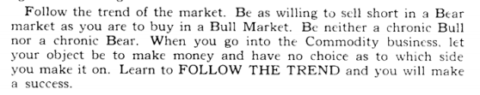

We shall discuss, precisely, in exact detail, a little bit later, under Exact Price Entry Points, how an exact price point, of an exact proportion, of a M.M.L. Line, shall trigger a signal, for us to be ready to enter or exit, a position.

Stocks Trading From the Ceiling of 12.5 to Zero The Appropriate Color for each 1/8 th Line are: (M.M.L. Line) Wide Band (12.5 to zero)
12.50 8/8 th line 100.0 % Line Blue 10.93 7/8thLine 87.5 % Line Yellow 937 6/8thLine 75.0% Line Pink 781 5/8 th Line 62.5 % Line Green
6.25 4/8 th Line 50.0% Line Blue
468 3/8 th Line
3.12 2/8 th Line
1.56 1/8 th Line
000 zero Line
37.5 % Line Green 25.0% Line Pink 12.5% Line Yellow Blue

Stocks Trading From the Ceiling of 6.25 to Zero

The Appropriate Color for each 1/8 th Line are: (MML. Line) Wide Band (6.25 to zero)

6.25 8/8 th Line 100.0 % Line Blue
5.47 7/8 th Line 87.5 % Line Yellow
4.68 6/8 th Line 75.0 % Line Pink
3.91 5/8 m Line 62.5 % Line Green
3.12 4/8 th Line 50.0 % Line Blue
2.34 3/8 th Line 37.5 % Line Green
1.56 2/8 th Line 25.0 % Line Pink
.78 1/8 th Line 12.5 % Line Yellow
.000 zero Line Blue

Stocks Trading From the Ceiling of 3.12 to Zero

The Appropriate Color for each 1/8 th Line are: (MML Line) Wide Band (3.12 to zero)

3.12 8/8 th line 100.0 % Line Blue
2.72 7/8 th Line 87.5 % Line Yellow
2.33 6/8 th Line 75.0 % Line Pink
1.94 5/8 th Line 62.5 % Line Green
1.56 4/8 th Line 50.0% Line Blue
1.16 3/8 th Line 37.5 % Line Green
.78 2/8 th Line 25.0 % Line Pink
.39 1/8 th Line 12.5% Line Yellow
.000 zero Line , Blue
Stocks Trading From the Ceiling of 1.56 to Zero
The Appropriate Color for each 1/8 th Line are: (M.M.L. Line) Wide Band (1.56 to zero)
1.56 8/8 th line 100.0 % Line Blue 1.36 7/8 th Line 87.5 % Line Yellow
1.17 6/8 th Line 75.0 % Line Pink
.97 5/8 th Line 62.5 % Line Green

price percentages, which are an exact percentage of a lesser or greater exact price.

We are trying to dispel the 2 theories that:

- the "pure fundamentalists" espouse, and that is that
the driving force behind all stock movements (up or down) are "good" or "bad" fundamentals reactions,

- I want to totally erase, from your mind, any notion, in the slightest, that all markets are either "chaotic" or "random."

- My studies prove that everything that is "publicly" traded, has an exact mathematical rhythm, at which it wants to trade, on an exact proportion, of a greater or lesser exact 1/8 th of a perfect fractal square.

Enthusiasm makes a stock run above the line, and bad fundamentals pushes a stock below the line, on "weakness" or "bad news."

(We shall discuss why a stock or market, would run up above or below, a major Murrey Math Line, and barely pass the line by 19 cents or 39 cents, then suddenly, reverse, and nm in the opposite direction, of the MML Line, it has just passed, in the section called 19 Cent and 39 Cent Reversals.)

The most "classic" example of how the rhythm changes, when it moves from one set of 1/8 th lines to another, is back in Mardi,'1987. when the S & P 500 Cash Market moved up, from 200., to 250., and higher. (see Figure J. ).

When it traded below 250., we set our major MML. Lines at 12.50, points per 1/8 th. Then, when it moved 1 point above 250., we had to draw our 1/8 th line at a width of 15.625.

Had the market run up and down through this line, we would have kept our 12.5, MML. Lines below the line, and our 15.625 1/8 th above the MML. Line.

No one has ever asked you to set the exact rhythm for a stock, and then, as soon as it goes through an exact price range, into another, you are immediately asked to "shift gears" into another width l/8th of a larger 8/8 ths.

But, we proved that everybody is already doing the very same thing, in their everyday life, when they consider buying anything such as: tomatoes, clothes, cars, or even the home they live in.

It only stands to reason, that if one were to see that all stocks, or markets, are running concurrently in the "3rd dimension, of its current price, and a lesser 1/8 th, and a greater 1/8 th, then one would assume that there is an exact price, where the rhythm, will increase or decrease, based on the fact that, you are already doing the same thing in your everyday life, when you actively buy and sell, or "barter" all items that you choose to buy to make your life more efficient.

Another "revelation'' one might deduct, from the fact that all stocks are trading on exact mathematical prices, is that, if we are in a position in a stock, and this stock splits, we don't have to reset our Murrey Math Lines.

Can you imagine that ? Please take a minute and think about it ! That's long enough.

Let's take a stock, that is trading at 56.1/4, and at the end of the trading day, it shall be split, two for one, for whatever reason.

This price 56.1/4, is a major 50 % line between 50. and 62.5.

When it splits, the price now becomes 28.125, which a 25 % (pivot) reverse line.

Both of these prices are (pivot) reverse lines, that W. D. Gann said we should expect to see a stock get support or resistance more frequently, as it trades within its "range of fluctuations" from any extreme high or low.

When our stock was trading at 56.1/4, it was just above the 50 % line, between 50. and 100. And when it split, and started trading down at 28.125, it was above 25., between 25., and 50., to the exact proportion, as it was trading at 56.25.

When we look back to our Quick Reference Murrey Math Lines, we see that our stock has automatically shifted from a 50 % (M.M.L. Line) down to a purely mathematical 1/8 th, of the 1/8 th range between 25., and 50.

Why did we use 56.25, for our example ? simple !
it is easy, for any novice, to see the correlation between 2 numbers that is an exact proportion, when it is setting on a 50 % line, but is it true, when the pre - split price is set on a 1/8 th, or 7/8 th line ?

Let's look at 100., when it splits to 50.; and 75., when it splits to 37.5; and 62.5, when it splits to 31.25; and 87.5, when it splits to 43.3/75, are all splits that hit exactly on Murrey Math Lines.

So, it stands to reason, that if it splits, and lands on 4 exact Murrey Math Lines, all other prices are proportional, although, they don't touch and exact Murrey Math Line.

Remember, that when it splits front 56.1/4, down to 26.125, we don't reset "anything."

We simply expect this stock to trade above 25., which is a major 25 % (MML. Line) between zero and 100.

But, if it can't hold 25., then it is not considered worthy to try and ever get to 37.50, much less up to 50.

Exportations of Your Stock (Higher Prices) Based on Its Current Price Trading Range If it has Never traded up in a higher range
One may listen to C.N.B.C.- T.V. for just one week, and some "expert" on their market, will see a stock, or market, that has never traded up in a higher price range, so there is no price range data numbers, that may give us a predictable upside expectation, and they will tell us. that one is unable, to tell, when to expect it to top out, in the future ?

Well, by now, you may already be thinking, that we now have a purely mathematical trading System, that will automatically tell us how far up above any new high, we may expect our stock to run up, before it gets over bought and retraces, back down, for support, and consolidates, before it runs back up a second time, to try and break out to higher highs.

You may, or may not, have forgotten, that I have already told you the answer. in another portion of this book, but just as W.D. Gann, in his writings, was subject to reiterating basic trading premises, several times, I must do likewise, so that you know how to integrate all our rules into a consistent, cohesive, comprehensive trading System, that adequately addresses every trading probability, from where it was. to where it is, to where it wants to go, into the future.

First: Fibonacci, said that all markets, would want to run up, or down, in a proportion of 12.5 %, orl. 125 % of a significant high or low extreme.

Since we know that all stocks, or markets, are trading on exact mathematical price percentages, of 1/8 th of a perfect fractal square, we would expect to multiply our 12.5 %, or 1.125 % off the 12.5 %, 25 %, 50 %, or 100 % Line, within each perfect fractal square, (see Figures R, S, or T).

Let's see if Fibonacci was correct in his observation, of where he expected our stock to run up or down, back in Italy, in 1124 a.d.

12.5x1.125% = 1.5625 (1/8thof 12.5) 25.0x1.125% = 28.125= 3.125 (2/8 th of 12.5) 50.0x1.125% =56.25 = 6.25 (4/8 th of 12.5) 100.0x1.125%= 112.5 = 12.5 (1/8thof 100)

Now, we deduce, that we shall be able to predict, that every stock, or market, shall not be expected to trade up any higher, into uncharted highs, by anymore than 1.5625, 3.125, 6.25, or 12.5, above its all time high, when it hits any 1/8 th of its perfect fractal square, it is currently trading

Again, we need several examples to solidify this "revelation" that all stocks, already know how far they want to run, as soon as they reach any particular

M.M.L. Line.
,
The days of guessing where your stock will run up or down, are over.

We need to change our mind - set, from pure fundamentals, to pure math. And when we convert to math, everything your stock, or market does, is predictable. down to the N th degree (price).

So, after any stock breaks above this perfect fractal square, you should never expect it to trade any higher than this 1/8 th, of the next bigger square, it has moved into.
************************************************
Please commit to memory the following price momentum expectation for any stock, or market as it moved up in price through time:

a) all stocks trading at 12.5, or below, must be divided into 4 categories that it must move above, before you might ever expect it to go up any higher, into another price range, and they are:

- zero to 1.5625, (divide this range by 8)
- zero to 3.125, (divide this range by 8),
- zero to 6.25, (divide this range by 8),
- zero to 12.5, (divide this range by 8),

b) Zero to S 25. (remember that no stock shall ever run in the "true rhythm" of its potential until it moves 19 cents higher than 25., and trades above this line for at least 4 days in a row, then moves into this new territory).

25.0, is actually 25. %. of a perfect fractal square set on the base 10. (remember to stay in the rrund set of zero to 12.5, then 12.5 to 25., until it closes above 25., for at least 4 days in a row, and holds, then moves higher.

We should not expect our stock to trade up or down, in momentum, any faster than the Fibonacci "golden section" rhythm of 61.8 or 38.2 (but since we live on Earth, we must shift back to 62.5, and 37.5, because Edwin Hubble told us to shift to a pure mathematical percentage because the specific gravity of the Earth takes ont the "wobble" as it trades through time into the future, (we shall discuss each exact Fibonacci "golden section" in the chapter on Pure Mathematical Percentage Exportations.

Remember that the First perfect fractal square, shall be set at 100.

The next square shall be 1.000. and the next square shall be 10.000., and then 100,000.

Since the Nikkei Dow, has never traded above 50,000., we don't have to worry about setting our squares any higher

Common sense says, that, if we set up a pure math fractal square, within which we may predict the mathematical rhythm for the Nikkei Dow, then every stock, or market, below it, shall trade in the same rhythm, that the Nikkei Dow did as it moved up from 100., to 1,000., to 10,000., to 100,000.

c) Zero to 50.. This is the major resistance line, for any stock, trying to make it to 100.. (now, we are able to shift our Fibonacci "golden section" into a higher rhythm (as soon as it crossed 25.) to the rhythm set for a stock trading from zero and 100., which we shall discuss, in detail later.
•
d) Zero to 100. We set all of our Fibonacci "golden sections" off 62.5 and 37.5 moves, as it trades into the future.

We shall discuss these percentage runs, later, in Chapter 8. Harmonic Rhythm.

Indexes Fall into One of Three Mathematical Pure Fractal Squares which are:

a) Zero to 1,000., which includes most of the traded Indexes. We must remember to keep our mathematical rhythm for any Index down at 12.5 per 1/8 th, until it reaches 250., then we must divide 1,000. by 8, and use 125, or 15.625, as 1/8 th, for the trading rhythm. We must see this pure mathematical rhythm shift, in order that we trade on the exact rhythm, every time it moves into a higher priced area, within in each pure fractal mathematical square.

Look at Figure J. S & P 500 Cash (Mardi 1987). This chart was copied from page 48., from J. Welles Wilder's book, The Atom Theory.

I didn't even know that this mathematical law of nature existed, back in 1987, and it is still in effect.

So, we must expect a tree to make a noise, if it falls in the woods, even if no one is present ! You decide.

Please notice the "incredible revelation" that are evident, when we study this index more closely. Let's put into practice our pure mathematical fractal square "theory" into practice, by placing a line 12.5 points below 250., and a line 15.625 above 250.

The zero line is 250

Notice that the height of each square, below, and above, the zero line.

The height of the lower horizontal line is 1 inch, and the height of the upper horizontal line, is 1. 1/8 th inch tall.

And we have set our "Square in Time" the very same way, but off 12.5625 points below the line, and 15.625 points above the line.

You see that it reacted to the "Babson" momentum lines,(diagonal dashed lines), on both sides of 2 different squares.

Isn't it interesting, that I never discovered that this "natural" rhythm existed, or much less that it would shift gears, when it got one point past 25 % of any perfect fractal square, which in this case is 1,000, which makes the 25 % line to be 250, as we have just discovered. 2 paragraphs prior, especially since I discovered it just 18 months ago.

Remember that all Indexes trading below 250, must continue to trade on the rhythm of 12.5, until it passes 250.

Now, we must be able to draw our "Square in Time," off our standard Time lines, and run our vertical lines forward and backward, and that we shall draw our equal angle triangles off each even Murrey Math Line, so that we might set the rhythm, as it runs to the high through time.

Look at chart # 200. S & P 500 Cash Market. (4 Months chart). and chart # 201. (daily).

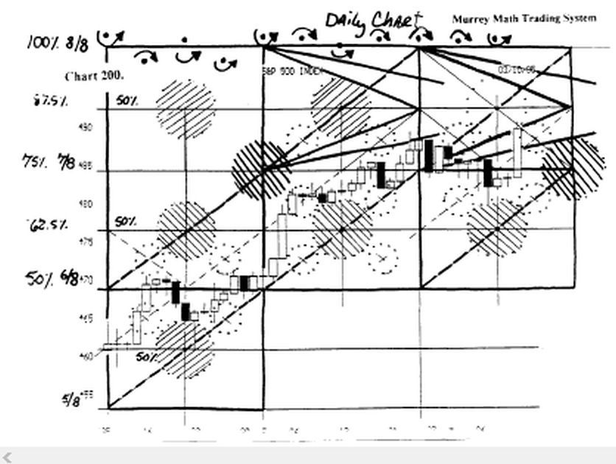

We see that our base is the 50 % line (4/8 th) 437.50 line Please refer to Quick Reference Sheet # J.

The top line is set at 500., which is the "major" 50 % line of our perfect fractal Square in Time of 1.000.. Our base line (zero = 0/8 th) is 437.5

Now, since the base line is a (minor) 4/8 th line, and the top line is a (major) 4/8 th line, we would use each (minor) 50 % line, which are: 445.31, 460.93, 476.56. 492.18. We would, now, assign 1/8 th, 3/8 th, 5/8 th, or 7/8 th lines.

These are actually (M 50 % lines) as described by W. D. Gann, as being great resistance and support levels for your stock, or market to reverse.

Please find (A) and (6), and you will see that this index reversed 2 times exactly on this minor 50 % line.

Now, back to the main topic, at this time, on the shift of rhythm, we would expect our 1/8 m lines, to be set at 1/8 th of 1,000.

Then, 1/8 th of 1,000. of 1,000. = 125.
Then we divided 125. by 8, and we get 15.625.

62.5 from 500.0, we get 437.5, which is a (minor) 50 %
If we multiply 15.625 x 4, we get 62.5. If we deduct 62.5 from 500.0, we get 437.5, wh of a (major) 1/8 th, which = 125.

We are trading on the perfect fractal Square in Time of 1,000., which is 125, or 15.625, or 1.953125, or .24414.

If we were to trade on an intra-day strategy, we would watch for reverse signals on 25 % lines (.488) above, or below, any minor or major Murrey Math Lines.

Please refer to Quick Reference Sheet T

We see that the 25 % line shall be .488 of 1.953125.

b) zero to 10,000. The Dow 30 Stocks falls under this pure mathematical fractal square. The 25 % line for Indexes trading inside this square is 2,500. We must divide 10,000, by 8 and get 1,250. Then we divide 1,250 by 8, and we get 156.25.

We must expert this Index to run 156.25, then meet resistance and support.

Look at chart # 143. Dow Industrials (weekly) (3 year chart).

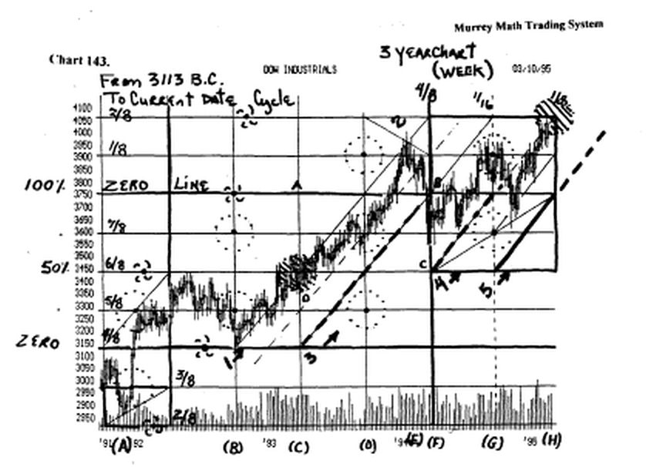

I have conveniently written (zero Ime) alongside the 3/8 th line (3,750), which we know is 37.5 %of 10,000.

Then we court above and below this zero line, every 156.25 points to set the Murrey Math Lines, within each 1,250 points.

Now, if we use all of W.D. Gann's other rules, except his # 1. rule, we shall be able to set and find the exact rhythm for this market using nothing but math on a vertical plane, and by using the seasonal rhythm of all markets, against the 3rd quarter of the U.S. 30 Year Bond Market.

Looking back to January,'92, at (A), we see that it bounced off a diagonal line, which was in the center of a "circle of conflict" which just happened to be at the very same time as the "January Effect," which W.D. Gann said on page 58. "January 2nd to 7th and 15th to 21st,: watch these time periods, each year and note the high and low prices made. Until these high prices are crossed or low prices broken, consider the trend up or down."

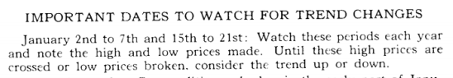

Look at chart H 144. Dow Industrials (daily).

We see that the Dow closed up at 3,925., then it reversed, and fell back for support on the 21 st date at the 50 % line, on the day down at 3,8270, and closed the day back up at 3,866., which was the 75 % line. It spent the next 7 trading days, trying to get support, and not fall below the day.

Remember that W.D. Gann said was the last time in the month, for the Dow to hold for support, for this market to continue as an up market, and it made a "double bottom" on the 5 th day, after the low on Jan. 23 rd,'95, it formed a "doji" on the next day, then another "doji" on the cycle pivot day, at the end of the square, at (D.), and we see that it bas gapped up on an incredible demand for Dow 30 stocks, and was up as high as 70. points during the middle of the day.

So, we must expert 3,905.75 to be major support on the down side, should this market fall back for support, on the next pull back. 3,905.75, is a major (1/8 th) above the 3/8 th line 3,750., so we would expert great support on this line.

Remember that the 1/8 th line is weak, and that this market would have run up only 1.1/2 ths, if it moves up to 4,062.5, which is the 2/8 th line, which is the next pivot line above 3.750.0.

Notice, that at (H.) it stalled for the day. right on the (RI) line. (see figure B.). It must close above this line, to get outside of the influence of this equal angle triangle, inside its current square in time.

The critical price, for direction, for today, and tomorrow, shall be the price inside the upper right " major area of conflict," which is 4,043., which is the pivot price, for the Dow, for direction. We must remember that this week is triple "witching hour" for all options traders, so we shall see some wild swings, in "position" traders' action, for they shall have to even up their positions, against the last move up in the Dow 30.

Just a note of confirmation for the validity of the equal angle triangle, is seen most graphically, by the struggle that the Dow had in the previous square, along its (RI) line, for 9 days into the next square, until it finally broke "free" of its influence at (G.) on the 50 % pivot day, in the middle of this last square, which just happened to be in the middle of the "major area of conflict" and it needed confirmation of direction, with no pressure on it, and when it was free of that pressure, it burst up to a new all time high, this past Friday.

Look at chart # 143. Dow Industries (weekly) (3 year chart).

Notice that the Dow ran up to the 6/8 th line, till June/92, then it fell back at (B), in August,'92, on the 4/8 th line, then it reversed, and ran all the way up to (C), and ran into a "major area of conflict" in April,'93, and it had to "think about it," then it bounced off the upside momentum line.

Then fell back to the 6/8 th line, then it ran all the way up to the "minor area of conflict," in October,'93, at (D), then it ran all the way up to the 5/8 th line, at (E), then it reversed, and fell back for support, down on the 7/8 th line, at (F), then it moved up along the upper momentum line, and closed above 3,750.

Then it closed back down at the 7/8 th line, and bounced off the 7/8 th line, and ran back up to the "minor area of conflict" in October,'94, then it fell back for support, and retraced back up off the 45° angle off a square, at (G), and it ran back up for a new high, at (H), right into a "major area of Conflict."

This market is running into 2/8 th line, after it has just run up almost 3/8 ths, plus, it is running into a "major area of conflict," plus the U.S. Dollar is struggling, against the other world currencies, and the U.S. Bond Market must move to prop up the Dollar.

Plus, everyone starts thinking about selling stocks about now, to pay their taxes, so we must watch this present advance, to see if it stalls out up here, and falls back down to die 1/8 m line for support. Anyway, by all standards, we are late into this move to the upside, to try and get excited about going long on many stocks.

Look at chart 143 A. Dow Industrials, (2 Year chart) (weekly).

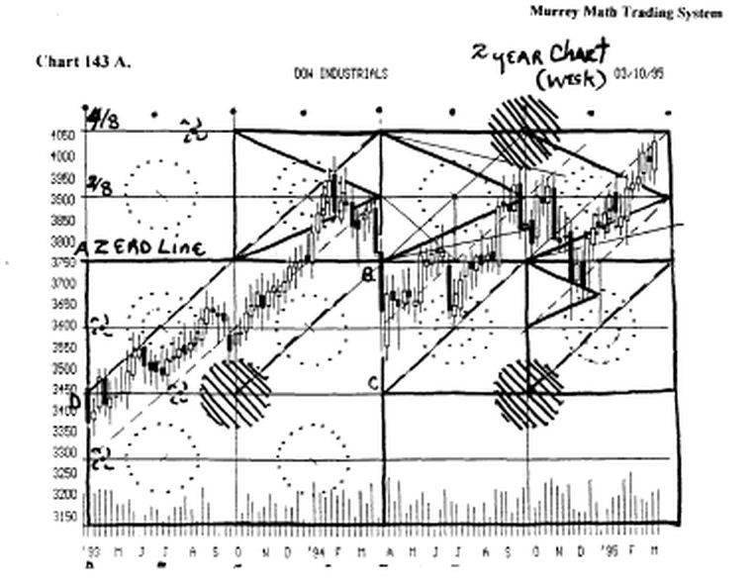

We have just shifted from a 3 year chart, to a 2 year chart. Just look at it for a few minutes, and marvel at the simple truth, that this market finds support and resistance along Lines that we have already covered in figures A., B., C., D., E., F., G., H.

The most astounding "move" is seen at (B.), when it worked its way around its "minor area of conflict'¹ in July/93, and finally, broke free for good, as soon as it cleared 3,600.0, then it fell back toward the (C.) at the "major area of conflict," then it took off, up toward new highs.

Now, you tell me about another trading System that sets 2 parameters off no fundamentals at all, and it still rotates around one of our "minor areas of conflict."

You may think, that I just draw a bunch of squares, then a bunch of Lines, when I see the rhythm, after it happens, but, hey listen, this trading System, is for traders, not fortune tellers. We want to know the "trend," then we trade with it, until it stalls out.

My 2 parameters are:

- the start of the 3rd quarter of the Bond Market,

- talung a pure mathematical fractal square, and dividing it by 8, then dividing this 1/8 th by 8, again !

Look back at (B ) and we see that this index rotated around our circle for 13 straight weeks, before it broke free. of the influence of this "minor area of conflict."

Look back to figures A., B., C., D., E., F., G., and H., to see that all of my lines are set off the laws of rhythm, of the Universe.

Look at chart # 141. (Dow Industrials) (weekly) (9 months).

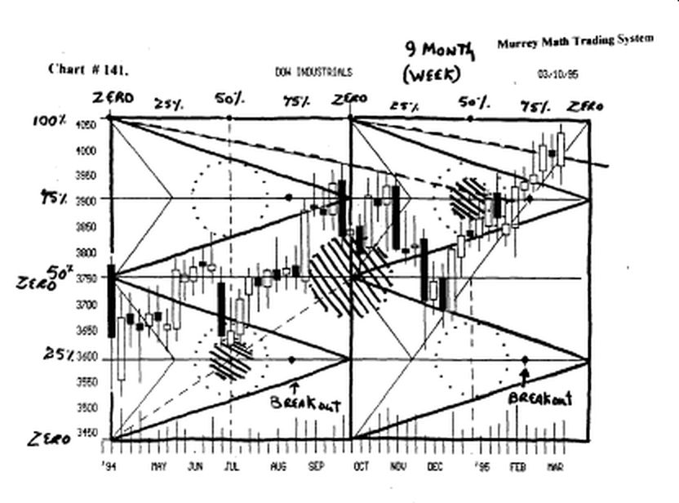

This is a "traders" view of this Index using the same squares, which signals, when we must expect to enter or exit any position.

Refer back to figures A., B., C., D., E., F., G., and H., and find the equal angle triangle, then locale the "break out" time, which is the 75 % line, of each triangle. You tell me if it was a good signal, or what?

Notice that back in July,'94, it reversed right on the 50 % line, and picked up upside momentum on the 75 % line, later in August,'94.

Look at January/95, and how the Dow Industrials had to struggle to break above the "circle of conflict" inside its equal angle triangle, and it took 5 weeks, to break free, and move up to an all time high, as soon as it got to the 75 % in time line, which was the "break out point."

c) zero to 100,000.0. We don't have many markets that fall into this category. We have used the Nikkei Dow to prove that as a market exceeds ns 100 square, then up to its 1,000 square, then up to its 10,000 square, it expands to its 100,000 square.

We divide this square of 100,000 by 8, and we get 12,500;
then we divide 12,500 by 8, and we get 1,562.5;
then we divide 1,562.5 by 8 and we get 195.3125.

Since we are trading in the 3 rd dimension, we set our rhythm against the 1st square of 100, then 1,000, then 10,000.

The next higher square 100,000, which is 100 x 1,000.

So, just as we set our Murrey Math Lines to 1.5625, from zero to 100, we set our Murrey Math Lines, from 1,562.5, from zero to 100,000.

We should go back, to page 15. and 16., and review what we might expect for a stock trading from zero to 25.0, to get the "feel" for the rhythm for the Nikkei or Dow Index.

We should check back to the Quick Reference Sheet (G) stocks trading from 100 to zero.

We simply add 2 zeros, to the end of each MML Line, from 25 down to 12.5, and we shall have set each of the 1/8 ths for the Nikkei or Dow, and as "natural rhythm" 1/8 ths within this Murrey Math 12.5 % of 100,000, which is 25,000 and 12,500.

Each 12.5 % = 1,562.0. So, we must divide 1,562.5 by 8, and we get 195.3125.

Then we divide this 195.3125 by8, andweget24.414.

We should expert to get buy or sell signals for the Nikkei Dow, off price reversals of as small as 24.4414. (price fluctuations below this, shall be ignored, unless, it is an extremely slow trading day.

Look at chart # 197. Nikkei Dow (3 year chart) (weekly)

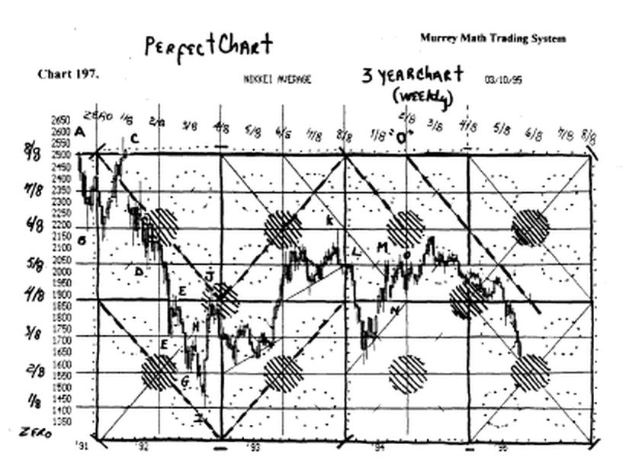

The pure math fractal Square in time, starts at 25,000 as the 8/8 th line, and we set 12,500, as the zero line.

We have set each 1/8 th at:

8/8 th = 25,000
7/8 th = 23,437.5
6/8 th = 21,875
5/8 th = 20,312.5
4/8 th= 18,750
3/8 th= 17,187.5
2/8 th= 15,625
1/8 th= 14,062.5 zero = 12,500

Find letters (A. through 0.), where the Nikkei Dow, pivoted 14 times, off pure Murrey Math Lines.
(Does this work or what ?)

Look at chart H 198. Nikkei Dow (9 months)

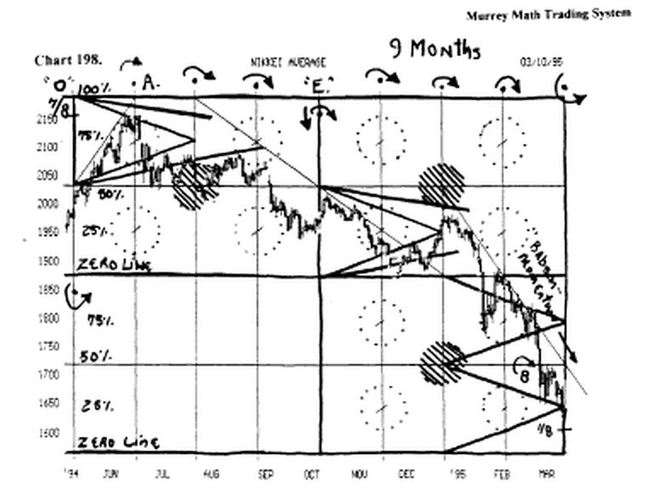

(weekly). Before we go too far into this chart, look back at chart # 197. and find the "O" in June,'94, and go forward.

Now, let's go forward. to chart # 198. Nikkei Dow. (9 months)
(weekly).

Look at this chart, and notice that we have once again set our 8/8 th line (100 %) at 21,875, (6/8 th), and we have moved our zero line up to 15,625, (2/8 th), because this market is pivoting around 18,750, (4/8 th) major support / resistance line.

(remember the rule: setting base lines, must always be set on a zero. 2/8 th. 4/8 th, or in very narrow markets

we may set the zero line on a 6/8 th line, if it is trading above 12.50.
•
We just use all of W.D. Gann's rules, now, to trade this Index, into the Future.

Notice the (A) right on the 7/8 th line, which W.D. Gann said on page 35. "fourth, if the range is very wide, it is important to watch the 7/8 th point, or 87 1/2 %, of the move. This will often mark the TOP of an advance."

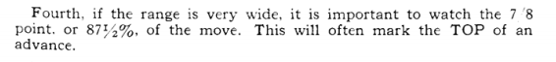

The Nikkei Dow should base out down here at 15,625. And if it reverses 195.3125, or 390.625, above 15,625, we would expect to see it want to run back up to 17,187.5, where it will run into major resistance, because at (6) it could not hold, on the line, the 1st time down, and when it reversed, and tried to get back up to this (currently) 25 % line, it closed below the line 5 weeks in a row, and fell down even further, for support.

Look at chart # 199. Nikkei Dow (90 days) (daily).

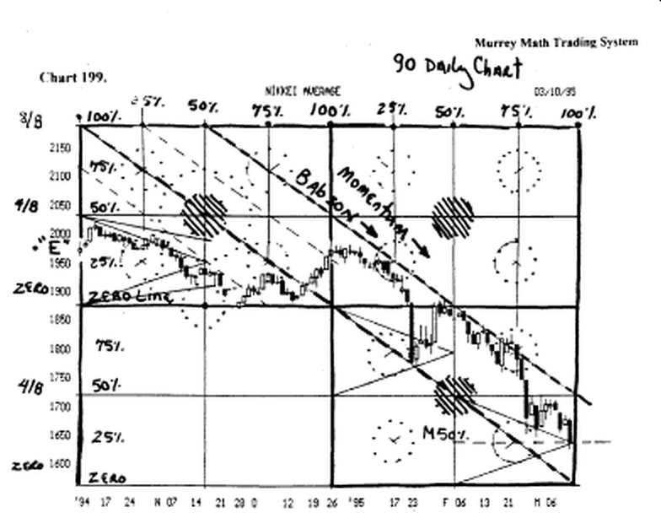

Look back to chart # 198., and the "E" and then return to chart # 199.

We have set the 18,750.0, (4/8 th) line, between 25,000, and 12,500, and we have changed it to the 50 % line between 21,875 and 15,625. This market was in a downtrend, so we measure any upside pressure, by drawing a "Baboon" momentum' line, in parallels, off our squares in time, as we observe the market's weakness reflected, by its failure to "break through" the next to the right parallel momentum line.

Please refer back to figure (A) and you shall see that we have already addressed this natural resistance of a market to higher, or and support, as it runs through time to the right.

We must go long, if our market reverses, and breaks through its "Babson" downward momentum lines, and closes above the downward trend line for 4 days in a row.

It is easy to see now John Murphy, on C.N.B.C. T.V., would also draw a similar, "Babson" momentum line, just off its "evident" general price action, (remember that we set our horizontal lines off dividing 100,000 by 8, and we set our vertical lines off the 3 rd quarter, of the U.S. 30 Year Treasury Bond Market. (1s this amazing ?)

If you want to be even more amazed, you shall see along the top of the page, you will see that our square in time, predicted, when it would want to reverse, and it did, but it only did it 7 out of 8 times.
Please, don't be too amazed, for if you look back to chart # 197. Nikkei Dow (3 year chart) (weekly).

From October,'91, at zero, it reversed, and fell for the next 3 weeks, (1), then it went up to the 1/8 th line, in time, to 25,000, (2), then it reversed and fell back for support, until 2/8 th line in time, and it reversed and fell, (3), then it fell once more.

Then it reversed, and moved back up, and at the 3/8 th in time line, it reversed, and fell (4), al) the way down to the 1/8 th line, (horizontal price level), then it reversed fast, (remember we said markets wants to reverse fast off the 1/8 th line, if they have had a steep decline, which it had , for the past 6 months.

Then, it ran back up to the 4/8 th line in time, and reversed, (5), and fell back lower for support, then at the 5/8 th time line, it reversed, and ran all the way up to the 6/8 th line, then it reversed and fell, (6), back for 2 weeks, then it moved up, and then it fell back on the diagonal line, and it reversed, on the 7/8 th line, and moved up, (7).

Then it moved up to the 8/8 th time line, and once again. it reversed, and fell hard this time, (8). You have seen that we have tracked the Nikkei Dow, for 2 years, on a weekly basis, and it just happened to reverse 8 times in a row. Is this luck or what ? Who cares ? all you want to know is: What is the rhythm of this market?

Shift your brain back to chart # 199. Nikkei Dow (90 days) (daily). This is a daily- trading chart, and the fantastic ability of this trading System, is that one may shift from a long range, (weekly chart), to a short term, (daily chart). and you are still in touch with the rhythm of this Index from both.

We have just run through every rhythm "shift" as each market shifts "gears" as it increases in price through time, and as a result. it shall increase the width of its price span, as it goes up to a higher price level.

Since page 26 . through to the present, we have set the rhythm shift for: stocks trading from $ 12.50 to zero,

which includes 4 separate rhythms; then stocks from 100 down to 25.00; then Indexes from 1,000 down to 250;.

Then Indexes from 10,000 down to 2,500; then the Nikkei Dow rhythm shifts, from every price range. shall be based on the same rules that we might set on a stock trading from 100 to 12.50; except for the fact that we simply multiply each number by 1,000

We want to give you one more "revelation" that proves that this trading system "already bas the inherent trading rhythm" set, even before it comes onto the market.

Can you believe, that is possible to set the rhythm for any stock, before it has ever come on the Big Board ?

Look at chart # 147. O.R.EA. This was a brand new stock that was planned to come out on the NASDAQ, October 23, 1994.

Well, let's just set the Murrey Math Lines, as soon as it opens up to trade to the public, and we find it opened the day at 19.34, lower on the day.

We immediately know that 20.3/8 ths, is the 5/8 th line, which is the top of the trading range, for any stock trading between 25, and 12.50. so we know that it must break through this price range to ever hope to move up to 25.00.
h opened the day, in a narrow range, and closed the day lower, and closed the day on the low.

The next day it tanked, on increased volume.

We went back to October 10, 1994, and set the first vertical day for our stock, although it had never traded we just ran its vertical cycle forward, until it finally took in the current day's trading, the last 2 trading days of the month of October,'94.

We immediately watched our new stock reverse, off its 1st diagonal, of its 1st square, just the 3rd day, it had ever traded. Then, we set our squares out into the future, by setting a vertical line every trading day past October 10, 1994.

Let's see how it reacted ! If you want to count, you will see that we placed an (A through M) by every reverse that just happened to be right on a time reversal into the future.

You may note the (black dots) at the top of the page. These dots are pre set times when one might expect to find that this stock might want to reverse.

This predictor was 100% right 13 times in a row !

Please find another trading System, that needs no prior history, mat must set the same parameters for everything that has ever been traded off the same horizontal (price) Lines, and the same vertical Lines for every stock traded, and it still, even without, any prior history, shall trade in a 100 % predictable manner, subject to the very same market influences that work for or against, the oldest traded stocks, or even the most debt ridden "dog" trying to send out "good news" on itself.

Why would one have to spend much time studying any stock, if they all want to move up, or down, on the simple laws of math, and the possible reversals into the future, than to just draw vertical Lines, on a set basis, which we call it the "Square in Time" which was coined by W.D.

.
But, hopefully, you already know, that we don't use a square, to set our squares in time.

We use the time of the 13 weeks of the U.S. 30 Year Treasury Bond Market.

We, then divide these thirteen weeks into the 64 trading days of the quarter of the bond market
.
Remember, we know, that since, we have the largest arsenal of nuclear weapons, in the world, as a democracy, we have the most stable bond market, against which the rest of the world trades.

Besides, you already know, that of the 140 countries, on this Earth, the U.S. Economy, is more productive, and valuable, than more than 132 other countries on this Earth.

So, common sense, would dictate us, to not put much stock into what Mexico is doing, since we probably have more money in the banks in California, than Mexico produces each year in their gross national / product.

The point is simply this: please set all Vertical Time Lines f off the beginning of the 3rd quarter of the U.S. 30 Year Treasury Bond Market. (it has something to do with the influence of the Sun on the Earth), but only 2 % of all Americans, see no connection, between the Sun, and the /l affects on the Earth, except when they get a sun bum, or if they are marching to protest the hole in the ozone.

One final comment on chart # 147. O.R.E.X.

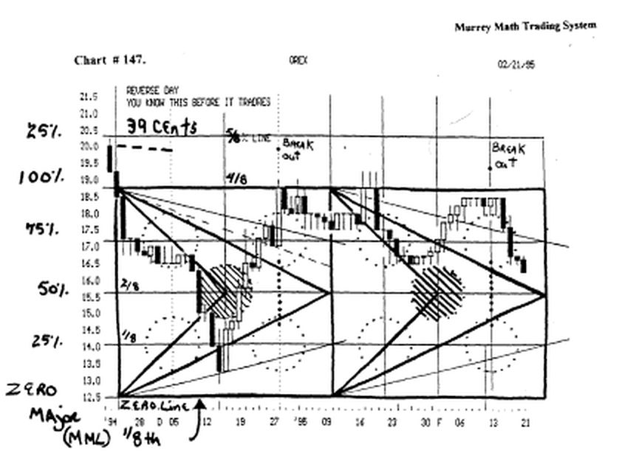

It tried to avoid all of the "5 Areas of Conflict."

It made a concerted effort, to rotate around the "major area of conflict" in the middle of the large square from the 21 st of November,'94, through January 10, 1995.

If you need to refresh your memory, turn back to Figure (B), and look at the equal triangle with its (RI) and (SI) Lines, that helps us determine the normal speed of a stock or market, as it trades to the right, through time.

It got major support off (G) (SI) 25 5 Line.

And when it moved up, from (G) to (H), it stalled for 2 days, on the (RI) line, and it moved up to '(H), at 18.3/4, which is the 50 % line, and it closed exactly on the line, two days in a row, then sold off, lower, for 12 straight days, and tned to move back up to 18.3/4, and it traded 39 cents above the line, for 3 days in a row.

But, our rule is to never to expect it to trade any higher than 18.3/4, unless, or until it closes above 18.3/4, for at least 4 days m a row. No matter, if it trades above the Line on the day. (this is why we must always be careful to always know where our stock closes the day, not just how high or low it has traded intraday).

One last simple rule to react to is the (4 to 7 day) rule, where, if a stock, closes laterally, for 4 to 7 days in a row, at or near, the same price level, it will want to reverse, and retrace toward its last support or resistance level.

Look at (L) and then count how many days it could not close above the same opening or closing class, and on the 7th day it fell. Great role to know

There are 4 "revelations" in this chapter:

1 ) all we need is the current price at lunch time, to find the trading rhythm, for any stock, or market, by placing it inside its perfect square fractal, so we don't need the last low or high to form our trading strategy, but we do need them to set the exact rhythm for any particular stock, or market,

- all stocks, or markets, want to trade on a pre set
rhythm, as an exponent of time, even if the stock has
never ever traded in the past, ail stocks, or markets, will shift, or increase, in their trading width (1/8 th), as it passes the 25 % Line,

- if a stock splits, we don't have to reset our Murrey Math Lines; they are already down there. We just divide the stock by 2: 1, and go on trading as we did off the same time Lines that we used at the higher prices
Horse Shoes and Murrey Math Lines Count !

Most people say that it only counts in horse shoes, if you just get close to the stake.

Well, if our stock, or market, just gets close to a major or minor Murrey Math Line, then we count it as getting there. Why ! Because it was trying to!

If it even moves above the Line, at least 19 cents, or 39 cents, just simply means that the shoe flipped past the stake, because

This is the reason that any "break out" trading strategy, will 'whip lash" you 50 % of the time.

I would never advise anyone to get in, at tops or bottoms, when you should have reversed, when the stock, or market reversed, and rode it up or down, during the run, not on added momentum.

All stocks or markets want to run 37.5 %, or 62.5 %, so the closer it gets to its maximum percentage, the greater the chance that the "real traders" will increase the volume by getting out just below the top: they are the horse shoe players, who just want to get 95 % of the run.

Why is this line of thinking and setting up this line of logic important to our trading system ? Simple ! We need to set our Murrey Math Lines (2, 4, or 8) off the most recent high and low retracements, that our stock, is currently trading within. An example is worth more than ail this rhetoric !

Examples: find chart #: 81) General Motors:

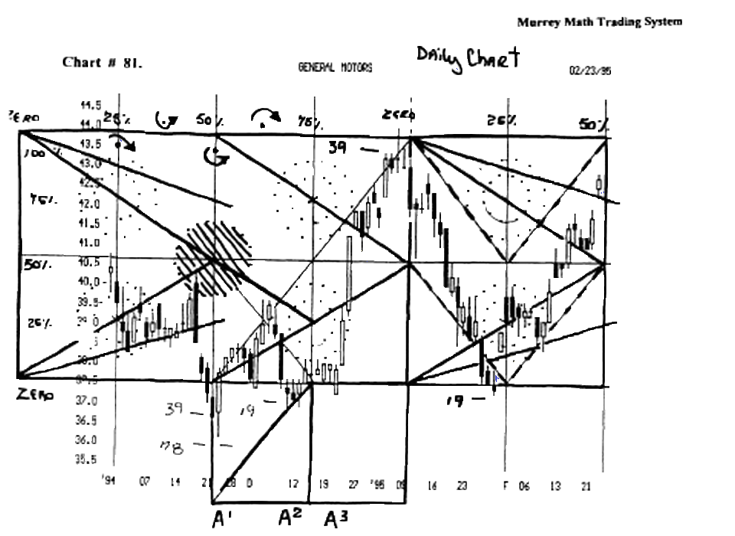

zero line = 37.5 (M.M.L.3/8 th)notice that ail the break out traders lost big time, when they went short, when it traded 78 cents below the line, reversed on the day, closed 39 cents below the line.

The next day it tested the 78 cent (minor 50 % line) and ended the day above the 3/8 th line, which now is the zero line. (remember that it must close 4 days m a row above this line to prove that it will go up toward the next 4 Lines, which short term will represent 100 % of its last old move. It pivoted on the reverse day, and fell back down to test the zero Line, which it broke, but only by 19 cents, which proved that it was still being controlled y the number 37.5, which was our zero line.

It formed a "reverse hammer" and moved up above the line, for 5 days this time, and on the 6 th day, it opened below the zero line, and then closed the day above the line.

This was a 3rd lower high, which W.D. Gann said was a great buying opportunity, so it went up and fast !

Why did we chose 43. 3/4 as the 100 % line ⁹

Look at chart # 83. General Motors.

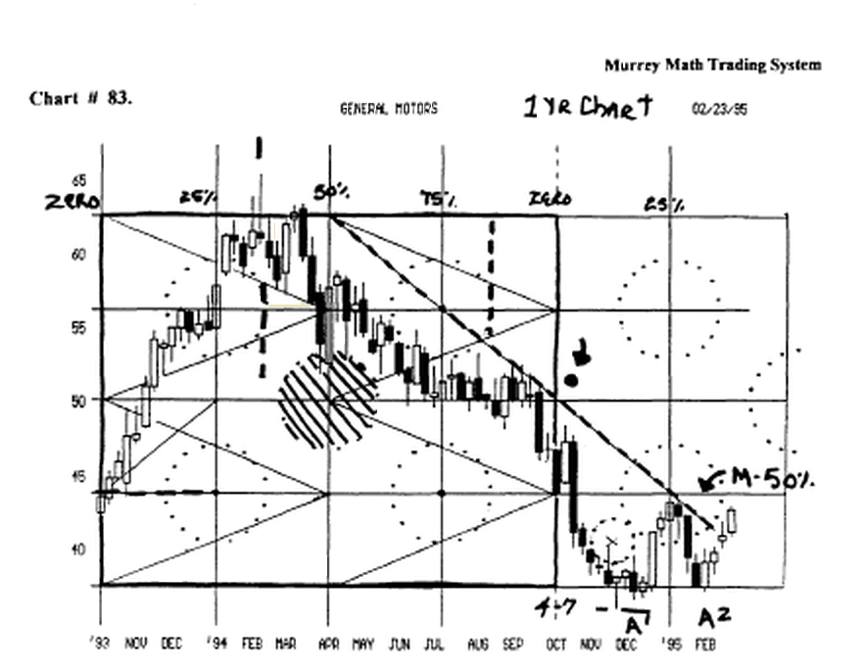

This stock moved laterally for 12 weeks in a row, at 50, which is 50 % of 100, so the next Murrey Math Line down from 50, is 37.5, so we would expect this stock to get major resistance at 50 % of the difference between 50 and 37.5, which is 43. 3/4.

We may also see the major down trend line that was set up back m Apr.,'94, through Oct.,94.

As the Line moved down and to the right through time, it must break above this line to move higher, but we don't know it yet, but we must get ready for it, long before it happens. (they will call us traders).

Looking at the daily chart and the one year chart, we see that no it couldn't break back to the upside.

Look at chart #81. General Motors.

It moved back up, and on January 8, 1995, it closed the day 39 cents below the 100 % line. It fell back down to the zero line, at 37.5, and closed just 19 cents below the Line, and it formed another "reverse hammer" and gapped up the next day.

Look at chart # 82. General Motors.

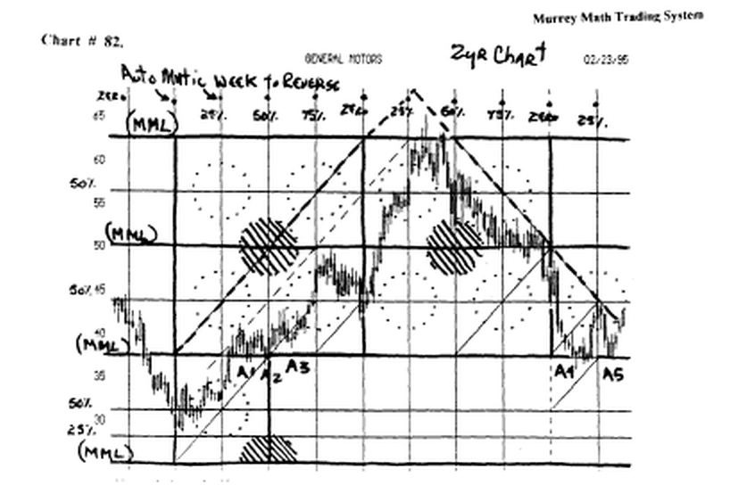

It stopped just 19 cents above the 5/8 th Line (62.5 of 100), in March,'94, then it reversed and fell all the way back down to the 3/8 th Line (37.5 of 100), which was the 4 th time it had fallen back down to this support Line.

remember: I never consider the price action to set our "Squares in Time." It works doesn't it ?

.78 4/8 th Line .58 3/8 th Line .39 2/8 th Line 19 1/8 th Line 000 zero Line
50.0% Line Blue 37.5 % Line Green 25.0% Line Pink 12.5 %Line Yellow

