EUR/JPY Trade Example – Tuesday 25 August 2020. Entry - 125.24 / SL – 125.00 / TP – 125.60
60 Min Chart – Price forms a base in late NY and throughout Asia and then breaks the EMA.
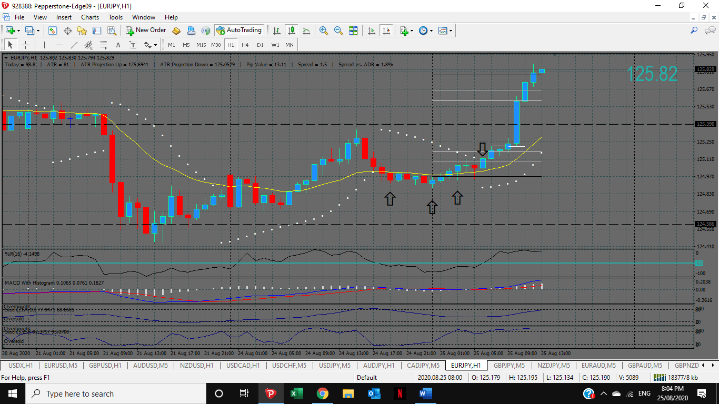
5 Min Chart


