APPROACH TO DRAWING TREND LINES:
Normally trend lines are lines drawn connecting price highs and lows on a certain time frame. It helps the trader to see more clearly possible support and resistance levels of price....the little variation on how I draw trend line is that sometimes, my trend lines is drawn connecting not only highs and lows, but the candle bodies itself. If you carefully go or look through my charts you will see that some or many times the trend lines that I draw connects not only the lows or highs of price but there is an approximation involved, which has to do with those trend lines passing through some candle bodies...So my trend lines are drawn with a combination of price highs/lows and the candle bodies.
SEE THE CHART BELOW FOR ILLUSTRATION
Note: the circles in the chart are showing how my trend lines connect to price highs and lows, while the pink boxes shows how trend lines connect to candle bodies...and both of them (the bodies and the tails/highs/lows) produced successfully useful information for correct trading.
Thanks for your questions. It will help put others through who may be having similar issues.
You are blessed.
Regards,
Naustingfx.
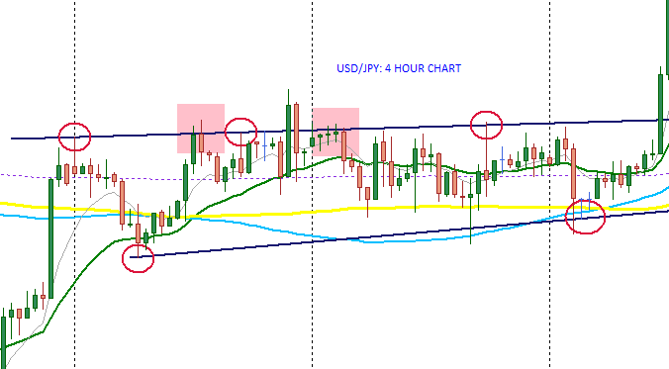
EUR/JPY TRADE: 18th February, 2016
I entered this trade about 1hr now. Price has found a strong support on that trend line below. Hope everything goes well.
Quote: "when you are using a very nice risk, you will not be afraid of taking trades setups when you see them. Also you are not afraid of losses....this gives one the real raw mindset set of a successful trader"-Naustingfx
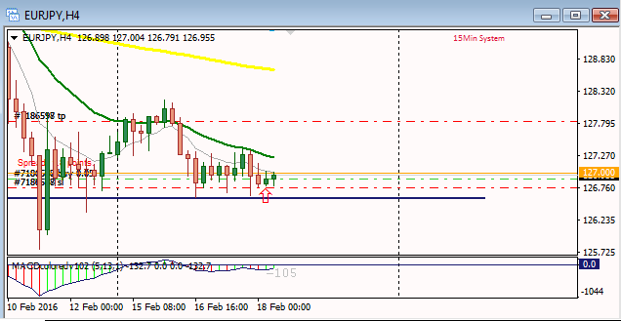
update: I do not recommend trading just the chart...I know why I took this trade....I am testing something new in my live account...yes it is part of the 4hr macd system, but just testing something unique.
Thanks
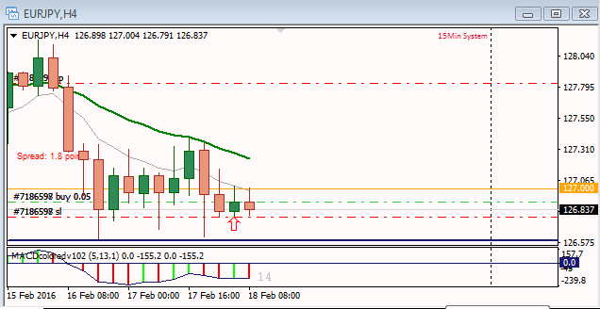
Trade reversed: To set stoploss to break even once price gets at that support trend line.
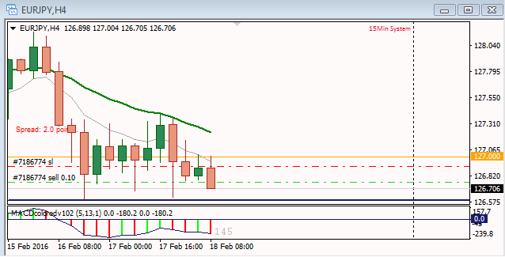
Scalping trade
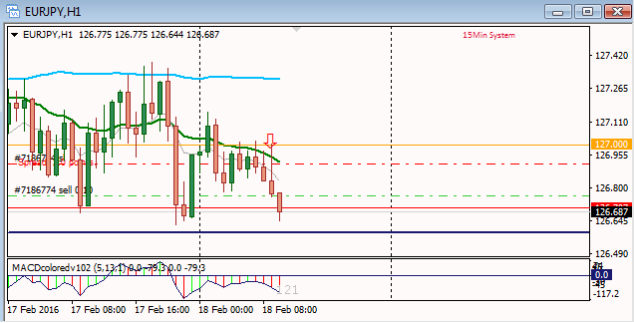
Leaving for a meeting...It is a scalping trade, and I have closed with little pips as I cannot watch it live.
I do not recommend this...just doing testing...but the focus is still on 4hr macd market rhythm.
Thanks!
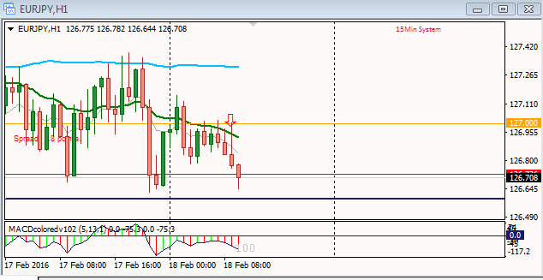
Market Rhythm

AUD/USD Trade: 14th April, 2016

Greetings!!!
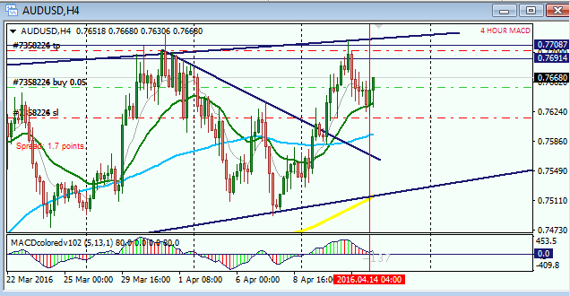
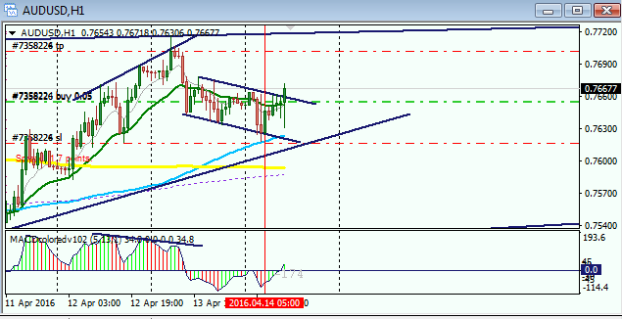
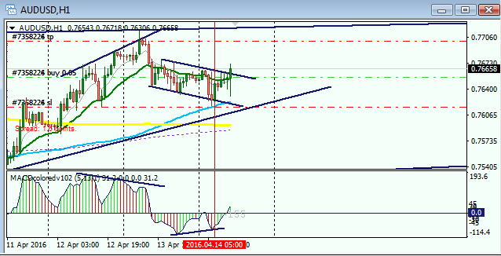
EUR/JPY

My trading platform is freezing...cannot post more details now.
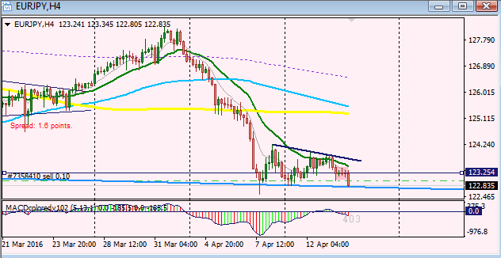
EUR/JPY: 1HOUR
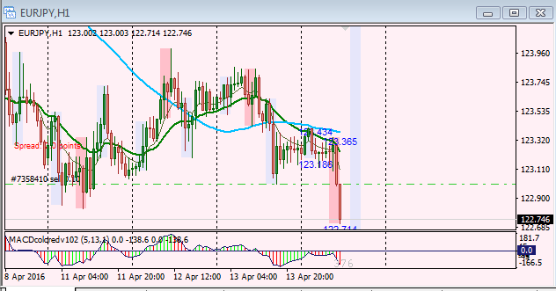
I have taken profit on the EUR/JPY pair due to that trend line there which is strongly suggesting support for price.
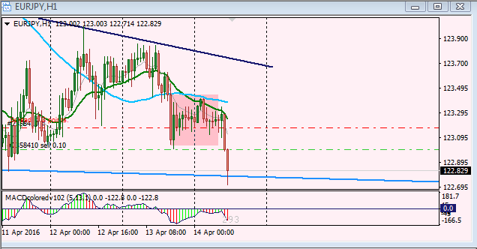
result update on the aud/usd trade today.
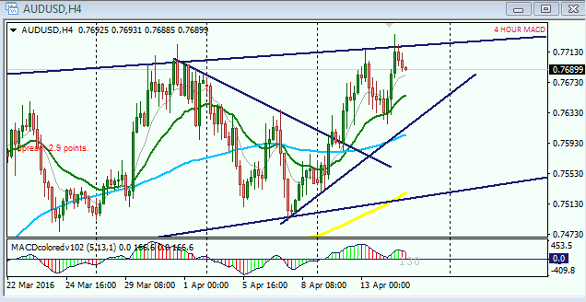
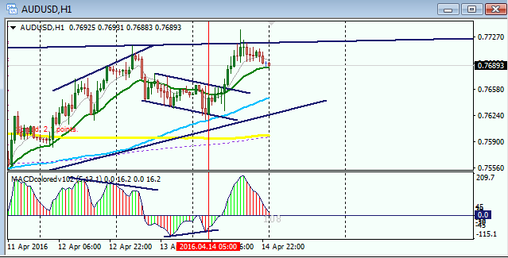
Quoting JonnyPip
{quote} Thanks Nausting, I always have my trades anticipated in advance, I think many new traders unfortunately open the charts and look for a trade straight away just want to trade, trade and trade some more more. I know this because I did it my self once and then you learn to trade for money, not to trade for the sake of trading. I'm hoping that by putting up some charts in advance it will give some new traders the opportunity to start anticipating trades as they should be, not just jumping in. There is a lot of junk on forex factory and what...
Great!
What you said is a reality! It is just the fact...I hope not only the new ones, but those who are as well still struggling with this business comes across your this post, read and digest it properly...thanks for the great insight.
WOW! You have as well spotted great trading scenarios from all your many charts and analysis...and I think the way you are doing it is an excellent way to go. The problem or challenge I had from your post is that you tempted me to jump around multiple pairs...your charts and analysis were very interesting, and attractive that if not that I have built a strong discipline to be focus on just few pairs, I would have seen myself jump to some of the currencies you presented with very good trading opportunities coming up based upon your analysis, and which are not part of the currencies that I trade...for example, Gbp/Chf, Gbp/Jpy, Usd/Chf...BUT I like the way you are doing it! And once I get any of your insight on a currency pair that falls within the ones I trade, I most likely for sure follow it energetically to take any available trading opportunity.
Thank you very much for your time and very educative posts.
THE CHART BELOW: 19TH APRIL 2016: TRADE ON AUD/USD
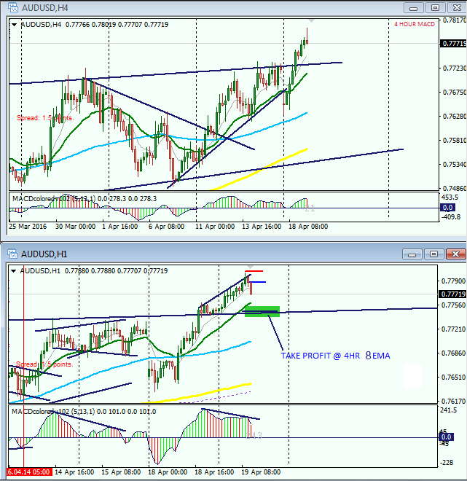
Late Entry
I have taken the trade as indicated above...I was not on my computer on time, but for me the move is very nice and is still on. So I decided to take it on.
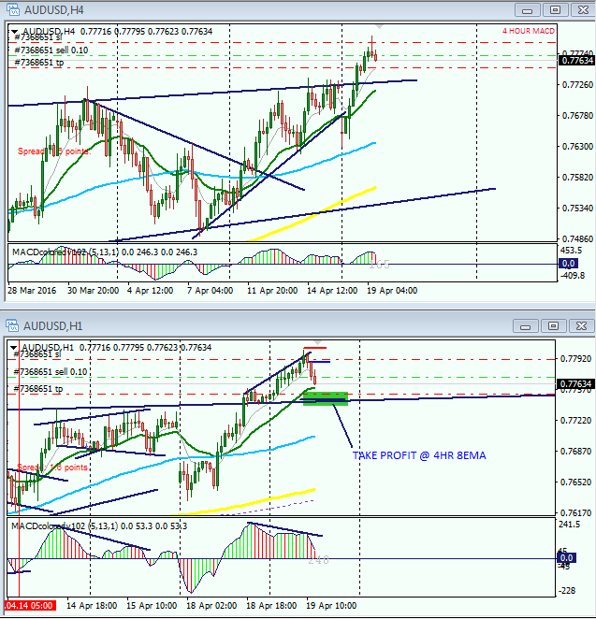
Aud/Usd: 20th April, 2016.
Analysis is as shown in the last MACD DIV. trade that I took. That one was a late entry, but this one, I was early and have taken profits.
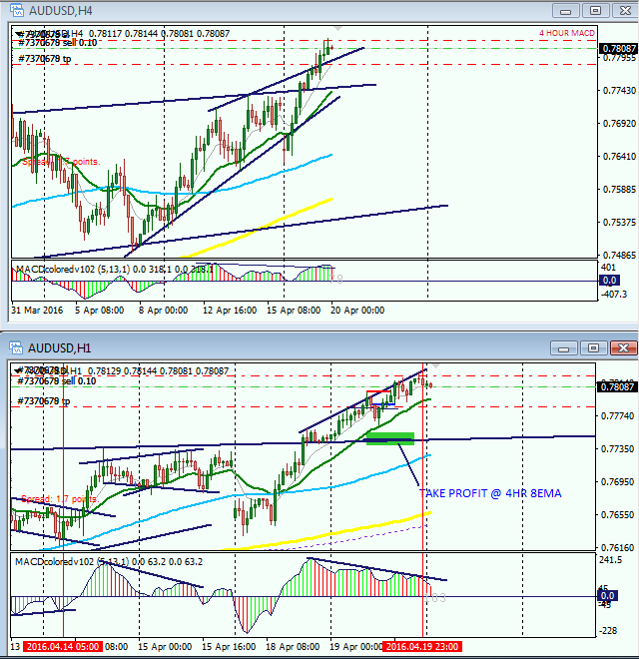
Update on performance.
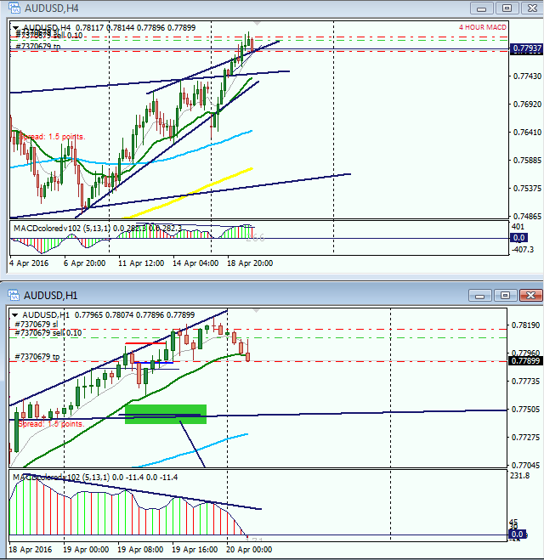
USDJPY TRADE; MAY 13, 2016

Market Rhythm Traders will Always Be Happy.
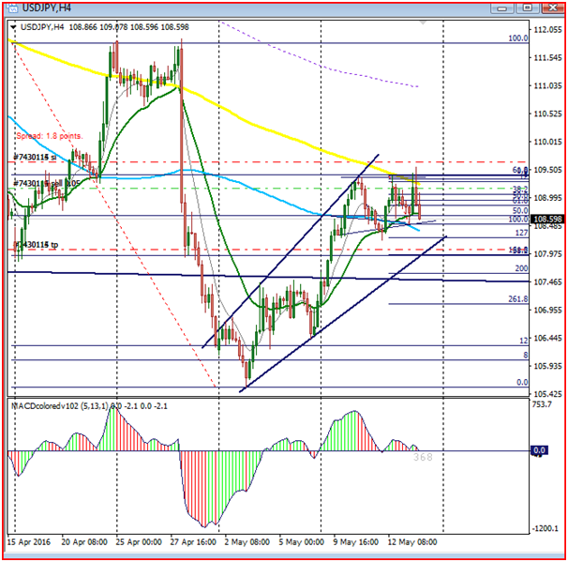
Stoploss adjusted.
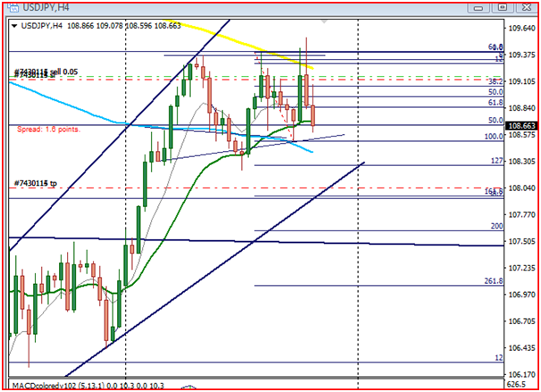
TOPIC: POSITION MANAGEMENT
This is a very versed trading Strategy! Position management is trading in itself. A trader may have a very nice strategy and knows how to apply it correctly, but will have problems in either the short or long run of his trading career due to the lack of the ability to manage position well.
Position management has to be the focus of a good trader once he/she has executed a trade! This topic has to do with how a trader manages his executed trades such that at the end of a transaction, whether his result was a win or loss it will not break his heart or account...when the outcome of your transaction always breaks your heart it means that your confidence is under high level attack and if this is not checked it will come to a point that a trader begins to loose confidence in his tested and trusted strategy. The effect of this is that; a trader will see a very nice signal and will be afraid to (pull the trigger) take it...THE MAJOR OR ROOT CAUSE OF THIS PROBLEM IS WRONG EXPOSITION OF A TRADERS ACCOUNT IN AN EXECUTED TRADE....IN OTHER WORD, WRONG STOPLOSS SETTING.
It is for this reason I have posted the trade that I took yesterday above. From my analysis, I was very comfortable with the trade when I took it on the 1hr chart. The stoploss is $400 dollars standard account, and I reduced it to just $40 dollars. I shared this $40 into two positions...I took the first 50% at $21 dollars profit and then adjusted stoploss into some pips profit assuming it turns against me...then I left the remaining trade to run. My initial intention was to allow it into next week...I later adjusted my stoploss to $17 dollars profit and left the position or trade to play out long term....THE POINT I AM TRYING TO MAKE IS THAT, A TRADER IS MORE COMFORTABLE AND TRADES WITHOUT FEAR OR EMOTION WHEN YOU ARE USING THE RIGHT RISK FOR TRADING AND IS VERY BOLD TO ALLOW TRADES TO RUN IN THE LONGER TERM FOR MORE PROFITS.
I AM MAJORLY POSTING THIS BRIEF ARTICLE FOR THE NEW ONES...EVEN AS YOU BEGIN TO ENJOY THIS THE SYSTEM WE USE HERE, PLEASE NEVER BE CARRIED AWAY AND BEGIN TO USE BIG RISKS DUE TO THE URGE TO MAKE BIG MONEY.
SUMMARY:
- 1% or 2% of capital for a given trade
- 1 trade at a time
- 2 trades at a time, but risk is to be shared into 2 equal halves to accommodate the two postions
- Avoid jumping around pairs for now as you may be easily thrown off balance or sync due to unexpected behavior of a certain pair. Be FOCUSED!
- Never forget the POWER OF COMPOUNDING! Therefore always take partial profit and allow the 2nd position to run if there is still potential for further moves. The initial or partial profit you take few hours or minutes after executing a trade puts you in a sweet mind to withstand sudden attack or behavior of price that may come against your expectation...
- Remember this is a 4hr system therefore you should not always be in front of you computer looking for trades. Even Scalpers are disciplined with time....
Just to mention this few.
God bless and Happy trading to all!

Usd/Jpy Trade: 18th May, 2016

Market Rhythm
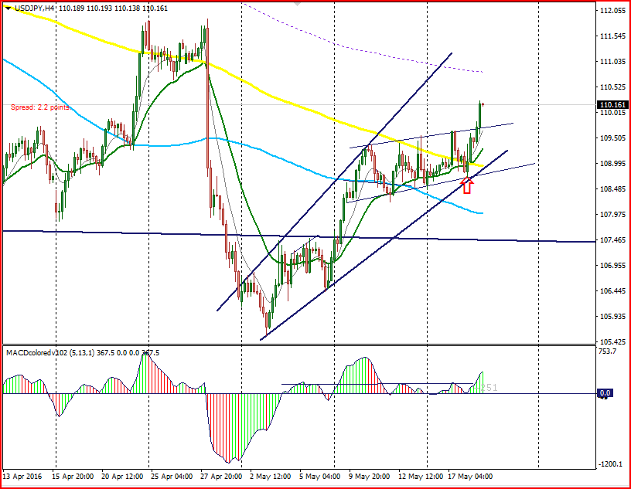
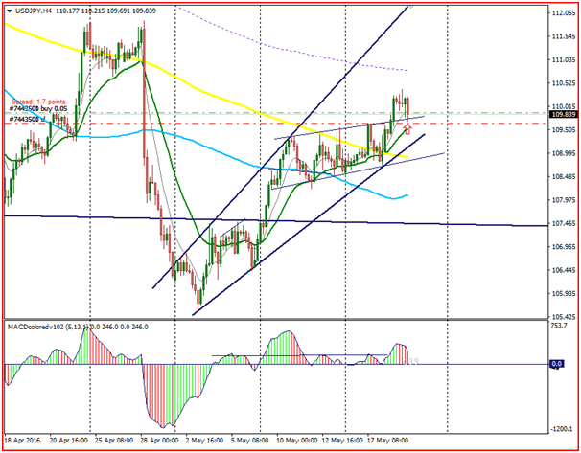
result update of trade taken as seen in my chart above
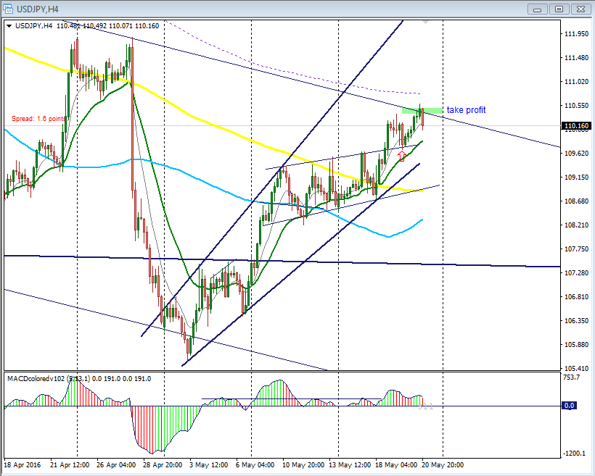
EurJpy: 31st May, 2016
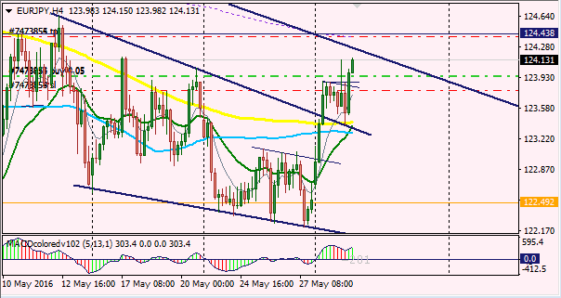
1 HOUR CHART
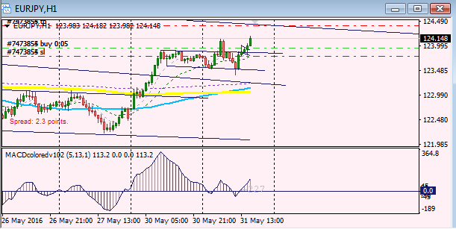
UPDATE: EURJPY TRADE ABOVE.
I closed up of about +5pips...price was so sluggish moving to the north as anticipated...I later discovered it was as a result of a strong DAILY TREND LINE which was serving as a strong resistance for price...so when price began to retrace sharply, I closed my positions.
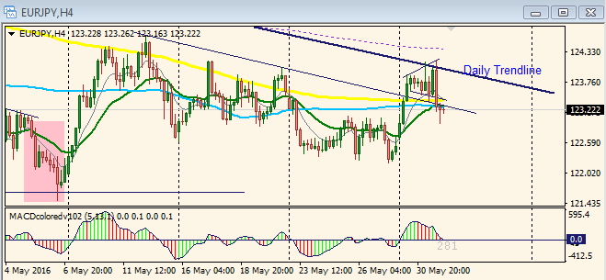
DAILY CHART BELOW
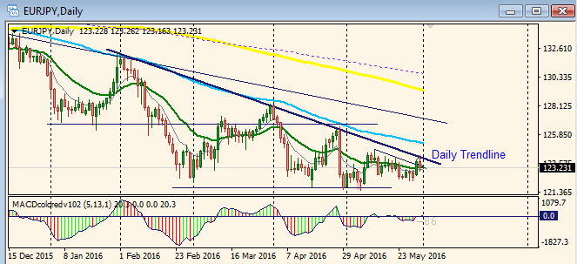
END OF THE MONTH TRADE: TRADE: 31st MAY, 2016

AUD/USD TRADE
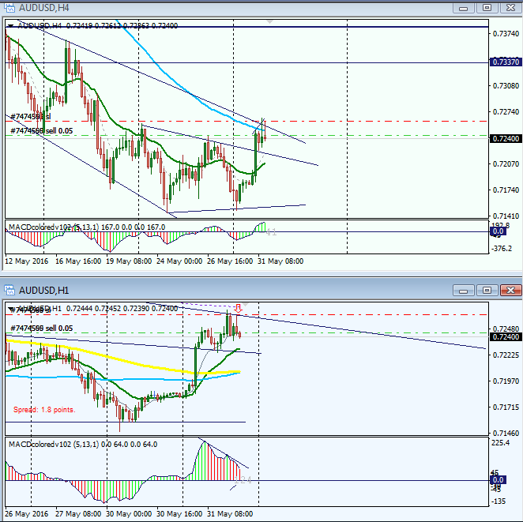
I give thanks to God almighty for helping me to end this month well!
Did not have all the time to take all the excellent signals this month, but the few I took blessed me a great deal.
Happy trading to all!
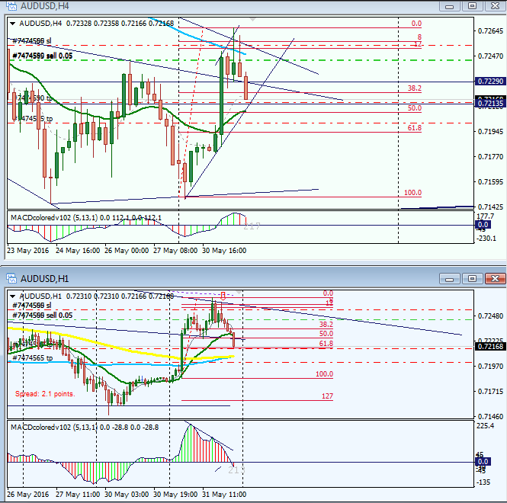
to whom it may concern

usd/jpy trade; i am just scalping here....
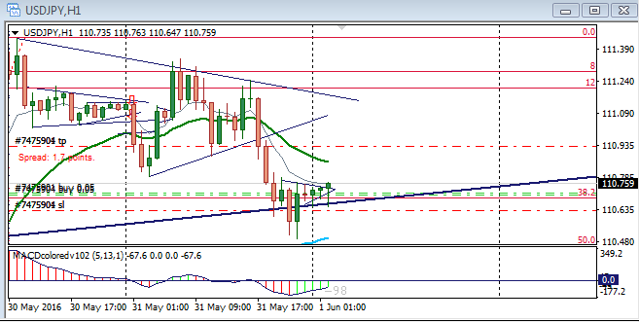
Scalping...just scalping, but with respect to overall picture...on the 4hr
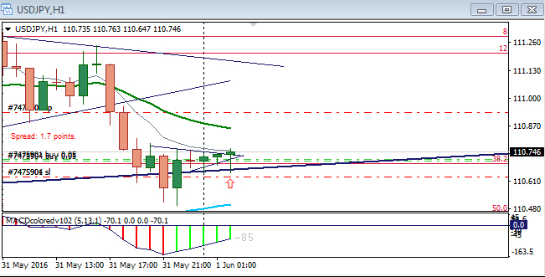
Update...trade reversed.
Attached Image (click
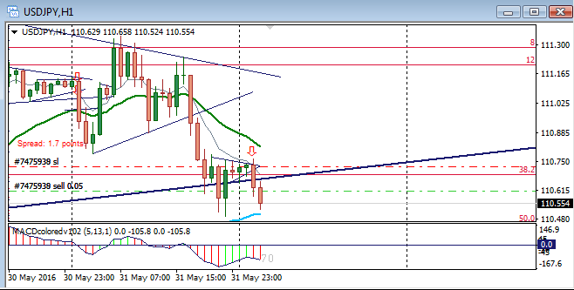
Stoploss adjusted and Tp at 50% Fibonacci
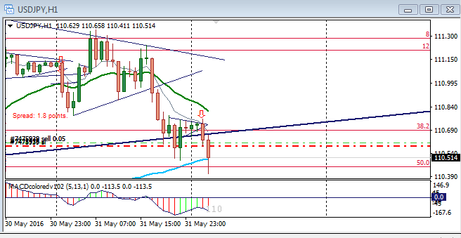
ANTICIPATION FOR TRADING WEEK AHEAD FOR GBP/NZD ACROSS TIME FRAMES
Hint: Weekly = downtrend; Daily = downtrend; 4hr=downtrend.
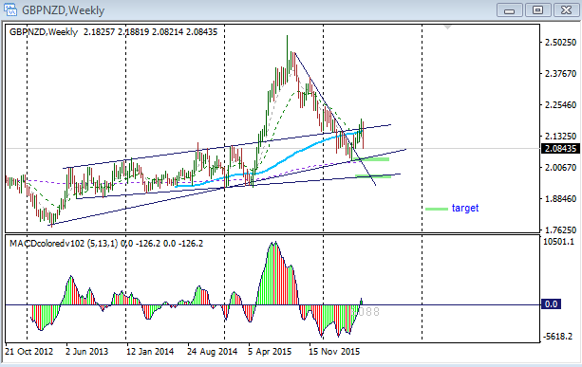

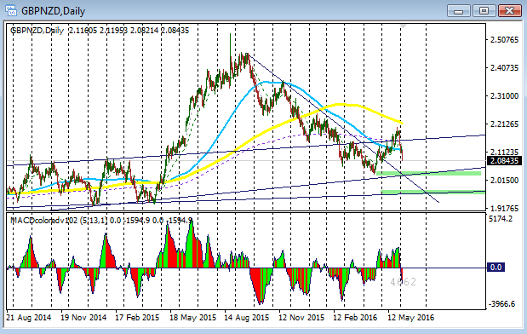
Note: Price can as well find support at those target levels and reverse. Also some other force or information-news, etc can change the whole situation. But as a technical analyst or a chartist the pictures below is what I will be watching for next week...the atmosphere looks encouraging or possible good pips next week

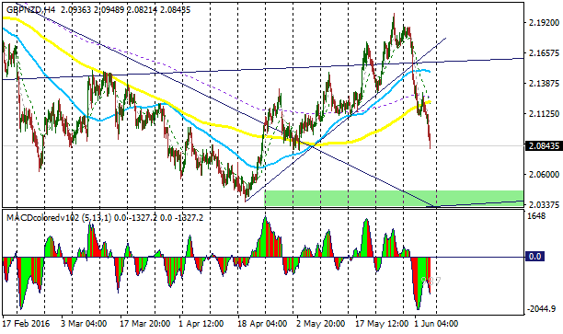
Below are more charts across time frames giving a trader more information and insight on what is very likely to happen next week.
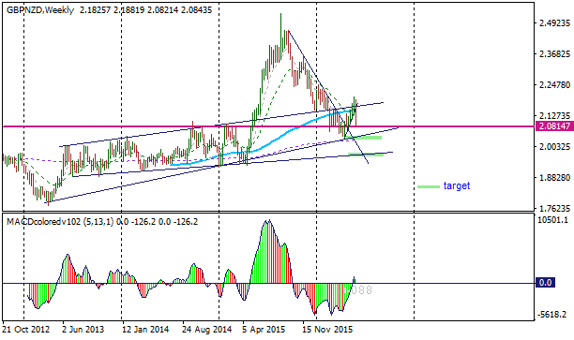
Fig: Weekly Chart revealing more info to support previous weekly chart
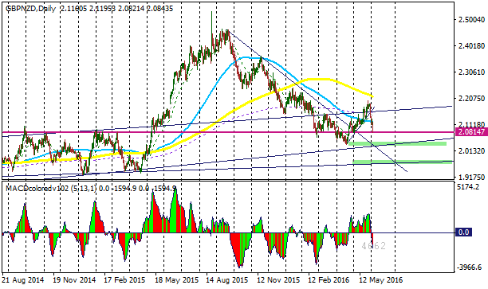
Fig: Daily Chart zoomed for clearer picture of expectations.
Daily Analysis: The additional information is that thick brown horizontal line which I have shown in weekly chart above. The horizontal line has served as strong resistance for price in the past from 21st August to around 17th February. And around 12th February and 12th May it served as support. Now price has come to the same level again...so by next week, price may find support again at that level and reverse to kiss the eighty nine sma which is what the rule says that when price breaks that moving average, it tends to pull back to it...
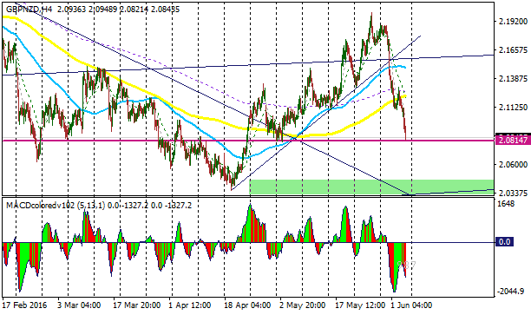
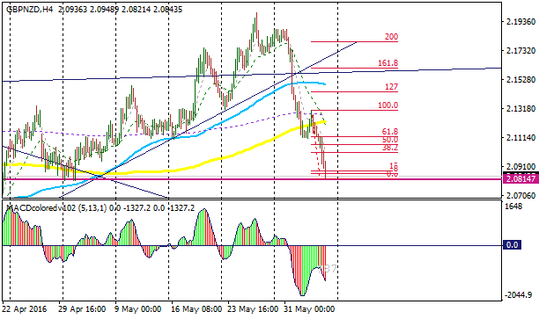
Fig: 4hr zoomed; I will also watch for a possible retracement of price to the Fibonacci levels as shown above. You can see that the 50% Fibonacci level is connected to the 8ema...so that can happen, or price as well has the “right” to break through that horizontal line, pull back to it and proceed...hopefully one can make some pips next week with this pair. I do not trade it as the spread is high for me...So I wish you success in this pair in next weeks trading...you/we may review these charts next week as trading proceeds to what happens.
Happy weekend, happy trading...
God bless!
Naustingfx
Update on GBPNZD:
From the anticipation as I have shown in the Microsoft document above - in the 4hr chart in the document; I have now adjusted the Fibonacci that I drew their based upon what the market is doing currently...and here is the chart below.
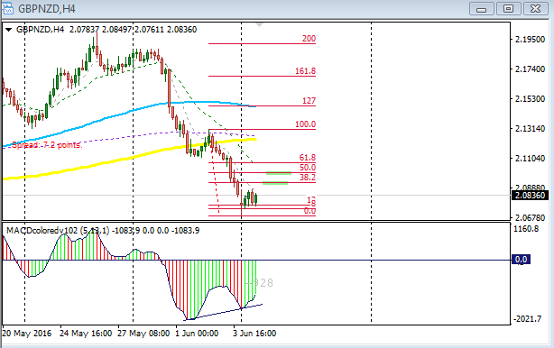
Update for the 1hour chart
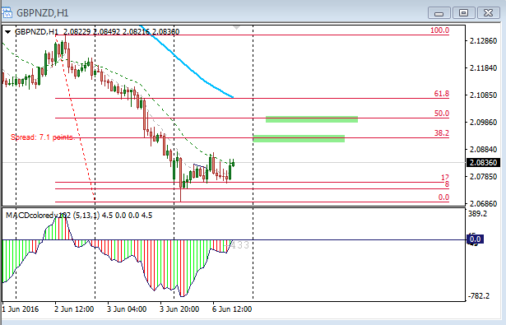
Quoting mkain
Glad to see this thread is still active, keep on going with the good teachings of Phillip Nel.
Yes, by God's grace. And to God be all the glory in Jesus name!
Attached Images
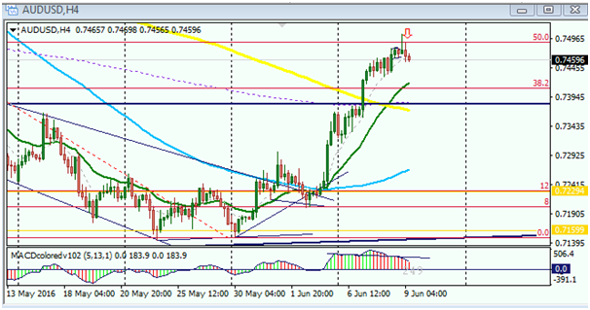
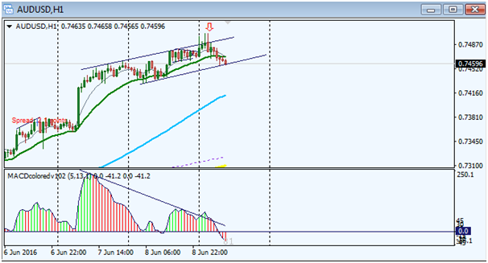
AUD/USD TRADE RESULT: 8TH JUNE, 2016

Market Rhythm
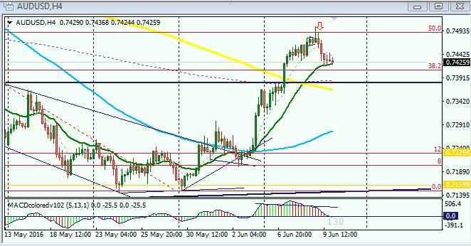
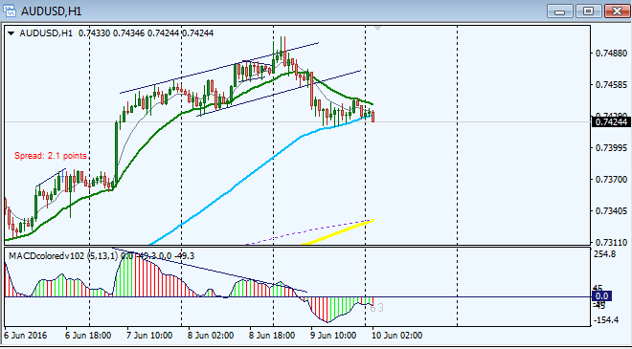
Quoting nic73
Nausting, I have question on NZDUSD. Post above on anticipation. Question: 1. From the chart, is this how 1hr early entry is to be taken? 2. Price didn't quite move to target price, it pull back about half way through. What went wrong is it my anticipation / or entry too soon? {image}
I have boxed up my explanation in white boxes/rectangles...both on price and on macd...
See my chart below, I have used your chart to do the correction....that is the way I will do it.
When taking a 1hr early entry trade, the signal or entry setup has to be like normal as if it were in the 4hr...you do not just take an entry because you saw one candle in the direction of your anticipation...from your chart the place you pointed for an entry for 1hr is just one small red candle in the direction of your anticipation to go south....some times it can work out, but some other details has to back it up...but look at my chart below, I had to wait for a lower high on the macd and on price itself along that yellow trendline which you have drawn...you can see my own yellow arrow as well...the first arrow is yours and the 2nd one is mine...
Exit: then once you see that consolidation after that nice move to the south, and that little green/bullish bar, it is a good place to exit for at least a partial profit and set to BE if there is still need to remain in the trade....Hope you understand? If you do not, please let me know, and I will put more details maybe in charts to give more insight.
Thanks and God bless
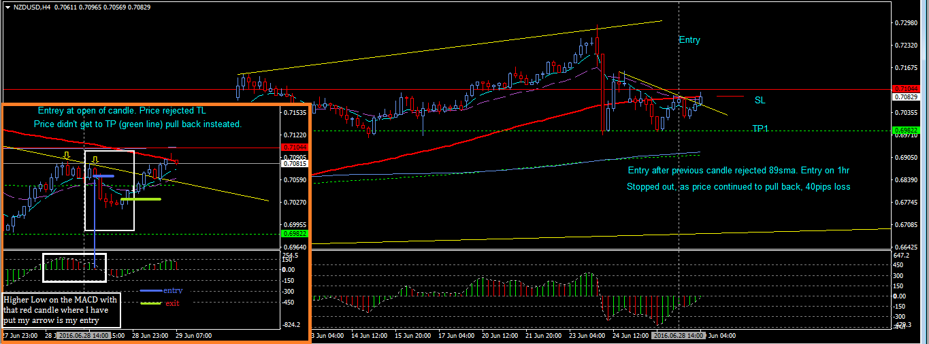

Quoting JonnyPip
{quote} Hey Nausting, Sorry to hear you are having problems my friend, I look forward to seeing you back on here with some great posts when things are up and running again. Hopefully soon! JP 
...thanks bro for your concern and God bless.
I am on it today...see chart...I am on a FX TRADING PROJECT testing one of the strategies Phillip had shown here. I started doing something very unique recently...trading is a business...we are all on the path already...
Wishing everyone well.
God bless
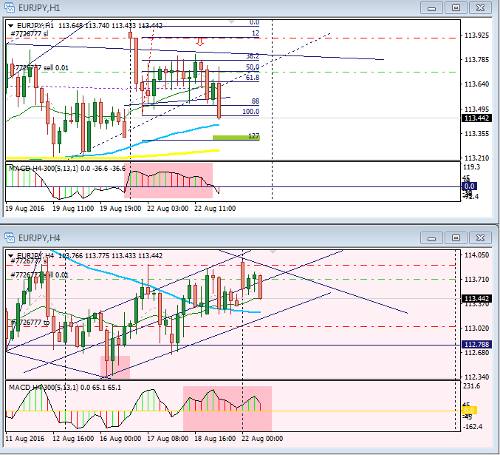
EUR/JPY UPDATE:
Watching out for support and resistance levels or trend lines as indicated in the chart below...Yes I am in a short trade, but in the other hand there could be a break out to the north...heading to the 200
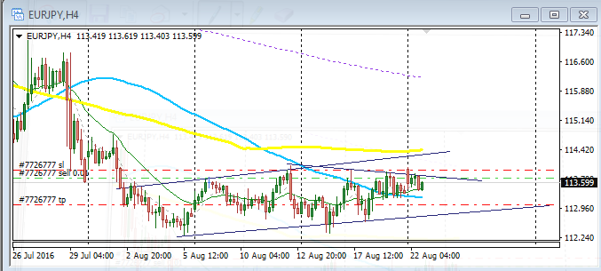
Quoting Cheeseburger
{quote} ... Also, it would be awesome to haveNaustingfx and Nic73 join us again, as they were very active on the thread when I first joined. Finally to anyone in doubt, believe me when I say, this system/strategy works, once you've mastered the basics Happy Weekend to all.
Hi brother!
Yeah....I am here from time to time...one of my purpose is to try to reduce the number of my posting so that the traders who find my work here interesting can be able to read through all my posts just in few day, and that is why I do not post a lot of my trades here...besides, if you study my work well, you will see that I am always doing the same thing in my way of analysis and taking trades...Phillip has given all it takes to be successful, so I do not want to add more work for the new ones as they study...Below is a trade I have taken based upon the rules, but this time in the daily time frame...I hope to leave this trade till next week.
See chart below for AudUsd pair.
Thanks and happy weekend to all.
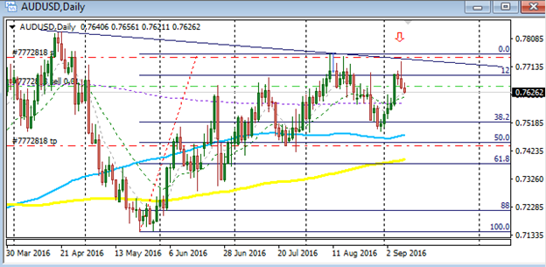
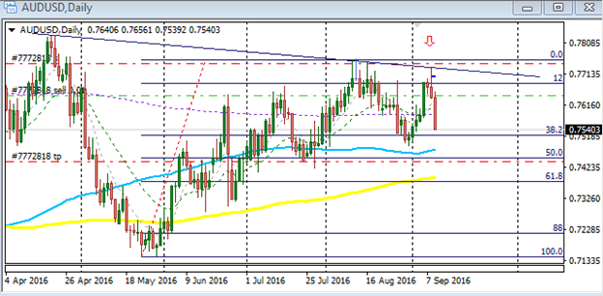
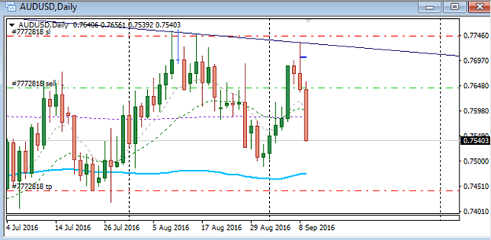
Previous trades:
EUR/JPY TRADE: 24TH August, 2016 at 12:00 and 16:00 candles
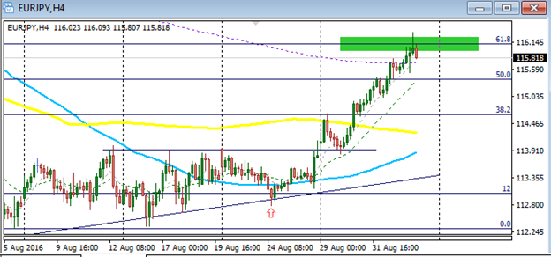
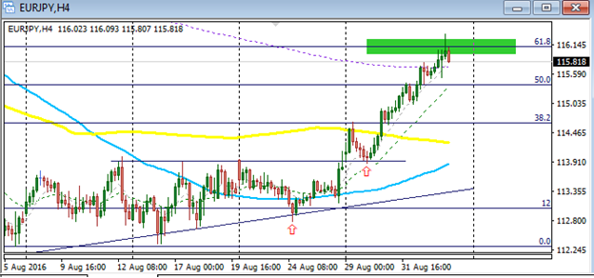
EUR/JPY TRADE: 6TH September, 2016 at 12:00 candle
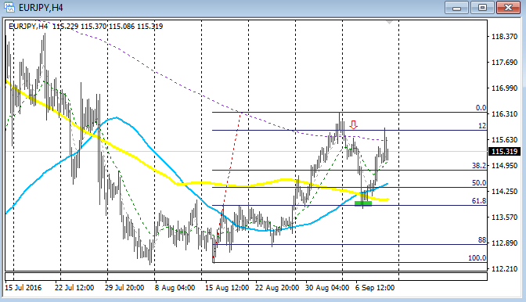
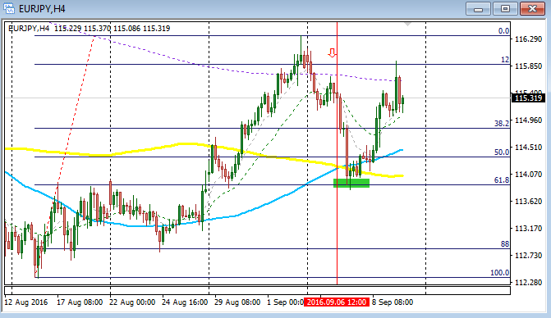
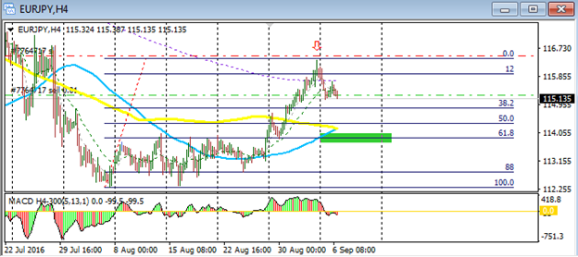
Quoting Cheeseburger
{quote} Hi Nausting Good to here from you again. I completely understand your reason for not putting up just as many trades, but I'll let you in on something. The many posts that you have previously posted kept my busy throughout most weekends and it was from that experience that I picked up the pattern of how you were placing your trades. So believe me, from a beginners point of view, that the more the merrier. I also commend you on taking a step further by applying the strategy on the daily tf. I should guess that it requires more discipline and...
It is well!
I get your point clearly, but you know bro that your experience may not be same with all other traders here. But no problem, I am here in the forum...and lets keep going...
For the daily time frame...it is what I also do when I have lots of commitments, I have for some few years ago and recently done some work with the daily and it is nice when you learn how to do it...You can see the chart below,the AUD/USD pair... I just took the trade yesterday and went my way and just in about an hour ago, I logged in to see how my position is doing...the rule is same and works on all time frames. I am leaving my position till next week...I really hope it will go well...
Thanks and shaloom!
Quoting Cheeseburger
{quote} Nausting Incredible performance with that trade. Please keep us updated on how it turns out. Have a fabulous weekend Cheeseburger
Like you demanded bro, see chart below...I traveled for few days now and have not been able to post or trade... Thanks to God I am able to do it today. And the chart below is the update you asked for.
Happy trading to all.
God bless.
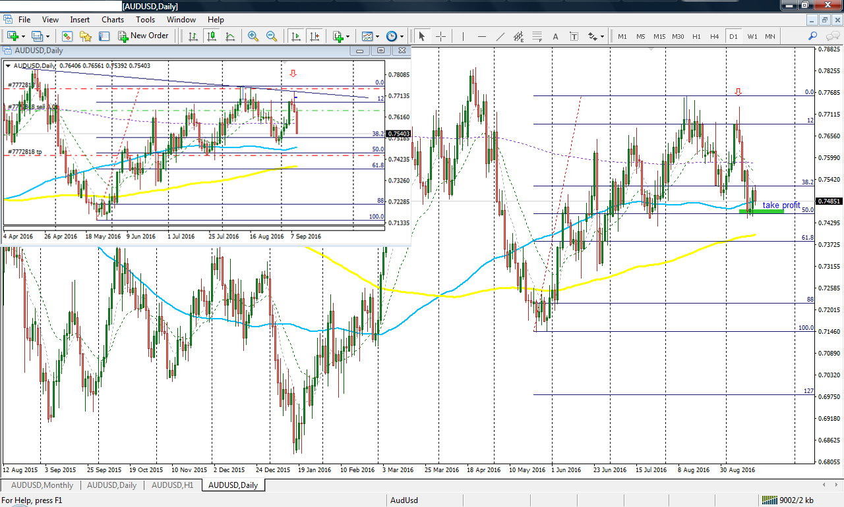
Quoting Phillip Nel
Hi. Yes I am still using the 4Hour MACD but mostly the Market Rhythm. Here is a chart with some trades that could have been taken. I like trading the MACD divergence when the price have moved away from 89. {image}
The MACD Divergence trade is very effective with Market Rhythm methodology of trading it... As it does not come often on the 4hr chart, one can check on multiple currency pairs to get more signals per month...that helps me a lot. I have taken few of them just within 3 days of this week...the EurJpy and AudUsd...I am posting the chart on EurJpy below...
Thank you Phillip!
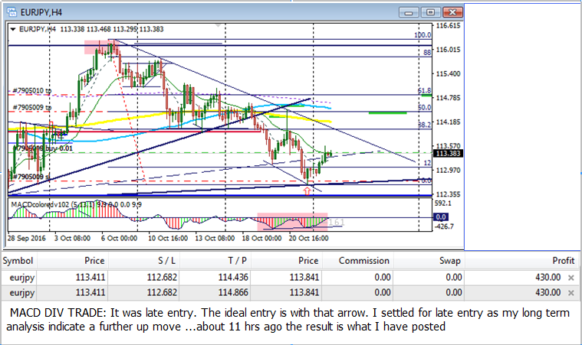
AudUsd pair
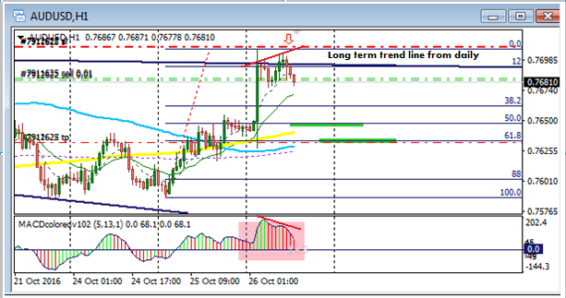
Profits taken:
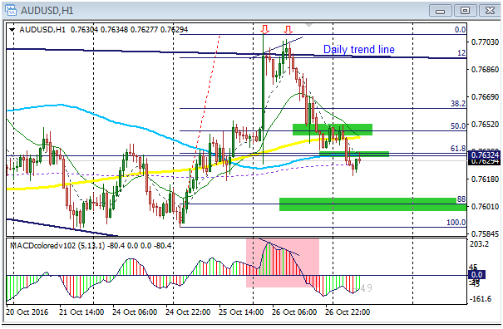
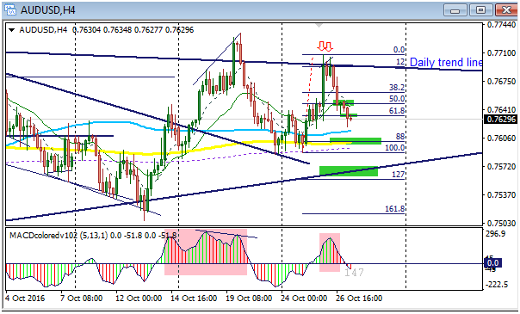
Quoting naustingfx
{quote} The MACD Divergence trade is very effective with Market Rhythm methodology of trading it... As it does not come often on the 4hr chart, one can check on multiple currency pairs to get more signals per month...that helps me a lot. I have taken few of them just within 3 days of this week...the EurJpy and AudUsd...I am posting the chart on EurJpy below... Thank you Phillip! {image}
I am still on this trade... I think I am going to allow it till towards weekend, hopefully Friday evening...lets see how it plays out.
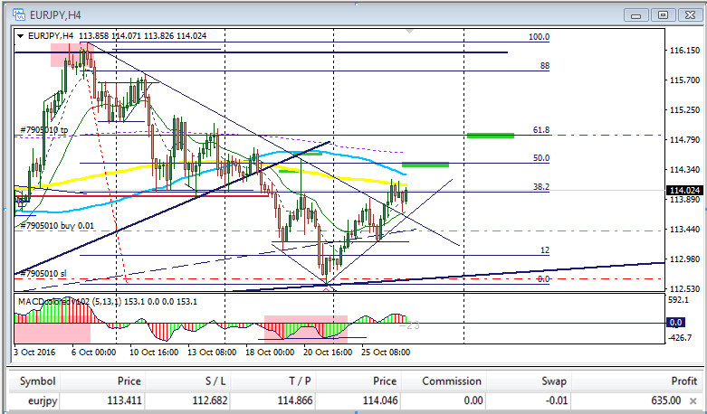
GIVE US THIS DAY OH LORD OUR DAILY BREAD - Pips "Matthew 6:11"

macd divergence trades and results

EurJpy and AudUsd pairs

thank you Phillip Nel
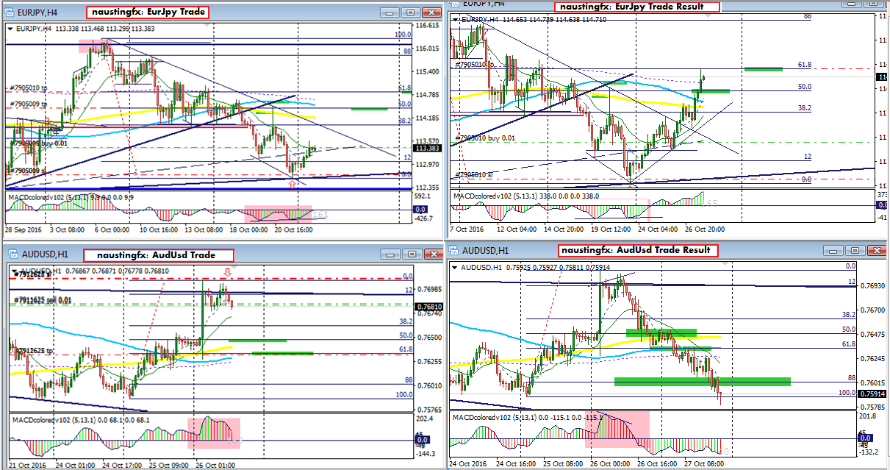
welcome to the world of energies

trading energies with the macd system...my recent great discoveries!!!

here are trades on brent crude oil
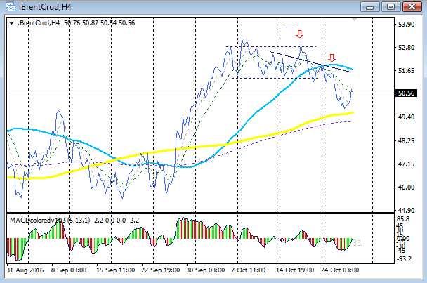
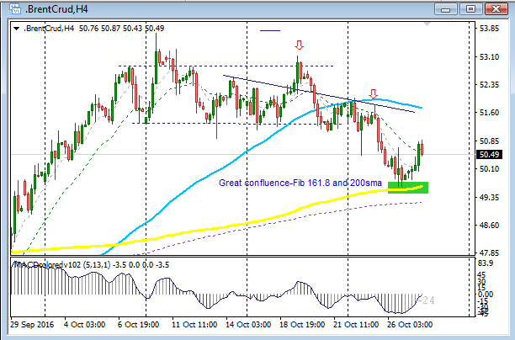
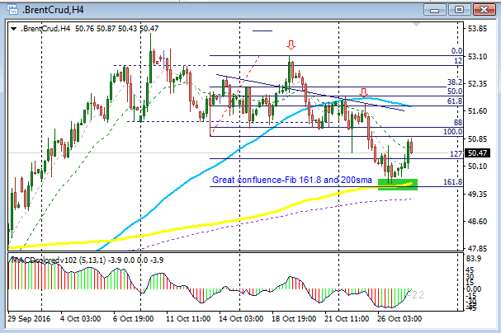
trade on natural gas
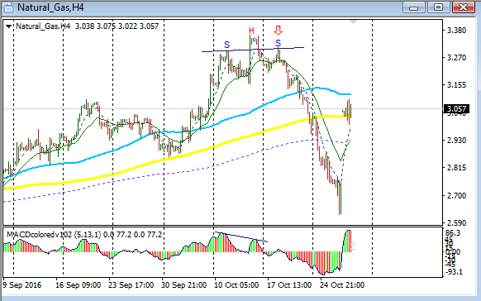
ANOTHER MACD DIVERGENCE TRADE ON AUDUSD PAIR
It was a late entry trade, but my long term analysis suggests a strong potential for further move to the north....actually the signal was due to be taken just before the close of trading on Friday...but I just closed my short trade for the week and a little reluctant, so I did not take the trade; but on Monday morning the deal was still on and the market was breathing well....so I took it on...see charts for details and updates on trade performance.
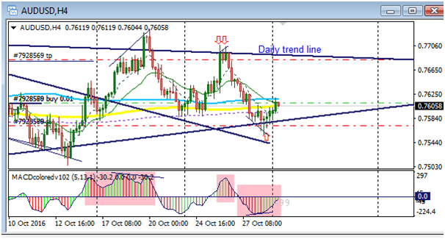
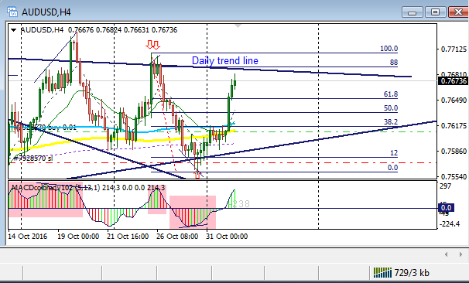
1 Hour Chart
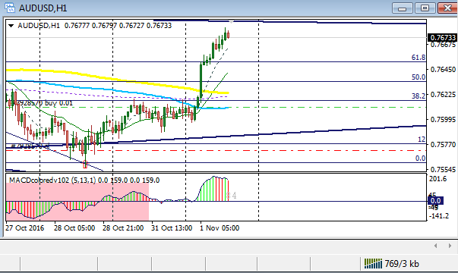
AUD/CAD
I have not been following this pair for many years...but someone called my attention to it today, and I liked what I saw, and took the deal on...I am hoping that it works well.
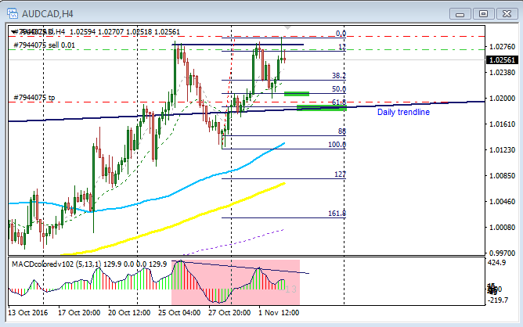
A TRADER'S EXIT BECOMES ANOTHER TRADER'S ENTRY
Price moved in my favor for about 40 pips, but did not get to my profit target...so I am giving my position further chance to run..I have adjusted my stop loss to a minimum number as I am not going to be watching it live...
Regards,
naustingfx
Attach
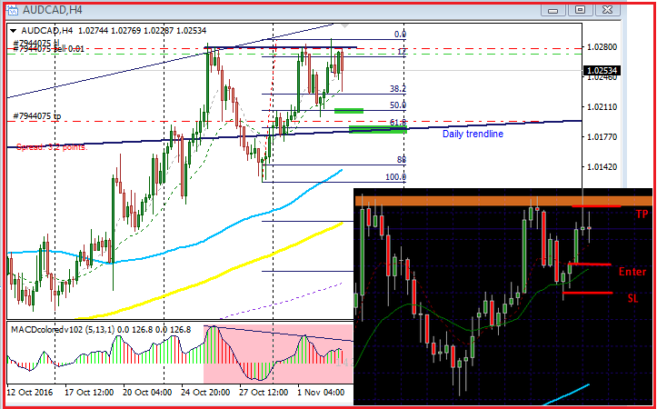
Quoting Cheeseburger
For your attention Nausting...thank you. {image} {image} {image} {image}
THANK YOU FOR YOUR PATIENCE...I HAVE IN THE DOCUMENT ATTACHED TO THIS MESSAGE THE ANSWERS TO THE QUESTIONS YOU HAD ASKED.
This document for me is very essential and I encourage any other trader to read it...I think it worth the time that will be taken to read, or rather study it.
I have titled this document;
TREND LINE TECHNIQUES, MARKET RHYTHM AND SPOTTING HIGH PROBABILITY TRADING SIGNALS FOR USD/JPY CURRENCY PAIR

Happy trading to all
TREND LINE TECHNIQUES, MARKET RHYTHM AND SPOTTING HIGH PROBABILITY TRADING SIGNALS FOR USD/JPY CURRENCY PAIR

ANSWER TO YOUR QUESTIONS
Please when viewing this piece of information, go to the bottom right of MS Word and click the “Web Layout” button to have a better view of it or you can use the zoom scroll button to get a better or larger view of it.
This document is very powerful for me with respect to my trading style. I hope that you understand it in Jesus name.
Look at all the trades taken as shown with the arrows...none of them was a looser...if you trade this way, you will begin to enjoy trading...it will as well help you to destroy the killer disease called “emotion” in your trading, and the good guy called “discipline” will have its way and bless your trading career.
Please bear with me for not coming to you as fast as you may have expected...I do have busy schedule from time to time, and another thing is that I do not give people half information, it is my way of life to always give good details when I am helping someone...if I rushed it, I do not think it will as better or more informative as you can see below... remember you are not the only one I am attending to generally...But thank you for your patience!
Key: The thick trend lines are the major ones, while the thin ones are the minor trend lines. They are called major because they tend to determine the momentum of price in the long term and they are confirmed resistance and support trend lines...the thin ones are short term trend lines they also rely on the major trend lines for market and short term price action anticipation...from the charts that I have below, you will see clearly how the thin trend lines took their points from already established points stipulated by the major trend lines.
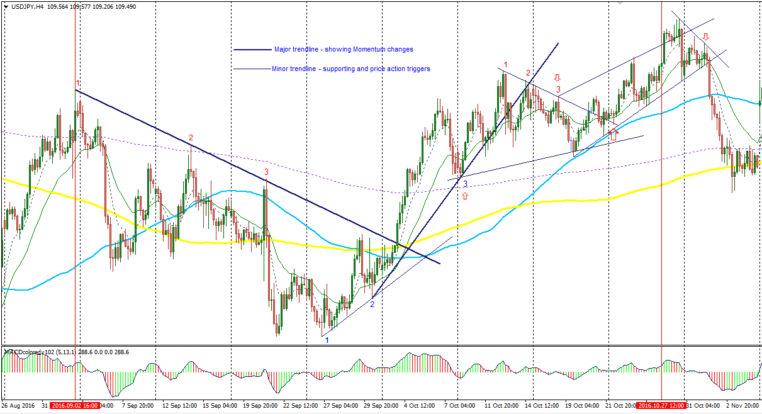
Fig; showing Usd/Jpy – 4hour chart
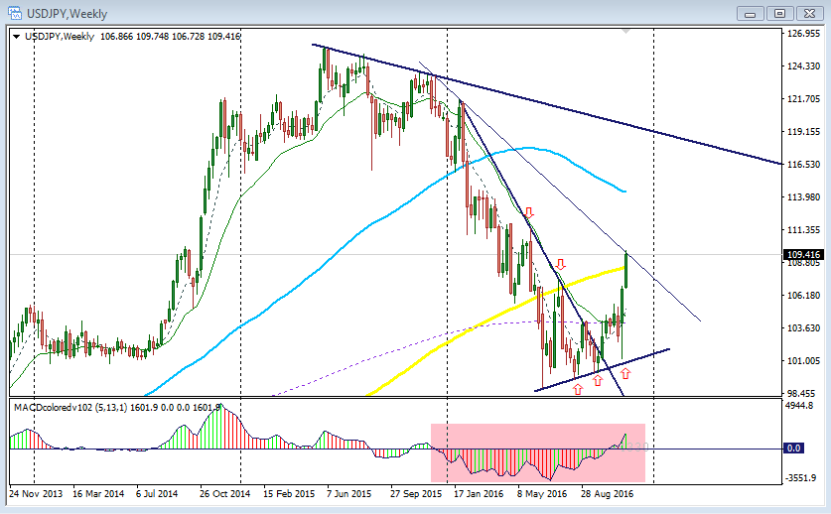
Fig; showing Usd/Jpy – Weekly chart

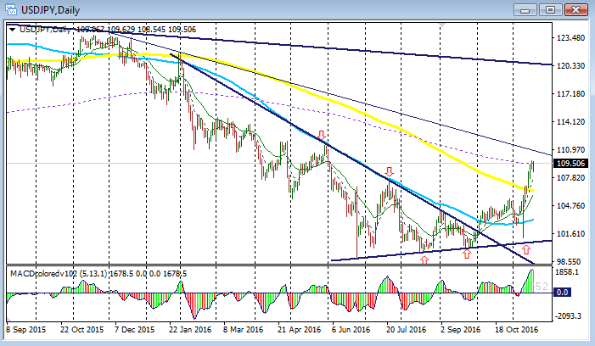
Fig; showing Usd/Jpy – Daily chart – zoomed out
Below is still a Usd/Jpy daily chart but zoomed in to make price action bold.

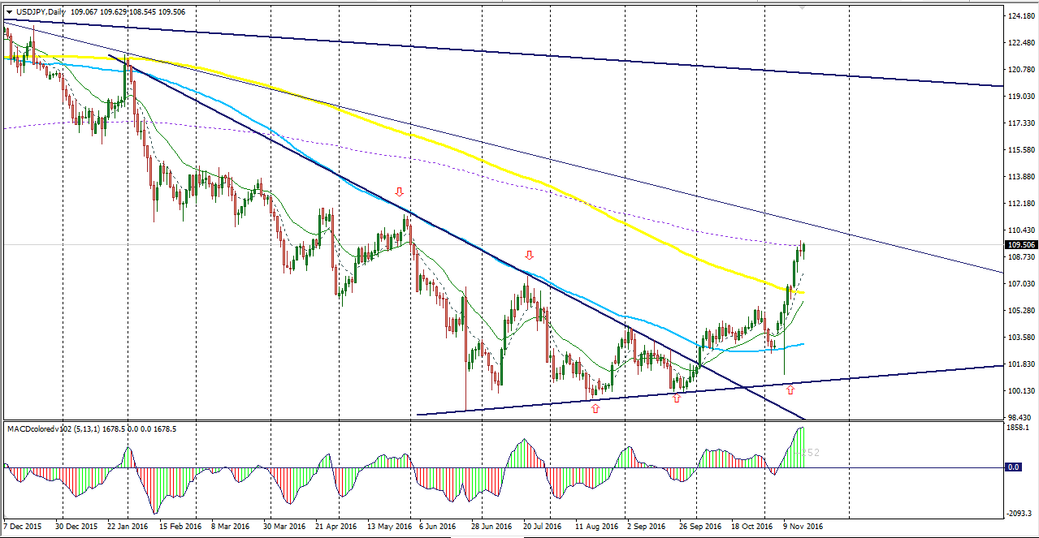
Fig; showing Usd/Jpy – Daily chart
I just switched the weekly chart to Daily time frame and got what you see above for the daily chart.

I have given this insight from the bottom of my heart to bless you, the reader. Be happy and worship God always.
Thanks!
Regards,
Naustingfx

