August 3rd, 2015: AUDUSD (4 HOUR): 8:00 candle
The day is bright and fair!
Continued from previous analysis as revealed by my chart in previous posts.
Happy trading!
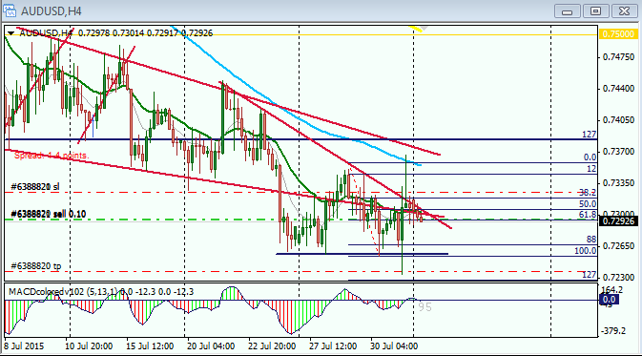
AUDUSD: 4HOUR:
UPDATE: Partial profit taken 25pips, and the remaining position I have left to allow it to run further as I am anticipating a break out to the south.
Position management: Yes, I have set stop loss to about 5pips.
This is sort of positional approach to trading...I have positioned myself so travel to the south with the break out which for me is very likely to happen
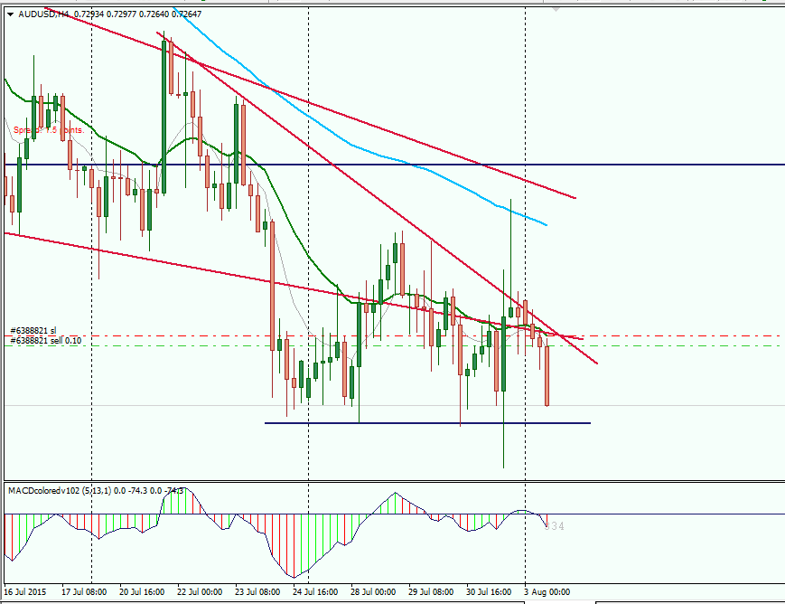
Quoting JonnyPip
Wow the volatility on Friday was unexpected! Got stopped out at b.e but should be another chance to jump on a few pairs heading lower this week. Naustingfx - it is a nice set up on the AusUsd, but don't forget there is a rate decision by the RBA tomorrow morning at 5:30am GMT. My fear here is that price will more or less meander sideways or slightly higher and we would be left in the situation of having an open trade just before a major news release, which essentially equates to gambling unless you are already nicely up and any volatility is unlikely...
I am very happy reading your post. I got a very good insight from your very insightful and logical analysis...I think that is how real traders also think. Your post blessed my soul. Thank you!
FACT: For many years now, I can't really remember the last time I really considered NEWS information before either opening or closing or staying away from a trade. Initially, it was not intentional, but due to the sluggishness of internet subscription that I was using...it was like very distracting or frustrating to me many years ago...so I quit checking anything NEW announcement...Like a surprise to me, everything has been working well with me without the NEW for many years now...
Also I did get bothered from time to them then about the NEWS, so I carefully began to study the 4hour system very closely....and I discovered that there are scenarios that actually tells me when a major NEWS announcement is coming up, and it as well tells me the direction the NEW is very likely to take the market or price to...for me the discovery was very very surprising...and I have watched the scenario for years now and have used it to forecast the market or future direction of price and it worked excellently well....SO I do not even know that there is any news coming up, I just put knowledge and experience together,and by God's grace I make good results...my discovery over the years has really discouraged me from using considering NEWS announcements before taking any trading decision...
I have to say thank you again for your comment. I really learned from it.
Happy trading.
God bless bro.

XauUsd (Gold/Usd): 4HOUR
I took this one too. I also took the EurUsd, and UsdJpy...all of them at almost the same period. So I am holding on all positions for further moves.
EurUsd, I am heading south with it...
UsdJpy, I am heading north with it...
XauUsd heading south with it...
AudUsd, heading south if the break out occurs
I may post all the charts later...
God bless.
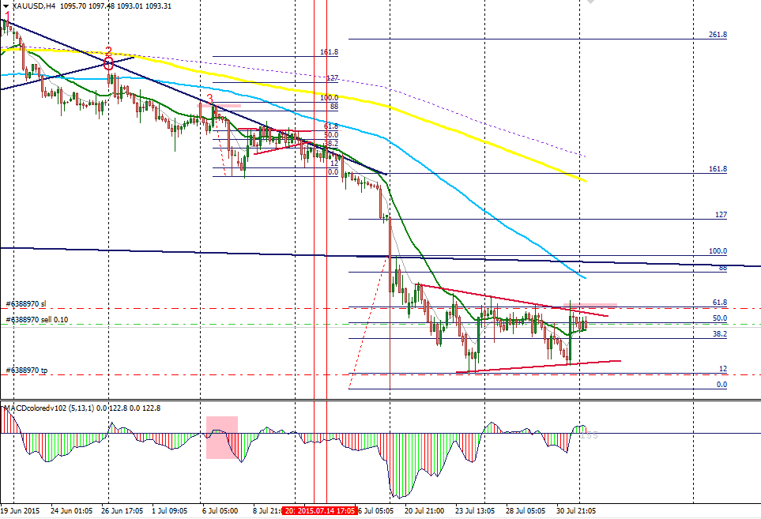
UPDATE: GOLD/USD
About 44pips gain. Considering to adjust stop loss soon...I am here now watching my trades live...so I have decided to do things manually as usual.
EURUSD: Daily time frame...move seem to be sluggish...maybe because of some sort of NEW too...
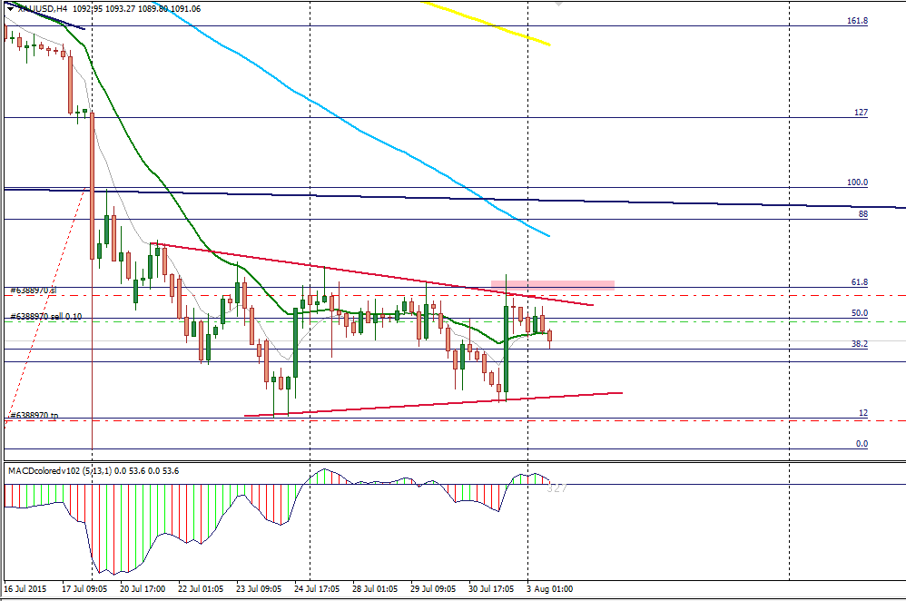
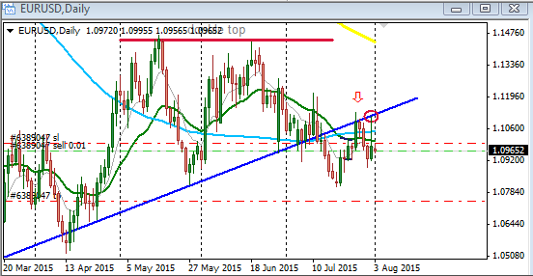
Quoting JonnyPip
{quote} Hi Nausting, No problem I am happy to help if I can  You are correct in what you said, the news often will confirm what is on the chart. The reason for this is because those who already know the result of the news "the smart money" have already priced it into the market. It mainly depends on how someone trades as to whether the news has much effect or not. I like to enter on the smaller time frames as it can give much better risk:reward ratios and as a result you can be slightly more leveraged in your position. If you have an entry on...
Yeah! Great insight...
This is about decision time for me, some of the pairs seem to be sluggish or struggling...I will be taking my stand (decision) on them soon...
Still watching the AudUsd pair...I am also (a little influenced) making use of the information you and nic73 has provided...
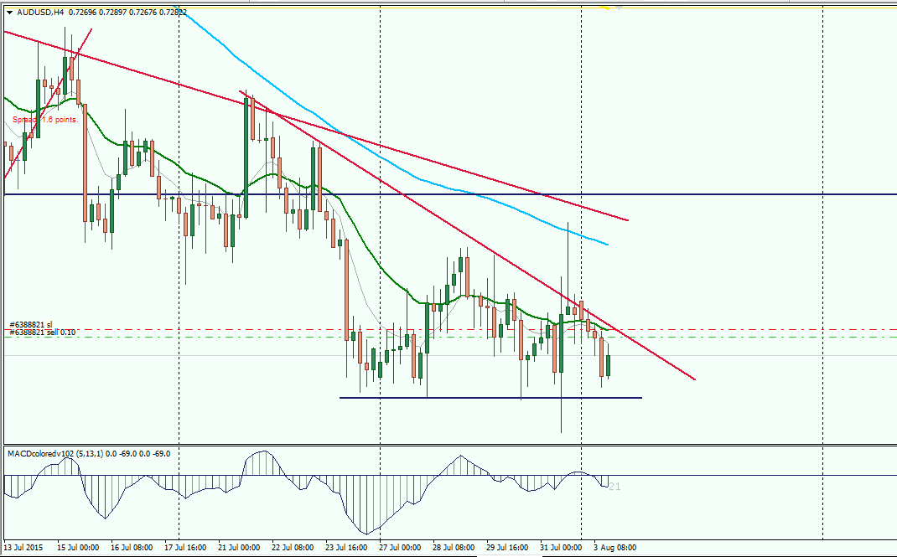
Quoting nic73
{quote} Hi Nausting, FACT: I started using the MACD again recently, for a long time it has just been there on my chart, but not being applied...this is because from my early days in this thread, I bent on learning strictly MARKET RHYTHM price setups...and if you go that way, you will be taking lots of trades even when the MACD is not supporting your direction... Quoting you statement from above I tried trading without using the MACD. This is my rationale for entering EURUSD - > Price rejected trend line a few time. > pull back to 21ema and move...
Great:
I will come back to you okay?
My internet subscription got finished while we were busy the other day analyzing the AUDUSD pair and other pairs I took (that is, on the 3rd of August). It happened suddenly and I thank God I had adjusted my stoplosses on all my trades before it happened.
Because of that, I lost back the +138pips I made in the XauUSD (Gold/Usd) pair back to the market and made a loss of -2pips...
On the AUDUSD, I lost back my +25pips on the 2nd position I left to run and made a loss of -7pips
on the same pair (AUDUSD), I missed that very great move to the north (+126pips move with a stoploss of about 30pips)...there were really lots of opportunities for pips recently, and even now....
I have subscribed again few hours ago, and decided to check in here....
I will come to you shortly...
Happy trading.
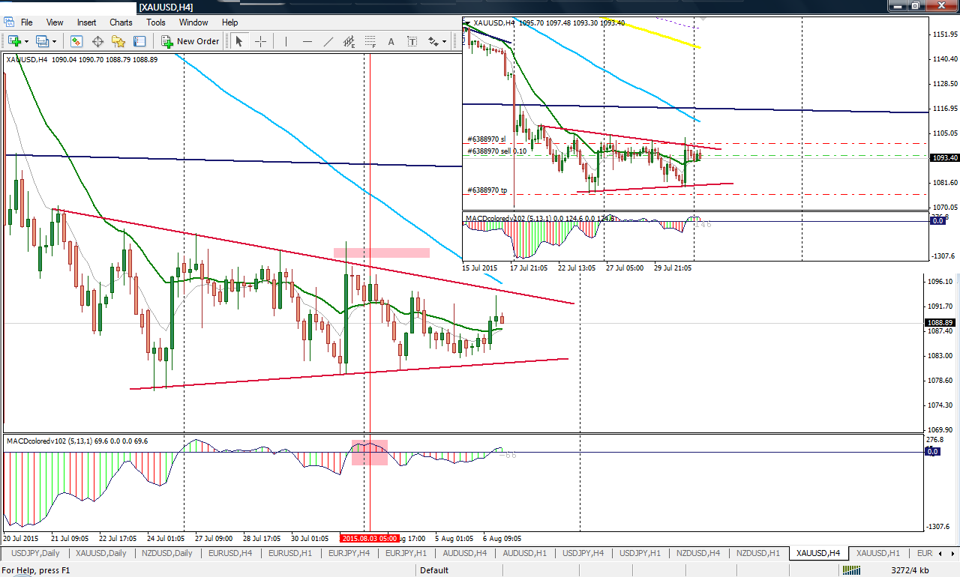
XauUsd (Gold/Usd): 4HOUR: August 7th, 2015
See chart for entry technique and result.
Note: partial profit is just taken at that price level (result chart), it is based on 127% Fibonacci from my daily time frame view. Other methods can be employed to take profit as well.
Edit:
stoploss = 27pips
take profit = 80pips
Happy trading!
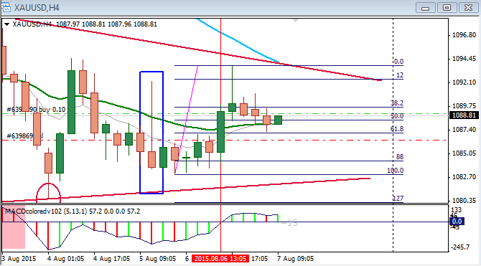
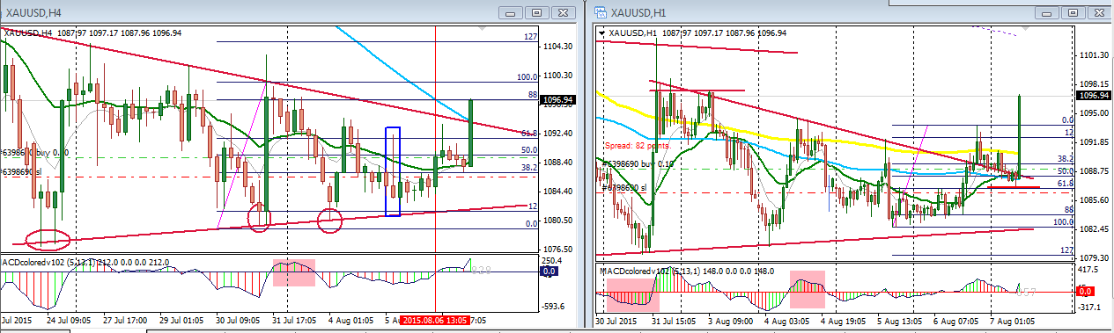
EurUsd: 4HOUR: August 7th, 2015
I am here too and watching...
Stoploss = 7pips
Take profit = 100pips (@ 4hr 200sma)
Happy trading!
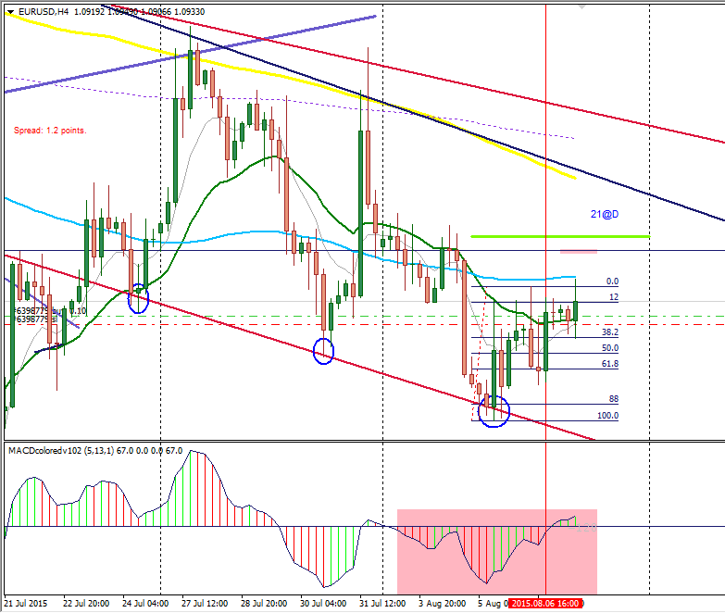
Update: Controlling from the 1min chart...maybe scalping...but not my intention
Edit: my chart tells me that something serious is about to happen...there is a very high tension in the market now. This is one of the ways I suspect NEWS is coming up...very solid setup, but price finding it very difficult to flow in either sides (north/south). This is my own type of NEWS...
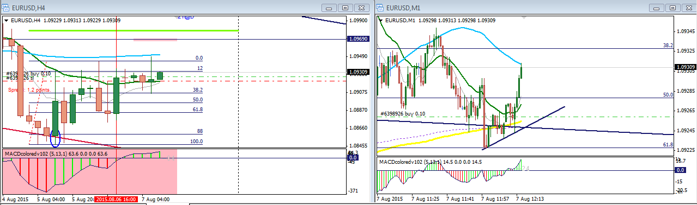
Quoting nic73
{quote} I did the opposite. I lost 90 pips on this. Why were you so sure this was going up? Tell me your secret to success. I still can't trade profitably and confidently.
Hi Nic73:
I think seeing your chart will help me a lot.
Also two traders can execute a trade on the same currency pair, at the same entry level, BUT in opposite direction and YET the two of them will WIN pips.
In the eyes of every trader, the anticipation can be for a move to the NORTH, but we also know that price moves in a wave form, such that before the agreed move to the NORTH takes place, there could still be a short term bearish wave forms that can cover up to 10, 15, 25, 30, ...pips distance. So a trader (maybe a scalper) can decide to lock in into his pocket those little, little bearish pips, while waiting for the bigger move to the NORTH to happen...then when the bigger moves to the north occurs, this trader will now total all the little little pips he/she had already made and use it as stoploss for the move to the NORTH. By doing this, this trader does not risk any of his capital, rather he/she is using the little, little pips he/she had pulled out from the market to take a new trade...
The concept above is another perspective of Money Management and Risk Control.
From my char above, price has already ran for 26pips..., I could have taken it, and keep it for the sake of taking another trade in the future.
I have also being checking my own char, the 4hr chart to see exactly where you could have taken the trade and lost 90pips, but I have not figured it out yet.
I hope this explanation helps... But I know you can make it here. You have the insight already, maybe you need to do some filtering a little, as regards the setups that you will stick to, to keep making pips, while you try to learn more on the ones that are not very clear yet...you may be amazed if I tell or show you how much money you can make by sticking to like 1 or 2 setups alone and trading them consistently every month...once you have success on them, you take a bold step and load up your account to a higher level standard account and begin to trade at that level...such that 2 or 3 trades in a month will leave you with $8,000 to $12,000 USD.
God bless.

Quoting nic73
{quote} I did the opposite. I lost 90 pips on this. Why were you so sure this was going up? Tell me your secret to success. I still can't trade profitably and confidently.

NON-FARM PAY ROLL NEWS ANNOUNCEMENT TRADE

EUR/USD: FRIDAY: AUGUST 7TH 2015

1 Hour Early ENTRY Technique/Strategy

Stoploss = 19pips
Take profit = 100pips

I have taken hours since weekend to put up a detailed explanation to answer a QUESTION raised from one of the traders here (nic73). His openness and strong desire to be successful I think was part of what drove me to go extra miles extensively in putting up this document below.

I have complied comprehensively charts from the weekly time frame to the 15min time frame to show my approach to certain trades and toward trading generally. I normally break down event and long term history of price into what is happening currently with price to make solid decisions before executing a trade or staying away from trading...

Honestly, I recommend this document to any trader.

The Non-Farm Pay Roll News Announcement trade (EurUsd) is the last one, the first trade in the document was a trade that I took on the EurUsd pair shortly before the Non-Farm Pay Roll News came out. And that was to answer nic73's question. Then I now added the Non-Farm trade.

The key to taking that Non-Farm Pay Roll trade is based upon the full analysis as I have shown from the weekly time frame to the 15Minutes in the document below. A trade of 19pips stoploss and a gain of 100pips on Friday, August 7th, 2015

Comments are welcomed!

God bless
August 10th, 2015:EUR/USD: 16:00 Candle Close

The foundation of the success of this trade is with respect to the .pdf document I have posted above. There is no magic about it! When analysis is properly done with respect to higher time frames, and well narrowed down to smaller time frame, one will find it very easy to take trades, because everything (the whole facts) will just be in front of you...watching and asking to pull the trigger.

It seems many currencies are heading north. Lots of opportunities in the market, for me, EurJpy, EurUsd, the one I have posted, AudUsd, XauUsd, NzdUsd, etc...

Hope this whole information bless those who read them.

Happy trading....
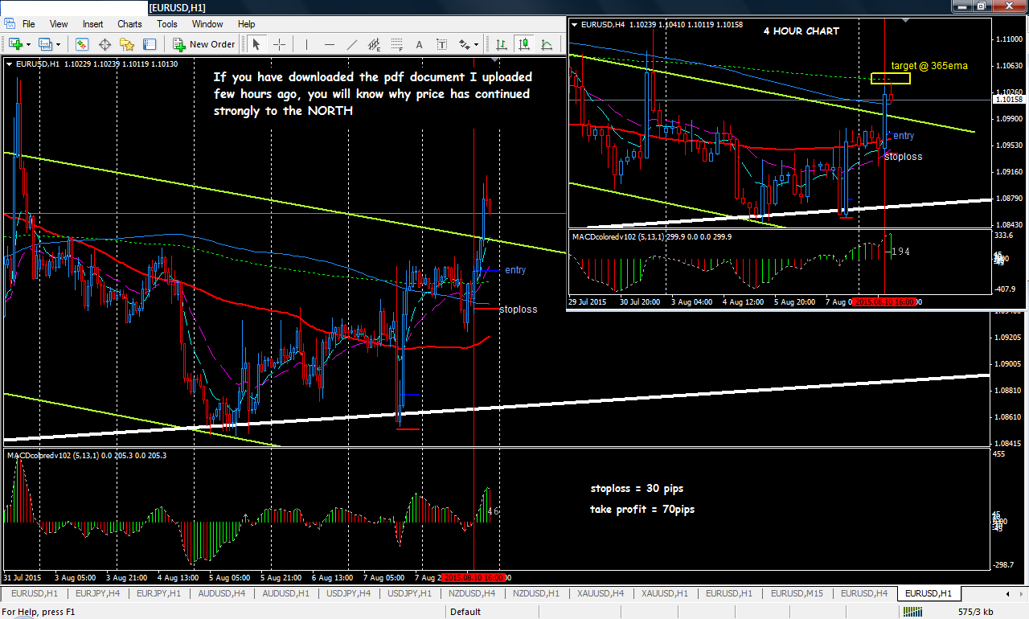
Quoting nic73
AUDNZD anticipation 11th August 2015 I have mixed feeling about this pair. By just glancing at it I thought it was going to move further downwards. But having analyzed it in depth I thought to sell pair could put my capital into a lot more risk. Here is how I see the pair: 1. There are 2 trend lines drawn from the H4 chart and Daily chart. The 2 trendlines intersected each other. 2. I inserted the fibonacci lines and price is reacting at between 23.6% and 38.2% for some time how. (provided the FB are drawn correctly, I am not exactly familiar with...
3 Little Sister
Already we missed the very nice first entry opportunity at point C. We are now looking for a 2nd entry opportunity to the south. I have put in what for me are the necessary trend lines...and I am watching to see how things play out in the future...what I like is that STRONG bearish candle (the vertical red line) and the TC following it on the MACD...that behavior is always an indication of a very strong move to the south...I normally like taking such nice candle...but I am respecting those two "guys" (the swing trend line and the 200sma) kissing or intersecting each other just exactly at the close of that nice bearish candle...that is just what has made me to hold on
That very point where they intersect is exactly the 1st take profit level for the trade taken at point C. For me, I do not really like taking trades at a place which should have been an exit level. From past experience, that is where price always turns around...
For the 1st trade at point C:
stop loss = 38pips
take profit = 112pips
You see! For those who took the 1st trade, they are already 112pips to the south, and if I did that, I will never be thinking to still take a 2nd trade at that point. Instead, I will wait for a break out from that level, then when price pulls back to them (swing trend line and or 200sma) and begins to move away, I will look for how to get involved with a very nice stop loss...at such stages one can switch to 1hr or even lower time frames (if you have learned how to do that) to look for nice entry opportunities and for sure smaller stop losses...
Hope this helps!
Happy trading!
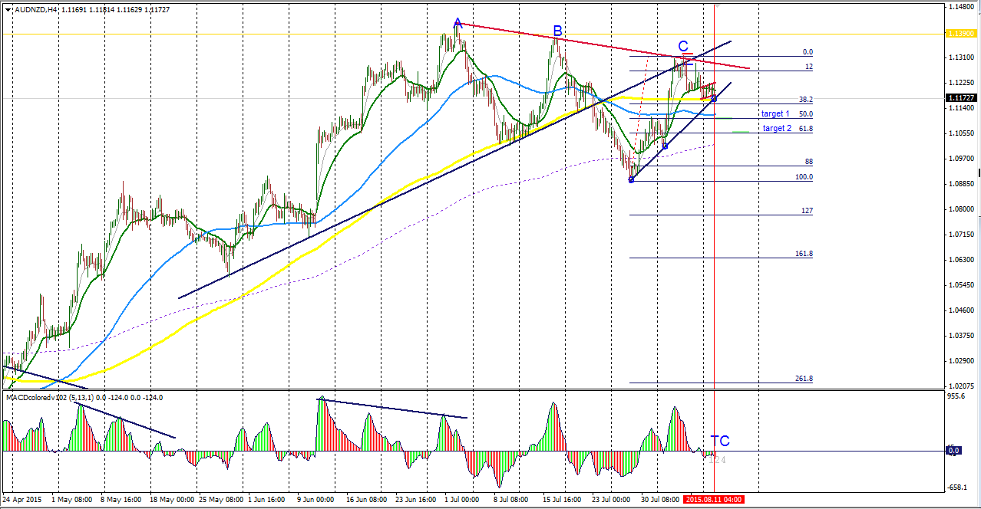
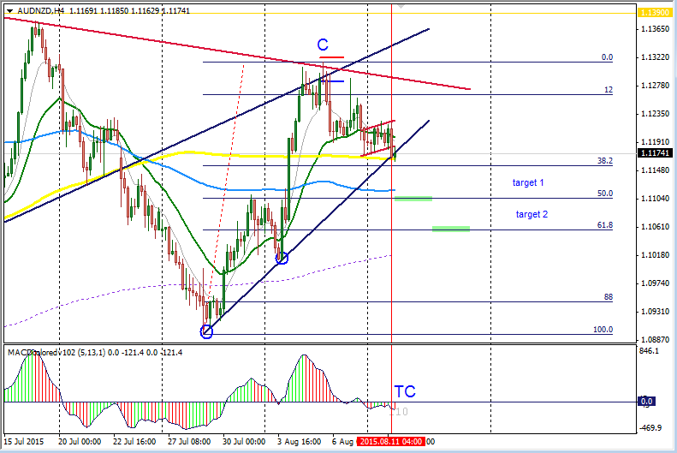
Quoting nic73
USDCAD 11 August 2015 Please see analysis within chart. I think this could could up north and bearing in mind that there looks like a divergence in H4 and daily time frame. Value your feedback on this. Tx. {image}
Good Insight.
I have currently 7 currencies opened and I am watching...the USDCAD is not among them and I tried to open it now, but my meta4 trading platform is like freezing (just stand-still and mouse cursor not even moving). So I cannot access the chart now...but like I said in one of my posts...I have stipulated entry setups/patterns that I am looking for, and once I open my chart, I begin to scan for them...once they are there, then I will do further analysis to see if there is anything that could hinder the move, and if there is nothing, then I will jump in...this approach saves me a lot of time and the stress of intensive analysis
Just few trades in a month will leave you with thousands of dollars per month when you begin to trade a standard account....for example the Non-farm Pay Roll trade which I posted earlier...you see how 19pips stop loss trade gave us 100pips gain...for a standard account it implies a stop loss of 190pips and a gain of $1000 (a thousand dollars)...and from my personal experience, there are many many places in the market where you can have such returns with minimal stop losses...but the issue is that many traders want to go through the whole process of intensive learning before they now settle for what really matters....I did that too and for sure blew my accounts a few times...my head is cool now. Thanks to God!!!

Quoting nic73
USDCAD update: Stopped out at break even. Was making some 30 odd pips gain and set SL to entry. {image}
ANSWERS TO QUESTIONS:
nic73: By the way, perhaps you have missed some question on the posts above. On scalping method, does one set stop loss on 1-hour time frame if trade take was from 1-hour?
naustingfx: Not really...Stop losses are generally set in the following ways:
- some pips away from most recent swing point
- some pips away from a certain resistance/support level as the case may be
- some pips away from certain moving averages, like above/below 21 or 200, etc
- some pips away from certain trend lines (long or short term trend lines)
- some pips away from a certain psych level or big numbers....etc
I set stop losses based on insight obtained from my overall analysis. Like the Non-Farm Pay Roll trade example, you will see that in that 15Min chart, my stop loss was set some pips away from that DAILY trend line running through the 15min chart.
nic73: And on USDCAD where my trade was stop out after setting SL at entry after price has move 20-30 pips so that should the market turn around and going against me, I would have been stop out at a breakeven.. Give me your insight how you would handle this?
naustingfx: Normally, I take 2 trades at a time, and when price moves that 20-30 pips, I will take my 1st profit at that if that is what my plan says, and I may not necessarily set the 2nd position to BE but will allow it to run at initial stop loss or I may reduce the stop loss a little (previous chart that I have posted showed that too) according to plan where necessary...so if I am taken out of the trade, I will not loose money...rather my overall result will balance things up for me as I have already taken partial profit...(this is Phillip's concept, raw...)
nic73: ...stop loss readjust too early that I was stop out? Market actually went towards my direction for 100pips after I was stop out.
naustingfx: ...and that would not have happened to you right??
These are the few question I spotted from your posts...I hope my feed back helps.
Happy trading!

Quoting nic73
EURUSD Having a very tough week after some successful weeks in first 3 weeks of July. Then trading results started to plunge. Charts and everything suddenly look very complicated, very difficult to analysis. Don't know how many traders go through this but it happens to me quite often. Anyway, I have EURUSD here, do have a look if you are interested. I think EURUSD is likely to sell to 21ema. It's a counter trend. Price rejected upper trendline 2-3 times. 2 previous candles closed lower with a inverted tail / spike, after pulling back to to trendline....
Beauty!
That is a professional approach to trading. Every thing was in agreement (confluence) naturally. The facts are there speaking for its self, then you were able to see it all and put them down in words...this is exactly how our chart (price movement, candle patterns, trend lines, moving averages, etc) speak to us always.
Once you understand the language and put it in words or in writing and read it aloud in your heart, you build confidence in your soul and (maybe) you see yourself trading like a robot per say (that it, clicking the mouse button to execute a deal just because the rules have been met and with no emotional attachment).
You see how the whole analysis went smoothly and there were no uncertainties to it. That is the kind of places (and mind set) at which trades are taken successfully.
I encourage you to take note of the inner feeling you normally have after analyzing and executing a trade, over time you will be able to build up your instinct (abstract mind) and you will notice that in the future, after just looking through your chart, your instinct alone can tell you exactly where to trade and when to do that...it becomes your personal discretion (psych man) and filtering strategy...such that when you take a trade, and your inner person (psych man) begins to get worried, you just have to have another look to your trade and can close it and wait for another opportunity...even if the trade later became successful, it does not matter....that trade maybe just one winner out of multiple losers detected just by your instinct...
I hope the information I have conveyed makes sense to you.
God bless

1

AUDNZD

16:00 Candle: August 19th/20th, 2015

WHEN YOU DISCOVER A PAIR THAT LOOKS GOOD, NEVER QUIT FROM WATCHING IT UNTIL YOU EVENTUALLY TAKE THE PIPS YOU ARE LOOKING FOR FROM IT AS THAT MAY BE THE MOST PROMISING OPPORTUNITY YOU MAY HAVE FOR THE MONTH
Yes! This has to do with a currency pair I have been watching for more than a week now. A trader here posted the chart with decent analysis, and I have to open the chart for the first time I guess since my trading career and I saw that this pair Aud/Nzd was moving smoothly...the road was just free...NOW the final target has been reached.
I feel I should post it to help show that sometimes the best option is to just stick to a very promising pair because that may be the exact opportunity that will bless you account for the month.
I had posted detail analysis on the pair few posts behind http://www.forexfactory.com/showthre...4630&page=1451 (PAGE 1451, POST 29005 AND 29006)
There I showed my thoughts/analysis clearly.
Today, the full destiny of my analysis was fulfilled!
Stoploss = 35pips
Take profit = 80pips
Happy trading!
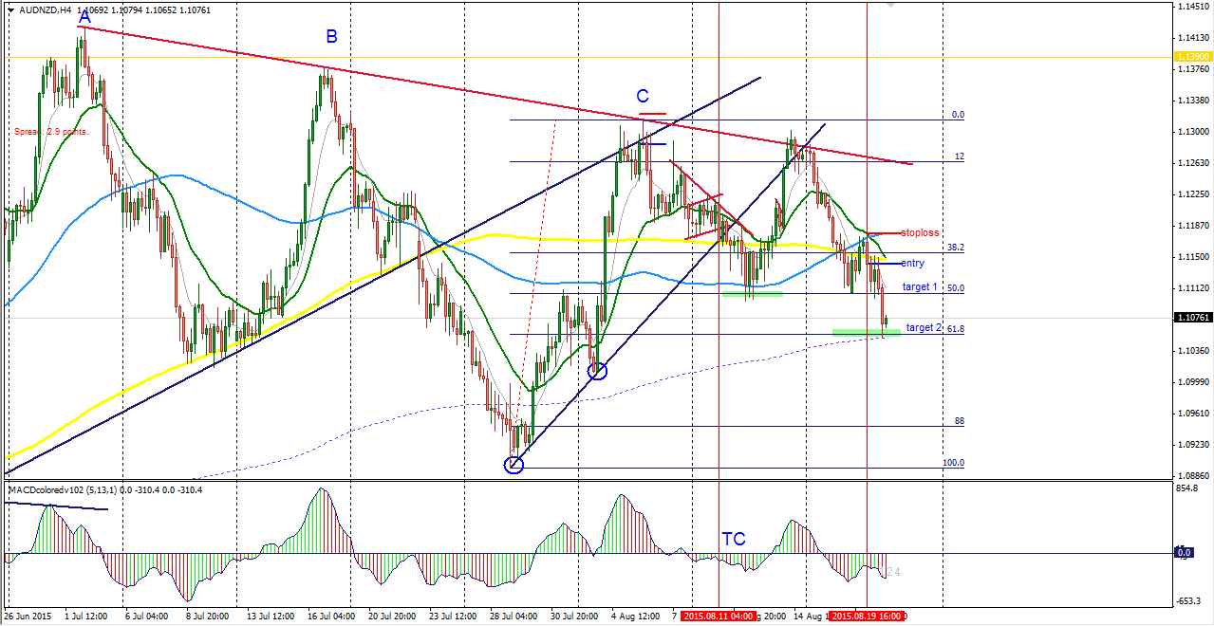
USD/JPY : August 20th, 2015
I entered on the 1hr chart.
The blue mark is my entry and the red is my stop loss anticipation.
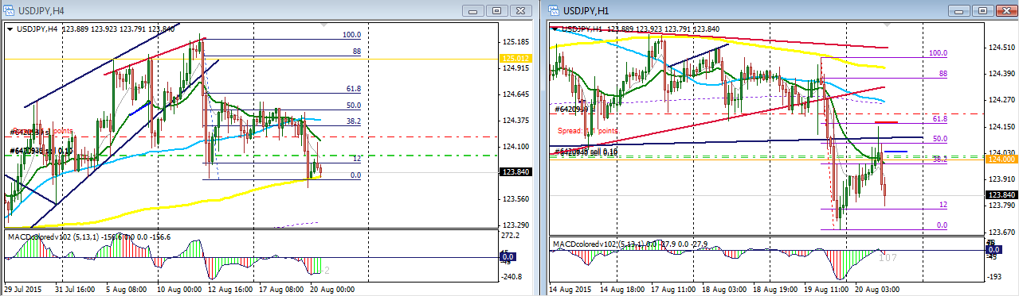
Result Update: USD/JPY (See Page 1452)
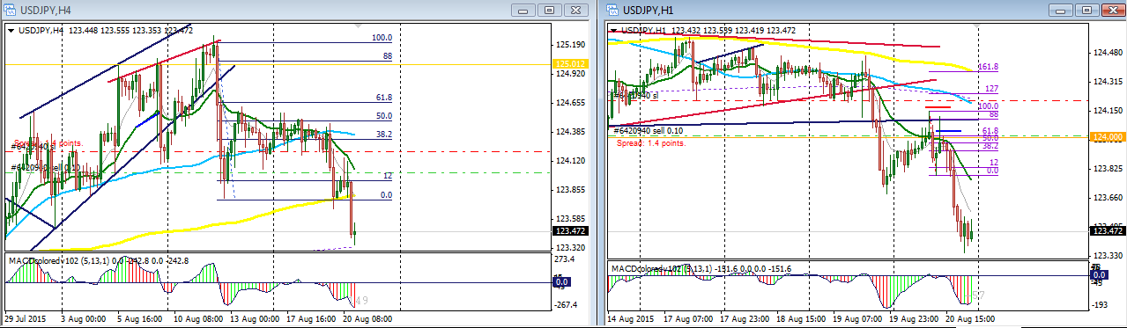
Battle Plan

Daily OUT LOOK
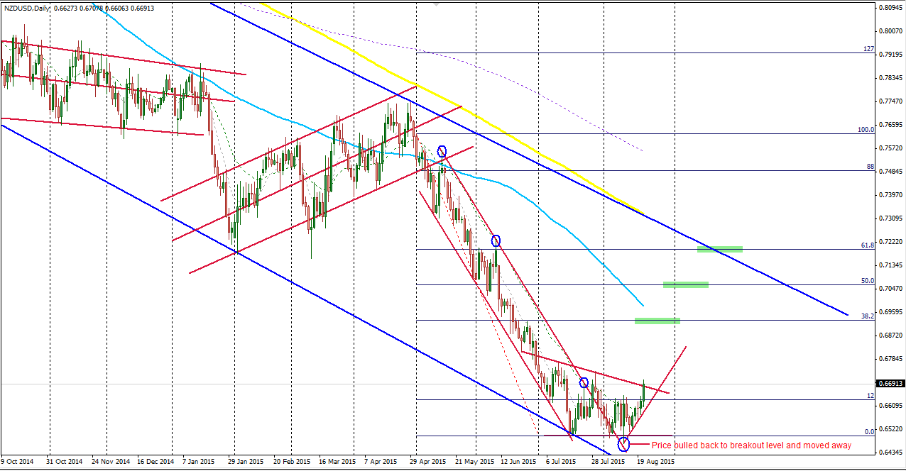
The Focus is now on setups. I think the most popular setups to be looking for on the 4hour or 1hour, even in the 15min time frame is the pull-back and move-away kind of setup... we are likely to see price doing some little little consolidation and breaking out upward as it journeys its way to targets.
Happy trading.
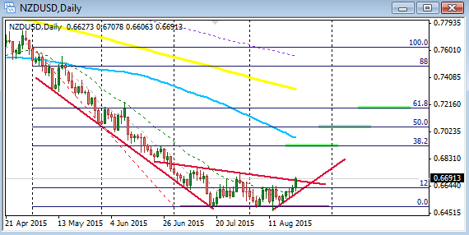
NzdUsd: August 24th, 2015: 08:00 candle close
When the market opened it was sleeping time for me... I woke up this morning and made some little more analysis to reaffirm (re-assure myself ) on my anticipation that price is most likely to go north as I had posted earlier "Battle Plan".
I like what I saw...price is busy making higher lows on that blue 4hr trend line...a strong indication for an up move, so the best way to trade such scenario is to look for some place from bottom (along the path of price which in my chart has been established with that blue trend line on the 4hour) where entry can be made with a nice stop loss for the move to the north. And that is exactly what I have done. I have positioned myself for a big move up...my hope is up.
I like the stop loss number that this trade provided for me, and that is why I am in and have decided that I will for sure let my position run.
Stop loss = 18pips
Take profit = 145pips
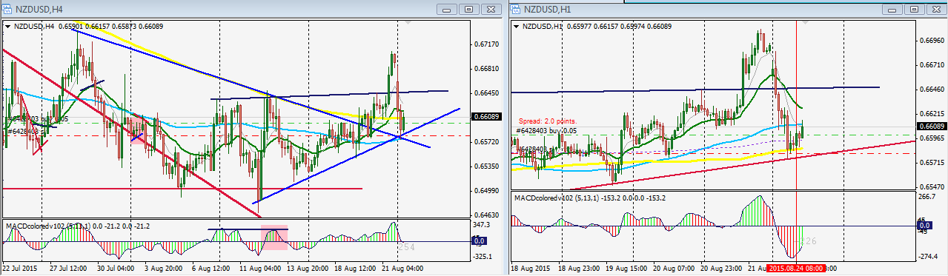
Update: My risk was 18pips and price moved +24pips in my favour and began to reverse against my position. I did not take any profit as that is not my plan. So I have adjusted my stop loss with respect to what is happening currently...We are between the 200 and the 89 on the 4hr chart, so there could be some sort of shaky/zigzag/ranging behavior for price...
Price can also retest that bottom trend line on the 1hour and can find it way back up. So I have adjusted my stop loss according to that. And that is the place I will remain...I do not want to put more risk to this trade. So if I am taken out, I will not feel bad as my stop loss is little.
Attached Image (click to enlarge)
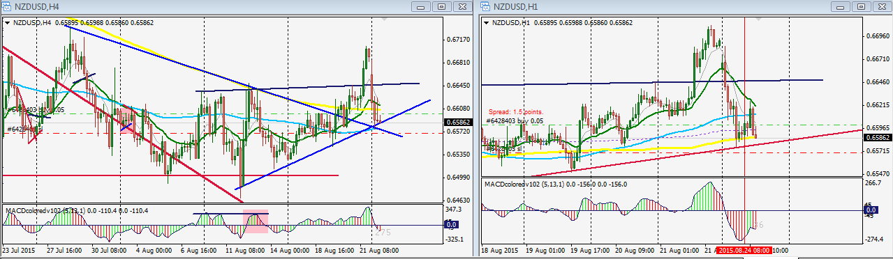
Wow...the game is over!
For me, there was no way to set my stop loss to Break Even after price went +24pips in my favor as that for me is not the right environment to do that. I needed to give my position more room...so I bear the loss...
The strong break and bearish candles confirms for me a strong move to south...as usual will be expecting retracements as price goes to south, and look for a nice stop loss to get involved if I am here to see all that happen. 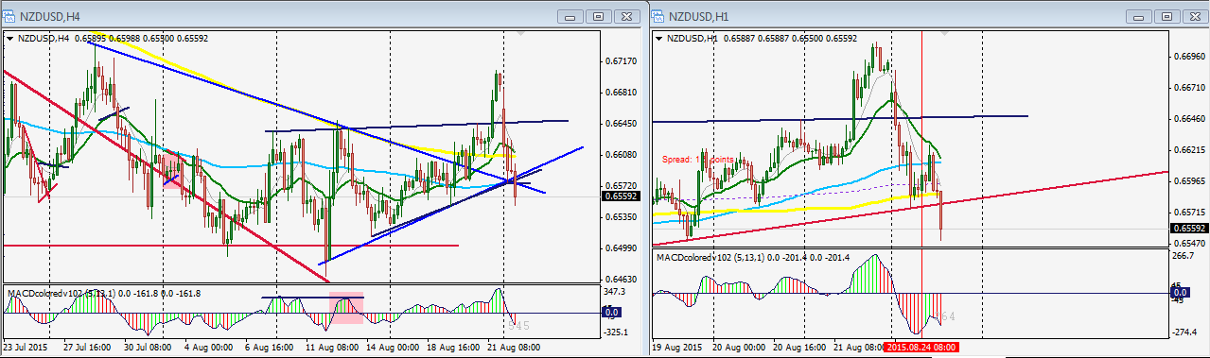
Quoting nic73
EURJPY analysis Anticipation 1 as per chart attached, for move up north. If that does not happen price could then move down pass 21ema, pull back and move away to 89sma (counter trend). {image} Watching the pairs I usually trade and market is very odd since last weak. Cannot decide where to go yet. Please leave your valuable insight. Thanks
EUR/JPY TRADE. 08:00 CANDLE CLOSE: 15TH OCTOBER, 2015
Hi Nic,
I am back from journeys...and I had to take some little time to draw some nice plans for my trading activity...so during my plan period, I do not really post to the forum...this is because I do not like giving people something brief...I like to throw details open, that is, I like operating from a broader perspective (I like looking at things or events from the bigger picture...and that is always very powerful), and this can be applied not only to trading, but in every life situation (at home with wife and kids, at your work place, and in the society or world at large)...Therefore, I took time to put myself in order so that I can help in some way to put another person in order here in this forum and in other things that I get involved with....Yeah!
Right! Let's look into your post now:
I have taken time to read go through posts...the post you have above on the EurJpy pair is very very nice...all the details you exposed about the current situation of the market is good and any trader can bet his money, live money on your analysis in anticipation that price will go north...but that has to be done at just the right time/level/price and with good position or trade management one can make good pips....
But please like I said earlier and in my previous reply to your post and other posts I have given to this forum...I like to view the actions of people (price chart) from a bigger picture...I have always point this out here and to you...ONCE AGAIN YOUR ANALYSIS IS NICE BUT I WILL NOT BET MY MONEY ON OR ACCORDING TO IT BECAUSE YOU DID NOT SHOW ME WHAT THE LONG TERM SITUATION WOULD LOOK LIKE (YOU DID NOT SHOW ME THE BIGGER PICTURE). YOU HAVE BUILT YOUR PLAN ON A VERY SHORT TERM BASIS...
NOW YOU ARE GOING TO SEE FROM MY TRADE BELOW (15TH OCTOBER, 2015: THE 08:00 CANDLE) HOW ONE WOULD HAVE RUN INTO A BIG PROBLEM IF A LONG TRADE WAS TAKEN BASED UPON VERY SHORT TERM ANALYSIS...
From your very short term analysis, anyone that followed you would most likely be only focused on price going north and will not be prepared for anything otherwise....
AND THAT IS EXACTLY WHAT HAPPENED 2 DAYS LATER...THE REVERSE BECAME THE CASE...PRICE WENT SHORT (SOUTH), AND DID NOT GO NORTH AS YOUR ANALYSIS SUGGESTED...SO I WAS IN THE MOVE TO THE SOUTH INSTEAD AND THE TRADE TO THE SOUTH PRODUCED FOR ME +170pips MOVE...AND I TOOK ALMOST ALL OF THEM...
SEE MY CHART BELOW
I TOOK THE TRADE FROM 1HOUR EARLY ENTRY TECHNIQUE
CHART ANALYSIS:
I have put some chart together...the first chart gives the BIGGER PICTURE of events...and you can see there clearly that the trend line ABC is very important. And what is happening at point C is a warning against any anticipation for price to move or proceed to the north as regards long term view...
INSET M: That is the 4hour chart...there, what is happening in the BOX C on the DAILY time frame was revealed...it is in that little BOX that you did almost all your analysis (and that is short term for me).
The vertical line which I have drawn there (16:00 candle, on the 13th Oct, 2015) is on that last candle you were analyzing on your own chart (INSET N) as an additional point or backing to take a long trade...
Any yes...just as you pointed out, that very candle closed and stayed above the moving average...that is very good signal to go long for me and for you right...but the risk reward at that stage was not perfect, but the trade can still be taken...BUT WITHOUT THE BIGGER PICTURE in place, one may relax and would want to see price running to the north for a long time, yes because that signal your spotted is a very powerful one for a longer move to the north...then you take it and you believe it will go in you favor and continue to the north....and you may not even think of taking any partial profit, yes because the signal for sure is very promising...and suddenly price turns against you...
So assuming the trade was taken to the long like you suggested, it is very nice and okay, but without having the longer term view in mind, it will be difficult to manage that sudden move to the SOUTH that happened about 2 day later...anyway, price also indicated sluggishness in moving to the north before that happened...and normally when I take a deal and begin to sense some sluggishness in price move, I begin to take a 2nd look at my position and analysis...
My summary is that the BIGGER PICTURE should be the major focus as we do short term analysis...Something happened and I went far behind and I saw a trade you took and made about +120pips in the month of MARCH 2015; (http://www.forexfactory.com/showthread.php?p=8144047#post8144047) post 28,806 and 28,808...those posts are very interesting, and I would like you any anyone to visit that post and absorb the info there...
Please I hope that my explanation makes sense and benefit everyone.
God bless

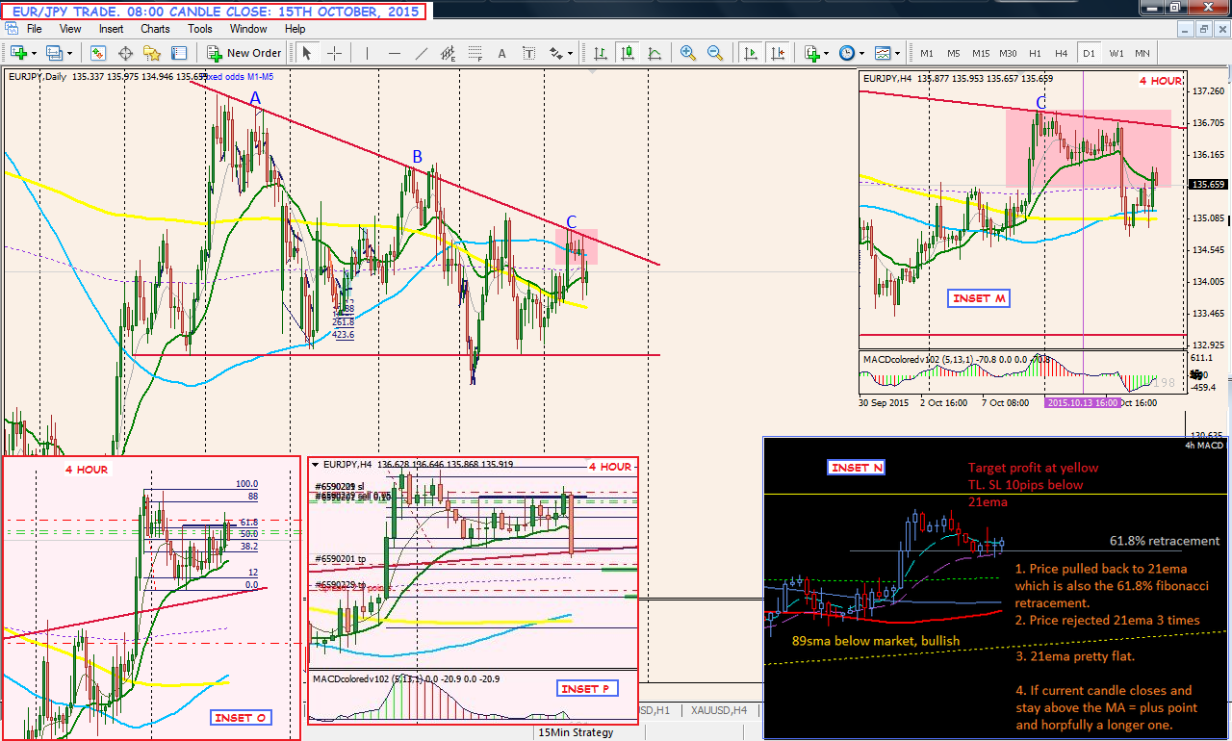
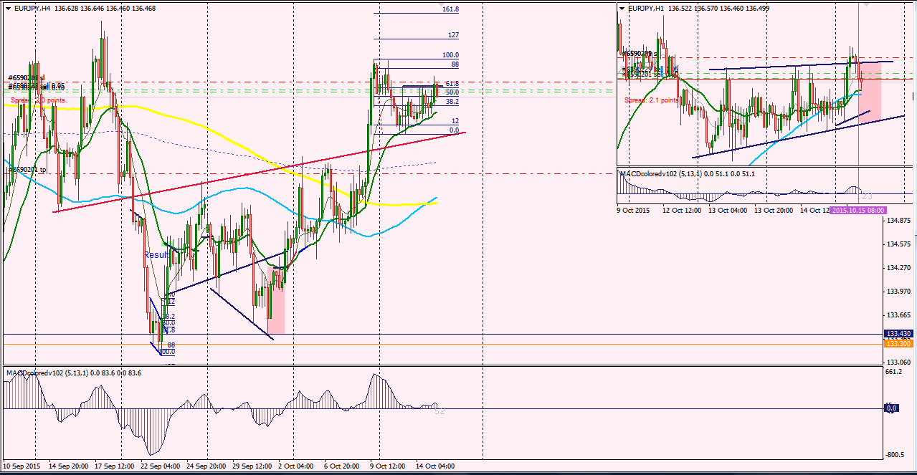
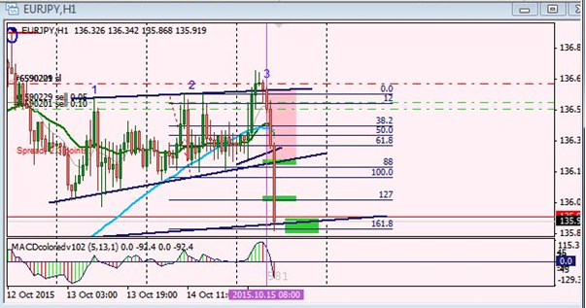
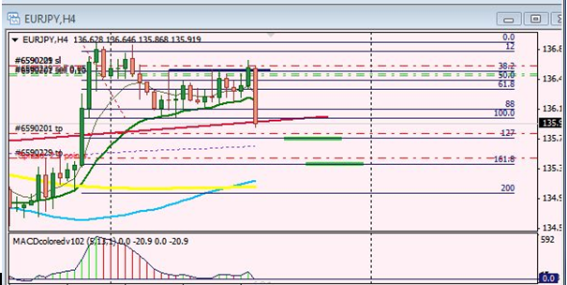
usd/jpy. 15th october, 2015
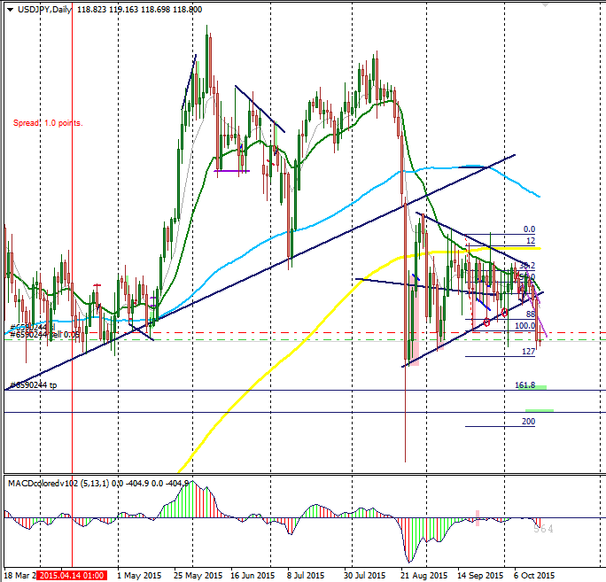
HOW I ENTERED
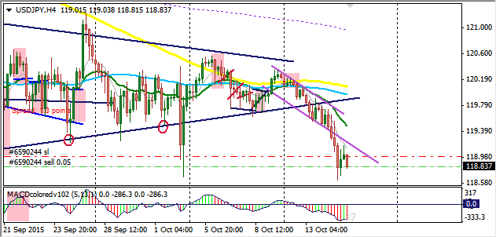
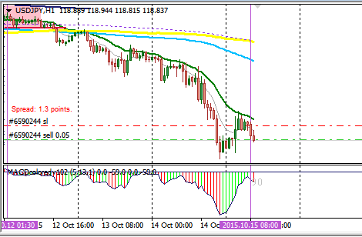
performance update chart
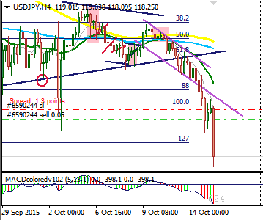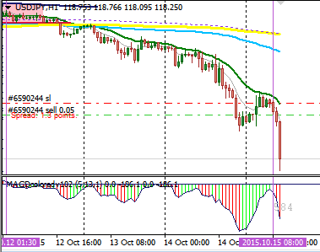
OVERALL
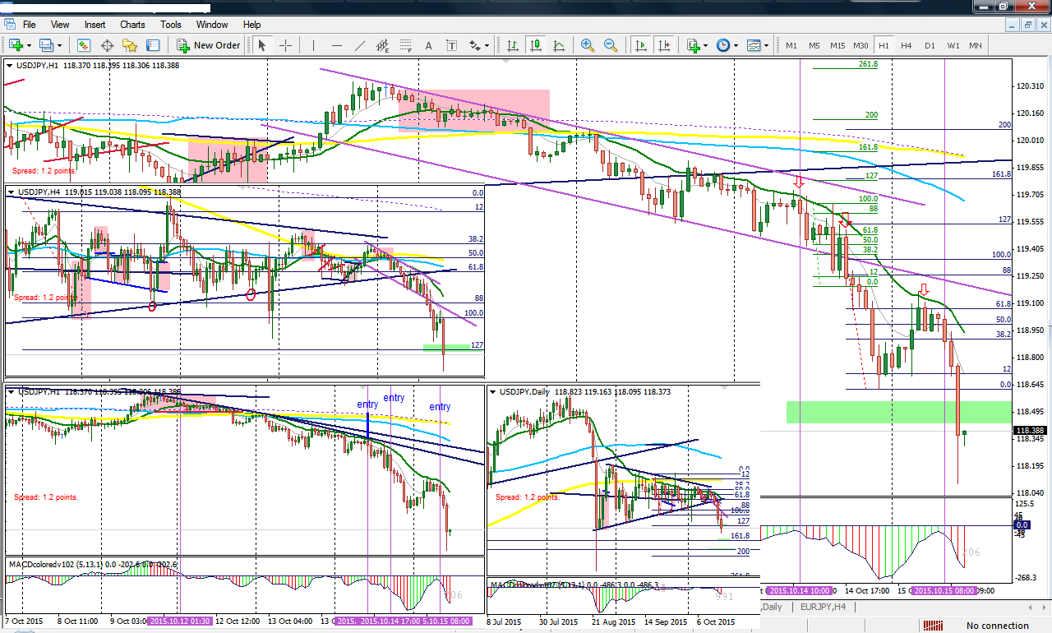
previous trades:

usd/jpy. 14th october 2015

purpose: Just to show that the system is working...then you have to put the effort, have the patience, pray to god, and eat the fruits of your hard work.

reality:
knowledge, hard work, discipline, patience... Alone cannot give birth to success, unless god pours out his grace on them!!!
this is the reality of divine prosperity!!!

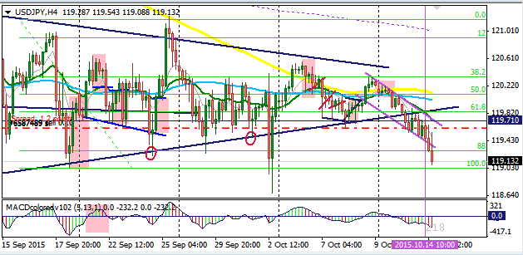
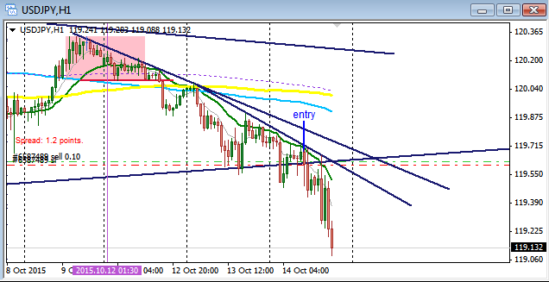
PREVIOUS TRADES:

EUR/USD. 14th october 2015

purpose: Just to show that the system is working...then you have to put the effort, have the patience, pray to god, and eat the fruits of your hard work.

REALITY :

knowledge, hard work, discipline, patience... Alone cannot give birth to success, unless god pours out his grace on them!!!

this is the reality of divine prosperity!!!
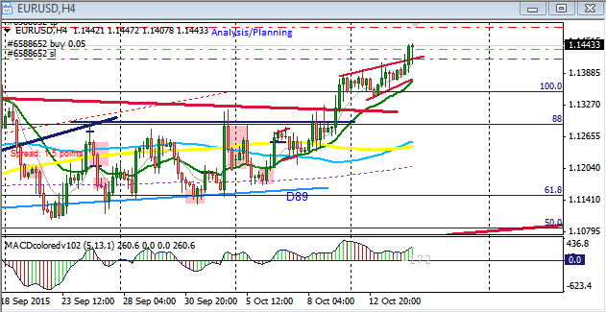
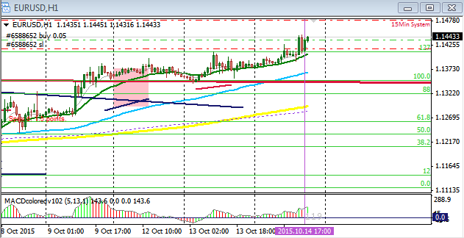
PERFORMANCE

Profit taking is at the 127% Fibonacci extension level as seen on the 4hour chart below.

Reality of Success:
knowledge, hard work, discipline, patience... Alone cannot give birth to success, unless god pours out his grace on them!!!
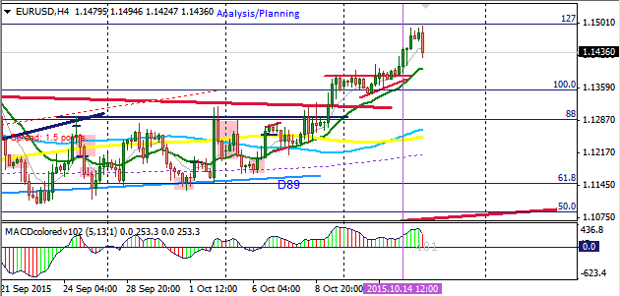
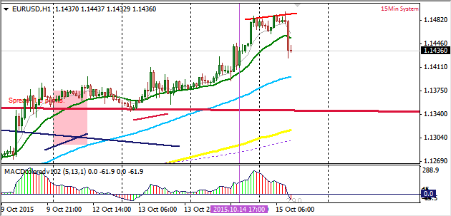
USD/JPY. 7TH OCTOBER 2015

PURPOSE:

Just to show that the system is working...then you have to put the effort, have the patience, pray to God, and eat the fruits of your hard work.

Reality of Success:
knowledge, hard work, discipline, patience... Alone cannot give birth to success, unless god pours out his grace on them!!!

JESUS IS LORD!!!

HE IS THE SOURCE OF MY SUCCESS...I REMEMBERED MANY TIMES WHEN I ALMOST QUIT FROM THIS BUSINESS, AND HE WOULD NOT LET ME BECAUSE GOD SEE THE END OF MANS JOURNEY FROM THE VERY FIRST DAY HE TOOK A STEP. HE KNEW I WOULD BE SUCCESSFUL.
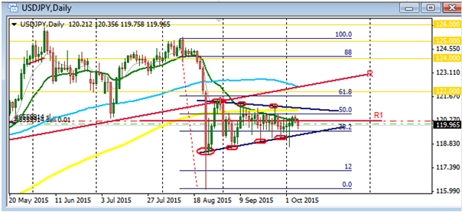

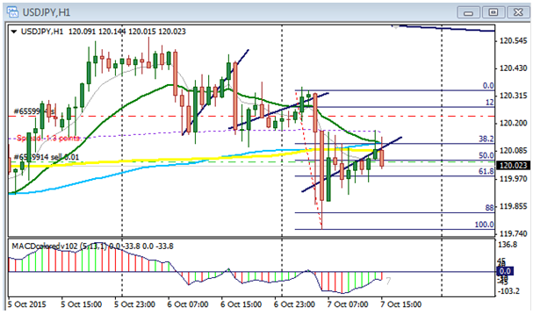
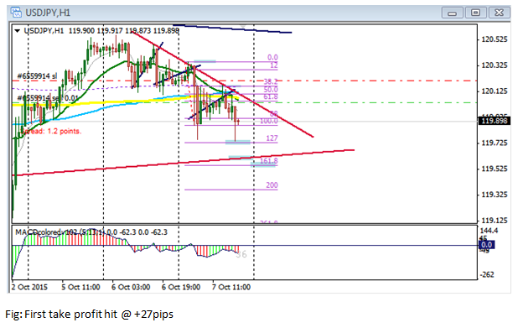
USD/JPY. CURRENT SITUATION OF THE USD/JPY PAIR
...I FOLLOWED THE MOVE TO ITS VERY LAST END @ 127% FIBONACCI EXTENSION BEFORE IT REVERSED. I HAVE SHOWN HOW I FOLLOWED THE MOVE IN THE EARLIER CHARTS POSTED....
Reality of Success:
knowledge, hard work, discipline, patience... Alone cannot give birth to success, unless God pours out his grace on them!!!

JESUS IS LORD!!!


