I am having a little issue with my posting as I can not see the tools menu bar in the thread reply window so as to put up my posts the way I want it. So am just posting the way I am allowed to. Will try to figure what the problem is...even my charts are not showing, but when I opened the thread on my mobile phone, I saw everything clear. So I believe people will be able to see them from your side...God bless!
USD/JPY Trade for September 24 and 25 2014
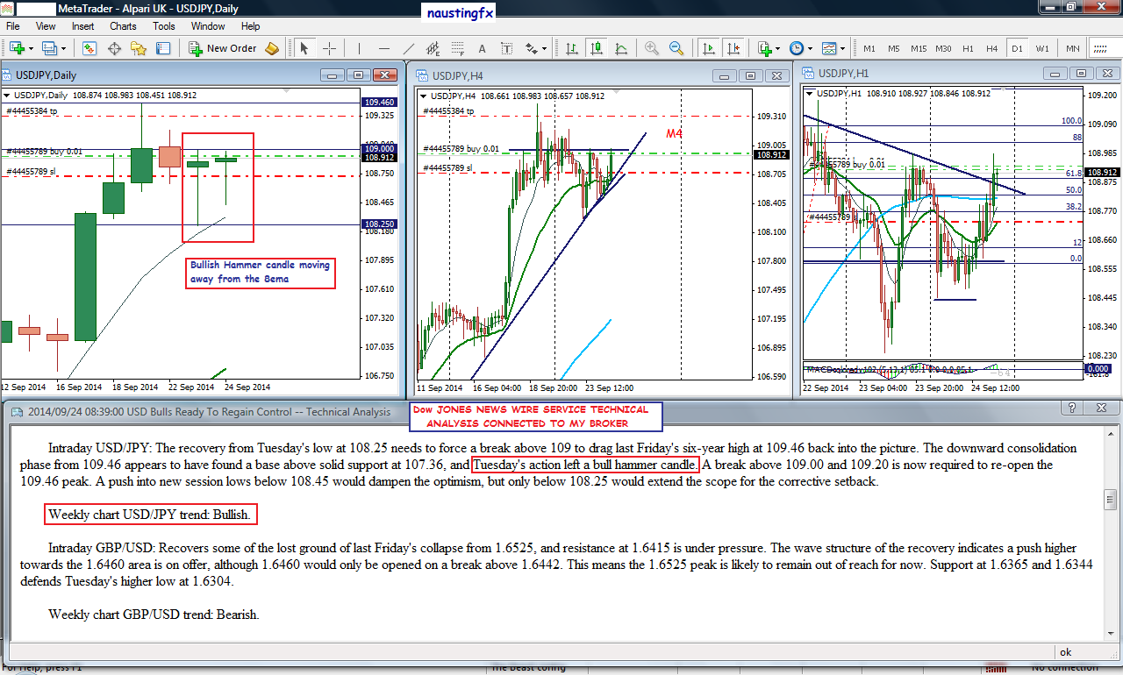
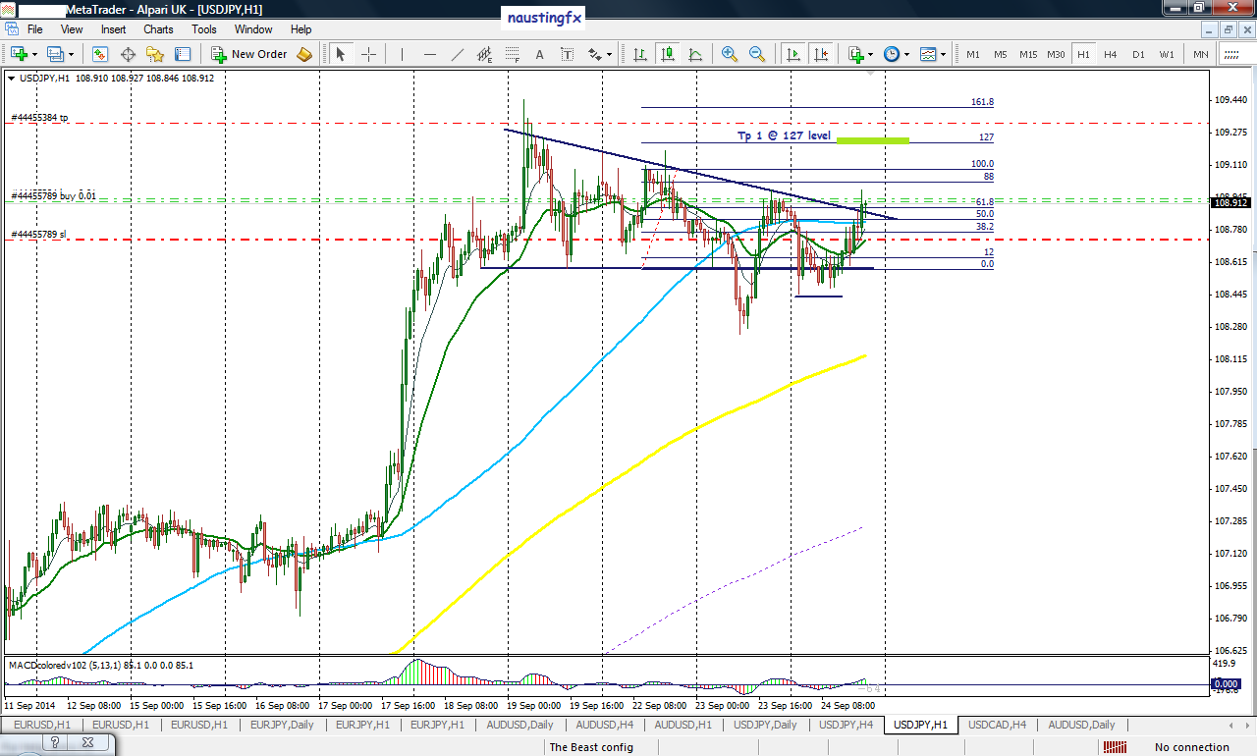
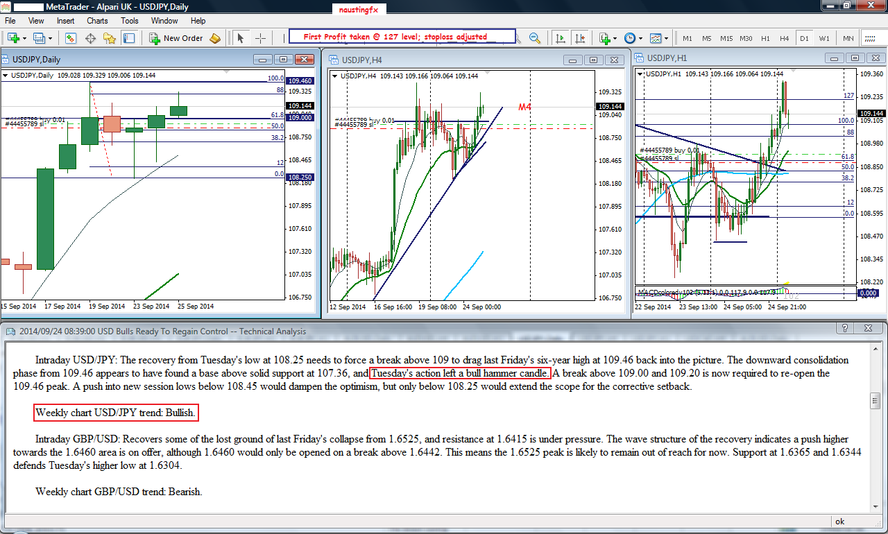
Momentum of the market showing that we are in a strong bullish mood and at a very high speed. I will try to post how this great move on usdjpy began and how i jumped into this whole run to the north at a very nice early stage.
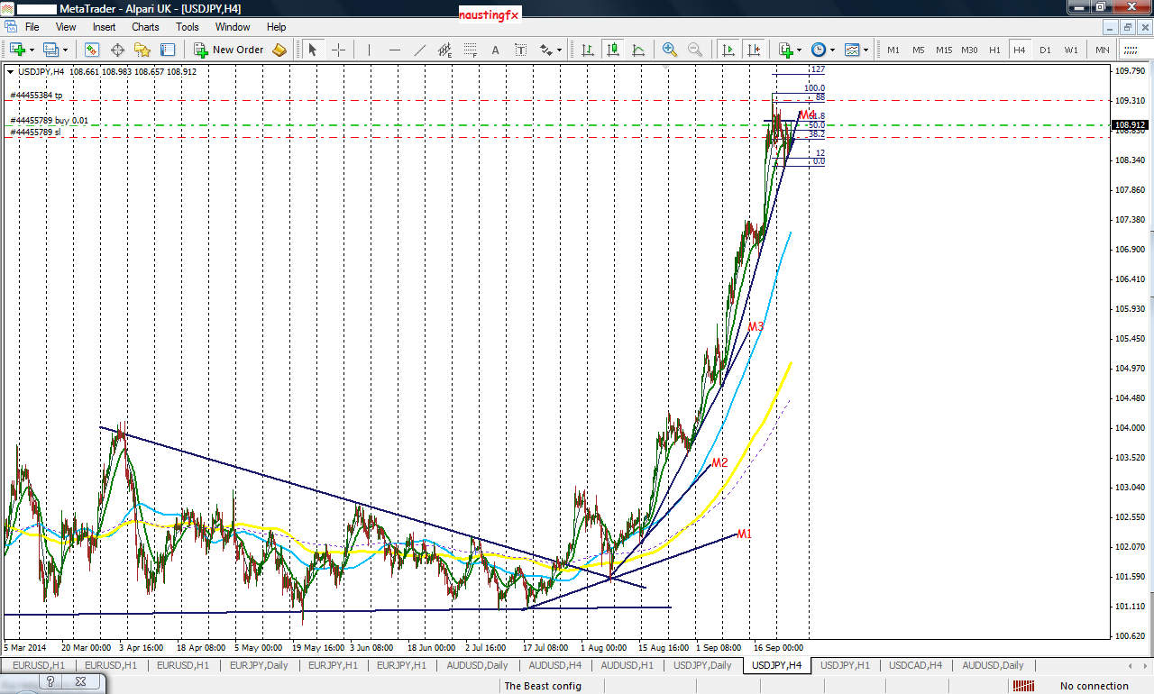
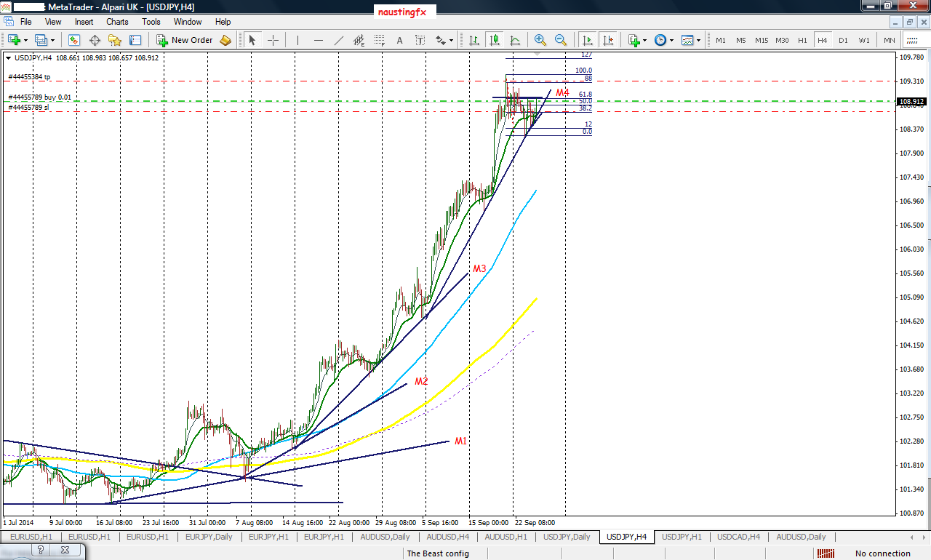
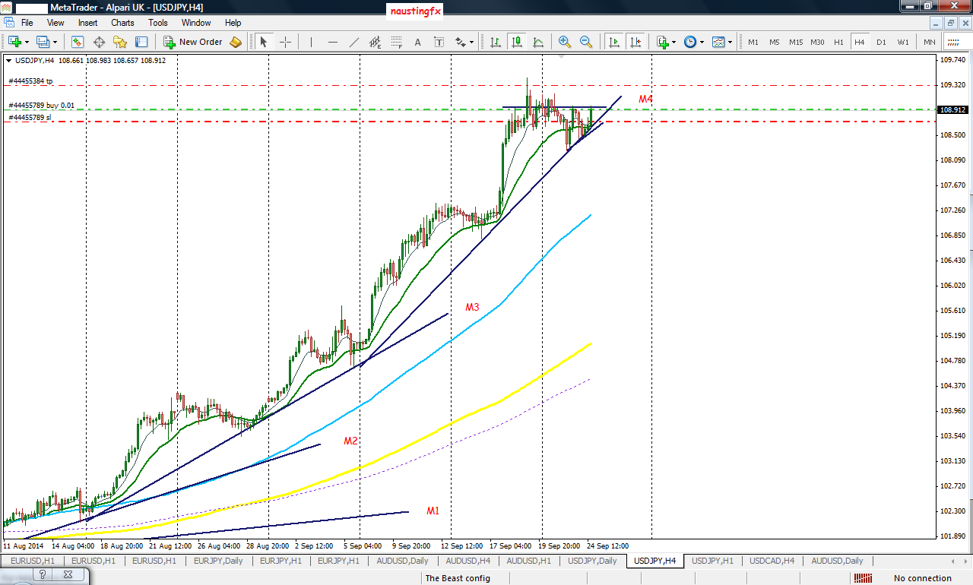
Anticipating my 2nd take profit level with the help of the momentum lines. There are some nice explanation to how these trades were taken but cannot post now as i am having issue with posting...but i have tried to put some details in the chart to make things clear...questions and contribution as always are welcome....thanks!
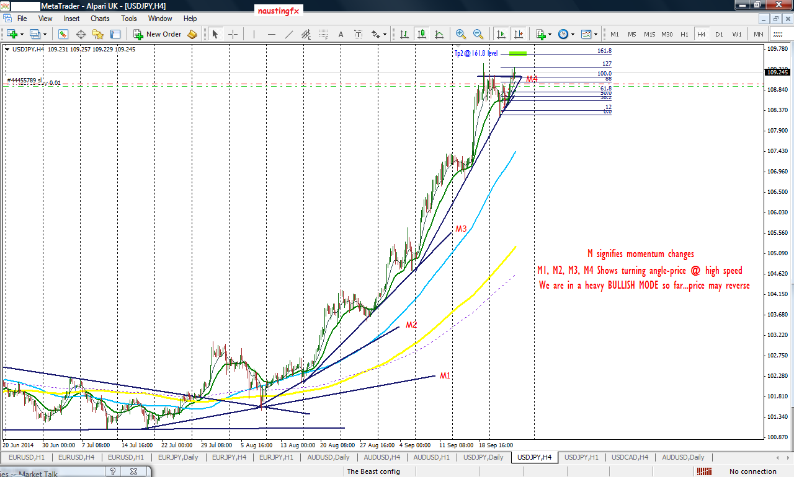
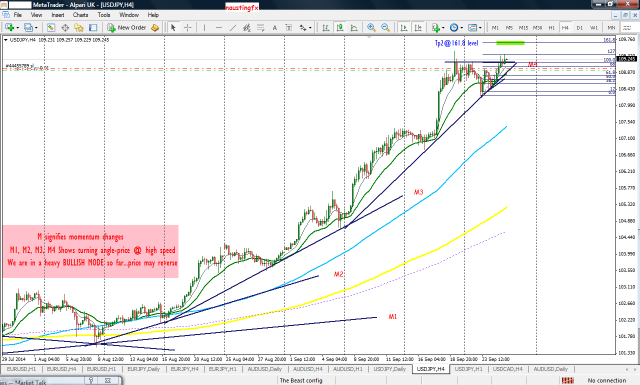
USD/JPY: AUGUST 18TH 2014.
SEE HOW THE WHOLE MOVE AND RUN TO THE NORTH STARTED....ALSO SEE HOW I GOT INVOLVED FROM THE DAILY TIME FRAME PERSPECTIVE...thanks.
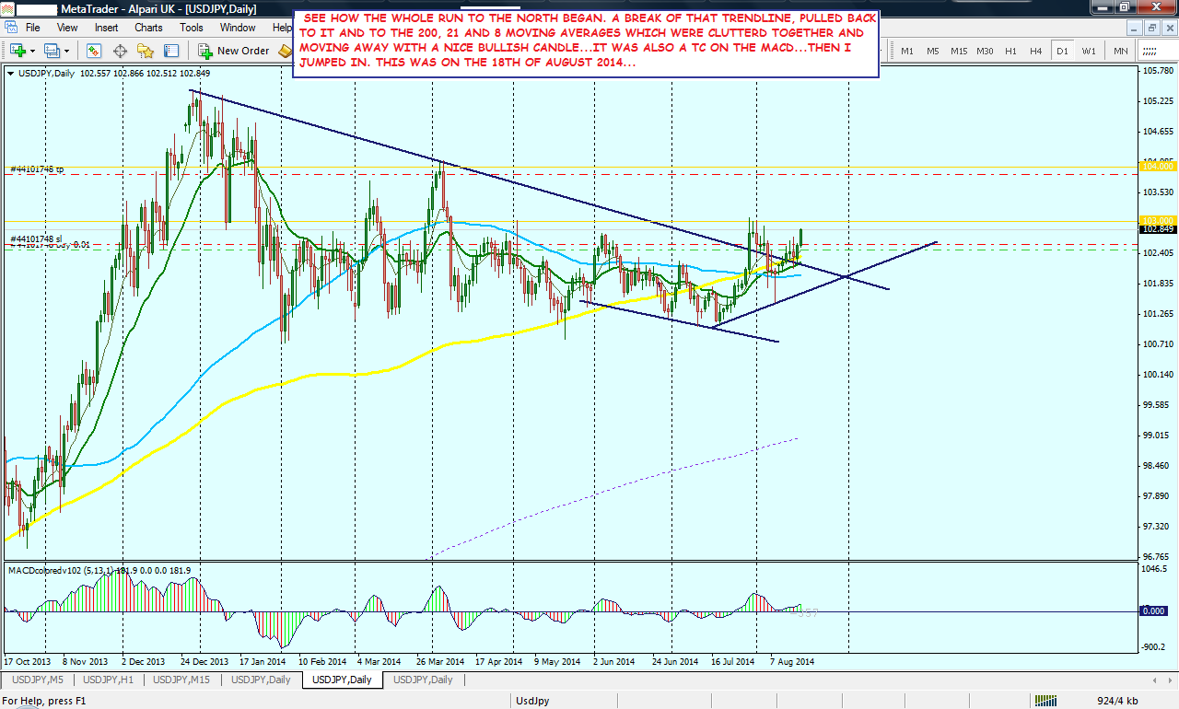
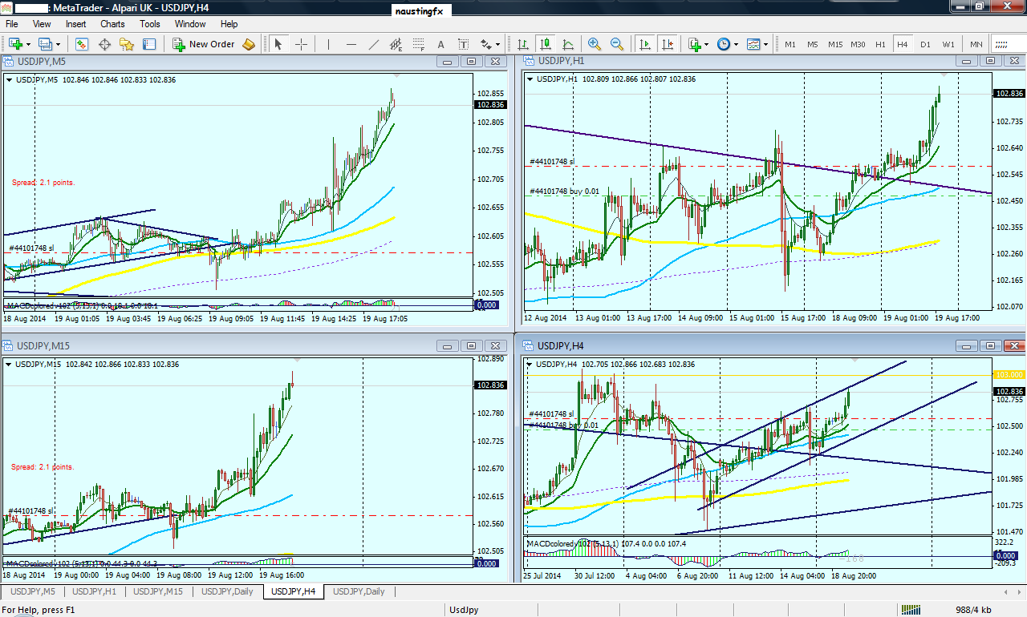
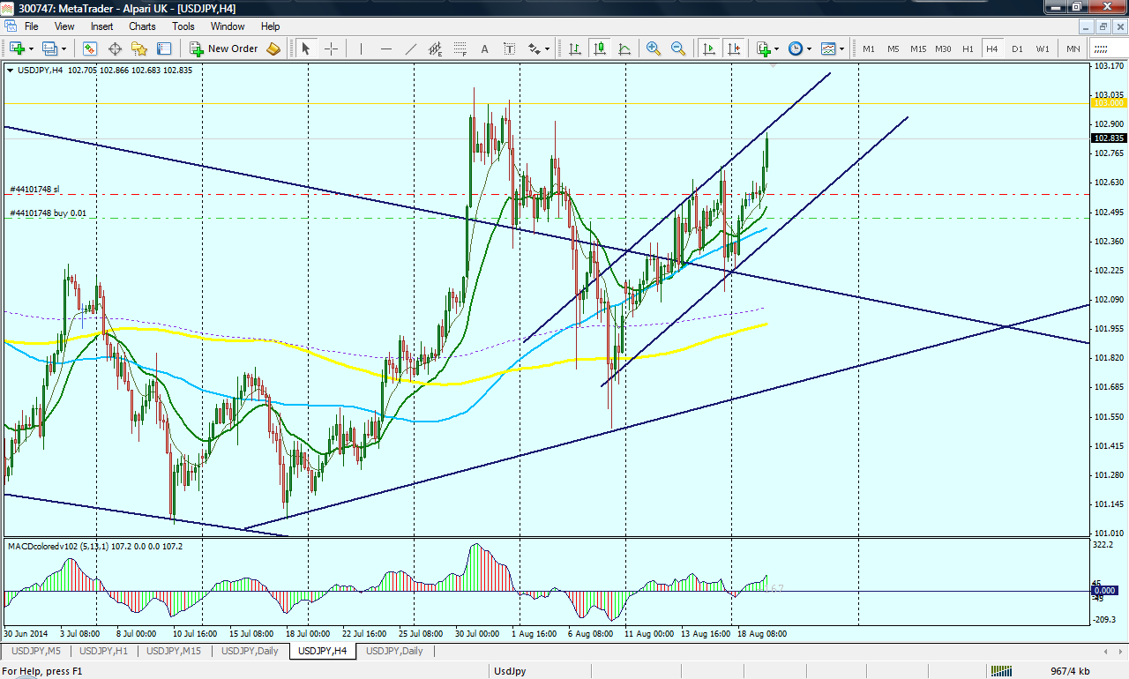
I am still having issues with my posting rights. Also my charts are not showing. I can even see my charts and know how it looks from here and I cannot aswell see other posters charts. I can only read their comments. I begin to suspect if my computer has got infected or something...
I have just for now uncountable posts to make. But because of the issue I am having now, I am reluctant to post. But I will try. If things work out well, I will fill this place will good charts and info I believe someone can benefit from.
As usual, I try to take record of almost all the trades I have been doing for many years now. I snap them and keep them and read them myself as if it is someone else who posted them to me to learn from them....
I read my posts as well as posts from others here as if I just started trading forex few days ago. Everyday I learn like child. No matter how much I have known, I still listen to other people's good info here as just a little student or pupil that just started school. This helps me to meditate on what they are revealing here and I am able to extract fresh and nice knowledge.
Below is a trade I took on
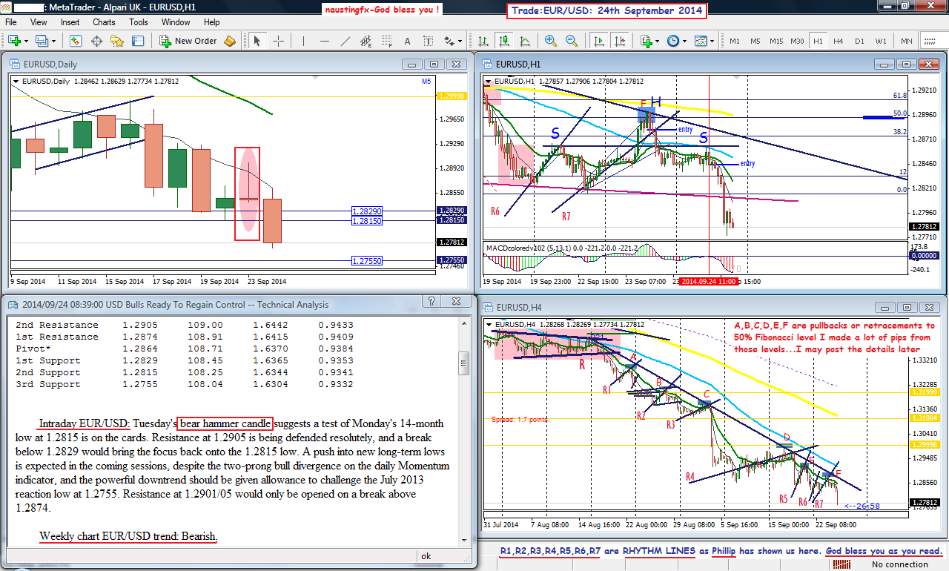
Market rhythm our motto!
4 hour situation
(unleashing the power of rhythm lines)
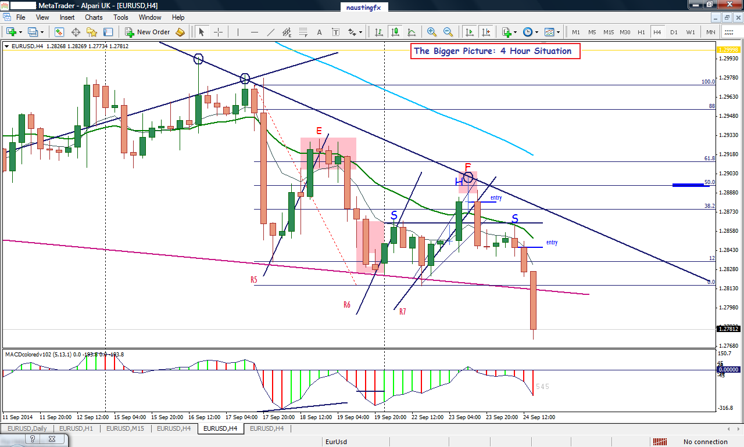
Thanks folk for your insight. I am happy over there you can read me and see my charts clearly. It's good. I equally want to have the same "fun" with you from my own end on other people's post...I have contacted FOREX FACTORY twice on this. Hopefully they will respond soon.I have been following some of your post and that of a guy called nic73...the challenges you are having and all that...I try to assist the way that I can, and it is because of some of the complains I read here that I am also encouraged to post...one of the challenges I see the forum is having sometimes is that many other nice ideas are shared here by other traders, that is very good, but for the newbies, that might at sometimes throw them off balance as they are faced with a whole lot of information that are very promising and they lack concentration at some points...and that is why I have decided not to post some trades which I have taken based on some "heavy mixed principles"...Another challenge is that we are not trading from same brokers and not on the same time frames or time zones....so if I posted a trade setup, it might not be useful to many people, because that might be at their sleeping time, working hours for those who are doing other jobs, etc...But I know that if the newbies here can at least concentrate on how to DRAW THE RHYTHM LINES and HOW TO MAKE USE OF IT IN TAKING TRADES, that is enough to give very good pips per month, about +150 to +200 pips per month for a mini lot. And if that is maintained, then over sometime when you begin to operate at a standard lot, the 150 will become 1,500 and the 200 will become 2,000 dollars per month. That's nice right?I have never been a trader before joining this forum. I started from a "nobody" level. A completely zero level. I studied Engineering in School, so I have never had a really fundamental knowledge of business, or marketing...God just raised me from a nobody to a somebody in this business and in life...SO IF that can happen to me, I can therefore see the future success of anyone here who is for now having problems or still struggling with trading or in anything in life...What helped me is this: While Phillip was heavily sharing a lot of ideas and strategies on how to trade the Forex market successfully, I simply told myself that I have to stick to just one thing at a time, then in the future after I have found my feet in this business, I can then start looking into other strategies...this was one of the things that saved me. I was able to focus and concentrate on just one thing, but still busy downloading other different ideas from Phillip and storing them in my external hard drive to start reading them when the time was ripe. Remember that Phillip is a king in this business, and as such has a broader trading soul/heart/brain than us, so it will not be easy to follow at his own pace...naturally that is impossible...so everyone has to work according to his own capacity...Lots to say and a lot to post; but I have also said a lot over the years in my posts. I also have not posted so much here. So anyone can even in one day go through all my previous posts to read a lot of insight I have shared here. Just click on my name and go to my "activity" window in my profile and I believe none will regret doing that.Please go learn how to draw the lines and to use them appropriately. Then take the trades as they come.It is WELL !GOD BLESS PHILLIP!GOD BLESS EVERYONE!!!
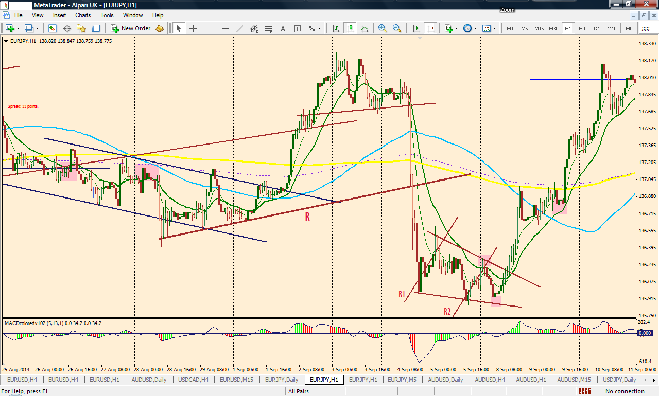
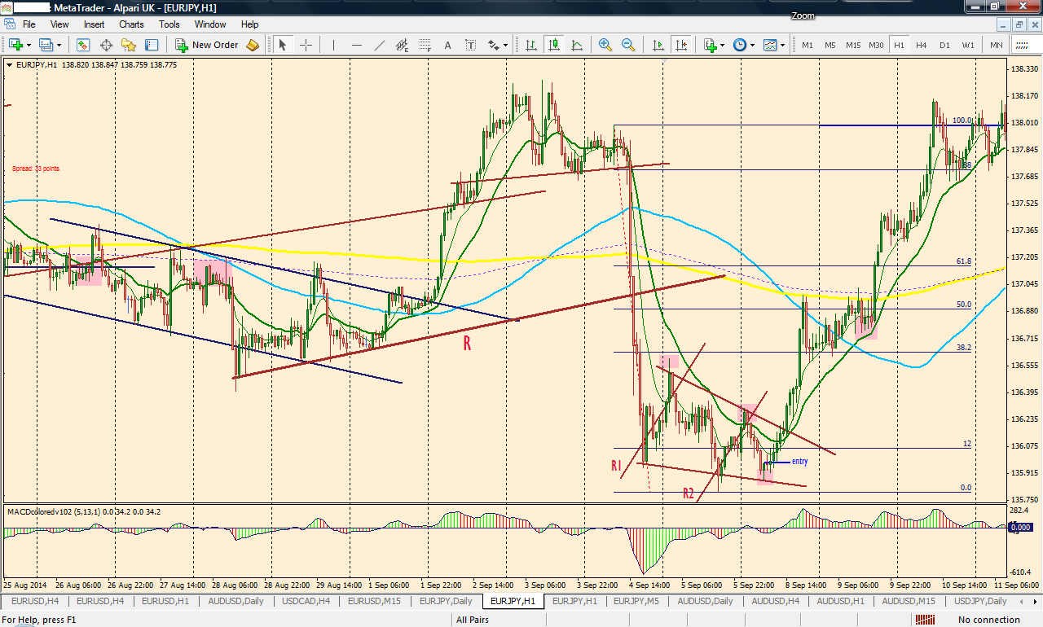
You see above how clustered my writings are in the post. I clicked on the "Edit" button to at least separate them into paragraphs and put spaces to make it look nice and easy to read. But I was denied the right to EDIT my own post... It's not interesting...
MARKET RHYTHM OUR MOTTO!
Below is USD/JPY trade on July 10th,2014.
Our normal set up: Break of trendline, pulled back to it and moving away with a TC on the MACD.
Don't forget for those who so much like using the MACD that you must have finished price analysis and anticipation on your chart before looking at the MACD...this is the very words of Phillip Nel.
Market Rhythm is the key: there are also many cases where deals can be taken successfully yet MACD is not showing any confirmation.
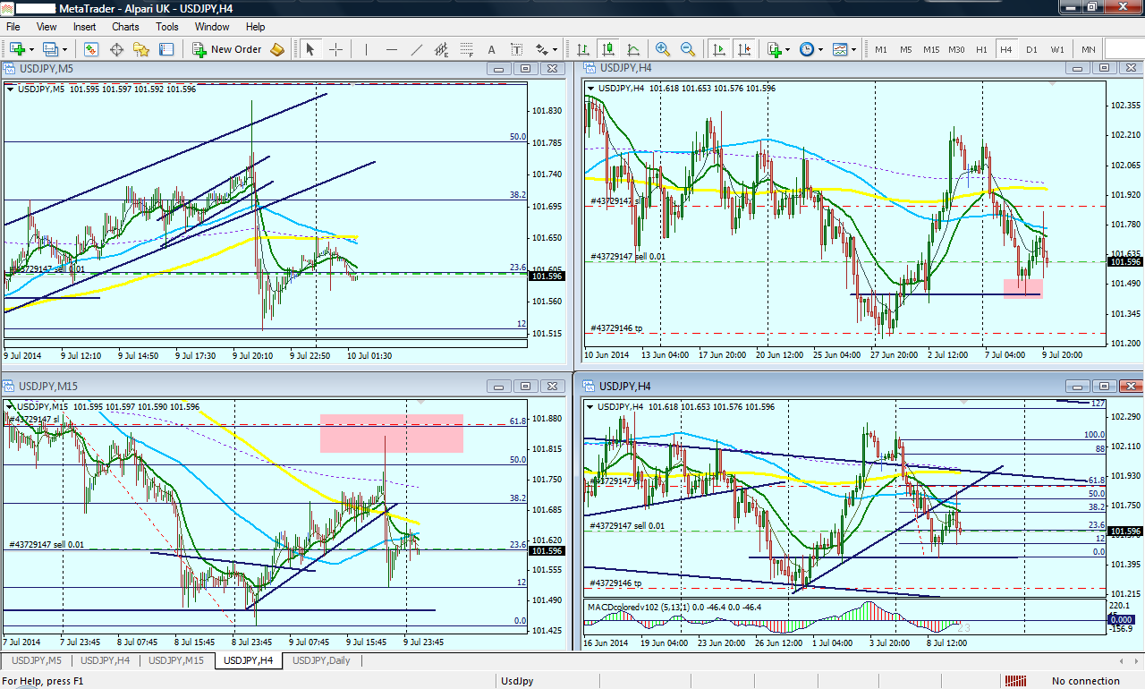
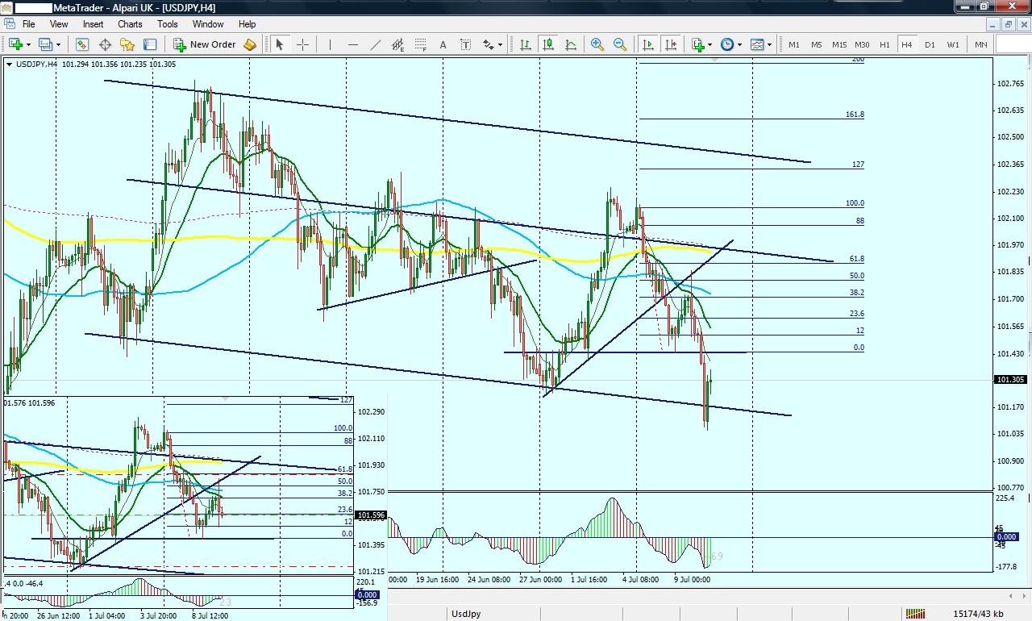
MARKET RHYTHM OUR MOTTO !
TRADE: USD/JPY: September 15th, 2014.
God Bless you as you read!!!
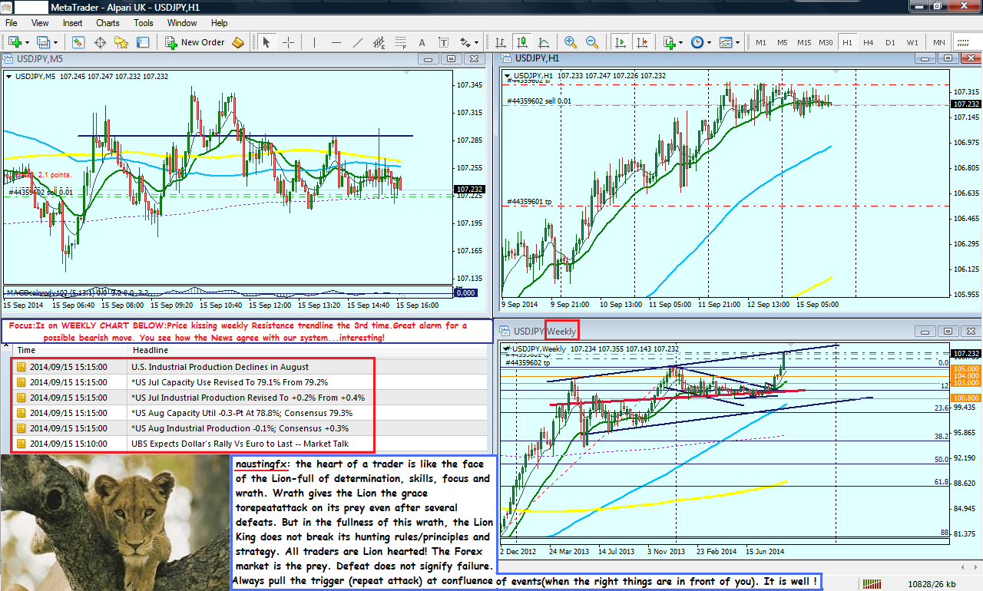
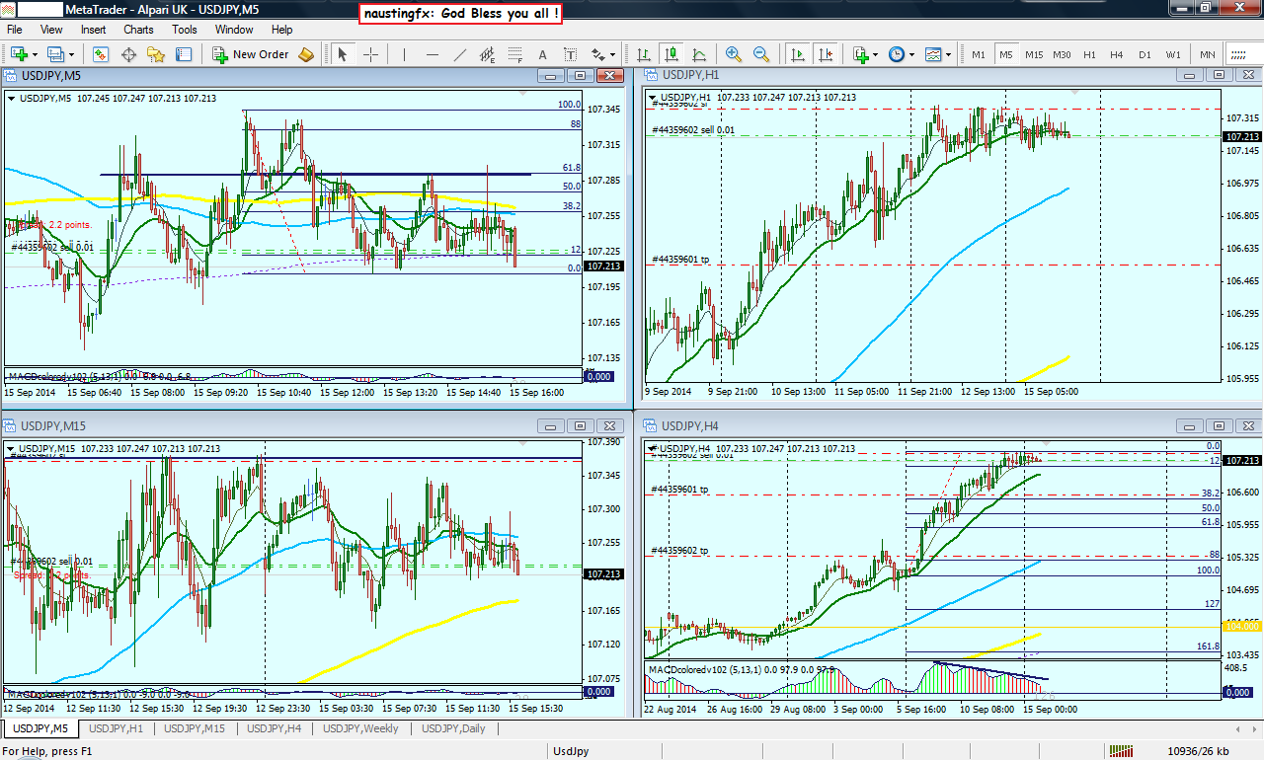
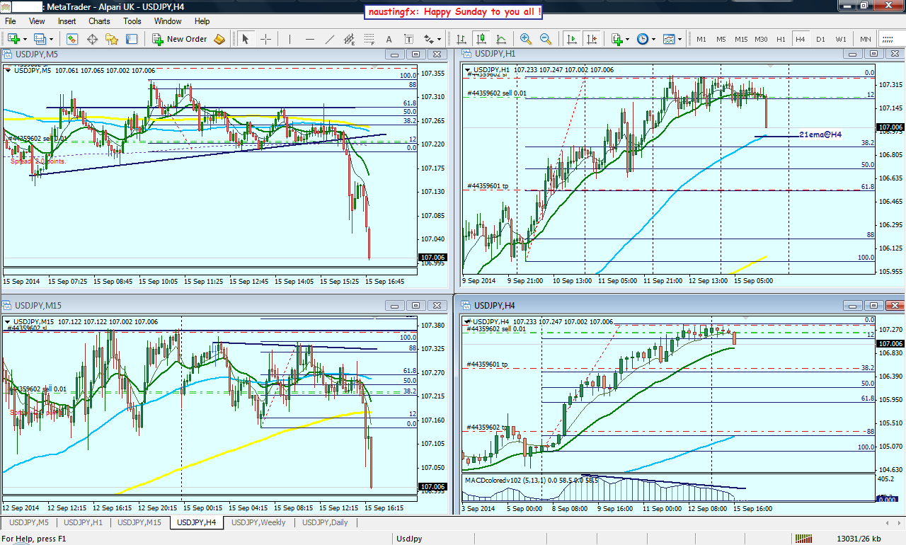
MARKET RHYTHM OUR MOTTO
TRADE: EUR/USD: 17th September,2014
naustingfx: &quot;the eyes is the door or an entry point to the human soul and the soul is the citadel of all logics, analysis and mathematics, tricks and imaginations...
therefore learn your eyes on how to see and recognize high probability price and chart patterns so as to develop a super successful trading mindset and psychology for optimum success in the FOREX market.
When the training is completed successfully, the reflection is the consistent making of pips in a trader's live account.
And that is why the answer to success here is not only dependent on getting a very successful strategy like the one we are using here, but the trader is the key factor to practical success-his ability or capacity to receiving information, digest it properly, then retain not part, but all of the information received, then to be able to scan his chart based on already stored information in his trading SOUL or what I call brain-soul and to apply this knowledge or pull the trigger at the right time...
and that is why; in as much as we have the correct strategy, but not all have started making consistent pips...we are all in the classroom here and we write exams or continuous assessments every trading week, and at weekends maybe we go to the result board (our trading accounts) and see our performance...
some are sharp brains, some are dull brains, while some are in the middle...God knows us better...He said: if we endure to the end we will be saved-in other words, after working hard and being put through, by His grace, we will start making consistent pips...God Bless !
Nice details on how I took this live trade are in my charts...
Questions, and comments are welcome.
I have tried to post some of my trades. I don't a lot of time to do postings now. But will try to follow events here and give my help where necessary.
God bless Phillip!
God bless you all!
Thanks!
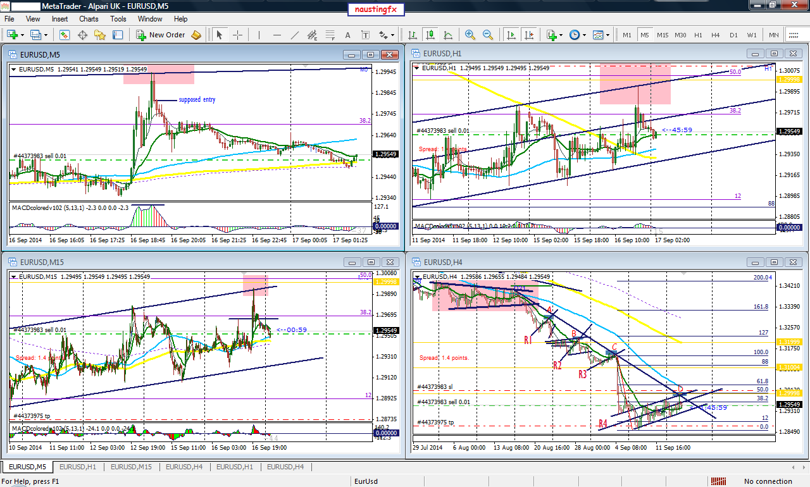
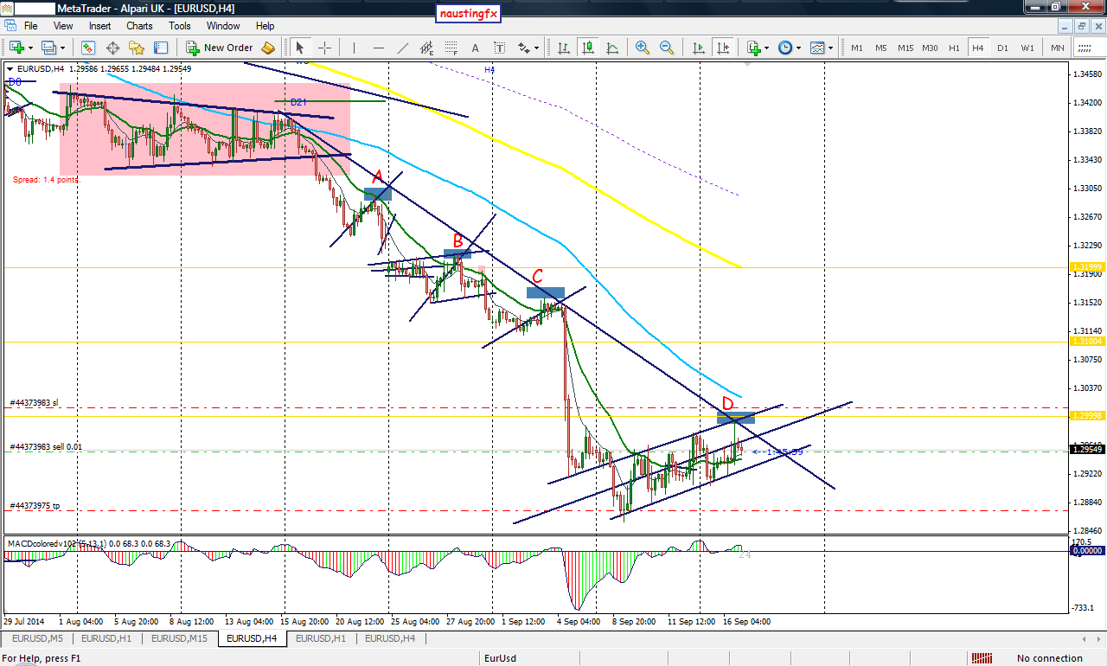
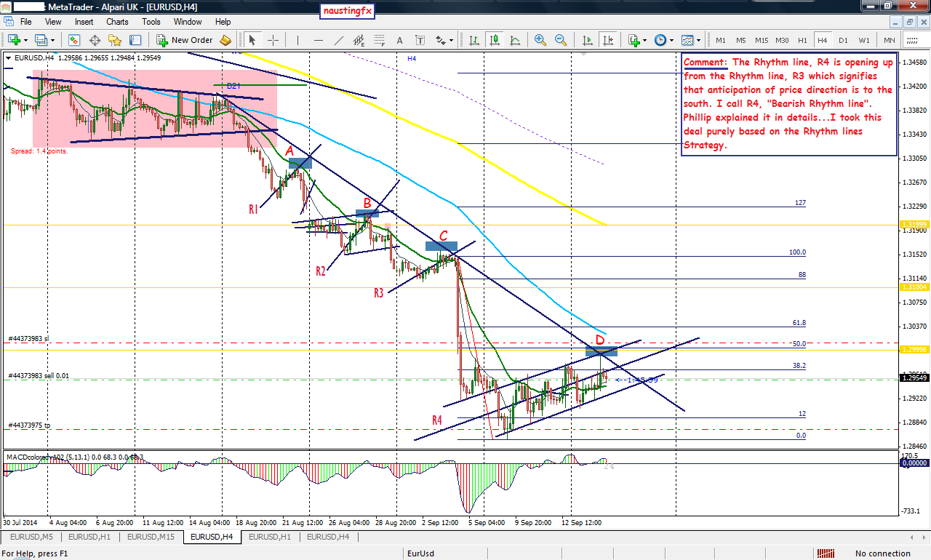
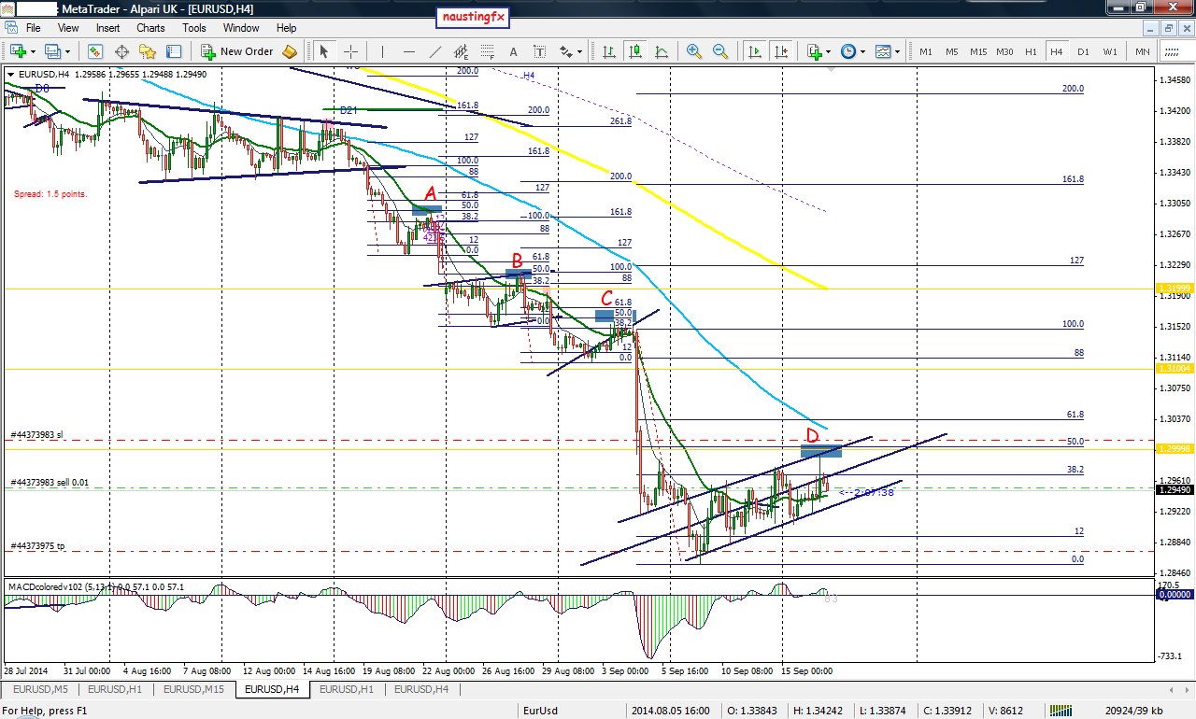
RESULT OF TRADE: 17th September,2014.
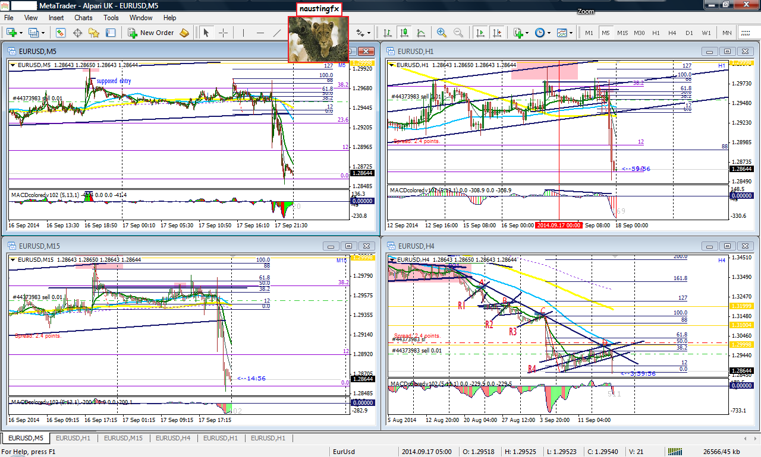
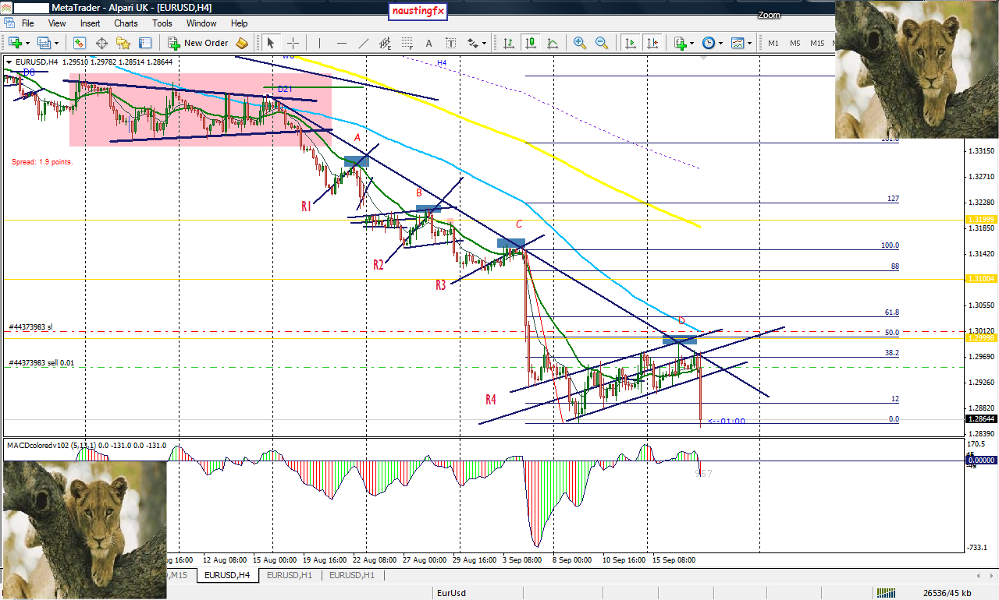
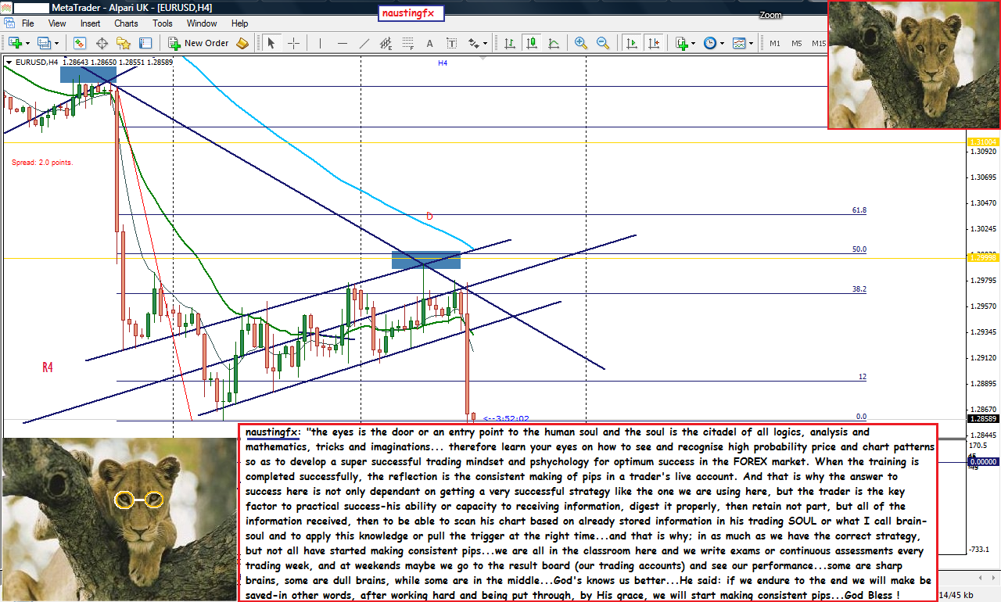
Market Rhythm-OUR MOTTO

Trading from the Google of Phillip Nel

TRADE: EUR/JPY: 29th September 2014 (11:00 Candle Close)
A trade I took at 11:00 candle close (1hour early entry technique) with respect to the RULES OF RHYTHM LINES STRATEGY.
Price went in my favor for +27 pips. But I decided not to take profit as I am anticipating for a break to the south. So I am still in the trade hoping to see further move to the south, that is, I am expecting a breakout trade to the south.
Although, there is possibility for price to go north (long), but based on my analysis below, as indicated in my charts itself, I am still hoping that the potential for price to go south (short) is higher that the later.
So I have decided to let my position be. And hopefully my anticipation can happen.
Stop loss = 23 pips for each of the two positions taken (23+23=46pips)
First take profit = 55pips
Second take profit = 115pips
There was a lot of thinking how and why I took this trade. There are little more thinking why after many hours till now, I still decided to let my position be.
I have tried to summarize mainly the 2nd part of the thinking on the chart itself. I think it should serve for all purpose...
But I can as well answer any question. Also would like to see comments from anyone...of course, you can advice me on what to do next...
Thanks!
Notice: Thanks to God: Forex factory has resolved the problem. As you can see, I am able to edit my posts, I can now see and use all the fonts...tool bar and tools.
God Bless Phillip!
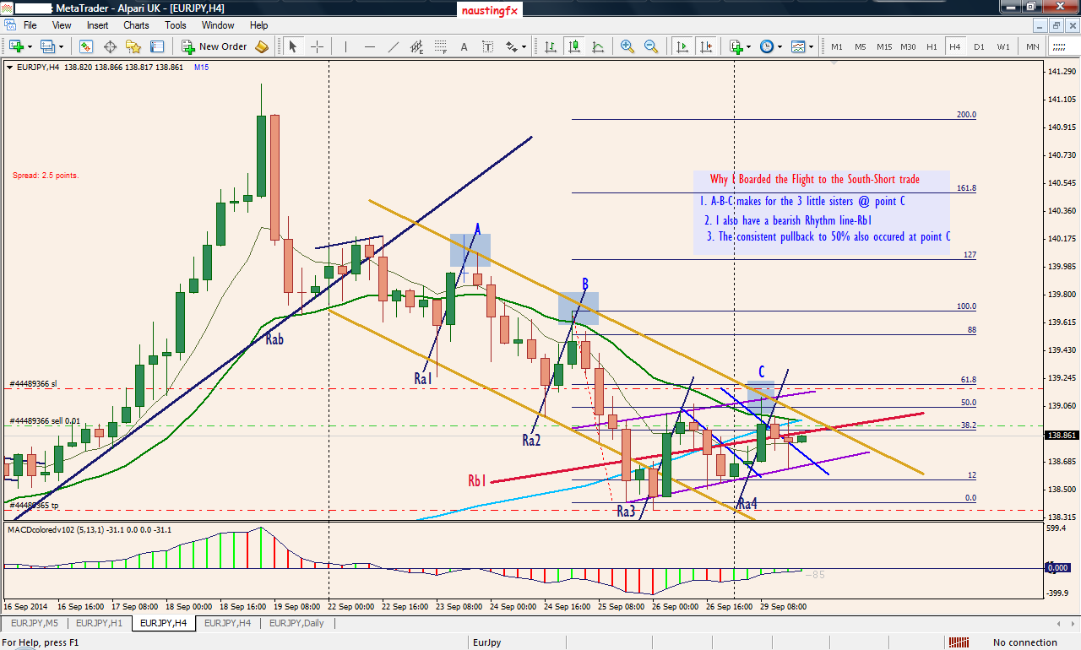
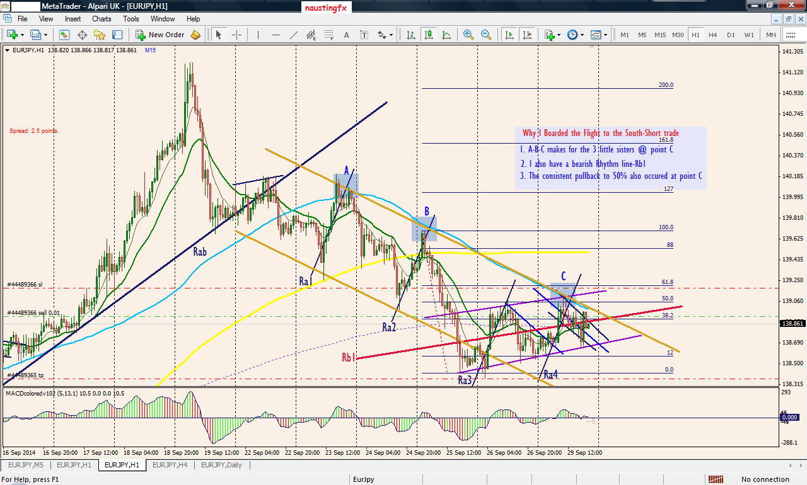
TRADE RESULT: EUR/JPY: 29th and 30th September 2014
Update 1: First take profit was hit (65pips) for a mini lot
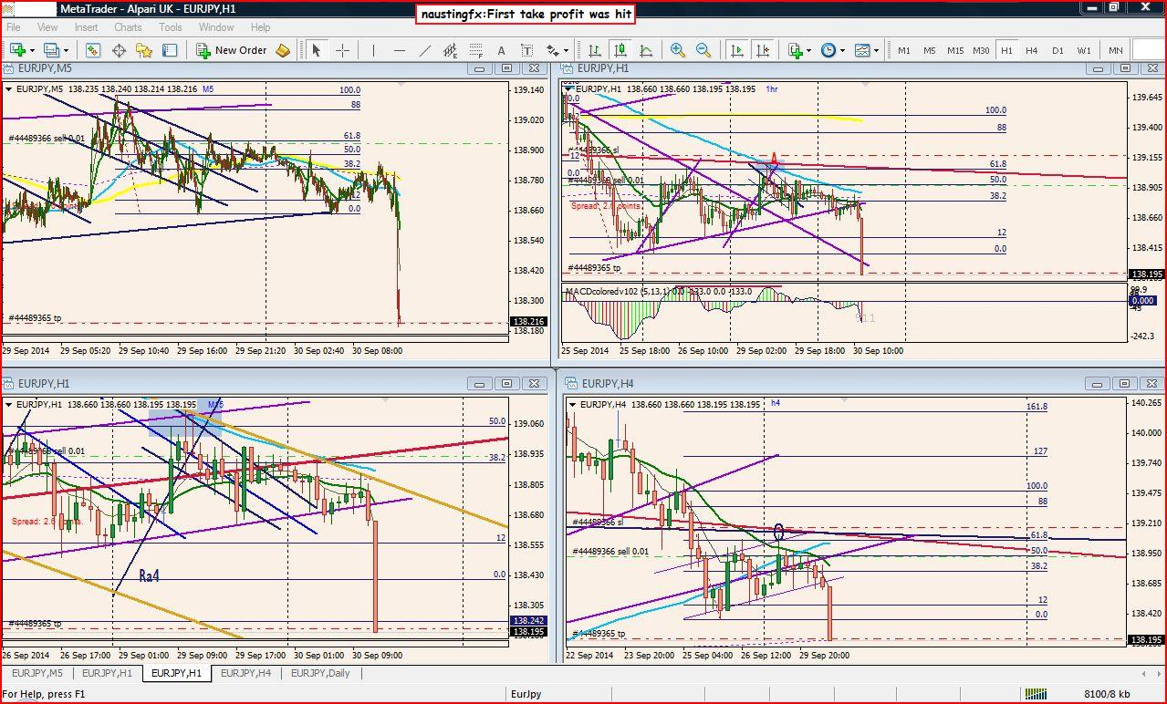
Unleashing The Power of Rhythm Lines
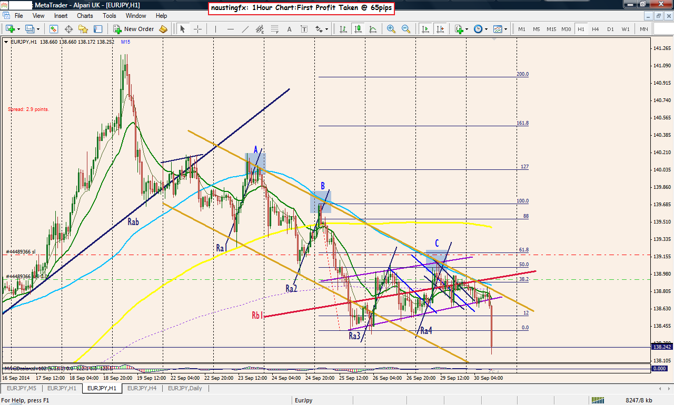
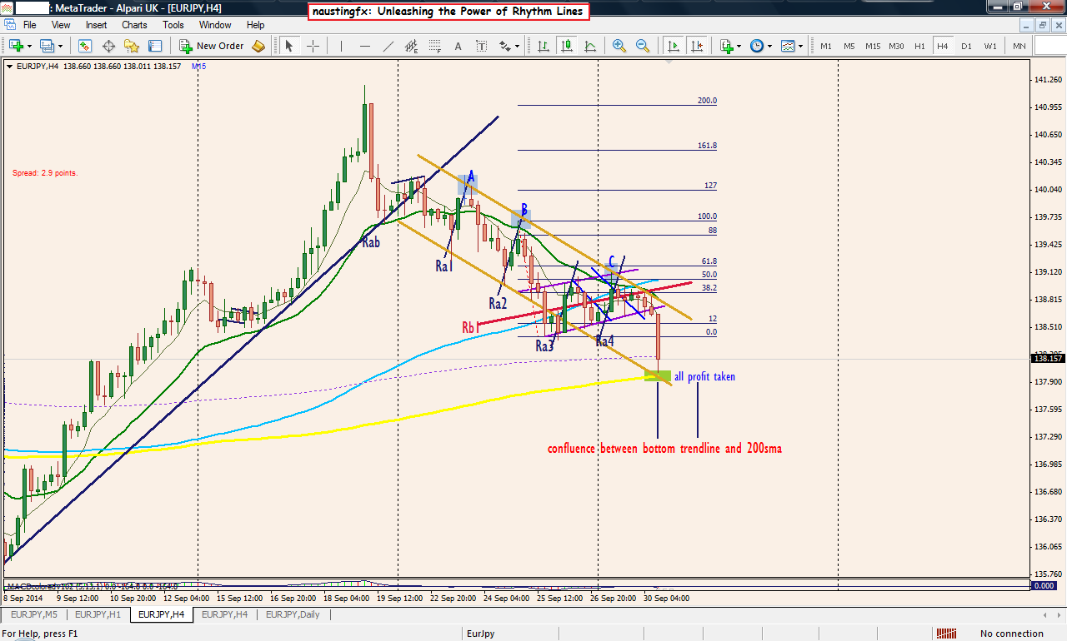
ADDITIONAL REASON FOR THE SHORT TRADE AND ENTRY OPTION 2:
1. There are 3 lower highs - X Y Z
2. The 3 little sisters setup with X Y Z
3. We are in a bearish mood: price below the 89 and 200sma
4. The SPEED of the Market was on the 89sma (the blue moving average)
4. Price broke the purple trend line, pulled back into it and to the trend line-point Z (resistance) and moving away with a bearish engulfing candle and a TC on the MACD...
SEE MY CHART FOR MORE DETAILS.
I Believe my posts are self explanatory as no much questions and comments to my postings so far... Thanks!
Assuming you missed the Flight yesterday (EUR/JPY:29th September 2014 @ 11:00 candle close), just today @ same time (11:00 candle close: 30th September 2014) there was another opportunity to board the same Flight I was in yesterday....See my chart below (I have labelled it as entry option 2) for details.
Thanks!
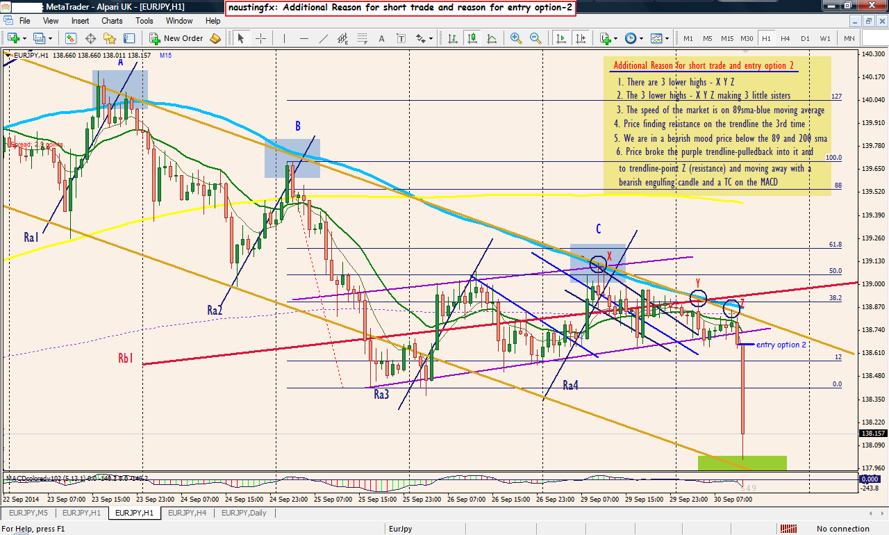
{quote} When you trade the H1 and respecting the H4 do you try to trade the top of a RT on the H1 or ignore the macd and just follow it on the H4. I see your macd on the H1 was above zero when you pulled the trigger.
Answer: Part 1: When I am taking a trade on the 1Hour respecting the 4Hour, what I mainly look at on the 1Hour chart is price action and not MACD. But there are as well some cases where I look at MACD on the 1Hour chart; such MACD patterns like MACD Divergence, TC, Head and Shoulders, Double and Triple tops, etc. I can't remember if I have ever taken a 1Hour early entry trade considering RT and RB on MACD.Part 2: Sorry I did not show it, but see it in the chart below: It was one of the setups I mentioned above (MACD Divergence) that served as a trigger for the trade in the 1Hour chart. That is, after I was through with my analysis on the 4Hour chart, I looked at the 1Hour time frame and saw a nice MACD Divergence setup at that very point...I think I have already executed the trade on the 4HOUR because I was very satisfied with my 4Hour analysis before I saw the whole setup clearly on the 1Hour. But when I observed the 1Hour I was happy with how the divergence in the 1Hour is supporting my anticipation on the 4Hour.NOTICE: Actually I don't really consider the MACD anymore in my trading as I have learned over the years to trade Market Rhythm setups only. But when I read posts here, I discover that many people seem to depend so much on it, such that, if you put up a post here without laying emphasis on how MACD was part of your decision to take the trade, some traders may not really get attracted...In as much as I don't really use the MACD, there are some MACD setups that attract me when I see them on my chart, if the particular chart I am using had MACD on it. They are as follows - MACD Divergence, Double and Triple tops of MACD, Head and Shoulders (sHs) on MACD, TC on MACDIt has been a long time now, I do not consider RT (Round TOP) and RB (Round Bottom) setup on MACD. One of the reasons for this is because I discovered that the RT and RB do not make much sense when when the market is in a strong up trend...such that if you do not know how to use them you will get hurt a lot of times.Thanks!
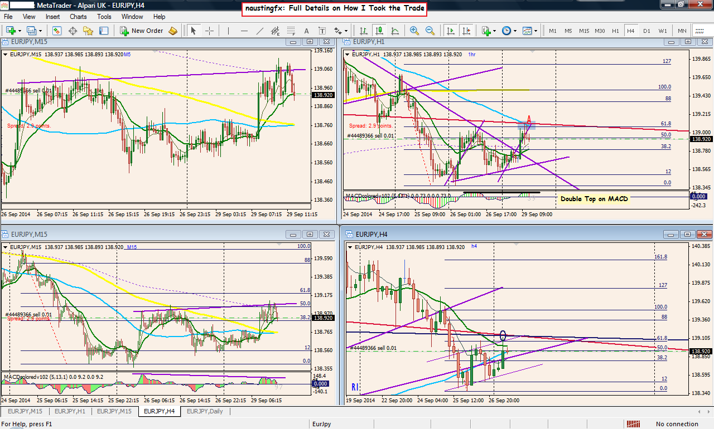
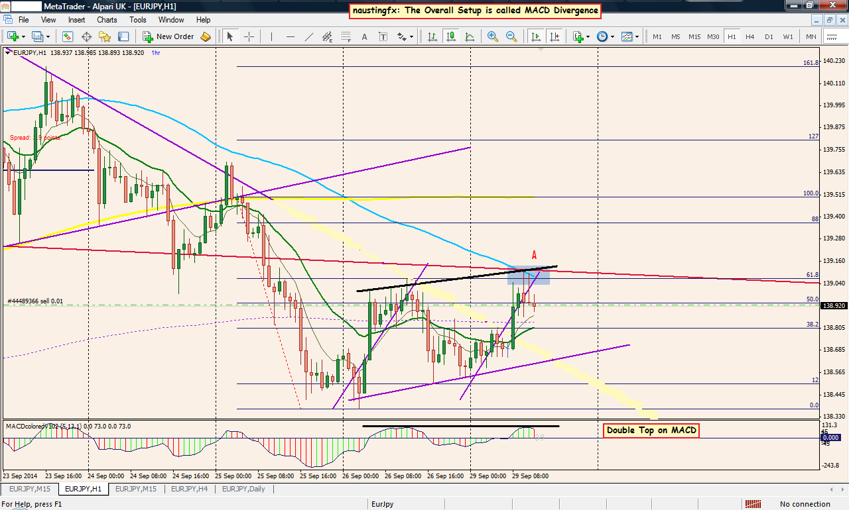
There are some insight may like to give later about the special relationship between the 89sma on the 1hour chart and the 21ema on the 4Hour chart.
I saw some traders here discussing it already and they are trying to relate it with some sort of wave principle or something...
I have shown some nice information on the topic in the past...
I will like to show more excellent setups that can be taken successfully with the relationship or confluence between those two moving averages (89sma on 1Hour chart and 21ema on 4Hour chart)... if I have all the time to make posts...
When it sets up, you do not need to even draw any Rhythm line, you just pull the trigger...I found out that whenever it sets up, many times it is always in confluence with Market Rhythm...
But meanwhile I can still answer questions on it. If there are traders who still find delight in it. Questions helps me to know what people need, so that I can go straight to the point to deliver answers as I do not have all the time to make a lot of posts...
Happy trading week and welcome to the month of October!
It is well!

