Practical Application of Cycles to Investment Markets

Jim Tillman

Introduction

Analysis of chart patterns leads one to observe rhythm in the prices as they rise and fall yet the vast majority of technical books and papers dwell mainly on pattern recognition and not on what formed the patterns—cycles.

Successful investment methods are not to be tampered with but experience has shown that cycle studies compliment these methods by adding a new perspective,

This paper will suggest 4 practical ways of adding cycle work to your technical tools arsenal for additional perspective.

They are

1) The creation and use of centered moving averages to get price objectives,

2) How cycles and channels will help develop long term investment strategies,

3) Momentum indicators compliment cycles and vice versa,

4) Subtle hints cycles reveal, & How cycle "mirror images" refine price and time objectives.

It is also hoped that this paper will encourage others to back off and look at the bigger picture occasionally instead of pursuing the road to success "tick by tick".

Background

Cycles are rhythms within nature that produce order as they first expand and then contract, producing trend.

Statisticians argue whether cycles exist at all, yet any technician that draws a straight line on a chart is admitting there are cycles because they eventually expect change when that trend is broken.

Oscillators that monitor overbought oversold conditions are simply observing the change of small cycles within larger cycle trends.

The vast majority of technical methods developed to give "signals" of change in market conditions are based in one way or another on cycles, whether it be short term or an indication of major change such as the 3 to 4 year cycle.

The 1989 recipient of the MTA award, for example, was successful in finding a way to buy and sell the market at points in time when the major cycles were past their peaks or troughs and beginning to take over control of the major practical investment trend.

Since the dominant Bull/Bear cycle has been 40 to 54 months for the last 40 years, Mr. Coppock's moving average method was successful in tracking this cycle and ignoring smaller ones.

Even larger cycles do exist, however, and while the 3 to 4 year cycle is the most practical investment cycle, those up to 60 years in length may also be considered.

Even these long cycles may be tracked using the centered moving average method and have been useful in the past to develop investment strategies that lasted for many years.

Centered Moving Averages and Channels

For longer term investing I recommend the centered moving and channel approach.

A moving average is the best mathematical method of seeing where a cycle has been when it is placed correctly back in time on a chart.

How to begin.

First, a cycle is tracked with a moving average 1/2 its length (called a half-span average), then placed back 1/2 the time of the average on the chart.

For example, a 78 week or 18 month cycle would be shown with a 39 week average and be placed on a chart 19'/2 weeks back from this week.

For the larger and larger picture, keep doubling the length of the average to track larger cycles.

Place all of these on one chart in their proper time period.

You will find over time 3 or more of these averages will converge toward one central point (a focal point) at the center (or halfway point) of a long move in one direction.

This in fact is the center of at least 3 of the cycles you are tracking and is the first step in determining the objective of these cycles.

Measuring from previous lows (left of a focal point on chart), to the focal point, expect objectives to be accomplished when time is equal on the right of the focal point.

Think of a typical sine wave.

Focal points occur at the center of the up wave and again at the center of the down wave, thus showing the form and amplitude of the up and down portions of the sine wave.

Chart 4 is an example of this and will be discussed further later.

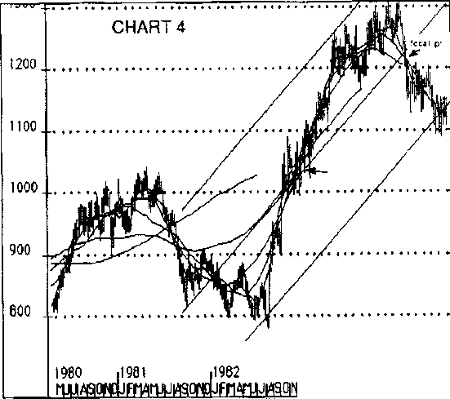

We recommend 5 or more centered averages for best perspective.

A half span average shows you the profile of the actual cycle.

A full span average, or one the full length of the cycle, will cut through this sine wave at the center because it is the average of the full
cycle.

Thus a full span average becomes the center-line of an imaginary channel that prices (and the half span average) will stay within for that cycle.

Because the full span average is lagged 1/2 in time, it confirms both price and time objective have been met for the cycle when it passes through the half span average and near by prices.

Constructing a chart, for example, a 20 week full span average is lagged 10 weeks and shows the direction of the channel because this full span average is also the half span average of the next longer cycle.

Longer averages tend to pass through price in the same area as three of the shorter averages, (it can be the center of a much larger channel or the main intermediate channel), therefore the half span average may be used to obtain a general price objective quicker for the cycle period you are interested in.

The 10 week half span average is lagged 5 weeks on a current chart so when it intersects past prices (of 5 weeks ago) this shows where the center of the current sine wave is.

When this occurs, prices are at the top of the sine wave in current time.

Some allowance may be made for translation (right or left) because of the direction of the next longer cycle, (is the 20 week average trending up or down), but the difference is usually minor.

When a cycle objective has been fulfilled and begins to change direction, let's say to down, the degree of correction depends on the support of the next longer cycles until the cycle you are tracking is again ready to turn up.

When the half span and full span averages again cross (during the correction), the shorter cycle is ready to turn up.

Chart 4 is an example of shorter cycles fulfilling down objectives preparing to turn up with the major trend.

The major trend can usually be determined by drawing a trendline through 2 focal points formed by the smaller cycles (center trend of the sine wave).

Since focal points are the result of 3 or 4 smaller cycles working together, they form near the center of the next larger degree cycle sine wave.

Placing equidistant parallel trendlines from highs or lows in the past, beside this centerline, will generally show the dominant channel a stock or market average is operating within.

The outer boundaries do not have to be anchored to previous prices but normally will.

Having the "right look", is the most important thing.

As you can see in chart 4, channel boundaries add valuable perspective to the chart history.

Developing a Market Strategy

Applying the centered moving average technique to long and short term market indexes you begin to experience an overview of what the indexes might do based on the trend and profile of the moving averages.

Applying this technique to various group sectors you also discover different patterns that suggest one group may be bottoming while another is topping.

As objectives are met for major cycles you learn to expect, shorter cycles to change behavior because they no longer will have the same support from trend (the next longer cycles) as before.

This is called left or right translation of a cycle high.

Applying a complete spectrum of several centerlines allows you to see this change and how smaller cycles change after larger cycles begin rolling over.

Look at chart 1-a and see the change in market character in the late 1960's/early 70's after major cycle objectives had been met in the S&P 500 (measurement through the focal point).

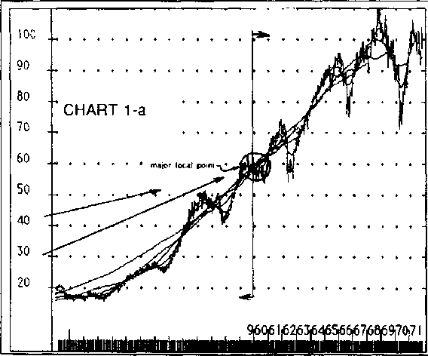

The Dow average met it's measurement as early as 1966.

Knowing major cycle objectives are being reached, you are alert for small changes in trend that confirms this to be true.

Thus you may see potential long term changes in market sectors well before they become obvious.

Using this method on long term monthly charts made it possible to understand how the flat market of the 1960's and 70's fit into the much larger long term picture (as you will see later).

It was also possible to anticipate why the market was ready to return to the old Blue chips in the early Eighties as major cycles were again ready to turn up.

An example of how major cycles reaching their objective can change the market environment from trending to a trading market may be seen in the long term monthly S&P chart (1-a) with 400, 200, 100, 50 and 25 month centered averages.

These track 66, 33, 16.5, 8.3 and 4.16 year cycles.

Remember these are cycle averages that cover price movement much longer than this chart can show.

By 1971 this chart began to show all of the centered averages converging toward one focal point (remember they are lagged in the past and the longest averages were not clearly converging before this) about halfway up the total advance from 1949 to 1966 (see focal point).

This meant perhaps the 66 and/or 33 year cycles had reached their upside objectives and would either have to correct down or sideways until they again turned up in line with the secular trend (also a major cycle).

Studying chart 1-b, one begins to understand that the long flat period of the 1960's-70's was perhaps simply the result of the down phase of one of these cycles holding the market back most of those years, after topping around 1966 or 1968.

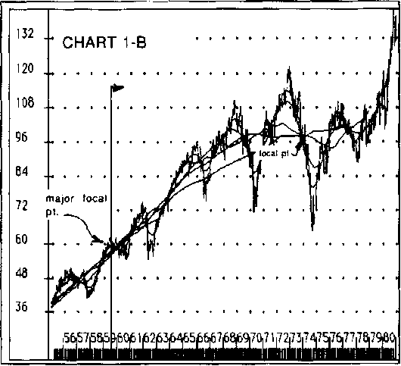

Being up 17 years from 1949 to 1966 suggested the 33-34 year cycle as the culprit.

It was indeed 33 years from 1949 to 1982.

Remembering that centered averages tend to point at the center of a correction or consolidation when it is almost over, the large focal point of 1973-74 (formed by smaller cycles and the direction of the longer averages (still moving up) began to suggest that the focal point in the 1974 decline had even longer term meaning.

The next major advance was due when these longer averages begin to push up through the consolidating flat period of the 70's or continued to move toward the already formed focal point, proving it was the halfway point of a larger cycle that was pushing down but only moved sideways because of the secular uptrend.

If late 1973-early 1974 represented the halfway point in the consolidation and most of the blue chip sector had seen a high in 1966, then both the market and blue chip stock cycles were due to start improving by 1982 (1966 to 74 = 8 years - 1974 + 8 = 1982).

This then began to develop a very important long term market strategy.

Chart 1-c shows how the longer averages did go up through the 1974 focal point and up through the 1970's consolidation.

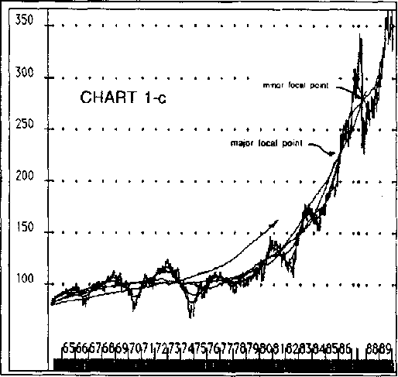
Using the concept that a major cycle may have turned down in 1966 and had been holding the market back during the 1970's (more obvious in the Dow Jones Industrial average than the S&P 500), added a new perspective when viewing long term stock charts.

It was found that American Telephone, Dupont, U.S. Steel and a majority of older large consumer companies and Blue Chip names had topped in 1966.

When trendlines were drawn across highs made by many of these stocks in 1946 and 1966, and parallel trendlines drawn from lows in 1949 or the early 1950's began to hold in 1980, a pattern began to emerge.

Blue chip stocks appeared to be completing a major down cycle and ready to turn up.

These trendlines could also be drawn equidistant on either side of the 66 and 33 year centered averages and produced excellent channels on 30 to 40 year monthly charts (available from Securities Research, 101 Prescott St, Wellesley Hills, MA 02181).

Chart 1-d shows this channel for the Dow Industrial averages.

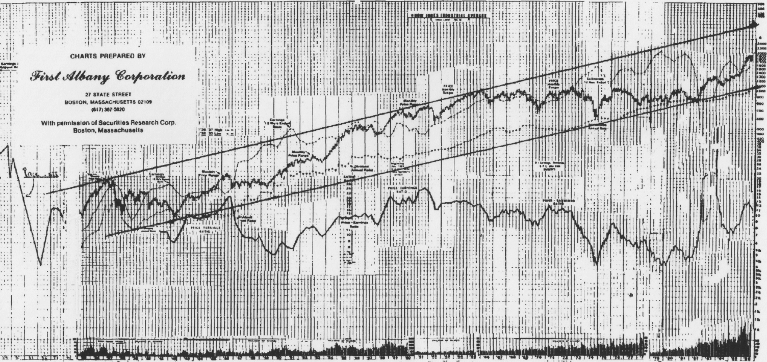

Stocks with patterns similar to the DJI, were basically moving sideways across their secular up channels (although they traded up and down with the 4-year cycle) until they began to reach the bottom of uptrending channels from the 1940's.

From 1980 to 1982 more and more of these stocks were turning up, breaking 16 year downtrend lines.

These chart patterns suggested the Blue chips were ready to begin long term advances again.

This helped confirm the same conclusion reached through the cycle study of the Dow Industrial Average.

Finding stocks that mirrored the DJI profile helped define which sector of the market was ready to advance. Conversely, Oil and Gold stocks reached their long term upper channel boundaries in 1980 (using their long term monthly charts) and therefore were expected to have a long term consolidation even if the overall market advanced.

Recognizing how long term cycles and channels effect price action is the key to developing market strategies when reviewing sectors.

Channels, Momentum Oscillators and Centered Averages Working Together

When market indexes begin to approach major channel boundaries, it is best to concentrate on smaller cycle objectives and their short term channels from then on.

As smaller cycles reach objectives (by short term half span and full span averages crossing), their channels are usually pointing toward a combined low of all significant cycles (see low in 1974, chart 2).

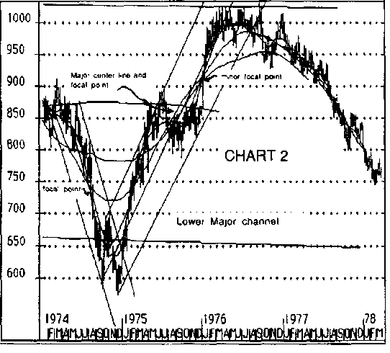

On this chart, a 213 week moving average (tracking the full span 4.1 year cycle) was the center of the largest channel shown.

As shorter term centered averages formed a focal point (lower left) near the center of the last decline, it indicated these cycles were reaching their objectives.

Notice also the slope and time period the steeper averages (shortest cycles) were pointing to as they went through the focal point.

Because this was also the bottom of the 4 Year cycle channel, and momentum (a 10 Week rate of change) showed a positive divergence, (bottom of chart 3)—the market was ready to reverse as all cycles turned up together.

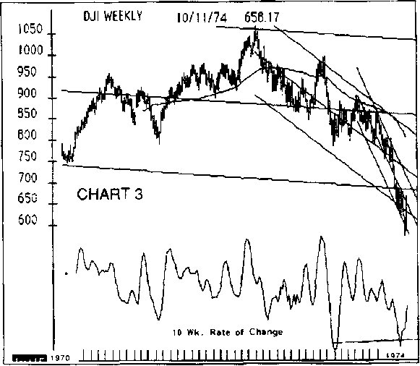

The moving average on this chart is not centered so disregard it).

Incidently, when the Dow Industrial Average picture is completed, as this one was, is one of the best times to pick stocks based on their relative strength.

Strong stocks that turn up before the DJI, at major 4-Year cycle lows, show they are already being supported by larger up cycles underway for that group or sector.

With bigger cycles already up, early leading stocks (out of bear market lows) tend to be market leaders for the rest of the bull market.

Later in the cycle relative strength may be misleading because of oversold bounces in a major downtrend (witness Oils in the mid '80's).

Charts 4 and 5 illustrate;

1) a major channel strongly up and confirmed by all major centered averages still rising.

This indicates cycles larger than those with averages pointing down into mid '84, are up.

2) daily centered moving averages had formed a downward focal point at the center of the main up channel, indicating smaller down cycle objectives were being met and ready to resume in the direction of the bigger channel,

3) the weekly momentum oscillator (a 10 week rate of change at the bottom of chart 5) is giving a positive divergence buy signal.

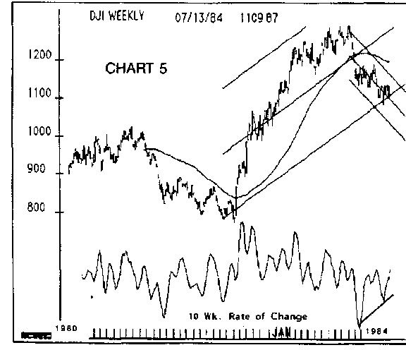

All ingredients suggest an up market is about to begin.

Chart (6), ending mid 1987, is almost the opposite of the bottom in 1974.

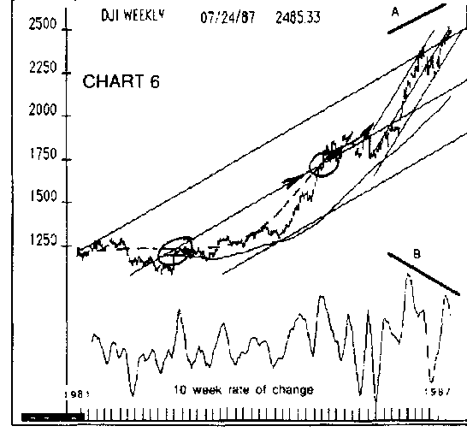

Prices were at the top of large and small channels alike, long and short term centered moving averages objectives were being fulfilled (by forming large degree and small degree focal points).

In addition there was a negative divergence in momentum, (points a and &), to prove the cycles were slowing their advance.

Notice also that the Dow Industrial Average was at new highs but stalling below the centerline trend of the smallest channel.

When prices are unable to regain the top of an existing channel they tend to stop at the centerline of that channel on the last advance.

Momentum divergences versus price are simply ways of monitoring this cycle phenomena.

As in 1974, at extremes such as this, when channel resistance is evident any trendline connecting previous lows, when broken, is a sign the cycles have changed direction.

Subtle Hints Cycles Provide About Groups and Sectors

Comparing a stock or group to a major market average for various periods of time is a common method of looking for new stocks to invest in based on relative strength.

Cycles provide subtle clues, however, that are just as powerful but less obvious and sometimes quite simple.

For instance, always study which stocks turn up 6 to 8 weeks ahead of a major market bottom and which turn up 6 to 8 weeks after.

Those stocks turning up early just before a major market cycle low have longer cycles already up (touched on earlier).

Those stocks turning up late may still have longer term cycles down.

Once a bull market begins to mature several months later is when this information is important because when intermediate up cycles lose strength, the longer down cycles will again be able to show their effect.

This knowledge provided a clue that the "nifty 50" growth stocks would top early in the bull market of 1975-76.

In December 1974 (chart 2) the DJI made a double bottom but the "nifty 50" reached new lows by 10 to 15%.

That lower low by growth stocks during a minor 10-Wk cycle pullback for the rest of the market, after major market cycles had already turned up, proved there were long term cycles (not shown) harder down on that sector.

The longer term down cycles would show their effect at the next major market high—usually by forcing an early top.

It did.

This group topped 7 to 8 months ahead of the DJI in 1976.

The same thing happened after DJI low of 1970 when secondaries took 5 months finally to participate in that bull market.

Secondaries then topped in April 1972 (according to the Value Line Index) 8 months before the DJI high in early January 1973.

They decided even more than the DJI in 1974.

In 1981 consumer and retail stocks bottomed well before the DJI in 1982, thus they were the leaders of the next bull market.

Oils topped in 1980 well before the DJI high in 1981 and lagged badly in the next bull market.

Observing strength or weakness in stocks or groups relative to market cycles is one of the more subtle but powerful tools of cyclic observation.

It has been said that centered moving averages are not useful because they are lagged in past time.

By now you know this is not true but there are times when you may want to know where a focal point is likely to form much quicker than normal.

It is possible to see a focal point forming much sooner than simply waiting for longer averages to cross.

A focal point formed by 3 short term averages (say the 5, 10, and 20 day or week) crossing at the same price acts like a magnet for other longer term averages to pass through the same price and become the halfway point of a larger cycle channel.

There are many cases where clear hourly focal points have become the center of daily and even weekly cycles seen much later.

This helps avoid the disadvantage of the moving averages being lagged in past time by providing an early clue where the center of a larger cycle channel may be.

(See the focal point at the center of the "crash" week in 1987 (chart-7) and then notice the position of the next longer centered average.)

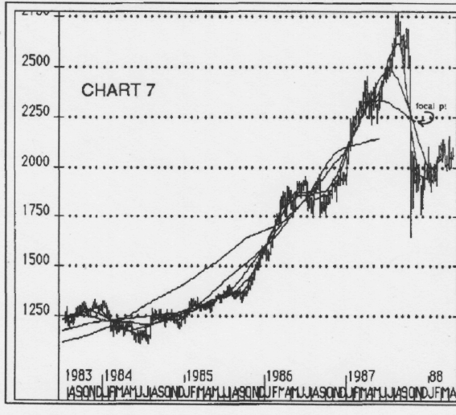

Knowing this average will normally also try to go through the "focal point", you can determine what future prices will be needed to pull a longer cycle average through the focal point.

In 1987 higher prices yet to come would be required to continue pulling the average up through this same focal point.

Chart 1-c shows how that same average has now been pulled up to that level.

Incidently, the first focal point formed like this in 1929 was below the next longer average, suggesting prices would continue declining to pull the average down through that point.

This is a subtle but important characteristic of centered averages.

Mirror Images

"Mirror image" in charts occur when there appears to be an identical pattern forming in current time but is the reverse of a pattern from the past.

There have been instances when a chart folded in the center showed a duplicate pattern on both sides.

Thus the mirror image name Under cycle theory this is not unreasonable as cycles combine and then separate in similar fashion.

If certain cycles combine to form a certain pattern on the upside, then these same cycles may reverse their pattern in the same way on the downside of the sine wave.

If they do, you have a mirror image of the last low, at the next high, as these cycles unwind.

Drawing a trendline from each past low up through the focal point, generally along the centered averages, will point from where each short term cycle begin to where it may end.

Chart (8) is an example of this.

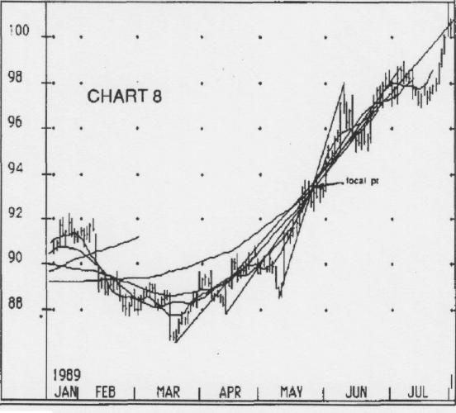

This is a chart of Bonds Futures at the August '89 high.

Once a focal point was formed these lines could be drawn in advance from past price lows, letting the focal point be a halfway measurement to the objective.

This gives a general forecast of both price levels and time.

3 averages form the focal point tracking 3 cycles, so it is best to only go to the third low back from the focal point.

This method works best when there is a clear focal point at the center of a strong trend.

Focal points should always be looked for as an additional analytical tool.

I have described several good methods of viewing the market based on cycles.

There are many others but these are simple, straight forward, and may be applied to any time period of your choosing.

MTA JOURNAL / SUMMER 1990

The Tillman Method

Jim Tillman (1990) of Cycletrend Inc. has developed a number of methods for cycle projections.

He uses centered moving averages of half-cycles after having determined the dominant cycle periods.

Tillman's analysis concentrates on what he calls "focal points."

Focal points occur when 3 or more half-cycle moving averages cross at roughly the same location.

In Figure 19.17, only crossovers of 2 x half-cycle moving averages (11-day and 21 -day) are shown, but Tillman's observations can still be made.

One observation is that focal points occur at roughly the halfway point of cycle advances or declines.

Notice the horizontal lines at the 41-day cycle peaks, troughs, and crossovers in

Figure 19.17. The crossovers occur roughly halfway between the peak and trough in points.

The practical problem from this observation is that by the time the lagging half-cycle moving averages have crossed, prices have usually already reached their projection.

The crossover thus occurs when the cycle is ending its run up or down.

When you see a crossover in an upward leg of a cycle, you know that the upward leg is about to peak or already has.

In Figure 19.18, lines are drawn through the high or low of a cycle through the focal point.

The upward sloping lines will continue through to the high of the cycle, and the downward sloping lines will continue through to the low of the cycle.

The time from the low (high) to the focal point will equal, approximately, the time to that high (low).

In our example in Figure 19.18, the time from the first low close to the focal point was 11 days, and 11 days later, the high was reached.

The crossover is the center of the cosine wave. It is the center in time as well as distance.

If we then draw a trend line between 2 successive focal points, we have an estimate of the direction of the next higher order cycle.

Lines drawn parallel to that trend line to the immediate highs and lows will show that the trend is roughly midway between the parallel lines and that they represent the boundaries of the cycle, just as the earlier lines parallel to the moving averages
showed.

The advantage of using these parallel lines formed from the trend between focal points is that they can be projected into the future, whereas the moving average parallel lines had to be drawn freehand as a guess.

As it rums out, the upper parallel line was broken, indicating that the hypothetical 81-day or longer cycle turned upward again, and that the low in October was a higher order low.

To see where that longer cycle is likely to go, we need to analyze the next higher order 81+ day cycles

When the parallel lines are decisively broken, we know that the next higher order cycle has changed direction.

This makes sense because the parallel lines define the boundaries of the lower order cycle.

If they are broken, it must be due to the change in direction of the next higher order cycle.

For example, look at early October in Figure 19.19.

The lower parallel trend line of the next cycle larger than the 41-day was broken downward.

This indicated that the next higher order cycle, say the 81-day or longer, was reversing downward.

When we draw the trend line between the 2 focal points on the way down, we can estimate that the crossover occurred when the 41-day low was being formed, and we can draw the 2 parallel lines to that trend, which tell us the approximate bounds of the next rally.

By placing a buy order then in the vicinity of 1,185, with appropriate exit stops, we estimate that the 41-day rally will at least run up to
the upper parallel line in the vicinity of 1,210.

using weekly data.

Tillman's method, therefore, is much more precise in measuring not only the cycles, but also their estimated projections.

