Type:
Trend Trading Strategy
Premise:
We follow the trend that determined on H4 timeframe and trade on the M15 timeframe.
Definition of Trend:
- Up Trend
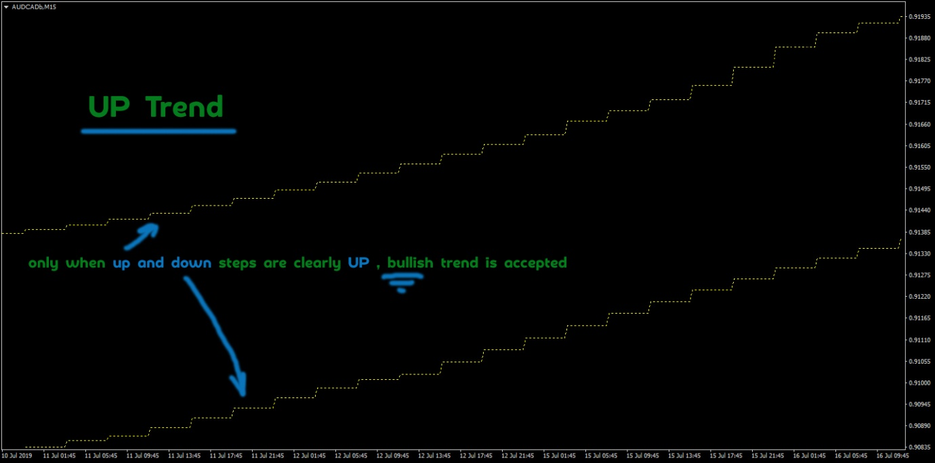

- Down Trend:
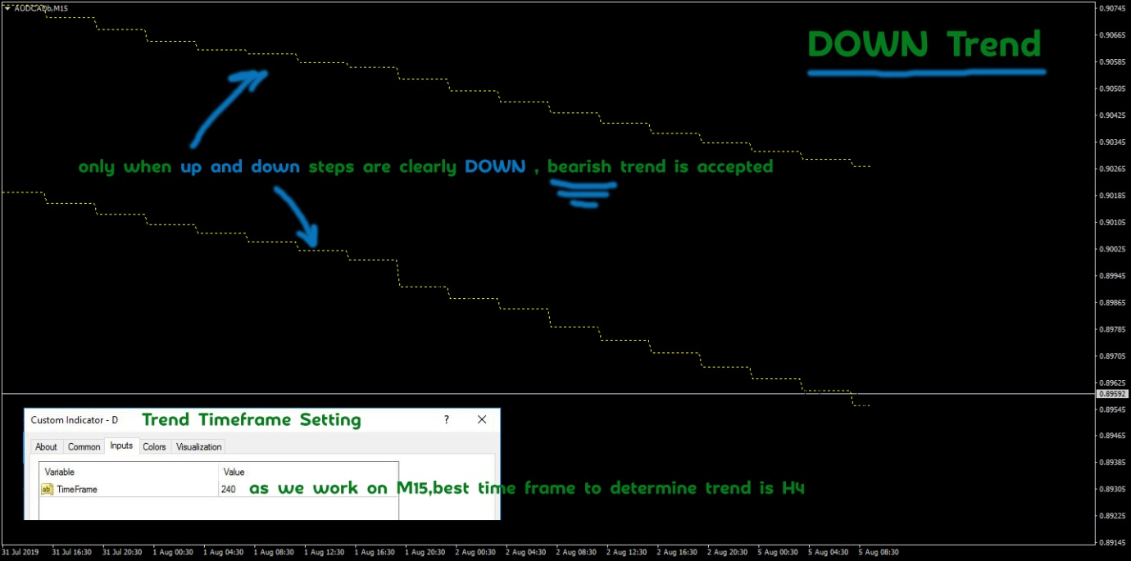

- Range: We Avoid Taking Trades in Range Conditions:
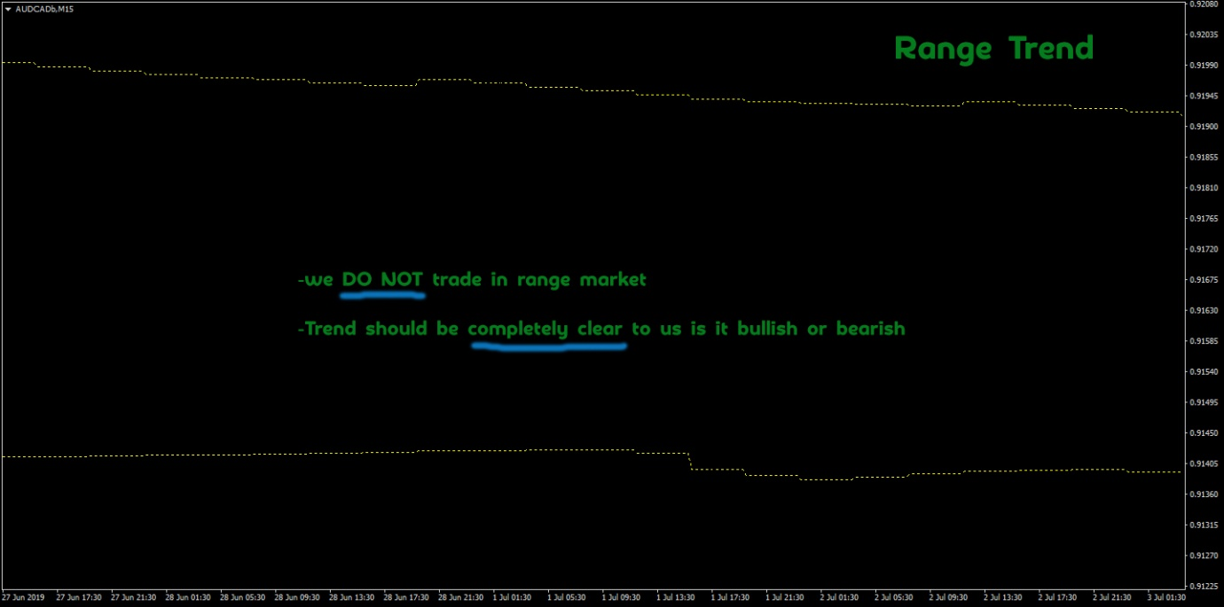

On a previous Dashboard; the logic for determining trend is as below:
FF User Zed.fr used TMA slope to determine trend
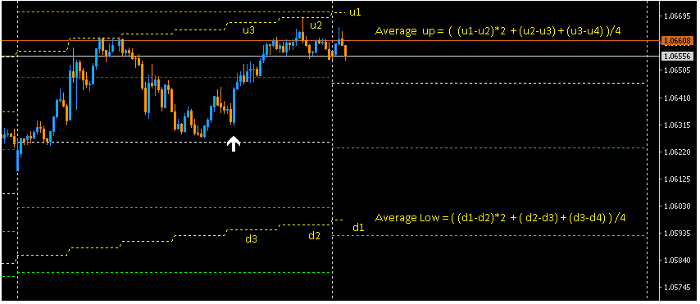
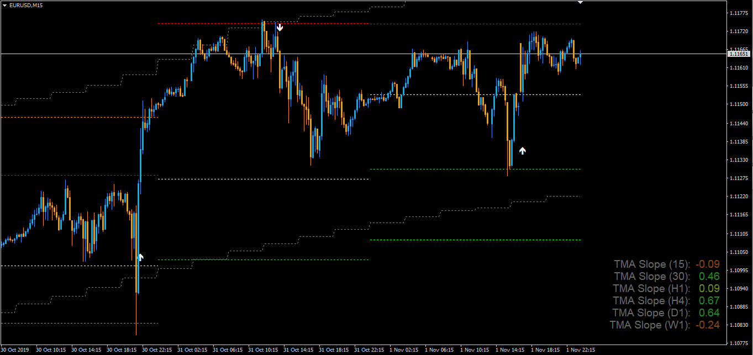

TMA slope H4 ≥ 0.3 uptrend
TMA slope H4 ≤ -0.3 downd trend
0.3 >TMA slope H4 > - 0.3 ranging
The above way of determining trend is an example-other ways may be considered if needed, but based on TMA indicator only.

Trade Entry:
There are two entry types and the user should be able to select one of them in the EA.
Entry Type 1: xSuper Trend

Buy Trade is triggered when the following conditions are met:
- TMA shows Buy Trend
- xSuperTrend is blue and crosses base line (white line)
- TP1 ≤ TMA upper band
- Only One Trade per day for a given pair

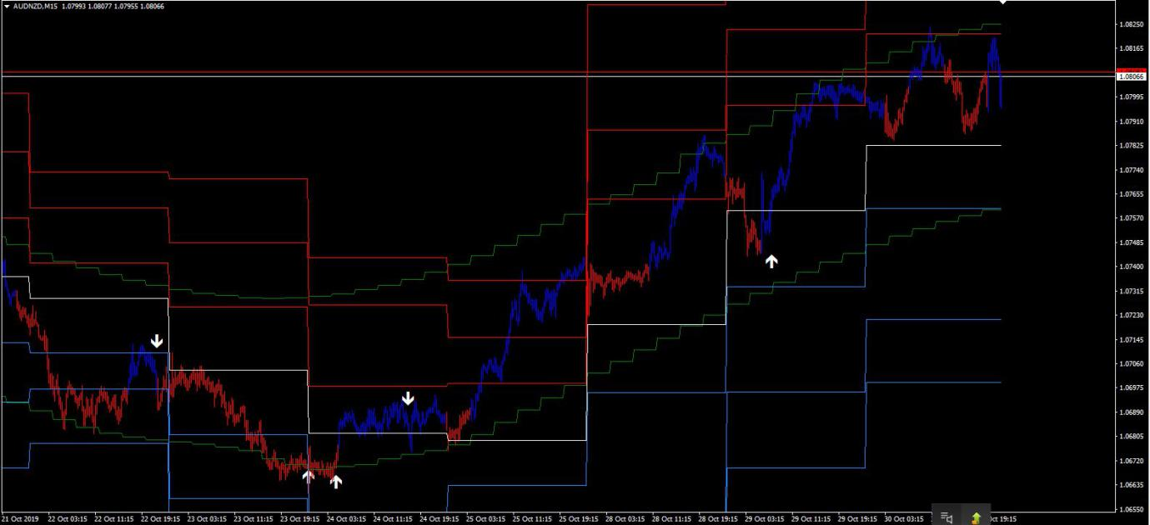

Stop Loss for xSuper Trend Buy:
The line which is just below the white Baseline.
Take Profit for xSuper Trend Buy:
If TP1 ≤ TMA upper band, but TP2 ≥ TMA upper band, then:
Full position is closed at TP1 {the line above the white base line}
{or}
If TP1 ≤ TMA upper band and TP2 ≤ TMA upper band, then:
Once TP1 is hit move to BE and wait for TP2

Sell Trade is triggered when the following conditions are met:

- TMA shows Sell Trend
- xSuperTrend is red and crosses base line (white line)
- TP1 ≥ TMA lower band
- Only One Trade per day for a given pair
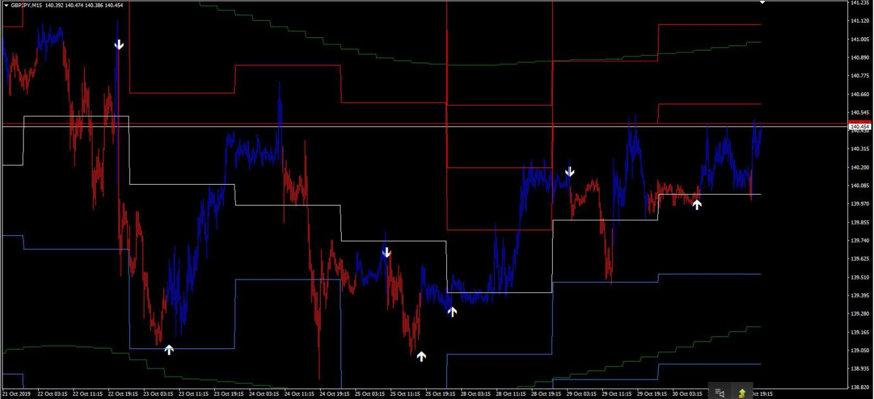

Stop Loss for xSuper Trend Sell:
The line which is just above the white baseline.
Take Profit for xSuper Trend Sell:
If TP1 ≥ TMA upper band, but TP2 ≤ TMA upper band, then:
Full position is closed at TP1 {the line below the white base line}
{or}
If TP1 ≥ TMA lower band and TP2 ≥ TMA lower band, then:
Once TP1 is hit move to BE and wait for TP2

Entry Type 2: BTM
Condition for BTM Buy:
- TMA Up Trend
- TP1 ≤ TMA upper band
- Wait for Buy Arrow and if price is below the white baseline, when the buy arrow is triggered, wait for to price to cross the baseline from below and trigger buy order.
{or}
Wait for Buy Arrow and if price is already above the white baseline when the buy arrow is triggered, take the buy order immediately.
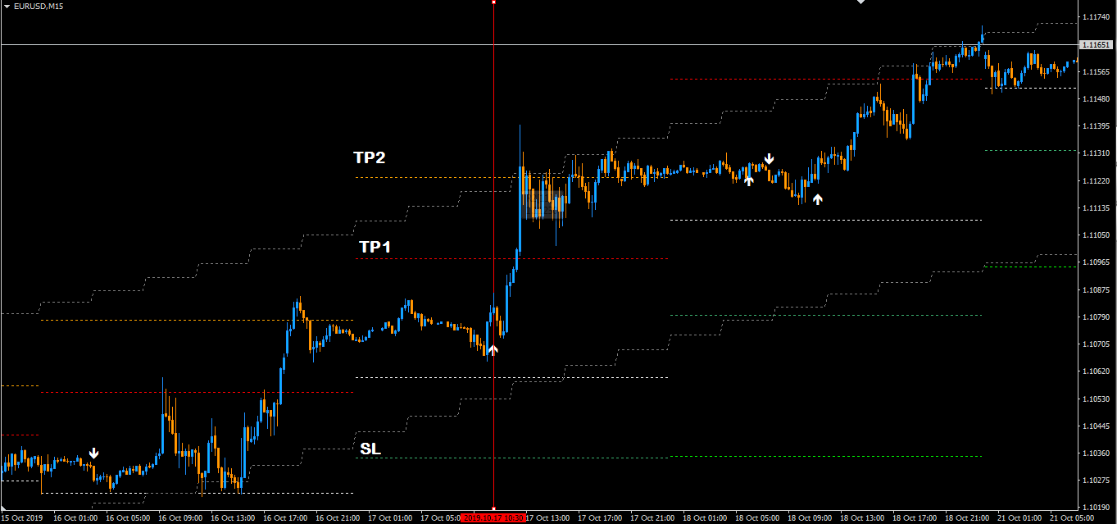
Stop Loss for BTM Buy:
The Line just below the White Baseline marked as SL.
Take Profit for BTM Buy:
50% of the position is closed at TP1 (the line just above the white base line) and brought to Break Even and remaining positions are closed at TP2; the 2nd line above the white baseline.

Condition for BTM Sell:
- TMA down trend
- TP1 ≥ TMA lower band
- Wait for Sell Arrow and if price is above the white baseline when the Sell arrow is triggered, wait for to price to cross the baseline from above and trigger sell order.
{or}
Wait for Sell Arrow and if price is already below the white baseline when the sell arrow is triggered, take the sell order immediately.
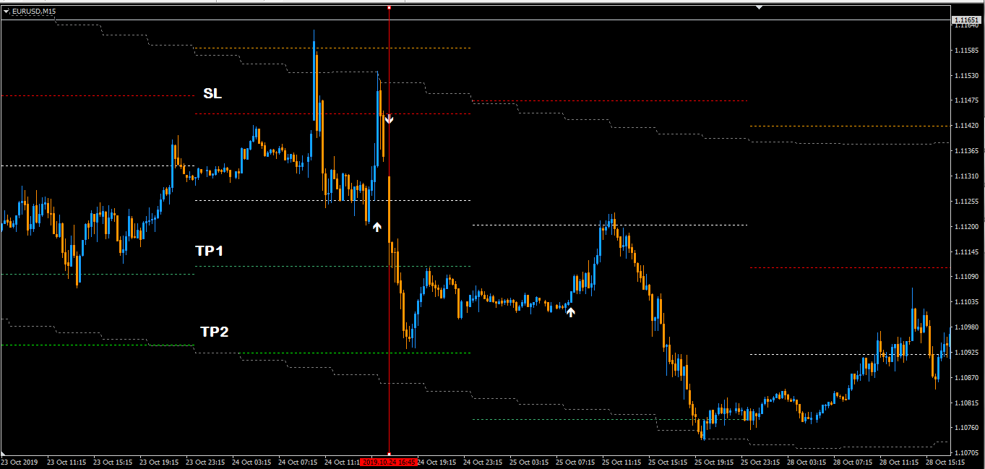

Stop Loss for BTM Sell:
The Line just above the White Baseline marked as SL.
Take Profit for BTM Sell:
50% of the position is closed at TP1 (the line just below the white base line) and brought to Break Even and remaining positions are closed at TP2; the 2nd line below the white baseline.

