My Day Trading System (MDTS) is a Trend Following
I) Determining the trend
Up Trend: 5/10 cross up and confirmed by Force Index is above zero (white) and Stochastic cross up (white)
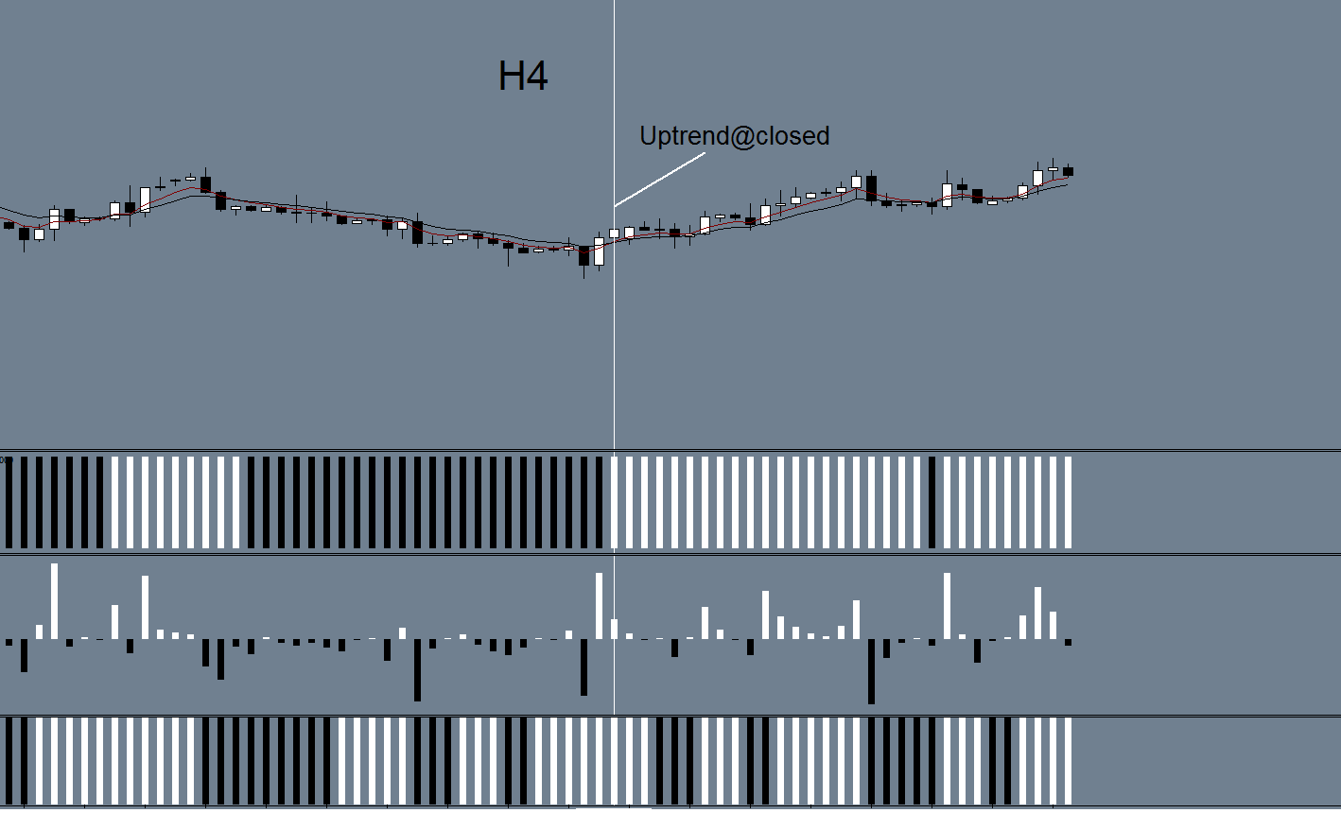

Down Trend: 5/10 cross down and confirmed by Force Index is below zero (black) and Stochastic cross down (black)
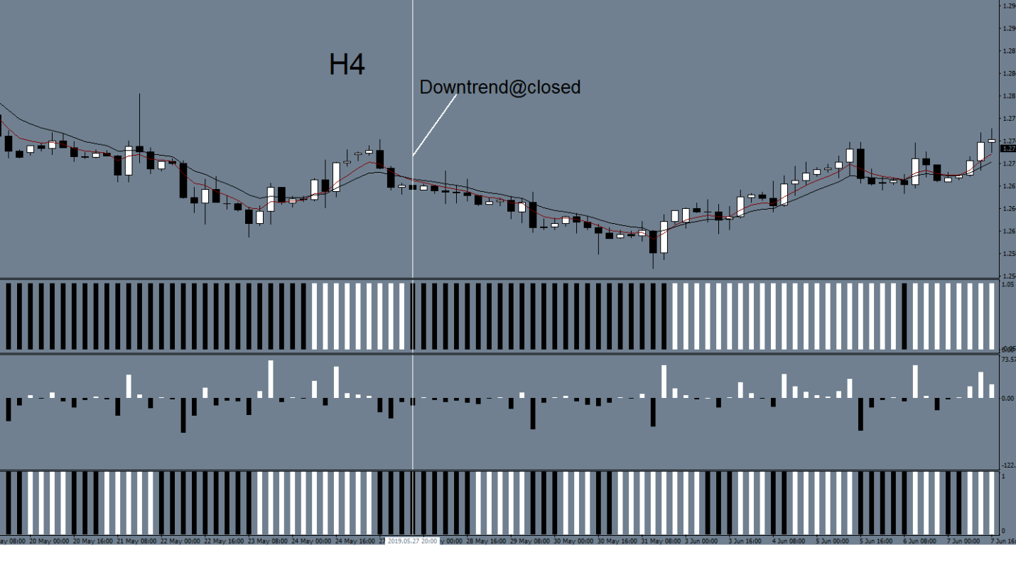

II_UT) Wait for the retracement
For an uptrend:
H1: Force Index goes below the zero
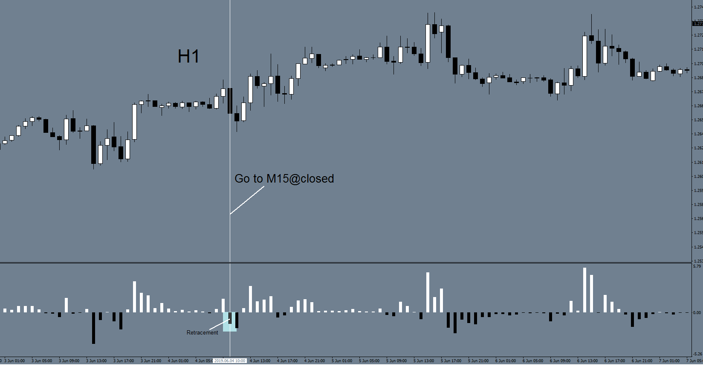

III_UT) Enter a trade
M15:
For an uptrend: The 3 Force Index must be aligned before pulling the trigger
1) Force Index_2 (H4) is above zero;
2) Force Index_8 (H1) is above zero;
3) Force Index_13 (M15) is above zero.
Buy = 1) + 2) + 3)
a) Stop Loss is placed below the previous cycle low or 20 pips but 20 pip min.
b) Take Profit is your discretionary.
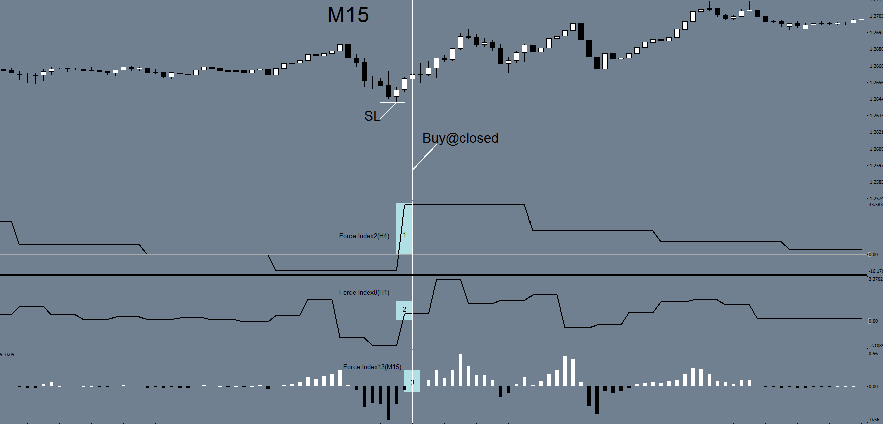

II_DT) Wait for the retracement
For a downtrend:
H1: Force Index goes above the zero
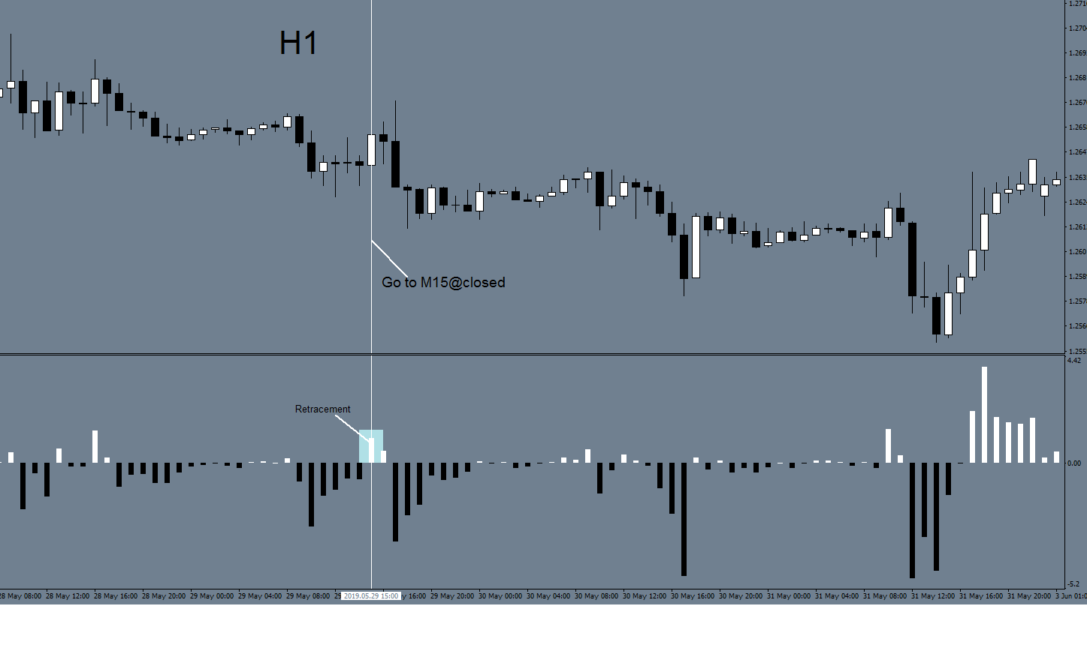

III_DT) Enter a trade
M15:
For a downtrend: The 3 Force Index must be aligned before pulling the trigger
1) Force Index_2 (H4) is below zero;
2) Force Index_8 (H1) is below zero;
3) Force Index_13 (M15) is below zero.
Buy = 1) + 2) + 3)
a) Stop Loss is placed above the previous cycle high or 20 pips but 20 pip min.
b) Take Profit is your discretionary.
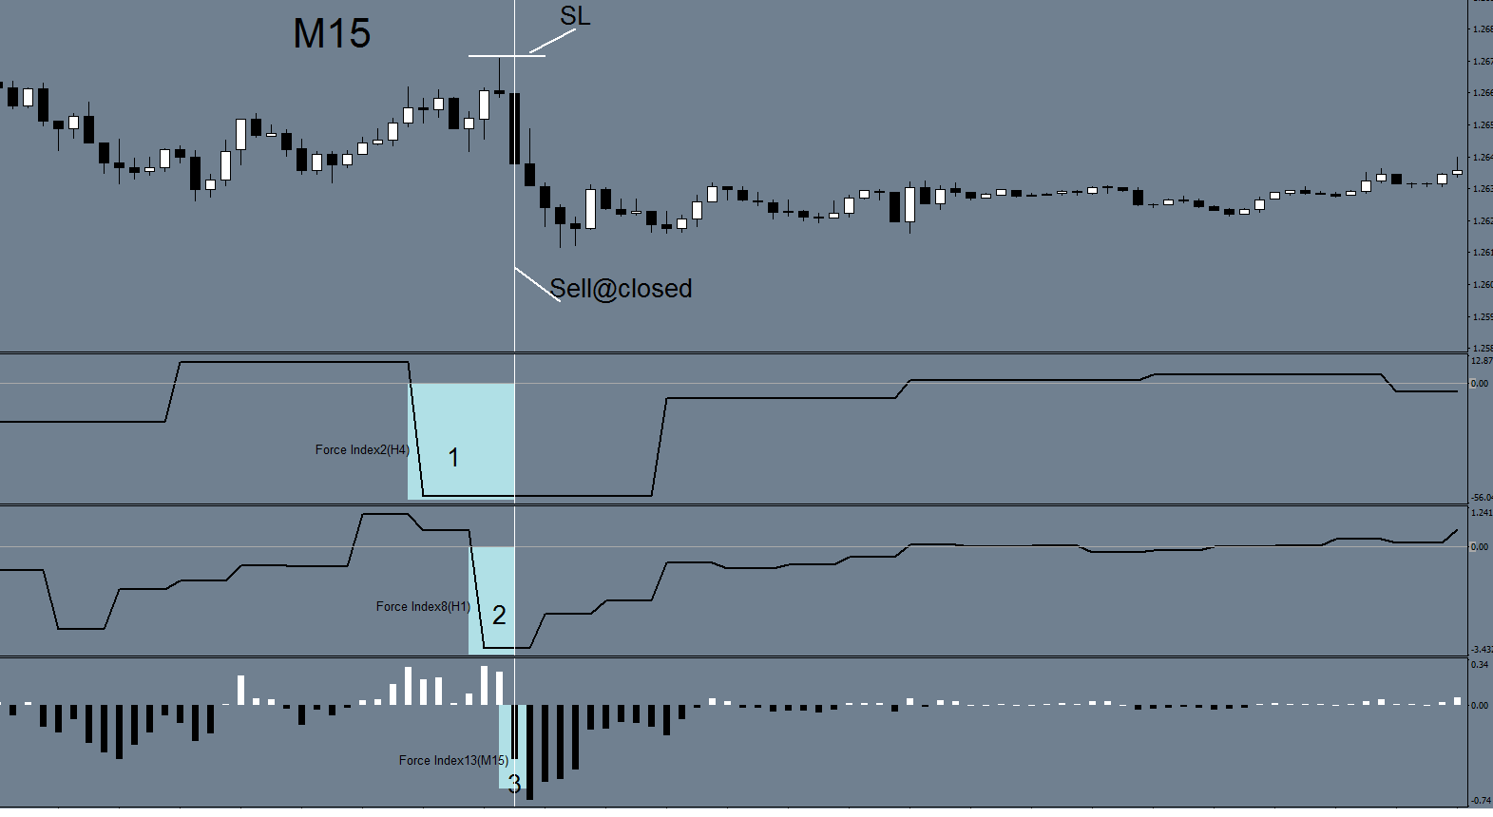

May the force be with you
Good luck, guys

