A New Introduction to the Goodman Swing Count System

The Goodman Swing Count System (GSCS) is a method for analyzing and trading the markets based on the 50 % and Measured Move rules.

It has similarities to Elliott Wave theory but is more systematically defined and objective.

By objective I mean it is more of a predictive method whereas Elliott is a descriptive method.

It is not a mechanical system; it requires study, effort, and subjective interpretation.

I have spent 35 years studying and learning GSCS and am still finding new and
useful nuances.

Trading Goodman successfully is a feedback loop process of learning → trading → learning → trading.

The goal of the 2 GSCS volumes (Theory and Praxis) is to allow a new user to begin trading with the method quickly, learning as he or she goes, working from the most general ideas to the more specific ones.

You should be able to at least dabble in Goodman after reading and studying
GSCS-Theory.

The principles of Goodman’s Swing Count System were informally set forth in a series of mostly annotated commodity futures charts from the late 1940s to early 1970s.

These trading studies, simply titled “My System,” were the work of Charles B. Goodman and were never published.

I met Charles Goodman at the Denver, Colorado, offices of Peavey &
Company (later, Gelderman) in the fall of 1971.

It was the occasion of my maiden voyage in the great sea of commodity trading (later, futures). In 1971 silver prices were finally forging ahead to the $2 per ounce level. A .10-cent limit move in soybeans elicited a full afternoon of postmortems by
traders and brokers alike.

This chapter is adapted from the www.fxpraxis.com Currency Codex feature
The Peavey office, managed by the late, great Pete Rednor, employed
eight brokers (later, account representatives).

The broker for both Mr. Goodman and me was the colorful—and patient—Ken Malo.

Brokers, resident professional traders—including Mr. Goodman and the Feldman
brothers, Stu and Reef—and a regular contingent of retail customers drew
inspiration from a Trans-Lux ticker tape that wormed its way across a long,
narrow library table in the back of the office.

Most impressive was a large clacker board quote system covering almost the entire front office wall.

This electromechanical quotation behemoth made loud clacking sounds (thus its name) each time an individual price flipped over to reveal an updated quote.

Green and red lights flashed, denoting daily new highs and lows. Pete, apart from being an excellent office manager, was also a fine showman, using the various stimuli to encourage trading activity.

Almost everyone made frequent reference to Charlie’s huge bar charts, posted on 21/2-by-4-foot sheets of graph paper, mounted on heavy particle board, and displayed on large easels.

No one ever really knew what the numerous right-hand brackets (]) of varying lengths scattered throughout each chart meant.

But there was always a great deal of speculation !

The present work finally reveals the meaning of those mysterious trading hieroglyphics. (See Figure 27.1.)

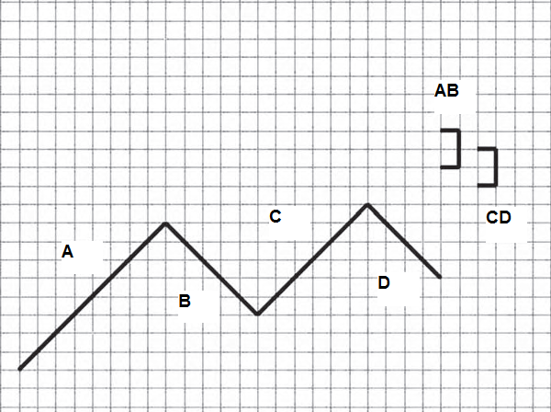

FIGURE 27.1 Those Mysterious Brackets

In the diagram, the brackets represent the price range projections for the 2 potential matrices AB and CD, in accordance with the Compensation-Carryover-Cancellation (3C) Rule.

Where they overlap is said to be an Intersection.

But nothing made a greater impression on me than the work of Charles
B. (Charlie) Goodman.

He instilled first some very simple ideas

: “Avoid volatile markets when at all possible.

” “Trade only high-percentage short term ‘ducks.’”

“Sit on your hands, dad, sit on your hands.”

It didn’t take long for me to adopt the ultraconservative “Belgian Dentist” style of trading, that is,

“Avoiding losing trades is more important than finding winning trades.”

(In Europe the term Belgian Dentist references an ultraconservative
investor.)

The Belgian Dentist approach carried with me when I developed my
artificial intelligence (AI) trading system in the 1980s—Jonathan’s Wave.

Even though it generated 48 % annual returns with a zero expectation
of a 50 % drawdown (according to Managed Account Reports), it
drove the brokers berserk because it could easily go a full month without
making a single trade!

At least some of Charlie’s wisdom did not fall upon deaf ears—or microchips.

Charlie’s trading advice, I am certain, allowed me to survive the financial
baptism of fire that destroys most commodity and currency trading newcomers in a matter of months, if not weeks.

Too many new traders hit the door trading with no comprehensive plan and with unrealistic expectations.

It is the same door that hits them in the rear on the way out a few months or even a few weeks later.

Mr. Goodman was to be my one and only trading mentor.

Over the decade that followed, he entrusted to me many, if not most, of his trading
secrets.

To the best of my knowledge he shared this information on his work with no one else in such detail.

Charlie’s other major contribution to technical analysis was Market Environment (ME). A summary of this method is in Chapter 28.

Charlie and I spent hundreds of hours together analyzing the trade studies from

“My System.” We also analyzed hundreds of other commodity, currency, and securities charts.

Charlie was happy with “My System” being organized in his mind.

But as a new-generation technical analyst, I was anxious to see it formalized on paper and eventually in source code on a computer.

To be honest, this created a small amount of friction between the 2 of us—Charlie was dead set against formalized systems and believed strongly in the psychological and money management elements of trading.

A trading method was simply a tool to focus the mind—“like a psychic with a crystal ball,” he would say.

Notwithstanding, by 1978 I was finally ready and able to formally state the principles of “My System.”

Because of its equal concern for price measurements (parameters) and price levels interacting together (matrices) I originally renamed “My System” ParaMatrix.

My first investment management company in the late 1970s was ParaMatrix Investment Management, and I acted as both a Registered Investment Advisor (SEC) and a Commodity Trading Advisor (CFTC).

I am currently writing a program to identify the 3 Primary Goodman trading opportunities:

The Double Intersection,
The Return,
The Wave Propagation.

However (and Charlie would certainly agree with me), I do not think it a good idea for this information to be used by anyone who is not firmly grounded in GSCS principles.

There is too much temptation to use what should be a check on one’s work as a decision-making tool.

It is the fuzzy core of GSCS that can make you successful !

The systematic exposition of GSCS in rules and principles is one of the things that separates it from other market trading systems and methods and must always be emphasized.

Contrary to ongoing speculation, only 2 copies of my original 1979
“Principles of ParaMatrix” ever existed. I possess both of them.

Charlie’s original “My System” trade studies were mistakenly destroyed shortly
after his death in 1984.

What remains of them are the 200 or so examples I copied into “Principles of ParaMatrix.”

Most of these are commodity futures charts, although perhaps 2 dozen or so of them are securities charts.

The subsequent work, “Goodman’s Swing Count System (GSCS),” is a substantially reorganized reissue of “Principles of ParaMatrix” with updated
charts, much of what I have learned in the intervening years, and a simplified nomenclature that I am sure Charlie would have appreciated.

“Keep it simple!” he would always advise.

I’ve also expanded on Charlie’s ideas by filling in some less formed ideas such as his market notation, or calculus as he referred to it, and a method for charting which I have dubbed Goodman Charting.

The codification of Charlie’s work has not been a simple task.

As many of you know, it has been a work in progress for many years.

For A New Introduction to the Goodman Swing Count System every word you see in this volume I have perhaps written 200 more !

Charlie also had a Dependent Interfacing Rule he was working on at the time of his death. He wanted to fold it into the main GSCS rule base without interrupting the inner logic of the theory.

I am currently working on this problem and, should I solve the problem of the Ninth Rule, I will provide an Addendum to GSCS-Theory to all purchasers.

My own direction in futures and currencies turned in the 1980s to artificial
intelligence (Jonathan’s Wave) and in the 1990s and today to artificial
life and cellular automata (the Trend Machine).

In spite of, or perhaps because of, these complicated, cutting-edge computer efforts, I continue to view Goodman’s Swing Count System in a very positive light.

To this day, the first thing I do when I see any chart is a quick Goodman
analysis—

“Where are the Intersections?”

and

“How are the matrices propagating?”

GSCS is a natural system for pursuing the conservative Belgian Dentist approach to trading, even without the aid of a computer.

Charlie saw the oncoming computer revolution in trading and was neither impressed nor enthusiastic.

GSCS trade opportunities are as frequent today (perhaps more frequent, thanks to more liquidity and volatility in the markets) as they were 40 or 50 years ago.

GSCS formations can be found at all chart levels, from FOREX tick charts to securities monthly charts.

I believe the system’s foundations have stood the test of time well.

Patterns today are no different than they were decades ago, nor are the twin human emotions—fear and greed—and the underlying disequilibrium-equilibrium
and thesis-antithesis-synthesis of buyers and sellers that create them.

GSCS is an excellent method for finding support and resistance areas that no other method spots, and for locating potential turning points in any market.

One of its best suits is that it can easily integrate into other trading techniques and methodologies. But I leave that part to you, dear reader.

The better you learn GSCS, the more opportunities you will find in your charts—and the better will be the trades you make off of them and the more high-percentage ducks will fill your basket.

Is it really a system ?

I have christened it the Goodman Swing Count System because of the systematic way in which it is constructed.

But because it requires study, effort, and judgment, it is perhaps more accurate
to think of it as a Method.

Depending upon your perspective and knowledge of it, GSCS is between 70 % and 90 % mechanical and between 10 % to 30 % fuzzy core.

By comparison, I rate Elliott Wave theory as 70 % fuzzy core and 30 % mechanical.

Drummond Point and Line I rate 50 % / 50 %.

As you will learn in the GSCS-Praxis workbook, it is the ability to anticipate the propagation of Goodman Waves that separates the men from the boys and Goodman from Elliott.

And, such as life is, it is in Wave propagation where much of the fuzzy core lurks.

The program demo provided with the 2 GSCS volumes represents the kernel idea of mechanizing perhaps 70 % of the system.

It is available as a learning tool, for additional perspective, and not as a trading
tool.

My G-Chart drawing tool I built for analyzing Trends, Matrices, and Waves and conducting simple Goodman gedankenexperiments.

I also make it available.

Mr. Goodman passed away in October of 1984 after a brief illness.

I last saw Charlie at the hospital a few days before he passed; I’m sure he
knew his remaining time on earth was short, but he managed to give me one of his terrific smiles of encouragement and a thumbs-up.

It was always his desire to share with others—although, as is usually the case with true genius, few wanted to listen.

These days we are bombarded with ever more cryptic and computer dependent
software programs and black boxes.

The irrational lust for success without effort is greater than anything Charlie knew in his heyday, I am certain.

Perhaps now is the time for the simple yet theoretically well grounded ideas of GSCS to populate.

The advent of computer analysis in the 1980s and computer trading in the 1990s has not borne fruit relative to the effort expended, much as Charlie anticipated.

The majority of new traders are still shown the door quickly and it is the brokers who make most of the money.

The publication of GSCS-Theory and the GSCS-Praxis workbook would meet with Charlie’s approval (especially the workbook!).

His efforts in extracting an objective and almost geometrically precise ( à la Spinoza) trading system out of a simple trading rule (the 50 % Rule) is most
remarkable, and 35 years later simply leaves me in awe.

It has certainly earned him the right to be included in the elite group of early scientific traders: Taylor, Elliott, Gann, and Pugh.

As previously mentioned, GSCS-Theory very closely follows the 1979 ParaMatrix book and to a large extent is my effort in systematizing GSCS from notes I took after sessions with Charlie in the 1970s.

GSCS-Praxis more closely follows Charlie’s approach to teaching by example but incorporates many more up-to-date examples from stocks, commodities, and
FOREX.

Since the first short paper on GSCS appeared on the Internet in 1998 I have received perhaps 2,000 inquiries about it.

Both volumes attempt to incorporate what I have learned from explaining various aspects of it to others.

Areas of GSCS that have received the most questions I have attempted to go into in greater depth.

THE GSCS RULES

9 primary rules comprise the theoretical foundation of the Goodman Swing Count System.

The 9 Rules of GSCS

1. The 50 % Rule
2. The Measured Move Rule
3. The Rule of Buyer-Seller Equilibrium
4. The Rule of Recursion
5. The Wave Propagation Rule
6. The Return Rule
7. The Compensation-Carryover-Cancellation (3C) Rule
8. The Rule of Intersection
9. The Rule of Points

Charlie referred to them also as concepts or principles from time to time.

Insofar as there are a number of secondary rules, I have assumed the nomenclature of labeling the primary ones “rules” and the secondary ones “principles.”

A tenth rule, clarifying the 3C Rule, is thought to exist, and I continue to search for it.

The 50 % Rule

The cornerstone of GSCS is the old 50 % retracement rule.

This rule, familiar to most traders, is almost as old as the organized markets themselves.

FIGURE 27.2 The 50 % Rule

There have been various formulations of the 50 % Rule, but the underlying idea is this:

At the 50 % retracement of any trend, Prices will find either support or resistance.

This does not mean Prices will always reverse from the 50 % price point,

Only that Prices will find Support or Resistance of some kind for some period of time.

There is more to say on this in the Rule of Points.

Many traders have found the 50 %Rule to be a good rule of thumb, but observe that Prices rarely stop right at the 50 % point.

The GSCS 3C Rule is a result of this important fact; it is perhaps the most
interesting of the GSCS rules, although it is one of the last you should implement
in your trading scheme.

The logic of the rule is quite simple.

At a 50 % retracement, both buyers and sellers of the previous trend (up or down) are, ceteris paribus, in balance.

Half of each holds profits and half of each holds losses.

The 50 % point moves with the trend. (See Figure 27.3.)

The Measured Move Rule FIGURE 27.3 A Moving Target

This rule is almost always associated with the 50 % Rule.

It states that if Prices do reverse from the 50 % point, then they will carry to a distance equal to the price value of the first trend. (See Figure 27.4.)

However, as explained in the Points Rule, it is not accurate to tie the Measured
Move Rule always to the 50 % Rule.

FIGURE 27.4 The Measured Move

Prices unwind to the measure move point when one side is a 100 %
winner and the other side is a 100 % loser, on balance.
D E F I N I T I O N S
A trend is the movement of Prices in a given direction, up or down, without
significant price correction.

In Figure 27.4, AB, BC, and CD are all trends.

A trend may also be called a Swing.

A Matrix is a measured move of 3 trends.

In Figure 27.4, ABCD is a Matrix.

The Rule of Buyer-Seller Equilibrium

Both the 50 % Rule and the Measured Move Rule imply equilibrium
between buyers and sellers being established.

Charlie considered equilibrium to be the primary market paradigm.

It is the underlying force that moves all markets, in GSCS theory.

The equilibrium shown in Figure 27.5 is a tenuous one, indeed.

The distribution of buyers and sellers over the initial price trend or Swing is
obviously not perfectly even:

Some buyers hold more contracts than other buyers.

They have also different propensities for taking profits or losses.

Nor does it account for the buyers and sellers who have entered the market before the initial Swing or during the reaction Swing.

FIGURE 27.5.1 Equilibrium of Buyers and Sellers in the 50 % Rule

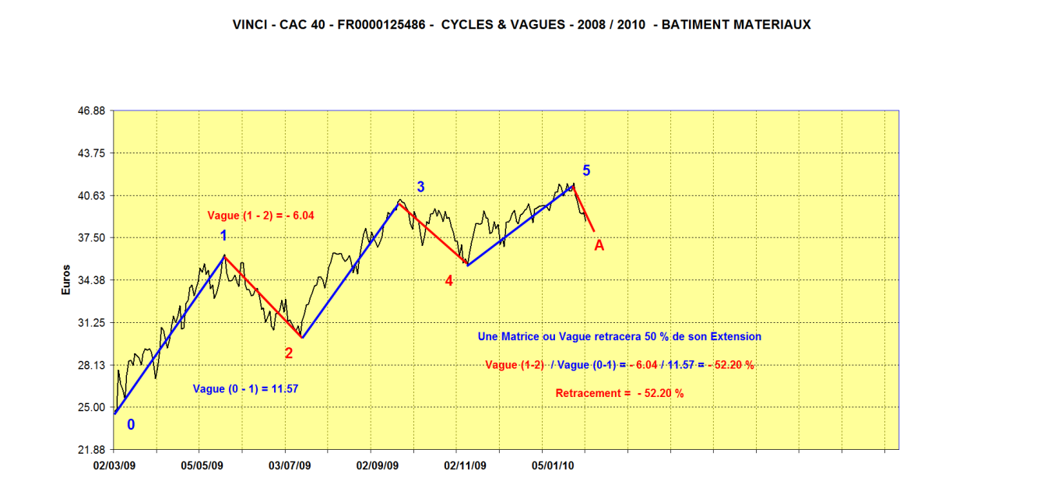

Not all of the buyers and sellers from the original Swing may be in the market any longer.

Remarkably, GSCS eventually takes all of this into account—especially the buyers and sellers at other price Swing levels, called matrices.

Nevertheless, the 50 % retracement point and measured move point are often powerful and very real points of equilibrium and are certainly known and defined hot spots of which one should be aware.

Remember that both the futures markets and the currency markets are very close
to a zero-sum game.

It is only commissions, pips, and slippage that keep them from being zero-sum.

At the 50 % point, it doesn’t take much to shift the balance of power for that particular Swing Matrix.
N O F R I ’ S T E C H N I Q U E
In 1975 a well-known Chicago grain floor trader, Eugene Nofri, published
The Congestion Phase System.

This small but power-packed volume detailed a short-term trading method using simple but effective congestion phases.

While not precisely a work on the 50 % Rule, it touched—from a different
angle—some of Charlie’s ideas.

FIGURE 27.5.2 Basic Nofri Formation - Simple Congestion Phase

Nofri Formations

This simple but logical and elegant method was described by commodity futures floor trader Eugene Nofri in his book Success in Commodities: The Congestion Phase System (Success Trading, 1975).

The most common of the book’s 16 basic formations is shown in Figure 27.5.2.

When 2 bars up (or down) are followed by 2 bars down (or up) with the fourth bar within the range of bars 1 and 2, the prediction is bar 5 will be in the direction of the first 2 bars.

For my own theory of a market paradigm, please see my article “The Forex
Propensity Index.”

It does not contradict the equilibrium paradigm, but rather expands on it in much greater detail and offers additional insights.

The Rule of Recursion

Rules occur and hold true at all price levels or matrices, and many are
being worked simultaneously in any given ongoing market.

This is a critical point. In modern terminology it would be said that price movements are recursive.

Simply stated, this means that without labeling you could not tell the difference between a 10-minute chart and a daily or weekly chart—they all exhibit the same behavior and operate under the same rules.

The bar graphs in Figure 27.6 were taken from actual market data.

FIGURE 27.6 Recursion

It is functionally impossible to tell the time units apart with respect to the chart
action.

The Rule of Recursion is critical to understanding the GSCS method
for calculating Wave and Matrix price objectives, since matrices and Waves
at different levels are recursive and “talk” to each other.

The Wave Propagation Rule

Much of what Charlie was attempting to teach me didn’t seem to fit until I understood the Wave Propagation Rule.

I had studied Elliott Wave theory and thought of Waves in series of 5.

In fact, all Waves are series of 3; it is their propagation (as Charlie first revealed) that erroneously makes them seem to be series of 5.

In GSCS, Waves propagate as matrices, the series of 1-2-3 or ABCD
trends given in the earlier definitions.

Once a Matrix is completed, it becomes a trend for a larger Matrix.

In the context of the larger Matrix, the Secondary trend of the first Matrix becomes insignificant with regard to the definition.

(It remains important for other aspects of GSCS analysis.)
D E F I N I T I O N
A Goodman Wave is a Matrix that has a smaller Matrix as one of its trends.
D E F I N I T I O N
Waves propagate inward and outward from any point.

The formation in Figure 27.7 is not to be construed as a 5-series trend
Elliott Wave, but a 3-series-trend Goodman Wave in propagation.

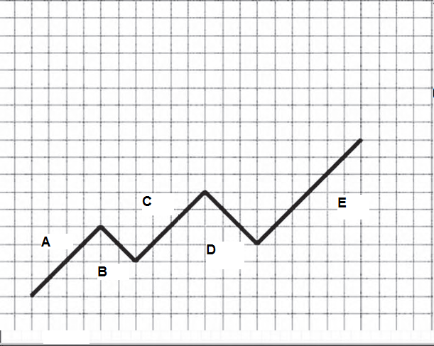

FIGURE 27.7 A Goodman Wave

The key is trend D, called the Return in GSCS theory.

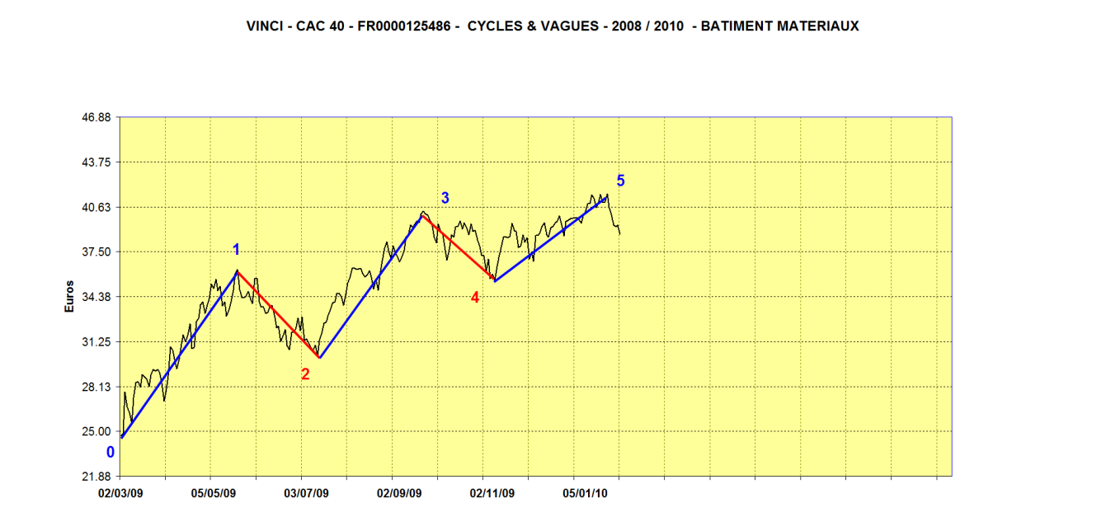
VINCI A Goodman Wave

The key is trend (1,2) called the Return in GSCS theory.

The difference is a critical.

In GSCS-Praxis, I try to show all the possible Goodman Wave forms.

As a market unfolds, you can gradually eliminate many of them and eventually
be able to home in on a limited number of possibilities with strong trading
opportunities.

So, we have trends (or Swings), matrices, and Waves.

I cannot emphasize strongly enough the importance of the Wave Propagation Rule. (See Figure 27.8.)

The Return Rule

It is the fourth trend or Return in a Goodman Wave that separates GSCS
from Elliott.

And it is a very significant difference.

The Return and the Wave propagation it implies make GSCS substantially
more predictive than Elliott, which is a descriptive theory.

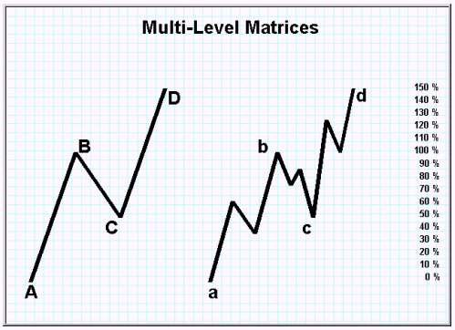

FIGURE 27.8 Wave Propagation: Multilevel Matrices

The fourth trend, D, in a 5-series ABCDE is connected to ABC, not just C.

Of course, Prices have minimum fluctuations and maximum movements,
but it will help to think in the fashion of Figure 27.8.

Charlie was fond of referring to Zeno’s Paradoxes when discussing this idea.

Matrices and Waves are propagating both inward and outward.

In theory:

_ All Price matrices (levels) in theory are part of a larger Price Matrix.

_ All Price matrices are composed of smaller Price matrices.

The Compensation-Carryover-Cancellation (3C) Rule

The rules thus far Charlie called ordinal rules.

They are not price dependent, and require no calculation.

The remaining rules he referred to as the cardinal rules, as they are price-specific and require calculation.

_ By ordinal Charlie meant without a value and without reference to specific numbering.

_ Cardinal meant with reference to specific numbering.

In teaching me to trade GSCS, Charlie suggested I work only with the ordinal rules before attempting to apply the cardinal rules.

I believe this now to be an excellent idea.

You have perhaps made the observation yourself:

The 50 % Rule and the Measured Move Rule aren’t always (in fact aren’t usually) exact.

Prices rarely stop at exactly the 50 % point and rarely run to exactly the measured move.

Charlie wanted to know why.

It is not enough to just keep a chart; you must actively work with it.

By active analysis, Charlie basically meant the process of hypothesis testing.

He felt unless you asked specific questions, made hypotheses, and sought
answers, you wouldn’t really see anything or learn much.

If you don’t look for it, you can’t see it!

Hypothesis testing is the correct way to look at a chart.

The human mind tends to want to draw conclusions and infer general
rules quickly.

We see a couple of examples of a phenomenon and assume it’s a general rule.

To avoid the temptation of this, always follow up your initial hypothesis testing with analysis of as many examples of the phenomenon as you can find.

Charlie called this “bathtub analysis” since he liked to take a book of
charts into the bath with him, formulate hypotheses, and see how they
played out on the charts.

If, after a trend, Prices move 60 % instead of 50 %, what can this mean vis- a-vis the Rule of Buyer-Seller Equilibrium?

Are the sellers stronger than the buyers?

Or are the buyers waiting for later to make their move?

(I always speak of buyers and sellers in the aggregate; obviously, individual
decisions to buy and sell vary enormously.)

To the extent a Price Swing overshoots or undershoots its ideal 50 %
retracement, that price value will be made up on the next Price Swing within the Matrix.

Now this is the trading rule that can make you rich!

For example, if Prices fall only 40 % of the initial trend and reverse, the measured move will actually be either 90 % or 110 % of the measured move point and value of the Primary (initial) Swing in the Matrix.

The 10 % difference, GSCS holds, must be made up eventually.

This is the subrule of Compensation. (See Figure 27.9.)

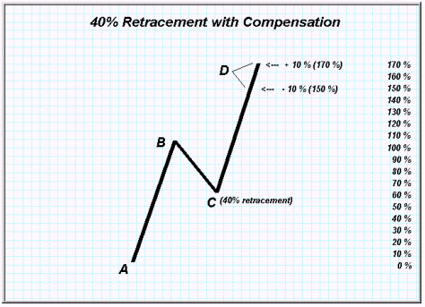

FIGURE 27.9 Compensation

Furthermore: If the difference is not fully made up in the final Price Swing of a Matrix, the cumulative “miss” value will carry over through each subsequent Price Matrix until it is made up.

This is the subrule of Carryover.

Charlie used a simple carryover table to add and subtract cumulative
carryover values until they cancel. (See Figure 27.10.)

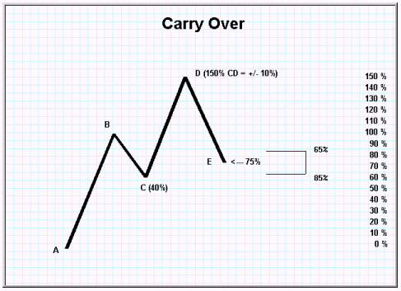

FIGURE 27.10 Carryover

When no carryover remains, the Price Matrix is said to have cleared or canceled.

This is the GSCS concept of Cancellation.

Cancellation is critical to finding GSCS support and resistance points and other chart hot spots where something much less than random is likely to occur. (See Figure 27.11.)

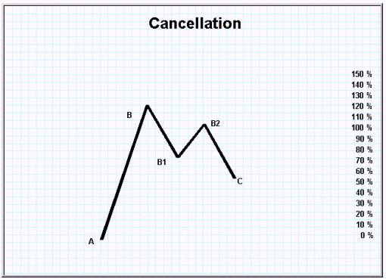

FIGURE 27.11 Cancellation

These calculations, intermatrix and intertrend, are not the easiest to keep, but practice does help.

The chapter in “Goodman’s Swing Count System (GSCS)” on the 3C Rule details how the calculations are managed, and GSCS-Praxis offers methods for doing them accurately.

One of the last discussions I had with Charlie was about the Over-Under component of the 3C Rule.

Ever the mathematician seeking exactitude, he wanted to find a rule for when the carryover was over and when it was under.

He felt strongly that such a rule—in harmony with all the other rules, of course!—existed.

Such a rule would make the number of possible price outcomes considerably less and, consequently, prediction both easier and more exact.

I had suggested that finding the rule would require more chart samples than could be observed with even the longest bath.

My idea was to run several thousand examples through a computer program in hopes of finding the new rule.

Charlie had an enormous disdain for computers but had given his blessing for such a study.

As I write these words, a program has been written and I will soon run and tally the results from over 15,000 examples in pursuit of the new rule. Stay tuned!

Ever the optimists, we christened the new rule before we even found it, naming it the Rule of Dependent Interfacing.

The Rule of Intersection

I have always believed a trader could make a decent living trading the Return,
an ordinal rule.

Elliott traders think it is just another trend in a 5 series Wave, but as we have seen, it is much more important and useful.

The cardinal rule equivalent is the Rule of Intersection with respect to trading opportunities.

If trading the Return could make you a decent living, correctly trading intersections could put you on easy street!

Solid, measured (cardinal) intersections aren’t common.

Double intersections are the most plentiful.

Triple intersections are downright hard to find.

Quadruple intersections are extremely rare—and finding them, with all the matrices involved, can make you downright dizzy.

An Intersection is a Price range or point where the cancellations of 2 or more matrices or Waves overlap.

They are the hot spots of GSCS.

There is no analogous concept in Elliott, the best-known competitor to GSCS.

Intersection makes GSCS much more objective and testable than other Swing systems.

A Double Intersection is the Price conjunction of the measurement points of 2 connected matrices.

For example, the measured move of a Matrix is the same price point as the 50 % move of a larger (connected) Matrix in Figure 27.12.

There are several Double Intersection templates in GSCS and many Intersection formations.

Since Waves propagate both inward and outward, every trend can itself be a Wave.

Nonetheless, the number of possible Wave permutations in Goodman is much smaller than the number in Elliott.

By definition, Intersections are cardinal.

But watch your charts for the basic Intersection formations; they are often tradable ordinally.

Don’t overemphasize the cardinal rules, at least while you are beginning
to learn Goodman.

Charlie taught me to be able to spot the basic rules ordinally, then overlay an understanding of the cardinal ideas later.

“Trading Goodman,” as I often call it, centers around 3 techniques:

1. Trading the Return
2. Trading Intersections
3. Trading Wave Propagation
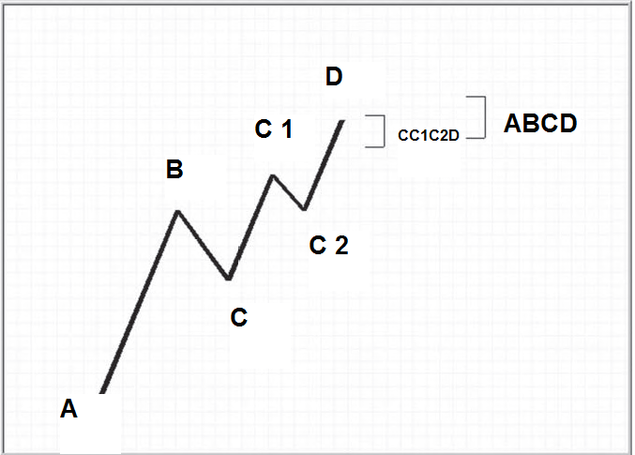

FIGURE 27.12 A Double Intersection

These often work as teams.

For example, if you have a strong sense of how the Wave is propagating, you will also have a good idea of which way Prices will break out from an Intersection.

When I look at an existing chart, I look for Intersections and the Return trend.

When I am trading, I try to watch for how the matrices are propagating.

The Rule of Points

From a theoretical perspective, the 5 GSCS points, beginning with the 50
% retracement, are simply prices where there should be additional
support and resistance and where something predictable should occur.

These points, in and of themselves, do not address Price direction. (See
Figure 27.13.)

FIGURE 27.13 Points of a Trend

Think of the markets as a pinball machine.

The plunger is the Buyer-Seller Equilibrium.

The pinballs are prices moving on a grid of Price and time.

The cushions are the GSCS price points.

Physics is the science used for determining how the ball moves in the pinball machine from cushion to cushion;

GSCS is the theory on how it moves from Price to Price in the market.

Remember—trends become matrices and matrices become Waves, and
in doing so become trends themselves.

As a trend develops you can visualize how these points shift. (See Figure 27.14.)

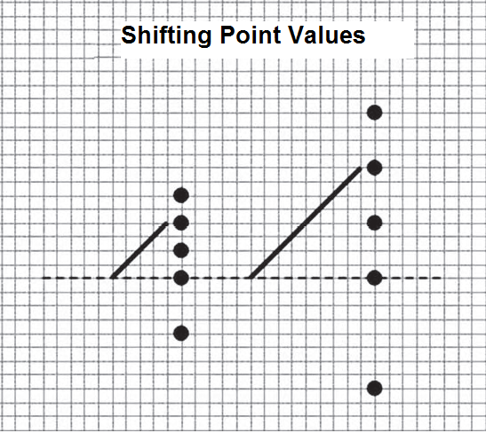

FIGURE 27.14 Shifting Point Values

The 50 % point is indeed an equilibrium point.

As such, the equilibrium must give way, but either side (buyers or sellers) in either a downtrend or an uptrend may prevail at any given Matrix or price level.

Charlie realized the possibilities both for a reversal (as in the case of
the completed measured move) and for a continuation.

A continuation would be equivalent to the sellers (in an uptrend) and the buyers (in a downtrend) winning the tug-of-war within a Matrix.

In price action, this means that Prices would fall or rise to at least the beginning point of the initial Swing!

Neither is either correct or wrong; they are both logical possibilities incorporated into GSCS theory.

In other words, the measured move is not a sure thing—the 50 %
retracement could also become a V or inverted V continuation.

The 50 % retracement is not a reversal point (necessarily) but should be
considered as a point of interest where Prices may be more likely than randomly
to reverse with exceptional force or certitude. (See Figure 27.15.)

Watching and calculating points on the fly is an aid to determining Wave propagation.

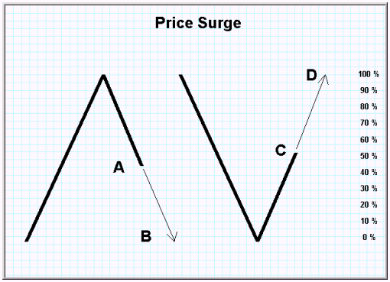

FIGURE 27.15 Reversal or Price Surge Continuation?

If Prices surge through a point, it may indicate that a larger Matrix is dominant and the currency Matrix of 1-2-3 is simply a single Wave of the larger Matrix.

See the Principle of Dominance in the following section for more detail.

In the context of GSCS, a continuation is not the failure of the Measured
Move Rule.

4 GSCS PRINCIPLES

There are 4 GSCS principles.

These are essentially lesser rules that help to apply the rules themselves to specific trading situations.

These are most properly handled in GSCS-Praxis, but an overview of the most important are included in GSCS-Theory for completeness.

The principles also help in the homing-in process, eliminating possibilities in order to get to a Belgian Dentist trading opportunity.

The 4 GSCS Principles

1. The Flat/Complex Principle
2. The Principle of Dominance
3. The Breakaway Principle
4. The Principle of Doublets

The Flat / Complex Principle

Given a 1-2-3 Matrix at any level of Goodman Wave propagation:

_ If the 1 trend is composed of no other component trends (flat), then the 3 trend will be a Matrix (complex).

_ Conversely, given a 1-2-3 Matrix (complex) and a 4 trend Return, the 5 trend of the Goodman Wave will be composed of no other component trends (flat). (See Figure 27.16.)

FIGURE 27.16 The Flat/Complex Principle

This chart shows that Swings tend to be composed of 2 major components—one in which Prices do not correct significantly and one in which a correction occurs.

The Swing that corrects is itself a Matrix and the combination of a flat + complex Swing is a Goodman Wave.

The Principle of Dominance

The Principle of Dominance is important to understanding and using Wave
propagation as a trading tool.

Dominance is the big question in GSCS.

What Matrix is dominant ?

Is a given trend a Secondary trend of Matrix A—or a Primary trend of Matrix B?

The problem of dominance, in this writer’s opinion, destroys any real
predictive value of Elliott Wave theory—there are just too many possibilities
at any given time to make useful trading decisions. (See Figure 27.17.)

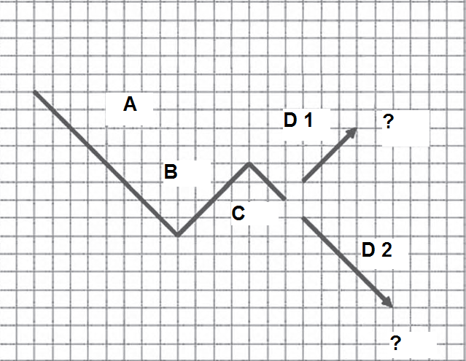

FIGURE 27.17 Dominance in GSCS

It is true that GSCS has the same problem—though in a much smaller manner.

There are multiple possibilities and many price junctures.

Fortunately, there are fewer of them to start, and other rules, such as the Rule
of Intersection, eliminate many of them.

In GSCS you know in advance when the possibilities are limited and exactly where, pricewise, failure is determined.

These are just corrective Waves (secondaries).

The number of permutations in Elliott is astronomical.

Trying to decide (in advance) which Wave is Primary and which Wave is secondary at any given level seems fruitless to me.

Remember that there are multiple Waves building at the same time,also.

Which belongs where?

The 3-series trend of a Goodman Wave already prunes many of the permutations from the 5-series trend of Elliott.

GSCS has many other features that make it a much more predictive method
than Elliott.

I have always believed Elliott is good primarily for description after the fact.

The big question in Figure 27.17: Is the dominant Matrix AB(CD2) or is it AB(CD1)?

Which are Primary and which are Secondary trends?

There is no 100 % quantifiable answer, but Goodman is much easier to figure practically than Elliott is.

The Breakaway Principle

A breakaway occurs when Prices jump out of one Matrix into another.

Breakaways are often easy to spot, and a breakaway is an excellent clue
as to the dominant Matrix. (See Figure 27.18.)

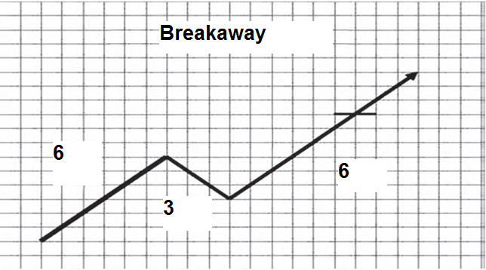

FIGURE 27.18 Breakaway

At the horizontal bar, Prices have broken away from the Matrix.

This almost always indicates that the Matrix is a Secondary trend of a larger
Matrix.

The 3 trend may turn out to be too small (less than 25 %) to be considered a trend itself.

The Principle of Doublets

Prices may sometimes bounce between 2 GSCS points, creating a doublet
trend.

Doublets also are useful in finding dominance.

Refer back the Rule of Points and the pinball analogy. (See Figure 27.19.)

FIGURE 27.19 Doublets
C H A P T E R 2 8
y

