Volatility or Standard Deviation

Next: Buy & Sell
There's this thing called Standard Deviation (or Volatility) which measures how far a set of stock returns tends to deviate from their Average or Mean.
To calculate the Standard Deviation you do this:
- Calculate the Mean (or Average) of the set of returns: R₁, R₂, ... R_{n}.
M = (1/n) ( R₁ + R₂ + ... + R_{n})
- Then calcuate the deviations from this Mean:
(R₁ - M) and (R₂ - M) and ... (R_{n} - M)
- Then calculate the average of these squares:
SD² = (1/n) { (R₁ - M)² + (R₂ - M)² + ... + (R_{n} - M)² }
- The square root of this average is the Standard Deviation, SD.
(You might call it the Root-Mean-Square of the deviations from the Mean.)
Perhaps a simpler (but equivalent) calculation is like so:
SD² = (1/n) ΣR_{k}² - M² = (The average of the squares of the returns) - (The square of the average return)
where Σ is a shorthand notation for summing of terms
>And that's useful?
To many, it represents how far the monthly (weekly? yearly?) returns deviate from their Mean.
For something like bank interest, where the annual returns are constant, then SD = 0 since all returns are equal to their Mean.
For something like the DOW, you might have SD = 0.1 or 10%.
For something like the WMT (Walmart), you might have SD = 0.15 or 15%.
For something like the XOM (Exxon), you might have SD = 0.2 or 20%.
For something like ...
>20% of what?
Good question.
If you're calculating the Standard Deviation of a set of temperatures, then SD would be measured in degrees.
If you're calculating the Standard Deviation of a set of areas, then SD would be measured in square metres.
>So the SD for stock return percentages would be a percentage.
Exactly ... and besides being a measure of how the returns are dispersed (about their Mean), many regard the SD as a measure of Risk.
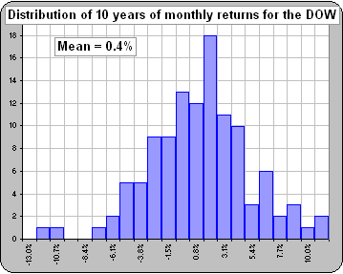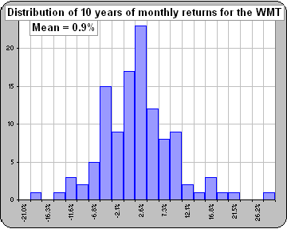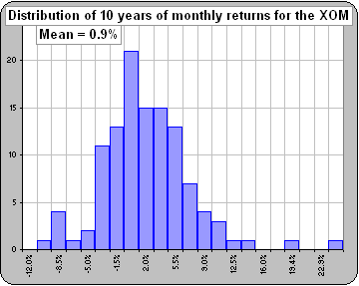
>A measure of Risk? As in losing money?
No, as in being uncertain of the expected future returns ... since you may expect them to vary greatly if the Volatility is large.
Of course, it wouldn't be MY definition of Risk. Indeed, people are still discussing what is the "best" (in some sense) measure of Risk.
These debates seem to go on ... and on. (See Poor Joe.)
>The distribution of returns ... that looks interesting.
Yes. We'll talk about distributions soon enough.

One thing you have to consider (before placing too much faith in what the SD is saying) is that, if you use monthly returns, the value will depend upon whether you take the return from the 1st of the month to the 1st, or the 10th to the 10th, etc.
That goes for a number of financial indicators, like Correlation or Beta ... or whatever.
If one is accustomed to seeing the Volatility of yearly returns, then one often multiplies the monthly volatility by the square-root-of-12 (because there are 12 months in a year).
Indeed, if you have the volatility for weekly returns, then multiply by the square-root-of-365 (because there are 365 days in a year).
Note, however, that some multiply by the square-root-of-250 because there are (about) 250 market days in a year.
>And that'd give the same number as you'd get by using yearly returns?
Uh ... no, but usually it's close.
However, so long as everybody uses the same prescription for "annualizing" monthly volatility then you can at least compare volatilities between assets.
One other thing about volatility: If you have two assets with the same Mean, the one with the larger volatility will make you less money.
>Huh?
Increasing Volatility will reduce your Compound Annual Growth Rate (CAGR or "annualized" return) ... but we'll talk about that later.
See:
- What's "Risk"?
- Risk and Volatility
- Time Diversification
- Drawdown as "Risk"
- the Ulcer Index as "Risk"
- Dependance upon WHEN things are calculated
- Correlation vs Days
- Square root of time
- Volatility and Square-root-of-Time
- Volatility and Returns
- Volatility, Risk and "Risk"
- Volatility and time period
- Measuring "Risk"
- Volatility: good or bad?
- CAGR and Volatility
- Yet another measure of "Risk"
What's risk?
Every so often one runs across debates concerning "What's the best measure of risk".
>And you'd like to enter the debate?
Why not?
Suppose we wanted a numerical measure of risk which was determined by stock returns.
What properties would you like this risk number to have?
How about these properties?
- If the returns were all doubled or tripled then risk should double or triple.
So, if all returns were positive, then multiplying these positive returns by 2 or 3 would increase risk.
- If 10% were added to all returns, then risk should be unchanged.
So, if my returns were always larger than yours by some positive constant (like 10%), our risk should be the same.
- Our numerical measure should assign a larger risk to these returns
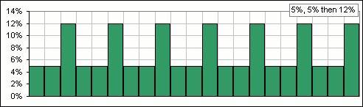
than to these
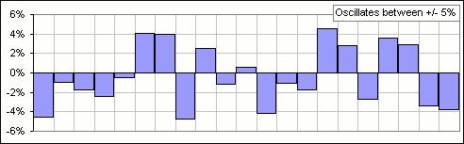
If you'd like risk to have these properties, then I'd recommend:
Risk = Standard Deviation
P.S. In the first chart, there is no uncertainty: the returns are 5%, 5%, 12%, repeated.
So if you wanted your definition to measure "uncertainty", you may not want Risk = Standard Deviation .


>Okay, so how do YOU define risk?
I suspect that "risk" is a personal thing (which may explain why there's such a debate over how to measure it).
After all, there are plenty of financial considerations that are associated with "risk", such as:
Sortino Ratios & Downside Risk Value at Risk Drawdown Risk Omega the Stutzer Index All Time Periods ...
>Yeah, yeah, but how do YOU define risk?
Did I mention that it's a personal thing? I've been retired for some fifteen years and MY favourite is:
- We assume a portfolio with a certain composition (like 25% each of large cap growth & value + 25% small cap value + 25% gov't long bonds).
- We start with a $1M portfolio and withdraw 5% annually.
- Our withdrawals increase annually by 3%.
- We rebalance yearly to maintain the prescribed allocation.
- We select, at random, annual returns for each asset from historical data from year 1928 to the current year.
- We apply these returns to our portfolio - and repeat for each of N years.
- We repeat steps 5 and 6 a jillion times ... a la Monte Carlo.
- We calculate the percentage of times that our portfolio failed to survive for N years.
- We define:
Risk = Percentage of Portfolios that failed to Survive for N years
>That's pretty complicated, don't you think?
Risk is complicated ...

risk and volatility
Motivated by a discussion on the Webring
I've always been amused (well, annoyed, actually) when somebuddy uses standard deviation to measure "risk".
>Are we doing that again!
Yes! It bugs me!
Consider two assets, A and B where:
(the returns of asset B) = (the returns of asset A) + 10%
>You just add 10% to A's returns?
Yes, so which asset is "riskier"?
>I have no idea, but I suspect it's asset A.
Actually, if you use Risk = Standard Deviation, they're equally risky.
>Do you have a picture?
Patience. Anyway, what I'm saying is that adding a constant to the returns doesn't change the standard deviation and, in my opinion, that makes standard deviation a lousy measure of "risk".
>Well ... maybe "risk" measures uncertainty, eh?
Okay, consider assets A and C, where:
The returns for asset A oscillate between +5% and -5%.
The returns for asset C are fixed at 5%, except that, every third year (as a Christmas Bonus ) you get extra shares so your return for that third year is 12%.
>So you get 5% then 5% then 12% and that repeats, right?
Right, so which asset is "riskier"?
>Asset C is some stock!
Actually, it's a mutual fund called the Mickey Mouse Fund. It gives a 7.3% average return over three years.
Anyway, which asset is "riskier", A or C?
>I have no idea, but I suspect it's asset A.
Actually, if you use Risk = Standard Deviation, asset C may be riskier.
>Do you have a picture?
Yes, here's an example. Now tell me whether asset C is more "uncertain" than assets A or B:
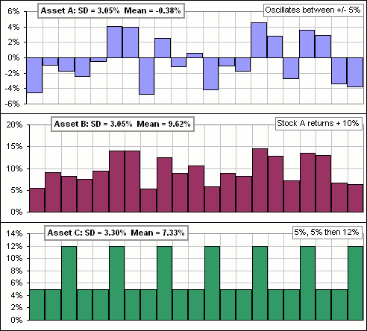
>Is that it?
Yes, that's it. I just wish they'd call it standard deviation or maybe volatility ... but not risk
Standard deviation is just a convenient measure of how far returns deviate from their average.
Big standard deviations need NOT mean a big probability of a loss ... or even big uncertainty.
>But risk, defined as standard deviation, is financial techno-babble. Why should it be Webster's "risk"?
Okay. Good point. So if the gurus kept it to themselves, I'd be happy.
>You needed to get that off your chest, eh?
Yes, I feel much better already

A poll conducted on the Webring Forum gave this result  >Over a thousand responses to the poll question, right?  That'd make it statistically significant, right? | 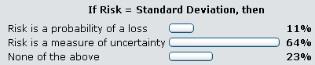
Well, close to a thousand ...
>The percentages don't add to 100%, so I guess they just take the integer part of the percentage?
Maybe.
>So the number of responses could be 200, 1100 and 400.
Maybe.
>Or they could be 2, 11 and 4.
Maybe.
Time Diversification ... and what it means (maybe)
As I get older and older I seem to understand less and less.
Once upon a time I thought I understood what people meant when they referred to a Rebalancing Bonus.
Now, I'm not so sure. The definition seems to have flourished, it's now part of the jargon ... and it now means different things to different people.
>Ain't that the truth! I remember when ...
I also thought I understood what people meant when they referred to Time Diversification.
>Yeah. I remember when ...
I thought, by "Time Diversification", one meant that :
"The risk of investing in volatile assets like stocks decreases as one's time horizon increases."
>Yeah. That's true. You wait long enough, you eventually make money in the market.
Well, that's not the understanding of some. Indeed, some people speak of the Fallacy of Time Diversification.
And that's confusing ... to me.
>But you're easily confused.  Consider the following:  Suppose a stock has a share price of $10.  The annual returns for this stock have Mean = 8% and Standard Deviation = 25%.  Then, T years into the future, we'd expect a distribution of returns something like Figure 1.  Note that the "spread" in prices increases as T increases.  The "spread" is the uncertainty in stock price and is usually measured by the Standard Deviation.  We might then conlude that: | 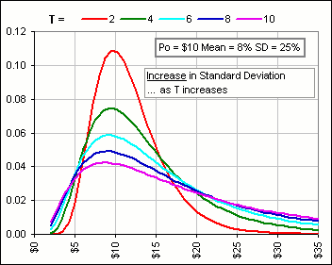  Figure 1
  the Standard Deviation increases with Time
>Yeah, so?
So now let's actually define:
Risk = Standard Deviation
>Don't tell me! Risk increases with time, right?
Yes, with that particular definition of risk.
Risk increases with Time
However, let's define:
Sex Appeal = Standard Deviation
>Don't tell me! Sex appeal increases with time, right?
Yes ... and at my age, that makes me feel warm all over
Okay, now let's take a more reasonable definition of risk:  That's not my definition of risk. It's Webster's.  Now let's consider again our $10 stock and the probability that, after T years, the price is less than $10. (That's a loss, eh?)  From the distributions of Figure 1 we can generate Figure 2.  After T = 2 years, the probability that the price is less than $10 is (about) 42%.  (See the red dot?)  After T = 10 years, the probability that the price is less than $10 is (about) 28%.  (See the magenta dot?) | 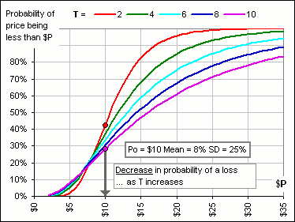  Figure 2
  Risk n The possibility of suffering harm or loss
>Can I say it?
Be my guest.
Risk decreases with Time
Thank you.
>So you're still confused?
Always.
>So why do they call it "diversification"?
Your portfolio benefits from having lots of different assets. That's asset diversification.
Presumably it'll benefit from having lots of time. That's ...
>Yes. You're still confused.
Drawdown stuff
motivated by comments by Travis M. on Bogleheads.
Suppose you'd like to know the largest loss you might have suffered, had you invested in stock ABC.
You might, for example, follow the maximum stock price as the weeks go by and ...
>And see how much the price has dropped from that maximum?  Sure. Why not? See Figure 1? It shows the weekly values of a $1.00 DOW portfolio, and we're following the maximum prices.  The shaded areas display the drops from that running maximum.  >The drop is in $dollars? Why not a percentage of the most recent maximum?  Good idea ... like so:  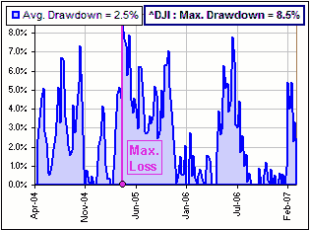 | 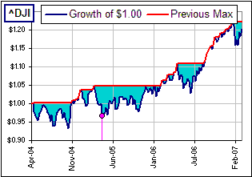  Figure 1
In other words, the maximum loss would have been 8.5% had you bought at a maximum and sold at a minimum.
>You're just looking at weekly prices, right?
Yes, but ...
>Don't tell me! You got a spreadsheet.
Uh ... yes. It looks like this:
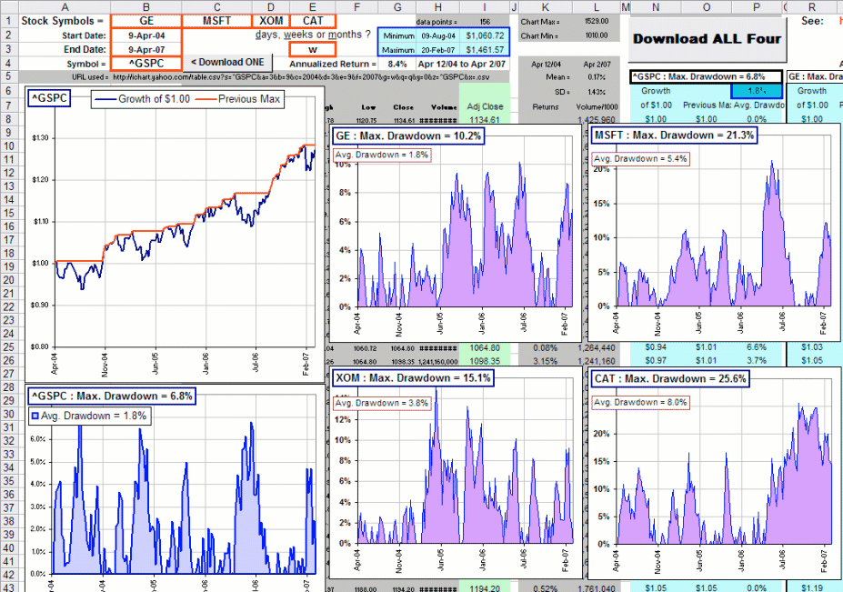
You type in some dates and whether you'd like daily, weekly or monthly data and enter four stocks and click a button and gaze in awe at the pretty pictures.
>And I just click on the picture of the spreadsheet in order to ...
In order to download the spreadsheet.
You might take this largest drop from the last maximum as a measure of "risk", eh?
At least it measures a loss rather than deviations from a mean return (as does that "other" risk measure: standard deviation).
>What's this drawdown stuff?
Uh ... I understand that, among the various definitions of "drawdown", this drop from the previous maximum is called a drawdown.
>Are you sure?
Huh? Me? Sure? How can anybuddy be sure of anything these days ...
PS#1
I might note that, having downloaded four sets of prices, you can then download a single stock or index to compare.
In the picture above, we've picked the S&P500 with symbol: ^GSPC
PS#2
If'n the spreadsheet don't work good, there's a money-back guarantee ...
PS#3
The spreadsheet may change dramatically without notice. (It may be a change from the pretty picture, above).
PS#4
There's another similar spreadsheet described here.
the Ulcer Index ... and the Martin Ratio
motivated by email from Dan M.
When we were talking about Drawdown, I never knew that ...  >Huh? Drawdown?  What!? You've forgotten already! We look at the moving maximum of historical prices  ... and we look also at the current price and see how far the latter has dropped below the former, like so  That drop is the Drawdown and ...  >Yeah, I remember ... but what's the Ulcer Index?  The Ulcer Index is a measure of the cumulative Drawdown. It's ...  >The total blue area, right?  Not exactly. It's the root-mean-square (RMS) of the historical Drawdowns, and it's called the "Ulcer" Index because ...  >Don't tell me. Let me guess. | 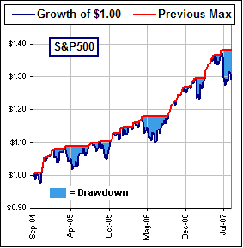
Anyway, it's the brainchild of Peter Martin and can be used (like Drawdown) as a measure of risk ... especially ulcer-generating risk.
>What about Standard Deviation as "risk"?
Let's not go there ... or there
In fact, the Ulcer Index can be used in place of the Standard Deviation (in many cases), like the Sharpe Ratio, for example.
Instead of dividing by the Standard Deviation, you divide by the Ulcer Index, giving the Martin Ratio.
In any case, you calculate the weekly (or daily or monthly) Drawdowns, say D₁, D₂, ... D_{n}, over the last n periods (daily, weekly or monthly) then calculate the RMS value:
Ulcer Index = SQRT[ (1/n) (D₁² + D₂² + ... + D_{n}²) ]
>What's n?
I dunno. You pick the number of historical periods that makes you happy, like n = 100 or 200 or whatever.
Note that each Drawdown is a percentage drop from the moving maximum price, so the Ulcer Index is expressed as a percentage as well.
For example, suppose we take weekly Drawdowns and pick n = 156. That's the last three years of weekly prices ... since 3*52 = 156.
We'd get these pretty charts, where we let n increase from n = 1 to n = 156 (spanning the three years from Sept, 2004 to Sept, 2007).
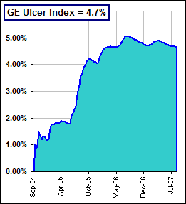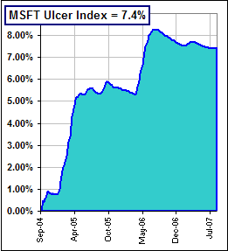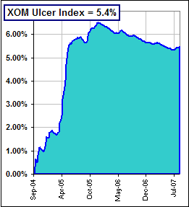
>It can go up and down?  Sure. If there are long periods when the Drawdown is small, the RMS value (that's the Ulcer Index) goes down.  For example, XOM had a Drawdown history like this  The maximum was 15.1% but there was a recent period when it was zero or, at least, smallish  ... which accounts for the recent, decreasing Ulcer Index for XOM = Exxon. | 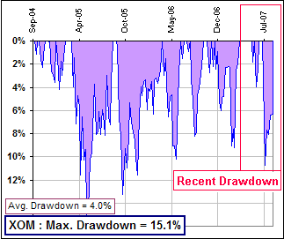
>I assume there's a spreadsheet?
Yes ... an addition to the Drawdown spreadsheet noted GUMMY ULCERS here.
The Ulcer addition looks like this:
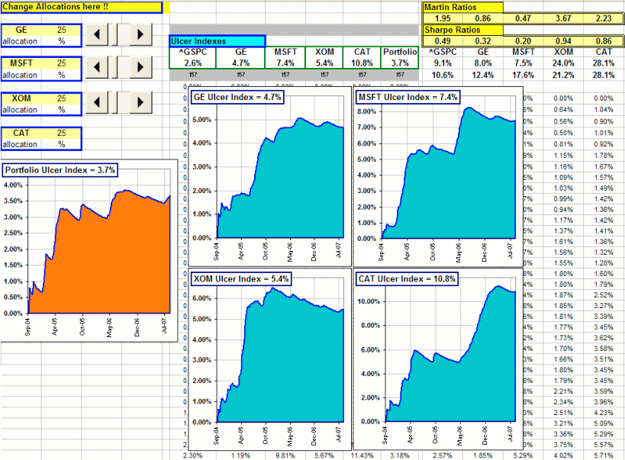
Note that you can vary the portfolio allocation of the four stocks and get an Ulcer Index for your portfolio.
Just as with the Standard Deviation, you might expect the diversification to reduce the Index.
>That's it?
That's it! Just click on the picture to download the spreadsheet.
I might note that you can do some Ulcer calculations for a single stock by downloading three years of weekly prices ... like so (for the S&P500 = ^GSPC): GUMMY ULCERS
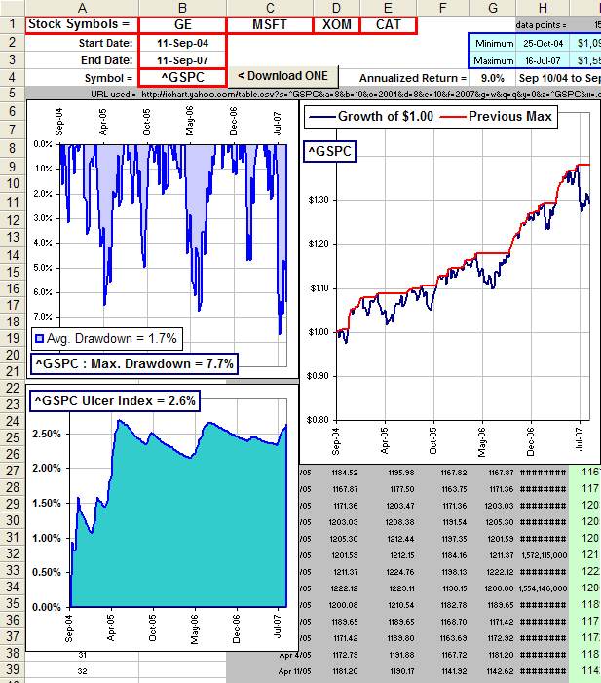
Of course, you also get all the Drawdown stuff for each stock.
>That's it?
That's it!
See also Peter Martin's website.

Martin Ratio vs Sharpe Ratio
It's interesting to compare the Martin to the Sharpe Ratio.
Let's take a bunch of stocks (from the DOW) and calculate a bunch of Ratios.
We get this: GUMMY 30 STOCKS ULCERS
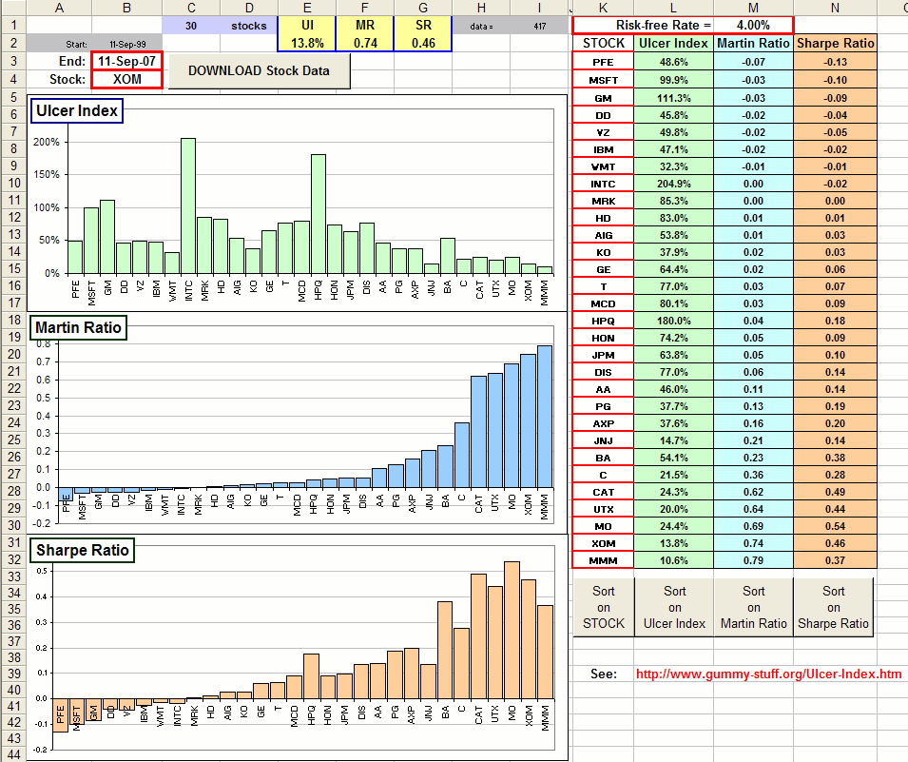
Type in 30 Yahoo stock symbols, pick a Risk-free Rate (so we can calculate the Ratios) then click the DOWNLOAD button. Neat, eh?
>But, when ordered by Martin Ratio, they're also ordered by Sharpe Ratio.
Uh ... close, but no cigar.
Anyway, to play with the spreadsheet, just ...
>Click on the picture.
You got it!
By the way, since prices are downloaded and weekly returns generated, you can calculate any other number you wish in cells E2, F2 and G2. (based upon the prices & returns).
They'll be stuck in columns L, M and N. In fact, the picture above should be modified, 'cause the spreadsheet's now got this:
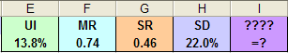... where the Standard Deviation has been added in cell H2 and there's somethjing for you to add, in cell I2.
Of course, E2 to I2 can contain any calculation you like.
>That's confusing.
Just download the spreadsheet and play!
For example, instead of the Sharpe Ratio you may want the Sortino Ratio

Sortino Ratios ... and Sharpe
motivated by e-mail from Dan M
First, we talk about the Sharpe Ratio which is an attemt to measure "Risk" and "Reward".
- We look at a the average annual return of some asset (say, R = 9%) and compare it to some risk-free return (say R_{f} = 4%, so R - R_{f} = 5%).
Our "Reward" is the excess return: R - R_{f}.
- That excess return may look pretty good, but the asset has volatility (or Standard Deviation, say SD = 25%).
That's our "Risk". It measures how far our annual returns deviate from their average.
In our example, we might expect most returns to vary between R - SD = 9 - 25 = -16% and R + SD = 9 + 25 = 34%.
- We consider the Sharpe Ratio: (R - R_{f}) / SD ( In our example, it's: 5/25 = 0.20
>Big reward, small risk ... that's good, eh?
Yes, so we might look for assets with large Sharpe Ratios.
However, if the returns get really large compared to R_{f}, we should be happy.
But that means the deviations from the average can be large, and that'd make SD larger and that'd make the Sharpe Ratio smaller.
>Then don't buy the asset!
But you'd want lots of returns larger than R_{f}, wouldn't you?
>Then buy it!
Ay, there's the rub. Enter Frank Sortino.
If we really wanted to use deviations from the average as a measure of "risk", then why include returns that are larger than R_{f}?
We could just measure the deviation of those returns that are smaller than R_{f}, eh?
That means we could take the standard deviation of those less-than-R_{f} returns, like so:
[1] SD_{d}² = (1/n) Σ (r - R_{f})²
where SD_{d} is the "downside volatility" and the sum includes only returns for which r < R_{f}.
If we take SD_{d} as our "risk", then we change Sharpe into Sortino:
Sortino Ratio = (R - R_{f}) / SD_{d}
where R is the Mean annual return,
R_{f} is some risk-free return (or Minimum Acceptable Return: MAR)
and SD_{d} is the downside risk: SD_{d}² = (1/n) Σ (r - R_{f})²
where the sum (or average) includes only returns for which r < R_{f}.
>And Sortino is better than Sharpe?
Define "better".
One thing is for sure: Sortino doesn't penalize an asset for "upside" volatility ... which is a "good" volatility.
However, there's a problem with Sortino. It may happen that no returns are less than R_{f} in which case SD_{d} = 0 and Sortino = ∞
>But how do they compare, Sortino and Sharpe?  First off, notice that the denominator in the Sortino Ratio is smaller than Sharpe's denominator  ... since SD_{d} contains fewer terms.  That makes the Sortino Ratio larger, as in Figure 1, and ...  >I'll bet fund managers like that! Smaller "risk", eh?  Yes, and I understand that Sortino is (usually) used by hedge funds. | 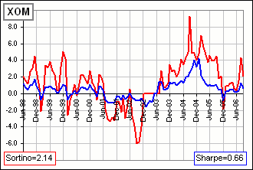  Figure 1
>In Figure 1 you're using annual returns?
Well ... I used ten years worth of monthly returns and used (as Rf) 1/12 of the annual risk-free rate (or MAR).
>Ain't that cheating?
Define "cheating".
>Where's the spreadsheet and what did you do when Sortino = ∞ and ... ?
The spreadsheet will look like this:
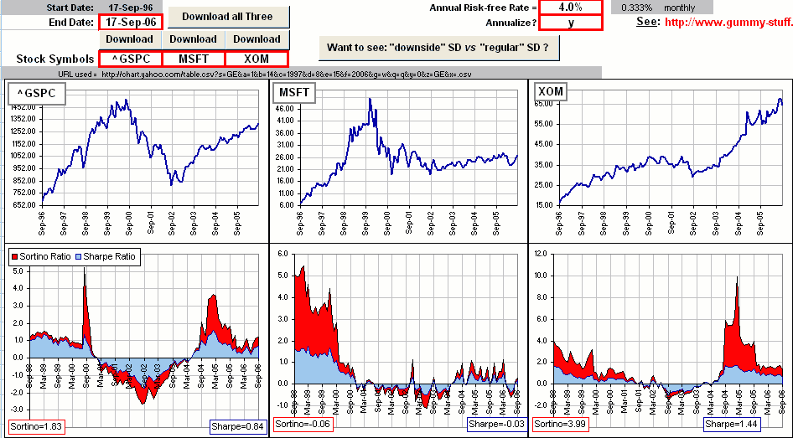
but it isn't finished ... yet. In fact, I keep playing with it and it keeps getting bigger and bigger.
When it's finished, you can download three assets (from Yahoo) and compare Sortino and Sharpe and ...
>Wake me up when it's ready ... zzzZZZ
Remember when I said that Sortino's "downside" volatility is smaller than the regular, garden-variety standard deviation used by Sharpe? You get a glimpse of that in Figure 2. See?  >zzzZZZ  The places where the downside volatility (that's SD_{d}) is 0 is evident. See that?  >zzzZZZ  Fig. 2 is actually the XOM example we considered above.  When it's 0 we just set the Sortino ratio = 0 ... instead of infinity.  >zzzZZZ ... huh? Is that legal?  Did you see the in progress sign? | 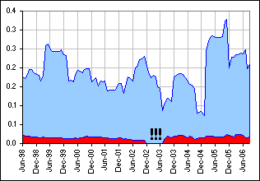  Figure 2


calculating Sortino Ratios
Okay, so here's what I did with the spreadsheet: GUMMY SORTINO
I used monthly returns instead of annual returns ... since there are so many more of those available
I multiplied the monthly returns by 12 to simulate annual returns.
Then I calculated the Sortino and Sharpe ratios, using these "multiplied-by-12" returns.
Then I noticed that the ratios didn't change by this "multiply-by-12" ritual.
>Huh?
Suppose we multiply all our returns by some positive parameter λ (for example, λ = 12).
Note that SD_{d}², which is (1/n) Σ (r - R_{f})², becomes (1/n) Σ (λr -λR_{f})² = λ²(1/n) Σ (r -R_{f})².
Hence the downside volatility SD_{d} gets multiplied by λ as well.
(Indeed, any standard deviation gets multiplied by that parameter ... which is one reason I don't like standard deviation as a measure of "risk".)
That'd change (R - R_{f}) / SD_{d} into (λR - λR_{f}) / λSD_{d} = (R - R_{f}) / SD_{d}.
In other words, the Sortino Ratio don't change at all !
Okay, so I just forgot about any effort to change monthly to annual, and just used monthly returns.
In fact, I wanted to see the variations in ratios in a moving 2-year window ... that's 24 returns
Note:  The charts in Fig. 1 and 2 actually use a 1-year window ... but I've changed that.  That makes it less likely that SD_{d} = 0 as in Fig. 2.  In fact, Figure 2 now looks like Figure 2a | 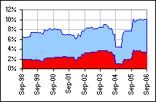  Figure 2a
One other thing.
The spreadsheet downloads 10 years worth of monthly returns.
In my moving 2-year window I need an average for 24 monthly returns. That means I use the first two of the 10 years just to get a single 2-year average.
That explains why, in the latest spreadsheet, the Sortino and Sharpe ratios (in the 2-year moving window) start two years later ... as in Figure 2a.
>And what about years when all returns were greater than Rf? You'd have SD_{d} = 0 and ...
Yeah, and Sortino = infinity. I know! I know!
In fact, if you have just a single return less than Rf, then SD_{d} = 0. That's a problem, eh?
However, in order that SD_{d} = 0 in a 2-year window, you'd need to have 24 consecutive returns all less than Rf.
Since that's unlikely ...
>But I could choose Rf = 50% then they'd all be less ...
Yeah, sure ... so pick a more reasonable Rf.
>And is that spreadsheet ready yet? GUMMY SORTINO
You can try it out by clicking here, but there are no guarantees.
>But don't you offer a money-back guarantee?
Uh, yeah ... I forgot. The spreadsheet is guaranteed to work admirably.
Almost forgot this, too.
If you actually downloaded a bunch of monthly returns and wanted to estimate the annual standard deviation, it's more complicated than simply multipliying all returns by 12 and getting a standard deviation multiplied by 12. You'd multiply the standard deviation by SQRT(12) !!
That means (R - R_{f}) / SD will have the numerator multiplied by 12, but the denominator multiplied by SQRT(12).
That means the Sortino and Sharpe ratios get multiplied by SQRT(12) ... since 12/SQRT(12) = SQRT(12).
The spreadsheet will do that if'n you ask nice. Just say y:
It will give ratios which are more like the ones you might see in the literature or on the internet (even tho' the increased values don't change the look of the charts).
>Didn't you say you did not like standard deviation as a measure of risk?
Yes, because I can add 10% to all returns and the standard deviation doesn't change which makes it a lousy measure ...
>Then why don't you invent your own Sortino ratio, with your own measure of risk? You could call it ... uh, the Ponzorino Ratio.
Hmmm ... not a bad idea:

or you may want to calculate, in cell I2, Kurtosis
Kurtosis
I want to talk about a total Portfolio gain, over N years (or days or months), and how it depends upon the MEAN return and the distribution of returns and ...
>Like Normal of Lognormal stuff?
Yes. Suppose that the N returns are denoted by x₁, x₂, x₃, ... x_{N} where, for a return of 12.3% we put x = 0.123, okay?
>So far, so good, but what about this kurtosis thing?
Patience.
Now, for N such returns, the Gain Factor is
(1) G = (1+x₁)(1+x₂)(1+x₃)...(1+x_{N})
Since it's not easy to deal with products, we take logarithms and get:
(2) log(G) = log(1+x₁)+log(1+x₂)+log(1+x₃)+ ... +log(1+x_{N})
Now let's talk about adding a bunch of terms in a SUM ... like (2), above.
If there are 100 terms in a SUM and 50 have the value 12, and 30 have the value 15, and 20 have the value 17 then we can evaluate the SUM as 50*12 + 30*15 + 20*17, right?
>So far, so good, but my doctor warned me about kurtosis and ...
Pay attention. We now look again at the SUM in (2), above. We suppose that many of the returns are the same ... or at least close to each other. In particular, we suppose that all returns lie between, say, -100% and +100% and we divide that interval into small subintervals of length Δx and a fraction of the returns lie in each interval ... between x and x+Δx.
>Example?  Well, we suppose that, for N = 100 returns:  11 lie in a small interval near r = 5% and  14 lie in a small interval near r = 6% and  13 lie in a small interval near r = 7% and ...  >A picture would be good here.  Here's the distribution  If you add up all the blue numbers you'll get 100, but many are the same (or, at least they lie in the same small intervals  ... near 5%, 6%, 7%, etc.). | 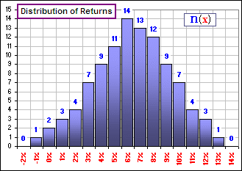  Figure 1
It'd mean that the SUM of logarithms (as indicated by (2), above) has terms like:
... + 11*log(1+0.05) + 14*log(1+0.06) + 13*log(1+0.07) + ...
which is a SUM of terms which look like: n(x)*log(1+x)
where n(x) is the number of terms which have the same x-value.
For simplicity, we'll write the SUM as Σ n(x)*log(1+x)
Is that okay, for an example?
>Yes, please continue.
Okay, in general we have, continuing from (2) above:
(3) log(G) = Σ n(x)*log(1+x).
Now, if the various values of x are small  (remembering that a 9% return would have x = 0.09),  then  (4) log(1+x) = x - x²/2 + x³/3 - x⁴/4 + x⁵/5 -  >You're assuming natural logarithms, to the base e?  Of course. Is there any other kind?  Notice how well the terms up to x⁴/4 approximate log(1+x)  Now we can rewrite equation (3) like so: | 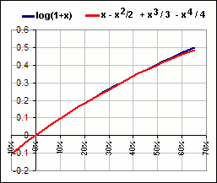  Figure 2
(5) log(G) = Σ x n(x) - (1/2)Σ x² n(x) + (1/3)Σ x³ n(x) - (1/4)Σ x⁴ n(x) + (1/5)Σ x⁵ n(x) - ...
If the total number of returns is N, then the SUM of all the n(x) is N and, in particular, n(x)/N is the fraction of terms associated with the same x-value. We'll call this fraction f(x), so
(6) f(x) = n(x)/N.
Now we divide equation (5) by N and get:
(7) log(G)/N = log(G^{1/N}) = Σ x f(x) - (1/2)Σ x² f(x) + (1/3)Σ x³ f(x) - (1/4)Σ x⁴ f(x) + (1/5)Σ x⁵ f(x) - ...
so we have:
(8) G^{1/N} = EXP{Σ x f(x) - (1/2)Σ x² f(x) + (1/3)Σ x³ f(x) - (1/4)Σ x⁴ f(x) + ... }
Figure 2A shows a picture of the relative size of the terms.  >zzzZZZ  Wait! We're almost there! If the x-values are annual returns:  - G^{1/N} is the Annualized Return  - Σ x f(x), the first moment, is the MEAN of the returns: M  - Σ x² f(x), the second moment, will give the VARIANCE  ... or the square of the Standard Deviation: S  - Σ x³ f(x), the third moment, will give the SKEW  - Σ x⁴ f(x), the fourth moment, will give the KURTOSIS | 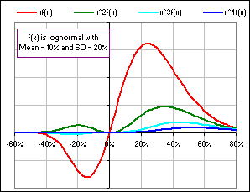  Figure 2A
  My stock has Kurtosis
  A healthy man called Moses
  Had a stock with Halitosis
  He gave it a pill
  But it got very ill
  And its chart got thoracic Kyphosis.
  His stock underwent Hypnosis
  To cure the painful Kyphosis.
  But the market tanked
  And his stock sanked
  And Moses got ill with Leukosis.
>Will give? What does that mean? Will give ... what ...?
One usually doesn't use the raw moments, except for the MEAN, but normalizes or standardizes them.
For example, here's a couple of distributions which look identical except that the MEAN has changed by +30% (or 0.30) ... and that has shifted the chart due East by the same amount:
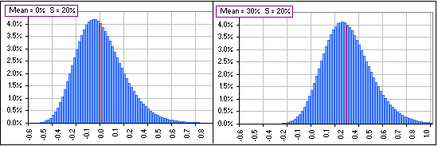
Figure 3
In order to ignore this shift when the MEAN changes (since we're interested in the "shape" of the distribution, not where it's located), we can replace x by (x - M) so we're measuring the deviation of the returns from their MEAN. Then, when we change the MEAN (by, for example, adding a constant amount to each return), the chart will continue to look just like the left chart above (where the MEAN is 0).
>And if we change the Standard Deviation? What then?
I was just getting to that. Here's what'd happen when we change the value of S:
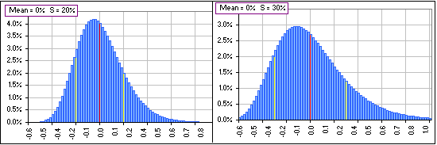
Figure 4
>What're the yellow stripes?
They're one Standard Deviation, S, above and below the MEAN. You'll notice that by dividing by N, as in f(x) = n(x)/N, we've changed the number of returns lying near an x-value to the fraction of returns lying near an x-value. That makes our analysis independent of the number of returns. In fact, the vertical scale in our distribution charts always run from 0 to 1 (or 0% to 100%).
>N could be 100 or 1000 or 10,000 or ...
Yes, yes, but now we should do likewise for the horizontal scale. We need some standardized horizontal measure. After all, people use this stuff when the horizontal numbers aren't annual returns but maybe degrees Fahrenheit or kilograms or maybe miles or hours or ...
>How about choosing "1" as the horizontal standard?
Well, that's close to what we'll do. When x = M + S then ...
>So x is at a yellow stripe?
Yes. Then we'll call that "1" unit from the MEAN. To do this we not only replace x by (x-M) ... to shift the chart so the "new" mean is zero ... but we'll also replace x by y = (x-M)/S so that ...
>So that when x=M+S then it's "1" unit from the MEAN.
Well, y = 1, where y = (x-M)/S is our new horizontal scale.  It has the advantage (over x) in that it's dimensionless. It'll have the same value whether x is measured in centimetres, miles or light-years.  Indeed, when generating a distribution from scratch, one often defines a standardized distribution for the y's, then use x = M + y*S to calculate x. For example, if we want to generate a Normal distribution with MEAN = M and Standard Deviation = S, then we get a bunch of y's from a standard Normal distribution (with M=0, S = 1), then get the x's via  x = M + y*S and the x's will have MEAN = M and SD = S. | 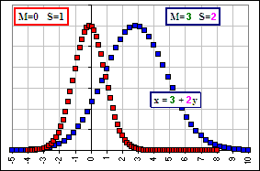  Figure 4A
In MS Excel, the function NORMSINV(RAND()) returns a standard Normal distribution (with Mean = 0, Standard Deviation = 1) whereas M+S*NORMSINV(RAND()) returns Normally distributed numbers with Mean=M and SD = S.
For example, suppose we plot the fraction of numbers (x's or y's) with a particular value, we'd get two curves (as in Figure 4A where the y's are a standard Normal distribution and the x's have M = 3 and S = 2).
The right curve is the left curve shifted right by 3 and the horizontal dimension stretched by a factor 2. The vertical dimension, which measures the fraction of x's or y's which have a particular value, doesn't change.
>I thought the area under the curve must be "1", no?
Well, there are the same number of x's as y's (for example: 100 of each) so the fraction (or percentage) having a particular value is the same ... and that's the vertical value. On the other hand, one usually sees the vertical dimension as the probability density and ...
>Yeah! That's what I'm talking about! The density!
Okay. If we have jillions (or an infinity) of numbers then we might want to consider the fraction (or percentage) lying within some interval along the horizontal axis (as opposed to the fraction having one of N = 100 values).  >Like: "How many lie between x = 1.0 and x = 1.2", eh?  Well, not "How many?". The answer to that question might be "Infinity.  More like "What percentage?". In that case the area under the curve must be "1" so, when we stretch the horizontal distance by S, we must shrink the vertical dimension by S as we have in Figure 4B which shows the probability density. (See Distributions and/or Normal/Lognormal.) It's like, if you have a rectangle and you increase the width by some factor, then you must decrease the height by the same factor in order to retain the same area.  The use of density is appropriate when you've got lots of numbers. For example, if we have a bunch of beads on a string we might plot the mass of the beads, as we move along the string.  If, instead, we have a bar of metal with variable density (like: aluminum at the ends changing continuously to gold at the centre), then we'd be better off considering the change of density (meaning the mass per unit length) as we move along the bar.  >I'll take the centre!  Are you paying attention? | 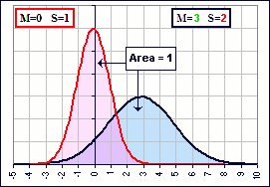  Figure 4B  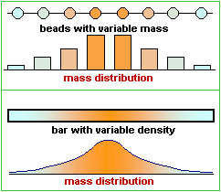  Figure 4C
For a Normal distribution (Mean = M and SD = S), the density is given by:
A: f(x) = {1/(sqrt(2π) S)} e^{-{(x-M)/S}2/2}
After standardization (Mean = 0 and SD = 1) we'd have:
B: f(y) = 1/(sqrt(2π)) e^{-y2/2}
Notice the division by S, in (A).
(This f is not to be confused with the earlier f which ain't a density !)
>That is really confusing, I mean ...
The earlier f is okay for measuring the mass distribution for beads on a string.
The f(x) and f(y) in A and B, above, are appropriate for continuous mass distributions.
>Okay, why should the Standard Deviation be used as a horizontal distance? Why not a vertical ... ?
Excellent point. I forgot to mention that S, the Standard Deviation, is a measure of how far the x-values are from their MEAN. In fact, S² is the average squared distance from the MEAN:
(9) (1/N) { (x₁-M)² + (x₂-M)² + ... + (x_{N}-M)² } = S²
or, in terms of our new standardized numbers:
(10) (1/N) { (x₁-M)²/S² + (x₂-M)²/S² + ... + (x_{N}-M)²/S² } = (1/N) {y₁ ² + y₂ ² + ... +y_{N} ²} = 1
Notice that (according to equation 10), points with coordinates (y₁, y₂, y₃, ... y_{N}), in N-dimensional space, lie on a hyper-sphere of radius SQRT(N). The greater the number of points, the greater the dimension N, the farther from the origin. That observation is connected to Einstein's analysis of a random walk or Brownian Motion and how far you'd expect to be from the origin (where you started) after N random steps and ...
>Let's not get off track, okay? What's the Standard Deviation of these new numbers, y₁ and y₂ and so on?
One.
>One what?
Equation (10) says it all.
The MEAN of these new y's is the number "0" (because we've subtracted M from all the x's)
... and the Variance (hence the Standard Deviation) of the y's is the number "1" (because we've divided by S).
Note, too, that if x were measured in kilometres (instead of return percentages) then M and S would be in kilometres and they'd all change if we changed the units to miles. However, y = (x-M)/S would have the same value in kilometres as in miles. Nice, eh?
>And if x were in degrees Fahrenheit then ...
Then we could change to Celsius and, although the x-values would change, the y-values wouldn't.
If we change to y-variables in Figure 1, where y = (x-0.064)/0.029, and we change the vertical coordinate to percentages
(so 14-out-of-100 becomes 14%), we'd get Figure 5:
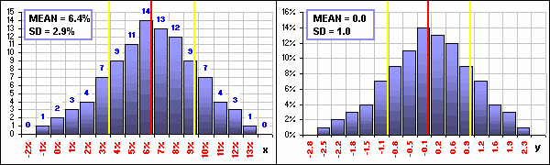
Figure 5
The right chart is standardized.
If we add some number (like 15%) to every x, the right chart wouldn't change.
If we multiply every x by some number (like 12), the right chart wouldn't change.
If x was the high temperature each Christmas for the past 100 years, measured in degrees Celsius, and we changed to degrees Fahrenheit, the right ...
>The right chart wouldn't change. Yeah, right, okay ... I get it!
Good for you.
>Okay, so what's KURTOSIS?
- M = (1/N) {x₁ + x₁ + ... +x₁} is the MEAN of the x's.
- S = SquareRoot[ (1/N) { (x₁-M)² + (x₂-M)² + ... + (x_{N}-M)² } ] is the Standard Deviation of the x's.
- then SKEW = (1/N)Σ y_{k}³ = (1/N) [ ((x₁-M)/S)³ + ((x₂-M)/S)³ + ... + ((x_{N}-M)/S)³]
- and KURTOSIS = (1/N)Σ y_{k}⁴ = (1/N) [ ((x₁-M)/S)⁴ + ((x₂-M)/S)⁴ + ... + ((x_{N}-M)/S)⁴]
Notice that, after changing from the x's to the y's, we'd have a set of y's with
MEAN = 0 (that's the first moment of the y's) and
Standard Deviation = 1 (that's the second moment of the y's) and
the third and fourth moments of the y's give the SKEW and KURTOSIS for the y's ... and for the x's !
Look carefully at the SKEW. If the x-distribution is symmetrical about the MEAN, then the distribution of x-values above the MEAN is the same as below. This gives rise to positive and negative y-values, hence positive and negative values for y³, and they cancel out, making SKEW = 0. That's the case for the Normal Distribution. On the other hand, if the distribution is more heavily weighted below the MEAN, the negative values for y³ predominate and that'll give a negative SKEW. More above and you get a positive SKEW.
Look also at the KURTOSIS definition. It involves the 4th power of the deviation from the MEAN (so they're always positive) and, if there are more and more x-values far from the MEAN, they contribute significantly to the sum of the y⁴-values ... and the KURTOSIS increases. KURTOSIS is then a measure of how big the "tails" are.
Remember Figure 1? Well, the MEAN and Standard Deviation for the x's are: M = 6.4% and S = 2.9% and if we calculate the SKEW and KURTOSIS, then make some changes in the x-values far from the MEAN ... voila!
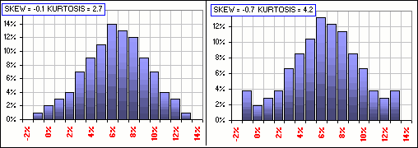
Figure 6
>Your charts are all inventions. Haven't you got a real, live ...?
On the right are General Electric stock prices, involving about a thousand daily returns.  Below, the distribution of these daily returns for GE, along with a Normal and Lognormal distribution with the same MEAN and Standard Deviation - for comparison purposes. (Nobuddy is suggesting that the GE distribution is one or t'other, but it's interesting to note that there's little to choose between normal and lognormal distributions, though neither is a very good representation for the GE distribution): | 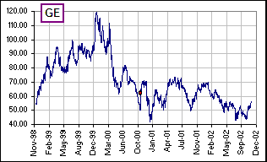  Figure 7A
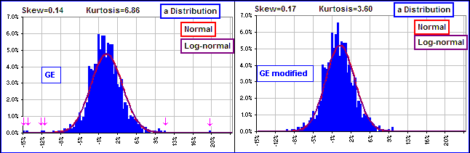
Figure 7B
The left chart gives the actual distribution: KURTOSIS = 6.86
See the outliers- those returns way out on the tails of the distribution, at -15% and -12% and even one at about +20%?
>20% for a daily return? You're kidding, right?
It was October 19, 2000. GE had closed at $51.75 on the 18th and at $61.88 on the 19th. That's almost a 20% jump (shown as a red dot in Figure 7A). This, together with a few more large changes, make for a big KURTOSIS.
However, if we replace a half dozen of these way-out daily returns by 0%, we get the right chart.
The outliers are gone, there are more returns at 0% and a we've got a smaller KURTOSIS.
>At 3.60 it still seems big to me.
Actually, for the Normal Distribution (which is perfectly symmetrical about the MEAN), KURTOSIS = 3.0 and, for this reason, KURTOSIS is sometimes defined to be:
(11) KURTOSIS = (1/N)Σ y_{k}⁴ - 3 = (1/N)Σ {(x_{k}-M)/S}⁴ - 3
which, by subtracting "3", gives the deviation from the value for the Normal Distribution.
With this definition, the Normal Distribution has a KURTOSIS = 0.
>Which one do you use?
I don't use either. I just regurgitate what others say ... just in case you run across one or the other in your travels.
>Why the two definitions?
Why are you asking me? But I can tell you, there are other definitions too. Want to see them?
>Definitely not!
Okay, here's another. The MS Excel definition: 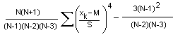
>Gee, thanks. I needed that.
However, for large values of N, it looks like 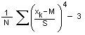 which you'll recognize from (11) above, right?
>Wrong! And by the way, what about Σ y⁵ ... that fifth moment? What's its name?
I have no idea.
>What? All this and you don't have a name for it? You should really look up the name before you start writing tutorials. I can't believe you'd go through all that stuff and not have a name. People like names. They're important! Haven't you noticed that? You see a strange bird and everybody says "What is it?" and they're not satisfied until you say, "a South American Twiddlewot" then they're all happy, they have a name and they're satisfied and they don't need any more information about the Twiddlewot, just a name because ...

Examples

Here are some examples of Skew and Kurtosis ... some stocks on the DOW, using eight years of weekly returns:  >And what formula are you using for ...  For Skew & Kurtosis? Excel's formulas:  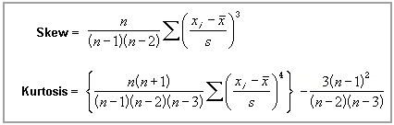  >How many formulas for skew and kurtosis are there?  How high can you count? For Kurtosis, some subtract 3 so that a Normal distribution has Kurtosis = 0.  In the Standard Deviation, some divide by (n-1) and some divide by n. However, for large n, they all reduce to equation (11), above.  Anyway, when ordered, they go like this:  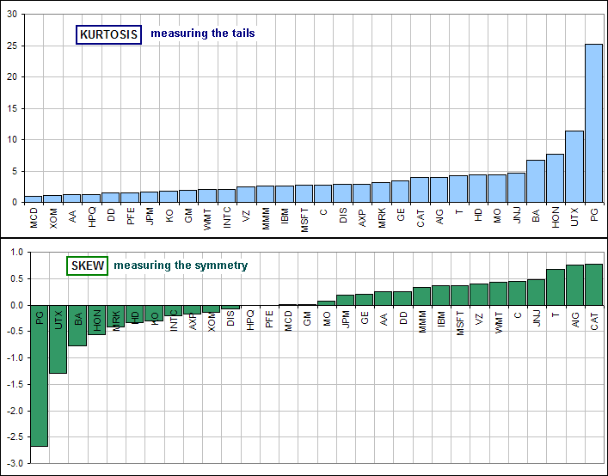
  Stock | Skew | Kurtosis
  AA | 0.25 | 1.17
  AIG | 0.75 | 3.92
  AXP | -0.18 | 2.89
  BA | -0.78 | 6.65
  C | 0.45 | 2.73
  CAT | 0.77 | 3.91
  DD | 0.25 | 1.44
  DIS | -0.08 | 2.82
  GE | 0.21 | 3.41
  GM | 0.02 | 1.92
  HD | -0.34 | 4.33
  HON | -0.55 | 7.67
  HPQ | -0.01 | 1.24
  IBM | 0.37 | 2.66
  INTC | -0.20 | 2.08
  JNJ | 0.47 | 4.72
  JPM | 0.18 | 1.65
  KO | -0.30 | 1.81
  MCD | 0.01 | 1.01
  MMM | 0.33 | 2.54
  MO | 0.08 | 4.43
  MRK | -0.42 | 3.13
  MSFT | 0.37 | 2.73
  PFE | -0.01 | 1.52
  PG | -2.67 | 25.19
  T | 0.68 | 4.20
  UTX | -1.30 | 11.42
  VZ | 0.39 | 2.44
  WMT | 0.43 | 2.02
  XOM | -0.14 | 1.13
>Mamma mia! That PG is really skrewed, eh?
Procter & Gamble? It looks that way. The return distribution is SKEWed toward returns less than the Mean.
Indeed, there were dramatically poor returns, opening at $117 on Jan 3, 2000 and closing at $94 by the end of the month.
Note, too, that the "tails" are big compared to the symmetric Normal distribution (as measured by Kurtosis), and they're larger than Normal (since Kurtosis is positive) and ...
>But MCD is more normal, wouldn't you say?
Yes, I guess McDonald's is normal.
Here's some more (mostly) Vanguard funds, using annual returns from 1972 to 2006 (obtained here):  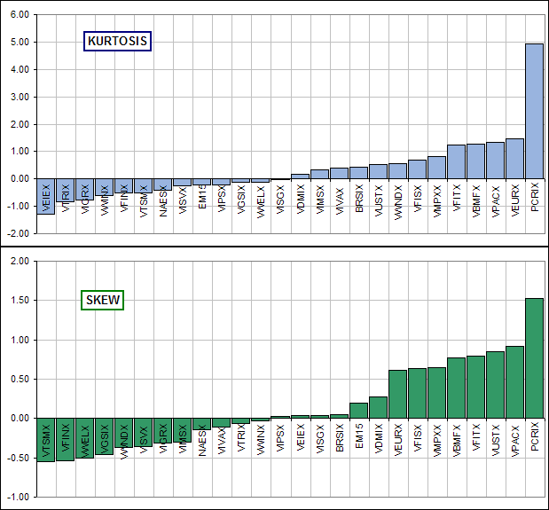  Note that here, Kurtosis is sometimes larger and sometimes smaller than Normal (so the spread or "tails" may be larger or smaller)  and VISGX, Vanguard's Small Cap Growth Index, is quite ... uh normal.
  Fund | Skew | Kurtosis
  BRSIX | 0.05 | 0.43
  EM15 | 0.19 | -0.23
  NAESX | -0.14 | -0.41
  PCRIX | 1.52 | 4.94
  VBMFX | 0.78 | 1.27
  VDMIX | 0.27 | 0.17
  VEIEX | 0.04 | -1.29
  VEURX | 0.62 | 1.48
  VFINX | -0.54 | -0.52
  VFISX | 0.64 | 0.69
  VFITX | 0.79 | 1.24
  VGSIX | -0.46 | -0.13
  VIGRX | -0.31 | -0.77
  VIMSX | -0.30 | 0.33
  VIPSX | 0.02 | -0.22
  VISGX | 0.04 | -0.01
  VISVX | -0.36 | -0.24
  VIVAX | -0.11 | 0.40
  VMPXX | 0.65 | 0.81
  VPACX | 0.91 | 1.35
  VTRIX | -0.07 | -0.84
  VTSMX | -0.55 | -0.52
  VUSTX | 0.85 | 0.53
  VWELX | -0.51 | -0.12
  VWINX | -0.03 | -0.61
  VWNDX | -0.37 | 0.56
>Yeah, so where's the spreadsheet? Just click on the picture below to download:
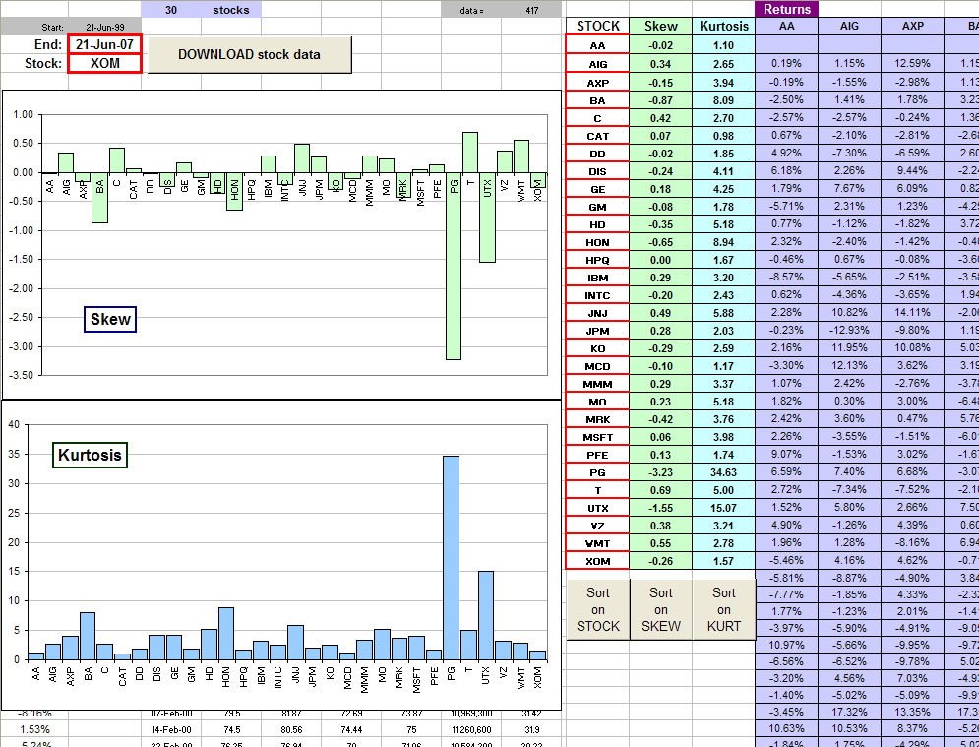
to continue

Black Swans  and Kurtosis, too  ... an appendage to Kurtosis | 
Them way out negative returns, like market crashes, are sometimes called Black Swans ... and the swans don't like it one bit!
Indeed, any unlikely, unexpected event is a Black Swan ... just as black swans were unexpected, until discovered in Australia
One measure of the number and size of fat tails is the KURTOSIS associated with the distribution of returns.
However, one can go from a comfortable, Gaussian (or Normal) distribution (with SKEW=0 and KURTOSIS=0) to a wild-and-wooly distribution with huge Kurtosis by including a single, remote Black Swan.
>For example?
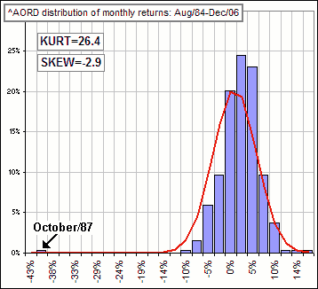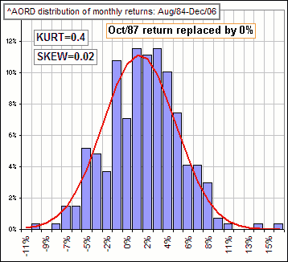
>^AORD? The Australian Index which got hit hard in 1987 'cause of the crash in October and ...
>So what's your point?
Note that, when the Oct/87 return is replaced by a nice, comfortable 0%, the Index becomes almost Gaussian with small Skew and Kurt.
>Ain't that interesting? Black swans first discovered in Australia and ...
... and the Aussie Index has got a nice one.

Here's a spreadsheet GUMMY KURT SKEW DISTRIBITION that you can play with: kurt-skew-distribution.xls
It looks like this.
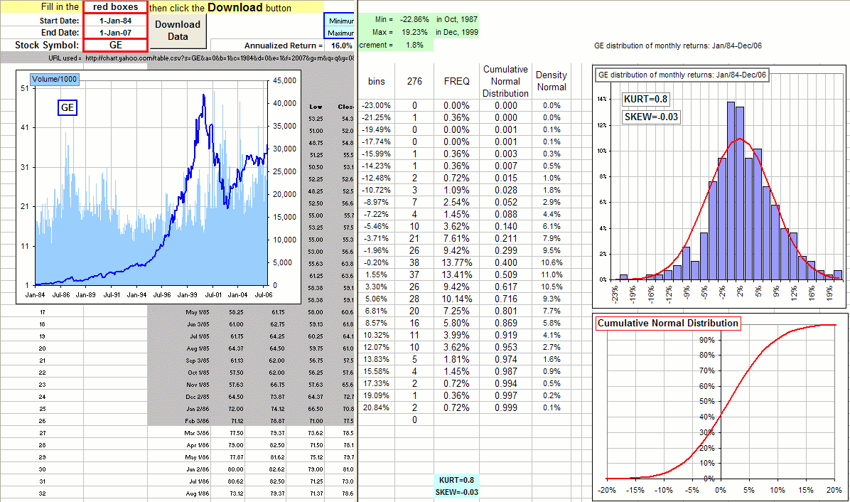

Fat Tails ... and how to get 'em

suggested by a Motley Fool discussion
Stare carefully at these charts  >Yeah, so?  The first chart gives the daily returns for GE stock over the past eight years or so.  The middle gives a set of daily returns obtained by randomly selecting from the actual daily GE returns (over the same 8 years).  The last gives a set of daily returns obtained by randomly selecting from a Normal distribution of returns that has the same Mean and Standard Deviation as the GE returns (over those 8 years).  >Yeah, so?  Don't you see the difference?  >No! They're all funny looking!  The actual returns have wild variations in returns, reaching to over 8%, both positive and negative.  >But so does the middle chart!  Exactly! Aaah, but that last chart doesn't. Indeed, the returns selected from the Normal distribution are ... uh, tranquil in comparison.  >Tranquil? Is that a technical term?  The point is that actual returns can vary wildly. If you replace actual returns by some mathematical proxy ...  >Like a normal distribution of returns?  Yes. If you replace actual returns you don't get that wild variation. | 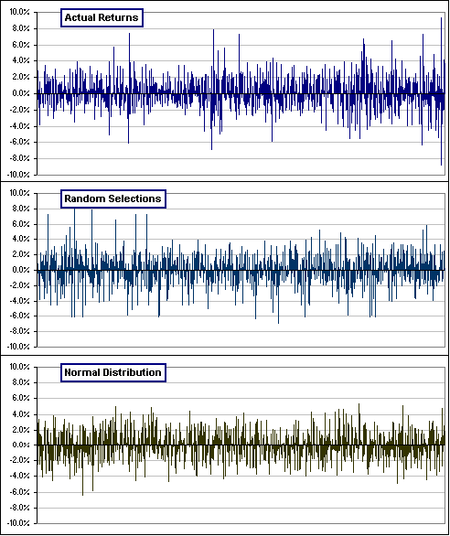
>Yeah, so?
So, to get a feeling for a possible future evolution of GE prices (if you're doing Monte Carlo or predicting or estimating whether your portfolio will run dry), my suggestion is to forget about assuming a Normal or Lognormal or Micky Mouse distribution. Instead:
Select returns, at random, from actual historical returns
>Haven't you already said that?
Yes, several times ... like here.
>And "Micky Mouse"? Is that a technical term?

You can play with a spreadsheet. GUMMY FAT TAILS

or maybe CAGR

Miscellaneous Stuff
suggested by discussions at morningstar.com and investorhub.com
Simple Return Calculations:
If your portfolio goes up 22% in a year, then $1.00 grows to $1.22 in that year ... since $1.00*(1.22) = $1.22
If, the next year, the return is 73%, you multiply your starting portfolio by 1.73
Your $1.22 portfolio grows to $2.11 since $1.22*(1.73) = $2.11
In general, you:
- write the annual percentage return as a decimal (by dividing by 100) example: 22% becomes return = 0.22
- then "add 1" (so 1+return = 1.22)
- then you multiply your initial portfolio by (1+return) example: multiply by 1.22
For negative returns ... same thing:
- Write -10% as a decimal (so -10% becomes return = -0.10)
- then "add 1" (so it's now 1+return = 0.90)
- then you multiply your initial portfolio by 1+return = 0.90
Hence, for annual returns of 22%, 73%, 21%, 45% and -10% a $15.00 initial portfolio would grow to
$15.00*(1.22)(1.73)(1.21)(1.45)(0.90) = $49.99
That's a gain of $34.99, since you started with $15.00, so that's a total gain of $34.99/$15.00 = 2.33 or 233%
What's the Equivalent "Annualized" Return
... or Compound Annual Growth Rate (CAGR) ?
That five year sequence of annual returns is equivalent to what "fixed" annual return, over five years?
Suppose this "fixed" return is r (so, if r turns out to be 0.123, that means 12.3%)
Then an initial portfolio of $15, over these five years, would grow to
$15*(1+r)(1+r)(1+r)(1+r)(1+r) = $15*(1+r)⁵
which is supposed to be equivalent to
$15.00*(1.22)(1.73)(1.21)(1.45)(0.90)
That makes (1+r)⁵ = (1.22)(1.73)(1.21)(1.45)(0.90)
or r = [(1.22)(1.73)(1.21)(1.45)(0.90)]^{1/5} - 1 = 0.272 or 27.2% per year.
and that gives the prescription for finding the CAGR from a sequence of annual returns, namely:
For N annual returns of r₁, r₂, ... r_{N},
(expressed as decimals by dividing the percentage returns by 100),
the Annualized Return is:
CAGR = [ (1+r₁)(1+r₂)...(1+r_{N}) ]^{1/N} - 1

Note:
In an MS Excel spreadsheet, if cells A1 to A25 contain 25 returns, then:
=AVERAGE(A1:A25) gives the Average (or Arithmetic Mean)) of these Returns.
To get the Annualized Return do this:
Type:
=GEOMEAN(1+A1:A25)-1
but don't hit the Enter key ... yet!!
Hold down the Ctrl and Shift keys and NOW hit the Enter key.
It changes to {=GEOMEAN(1+A1:A25)-1} giving the Annualized Return.
Example: for the five annual returns given earlier, we'd get
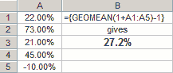
Note: The Annualized Return is not to be confused with the Average Return $#^@!&#
The Average and Annualized returns would be the same only if all annual returns were the same!
Example: for five returns all equal to R, the average return would equal R. The above prescription would then say:
CAGR = [ (1+R)(1+R)(1+R)(1+R)(1+R) ]^{1/5} - 1 = 1+R - 1 = R
Note:
The CAGR (or Annualized Return or GeoMean) is the answer to the question:
What constant annual return would make my portfolio go from $A to $B in n years?
The answer can be obtained from the individual annual returns (using the GeoMean)
or (more simply) as 100 [ (B/A)^{1/n} - 1 ] %
See also: Calculating Annualized Returns

Excel Tips:
Above, we noted the slick trick of using =GEOMEAN(1+A1:A25)-1 and Ctrl / Shift / Enter to get the Annualized Return (or geometric mean).
This ritual involves adding 1 to every cell. There are some other similar tricks, like the following (each using Ctrl+Shift+Enter).
In each case there's some arithmetic applied before the calculation:
=PRODUCT(1+A1:A25,1+A1:A25) where "1" is added before the PRODUCT is calculated.
=PRODUCT(1+2*A1:A25,1+2*A1:A25) where each number is multiplied by "2" then added to "1" before the PRODUCT is calculated.
=SUM(A1:A25/100) where each number is divided by 100 before SUMming.
=SUMPRODUCT(A1:A25-A26,A1:A25-A26) where the number in cell A26 is subtracted from every number in A1 to A25 before calculating the SUMPRODUCT.
=SUMPRODUCT(A1:A25-AVERAGE(A1:A25),A1:A25-AVERAGE(A1:A25)) where the AVERAGE is subtracted from each number.
This would give the sum of squares of the deviations from the Mean.
=SUMPRODUCT(A1:A25-A26,A1:A25-A26,N(A1:A25<A26)) where A26 is subtracted from each number and the SUMPRODUCT is calculated for those numbers less than A26.
If A26 is the Mean, then this would give the sum of squares of the deviations from the Mean for those numbers less than the Mean.
=AVERAGE(IF(B1:B25>B14,A1:A25)) where A26 is some date and column B has dates associated with each number in A1 to A25.
The AVERAGE of A1 to A25 is calculated for those numbers with dates less than A26.
=SUM(A1:A25*B1:B25) where each number in A1:A25 is first multiplied by the corresponding number in B1:B25 ... then the SUM of products is calculated.
This is the same as =SUMPRODUCT(A1:A25,B1:B25)
There are (probably!) other neat tricks ... but I don't know 'em

Simpler Return Calculations:
If you don't have access to Excel (hence the GEOMEAN function) or to a calculator that'll extract roots, you can try this:
- Determine a bunch of returns:
1999 | 13.26%
2000 | -3.34%
2001 | -5.49%
2002 | -13.09%
to May 31, 2003 | 9.80%
- Multiply together like so:
(1+0.1326)(1-0.0334)(1-0.0549)(1-0.1309)(1+0.0980) = 0.9874
- That gives 0.9874 as the increase over 4*12+5 = 53 months or 53/12 = 4.417 years
so, to get the "annualized" return, we need to determine R so that (1+R)^{4.417} = 0.9874 so 1+R = 0.9874^{1/4.417}
- That means we need to calculate a root, namely: 0.9874^{1/4.417}
So here's how you can calculate the n^{th} root of a (positive) number A, namely A^{1/n}:
- Take a guess and call it X₀. (Example: X₀ = 1.)
- Calculate X₁ = [(n-1)X₀^{n} + A]/[n X₀^{n-1}]
- Calculate X₂ = [(n-1)X₁^{n} + A]/[n X₁^{n-1}]
- Calculate X₃ = [(n-1)X₂^{n} + A]/[n X₂^{n-1}]
- Continue until the numbers don't hardly change none
Example 1:
For n = 4 and A = 0.9874 and we want 0.9874^{1/4} :
- X₀ = 1
- X₁ = [3 X₀⁴ + 0.9874]/[4 X₀³] = 0.996850
- X₂ = [3 X₁⁴ + 0.9874]/[4 X₁³] = 0.996835
- X₃ = [3 X₂⁴ + 0.9874]/[4 X₂³] = 0.996835
- We conclude that 0.9874^{1/4} = 0.996835
Example 2:
For n = 5 and A = 0.9874 and we want 0.9874^{1/5} :
- X₀ = 1
- X₁ = [4 X₀⁵ + 0.9874]/[5 X₀⁴] = 0.997480
- X₂ = [4 X₁⁵ + 0.9874]/[5 X₁⁴] = 0.997467
- X₃ = [4 X₂⁵ + 0.9874]/[5 X₂⁴] = 0.997467
- We conclude that 0.9874^{1/5} = 0.997467
Example 3:
For n = 4.417 and A = 0.9874 and we want 0.9874^{1/4.417} :
- Do Example 1 and get 0.996835 for n = 4.
- Do Example 2 and get 0.997467 for n = 5.
- For n = 4.417 calculate the approximate answer by interpolating between 4 and 5:
0.996835 + (4.417 - 4)(0.997467 - 0.996835)
and you'll get 0.997099 whereas the "correct" answer is 0.997133
That makes 1+R = 0.9874^{1/4.417} = 0.9971
so R = -0.0029 or -0.29% annualized return.

About Return Distributions:
Suppose you have a bunch of returns (or any other numbers!)
in cells A2 to A20 and bins from B2 to B13 ... as seen here

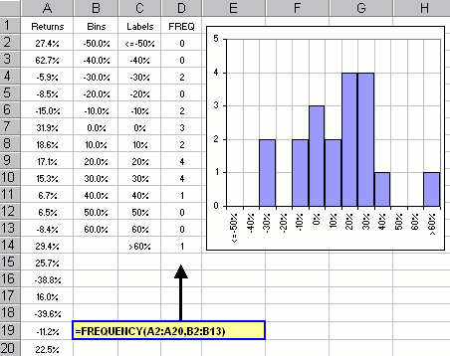

- Select cells from D2 to D14 with your mouse
... one more cell than the number of bins !
- Type: =FREQUENCY(A2:A20,B2:B13)
- Press three keys: Ctrl+Shift+Enter (as noted above).
Cells D2 to D14 will give the number of returns which lie in the various bins:
R<= -50%, -50% < R <= -40%, -40% < R <= -30%, ... and finally R> 60%
(You may want to put appropriate labels on a plot as in column C
so the chart has these labels on the horizontal axis.)

About Arithmetic and Geometric Means:
- Q: The annual returns of my portfolio over two years are P and Q (P = 0.12 means 12%).
What will my portfolio be in two years?
- A: After one year, $A changes to A(1+P). After two years it's A(1+P)(1+Q) = A G₁G₂
where G₁ = 1+P and G₁ = 1+Q are the annual Gain Factors.
- Q: The amount A G₁G₂ is equivalent to achieving what "constant" annual return?
- A: At a "constant" annual return of R, $A becomes (after two years) A(1+R)².
And A(1+R)² equals A G₁G₂ provided (1+R)² = G₁G₂ or 1+R = SQRT[G₁G₂]
and SQRT[G₁G₂] is the Geometric Mean of the Gain Factors G₁ and G₂.
That means our annual Gain Factor would be GM, the Geometric Mean of G₁ and G₂.
- Q: What would I have if I got the Arithmetic Mean?
- A: The Arithmetic Mean of P and Q is (P+Q)/2 and two years of this return would yield:
A[1+(P+Q)/2]² where we note that [1+(P+Q)/2] = (1/2)[(1+P) + (1+Q)] = (1/2)[G₁+G₂].
Hence A[1+(P+Q)/2]² = A[(1/2)(G₁+G₂)]².
That means our annual Gain Factor would be AM, the Arithmetic Mean of G₁ and G₂.
- Q: How do the two compare?
- A: Using R gives $A(1+R)² = $A[GM]² where 1+R = GM is the Geometric Mean of Gain Factors G₁ and G₂.
Using the Average gives $A[1+(P+Q)/2]² = $A[AM]² where AM is the Arithmetic Mean of G₁ and G₂.
Conclusion?
The Geometric Mean of Gain Factors gives the correct, final portfolio value
... not the Arithmetic Mean
... and the Geometric Mean is smaller than the Arithmetic Mean!
See Average vs Annualized.
Note:
There are (at least) two approximations to the Annualized Return if you only know the Mean (or Average) and Standard Deviation (or Volatility):
- AnnualizedReturn = AverageReturn - (1/2) Volatility²
- AnnualizedReturn = SQRT[ (1+AverageReturn)² - Volatility² ] - 1
To see the difference, click here for an online spreadsheet.

Money In - Money Out:
If you put money into your portfolio, and take some out, then in and out etc. etc. then we're NOT talking about a buy-and-hold return. That makes the calculation of Annualized return more complicated, but there's an MS Excel command for this:
The XIRR command. It goes like this:  =XIRR(A1:A50,B1:B50,0.10)  where the range A1:A50 contains the cash flows  and the range B1:B50 contains the dates  and 0.10 is an initial guess (like 0.10 meaning 10%)  Here's an example  where you stick in the cash flows (negative if they're withdrawals) and the dates and end up with the current portfolio value (entered as a negative number, like -$44.100) and today's date. It's important to note that the (positive or negative) cash flows are new money invested (from your salary, for example) or withdrawals made (to your bank account, for example) ... and not internal activity within the portolio such as dividends or expenses due to commissions or fees etc.. This internal activity is ignored when calculating portfolio returns. (Their effect, of course, shows up in the final portfolio value!)  It's also important to note when an investment (or withdrawal) is made!  For example:  - You invest $1K now.  - In N months you invest another $1K.  - In 12 months your portfolio is worth $2500.  You annualized return (or Compound Annual Growth Rate CAGR) depends upon N  ... going from 25% to 50%.  The 25% number is (final portfolio)/(initial investment) - 1 = 2500/2000-1 = 0.25 or 25%.  The 50% number is (final portfolio)/(initial investment) - 1 = 1500/1000-1 = 0.50 or 50%  (where the $1K investment at N = 12 months is ignored). | 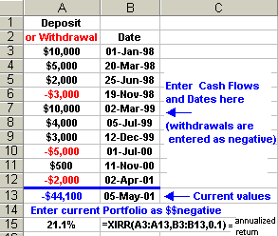  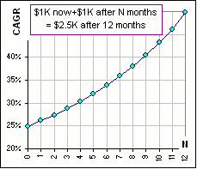
Note 1: XIRR is an Excel add-in and may need to be installed.
Note 2: There may be more than one XIRR answer, depending upon your initial guess! (See XIRR.)
Note 3: You can use XIRR to calculate YTD Returns. (See XIRR-stuff.)

About inflation adjustments:
- Q: $100 will buy how many $25 items?
- A: It will buy [100]/25 = 4 items.
- Q: If inflation is 3% per year, how many items will $100 buy next year?
- A: Next year the $25 item will cost 25(1+.03) so $100 will buy 100/{25(1+.03)} = [100/(1+.03)] /25 items.
- Q: If inflation is 3% per year, how many items will $100 buy in eight years?
- A: In eight years the $25 item will cost 25(1+.03)⁸ and
$100 will buy 100/{25(1+.03)⁸} = [100/(1+.03)⁸]/25 items.
Conclusion?
At an annual inflation rate of I (I = 0.03 means 3%), the "buying power" of today's $A is [A/(1+I)^{N}] in N years.
Just divide by (1+Inflation) ... for each year

REAL Rate of Return:
Your portfolio is currently worth $A.
A particular item is currently worth $P.
Currently, you can buy A/P items.
In N years you may or may not be able to buy that many items; it'll depend upon your portfolio gain and inflation:
Suppose that your $A investment grows at a rate r (r = 0.08 meaning 8%) and inflation is i (i = 0.03 meaning 3%).
- Q: How many items, currently priced at $P, can you buy in N years?
- A: In N years your $A portfolio will have grown to A(1+r)^{N}.
However, the $P items will then cost P(1+i)^{N}.
Hence you can buy [A(1+r)^{N}]/[P(1+i)^{N}] = A/P [(1+r)/(1+i)]^{N} items.
That means that, instead of A/P items, you can buy A/P [(1+r)/(1+i)]^{N} items (N years from now).
That means that the buying power of your portfolio has increased (or decreased) by a factor [(1+r)/(1+i)]^{N} over N years.
That's equivalent to an increase (or decrease) by a factor [(1+r)/(1+i)] per year.
- Q: A change in buying power of [(1+r)/(1+i)] corresponds to what "REAL" portfolio growth (taking inflation into account)?
- A: We need to find an equivalent, inflation-adjusted return R so that 1+ R = [(1+r)/(1+i)], hence the REAL rate of return is
R = [(1+r)/(1+i)] - 1.
Conclusion?
At an annual portfolio gain of r the "REAL", inflation-adjusted return is R = [(1+r)/(1+i)] - 1 = (r - i)/(1 + i).
Note: For small inflation (that is, i is small), one often puts R = r - i which is an approximation to the "REAL" rate of return.

REAL Return ... with several assets:
Now suppose that you have a portfolio with two assets worth $A and $B, so your portfolio is worth A + B.
Suppose, further, that the two assets have annual returns of r₁ and r₂ respectively and that inflation is i.
At the end of the year the assets have changed to A(1+r₁) and B(1+r₂) so your portfolio is now worth A(1+r₁) + B(1+r₂).
Aah, but inflation reduces the buying power of your portfolio, so in real terms, it's only worth [A(1+r₁) + B(1+r₂)] / (1+i).
The increase (in real terms) is from (A+B) to [A(1+r₁) + B(1+r₂)] / (1+i) and (dividing the latter by the former) that's a gain of:
[A/(A+B)](1+r₁)/ (1+i) + [B/(A+B)](1+r₂)/ (1+i).
Moral?
If your portfolio has a fraction x devoted to asset #1 and y = 1 - x devoted to asset #2, then your "real" return is:
x (1+r₁)/ (1+i) + y (1+r₂)/ (1+i) - 1 = [x + y + x r₁ + y r₂] / (1+i) - 1 = [1 + x r₁ + y r₂] / (1+i) - 1 = (x r₁ + y r₂ - i) / (1+i).
Note that this is the same as the formula above except that the portfolio return r is replaced by x r₁ + y r₂.
Note that the formula can also be written: x (r₁ - i) / (1+i) + y (r₂ - i) / (1+i)
so it's the weighted sum of the inflation-adjusted return for each component.
This ritual extends to a portfolio with a jillion assets ... just use the "weighted" return
For example, if 60% is devoted asset #1, 30% to asset #2 and 10% to asset #3, then you'd have a real return of:
(0.6*r₁ + 0.3*r₂+ 0.1*r₃ - i) / (1+i)
or
0.6 (r₁ - i) / (1+i) + 0.3 (r₂ - i) / (1+i) + 0.1 (r₃ - i) / (1+i)

About Annual Rebalancing:
- Q: My portfolio is 50% asset A, 30% asset B and 20% asset C (meaning fractions 0.50, 0.30 and 0.20).
The annual returns for each are P, Q and R (for a 12% return, P=0.12).
What is my portfolio return at the end of the year?
- A: For a portfolio worth $1000
50%x1000 = $500 is in asset A which changes to 500*(1+P) = 0.50*1000*(1+P) after one year.
30%x1000 = $300 is in asset B which changes to 300*(1+Q) = 0.30*1000*(1+Q) after one year.
20%x1000 = $200 is in asset C which changes to 200*(1+R) = 0.20*1000*(1+R) after one year.
The final portfolio is then 0.50*1000*(1+P)+0.30*1000*(1+Q)+0.20*1000*(1+R)
which is the same as: 1000(1 + 0.50*P + 0.30*Q + 0.20*R)
which is the same as having an annual return of 0.50*P + 0.30*Q + 0.20*R.
Conclusion?
For Portfolio fractions x₁, x₂, x₃ ... devoted to assets with returns of R₁, R₂, R₃ ...
the Portfolio return is x₁R₁ + x₂R₂ + x₃R₃ + ...
For Annual Rebalancing:
This is the way to get the annual return (each year).
Note:
If R₁, R₂, R₃ ... are the Average Annual Returns for each asset (over umpteen years)
then x₁R₁ + x₂R₂ + x₃R₃ + ... will give the Average Annual Portfolio Return (or Arithmetic Mean Return)
... provided you do "Annual Rebalancing".

About Saving for Retirement:
- Suppose that, were you to retire now, you'd need $50K per year from your investment portfolio.
- Suppose, too, that you intend to retire in 30 years.
- At 3% inflation, that $50K needs to be 50K(1+.03)³⁰ = $121K (to have the same buying power as $50K, today).
- Suppose you think that, at retirement, you can safely withdraw 4% of your starting portfolio (this withdrawal increasing with inflation).
- Then, the required $121K should be 4% of what Portfolio?
- You'd want 0.04 x Portfolio = 121K so that Portfolio = 121K / 0.04
- 1/0.04 = 25 so you'd want 25 x 121K or 3025K or about a 3 million dollar Portfolio.
This gives the Rule of Thumb:
Save for retirement so that your Portfolio is 25x the income you'd want from your investments, at retirement.
You can (of course) stick in your own numbers or use a calculator ...
If you think that, because your expenses would be less,  you can live on, say, 75% of your salary (after you retire),  and your current salary increases at some annual rate,  you can try this (quick-and-dirty) calculator  to see how much of your salary you should invest ... until you retire.  Warning: the answers may be harmful to your health.
  Years of Investing = (until retirement)
  Salary Increases = % (that's inflation)
  Return on Investments = % (while you're investing)
  Percentage needed = %
  (as a percentage of your current salary)
  Withdrawal Rate = % at retirement
  Percentage of Salary that you'll need to invest = %

or maybe Beta
Beta here Beta there

motivated by a paper noted by mathguy
On a recent Morningstar discussion there was a reference to an interesting paper which noted that financial rituals based upon a calculation of beta from historical data may lead to misleading (if not totally inaccurate) conclusions.
>Huh?
If we plot the daily (weekly? monthly?) returns of some stock versus the returns for "the Market", the slope of the best-fit straight line is beta.  One normally takes as "the Market" something like the Wilshire 5000 or maybe the S&P 500.  Figure 1A shows the monthly returns for GE vs those for the S&P 500 for the period Jan 1, 2000 to Dec 31, 2003.  >The slope of the red line is 0.988, so that's beta?  Yes, for this stock and time period and that market ... using monthly returns where we look at the end-of-month prices only.  >Huh?  We look at the end-of-month price for Jan, 2000 and Feb, 2000 etc. ending with the end-of-month price on Dec, 2003 and ...  >And calculate the monthly returns with these prices.  Yes. Now look at Figure 1B. We still use the period Jan, 2000 to Dec, 2003 and the S&P as "the Market". Guess what stock it is? I'll give you a hint. It's GE again, but now we look at the mid-month prices (rather than the end-of-month prices).  >Like Jan 15, Feb 15, etc.?  Well, yes, if the market is open on the 15th, else we use the day before. In any case, you'll notice that beta is different, eh?  >And that makes a difference?  Well, yes, if you use that CAPM thing.  In fact, if you compare the end-of-month beta with end-of-month minus 2 days you'd get (for GE and S&P): beta = 1.252 | 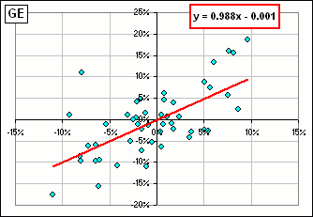  Figure 1A  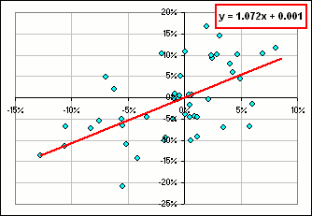  Figure 1B
>What's "end-of-month minus 2 days"?
For example, we consider the closing price on Jan 29, 2000 instead of Jan 31, 2000
and the price on Feb 27, 2000 instead of Feb 29, 2000
and the price on ...
>Yeah, I get it. Minus 2 days ...
Right. The CAPM prescription is:
[1] E[R] = R_{f} + beta (E[R_{m}] - R_{f})
where, R_{f} is a risk-free return (say 4%)
and E[R_{m}] is the Expected Market return (say 9% for the S&P 500)
and E[R] is the Expected return of your stock (like GE, for example) and beta is ... uh, some beta.
If you use end-of-month beta = 0.988 you'd get an expected GE return of E[R] = 4 + 0.988(9 - 4) = 8.94%
If you use end-of-month minus 2 days beta = 1.252 you'd get an expected GE return of E[R] = 4 + 1.252(9 - 4) = 10.26%
>I''ll take minus 2 days! Uh ... how 'bout minus 3 days or even ...?
You can play yourself with a spreadsheet (comparing your favourite stock with the S&P 500 for Jan, 2000 - Dec,2003)
and varying the day of the month when prices are considered and see what it does to beta. Quite intriguing.
This is for GE:
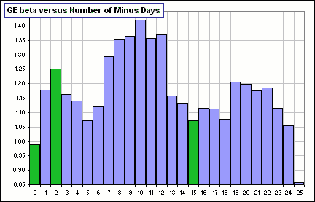
The green ones are the ones we've considered above: minus 0, 2 and 15 days.
>I'll take minus 10, okay? CAPM says my expected GE return is ... uh ...
That'd be 11.1%.
Anyway, click here to download a spreadsheet to play with.
>But what if I don't want to use the S&P 500 as "the Market" or I don't want Jan, 2000 - Dec, 2003 or ... ?
The spreadsheet let's you change them.
>But what if ... ?
Just try it!

I should point out that, according to CAPM, a bigger beta implies a bigger expected stock return.
Yet, during the last of the 1990s (when the market really took off), a bigger beta (obtained by changing the day of the month when the returns were calculated) ... these bigger betas were associated with smaller returns
>Huh?  Look at the chart  There we used the four years of monthly returns from 1996 to 2000, changing the day of the month when the prices were considered.  It shows the Compound Annual Growth Rate and the beta (as we change the day-of-the-month).  You'll notice that a bigger beta meant ...  >A smaller return!  You got it. | 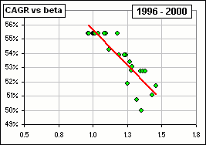
One other thing:
Sometimes beta is calculated using, say, monthly returns, reduced by some risk-free rate (called "excess" returns) ... like short term treasuries. If the risk-free rate is constant (say 4% month after month), then it has no affect on
beta = COVAR[stock,market] / SD²[market] = r SD[stock] / SD[market]
where r is the correlation between the stock and market returns.
If we subtract a constant risk-free rate from both stock and market returns, none of r, SD[stock] or SD[market] will change. (See stat stuff.)
But, if the risk-free rate varies wildly (month to month) then it's necessary to use the "excess" returns.
Note that the CAPM equation given in [1] can be written:  [2] (E[R] - R_{f}) / (E[R_{m}] - R_{f}) = beta  so the "excess" returns E[R] - R_{f} and E[R_{m}] - R_{f} play a prominent role.  Indeed, the fact that beta is a "slope" is clear ... as illustrated here  where we plot "excess" returns - the stock versus the market. | 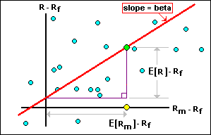
Note that the yellow dot is determined from the "excess" of the Expected Market Return: E[R_{m}] - R_{f}.
The "excess" of the Expected Stock Return (that's E[R] - R_{f}) is then determined so that the slope is beta.
>The green dot?
Yes.

Beta and CAPM and Equity Risk Premium
Okay, suppose that there's a stock that has consistently given spectacular annual returns ... like 20%.
Suppose, too, that this stock is completely uncorrelated to "the Market", so beta = 0.
>Is that possible?
Well, that'd be the case if the stock price increased at a constant annual rate, like 20%. Then its Volatility would be 0 and its Covariance with "the Market" (call it COVAR[stock, market] ) would be 0 and since beta = COVAR[stock, market] / Variance[market] then beta = 0.
Anyway, from that CAPM model, namely E[R] = R_{f} + beta (E[R_{m}] - R_{f}), we'd have an Expected stock return of E[R] = R_{f}.
>You call that spectacular?
No, I don't ... but it points up a problem with taking the CAPM model as an "Expectation" for the stock return.
>Then what should I take it as? I mean, what good is the CAPM model?
Good question. Let's think about it:
- Suppose the "excess" stock returns, plotted against the "excess" market returns, gives a regression line similar to Figures 1A, 1B.
- Suppose, too, that the points are close to this line. Then you'd expect the stock to behave much like the market.
- If that's the case, and the market returns are expected to be, say, 3% above the risk-free rate R_{f}, then it's reaonable to expect that the stock returns will be above R_{f} as well.
- In fact, since beta is the slope of the regression line, it gives an estimate of the ratio of "excess" returns.
- That means that if beta = 1.23 (for example), then you'd expect the "excess" stock return to be 1.23 x 3% or 3.69% above R_{f}.
>Yeah, so?
So, if the "excess" stock returns are NOT close to the regression line, then how can you come to that conclusion? How can you have ANY expectation that the stock returns behave in a manner similar to the market ... with beta as some sort of scale factor? How can ...?
>Yeah, so?
So beta alone is practically useless in attempting to estimate "excess" stock returns ... in my humble opinion
In addition to the problems noted above, about "when" one considers the returns.
I suggest that one first look at how closely these stock returns are to the regression line ... and that depends upon some measure of the distance between the points and the regression line. One measure of the error, namely the sum of the squares of the (vertical) distances of the points to the regression line, is:
Error² = SD²[stock] - COVAR²[stock,market] / SD²[market] = SD²[stock] (1 - r²)
where SD is the Standard Deviation and r is the (Pearson) Correlation between the stock and the market. (See Best Line Fit )
>So if that Error is small, or zero, then one should have some faith in the Expected "excess" stock return?
As per CAPM ? I don't think so. For our example (where the stock has a constant 20% return) the regression line is horizontal (since the stock returns are constant!) and every stock return point lies precisely on that line so the Error is 0 yet ...
>Yet the expected "excess" stock return still isn't the Risk-free return, eh?
Yes. I mean NO, it isn't.
>So when would you have some faith in the CAPM model?
Me? I have little faith in any predicted values. However, if there's a high correlation between stock and market returns (either positive or negative ... so r is close to +1 or -1) and beta isn't close to 0 (implying a respectable Covariance between stock and market returns) and the Error is small ... then I guess you'd expect stock returns to be similar to market returns.
>So is the market is 3% above Risk-free you'd expect the stock to be 3% above Risk-free, right?
No, you'd expect the stock to be beta x 3%. Remember that beta is an estimate of the RATIO: (stock excess) / (market excess).
Did I mention that the "excess" we've been talking about has a name? It called:
Equity Risk Premium = "The extra return that the stock provides over the Risk-free rate to compensate for market risk."
If the "excess" stock return (or Equity Risk Premium) is, say, 4% (that's above the Risk-free rate) then it's the extra return you'd want because of the extra risk you take by investing in the stock ... rather in a risk-free asset.
>To compensate for market risk? What's that about?
If the stock behaves much like the market, and market returns goes up and down, then you'd expect your stock to go up and down as well ... with changes in stock returns being beta times the changes in market returns. That's the risk associated with being in "the market".
>And the "market" might go up or down depending upon economic factors or some war somewhere or some terrorist activity or ...?
Yes, and your stock will probably participate to some extent in this up and down movement of the market.
>Assuming your stock is intimately connected to the market.
Well, yes, and it's things like beta and r and Error which measure this intimacy.
>Can you ... uh, summarize, like when to trust CAPM and ...?
Well, one often reads things like:
"An R-squared measure of 35, for example, means that only 35% of a fund's movements can be explained by movements in its benchmark index."
>R-squared?
Yes, that's r². You'll note that our Error depends upon R-squared = r².
>How come that google link has the exact same wording ... about "35% of a fund's movements"?
That's typical. Some respected financial guru says something (having presumably justified her statement) and everybuddy picks up the statement and repeats it (again and again and again) ... but avoiding the justification that the guru (presumably) provided.
>And should I swallow it?
That depends upon your appetite.

or maybe ...
>zzzZZZ
Don't you see? Whatever you calculate it'll get stuck in columns L, M, N, O and P and there's a SORT button so you can sort them and ...

Average Returns ... and such
Once upon a time I looked at the calculation of beta and the different numbers you'd get if you considered the end-of-month prices or one day before the end-of-month or maybe 5 days before or ...
>Yeah, so? So, since many investors are interested in the average monthly return of their favourite stock or mutual fund, I was wondering whether that number changed significantly if you used the month-to-month returns from, say, mid-month to mid-month or maybe ...
>Yeah, so? So I have this spreadsheet which looks like this: GUMMY MEAN VOLATILITY STUFF
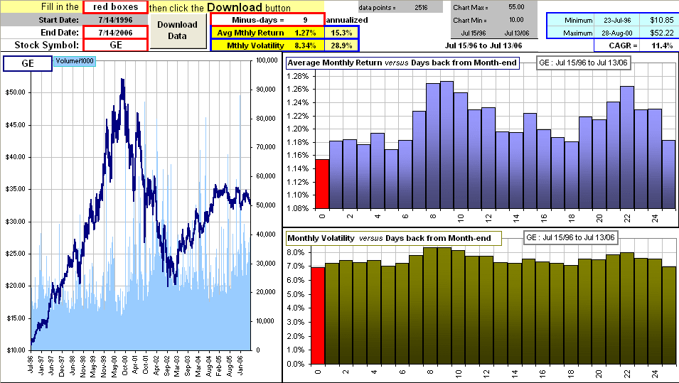
You type in a stock symbol then click a button and get ten years worth of daily prices.
You also get the Average of the Monthly Returns using the prices from end-of-month to end-of-month or a day before that or a day before that or ...
>Meaning the monthly returns using prices from the end-of-month less a few days, right?
Exactly! You also get the Volatility (or Standard Deviation) of those monthly returns.
Note that the very first numbers (coloured red, in the above example) use the end-of-month data.
>So why get worked up about this? I mean, did you expect ...?
I was surprised!
When you read about "historical averages", they may depend significantly upon when they are calculated. Weren't you surprised?
>No!
Suppose average annual returns were calculated considering September prices instead of end-of-year prices, or maybe ... ...
Note: The spreadsheet uses the EOMONTH command ... which is an Excel Add-In. If'n you haven't added it, then do this:
Tools
then Add-Ins... then Analysis Toolpack then pray ...

Standard Deviation ... and the Square Root of Time
When calculating the Standard Deviation for annual returns, one often computes the Standard Deviation of monthly returns, then multiplies by the square-root-of-12.
>Why 12? Because "annual" means 12 months and there are 12 months in a year.
>So if I want the Standard Deviation for 5-year returns I'd multiply the monthly returns by 60, because there are 60 months in ...?
Wrong! Pay attention! You'd multiply the Standard Deviation of monthly returns by the square root of 60 to get the Standard Deviation of 60-month Returns.
>I see. So, if I have the Standard Deviation of 1-month returns, then I multiply by SQRT(N) to get the Standard Deviation for N-month returns, right?
Yes, and it works for years as well as months. Multiply the SD for 1-year Returns by SQRT(20) and you'll get the SD of ...
>The SD of 20-year returns! You got it.
>So, is this square root stuff for real? I mean, am I guaranteed to get the Standard Deviation of N-month returns by multiplying the SD of 1-month Returns by SQRT(N)?
Well, let's do the following:
- We'll use the S&P 500 monthly returns, starting in 1950 ... and running for 60 months.
- We'll compute the Standard Deviation of these 60 1-month returns.
- Then we'll consider the 2-month returns, again starting in 1950 and calculate the SD for the 2-month returns.
- Then we'll consider the 3-month returns, again starting in 1950 and calculate the SD for the 3-month ....
>Okay, I get the idea. Then you plot the SD versus the number of months, right?
Right, and we compare to the plot of the (SD of 1-month returns) x (the square root of months). We get this:
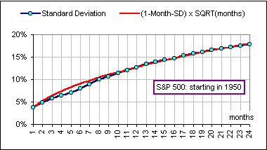
>Hey! That's pretty close, eh? Yes. Now let's do it for the returns starting in ...
>Try 1930! Okay, here's a couple:
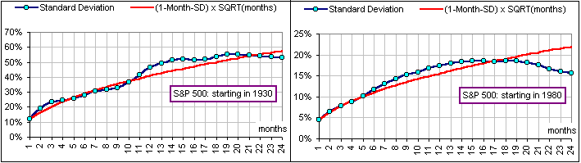
>Hmmm ... not so good. Nevertheless, this square-root stuff is often used to "annualize" a monthly Standard Deviation.
>By multiplying by the square root of 12. Right.
>But in these charts you're just going ahead 24 months or 2 years. How about ...?
Okay, let's try it with years. We'll again start in 1950 with the S&P 500 and calculate the Standard Deviation of 1-year returns, then 2-year returns, etc. etc. We get the following:
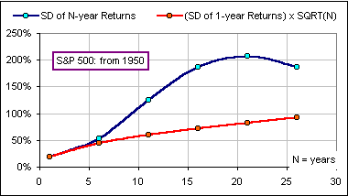
>It seems to work okay for a few years, then it's way off. Yes, it would seem that way.
>So where does this square-root stuff come from? It goes like so:
- We start at x = 0 and take a step, either right or left.
- The length of the step we take is somewhere between -0.1 and 0.1 and the average step length is zero.
- We ask: "After N such steps, how far are we from where we began?"
Here's a typical journey of a thousand steps:

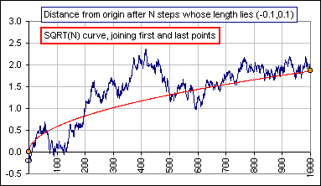
>So what does this have to do with investments returns and ...?
Okay, consider the U.S. Total Stock Market (TSM) from year 1928 to year 2000. Here's what we'll do:
- We consider the Annual Returns over this period, like so:
- 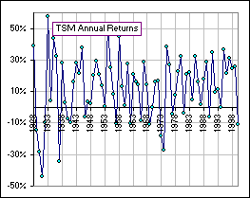
- The Mean and Standard Deviation are M = 12.4% and S = 20.2%, respectively.
>Wild! Pay attention. We can smooth this out like so:
- Consider the 10-year intervals, from 1928 to 1938, then 1929 to 1939, etc. and calculate the annualized return for each 10-year interval. That is, we invest $1.00 and if it grows to $7.89 after 10 years, then the "Annualized Return" is
7.89^{1/10} - 1 = 0.229 or 22.9% and, in general, if our $1.00 grows to $N, the Annualized Return is N^{1/10} - 1.
- These Annualized Returns (over 10 years) look like so:
- 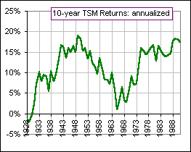
>So the volatility would be less, right ? Right. In fact, it's more like: (Annual Standard Deviation)/Square-root-of-10 = 20.2/SQRT(10) = 6.4%
>Aaah. The ubiquitous square root. That's exact, right? No. It's an approximation, but compares well with the actual Standard Deviation of annualized returns (over 10 years).
- The comparison looks like so:
- 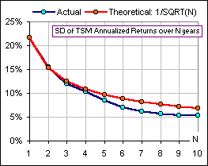
You can check out SD-stuff or for Part II: Risk/Reward ratios.
Volatility Stuff
motivated by questions raised by George L.
It's "standard practice" to calculate the volatility of monthly returns, multiply by the square-root-of-12, and take that as the annual volatility.
One convenient thing about this algorithm is that there are more monthly returns in the last 30 years than there are annual returns.
>Huh?
I've already explained this stuff here.
>Ah, yes, because there are 12 months in a year.
Right. So one could also consider taking the volatility of weekly returns and multiplying by the square-root-of-52.
>Or daily volatility multiplied ... Yes, yes. So it'd be interesting to see how that works ... or if it's reasonable and how that ritual compares to the real, live annual volatility.
We start with ...
>Wait! Does annual volatility really change all that much? Does it really matter if ...?
Here's a picture:
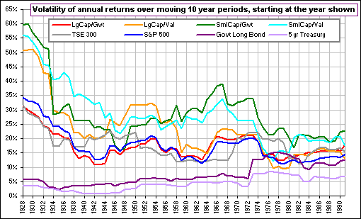
Continuing, we start with some stat-stuff, obtained here, namely:
Suppose x and y are random variables.
Let M[x], S[x], VAR[x] and r(x,y) denote the Mean, Standard Deviation, Variance and Correlation. Note: Variance = StandardDeviation²
Then:
[1] M[Σx_{k}] = ΣM[x_{k}] ... the Mean of a sum is the sum of the Means
[2] VAR[Σx_{k}] = ΣVAR[x_{k}] + 2 Σr(x_{k}, x_{j}) S[x_{k}] S[x_{j}] ... the Variance of a sum is the sum of the Variances + something that depends upon the correlation
[2A] VAR[x+C] = VAR[x] ... for any constant "C"
[3] VAR[Σx_{k}] = ΣVAR[x_{k}] ... if the variables are uncorrelated, so r = 0
[4] VAR[xy] = M²[x]VAR[y] + M²[y]VAR[x] + VAR[x]VAR[y] ... if the variables are uncorrelated
[4A] VAR[xy] = 2M² S² + S⁴ ... if the variables also have the same Mean and Standard Deviation
Now let's consider our random variables to be uncorrelated monthly returns with common mean M and Standard Deviation S.
If x and y are returns for 2 successive months, what's the 2-month return?
>It's ... uh, it's ...
It's (1+x)(1+y) - 1
If what's the standard deviation of this 2-month return?
>Is it SQRT(2)*S ?
We'll see.
We stare intently at the stat stuff we've noted above (especially [2A] and [4A]) and get:
VAR[(1+x)(1+y) - 1] = VAR[(1+x)(1+y)] = M²[1+x]VAR[1+y] + M²[1+y]VAR[1+x] + VAR[1+x]VAR[1+y]
or, in terms of the common Mean and Standard Deviation of 1+x and 1+y, namely (1+M) and S:
[5] VAR[(1+x)(1+y) - 1] = 2(1+M)²S² + S⁴ = 2 S² [(1+M)² + 0.5 S² ].
To get some idea of the size of these terms, let's assume
M = 0.01 ... a 1% monthly return or (roughly) 12% annualized return
S = 0.06 ... a 6% volatility for monthly returns or (roughly) 21% annualized volatility.
Then (1 + M)² + 0.5*S² = 1.01² + 0.5*0.06² ≈ 1.03
so we'd get from [5]:
[5A] S²[(1+x)(1+y)-1] ≈ 2.06*S² so S[(1+x)(1+y)-1] ≈ SQRT(2.06) S
So the volatility for the 2-month return is very nearly SQRT(2)*S
>Close, but no cigar, eh? Yes, but even this result assumes zero correlation between monthly returns. That means there are no "trends" in the prices.
In particular, I'd expect the actual, real-live annual returns to be somewhat larger than what we'd get with that square-root-of-time stuff.
>Is that a proof? Hardly. But I can generate 5000 random monthly returns, calculate their volatility, then look at actual 2-month, 4-month, etc. returns, then calculate their volatilities, then compare with what I'd get by multiplying the 1-month volatility by SQRT(2), SQRT(4), etc., then ...
>A picture is worth a thousand ... Here's a picture:
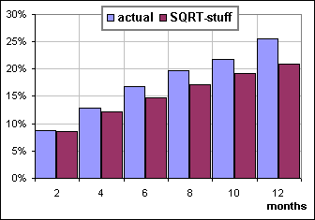
>Is that a proof? Hardly ...

Returns and Volatility
In a Morningstar post Taylor Larimore noted that:
An ounce of higher return is worth more than a pound of lower volatility.
That's such a slick observation I couldn't help myself so I ...
>You wanted to illustrate it, right? Well ... uh, yes, to illustrate that changes in Average Return are more significant than changes in Volatility.

In the chart below, we change the Average Return by 2%
(from 5% to 7%, without changing the Volatility of 24%)
and note that the Annualized Return increases by 2% as well
... very nearly
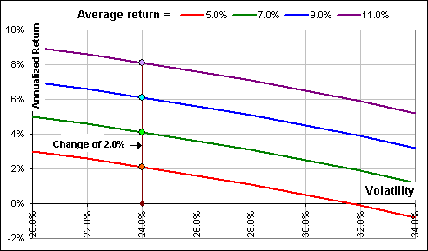
On the other hand ...
In the chart below, we change the Volatility by 5%
(from 35% to 30%, without changing the Average Return of 11%)
and note that the Annualized Return increases by just 1.6%
... very nearly

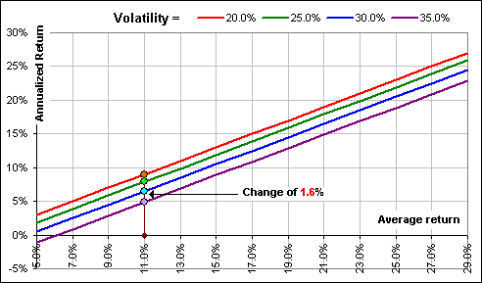
In fact, if the Volatility is v%, we can expect the change in Annualized Return to be roughly v % of the change in Volatility.
In the above example, the Volatility is roughly v% = 32.5% ... changing, as it does, from 35% to 30%.
Hence we can expect the change in Annualized Return to be roughly 32.5% of the 5% change in Volatilty
... and that means 32.5% x 5% or roughly 1.6% ... as indicated in the chart
>I assume you can prove all this, eh? That the Annualized Return increase is roughly equal to the Average Return increase?
And that it's just a percentage of the Volatility increase - the percentage being roughly v%?
Yes, I can prove it. Would you like to see the proof?
>Certainly not! Besides, why all those roughly thingys ? Nothing is precise in the shadowy world of finance.
Indeed, I assumed that the Annualized Return is related to the Average Return and Volatility according to:
Annualized Return = Average Return - (1/2) Volatility²
Note that (as Tom C. points out):
"Given 2 assets with the same average return, the asset with the lower volatility will result in a higher annualized return."
See CAGR
>I assume that's roughly true? You got it

P.S.
Here are a few Volatilities
obtained by looking at the Standard Deviation of monthly returns
... then multiplying by SQRT(12)
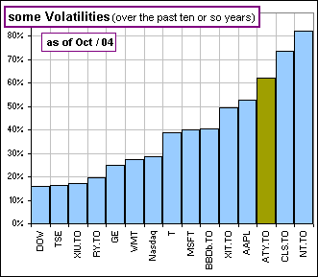
... and some Vanguard Mutual Funds
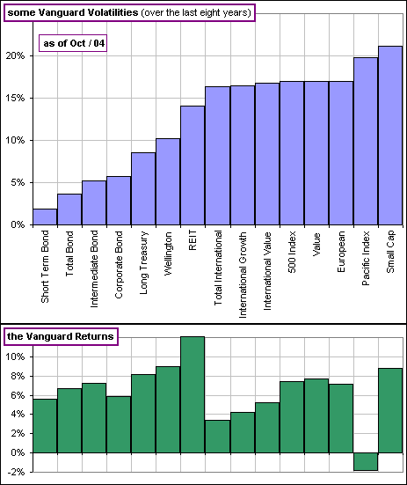

Standard Deviation: some comments on Volatility and Risk and Risk

We consider, at some point in time, the various monthly gains in our portfolio over the past N months ... like so (where the number of occurrences of each gain, out of N = 200, is plotted):  The spread about the average (or mean) gain is measured by the Standard Deviation:  SD² = (1/N)Σ (G_{k} - A)²  where there are N portfolio gains, G_{k} (k=1 to N), and A = (1/N)ΣG_{k} is their Average (or Mean) and SD is the Root Mean Square Deviation between the gains and their average and it can also be computed like so:  SD² = (1/N)Σ G_{k}² - {(1/N)ΣG_{k}}² | 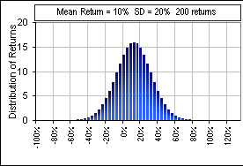  Fig. 1 A 10% monthly gain is unusual, but what the heck.  It looks like a Normal Distribution, but that's an accident!
i.e. SD² is the difference between the average of the squares and the square of the average.
To prove this we first drop the subscripts (for sanitary reasons) and write:
SD² = (1/N)Σ (G - A)² = (1/N)Σ{G² - 2GA + A²} = (1/N)ΣG² - 2A(1/N)ΣG + (1/N)ΣA²
= (1/N)ΣG² - 2AA + (1/N)NA² = (1/N)ΣG² - A²
>Why the "squares" of the deviations from the Mean?
It's convenient, mathematically speaking. We could, however, consider other things to measure how far the returns are, from their Mean. For example, we could pick the largest deviation magnitude, or the average of the deviation magnitudes:
(1/N)Σ |G_{k} - A|
>Example?
For the S&P 500, if we consider the annual returns from Jan 1 to Dec 31, starting in Jan/50 (and ending Jan/00), we'd get:
Mean = 10.1%
Standard Deviation = 15.8%
Maximum Deviation magnitude = 39.8% in 1952
Average Deviation magnitude = 13.1%
>I like the last guy.
Pay attention.
Suppose each G_{k} is increased (decreased) by a factor λ. Then:
SD = {(1/N)Σ (λG_{k})² - {(1/N)ΣλG_{k}}² }^{1/2} = λ{_{k}² - {(1/N)ΣG_{k}}² }^{1/2}
Conclusion? SD also increases (decreases) by the factor λ. (If all gains double, then SD will double.)
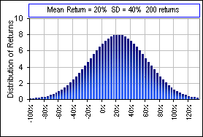
Fig. 2 & 3 Distribution of 200 Normally Distributed monthly returns where each has doubled
Now, suppose the individual gains are changed by ADDING a constant C (rather than multiplying by a constant λ)  Here's a picture of two stocks whose returns differ by a constant  We have, as the new average:  (1/N)Σ(G + C) = (1/N)ΣG + (1/N)ΣC = (1/N)ΣG + (1/N)NC  = A + C  hence the new Standard Deviation:  (1/N)Σ{(G + C) - (A+C)}² = (1/N)Σ{G - A}² = SD²  In other words, the SD is unchanged by the addition of a constant. (Uh ... did I mention that we dropped the subscripts again?) | 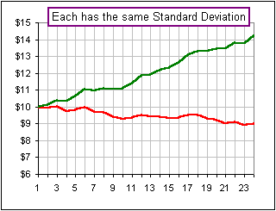
These results are independent of the type of statistical distribution: Normal, logNormal, MickeyMouse, etc.
One important consequence of these results is that if we have a collection of numbers, say {G_{k}},
with Mean = 0 and SD = 1, then the collection {λ G_{k} + C} will have Mean = C and Standard Deviation = λ.

Aah, but what if the individual gains do NOT increase by the same factor?
Write:
SD² = (1/N)Σ G_{k}² - {(1/N)ΣG_{k}}²
and consider the effect of modifying a single gain, namely G_{i}.
Compute d/dG_{i} of each side and get:
SD dSD/dG_{i} = (1/N) {G_{i} - {(1/N)ΣG_{k}} = (1/N) (G_{i} - A)
and this is positive (or negative), implying an increase (or decrease), if the gain G_{i} is greater (or less) than the average of all the gains, A = (1/N)ΣG_{k}.
Increases in those gains which are LESS than the average gain, will cause the SD to decrease.
Decreases in those gains which are GREATER than the average gain, will also cause the SD to decrease.
That's sort of obvious since SD measures the spread of gains about the average. Increasing the smaller gains and/or decreasing the larger gains will reduce this spread, hence the SD. Indeed, for a Normal Distribution (the infamous "Bell Curve"), about 2/3 of the returns lie between Mean - SD and Mean + SD. Stare at the above graphs and convince yourself that this is true. (For the first graph, this range is from 10% - 20% = - 10% to 10% + 20% = 30%.) When SD decreases, these 2/3 crowd closer to the Mean.

Now, it's reasonable to measure the volatility of the gains in terms of their spread: widely varying gains means high volatility, right? So, investment gurus DEFINE volatility as the Standard Deviation. Who can argue with that?
Now suppose MY monthly gains are all increased by some positive constant C compared to YOUR monthly gains.(Say C = 30%, that'd be nice.) As we've seen, SD, hence the volatility, doesn't change. Our graph just gets shifted to the right by an amount C. Same spread, same SD, same volatility. But wouldn't you say that the risk has decreased, for my portfolio? After all, my gains are now 30% higher than yours. Less risky, right? Alas, the investment community says the risk is the same for both our portolios because they normally DEFINE risk as the Standard Deviation (and not as the risk of a loss).  For this association of "risk" with "SD", see 1 and 2 and 3 and ... and n. Even William Sharpe defines the Return per unit of Risk as some Return divided by the Standard Deviation! | 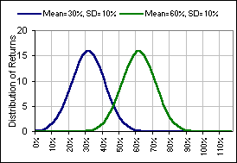  Fig. 4

Now suppose MY monthly gains are all increased by some positive multiplier F > 1 compared to YOUR monthly gains. If your monthly gains are all positive, then F = 2 would be nice. That'd make my gains twice the size of yours.  As we've seen, SD, hence the volatility, changes by the same factor. All the gains in MY distribution graph get shifted to the right by a factor F, the spread increases by that factor and the SD (and the volatility) change by the same factor. (The height of my graph decreases 'cause the number of returns hasn't changed, so there are fewer in each of the intervals along the horizontal axis - because of the increased spread.) Because of this increased spread, there is a greater probability of Returns far from the mean; that's the extended tail of the distribution chart. For some distributions, this extended tail means a greater chance of disastrous Returns! (See Kurtosis)  See Fig. 3, compared to Fig. 2, or, better still, here's a closeup of the tails:  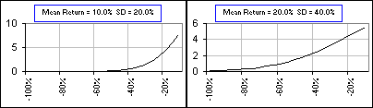  Fig. 5a The tail of the distribution | 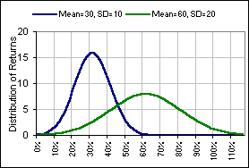  Fig. 5
But, if all YOUR gains were positive, wouldn't you say that the risk has decreased, for my portfolio? After all, my monthly gains are now higher than yours by the factor F. Less risky, right? Alas, the investment community says the risk is higher for my portfolio because (have we said this before?) they usually DEFINE risk as the Standard Deviation ... and that's increased!
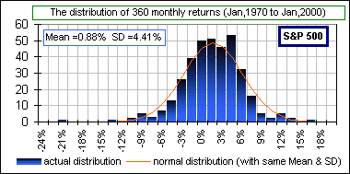  Fig. 6 | One other thing: the charts above look like Normal Distributions. Well ...uh, they are, but it's only so I could get pretty pictures. The real, live monthly returns for, say, the S&P 500 look sorta Normal ... but that's not important for what we're discussing.

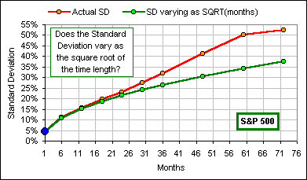  Fig. 7 | Oh yeah ... one other thing: We often (?) hear that the Standard Deviation increases as the time interval increases. In fact, a common statement is that SD varies as the square root of the time: SQRT(time).  This follows (mathematically speaking) from Einstein's 1905 analysis of a random walk (or Brownian Motion) and, earlier, it's associated with Louis Bachelier and even earlier with Jules Regnault (See this.PDF). It assumes the returns are random in this sense. Are they?  Looking at all intervals of length 1 month, 6 months, 12 months, etc., and calculating the SD for each set, we get this chart. Close, but no cigar.
P.S. The argument goes something like this:
If you start at x = 0 and take N steps of length x₁, x₂, ...., x_{N} then your distance from the origin (x = 0) is R where, to get the Standard Deviation of the set of distances from the origin (over all possible sets x₁, x₂, ... ), we consider the Mean Square of R ... hence we consider:
R² = (x₁+ x₂+...+ x_{N} )² = x₁²+ x₂²+... +x_{N}² +2x₁ x₂ +2x₁ x₃+ ...
If the Mean = 0 (for the steps x₁, etc.), then each is equally likely to be positive as negative and, for large N, the cross terms like x₁x₂ will average to zero and we're left with
R² = x₁²+ x₂²+... +x_{N}² = N { (x₁²+ x₂²+... +x_{N}²)/N } = N {Standard Deviation of the x's}²
leaving us with: R = N^{1/2} {Standard Deviation of x's} * ... and the square root pops up.
If the number of steps, N, increases with time, then this is proportional to SQRT(time).
* Note that {Standard Deviation of the x's}² is the difference between the average of the squares and the square of the average. That is:
{Standard Deviation of the x's}² = (1/N)Σ x_{k}² - {(1/N)Σx_{k}}²
But, if the average value of the x's is zero, then Σx_{k} = 0 so
(1/N)Σ x_{k}² = {Standard Deviation of the x's}²

We might also do this is 2 dimensions.
Suppose we start at the origin (0,0) and move left or right in steps of length x₁, x₂, ...
and, at the same time, move up or down in steps of length y₁, y₂, ...
Then, after N steps, we're at position (x₁+x₂+ ...+x_{N}, y₁+y₂+ ...+y_{N})
Our distance from the origin is then R where:
R² = (x₁+x₂+ ...+x_{N})²+(y₁+y₂+ ...+y_{N})²
As above (assuming that the Mean of the x's and y's is zero and there is no correlation between successive x's or y's), we'd get
R² = N [{Standard Deviation of the x's}² + {Standard Deviation of the y's}²]
or (since the Variance is the square of the Standard Deviation)
R² = N ( Variance[x] + Variance[y] )
We conclude (again!) that the distance from where we started increases as the Square Root of N.
See also Square Root of Time

If we accept this Square-Root-of-Time scenario, then a Standard Deviation of N-month returns will be larger than the Standard Deviation of 12-month (that is, annual) Returns ... larger if N is greater than 12.
In general, if SD(N) and SD(M) are the Standard Deviations of N- and M-month returns, we can write:
SD(N)/SQRT(N) = SD(M)/SQRT(M)
To annualize "Monthly" returns, we can do the following:
- Calculate the Standard deviation of Monthly percentage Returns (over, say, 36 months).
- Annualize this SD of 1-month returns by writing:
SD(1)/ SQRT(1) = SD(12)/SQRT(12)
Hence, the Standard Deviation of annual returns (meaning 12-month returns) will should may be estimated as
SD(1) SQRT(12)
so y'all just multiply the Standard Deviation of monthly returns by the square root of 12 in order to estimate the Standard Deviation of annual returns.
If we wanted the SD of annual returns and observed these annual returns over a 36 month period, we recognize that there would only be three returns to consider (in this 3-year period)! So we can take the SD value for monthly returns (there's 36 of them!) and multiply by SQRT(12) = 3.46 (roughly) to get estimate the SD of 1-year returns.
>That's assuming you believe in this Square-Root-of-Time stuff.
Right! But it makes some sense. After all, one would expect the 12-month gains to be 12 times the monthly gains (roughly), so the Mean Squared Deviation would be 12² times larger, but over any given time interval (like N years worth of gains), there would be 1/12 as many terms in the sum (1/N)Σ (G_{k} - A)² so we're up by a factor 12²/12 = 12 and the Standard Deviation (being the square root of the Mean Squared Deviation) would be SQRT(12) times larger ... roughly.
>I haven't the foggiest idea what you just said.
Here's an example. Over the 51-year period Dec/50 to Dec/00 the 1-year returns for the S&P 500 averaged 10.1% - that's the return for the year ending Dec 31/50, then the return for the year ending Dec 31/51, etc..
The Standard Deviation of these fifty-one annual returns is was 15.8%.  On the other hand, the Average monthly return was 0.79% and the Standard Deviation of these monthly returns was 4.09%  (and there were 12 x 51 = 612 of these monthly returns).  The ratio of SD(Annual)/SD(Monthly) = 15.8/4.09 = 3.86 whereas  SQRT(12) is ... uh ...  >3.46 (roughly)?  Right!  >And I notice that the 12-month average return is larger than the average 1-month return by a factor 10.1/0.79 which is ... uh ...  12, roughly. | 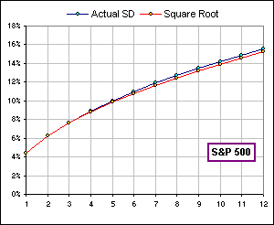
>12.78, actually.
However, I should mention the following:
- We consider just monthly returns over N months.
- We calculate the Standard Deviations of these monthly returns, as N increases.
- We get an decreasing Standard Deviation!!
>Didn't you just say the Standard Deviation increases?
That's if you consider the Standard Deviation on N-month returns. What I'm talking about now is the Standard Deviation of 1-month returns, over N months. See the difference?
>No!
Then just look at this picture. See? The variability decreases as N, the number of 1-month returns, increases.
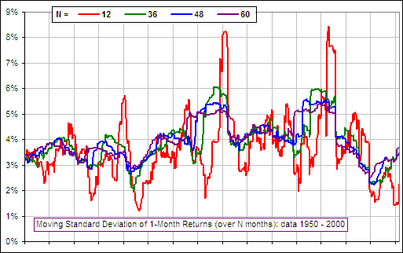

Okay, if the risk (in the investment guru sense, meaning Standard Deviation) goes UP when the time period increases, what about the risk (in the dictionary sense)?
risk n. The possibility of suffering harm or loss. -v To expose to the possibility of harm or loss.
(That's not my definition of risk. It's Webster's.)
We want to investigate the possibility of suffering harm or loss, so here's what we'll do (for investing in the S&P 500, for example):
We look at all 1-month intervals between Jan 1, 1970 and Jan 1, 2000 (that's thirty years and 360 such 1-month intervals) and count the number of times we would have LOST money. Then we look at all 6-month intervals, then 12-month intervals, ... then 120 month-intervals. (The last is 10 years, right? And there's 240 120-month intervals between Jan 1/70 and Jan 1/00.) For each we plot the percentage of intervals when we would have lost money (i.e. the gain over the given N-month period was less than 1). (That's our suffering harm or loss.)
We'd get:  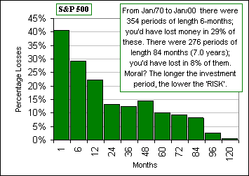  Fig. 8  risk HAS decreased with length of investment horizon!  ... and, for the NEXT thirty years? | 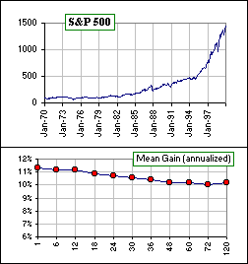  Fig. 9  Showing the average of the N-month gains, annualized.  P.S. Note that the '87 CRASH is just a minor blip!
Of course, in addition to the risk of loss, we should consider the degree of risk ... maybe like so:
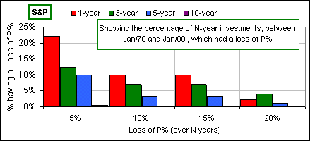
Fig. 10 The percentage of times that we would have incurred a Loss of P% (Jan 1,1970 to Jan 1, 2000)
For example, in all the 3-year intervals (between Jan/70 and Jan/00), 4% of them would have suffered a loss of at least 20%.
'course, mebbe the time length (30 years) is too short (too small a sample?), so here's 50 years:
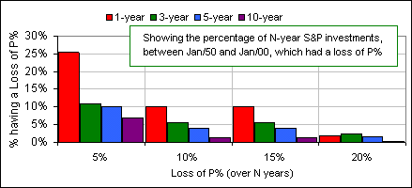
Fig. 11 The percentage of times that we would have incurred a Loss of P% (Jan 1,1950 to Jan 1, 2000)

and then there's:  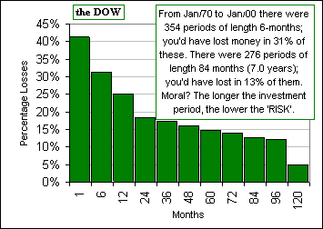  Fig. 12 ... but, what about the NEXT thirty years? | 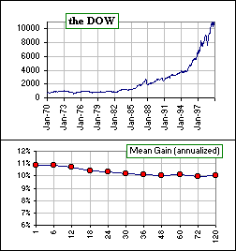  Fig. 13

and:  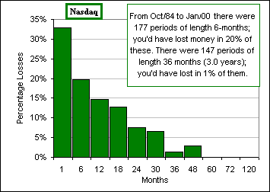  Fig. 14 | 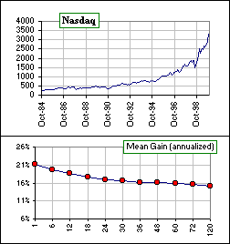  Fig. 15

  and finally:  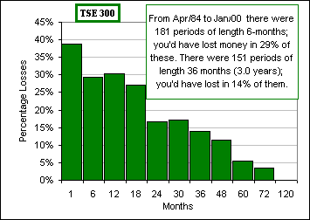  Fig. 16 | 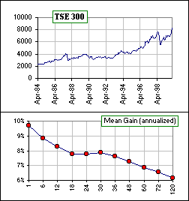  Fig. 17

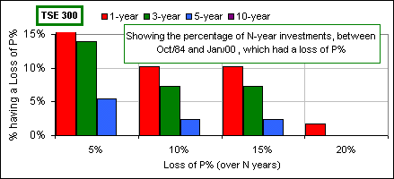
Fig. 18 There were 64 10-year periods in Oct/84 - Jan/00. None suffered a loss of 5% or more.

Data obtained here
Uh ... one more thing. The set of monthly gains for, say the S&P 500, may be rearranged and the rearranged set will have identical Distribution, Mean and Standard Deviation. For example, if we were to rearrange the gains so they occur from Minimum to Maximum (over the past thirty years) the S&P would look quite different (though it'd end up at the same place). If the ordering were from Maximum to Minimum ... well, a picture is worth a $1000 words:

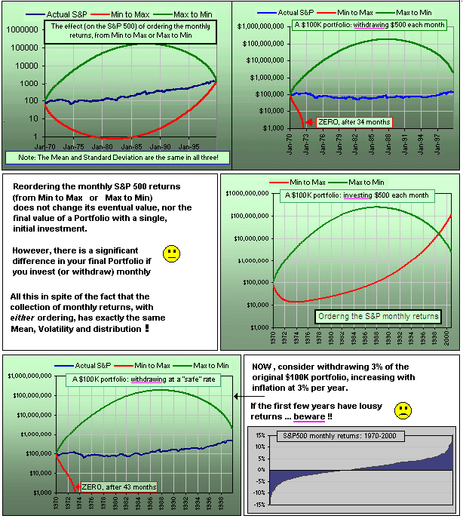
Fig. 19 The best of times, the worst of times ...

And if we invest in the S&P 500, but make monthly withdrawals? What'd our portfolio look like in each reordered case?
A BIG difference in the final result, eh what? (... yet the Distribution of Returns is the same.)

In all fairness, investment gurus equate risk with "uncertainty" so, when the spread of monthly gains increases, there is greater uncertainty so it's reasonable to say there is greater risk.
Or is it? If I invested in a stock that decreased by a fixed amount each month*, there would be no uncertainty (SD = 0) and ... uh, no risk ... even tho' I lose every single month! No risk, eh?
Strange world, this world of investing. They've got a language of their own.
* An investment with a constant negative return? Yeah, that's my mutual fund. You might like to invest in it.
I invest in GICs at 2% and my MER (Management Expense Ratio) is 3%
"One should always change the meaning of a word when practising the art of obfuscation"
Related stuff: Random Walks and Portfolio Growth
and A discussion of risk and risk
I forgot to mention how the Standard Variation varies, depending upon the time interval over which it's computed. Normally, for investment purposes, the SD is computed using monthly returns over three years. If (for a change of pace) we compute the weekly percentage gains (instead of monthly) for, say, the Dow Jones Industrial Average, we get:

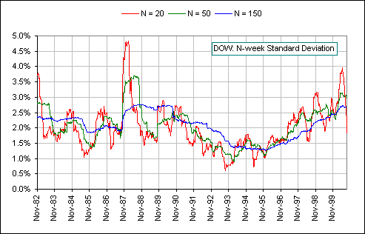

For the crash of '87, the high volatility hung around for nearly three years, for the 150-week Standard Deviation!
> Aha! Weekly? Why weekly? Why not Monthly?
Okay, here's monthly:

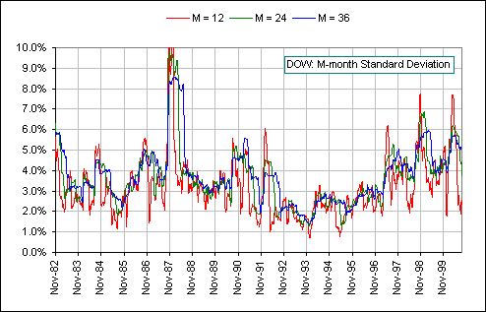

Notice that the monthly SD is roughly 2 times the weekly SD because the time interval is about 4 times longer
and the SD varies (roughly) as the square root of the time interval and the square root of 4 is 2.
Neat, eh?

Uh ... one more thing:
If the lousy definition of risk is disagreeable, perhaps because it doesn't distinguish between POSITIVE deviations from the mean and NEGATIVE deviations - the POSITIVE ones are good, eh? ... and the NEGATIVE ones ain't good - then there is something called downside risk where we set some goal (say 12% per year or maybe 1% per month) and ignore every monthly gain above this goal (because we feel there's no risk associated with gains above our goal) then compute the Standard Deviation of just those below our goal. (There are variations on this theme, but it means, for example, that we ignore the blue gains in the following chart and use only the green gains when computing the SD):

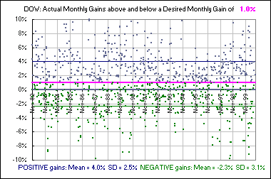
In case y'all are wondering, the Standard Deviation (SD) for ALL monthly gains, both POSITIVE (above the goal) and NEGATIVE (below the goal), is 4.2%

One last thing (I promise):
Suppose you invest a certain fraction of your monies in an Equity Mutual Fund (say 75%) and the balance in a Bond Mutual Fund (that'd be 25%), then you'd expect less volatility ... compared to investing everything in Equities, right? Here's a chart which shows two Funds: an Equity and a Bond fund. It also shows the growth of a portfolio which invests certain fractions in each ... along with the Standard Deviation (SD). Note that the SD increases as the percentage devoted to Equities increases ... and the overall gain decreases.

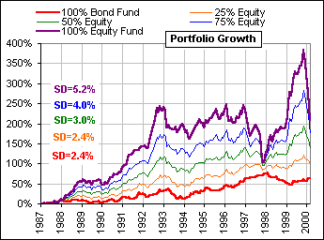
Moral? If volatility scares y'all ... try some Bond Fund.
It may not make you rich ... but you'll sleep more soundly.
And one other thing: You might have gained sorry the impression that increased Gains means having to suffer increased Volatility.

Here's a chart with thirty points.
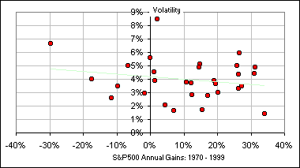

Each point identifies a Standard Deviation (or Volatility) and a Gain for the S&P500, for each year from 1970 to 1999. The Gains run from -30% to about +35%. The SD runs from about 1.5% to 8.5% and you'll have noticed that there is little if any indication that they're correlated. Indeed, it would appear that the bigger Gains were associated with the smaller SDs.
>Look closely and you'll see a faint line. That's the "best-fit" regression line ... and it slopes DOWN to the right !
We should also note the effect of increasing the Standard Deviation on your eventual portfolio after 1, 2, 3, ... 15 years.
If we look at the range of possible portfolios (within 2 standard deviations of the Mean Return), assuming (for example) a Log-normal distribution and SD = 15% and SD = 25% ... we get
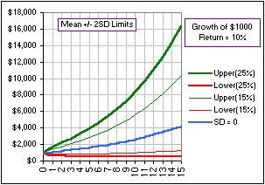

Risk: how to measure it?
Once upon a time I played with the monthly returns for various world markets from Jan, 1975 to June, 1997 and found a number of interesting things I'd like to share (connected to the topic of Risk):
Did you know that:
- There was not a single 2-year period when you would have lost money in the U.S. Large Cap market.
- The chances of losing money in European Large Caps was only about 30% of the chance of making more than 10% ... over any 3-year period.
- In Cdn Small Caps, you were 1 1/2 times more likely to make more than 10% annual return over any 12 month period than to make less than 0%.
- In Pacific Large Caps, you would have lost more than 5% of your investment over a 6-month period 45% as many times as you would have made money.
From here the road gets bumpy ...
Consider the following:
There are 246 intervals of length M=24 months (from Jan, 1975 to June, 1997).
You invest in Stock XYZ or perhaps Mutual Fund ABC.
- What fraction of these 246 24-month intervals would have given you an annual return greater than U = 10%? (U stands for Upper.) Suppose the answer is 0.5 meaning 50% these intervals would have given you an annual return greater than U = 10%).
- What fraction of these 246 24-month intervals would have given you an annual return of less than L = 0%? (L stands for Lower.) Suppose the answer is 0.1 meaning 10% of these intervals would have given you an annual return less than L = 0%.
The ratio gR³ = (fraction over 10%)/(fraction under 0%) = 0.5/0.1 = 5 means that you were 5 times more likely to achieve a return of 10% or greater than to make less than 0%.
>You could've just divided 50% by 10% and get 5, right?
Uh ... yes.
>What if gR³ = 2?
Twice as likely to achieve 10% than to lose money.
In fact, for Canadian Large Caps, we have gR³ = 2.0 and for other markets we have the following values of gR³:
Cdn Large Cap 2.0
Cdn Small Cap 1.5
U.S. Large Cap 4.9
U.S. Small Cap 7.6
Euro Large Cap 3.2
Asia Large Cap 1.7
Of course, gR³ depends upon the values of Months, Upper and Lower (as well as the total time interval Jan/75 - Jun/97, of course). We'll call it gR³(M,U,L), so that, since the above list considered the case M = 24 months and more than U = 10% and less than L = 0%, then we're talking about gR³(24,10,0).
From the above list we can see that for US Small Caps, gR³(24,10,0) = 7.6 meaning you were 7.6 times more likely to achieve 10% annual return than to lose money, over any 24 month period!
If you've come this far along, you may be interested to know that:
- gR³(24,0,0) = infinity for the U.S. Large Cap market.
- gR³(36,10,0) = 3.3 in European Large Caps.
- gR³(12,10,0) = 1.5 in Cdn Small Caps.
- gR³(6,0,-5) = 2.2 in Pacific Large Caps.
You may recognize these "mathematical" statements.
They are precisely the statements 1, 2, 3 and 4 made earlier.
>Why gR³ ? Why not gR², like E = m c² ?
For those gallant few who have made it this far, R³ stands for Reward Risk Ratio:
making LESS than L = 0% is the Risk and
making MORE than U = 10% is the Reward
and we consider the Ratio so far, we've got R³
... and can y'all guess what g stands for?
>The Market Data, can we trust it? Where'd it come from?
Uh ... the data for the various large/small cap markets was obtained here:
>Where's the pictures? You usually have pictures! I mean ...
Here's one:
We consider all the N-year periods starting each month from Jan, 1928 to Year 2000. Then all the N-year periods starting in Feb, 1928 then starting in Mar, 1928 etc. etc. and determine the percentage where the annualized gain exceeded 10% and compare it to the percentage where the gain was less than 4%. The ratio would be ...
>Don't tell me! It's gR³(360,10,4) ... for 360 months and 10% and 4%, right?
Very good, but 360 would be for 30 years. In general ... well, here's the picture:
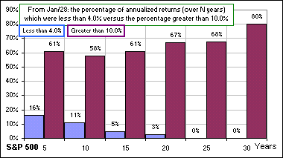
>Uh ... does that mean that, over 25 years, 68% of annualized returns were greater than 10% and ...
And none were less than 4%.
>That makes 25 x 12 = 300 months so gR³(300,10,4) = 68/0 = ... uh ...
Infinite. However, one can judge what the "risk" might be for various asset allocations just by staring raptly at the chart. For example, here's a similar chart where, instead of just the S&P 500, we invest in a 4 x 25 portfolio: 25% in each of Large/Small Cap and Large/Small Value and rebalance yearly.
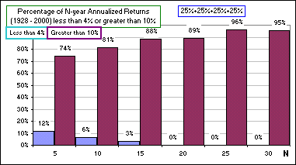
However, if we're lookimg for a single number which (somehow!) describes "risk" ...

Okay, let's think about a variation of the above measure of risk:
Suppose we look at the monthly gains (for some stock or mutual fund) which are greater than some pre-assigned percentage, U (meaning Upper), and those which are less than some pre-assigned percentage, L (meaning Lower).
We'll label the set greater than U like so: | u₁, u₂, u₃ ... u_{N}
and those less than L like so: | l₁, l₂, l₃ ... l_{M}
assuming there are N of the former and M of the latter. We're using the subscript "k" to denote a particular member of the set, so k = 1 or k = 2 or ...
Uh ... let's assume we ALWAYS choose L = 0 so the L-set corresponds to NEGATIVE monthly gains - that's the risk, right? We also choose U > 0 so it corresponds to POSITIVE monthly gains. Our goal is to invest so that the U-set is huge and the L-set is microscopic.
It's a battle.
Will the u's win?
Will the l's win?
GO U-set!!
>Keep going!
Okay. If the U-set were distributed about, say, +5% and the L-set were distributed just under "0" (with l's not too negative, corresponding to small monthly losses), and there were lots of u's and not too many l's, we'd be ecstatic.
In particular, if we plot the distribution of monthly gains for the S&P 500 we get the chart at the right (for the period Jan, 1970 to Jan, 2000) which gives the number of monthly gains in each interval.  >Finally! A picture! A picture is worth a thousand -  Okay! Pay attention!  Notice that's the distribution is close to being Normal ... the infamous Bell Curve. Later we may just assume it is normal. In the meantime, we want to ignore those gains which lie in the interval  L < gain < U  because we're only looking at the gains to the left of  L = 0 or to the right of U = something_positive. | 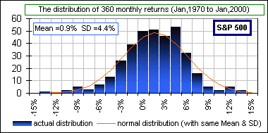  Fig. 1

 | 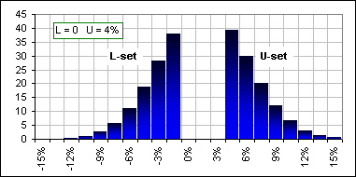  Fig. 2 | If we delete that part of the chart we get the chart at the left where, for the sake of concreteness, we've assumed  U = 4% and, of course, L = ...  >Concrete? Did you say -  Now we throw darts at the chart ...  >Darts? Did you say -  ... and see if it hits the L-set or the U-set. If it misses either of these, we ignore the dart toss. Then we see what percentage of our dart throws (not counting those which miss everything) result in a GOOD gain, lying in the U-set, compared to those which result in a BAD gain.
The percentage is the Area of the U-set divided by the Area of the L-set. For the case shown above, it's 1.08
Our conclusion? During the period Jan/70 to Jan/00, you were just slightly more likely to make a monthly gain more than 4% than you were of losing money.
>That's pretty lousy!  Of course, but asking for a monthly gain exceeding 4% is rather optimistic. If we ask only that it's greater than 1% (that's about 12% per year), then the ratio is about 2. We were twice as likely to make a monthly gain exceeding 1% than making a negative gain.  >Picture! Picture!  Okay, here's a little picture of the L and U distribution(s)  >So I'd be twice as likely to make 12% as losing - | 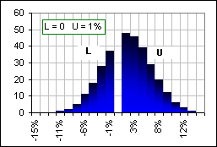  Fig. 3

We were talking about a single month here! Any of the 360 months in that thirty year period. Of course, we could also talk about the 12-month gains or the 24-month gains or ...  >So this ratio depends upon U and L and M ... sounds familiar.  Right. Now let's simplify the prescription for computing this ratio. Here's what we'll do:  - Determine the Mean and Standard Deviation of the monthly returns.  - Assume they are normally distributed, and construct a normal curve with the same Mean and SD.  - Delete the portion between L and U like so  - Compute the ratio of Areas, using well-known formulas ... | 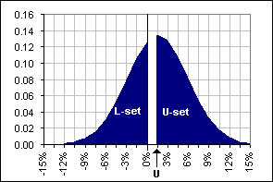  Fig. 4
>Well known? You're kidding, right?
Pay attention.
Let's assume that L = 0 so that the L-set corresponds to investment losses. In any case, that's what Fig. 4 illustrates. Oh, and I should mention that the vertical axis, in Fig. 4, doesn't measure the NUMBER of returns but the FRACTION of returns. Earlier, in Fig. 1, if we computed the total Area we'd get the total NUMBER of monthly returns, namely 360 (in the thirty year period). Here, in Fig. 4, the total Area would be "1".
>That's confusing ...
Okay, we just take all the numbers along the vertical axis in Fig. 3 and divide them by 360 and we'll get a fraction and that gives us Fig. 4 which we've also smoothed out so it's a normal curve.
Now, suppose we have a magic formula for the area, from x = a to x = b, under a normal curve which has Mean = m and SD = s.  We'll call it A(a,b,m,s). Stare at Fig. 5 to see the area we're talking about.  Then our Risk Ratio is : A(U,∞,m,s) / A(-∞,0,m, s)  Remember, the TOTAL area under the curve is "1", so A(-∞,∞,m,s) = 1  and if we choose U = the Mean monthly gain, then A(m,∞,m,s) = 0.5  >... and the magic formula for the area? | 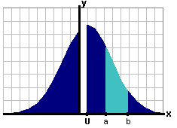  Fig. 5
Okay, let's do it. If y'all hate calculus, you can skip this part and go here.
The Normal distribution (meaning the equation of the normal curve, most of which is shown in Fig. 5) is
We'll call this function f(x,m,s) and the magic formula for the area A(a,b,m,s) is:
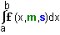
Whereas there are tables of areas for normal distributions with Mean = m = 0 and SD = s = 1, there ain't hardly none for arbitrary Mean and SD ... so we transform our function like so:
Set x = m + s t in the distribution function f(x,m,s) and get f(x,m,s) dx = f(t,0,1) dt
and we've succeeded in transforming to Mean = m = 0 and SD = s = 1.
The limits "a" and "b" also change to (a - m)/s and (b - m)/s. In particular, our Area function becomes:
A ( a,b,m,s) = A ((a - m)/s ,(b - m)/s,0,1 )
Let's give A ((a - m)/s ,(b - m)/s,0,1 ) another name. There's little point in including the parameters "0" and "1" since they won't hardly change; they're ALWAYS "0" and "1". We'll call it simply:
A ((a - m)/s ,(b - m)/s)
So where are we?
- We determine the Mean m and Standard Deviation s of the historical monthly returns.
- We assume they are normally distributed.
- We select some U value (making it a fraction, so 1.2% means U = .012 and we assume L = 0 so that "risk" is a risk of losing).
- We compute the ratio A(U,∞,m,s) / A(-∞,0,m, s) , namely:
A ((U - m)/s ,∞)) / A (-∞ ,- m/s)
where A (p,q) is the probability that a variable (normally distributed with Mean = 0 and SD = 1) lies between p and q.
> ... zzzzzz ...
Well?
>Uh ... where's the root of s?
It's a factor of both numerator and denominator so it cancels out. Neat, eh?
> ... zzzzzz ...

Okay, here's a picture of the cumulative normal distribution A(-∞,x) (the Area function we talked about earlier, where we consider EVERYTHING less than a value "x") with Mean = 0 and Standard Deviation = 1:
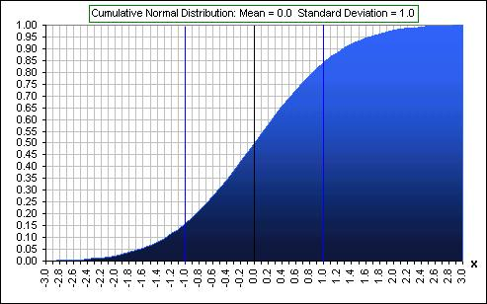
Fig. 6 Cumulative Normal Distribution, showing the fraction of values less than a given value
I've drawn a vertical line at x = -1. That's one Standard Deviation below the Mean of 0. Reading off the chart, a normally distributed random variable will have 0.16 of its values less than -1. There's a second vertical line one SD above the Mean, at x = 1 and, again, reading off the chart, 0.84 of the values will be less than +1. We conclude that 0.84 - 0.16 = 0.68 of the values of a normally distributed random variable will lie between x = -1 and x = 1. That is, 68% will lie within one Standard Deviation of the Mean.
>As long as the Mean is zero and the SD is ...
Well, actually, it's true for any Mean and SD. If we increase (or decrease) the Mean by some amount, the chart just slides to the right (or left) by that amount. If we increase (or decrease) the SD by some amount, the chart expands (or contracts) horizontally.
>Contracts horizontally?  Here's a picture to illustrate, where we decrease the Standard Deviation from SD = 1 to SD = 0.5 and you can see that it contracts ... horizontally, eh? The two values at x=-SD and x=+SD, namely 0.16 and 0.84, are the same so their difference still gives .68 or, to use the standard recitation of investment gurus:  "2/3 of returns lie within one Standard Deviation of the Mean".  >But 68% isn't 2/3.  It's close enough.  >Is this measure of risk any good?  Well, let's put it to the test. | 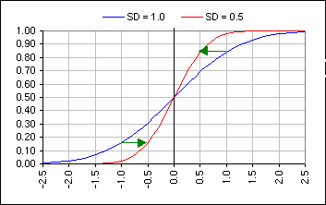  Cumulative Normal Distribution, showing the effect of changing the SD
We'll consider the monthly gains for the stock General Electric from Jan, 1970 to Jan, 2000 ... 360 months, where we get the data here.
- The average gain was 1.3% (so we put Mean = m =.013)
- The Standard Deviation was 6.5% (so we put SD = s = .065).
- We'll select our "reward" as 1% (meaning any monthly gain of 1% or more is a GOOD gain). That puts U = .01, so
- we now compute (as prescribed above) the number (U - m)/s = (.01 - .013)/.065 = -0.046
and the number - m/s = -.013/.065 = -0.20
- Now we compute (as prescribed above) the Ratio:
A ((U - m)/s ,∞)) / A (-∞ ,- m/s) = A(-0.046,∞) / A(-∞,-0.20)
We'll do this by reading directly from Fig. 6, giving the Ratio: (1 - 0.48)/.42 = 1.23
>Wait! What's this (1 - 0.48) stuff?
We get, from Fig. 6, that the fraction of values which are less than -.046 is 0.48, hence the fraction above -.046 is (1 - 0.48). Anyway, we conclude that you were 1.23 times as likely to have a monthly gain greater than 1% than you were to lose money, in GE stock, over the thirty years 1970 - 2000. That's 23% more often. That's good, isn't it?
>But you already have the data. Is it true? I mean that percentage, 23% ... was it 23%?
Hmmm, good question. Let's see ... I'm looking at the data ... there were 178 months with gains of 1% or more ... and 160 with negative gains ... that gives a Ratio of 178/160 = 1.11 so ...
>Aha! Just as I thought! You're way off the mark! A wise man once said:

"When possible, use the data and not a mathematical proxy"
Amen.

Here's another neat thing. A measure of Risk which goes like so:  - We assume a set of Returns with a certain Mean and Standard Deviation.  - We assume they're distributed Normally.  - We determine, from the Normal Cumulative Distribution, the percentage of Returns which are negative. It'll depend upon the ratio Mean/SD  - We define that percentage as the Risk.  It looks like so:  See also another Frontier. | 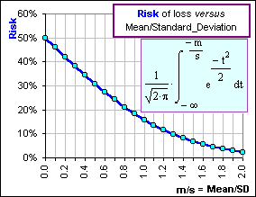
In any case, let the gurus use their silly definitions, like "Volatility = Risk".
For us mere mortals, let us not say that the GREEN stock
has been a riskier investment than the RED:
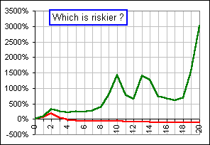
Let's just say it's been more Volatile.
Here's another definition of "Risk":
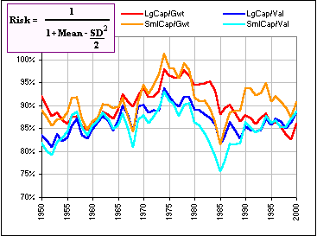
>Is it any good?
Okay, here's the question:
Over the past umpteen years, investment A has had a Mean return of 10% and a Volatility of 20%.
Investment B has had a Mean return of 12% and a Volatility of 25%.
Investment B has had a higher Volatility ... hence has been more risky.
Do you believe that? (See this for a Monte Carlo-type answer.)
Now suppose there existed a (fictitious) Mutual Fund which guaranteed a minimum annual return.
The chart looks like so, for the past twenty years.
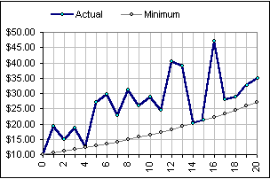
The Volatility has been greater than the S&P 500 ... so it's riskier.
>Do you believe that?
Several Nobel prize winning physicists DEFINE "Green Cheese" to mean the constituents of the moon.
The headlines read: "The moon is made of Green Cheese!"
Ain't definitions wunnerful?
You can turn the moon into green cheese
... and Volatility into Risk
>So what definition of "Risk" do you like?
Me? Personally? I like something like the following:
Assume a percentage, say 30%, of your portfolio is devoted to stocks (and 70% to bonds, with annual rebalancing):
(1) Pick, at random, annual stock returns (from, say, S&P 500 data over the past 75 years).  (2) Assume that the average annual bond return is 5% with Standard Deviation of 8%.  (3) Do a thousand Monte Carlo simulations, assuming a 5% annual withdrawal from this portfolio, this amount increasing at 3% annually, due to inflation.  (4) See what percentage (of the thousand simulations) do NOT survive for 30 years: call it X%  (5) Change the percentage devoted to the stock & bond components and repeat (1) - (4).  (6) Get excited about the percentage that minimizes X%. | 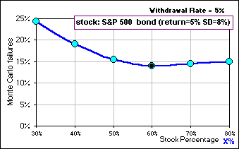
Of course, all these can be changed ...
>That's a complicated definition. I mean, what if I'm not even withdrawing from my portfolio?
That's not relevant. This definition is complicated, yes, but it does reflect the notion that "risk" is associated with loss and it depends upon many parameters like returns and volatility and inflation and asset allocation ... and it generates a number that investors can relate to.
>You think so?
Yes. Don't you?
>I prefer standard deviation. It's depends just upon one thing: standard deviation.
Fine.

Stock Path Volatility
... and other thoughts, questions & musings 
Motivated by comments of Taleb
Consider the chart in Fig. 1.
The big black dots are the monthly values of some stock (or portfolio).
The smaller blue dots follow the weekly values.
>Every 4 weeks gives a month? Are you kidding? It's 365/12 except leap years when ...?
Patience. I want to demonstrate something and we'll assume 4 weeks to a month and 12 months to a year ... hence 48 weeks per year.
If we calculate the mean and standard deviation of the weekly returns and the monthly returns, we get the numbers shown in Fig. 1.
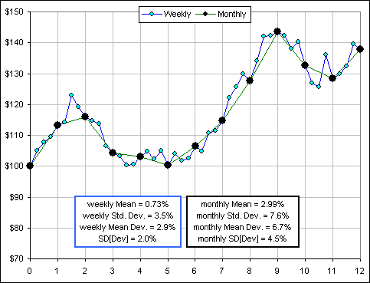
Figure 1
Note that the monthly mean is (roughly) 4 times the weekly mean (since there are 4 weeks per month) and the monthly standard deviations are (roughly) 2 times the weekly standard deviations (where 2 = SQRT[4]).
>Huh? Square root of 4? Yeah, that has to do with the square root of time thing ... but don't worry about it. Just observe.
>And what's that "Mean Deviation" and, I presume, its standard deviation?
Uh ... yes.
SD[Dev] stand for the standard deviation of the deviations of returns from their mean. We'll get to that later.

Note:
If we "annualize" the weekly values we'd multiply the returns by 48 and the standard deviation by SQRT[48], giving: annual return = 35% and annual SD = 24%.
To annualize the monthly values, we'd use 12 and SQRT[12] and get: annual return = 36% and annual SD = 26%.
Notice that ...
>They're pretty close, eh? Yes. I find that's usually the case even if we change the numbers from 48 weeks to 52 or ...
>Aah, but how do you generate the weekly returns?
I download a years worth of weekly prices for some stock then randomize the weekly returns and ...
>Where's the spreadsheet? There's a spreadsheet to play with and it looks like this: GUMMY PATH VOLATILITY
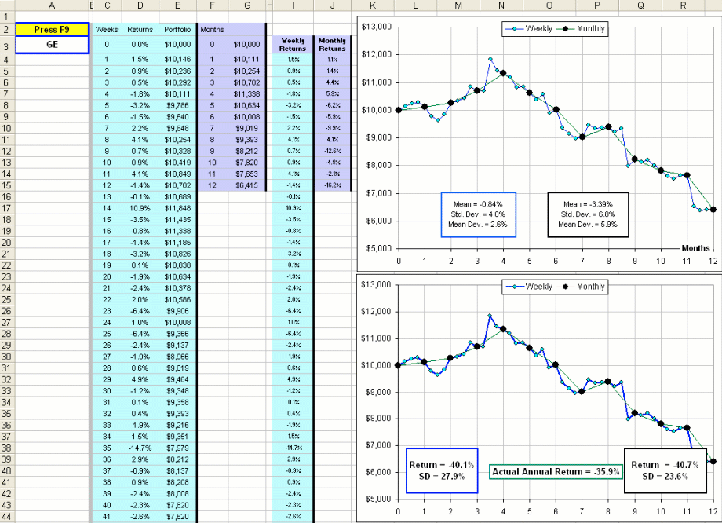
In the above example, we're using GE stock.
Every time you press F9 you get a different collection of weekly (hence monthly) returns.
The charts show the weekly values of a $10K portfolio ... and the values every 4 weeks which we're calling a month.
>I notice that the big black dots coincide with the small blue dots every 4 weeks.
Clever observation.
So, although the portfolio arrives at the same final value, after a year (and every 4 weeks), the path taken affects the calculated values of annualized return and volatility.
>But they're close, eh? Not always. Here's a few examples (using randomized weekly returns for MSFT):
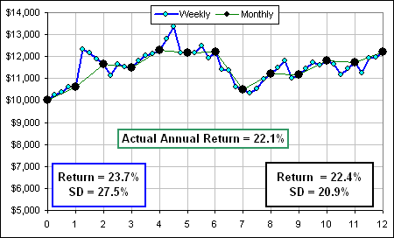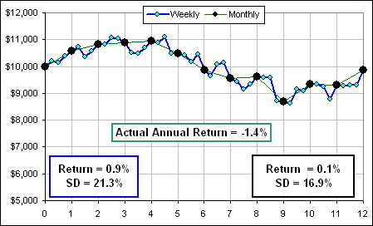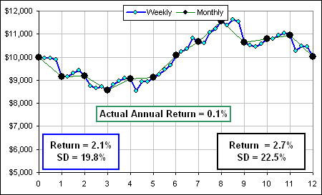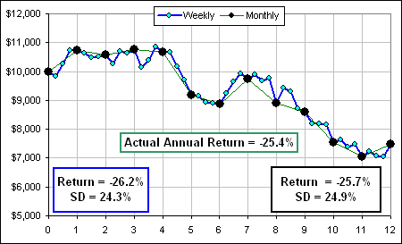
>When you say "Annual Return" you really mean 48-week return, right?
Another clever observation.

Mean Variation
Consider the following:
- r_{k} is a sequence of stock (or portfolio) returns, with k = 1, 2, ... n.
- m[r] = (1/n) (r₁+r₂+...+r_{n}) = (1/n) Σ r_{k} = the mean of the n returns.
- s²[r] = (1/n) Σ (r_{k} - m[r])² = mean-square deviation gives s[r], the standard deviation (or volatility) of the n returns.
- x_{k} = | r_{k} - m[r] | = the absolute value of the kth deviation (from the mean of the returns).
- M[x] = (1/n) (x₁+x₂+...+x_{n}) = (1/n) Σ x_{k} = the Mean of the n deviations.
- S²[x] = (1/n) Σ (x_{k} - M[x])² = mean-square deviation gives S[x], the standard deviation (or volatility) of the n deviations.
Now expand the sums like so:
[A] s²[r] | = (1/n) Σ (r_{k} - m[r])² = (1/n) Σ (r_{k}² - 2 m[r] r_{k} + m[r]²)
 | = (1/n) Σr_{k}² - 2 m[r] (1/n) Σr_{k} + (1/n)Σm[r]²
 | = (1/n) Σr_{k}² - 2 m[r] (1/n) Σr_{k} + (1/n)m[r]²Σ(1)
 | = (1/n) Σr_{k}² - 2 m[r] m[r] + (1/n)m[r]²(n)
 | = (1/n) Σr_{k}² - m[r]² = (the mean square) - (the square of the mean).
Similarly:
[B] S²[x] = (1/n) Σx_{k}² - m[x]²
Note, however, that (1/n)Σx_{k}² = (1/n)Σ| r_{k} - m[r] |² = s²[r] (see #3 and #4, above.)
We conclude, from [A] and [B], that:
S²[x] + m[x]² = s²[r]
>And that makes S[x] smaller than s[r], right?
Yes, the standard deviation of the deviations of the returns (that's S[r]) is smaller than the standard deviation of the returns themselves (that's s[r]).
>So what's this Mean Variation you're talking about?
I forgot. It's M[x], the Mean of the deviations in the returns. (see #5, above.)

"Expected" Return
Suppose we have a bunch of historical returns (weekly, monthly, yearly, whatever).
We'd like to use that info to try to predict the next return: next week, month, year, whatever.
That'd give an "Expected" return. What would you use?
>I'd use whatever is the best predictor.
Define "best".
Suppose the returns have some (unknown) distribution. That is, f(r)dr is the probability of a return lying in the range r to r+dr.
In particular:
[1] 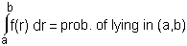
It's certain that the return will lie in -∞ < r < ∞, so:
[2] 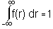
Suppose we consider all possible future returns (chosen from our assumed distribution f(r)).
The "best" choice for our expected return (we'll call it x) is the one which is closest to all possible future returns ... in some sense.
For some random future return r (chosen from f(r)), the distance from our "best" choice is | r - x|.
If we define "best" as that x-value which minimizes the mean deviation | r - x| we'd have:
[3] 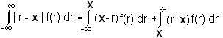
Now differentiate with respect to x and set the derivative to 0 and ...
>Hey! I vaguely remember that from 1st year calculus when we used to ...
Pay attention!
Differentiating the right-side of [3] and setting the derivative to 0 gives:
[4] 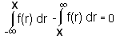
In other words, the probability of lying in -∞ < r < x is the same as the probability of lying in x < r < ∞.
To put it differently, there as many returns, r, less than x as there are greater than x.
That means that x should be the MEDIAN (historical) return.
>So the Median is the best predictor for next year's return?
Define "best".
We might also define "best" as that x-return which minimizes the mean-square deviation. That is we choose x so that:
[5] 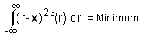
Again we set the derivative to 0 and get:
[6] 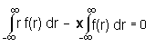
Do you recognize that first integral?
>You kidding?
It's the MEAN of the (historical) returns. How about the second integral?
>I thought that ... uh ... I saw that integral somewhere ...
Yes, it's [2], above and it's equal to 1.
>So the Mean is the best predictor for next year's return?
Define "best".
I should point out that, after exhausting exhaustive analysis of historical data, neither Mean nor Median seem to be a good predictor of near-future returns.

Risk ... how to measure it

motivated by an article by Mandelbrot & Taleb
The article noted above comments on various parameters involved in measuring or using Risk, such as variance, Sharpe Ratio, correlation, alpha, value-at-risk, Black-Scholes, etc. etc. ... in what they call "the pseudoscience of finance".
>So, what's wrong with that?
The point that the author's make is that the "finance gurus" too often use some well-behaved, tame and placid distribution (such as Normal or Lognormal) where returns which are far from the Mean occur infrequently. Since large deviations are not that rare (in real life), then ...
>Huh? Not that rare?  Remember that picture from here?  From 5000+ daily returns for the S&P500, we  delete the 10 largest returns (either postive or negative, replacing them by 0%) and compare with the same ritual using a Normal distribution of returns (with the same mean and variance).  >Yes, I remember. The real life returns have all those outliers, far from the mean! | 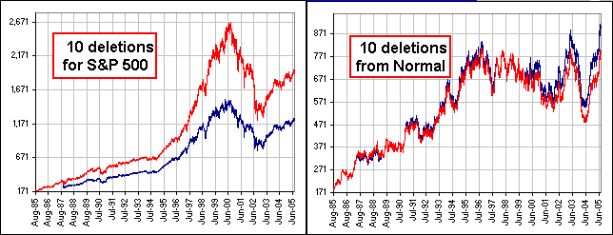  Figure 1

Yes.  For example, if we look plot the last 1000+ weekly S&P returns we get something like Figure 2.  See those large returns, indicated by wee arrows?  A Normal distribution which presumably "fits" the distribution is the red curve.  >And it gives little weight to the returns far from the mean, right?  Right.  So let's think about a measure of Risk which gives more weight to them thar outliers | 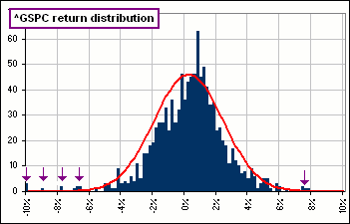  Figure 2
Remember how to calculate the Standard Deviation?
- We look at a bunch of returns: R₁, R₂, ... R_{n}.
- We calculate their Mean: M = (1/n) (R₁ + R₂ + ... + R_{n})
- We calculate all the deviations from that Mean and average their squares : VAR = (1/n) [ (R₁-M)²+(R₂-M)² + ... + (R_{n}-M)² ]
- That gives the Variance ... and Standard Deviation = Variance^{1/2}
Let's consider step #3 where we do the average thing.
If we wanted to put more weight on the returns far from the mean, we'd introduce weights which increase as we move away from the mean.
>Huh?
By a "weighted" mean of the numbers a₁, a₂, ... a_{n}, we mean**
[ W₁a₁ + W₂a₂ +...+ W_{n}a_{n} ] / [ W₁ + W₂ + ... + W_{n} ]
** sorry
The W's are the weights. If they were all the same, say "c", we'd get the garden-variety mean:
[ ca₁ + ca₂ +...+ ca_{n} ] / [ c + c + ... + c ] = (a₁ + a₂ +...+ a_{n}) / n
>So now you make the weights larger for ... uh, larger returns, eh?
Yes. Let's take our modifiedVariance as:
[ W₁(R₁-M)²+W₂(R₂-M)² + ... + W_{n}(R_{n}-M)² ] / [ W₁ + W₂ + ... + W_{n} ] = Σ W_{k}(R_{k}-M)² / Σ W_{k}
and we'll take W_{k} proportional to some power of ABS(R_{k} - M) = |R_{k} - M|:
W_{k} = |R_{k} - M|^{g}
That'd give us:
gVAR = Σ |R_{k}-M|^{2+g} / Σ |R_{k}-M|^{g}

If g = 0, we'd get the standard definition of Variance.  >And what'd you choose for g?  I'm not sure ... yet.  As an example, Figure 3 shows the size of weights as a function of the deviations from the mean (the mean is the red dot), for various g-values.  >Yeah, but what'd you choose?  Okay, let's look at the monthly S&P returns for the past twenty years. | 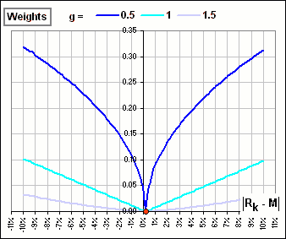  Figure 3
The S&P looked like this:
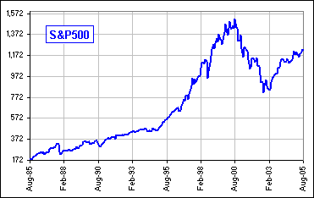
The Variance (for the twenty years of monthly returns) was 0.0020, corresponding to a Standard Deviation of monthly returns of SQRT(0.0020) (about 4.5%) and an annualized standard deviation of ...
>Don't you have a picture showing how gVAR depends upon g and ...?  Yes. In order to make the numbers more familar I'll multiply the variances by 12 and take the square root to get the standard deviations ... to get "annualized" numbers. Then, for example, a gVAR = 0.002 becomes 12(0.002) = 0.024 and sqrt(0.024) = 0.155 or 15.5% (annualized) so ...  >Got a picture?  Yes. Remember that choosing g = 0 would be the "standard" definition of ... uh, "standard" deviation.  A bigger g-value gives a bigger volatility and ...  >Yeah, but what'd you choose?  I have no idea.  >And what would your modified distribution look like? | 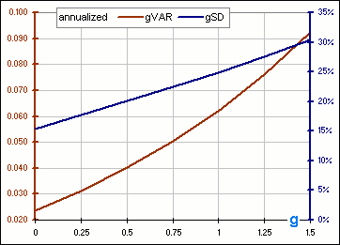  Figure 4
I'd probably use the distribution which (compared to Normal), looks like Figure 5:
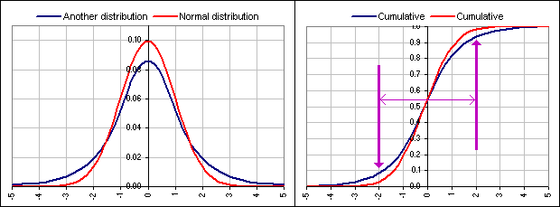
Figure 5: Mean = 0, SD = 1
>Huh? Another distribution? Yeah, it's described here.

another Distribution ... continued from here
Once upon a time we talked about a distribution of returns with Mean = m and Volatility = s, but one that'd give fatter tails and ...
>Is that your Mystery Distribution?
No. Here we want to consider yet another distribution of the form:
(1) f(x) = A e^{-b SQRT( 1+k(x-m)2 )}
where we need to choose the numbers A, b and k appropriately. In particular, to mimic the behaviour of some stock returns.
The cumulative distribution is determined by the area beneath the f(x) curve and denoted by:  F(x) = f(u) du  >Huh?  The probability that x will be less than, for example, 5% is F(5) = 20% as shown on the right-most picture, in Figure 1.  >And that 20 is the area under the f-curve?  Yeah, the area to the left of x = 5%. | 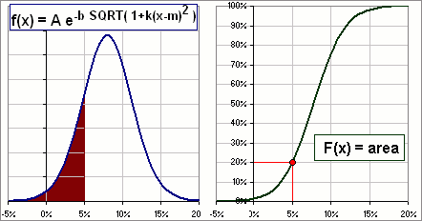  Figure 1
The probability that x is less than infinity is clearly 100% so we need to choose A, b and k so that:
F(∞) = 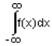= 1
>Is it equal to "1" or "100%"?
They're the same: 1 means 100%.
Now we'll search for appropriate values for A, b and k.

Note that, when z is close to 0, SQRT(1+z) = (1+z)^{1/2} = 1+z/2 ... approximately.
So, when x is close to its Mean m, SQRT(1+k(x-m)²) = 1+k(x-m)²/2 (approx.)
so we can write f(x) as:
f(x) = A e^{-b(1+k(x-m)2/2)} = Ae^{-b} e^{-bk(x-m)2/2} (approx.)
This is the form we'd expect since the Normal distribution has this form, namely:
f(x)_{normal} = 1/SQRT(2π) e^{-(1/2)(x-m)2/s2}
In order to match these characteristics near the Mean, we set
bk = 1/s² or b = 1/ks²
That gives:
(2) f(x) = A e^{-1/ks2 SQRT( 1+k(x-m)2 )}
Since we also want = 1 we choose A so that
A e^{-1/ks2 SQRT( 1+k(x-m)2 )}dx = 1
That makes A a function of k, so we'll write:
(3) A(k) = | 1  e^{-1/ks2 SQRT( 1+k(x-m)2 )}dx
>But A depends upon the Mean and Standard Deviation as well, right?
Yes, but we know the numbers m and s ... assuming we're trying to mimic the distribution of returns for some particular stock.
>Altogether now?
Yes. Altogether now:
f(x) = A(k) e^{-(1/ks2)SQRT(1+k(x-m)2/2)}
where A(k) = | 1  e^{-1/ks2 SQRT( 1+k(x-m)2 )}dx

>So what's k?
Like I said, we choose it so as to mimic the distribution of returns for some particular stock.
>Well, you're gonna have fun evaluating A, eh?
Not on a spreadsheet. Here's what we'll do:
- We'll download daily stock prices for, say GE, and calculate the daily returns.  - Then we'll plot the distribution of these returns, like Figure 2.  - We'll look at the Normal and Lognormal distributions with the same Mean and Standard Deviation as the GE returns. There's little difference, for daily returns.  - We'll note that the peak needs to be taller and we need fatter tails.  - We'll then try out our "other distribution" with various k-values to see if we can improve upon this.  >Yeah, so?  Okay, if we consider the distribution of GE returns (as per Figure 2) and pick a nice k-value, we can get Figure 2A, below. | 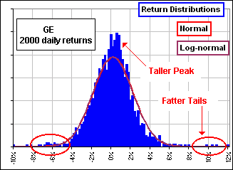  Figure 2

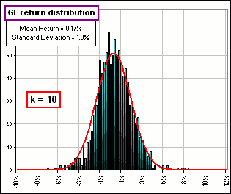  Figure 2A | >Why k=10?  Actually (it surprised me!), the chart of f(x) is relatively insensitive to your choice of k.  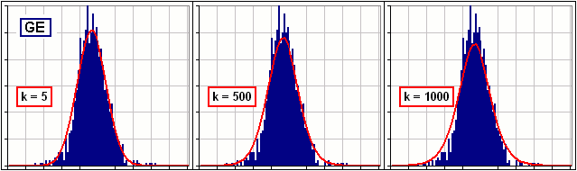  Figure 2B
>That peak may be relatively insensitive, but the tails ...
Aah, yes, the tails. I guess that's because we tried to match the actual distribution near the Mean - and that's near the peak.
But the tails, they're ... uh ...
>Fat!
Well, fatter, for large k-values, but the peak drops a bit. So we have to compromise between matching the peak and the tails.
Here's a few more:
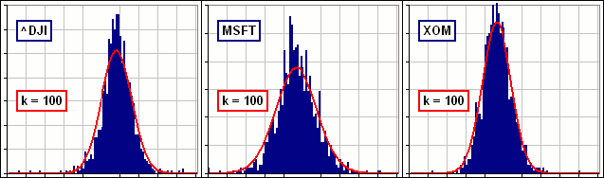
Figure 2C
>Okay, but how do you evaluate A(k)?
You mean: e^{-1/ks2 SQRT( 1+k(x-m)2 )}dx ?
I do a sum, like so, for a bunch of j's: Σ e^{-1/ks2SQRT(1+k(x}_{j}^{-m)2)}Δx
>Huh?
Don't worry about it.
Remember when we noted that actual returns can sometimes be extreme ... far more (or less!) than one would expect from a Normal or Lognormal distributions.
(See this chart where the upper chart with the wild returns is real whereas the lower is fictitious, based upon a Normal distribution with the same Mean and Volatility.)
In Figure 3 (top chart) we have the daily returns for MSFT (for the past ten years).  If the distribution were Normal (for example) then, as it turns out, we'd expect a return outside the range -8% to 8% once or twice. In fact, there were ...  >I count 6!  Yes, me too. Six in this 10-year period.  On the other hand, if we try to mimic the MSFT returns using our OTHER distribution we can get lots of returns outside (-8%, 8%).  >And the match? I mean the actual distribution vs ...  I know what you mean ...  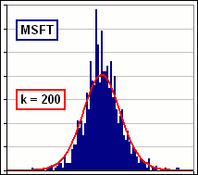 | 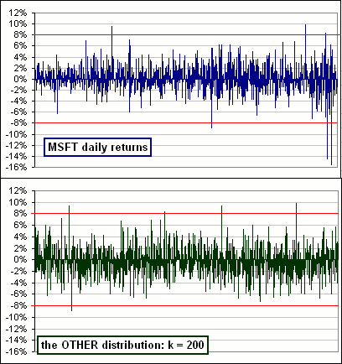  Figure 3
>Why k = 200? You just pick a k which works, eh?
Yes, of course. What would you suggest?
>I'd suggest ... uh, picking a k which works. So, where's the spreadsheet?
I'm thinking about it ...

Note that, for large values of |x|, this "other" distribution is still pretty significant.
Indeed, the probability of lying within 2 standard deviations of the Mean is 95% for a Normal distribution, but only 85% for our "other" distribution. (See the arrows?)
>But, in that "other" distribution, there's some k-value, right?
Yes. You start off, near the Mean, with the standard Normal distribution and when you're k standard deviations from the Mean, you give up the Normal (which decays like e^{-x2}) and adopt a simple exponential decay (which decays like e^{-x}). In Figure 5 we've used k = 1.
>So what's the best k-value? I have no idea.
>Do you ever have an idea? I have no idea.

Inventing Distributions ... with large tails
Because it's the tails of the distribution which greatly affect Risk, we invent distributions with large tails and ...
>Didn't you just do that? You mean switching from Normal to Another, when the return is a certain distance from the mean? Yes, we did ... but it's clumsy.
We've already talked about such a distribution in the link we gave above: click.
We could, for example, use this guy:
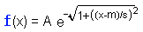

When x is close to the mean m  in terms of standard deviations, so (x-m)/s is small,  f(x) decays like e^{-(1/2)((x-m)/s)2}  just like the Normal distribution. | When x is far from the mean m  in terms of standard deviations, so (x-m)/s is large,  f(x) decays like e^{-|x-m|/s}  just like our Other distribution.
>So where's the spreadsheet? GUMMY ANOTHER DISTRIBUTION
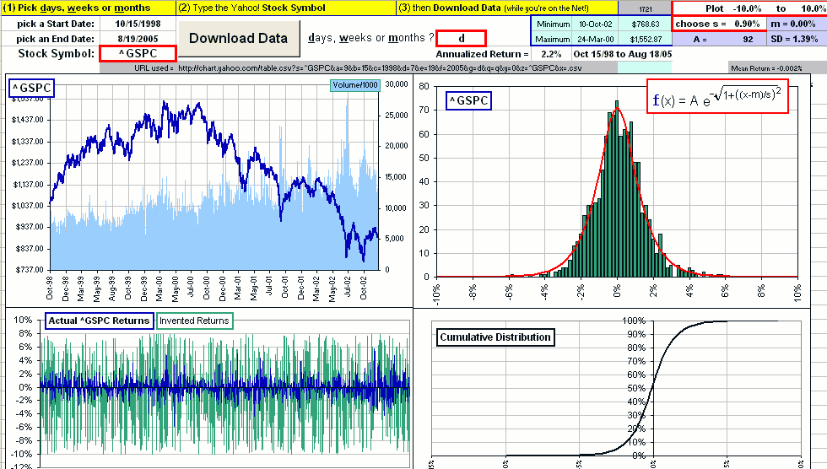
You can download stock data and play with the value of s until you get a good match with stock returns.
Each time you press F9 you get a bunch of random selections from your invented distribution ... to compare to the stock returns.
>And ... uh, what do you do with it when you got it? I have no idea

Volatility: good or bad?

motivated by email from Steffen
Suppose you're investing a fixed amount each month and you have a choice between two assets which have the same Mean return ... but one has a lower Volatility (or Standard Deviation).
>I'd go for the lower volatility, so I can sleep nights. Aah, but can you prove that?
>That's your job. Well, it ain't easy ... but I'm workin' on it.
We could assume a particular kind of distribution for the gain factors, keeping the average gain factor the same (as we noted above) then and changing the standard deviation.
>Is that easy? Well ... here's a spreadsheet GUMMY ASSET VOLATILITY that'll do that when you specify the Means and Volatilities of 2 assets. It selects random returns chosen from a lognormal distribution:
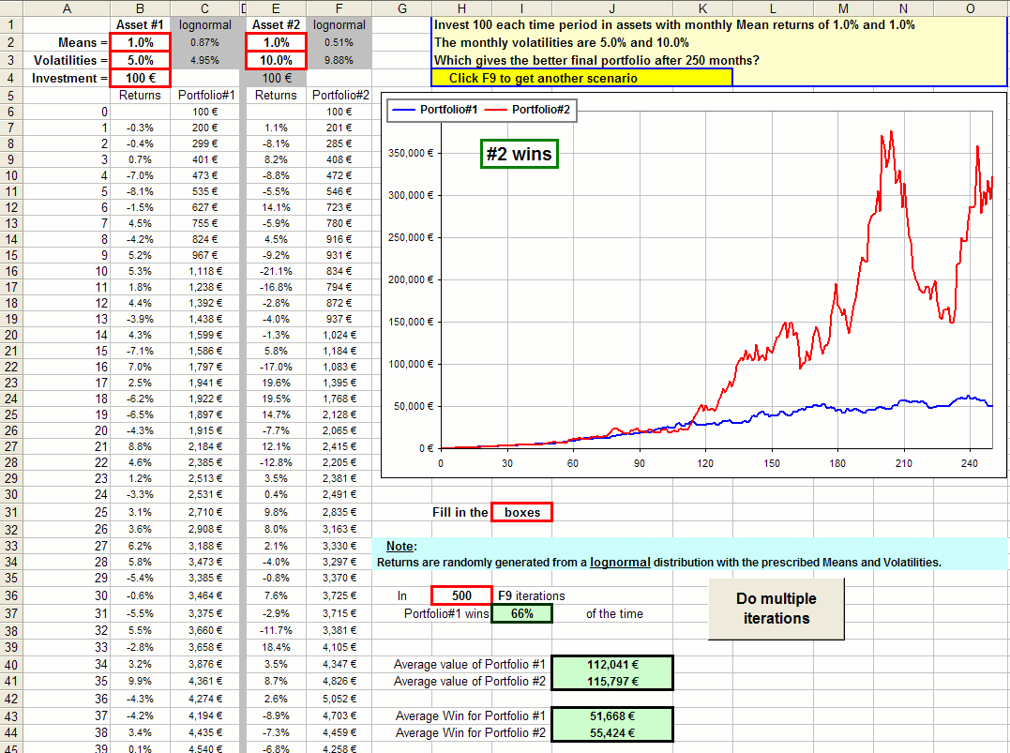
Click on the picture to download the spreadsheet.
Each time you press F9 you get another set of 250 monthly returns.
If you get tired of pressing F9 you can click a button and it'll press it for you a bunch of times.
Note that the portfolio is in Euros.
Note, too, that Portfolio#1 has the lower Volatility (yet the same mean return) and will "WIN" most of the time.
Nevertheless, when Portfolio#2 wins, it wins BIG ... so the average portfolio (after umpteen F9-simulations) is usually larger for the more volatile asset.
>And real asset returns are lognormally distributed, right?
Uh ... not exactly.
However, you could download a bunch of historical monthly stock returns, subtract from each their Mean return (which makes the average of the modified returns the same for all assets, namely 0%), then add some contant return to each, say R%, so now all returns would have the same Mean return (namely R%) ... and their Volatility would not have changed.
For example, this spreadsheet GUMMY ASSET VOLATILITY 2 will do this:
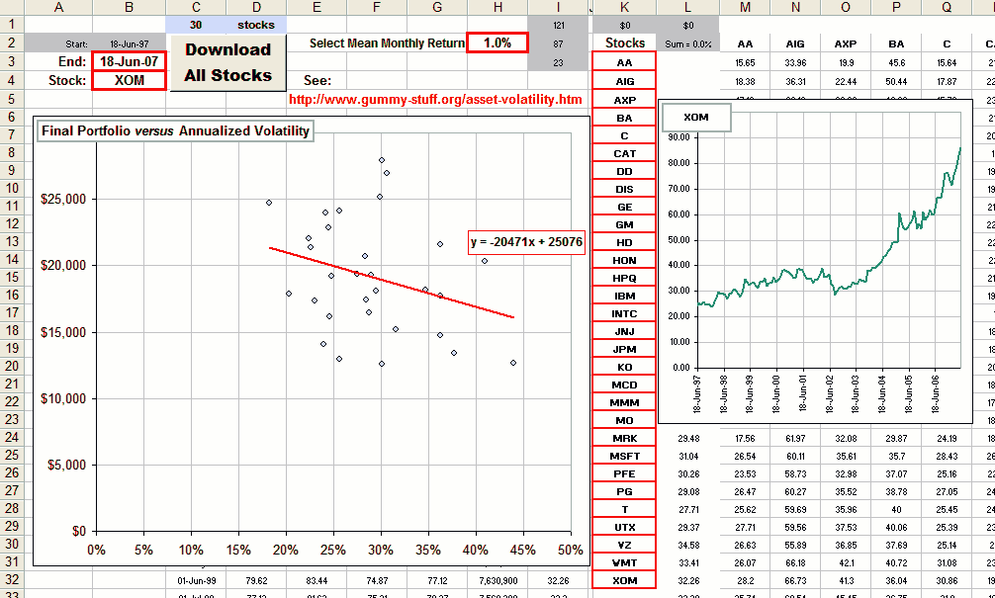.

You enter a bunch of Yahoo stock symbols (30 of them) , click the Download button, pick some Mean return to impose on all stocks and gaze at the cool chart.
>It looks like highr volatility means a poorer portfolio, right?
For this set of assets the tendency is to reduce your portfolio after 250 months ... since the slope of the regression line is negative.
Tha means that there's a tendency for these assets to generate a smaller portfolio if the volatility is larger.
Indeed, the chart of the regression line suggests that a 1% increase in volatility (meaning that x increases by 0.01) will reduce the final portfolio by $204.71.
>That's peanuts! For these assets and this time period.

Dollar Cost Averaging
Note that a constant monthly investment is Dollar Cost Averaging.
As noted here, the number of units accumualted after N months is:
Number DCA units accumulated after N months is A/P₀ (1 + gMS) = A/P₀ (1 + 1/G₁ + 1/G₂ + 1/G₃ + ... + 1/G_{N})
starting when the stock price is P₀ and investing $A monthly ... and G_{k} is the total gain factor after k months.
Note that, if the stock is very volatile, the gain factor over k months, namely G_{k}, is approximately (1+AnnualizedReturn)^{k/12}.
Further, the Annualized Return is approximately: (Mean Return) - (1/2) Volatility².
If the Mean Return stays constant, but we increase the Volatility, we'd expect the gain factors to decrease.
Hence their reciprocals, like 1/G_{k}, hence gMS, would increase and we'd expect to have more units after k months.
>More units is better, right?
Not is they're worthless! In fact, decreasing the returns would give you more units which are worth less.
In fact, after N months our asset is worth P₀G_{N} so we multiply by that and get the value of our portfolio, namely:
The value of a DCA portfolio after N months is A G_{N} (1 + gMS) = A(G_{N} + G_{N}/G₁ + G_{N}/G₂ + G_{N}/G₃ + ... + G_{N}/G_{N}) = A(g_{N} + g_{N-1}+ g_{N-2} + ... + g₁ + 1)
where g_{k} is the gain factor over the last k years.
>So, is buying volatile assets a good thing?
Not according to my Excel studies ... but I'm not finished yet.
Besides, the expression above has gain factors, g_{k},which will tend to be smaller for volatile stocks, so portfolio value would tend to be less.

Volatility and Trends
motivated by email from Bob S.
An interesting question one might ask is:
"Does volatility decrease when the stock is on an uptrend (or downtrend)?"
Here's a fun spreadsheet GUMMY VOLATILITY TRENDS that calculates the moving N-day standard deviation (or "volatility") of a stock so you can stare at the variation in stock price and at the variation in volatility and ...
>And see if there's any correlation, right? Right:
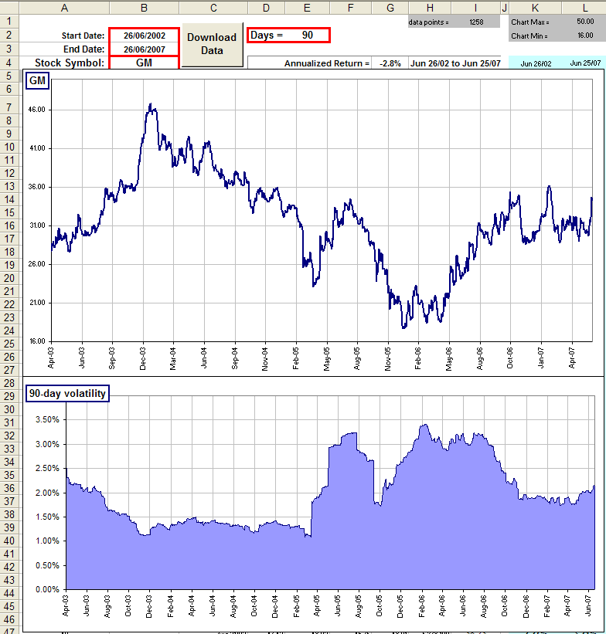
>So what's the relationship between them? That's your job.
However, here's a few more where we've changed the stock and/or the dates:
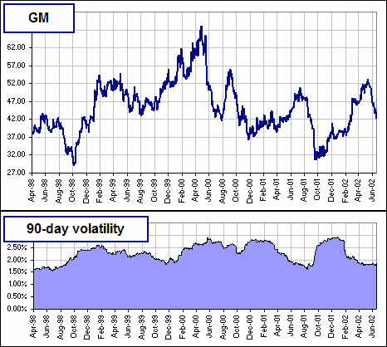 | 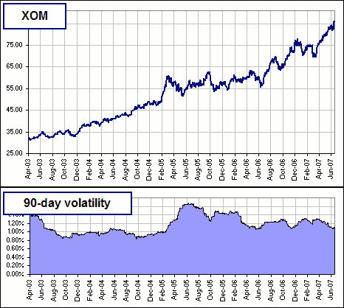
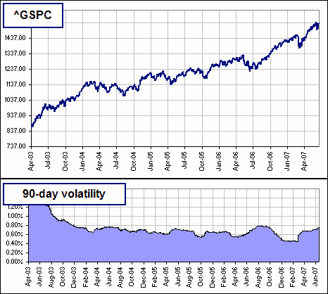 | 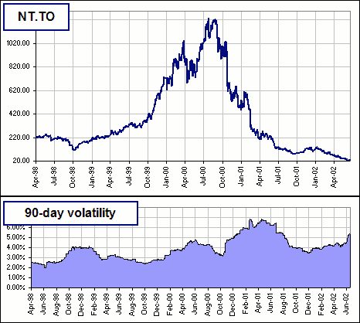

CAGR vs Volatility

Motivated by sleeplessness ;. So I was lying in bed and thinking ...
>Not again! Pay attention.
I was thinking that many gurus speak of risk and reward (where "risk" is measured by Standard Deviation, for reasons unknown to me).
One gets the impression that the higher the Standard Deviation (or Volatility) the higher the expected reward ... or maybe the other way around.
>The other way around? You don't know? It doesn't matter.
I just thought that there was a common understanding (among those in-the-know) is that there's some relationship between what you'd expect to get in the way of Compound Annual Growth Rate and the Volatility of annual returns. So I got outta bed and decided to ...
>To generate some spreadsheet, right? GUMMY CAGR VS VOLATILITY
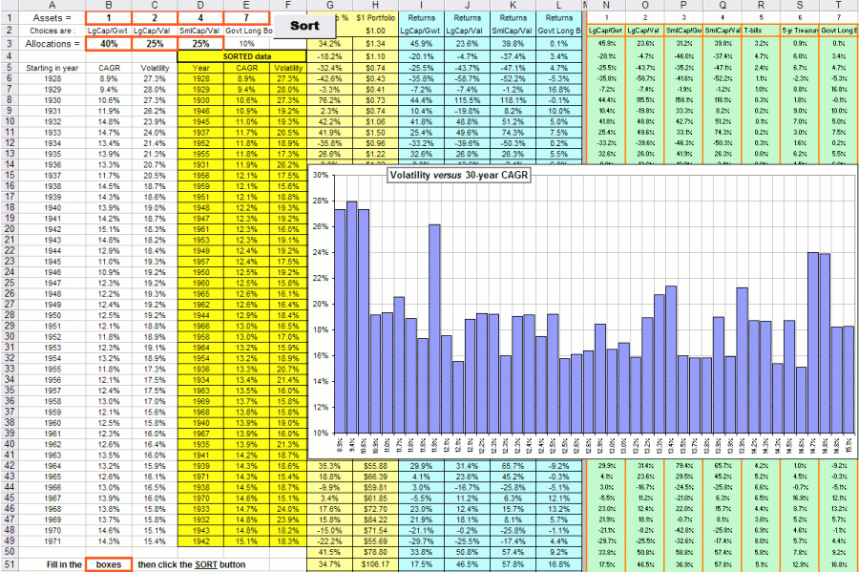
It goes like this:
- You pick four assets from a list of 10, including Large & Small Cap Growth and Value, T-bills, Treasuries etc.
- You pick your allocations, like (25% of this) + (30% of that) etc.
- The spreadsheet calculates the CAGR fo every 30-year period starting in 1928 and ending in 1971.
(I pick these 'cause I happen to have the data, here.)
- It also calculates the volatility of the annual returns over those 30-year time periods.
- Then you click a button called SORT (what else?) and the CAGRs are sorted, lowest to highest.
- Then you get a chart which shows the volatilities plotted against these increasing CAGRs.
>So?
So, try as I might, I can't identify any meaningful relationship between CAGR and Volatility.
>Then I suggest you go back to sleep.
zzzZZZ
P.S. There's some other bumpf on the spreadsheet ...
Another definition of Risk
There are a jillion definitions of "Risk" and I don't hardly like any of them.
>Don't tell me you're talking about risk again!
I know! I know! I've done it several times before. (Search here for "risk".)
However, I think many would like to think the following:
If stock A is "riskier" than stock B, then you'd expect:
- The probability of getting large returns is higher for stock A
- The probability of getting large losses is also higher for stock A
>Huh? Why would anybody think that?
You'd like to be rewarded for taking a larger "risk", knowing full well that there's also a greater possibility of getting large losses.
>Yeah, so why call it "another definition of risk"? Why not stick with existing definitions like ...?
Like downside risk or standard deviation or value at risk or ... ?
>And they are ...?
Did I mention that you can search ... here?
Anyway, I was thinking about such a definition and decided it shouldn't be called "risk" (which should imply only losses), but should be based upon both criteria noted above. That is, the probability of larger gains as well as larger losses.  For example, which of the two stock return distributions would you think is ... uh, "riskier"?  >With what definition of "risk"?  With a definition that satisfies 1 and 2, above.  >In that case, I'd say the red stock is "riskier" ... but you really should give it another name.  Okay, let's call it g-Risk. That is, if 1 and 2 are satisfied, the A is g-Riskier than B. | 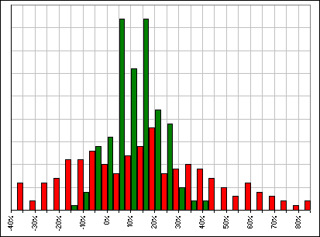
For example, here's a couple of stocks and the distribution of their weekly returns over the past ten years.
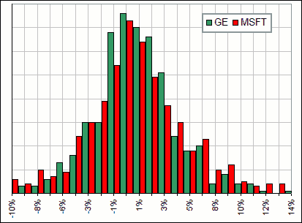
Which is riskier?
>You mean g-riskier, right? In that case, I'd say red ... that's Microsoft. But I coulda told you that without any g-risk mumbo-jumbo.
Well, yes but ...
>Besides, you're talking history, not future. I suggest you take a look at this.
Thanks ... but don't you think you'd like to avoid investments that are risky unless there's a reasonable chance of making BIG bucks?
>Investments that are risky? Define risky.
Okay, I mean investments that have a higher probability of losing money.
>Higher than what?
Higher than, say, some risk-free rate (like maybe 4%) or maybe higher than some Index, like the S&P500, or maybe ...
>Yeah, I'll go with that. I'd be prepared to accept a greater risk of loss, compared to the S&P, provided there was a good chance of getting a greater return.
Okay, then you'll like g-Risk. It compares the probability of getting a larger return (than some benchmark) to the probability of getting a smaller return.
For example, Value at Risk or VAR considers the probability of having a return less than some benchmark return.
We want to consider BOTH: less than something and greater than something so maybe we should consider a Ratio.
>Don't you have to assume some kind of distribution of returns?  Yeah. In VAR it's normal to assume a ... uh, normal distribution.  If we continue with that "normal" assumption, but do the Ratio thing, we'd get something like  ... as we did, once upon a time, in a Risk / Reward tutorial.  Notice that the integral in the denominator is the probability of getting less than some return.  It's subtracted from "1" to get the probability of getting "greater" than something.  >And if the returns aren't normally distributed?  Aah ... that's a problem, eh?
  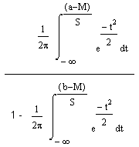
What we need is some mathematical distribution that mimics actual, historical returns ... especially if those returns aren't normally distributed.
Indeed, we're interested in probabilities of getting less than something (since both integrals in numerator and denominator are animals of this ilk).
That poses the following problem:
How to generate a mathematical distribution that mimics an actual return distribution vis-a-vis the probabilities of getting less than something
In other words, we need a mathematically defined distribution that mimics quantiles for some actual, historical distribution.
>Quantiles?  Yes. Consider a random variable R.  We want to have a 70% probability that R is less than something.  What's that something?  If the distribution satisfies Pr[R < ??] = 0.70  then ?? is the 0.70-quantile of the R-variable.  >Huh?  Just stare at the picture  For this distribution, x = something = 0.10 or 10%.  For example, the 0.50-quantile is the median since 50% lie below the median. | 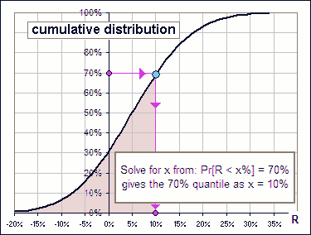
>And what's this special distribution that mimics ...? I'm thinking.

Another Distribution
We look carefully at historical returns of some asset and extract the Mean m and Standard Deviation s.
Suppose we begin with the Normal distribution as a first approximation to the historical return distribution.
We'll call the Normal distribution N(r) where r is our random variable and assign to N the Mean m and Standard Deviation s.
Our modified distribution is a perturbation of N. We'll call the deviation k.
Our "modified" distribution is then D(r) = N(r) + k(r).
To be a distribution, we'll need: ∫ D(r) dr = 1 ... the integration being over the range of r, namely -∞ to +∞.
That gives:
[0] ∫ k(r) dr = 0 ... since ∫ N(r) dr = 1.
Then we'll want m = ∫ r D(r) dr = Mean[ D(r) ] = Mean[N(r) + k(r)] = ∫ r (N(r) + k(r)) dr = m + ∫ r k(r) dr ... the integration from -∞ to +∞.
That gives us the "first moment" of our perturbation:
[1] Mean[k(r)] = ∫ r k(r) dr = 0
Now on to the "second moment":
We'll want ∫ r ² D(r) dr = ∫ r ² (N(r) + k(r)) dr = m</B² + s</B² + ∫ r ² k(r) dr ... since the 2nd moment for the Normal distribution is Mean</B² + Standard Deviation</B².
Let's call the historical moments that we want to mimic: μ₁, μ₂, μ₃ ...
The above equation then reads: μ₂ = m</B² + s</B² + ∫ r ² k(r) dr
Then we have:
[2] ∫ r ² k(r) dr = μ₂ - m</B² - s</B²
Now on to the "third moment" ...
>Wait! What are we doing anyway?
We're trying to match the various moments of our modified distribution to the actual moments of the historical distribution.
Remember: If we extract the Mean and Standard Deviation from historical returns, that would completely define a Normal distribution.
We couldn't require of this Normal distribution that it match higher order moments.
That's why we're introducing a "modified" distribution. That extra term, k(r), will be defined so as to incorporate those additional moments.
>Those additional moments being the moments of the historical stuff, right?
Right. Let's continue.
Then we have:
[3] μ₃ = ∫ r ³ D(r) dr = ∫ r ³ N(r) dr + ∫ r ³ k(r) dr = m³ + 3ms² + ∫ r ³ k(r) dr ... since the 3rd moment for the Normal distribution is m³ + 3ms².
>That 3rd moment for a Normal distribution ... I guess I take your word for it, eh?
Okay, consider this: for our Normal distribution where N(r) = e^{-(1/2) { (r - m)/s }2} / sqrt(2π)s
∫ r^{n} N(r) dr = 1 / sqrt(2π)s ∫ r^{n} e^{- { (r - m)/s }2/2} dr = 1 / sqrt(2π) ∫ (m + st)^{n} e^{- t 2/2} dt ... putting r = m + st.
Expanding: (m + st)^{n} = Σ _{n}C_{z} m ^{n-z} s^{z}t^{z} ... where z goes from 0 to n and _{n}C_{z} are the binomial coefficients.
Then:
[4] μ_{n} = ∫ r ^{n} D(r) dr = Σ _{n}C_{z} m ^{n-z} s^{z} { 1 / sqrt(2π) ∫ t ^{z} e^{- t 2/2}(r) dr } + ∫ r ^{n} k(r) dr ... the integration being from -∞ to +∞.
We now have:
[A]
∫ r ^{n} k(r) dr = μ_{n} - Σ _{n}C_{z} m ^{n-z} s^{z} P_{z}
where
P_{z} = ∫ t ^{z} e^{- t 2/2}(r) dr / sqrt(2π) the moments of the "Standard" Normal distribution ... with Mean = 0 and Standard Deviation = 1
>zzzZZZ
Don't you see?
We find the moments of the actual distribution, from historical data, and we know the values of P_{z}, so we can determine the moments of k(r) .
That way we can modify the assumption that the actual return distribution is Normal. We just add our k(r) .
>Huh? We know P_{z}?
Sure. Just look 'em up in a book. In fact, we already know that:
P₀ = 1 ... true of all distributions
P₁ = 0 ... the Mean = 0 for a "standard" normal distribution
P₂ = 1 ... since the Standard Deviation = 1
P₃ = 0 ... since all odd powers give a zero integral
>So what are the moments of this k-modification?
The first few are:
∫ r ⁰ k(r) dr = 0 ... that's [0], above
∫ r ¹ k(r) dr = 0 ...see [1], above
∫ r ² k(r) dr = μ₂ - m² - s</B² ... see [2]
∫ r ³ k(r) dr = μ₃ - m³ - 3ms² ... see [3]
>What happened to μ₀ and μ₁?
N, the Normal component of our modified distribution, D, will take care of them.
It's them higher moments that we want to mimic by introducing our k-modification and ...
>But how do we calculate μ_{n}, the moments of the historical returns?
A good question.
>Okay, suppose we know those moments. Now how do we construct k from its moments?
Another good question.

