Here is an easy, objective way of checking the extent to which any indicator repaints:
(note: you can do this at any time, even while the market is closed)
1. Open a blank chart, and attach only the indicator you want to test to the chart.
Press F8 to get the Chart Options, and then ensure that 'Chart shift' and 'Chart autoscroll' (on the 'Common' tab) are both checked ON:
Attached Image
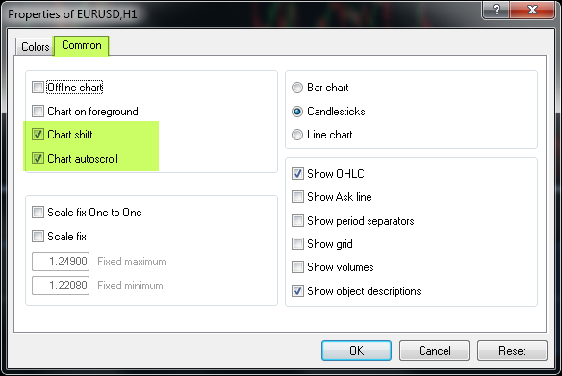
2. Save the chart as a template named tester.tpl:
Attached Image
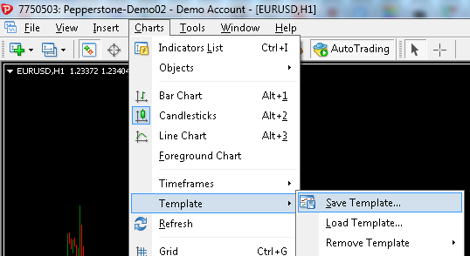
Attached Image
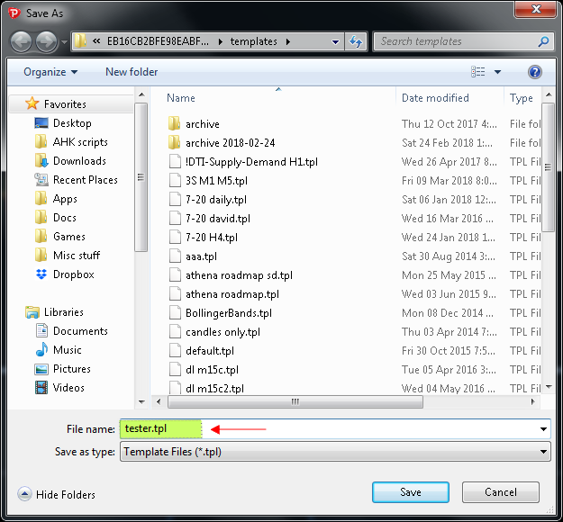
3. Press Ctrl-R to open MT4’s strategy tester. Then enter the settings as shown in the screenshot below, i.e.
Expert Advisor: MACD Sample (we are simply using this factory supplied EA as a ‘dummy’ EA. We are not interested in the test results; we merely want to see the extent to which the desired indicator repaints)
Symbol: EURUSD (or anything you want, ideally it should match the pair/instrument of the chart that's currently open)
Period: ideally it should match the timeframe of the chart that's currently open
Spread: Current
Optimization: check this OFF
Model: Open prices only
Use date: check this ON, and select any suitable date range, e.g. from a few weeks ago, to today
Visual mode: check this ON. Move the slider to about speed 15 (the speed is shown in the little help bubble that pops up).
The Skip to date is irrelevant.
4. Click the ‘Start’ button to start the process. You can click the pause/play button (next to the speed slider) to pause/continue the chart video. Watch the progress and you can see if/how the indicator repaints. (Ignore any orders placed by the MACD Sample EA, obviously they are irrelevant).
Attached Image (click to enlarge)


