MY CALENDAR EVENTS FOR THESE WEEK
On Monday calendar is full with events but I don’t see significant numbers. I will stay sidelanise in Monday I have decided.
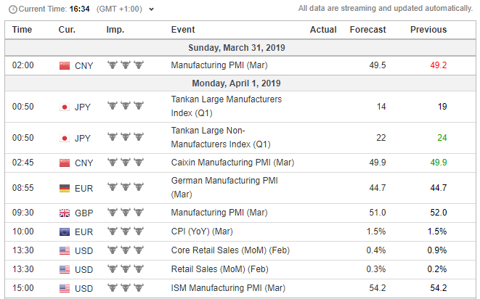
On Tuesday I think these is the day for me I see there RBA need’s to make interest rate decision, I will wait to Monday come and see/read what the expectations are for these event, even calendar says no change. My chosen pair will be AUD/NZD and EUR/AUD because I see the posicioned in very crucial areas for me. Here are the charts:
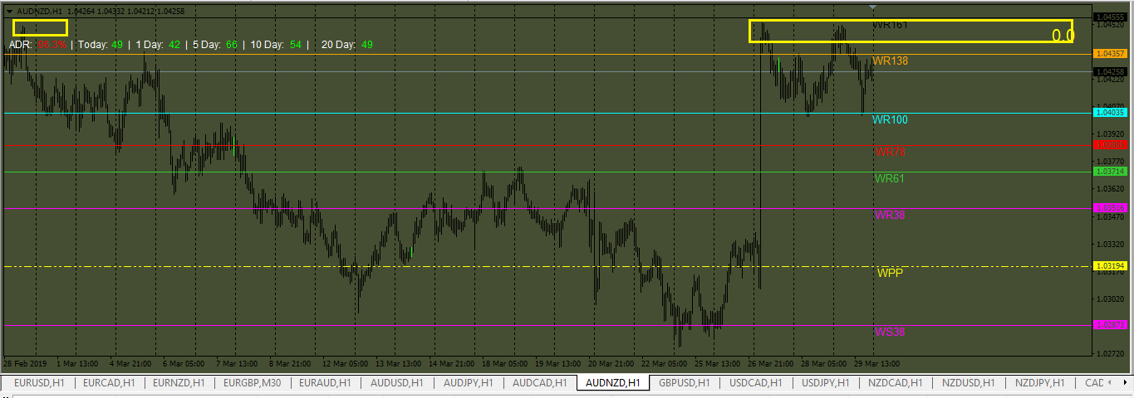

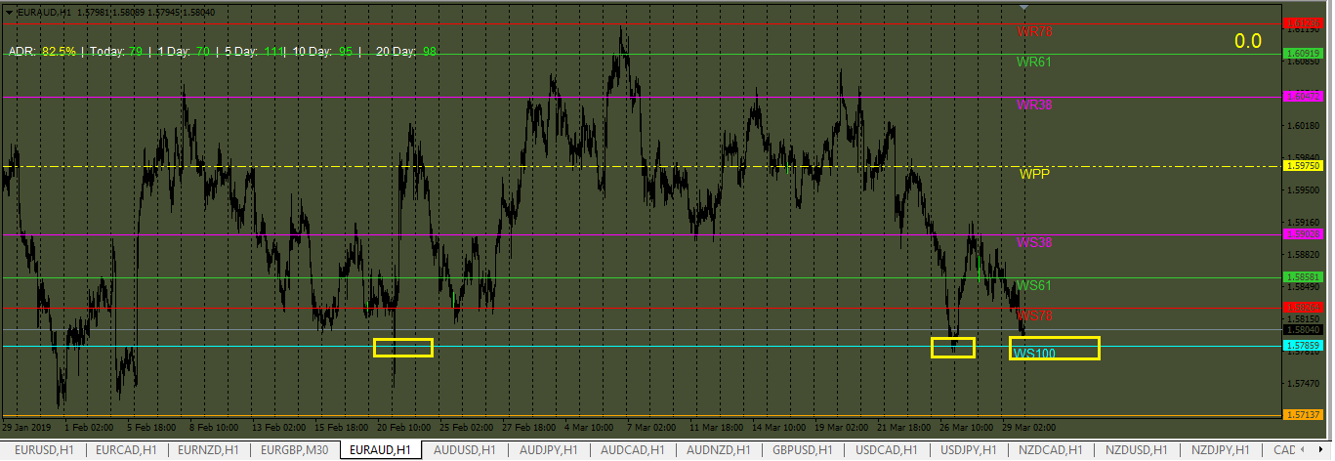
Some more news can been found here:
https://www.investing.com/news/economic-indicators/reserve-bank-of-australia-keeps-rates-at-record-low-150-as-expected-1200827
On Wednesday in calendar important are nonfarm employment news wich expected to be lower that actual these mean weakr dollar (anyway I em bullish in euro for next week because of the area were she is now)…
On Wednesday also there are expected U.S. Crude Oil Inventories news these will make CAD pairs to move but until then we have to see were they gona be areas on Weekly PP and from there I will make decision!
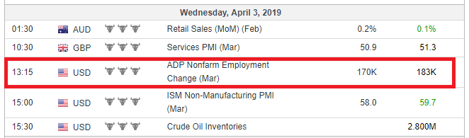
On Friday there are 2 very important events Nonfarm payrolls and employment change for Canada. Because datas expected from nonfarm payrolls to be negative for US dollar I have to wait and see the levels on pivots to chose between pairs, because during the week will be flucturations of prices..
Allso employment numbers for CAD expected to be in red so these gona make USD/CAD pair uncomfortable pair for trading we have to wait and see anyway….
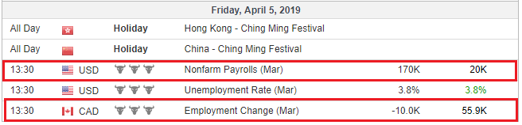
GREEN PIPS TO YOU ALL Mizi123

