EURJPY
Weekly
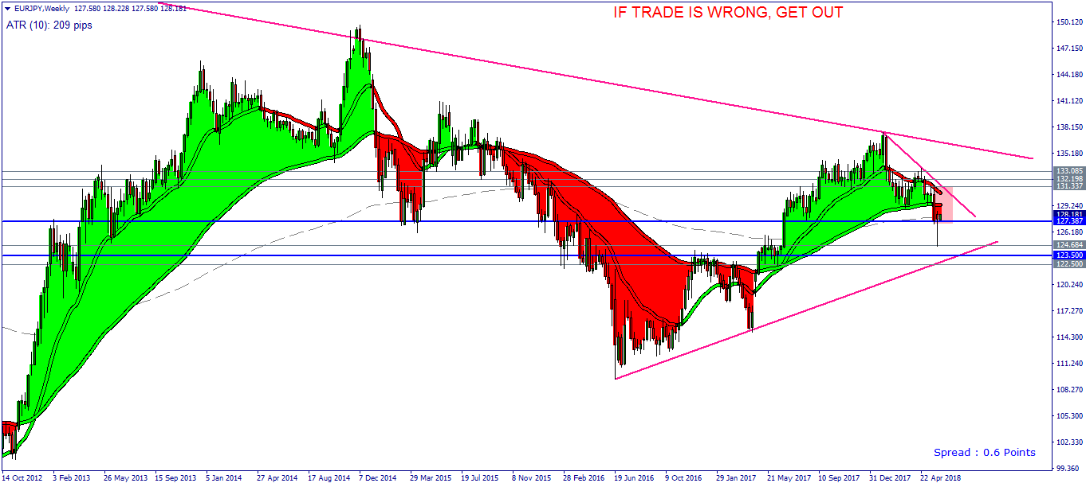
- Main Trend: DOWN; Primary Trend: Down
- Price: Closed below Strat Shadow, Trapped in WCC
- Signal: Hammer at Support
Daily
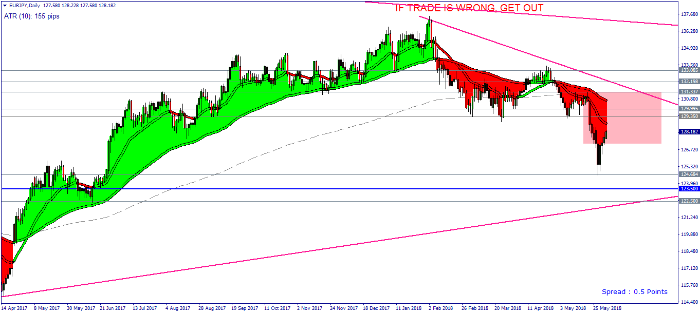
- Primary Trend: UP
PLAN: ALWAYS trade in the direction of the TREND. So, waiting price reach the 129.35 to look for Sell Signal.

EURCAD
Weekly
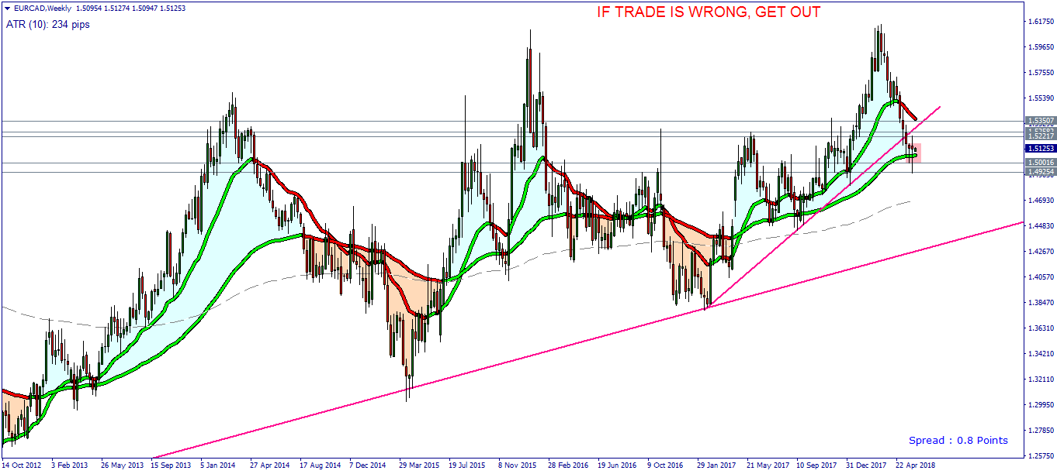
- Main Trend: UP; Primary Trend: Down
- Price: supported by the bottom of Strat Shadow and Support Zone, Trapped in WCC
- PA Signal: Hammer
Daily
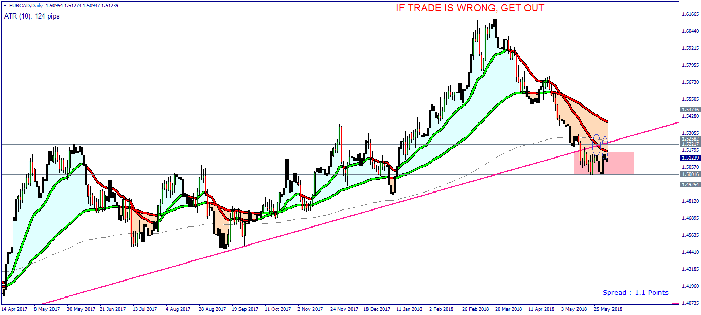
- Price was rejected by the top of Strat Shadow
PLAN: Waiting the Price is CLOSED above the Strat Shadow on Daily.

EURAUD
Weekly
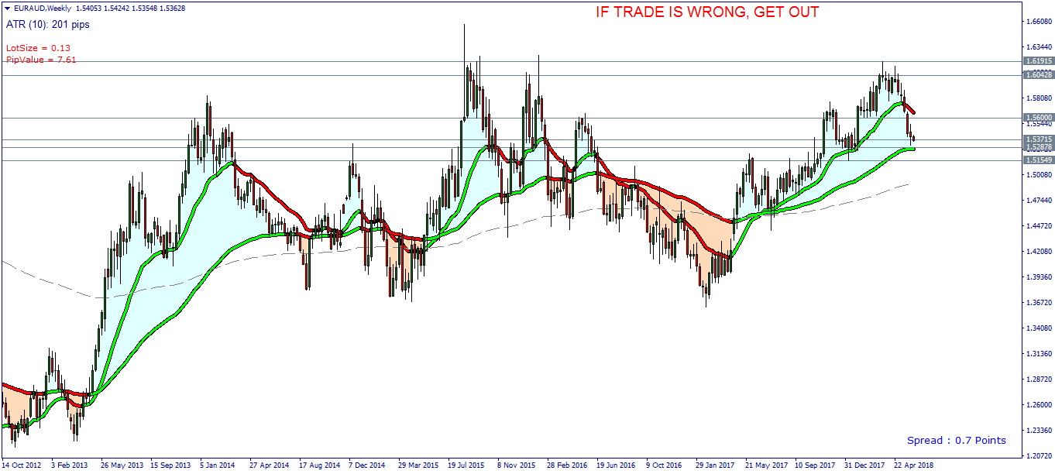
- Main Trend: UP; Primary Trend: DOWN
- Price: at the bottom of Strat Shadow as Support
Daily
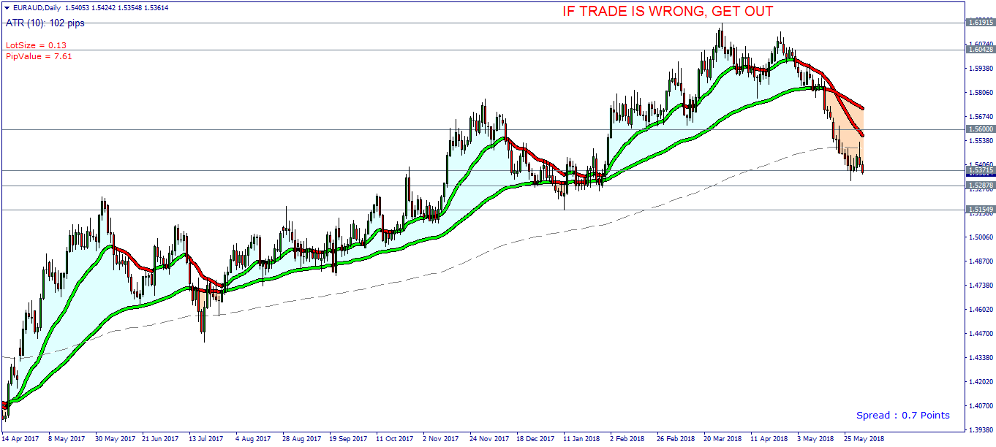
- Price at the Support Zone and Rejected by the Strat Shadow.
PLAN: Waiting the Price break out the Support or Resistance on Weekly.

USDCAD
Weekly
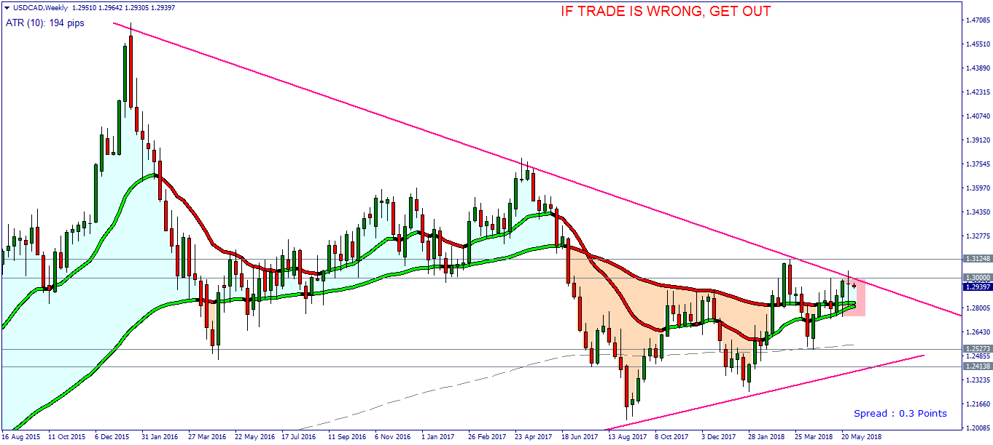
- Main Trend: UP; Primary Trend: UP
- Price: Trapped in WCC
- PA Signal: Doji
Daily
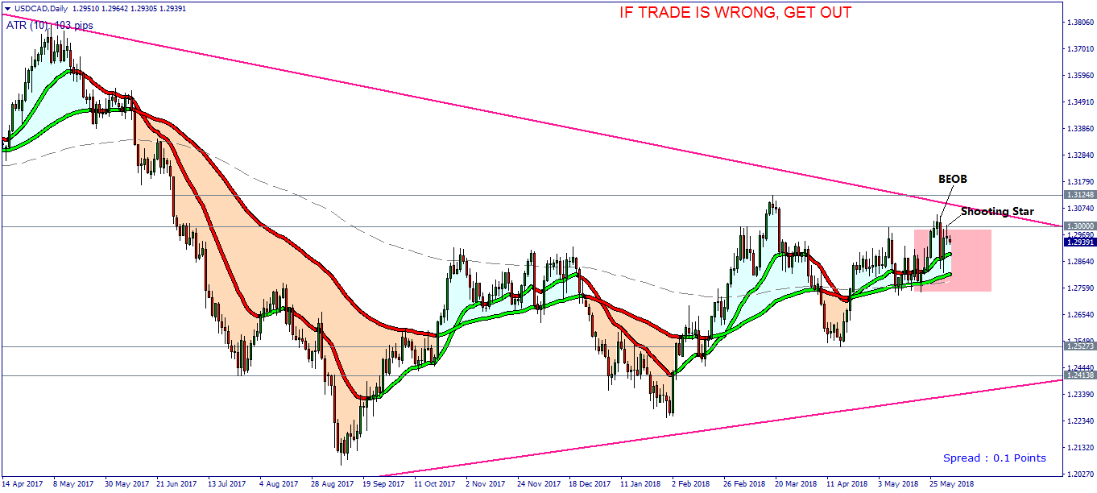
- Main Trend: UP; Primary Trend: Down
- Price: Trapped in WCC, LH, at the top of WCC.
PLAN: Sell at H4 chart, Stop Loss at 1.3025 above the high of Shooting Star, TP@1.2820

GBPUSD
Weekly
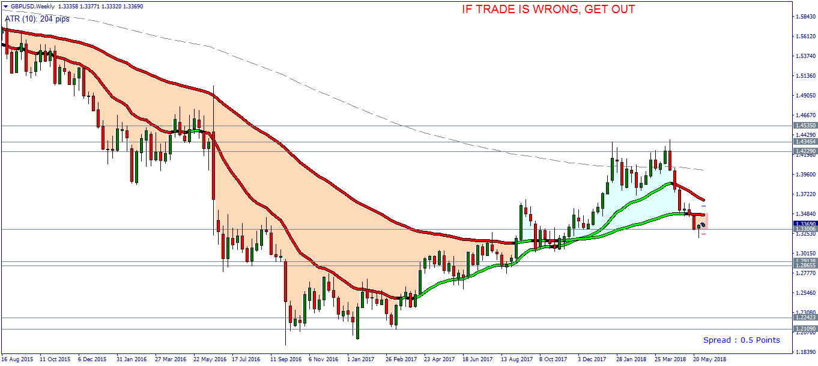
- Main Trend: DOWN; Primary Trend: DOWN
- Price: below the Strat Shadow, Trapped in WCC.
- PA Signal: Hammer at the Support 1.3300
Daily
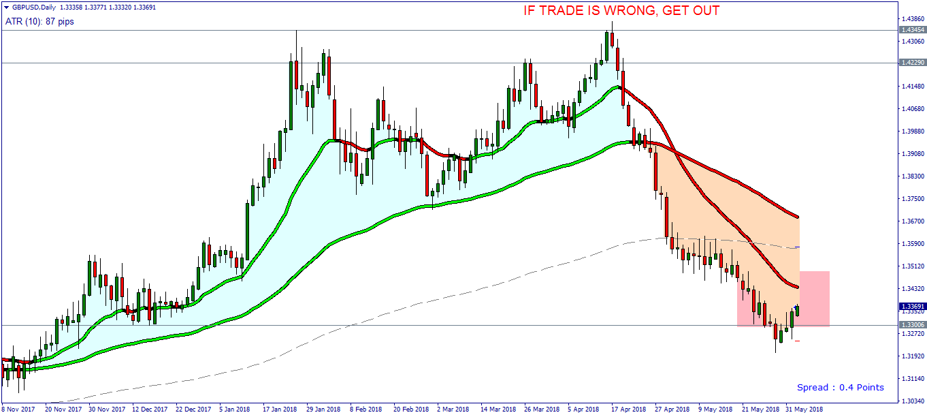
- Main Trend: DOWN
- Price: Trapped in WCC, at the bottom of WCC.
- PA Signal: BUOB
PLAN: Buy on H4 chart.

