TREND LINE TECHNIQUES, MARKET RHYTHM AND SPOTTING HIGH PROBABILITY TRADING SIGNALS FOR USD/JPY CURRENCY PAIR

ANSWER TO YOUR QUESTIONS
Please when viewing this piece of information, go to the bottom right of MS Word and click the “Web Layout” button to have a better view of it or you can use the zoom scroll button to get a better or larger view of it.
This document is very powerful for me with respect to my trading style. I hope that you understand it in Jesus name.
Look at all the trades taken as shown with the arrows...none of them was a looser...if you trade this way, you will begin to enjoy trading...it will as well help you to destroy the killer disease called “emotion” in your trading, and the good guy called “discipline” will have its way and bless your trading career.
Please bear with me for not coming to you as fast as you may have expected...I do have busy schedule from time to time, and another thing is that I do not give people half information, it is my way of life to always give good details when I am helping someone...if I rushed it, I do not think it will as better or more informative as you can see below... remember you are not the only one I am attending to generally...But thank you for your patience!
Key: The thick trend lines are the major ones, while the thin ones are the minor trend lines. They are called major because they tend to determine the momentum of price in the long term and they are confirmed resistance and support trend lines...the thin ones are short term trend lines they also rely on the major trend lines for market and short term price action anticipation...from the charts that I have below, you will see clearly how the thin trend lines took their points from already established points stipulated by the major trend lines.
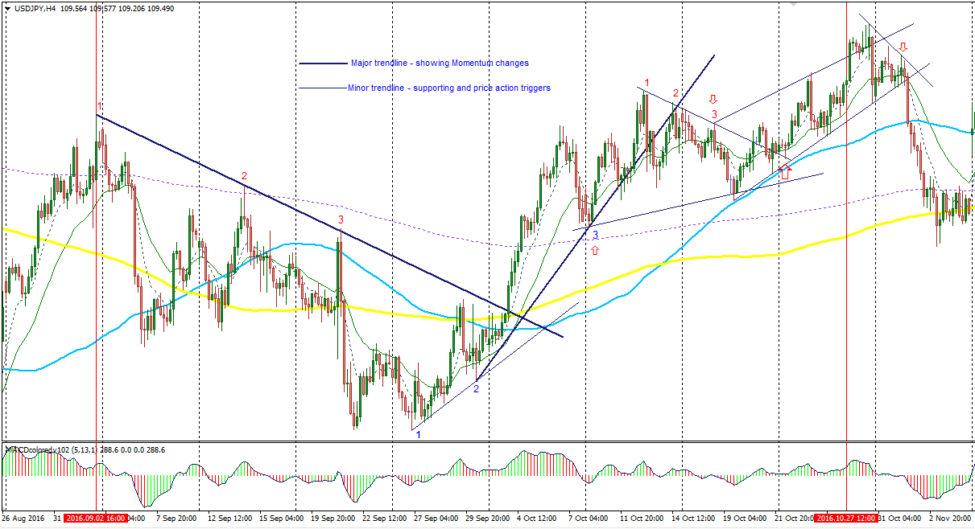
Fig; showing Usd/Jpy – 4hour chart
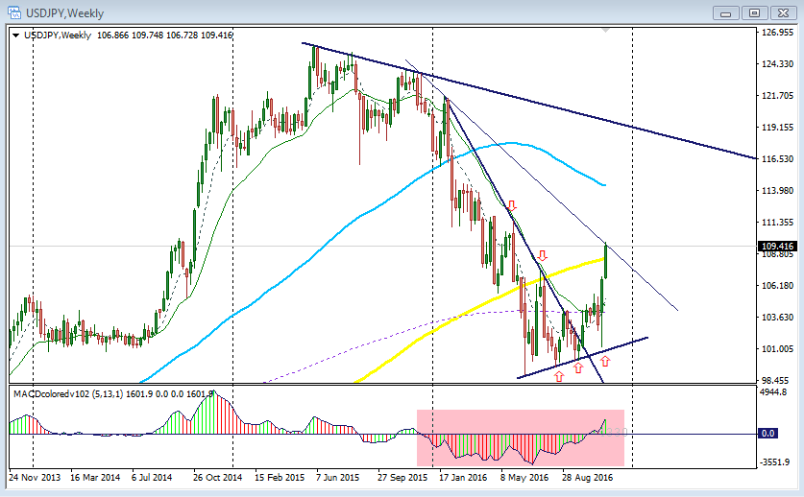
Fig; showing Usd/Jpy – Weekly chart

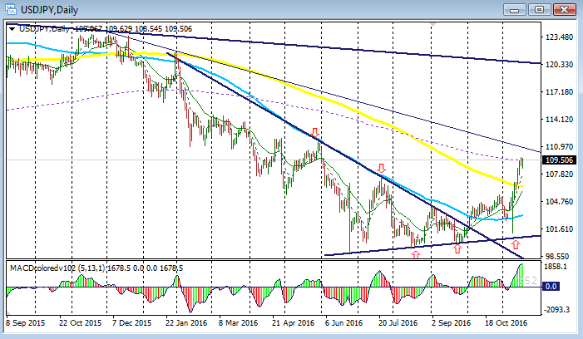
Fig; showing Usd/Jpy – Daily chart – zoomed out
Below is still a Usd/Jpy daily chart but zoomed in to make price action bold.

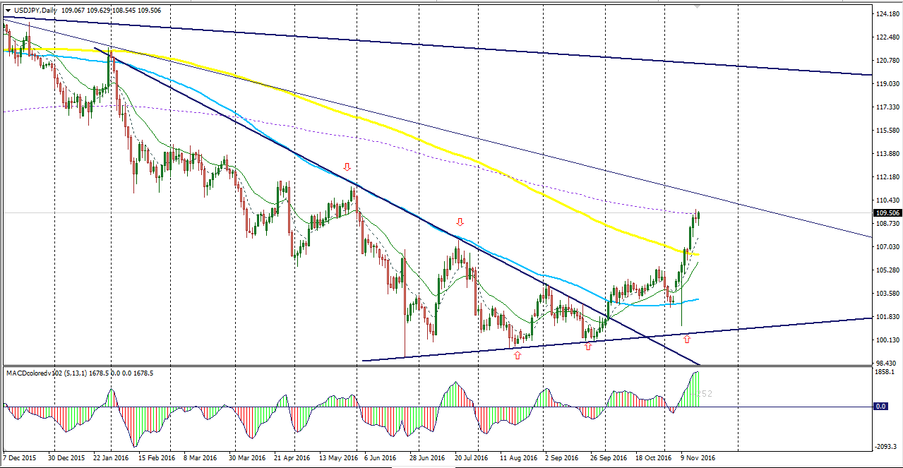
Fig; showing Usd/Jpy – Daily chart
I just switched the weekly chart to Daily time frame and got what you see above for the daily chart.

I have given this insight from the bottom of my heart to bless you, the reader. Be happy and worship God always.
Thanks!
Regards,
Naustingfx

