Wab | Dec 28, 2013 3:51pm | Post# 8

1 Attachment(s)
Here is one important use of fractals: Identifying the trend.
(I am using the USDCAD to illustrate a nice trend here that yielded some good trades today.)
HH = Higher High. HL = Higher Low.
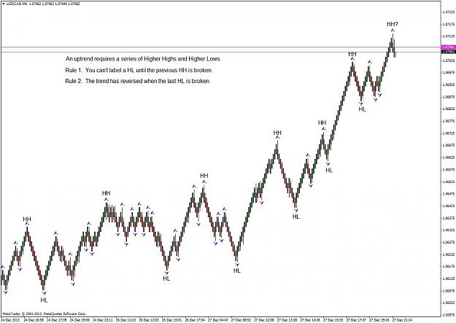
Forget "trend" indicators, price action alone tells us where the trend really is.
Renko, De Mark trend lines and Fractals. We will put them together next, but it is nearly midnight Mountain Standard Time and I am signing off for now.

Wab | Dec 29, 2013 2:15am | Post# 10

2 Attachment(s)
Thanks Zokynho. I actually have a similar indicator and use it myself. Yours is a bit better actually.
However you have to follow the rule that a new LH cannot be verified until price has broken out below the previous LH.
The indicator that I have and the one you have posted do not do that. If I could find an indicator that actually did follow that rule, I would absolutely use it.
Have a look at the chart to see what I mean.
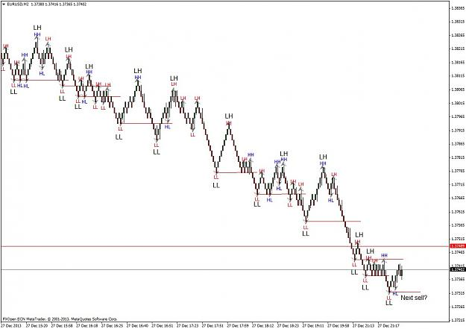
The black LL LH labels are the ones that I have determined. Your indicator and mine both label the fractals the same way. I put yours on the chart to illustrate the difference between an indicator labeling LL LH or HH HL and doing it yourself.
I added horizontal red lines to show where the price breaks below each LL. There are nine that have broken down and one still pending if the down move continues. Eight of them are in profit the ninth is in a small loss position. Stops are moved down on each of the LH fractals as a new LL fractal breaks out.
I added vertical lines from the entry levels to the close to see what each trade is currently worth. The stop at the most recent LH is about 40 pips, so if the market decided to go up now, the last opened position would lose about 60 pips the second last one would break even and all the others would end up in a profit.
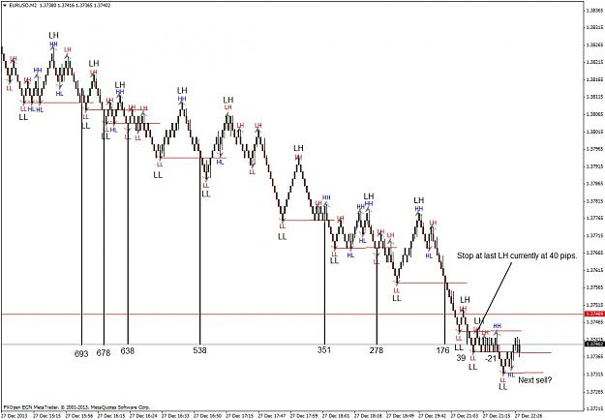
No indicators required.
Nine trades, eight with locked in profits, one potential break-even, one small loss if the market turns up and a pending tenth trade if it continues to move down. Renko makes this much easier to do than on a regular chart.
Fractals are very useful but the correct HH HL LL LH count is what makes it work. Learn to count the HH HL LL LH properly and you will be miles ahead of most people trying to trade. You will also be half way towards discovering Elliott Wave all by yourself. Soon you don't even need the fractals on the chart to do this.
I hope the charts are not too confusing. When you have done this for a while your eye is trained to pick it out easily. It takes practice.

Wab | Dec 30, 2013 7:53am | Post# 20

1 Attachment(s)
Well the Renko bar drought that occurs every weekend is over. I was busy working on a set of rings for a couple getting married on New Years Eve, so I was not looking at the EURUSD.
Let's see what is happening with the De Mark Tend Lines (DMTL).
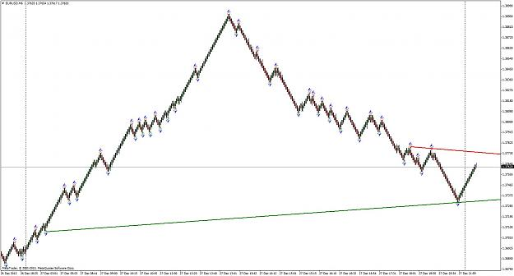
If you are familiar with DMTL they are drawn from the most recent fractal (usually) or De Mark point to the previous one.
Set "Show Arrows" to "True and the little circles (mostly at fractals) will appear on your chart.
An upper line is drawn to the first previous one that is higher.
A lower line is drawn to the first previous one that is lower.
On the chart we can see that the previous lower fractal was quite some distance back. This occurs in a down trend. The upper line finds a previous higher fractal a lot closer. A subtle clue about trend direction to be aware of. How far away does the DMTL indicator have to look to find the previous qualifying fractal?
I am going to get a little lazy her and call all the points that the DMTL uses to construct trend lines fractals, even though some of them are not fractals. I will also leave the MT4 Fractals off the chart so that it does not become cluttered.
Now, I am going back to work on those rings and will check in later.

Wab | Dec 30, 2013 10:40am | Post# 21

1 Attachment(s)
... later.
The chart is cooperating nicely and allowing me to illustrate:
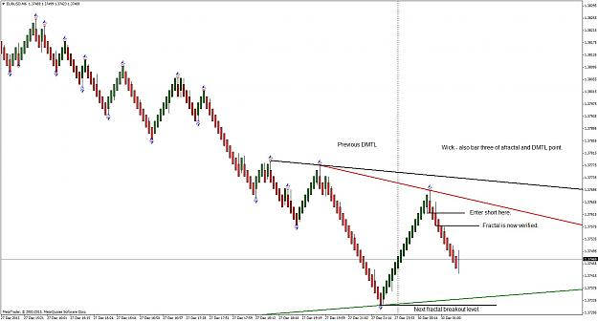
The DMTL has changed. Its previous position is noted with a black line.
Price went down and formed a fractal and a supply DTML line formed there.
Price then went back upwards to form another up fractal.
Now look at the up fractal. At the peak of the fractal (middle block or block three) there is a wick.
If you were watching, a block later, the DTML conditions are satisfied and the DMTL is re-drawn to its present position.
A short entry below the wick block is good. Two blocks later out fractal is verified. Also an entry if you like, but not as good as the wick entry two blocks earlier.
The arrival of the DTML line on the wick is like a confirmation of an entry.
We are taking short trades because the overall LL LH trend is intact and we keep a stop loss above the last up fractal.

Wab | Dec 30, 2013 10:54am | Post# 22

1 Attachment(s)
And the action continues. THE DMTL adjusts. More wicks form a block before the DMTL forms and up to two blocks before a fractal is verified.
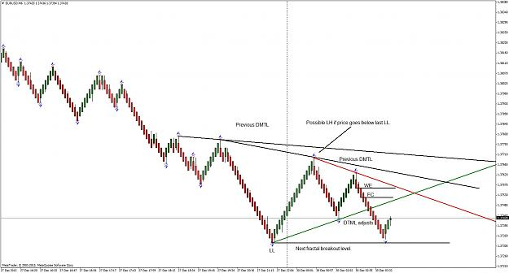
We monitor the last LL and if price moves lower we have a confirmed LH.
( I have to go show rings to my customers. No time to trade right now.)
Hopefully you can begin to see the potential here. As soon as I am able, I will enter a trade or two.
Meantime monitor that potential LH, which will be confirmed with a break below the last LL. Watch for the wicks and then the DMTL and the fractal following behind them.

Wab | Dec 30, 2013 12:55pm | Post# 34

1 Attachment(s)
Let's see how that EURUSD is doing. I have marked WE (wick entry levels) and FC fractal (confirmation levels) as they have occurred.
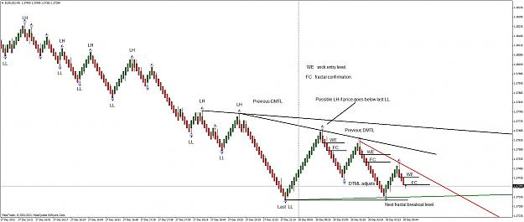
Now what will happen at the lower DMTL? A wick or a break?

Wab | Dec 30, 2013 2:26pm | Post# 38

1 Attachment(s)
OK here we go. Price breaks the DMTL and closes below it. No block color change, wick or fractal forming.
It also breaks the last LL fractal and confirms the new LH fractal in the process. Trend is still down.
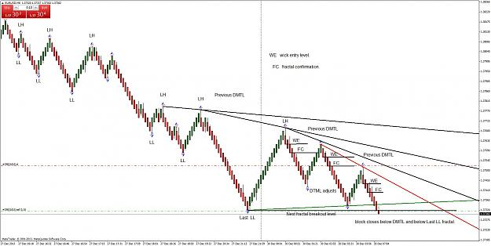

Wab | Dec 30, 2013 5:09pm | Post# 40

1 Attachment(s)
Half of Calgary is here to ski and the conditions are just ice.
My stop was hit. If it breaks above the last LH it is reversing. I should have has the stop there but broke my own rule.
In front of an audience too.
Doing this live on line, is going to be tough.
Now I have to watch it go back towards the LH and look for an entry when it turns - if the LH holds.
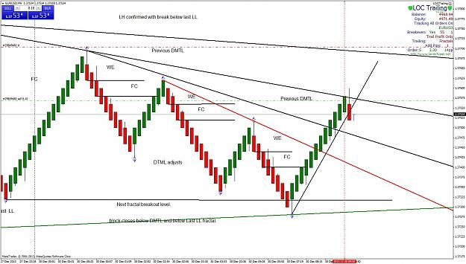
Stop is at the LH. Let's see how this does. I will leave a trade manager to trail a stop at each fractal. Way past my bed time.

Wab | Dec 31, 2013 1:33am | Post# 41

1 Attachment(s)
I managed to get a small profit, getting stopped out at the first fractal while I was asleep. Then the market did a turn around.
First it broke above the small red LL LH sequence at the thin red line then it took out the last LH at the thick red line and really that confirms it is now heading up making a series of HH HL as it goes.
Each HL has provided and nice wick entry. If I can, between other activities, will try and catch the next one.
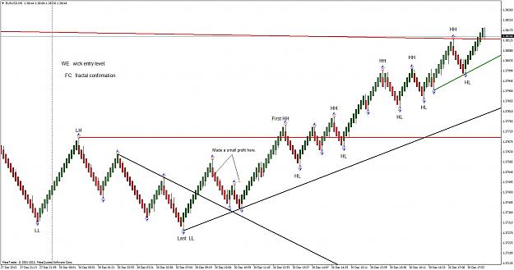
Having to sleep now and then makes for some missed trades, but more come along all the time.

Wab | Jan 1, 2014 2:16am | Post# 44

1 Attachment(s)
Looks good pappi. I actually took that trade as the HH HL sequence changed to LL LH. I will post the EURUSD chart and it really has some good examples.
With New Years and so forth, I have not been able to really sit down to this but that will change once things settle down.
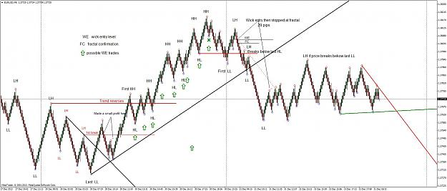
There is a load of information on this chart. I don't have time to go into it all now but will do so later.
Meantime have a look and see what makes sense and what doesn't.
Happy New Year. May 2014 be the year the pips rain down on us.

Wab | Jan 1, 2014 7:03am | Post# 46

1 Attachment(s)
Hi spyderman.
It takes a bit of head-wrapping-around to get this. (I will have to put together a graphic.)
Compare your count to mine. I do not label an LH until price breaks below the previous LL. We can only know that it is an LH after that happens.
I have added some more info to the chart showing possible WE bullish trades, that I did not take as I was busy setting rubies. I have also updated the LL LH fractals at the right.
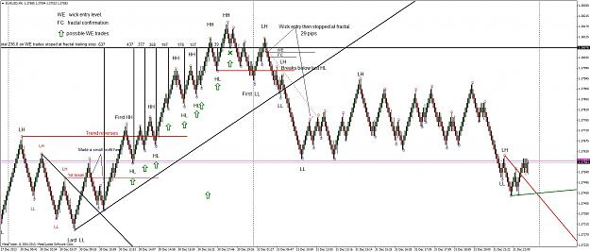
The next bullish reversal is confirmed when price breaks back above the last LH that we have confirmed. We may get more so just keep tracking them as they form and are confirmed by a break belwo the last LL.
(Another set of LL LH have formed while I write this, so my reversal level is now on a lower confirmed LH as price breaks its last LL.)
Once you can see this you will never again believe any of the so-called "trend indicators" which mostly get it wrong.
Now look at all of the bearish WE locations that were there for the plucking.

Wab | Jan 1, 2014 7:05am | Post# 47

A parable about indicators.
A MafiaGodfather finds out that his bookkeeper, Enzo, has cheated him out of 10 million bucks.
His bookkeeper is deaf.
That was the reason he got the job in the first place.
It was assumed that Enzo would hear nothing that he might have to testify about in court.
When the Godfather goes to confront Enzo about his missing $10 million, he takes along his lawyer who knows sign language.
The Godfather tells the lawyer, "Ask him where the 10 million bucks is that he embezzled from me.
The lawyer, using sign language, asks Enzo where the money is.
Enzo signs back, "I don't know what you are talking about."
The lawyer tells the Godfather, "He says he doesn't know what you are talking about."
The Godfather pulls out a pistol, puts it to Enzo's temple and says, "Ask him again!"
The lawyer signs to Enzo, "He'll kill you if you don't tell him."
Enzo signs back, "OK. You win!
The money is in a brown briefcase, buried behind the shed in my Cousin Bruno's backyard!
The Godfather asks the lawyer, "What did he say?"
The lawyer replies,
" He says you don't have the balls to pull the trigger."
Indicators are like lawyers. Don’t trust them. They often lie and you have to recognize that as a fact. Learn to read the signs yourself.
(Note: Any lawyers reading this are probably doing so on time that they are also billing clients for.)

Wab | Jan 1, 2014 10:56am | Post# 50

2 Attachment(s)
I checked the chart and after a more careful look ... sorry I missed that. ( A good student will always excel the teacher.)
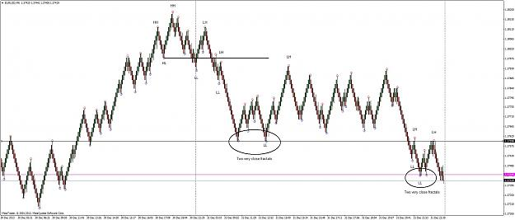
There were two situations where the fractals were very close, making it hard to figure out the sequence.
I would change time frames in a regular chart to sort that out. Going to a higher time frame often clears up any confusion.
I haven't experimented enough with different sized Renko blocks but the same trick would probably work. I know some people keep two or three charts with different size blocks running.
Anyone with thoughts/ experience on that please jump in.
The DMTL also helps when that second LL swings slightly lower and it adjusts and gets your attention.
Another thing I do is use the 5 34 5 MACD to figure out possible Elliott Wave counts. (We haven't got to that yet.)
I really don't want to get all EW on everybody at this point.
I will try to give ways to get around the dreaded wave four correction which always causes confusion.
Here is an EW view for those interested. All kinds of people will now jump up and down and offer their view of my count,
but as I said, I will try to avoid that and mostly keep this EW free.
Just be suspicious of fractals that are very close to each other in price.
Here is an EW view for those that might see how it applies.
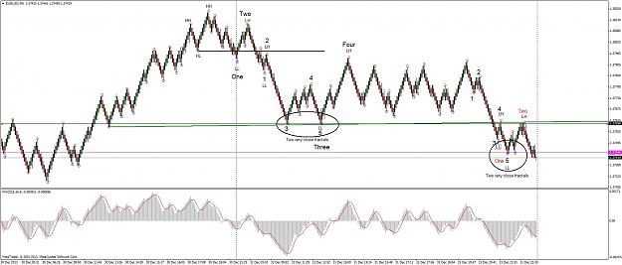
Again, I don't want to get this all EW oriented.
As the charts evolve the method will become more clear. I appreciate people like spyderman who call my attention to the things that I miss and thereby help me polish this.
Now, I am signing off for New Year's Eve in the Rocky Mountains. Where's my party hat?

Wab | Jan 2, 2014 4:39am | Post# 53

1 Attachment(s)
Welcome aboard 21vs7. At one time in his life, my father in law raised pigs. One day the government inspector came to visit and asked his wife where he was.
"He is out in the barn with the pigs,"she replied. "He is the one with the hat on."
*********************************** *********************************** *********************************** *******************
CRL.
I want to take the opportunity to stress an important point. From now on I will try to conscientiously add a line on the charts that I will label as the current reversal level. CRL. I encourage readers to do the same. Will I always get it right? Will it always work? No. But it will work often enough and as you try to add it you will get very good at it and find it becomes part of your price action analysis.
The CRL will be the most recent confirmed LH or HL. It marks the level at which a trend of HH HL reverses or a trend of LL LH reverses.
(In Elliott Wave it is where wave three is confirmed as it breaks past wave 2 or wave C is confirmed as it breaks past wave A. Not that we need to worry about that too much. I am trying to keep this as Elliott free as I can.)

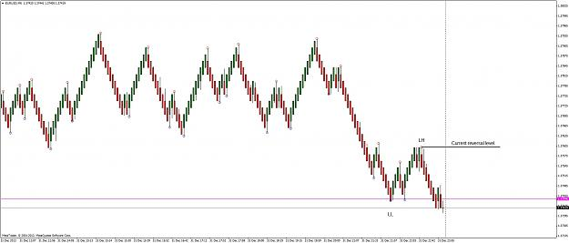
If the market breaks above this CRL level a reversal in trend has occurred. If a new LH forms we should move our CRL down to the new LH fractal. The CRL is always at the most recent confirmed LH or HL.
Note: There is one place where we will not necessarily have a turn that occurs on a fractal. I mention it now because I don't want you thinking I am making it up a as I go along. I will be sure to point it out when it occurs and will refer back to this note if questions arrive.

Wab | Jan 2, 2014 4:43am | Post# 54

Summary: I have tried to lay the groundwork of using fractals to count the HH HL LL LH sequence.
I have discussed the importance of wicks on median Renko bars where a color change occurs.
I have touched on the significance of where wicks occur in a fractal and how they predict fractal formations.
I have pointed out that not all De Mark Trend Line points are fractals but all fractals have the necessary three point patterns that DMTL uses.
I have discussed the fractal where a trend reversal can occur.
Abbreviations:
HH ... Higher High.
HL ... Higher Low.
LL ... Lower Low.
LH ... Lower High.
WE ... Wick Entry.
FC ... Fractal Confirmation.
CRL .. Current Reversal Level.
I think I have established the basis for a system and I am ready to take it in some different directions.
First of all, I think I will try to catch some trades (as time permits) and field any questions.
Time to go play some New Year's Hockey and relax for a bit.

Wab | Jan 2, 2014 9:48am | Post# 55

The LH (CRL in the last chart) was broken as price moved up. It is now dropping and this is what I referred to as a point where a fractal may not form when the price turns back up.
(This came up quickly, as I thought it might , so I am glad that I mentioned it in post 53.)
I am looking for a fractal or at least DMTL point, a change in the location of the green DMTL and a WE to go long form.
Let's see how it goes.

Wab | Jan 3, 2014 3:24am | Post# 62

1 Attachment(s)
Hi Monocor.
I guess I find it necessary to explain simple concepts. Often when you try to explain why a simple thing works, that explanation makes it seem complex.
I no longer add fractals to my charts but I use them all the time and need to explain that. The wick/fractal relationship is interesting to understand but you can use it without understanding it.
The HH HL LL LH analysis is a good one to go through on any chart in my opinion. The place where a trend reversal will occur is always good knowledge to have and or operate from. Of course you don’t know if it will happen until it happens, but knowing where it could happen is very useful.
As I mentioned earlier, moving to a higher time frame or bigger block clears up a lot of confusion. I am using small blocks here to illustrate as the price action forms more quickly.
If you have several different trading systems that work they will all point to the same places where the trading opportunity happens. I believe that we all trade our understanding of that in many different ways and eventually find one that works for us.
Anyhow, we are all here to learn and become better traders, or we wouldn’t be here. And any and all input is valuable if it is meant to be that.
I am certainly not in the Sonic R league and can only aspire. Meantime, maybe there is an additional morsel of material, that I will offer, that is of use to others. I will be adding a lot of ideas here and you can pick or chose if any are of use to you.
Now, having said all that, what is next?
Let’s look at a trade using 8 pips blocks and discuss various ways to manage it.
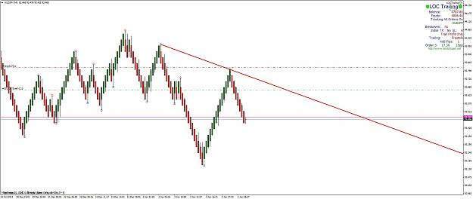
First of all, I somewhat relied on the DMTL here to convince me to go short. There was no wick bar and two red bars needed to give me a fractal confirmation. Two red bars needed by most people who trade Renko, but I got in a bit earlier because the DMTL had adjusted. So I gained a little bit there and every bit helps.
Now, I am in a short trade and I have placed my stop just above the last up fractal.
Time to discuss trade management strategy.
I can sit and monitor the trade, or have some sort of trade manager do that for me. There are a variety of ways to do this.
On the right of my screen you will see a trailing stop program called LOC. It is a commercial product, so please do not ask me for a free copy.
Look for "Land of Cash" on Forex Factory and you can find out about LOC.
LOC has the ability to trail a stop in a variety of ways. On this chart I have it set to move the stop down when a new up fractal forms.
That way, if I get a good move with multiple waves LOC will lock in profits fractal by fractal, until we get a market reversal.
So I will let that one run and come back to it later.
There are many strategies for managing trades. Another I will use, is designed to just catch the red to green green to red moves in Renko.
You will not need a trade manager like LOC to do this if you can watch the trades yourself.

Wab | Jan 3, 2014 4:51am | Post# 63

2 Attachment(s)
Here is another way to trail a stop. This time on a faster EURUSD 4 pip median Renko.
(I jumped in here on the DMTL arrow, wanting to show another stop trailing method.)
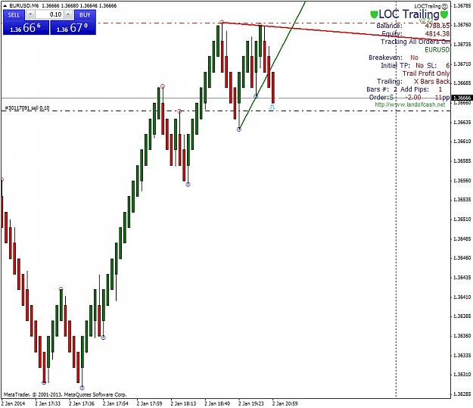
This time I am trailing the stop two bars back, plus a pip. I can do this manually, or let LOC do it for me.
You can see here that the stop has already been moved by LOC.
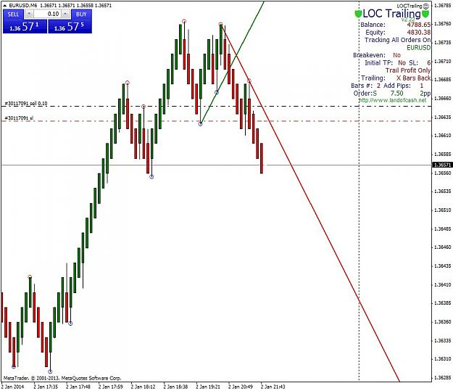
The stop will be moved down based on two bars back plus a pip - programmed into LOC.

Wab | Jan 3, 2014 5:07am | Post# 64

Meanwhile, the AUDJPY 8 block Renko has not broken below the last LL fractal. So I can close the trade or let it form a higher fractal and move the stop down to that level when it does and see what happens.
Since we are giving LOC trailing fractals a test run I will stay with that strategy there. If I was using the two bar trail plus a pip as I am in the EURUSD, I would probably be getting stopped out around this point.
I have experimented with trailing stops a lot. There are many methods: trailing on a moving average, PSAR, ATR stops and so on. I use them when I cannot sit and watch a trade, which is most of the time. They all work to some extent, some better than others.
Sometimes I switch from one to the other, based on what the chart is doing. Sometimes I pick one and the other does better. I have not found a trailing stop method that works perfectly, X bars back (two bars plus a pip) or fractals stops in synch with the trend do well enough.
I have pips locked in on the EURUSD now and the jury is out on the AUDJPY.
I will update in a while.

Wab | Jan 3, 2014 6:19am | Post# 65

1 Attachment(s)
I took the dog for a walk and the two bar plus a pip trail made a few dollars while I was out.
LOC is a very handy tool that monitors a trade when I can't.
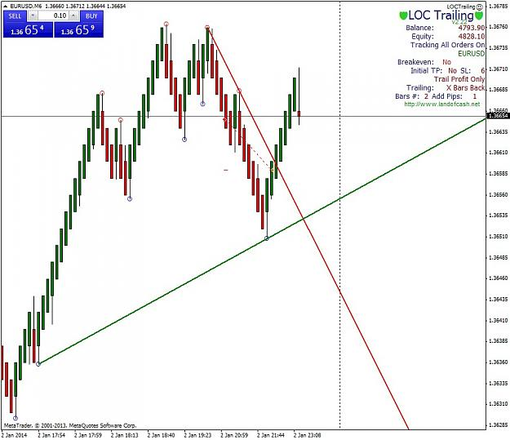
Wab | Jan 3, 2014 7:44am | Post# 69

1 Attachment(s)
It looks like the AUDJPY 8 trade is about to form an up fractal. We have a wick entry as well. If it does form an up fractal, LOC will move the stop down to it as soon as it breaks below the last down fractal. That would also trigger a DTML signal to go short as the lower trend line would break. It all works together and a lot of it becomes surplus as we gain experience.
(I left the fractals turned on to illustrate them. LOC does not need to have them on the chart.)
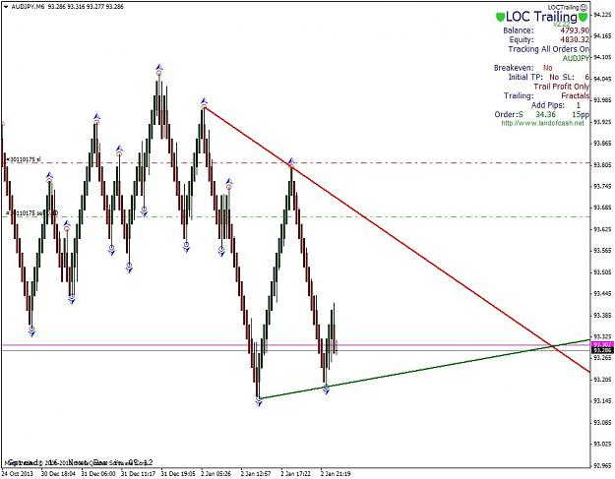

Wab | Jan 3, 2014 1:34pm | Post# 71

1 Attachment(s)
Here is how the AUDJPY trades worked out with fractal stops.
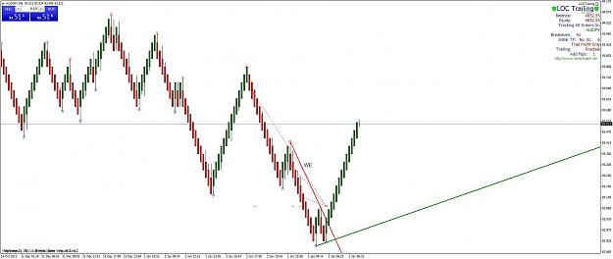

Wab | Jan 3, 2014 2:20pm | Post# 72

Hold that thought Blaiserboy.
There are mixed benefits to having smaller blocks. Think of adding on a trade at every new block.
I was at a friend's house tonight and we had a really nice 4 pip block run that started with a 5 pip risk and went to 30 plus pips in a few minutes. Adding on at each new block would have really upped the score there. What you end up with is an arithmetic progression and each new block rapidly gets to be worth a lot of pips while the risk is controlled nicely with an X bars trailing stop. At some point I hope a good programmer is interested in that.
I have written an Excel Spreadsheet that shows how the math of that works, but let's hold that thought back for a bit.
Too many things at once and we will just have total confusion.
How about some useful alert indicators next? A sound alert when a wick forms for example?
Coming up soon.

Wab | Jan 14, 2014 12:03pm | Post# 97

2 Attachment(s)
Attached, is a semi-useful alert for when a wick occurs on a Median Renko Chart.
Use these settings:
Attachment 1346755
You will have to re-set it if you have closed a Renko Chart just select Edit and then re-open it.
It sounds an alert and prints an arrow on the chart and draws your attention to a wick brick.
You can't follow it blindly but it is good for an alert. If you want to, you can compare it to fractals.
I like to try and enter when the market pulls back and catch an early move on its way to a fractal
break out. This helps.
MA Crossover Signal.ex4

Wab | Jan 15, 2014 11:34am | Post# 98

1 Attachment(s)
Here is a theoretical diagram that I hope will make the trend analysis a bit easier to understand.
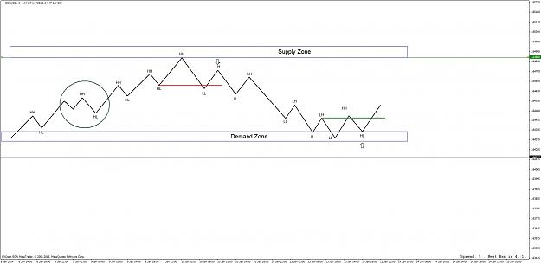
(Note that the HH HL sequence has to be counted carefully when the fractals are close in price. The area in the ellipse illustrates this.)
Then we get a LL that breaks that last HL and the trend change is confirmed. The best entry we can get is as close to the first
LH as we can. On a median Renko Chart that is the wick entry bar.
Our stop will be just above the HH. A new flow of Supply has turned the price down at the HH and when it attempts to go higher again, we are ready for it. That first LL break below the HL red line tells us it likely can't manage to overcome the Supply Zone.
Now, the price trends down with a LL LH sequence until a new HH breaks the last LH at the green line and the trend is reversing again.
This time off a Demand Level.
Lets look at a real time trade where this is applied.

Wab | Jan 15, 2014 11:39am | Post# 99

1 Attachment(s)
I was a bit late getting in on this one. Still it illustrates the method nicely. I also used LOC set to trail a fractal stop.
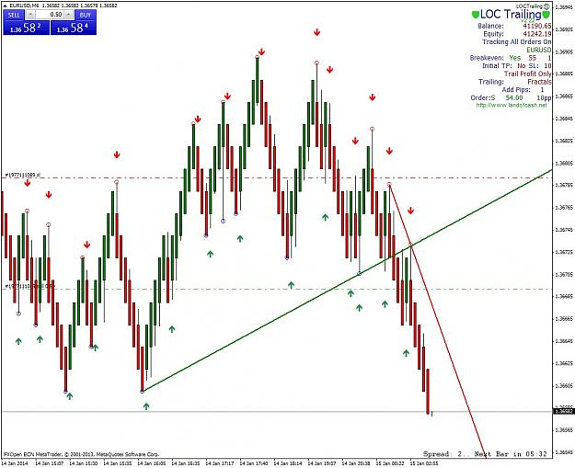
You can see the Wick Alert Arrows and the De Mark Trend lines. I will add labels in a bit.
See if you can figure out the best wick entry based on the first LH fractal.
Wab | Jan 15, 2014 11:41am | Post# 100

1 Attachment(s)
LOC waits for a fractal to form so that it can move the stop. You can do this yourself of course.
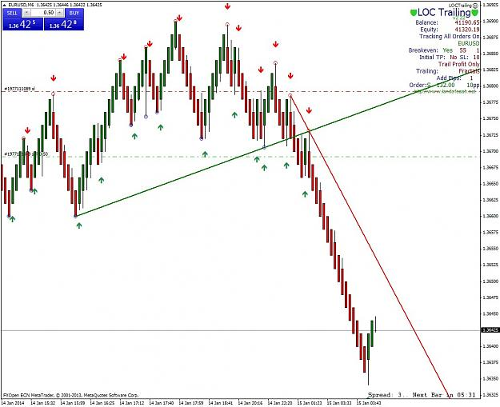
You could also take profit once you get a two bar reversal, but I am letting LOC do the trailing stop.

Wab | Jan 15, 2014 11:43am | Post# 101

1 Attachment(s)
An up fractal forms and LOC moves the stop one pip above it, just as it is programmed to do.
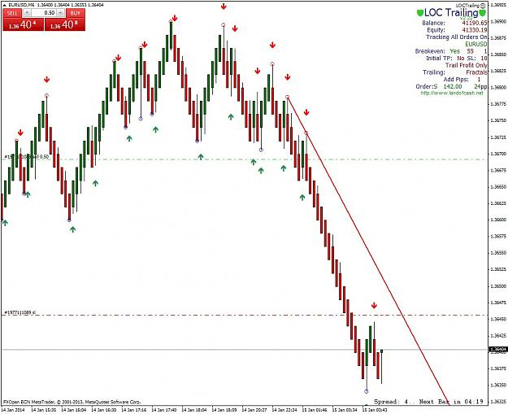
Wab | Jan 15, 2014 11:46am | Post# 102

1 Attachment(s)
Now will we get more downside action or ... will the trend reverse?
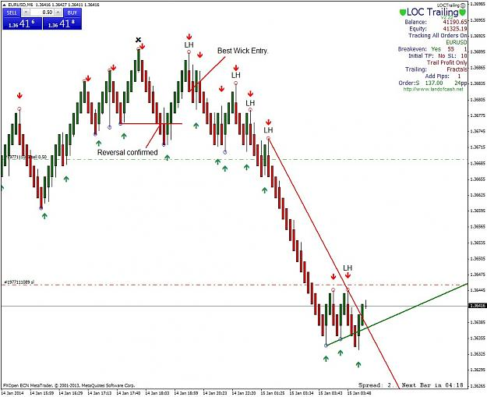
You only know after it happens.
However, the green wick alerts might be getting our attention.
Wab | Jan 15, 2014 12:35pm | Post# 103

3 Attachment(s)
And the run is ... stopped out.
Attachment 1347731
LOC has stopped us out just above the place where a two bar reversal would have done the same thing.
I have added labels so that you can see where the best wick entry (WE) was. We had a HH, then a reversal as the price
broke the previous HL (red line) to make a LL. It then pulled back to make a HL and that was the Wick Entry I wish I was there for.
(That's what happens when you eat desert.)
Initial stop just above the HH then trail it down LH by LH (LOC will do that nicely.)
A nice trade, even though I got in late and got stopped out.
*********************************** *********************************** ***********************************
I have added a MACD indicator to the bottom of the chart.
Like the Wick Alert the MACD is useful when we understand where we are in the HH HL LL LH sequence. When you know that,
and only then, the wick alerts and the MACD become extremely helpful.
Here are the settings for the MACD.
Attachment 1347738
Note the MACD Alert has an alarm for when it crosses zero. I generally leave it off. You will see what I mean when it goes off... repeatedly.
Note:
When you open and close your MT4 the wick alert arrows and the MACD alert will get scrambled up on the Renko Chart.
Just open them, select edit, and close them to have them display properly.
A lot to digest here before I get into the MACD too much. It told me that I would get another chance to go short - but I was busy writing this.
(Should have had another desert.)
Then it tells me that we will get a messy long correction. But, I am getting ahead of myself again.
MACD Alert.ex4

Wab | Jan 15, 2014 1:12pm | Post# 104

1 Attachment(s)
Such a nice teaching chart. Wouldn't you know it, the MACD telling us something, right on cue.
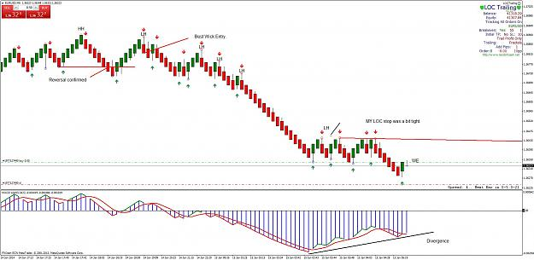
Note the bullish divergence on the 5 34 5 MACD.
As I explain this wonderful indicator more you will come to know that divergence very well and what it means.
(I expected a bit more of a down move after I was stopped out and I have a change in the stop strategy that
would have gained another 93 but let's wait until later to see how that works. It is using LOC in X bar mode.
Watch for that later.)
For now let's look at the MACD divergence. That divergence just about always occurs at the end of a strong run
just as a counter-trend, or a reversal arrives. This is where most traders lose their money. (The dreaded wave four
in Elliott Wave terms.) I expect the MACD to climb back to zero at least and to also create a triangle full of whipsaws.
In a Renko Chart this is somewhat smoothed but still a dangerous area to trade. A break of the De Mark Trend Line
that will form the bottom of a triangle will tell us when to go short again.
Having said all that, I did enter a long trade to demonstrate how LOC and Fractals work here. I don't expect to get
much, but sometimes the correction can go on for a long time and you can gain a little. Normally I don't trade these
corrections after a divergence. We may well see why, as this works out.
So, not much to do now. These corrections tend to be tedious. Let's see how LOC fractal trailing does with it. I will
likely be asleep as it works out.
Later.

Wab | Jan 15, 2014 2:22pm | Post# 106

1 Attachment(s)
Chart is back in shape and up a few pips.
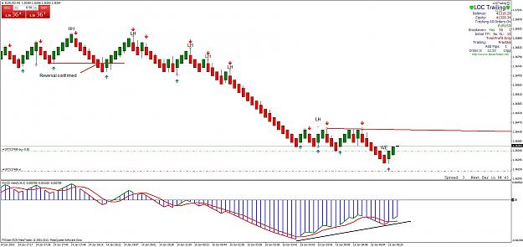
I will leave LOC to move stops fractal by fractal.
I will not be awake for the London open, 1:00 a.m. my time, so that's it for now.
*********************************** *********************************** *********************************** ****************
Next, I will talk more about the MACD and its use.
Can we do this without the Wick Alert arrows? Yes.
Can we do it without the MACD? Yes.
They do make it easier, but only if we use them correctly. Knowing how to identify the trend is the most important thing.
Go back to the theoretical diagram in post 98 and make sure that it makes sense to you.
No matter what method of trading you eventually settle for, that is the most important thing to learn.

Wab | Jan 16, 2014 1:49am | Post# 107

4 Attachment(s)
As expected, the counter-trend trade did not do well. It was stopped out by a fractal as the DMTL broke and signaled a short trade.
Attachment 1348329
I added a black line to show where the DMTL was at the time. A break of that trend line was a good entry for the next down move.
Now, I would like to draw your attention to the relationship between the trends and the MACD.
When the MACD is below zero then it is best to only trade down moves (LH to LL) and be in synch with the LL LH sequence - until a reversal occurs. Then trade the up trend moves (HL to HH) when the MACD is above zero, and be in synch with the HH HL sequence.
The purpose of the DMTL, the Wick Alert Arrows and the MACD is to help with this.
In the next chart I will display the MACD trend status on the Renko candles.
Attachment 1348353
The colors of the candles match the status of the MACD. Trend and counter trend above and below the zero of the MACD are now color coded right into the Renko Chart.
Here are the settings. ( I leave the MTF display off.)
Attachment 1348362
So lots to play with. Have a look tinker with it and see what you think. I will try to get some more charts up this evening.
MACD Candles v4.ex4

Wab | Jan 20, 2014 3:42am | Post# 125

2 Attachment(s)
Kmalex. I suspect that you and spyderman have different data feeds. This is often a source of confusion in Forex when peo0ple compare charts. Each broker tends to have their own data feed and minor differences occur.
I consider a break of a fractal as a break but when the fractals are very close in price levels is it time for caution. Soon the count will clarify itself. As you get to use the MACD more it will show that confused areas are always in count trends/corrections.
Monocor, thanks for your trade charts. You have a good system going. If anything here makes it better please comment. Your input is great.
I am going to talk about trailing a stop X bars, back. (Actually two bars back, plus a bit of room.)
I am also going to introduce another indicator that works very well with Renko.
Let's have a look at how a stop or an entry can be attempted:
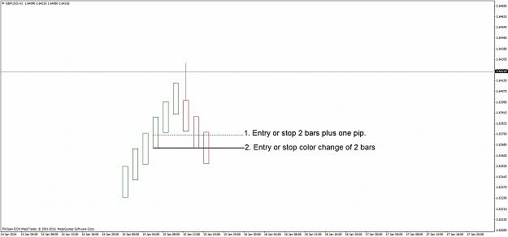
On the diagram, the method frequently used for an entry, is to enter is when the Renko Bars have changed color.
So if we have green bars going up and we get two red bars we close a trade or go short.
That is method 2. As illustrated in the diagram.
We know that the wick bar is a reversal signal, so entering at the bottom of the wick bar ( plus a pip ) gets into a trade a bar earlier.
That is the equivalent of two green bars plus a pip. I like earlier entries as the little bit you gain often covers the spread etc.
I can use LOC to trail a two bar stop, using its X bars back function. LOC will move the stop to the two bars back level as each
new bar forms. (Plus a pip or whatever you select as an additional buffer.) I set the initial stop to equal to the number of pips
that this would entail. So If I am using 4 block bars the initial stop would be set 4 + 4 + 1 pip = 9 pips back.
You will need to adjust the initial stop according to the block size that you use and trail it manually, if you do not have a trade manager,
such as LOC, that does it for you.
Using the two block trailing stop versus a fractal trailing stop will be something that we can discuss. Each has its merits.
The Fractal trailing system is very good at keeping you in longer term trades.
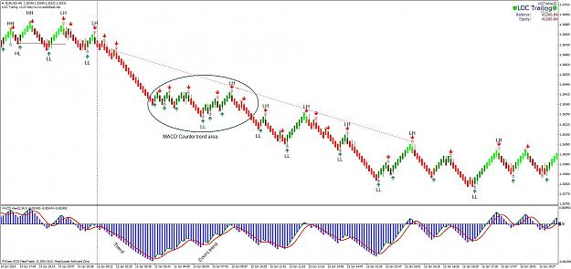
Here is an entry at a reversal on a wick bar. Using a fractal trailing approach, the stop is moved down from one LH to the next.
Then you run into an area (inside the ellipse) where the MACD shows a counter trend and it becomes tricky to get the
LL LH sequence correct. All of the up fractals are so close and then the last one, that is the actual LH shown, pokes just a little bit higher.
How do we avoid a premature exit there?
The solution is easy, just put a larger buffer on the fractal trailing stop. LOC will keep the stop any distance that you specify above the fractal.
A 10 pips buffer keeps you in the trade, safely above the tight, counter-trend fractals, until the trend resumes. (MACD confirms when that happens.)
The trailing fractal stop with a 10 pip buffer keeps you in for about 687 on that move. A larger buffer on the fractal trailing stop makes life easier.
The X bars back trailing stop does not weather the choppy counter trend fractals but it will manage a trend trade nicely.
Which one you use, depends on what you want to do.
Note that both trailing stop methods will sacrifice some of the move, that is the nature of a trailing stop.
Next I will introduce the last indicator that I use with Renko Charts.
After that, some strategy and I think we will be pretty much ready to test, torture and improve the method. Maybe even
develop an order ea that will take advantage of certain situations that occur in very fast markets.
I will let it sit at that now and field any questions.

Wab | Jan 20, 2014 4:05am | Post# 126

Just a note. I like to cite sources for indicators when I know where they originated.
The MACD Candles Indicator can be found at http://cjatradingtools.com
Thanks to CJA for sharing .

Wab | Jan 20, 2014 11:28am | Post# 127

2 Attachment(s)
Here was a bearish trade with an X bar stop.
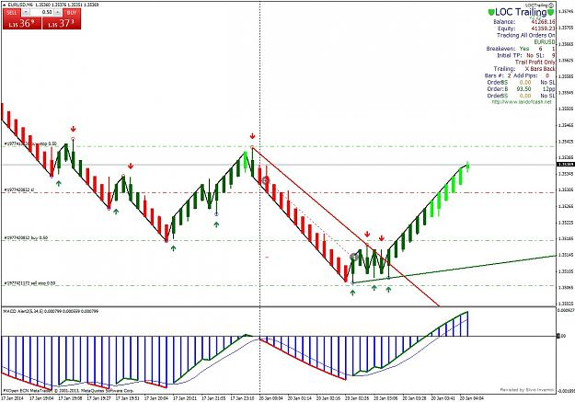
The trade was trailed and closed by LOC, while I had a Sunday Afternoon nap. The sound of the Wick Arrow
alerts woke me up in time to catch the bullish entry, though I was a tad late.
The bullish trade is now in progress.
Note that I also have pending orders in place at the fractals to catch any break out trades as well. The LL LH count
prevails at this time unless that upper buy stop above the LH fractal is broken. (LL LH is not labeled on the chart.)
The candles change color depending on the MACD. At this point we have bright green candles because
the MACD is above zero.
The black line on the chart is the close price line. It interacts nicely and we will use it in future charts, especially
when I introduce the next indicator - which it interacts very nicely with.
Just got stopped out by LOC, so I went short again.
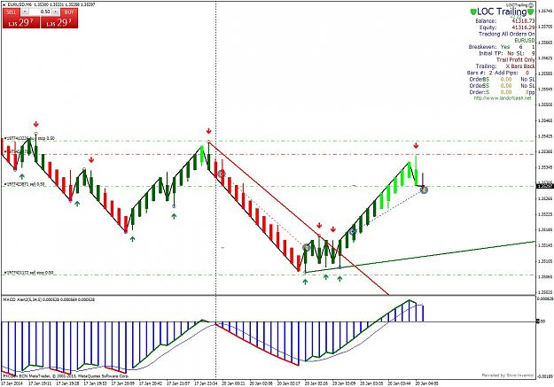
I will let LOC trail the stop and see how it goes. If it breaks the lower fractal, as mentioned I have a pending order there.
Wab | Jan 21, 2014 1:35am | Post# 130

Yes the divergence was the reason. That and the opportunity to show how the X bar stop works.
I think I will have to look at the USDJPY as monocor keeps nailing it. So far I have just been using the EURUSD for examples.
Wab | Jan 22, 2014 4:29am | Post# 135

2 Attachment(s)
A picture being worth a thousand words, here is a summary of the various signals and strategies so far.
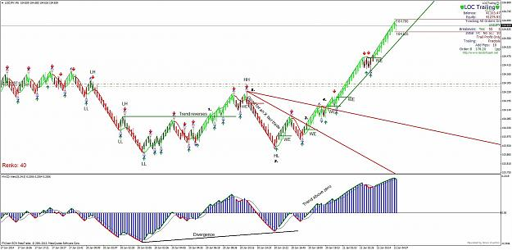
First of all is the LL LH count. A LH is not confirmed until price breaks below the last LL.
There is no indicator that will count the HH HL LL LH sequence properly … you have to learn how to do this yourself.
Everything else is secondary to this.
When price breaks above a confirmed LH a trend reversal has occurred. (See point 1 on the chart.)
This is tells us to look for an opportunity to go long after a correction.
The opportunity occurs at point 2 on the chart.
A Wick Entry forms on the Median Renko Bar and a long trade is entered just above the wick bar. (WE)
An additional entry signal is give as price breaks above the red De Mark Trend Line (DMTL) at 3.
Then the DMTL re-sets itself and a further break above it signals another place to go long at 4.
A break above the previous HH at point 5, is another long entry place. (This one was taken for a trade.)
Each additional WE can be taken if the MACD/candle colors/ HH HL LL LH analysis, shows a suitable trend.
Trends are identifiable, at a glance, by looking at the color of the candles.
If the MACD is above zero and price is rising, the candles will be bright green. If the MACD is below zero and
price is rising, the candles will be dull green. Bright Green candles mean a strong move is underway. Small
counter-trend moves, with MACD above zero, will give dull red candles and may present an opportunity to add
on new bullish WE trades.
Proper trend analysis using HH HL LL LH must match what the MACD is telling us.
The red and green arrows are alerts with a sound that is designed to draw your attention to the wick bars.
They are produced by the MA crossover signal set to EMA 1 and 2.
The circles mark fractals and the pivot points from which the DMTL is calculated.
Blue Fractal arrows are shown on the chart but they are redundant –see above. Just use the DMTL circles for fractals.
Divergence on the MACD and an understanding of the relationship between the MACD trends and counter trends and the
corresponding candle color is necessary.
The Close Price is displayed on the chart as a black line. “Chart on foreground,” is turned off in the chart properties to get
this displayed properly with the Renko Bars.
All of the above indicators are merely aids to help you see what is already there in the Renko Charts. If you can count the
HH HL LL LH sequence, locate wick bars and fractals, then draw trend lines, you can do everything the indicators are designed
to do. It takes practice and it is worth practicing because then you understand it better.
The Signal Line is displayed as a red or a green line on the Renko Bars.
I may or may not use all of the above indicators but I do like the Signal Line because it gives me the opportunity to gauge the
strength of a move.
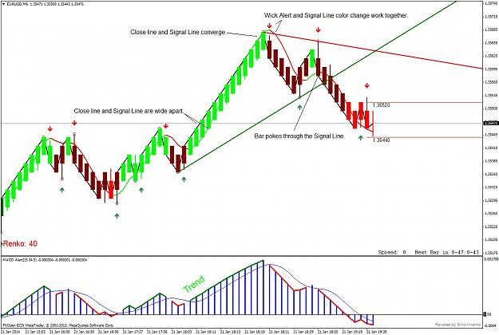
Note how the black Close Line and the green Signal Line are far apart at the beginning of a move and they converge as the move matures.
Then, the Close line drops below the Signal Line and the counter trend or reversal move starts. This works well in conjunction with the MACD
and MACD color candles. The Signal Line Close Line relationship gives us a bit of an edge in anticipating changes in direction as they converge
and cross and the momentum of a move weakens.
(Drop a vertical line anytime the Close Line and Signal Line converge or cross and see how they all line up.)
The Signal Line also changes color and that draws our eye to a possible entry along with a Wick Alert Arrow.
When a bar pokes through the Signal Line we get another possible entry signal.
At this point, I have presented a method for any and all to use, modify, debate, trade and so on.
I have used 4 pip blocks on the EURUSD and I am open to trying other size blocks and other pairs.
I look forward to seeing how this taken forward.
Wab | Jan 24, 2014 7:53am | Post# 149

1 Attachment(s)
Thanks for the Fractal support resistance indicator ducka. I have used it before and it is very useful.
I filter choppy markets with the Alligator. When price is in a counter trend (dark red or dark green) the
Alligator tends to be tangled. When price is moving strongly it will be bright green and above the Alligator
or bright red and below the Alligator.
The Alligator and the 5 34 5 MACD are designed to work together.
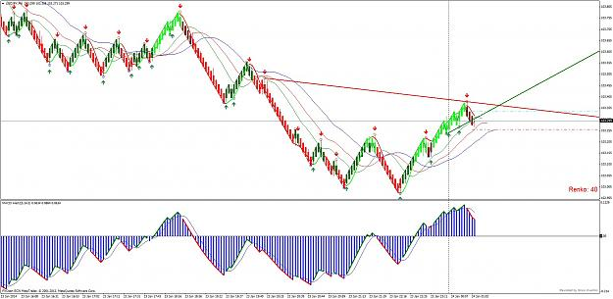

Wab | Jan 24, 2014 8:48am | Post# 150

kmalex,
On your chart there is actually a reversal that you can find like this:
(I would label it to show you but my Renko Chart will not go back that far.)
There is a LL between the last two HL and LL labels.
If you locate that LL then there is a LH between your LL and LH labels. When
price breaks above that you are back in synch with the bright green trend.
Once the choppiness passes it is easy to get the HH HL LL LH count sorted out. Mean time when you see
two HL fractals very close together in price or two LL fractals very close together in price you can be cautious.
Take the most distant one until it sorts out.
In regular charts I go to a higher time frame to solve the choppiness and sort out my HH HL LL LH count.
Larger blocks may help.
Another thing to consider is that bright green is trending and dark red shows counter trends. Because it is
above zero on the MACD the market it trending up overall, even if it it does counter trend temporarily and throw
a reversal pattern in there. The HH HL LL LH sequence is tricky at times like that and the MACD in particular helps sort it out.
I hope that helps. As you run into that situation again and again,you will recognize it and get good at dealing with it.
HH HL LL LH does not lie to us, but we have to listen to it carefully or miss what it is telling us.
 | Wab | Jan 24, 2014 2:11pm | Post# 152

1 Attachment(s)
Hi kmalex.
If anyone has a good set of instructions on how to get more M1 data please post it. Thanks.
Sorry the explanation doesn’t make sense. My data only scrolls back so far and I could not get back far enough to bring up that part of the chart to show you what I was trying to describe.
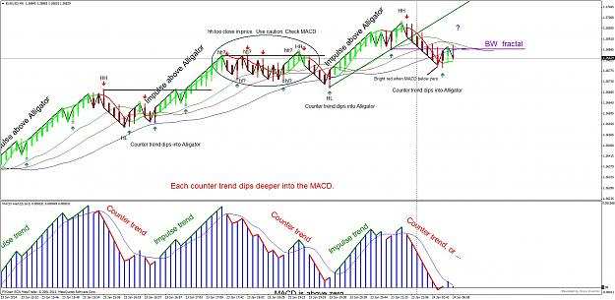
Let’s move on to a similar situation that is current. Look at the area in the ellipse on the chart. The HH HL count gets difficult to sort out there. I have shown the count with hh? and hl? If you look at the MACD in this area you see that it is in a counter trend. This, combined with very close prices for the hh? hh? and hl? hl? Fractals makes it difficult to do our price analysis. Eventually it becomes clear and we change the last hh? To a HH.
It is confusing at first and only gets easier with practice. This particular part of the sequence is what is referred to as a fourth wave in Elliott Wave terms and most losses occur in a fourth wave. Another way to look at that is if you cannot determine the HH HL LL LH count you are likely in a fourth wave and need to stand aside until the count becomes clear again.
I have put the Alligator (default settings) on the chart to show how it works. In Impulse, or trend moves, price stays well clear of the Alligator - above it in a bull move. The correction or count trend dips back into the Alligator. This corresponds exactly with the 5 34 5 MACD. Each dip gets a little deeper and then we get a trend reversal as the MACD goes below zero.
It does not do it without a fight. The price may cross the Alligator and the MACD may cross zero then pull back up for a re-test, which is possibly the situation we have here. I added a ? to show the idea of the re-test. Of course if goes higher than the last HH … we have to work with that.
We can’t predict the future we just try to understand where we are in the present.
Our last Green Wick Arrow may be a new HL or the first LL if price rallies then breaks below it.
A new bright red bar here will signal a down trend.
A new red WE, somewhere around the ? would also be a good short entry that I would take.
Finally I want to point out the last down fractal. I extended a violet line to the right from it and labeled that line as the BW (Bill Williams) fractal. This is the first fractal which is broken by a lower price and it is also below the Red Alligator line when it is broken.
I will not go into the BW fractal at this point because we have a lot going on here. Watch for it at a future time. When it shows up it is a good indicator of a trend change. I will explain it in due course.
Again, if anyone has a good set of instructions on how to get more M1 data please post it.
My M1 data goes back to Nov 27th any ideas on how to get more?
Wab | Jan 24, 2014 3:23pm | Post# 154

1 Attachment(s)
Sorry Michael. I haven't had to fix that yet. If you or anyone else finds a fix please post it.
*********************************** *********************************** ******
Back to our chart:
Once again the bars turned bright green and confirmed a HL.
Note that the Alligator is back open and price is once again well above it.
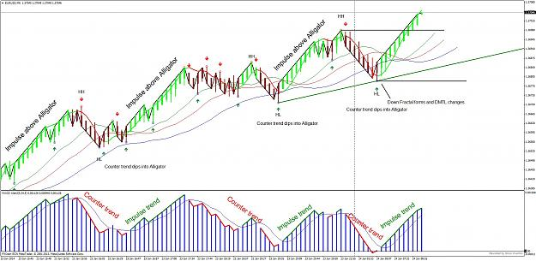
Each of these impulse waves can be traded nicely.
Wab | Jan 25, 2014 7:14am | Post# 160

2 Attachment(s)
Thanks for the help kmalex and Kiads. This is how it is supposed to work. We help each other out and it leads to a better world for all of us.
I upped the number of candles to 10,000 and I will see if I can get back to the area that you had a question about when I get a chance to do so.
Meantime, here is how the chart that I was following last night worked out.
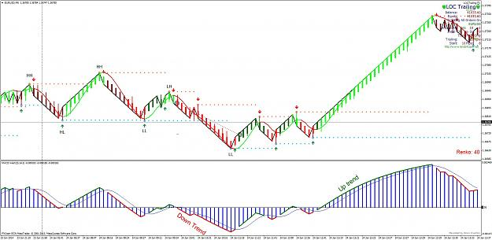
I left LOC to manage my trade and it did so nicely, with 16.4 pips. The MACD continued to give some little counter trend information then it decided
to go above zero and a combination, or any of the WE, DMTL breaks and Fractal breaks all would have been good entries.
Price finally broke above four fractals, confirming a trend reversal.
I wasn't at my computer to take any of them, so it is all academic at this point. If I was on line, I would have had a nice run of 59 pips from the first WE.
Here is the same chart with the Alligator and the BW fractal.
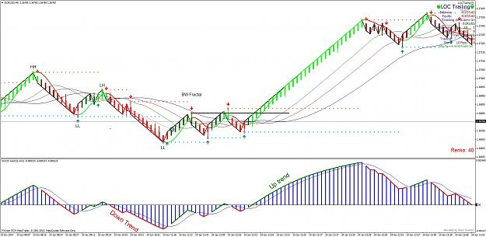
The bullish BW fractal, is the first fractal which has its price broken above the red Alligator line.
(If we had a bearish BW fractal it would be the first fractal to have it price broken below the red Alligator line.)
Note how the trend, once again, sees price stay well out of and above the Alligator which opens wide. When
price swings back into the Alligator we get a bounce up for another bright green, then MACD divergence and a
break below the Alligator tells us it is done.
Wab | Jan 25, 2014 9:27am | Post# 161

2 Attachment(s)
kmalex, regards post 142. Your M1 data suggestion worked ... thank you.
I was therefore able to scroll back to the area where you had your question about the HH HL LL LH count.
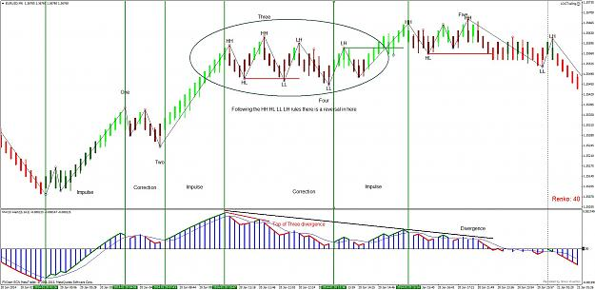
Following our rules for HH HL LL LH there is a reversal inside the ellipse.
In Elliott Wave Counting that area is a wave four, always an area of confusion, whipsaws and false signals. The Alligator
(Not shown on the chart) closes up there and clear trends do not happen.
The 5 34 5 MACD is also called the Elliott Wave oscillator and it helps to identify wave four.
The highest or (lowest level of the MACD is usually followed by a small divergence. This is shown in red on the chart.
This divergence marks the end of the strongest move (Wave three.) The MACD then heads towards zero, usually touching
or penetrating the zero level to confirm a wave four. (In this example it did not get to zero but it usually does at least go down that far.)
A wave five impulse follows but it is mostly weaker than the previous wave three impulse wave. A larger divergence (black) is the 3, 4, 5
Elliott Wave divergence.
Now I really hoped to avoid detailed Elliott Wave stuff here. So let's not worry about that too much and just focus on the
MACD and the brick colors.
When the MACD is above zero, we only want to take long, impulse trades, preferably with green bricks. If we know the HH HL
LL LH count, so much the better. If we have a confused area, check the MACD and see if it is a counter trend /correction and
consider taking entries in the direction of the trend only or just stay out until it becomes more clear.
Some people say that an entry at the third fractal (that would be the LL, Wick Entry, just above the "four" label) is a good place to enter.
If you can keep all of that in you mind and act on it, then you are really good.
You can see how the price finally broke above the LH at green line, the right edge of the ellipse, and resumed the HH HL count until it reversed
again below the last HL.
I know this is complex to explain and maybe a lot of what I have explained here is not necessary. The Elliott Trader in me gets loose once in a while.
Anyhow if you can be aware that the MACD peaks, diverges a bit, then heads for zero that is the area to be cautious.
Knowing why is not really necessary. If you like to know why, then I refer you to Bill Williams books on Trading Chaos.
*********************************** *********************************** ***********************
ducka regards post 159. I cant put up a Renko gold chart as the markets are closed.
I don't follow gold as much as I should, given that I work with it every day. I stocked up a long time ago
and I am glad that I did.
The last LH is correctly identified. You can trade using the MACD and keep an eye on that LH.
You are correct thinking that the LL label is not verified until price breaks below its fractal.
Knowing that, you have a range between the LH an the potential LL to work in. If price moves past
either of those there is a trend change.
Watch the DMTL for any breaks. Price is in the tight end of a triangle and will break out soon.
Check the H4 gold chart Alligator. Very strong move under way. Try a HH HL LL LH analysis
on the daily gold chart and see what is happening.
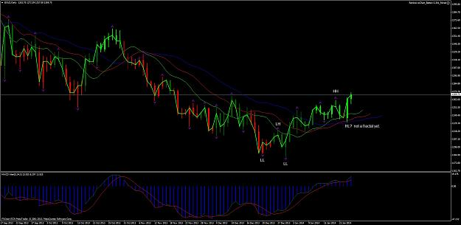
The problem you will have to solve is how do the Renko Bricks and the daily chart relate to each other.
Just taking long trades may be the solution.
Also look at the weekly gold chart and see what it is saying.
Wab | Jan 26, 2014 10:13am | Post# 167

Thank you pcca- matrix and Kiads for the help.
I have looked over the indicator based Renko from Ovo and like what I see so far.
I will also have a look at yours Kiads.
I have used FX Reds script based off line because I like the Median Renko.
I am always amazed at how many people on ff offer so much to others. You guys are great!
With the new update looming, I hope that we are able to carry on without too many issues.
I guess that we will know soon enough.
This weekend I have played with larger bricks and the method we have evolving here
seems to work just as well, if not better.
Generally I like to test ideas in shorter time frames and fine-tune them, then trade longer time frames.
The same will apply here. Four pip bricks are good to get action and test ideas and teach with.
Larger bricks for the real work.
Wab | Jan 31, 2014 2:29am | Post# 173

1 Attachment(s)
Some thoughts / examples on entries and stops:
Always know the HH HL LL LH sequence as best as you can.
Always see how that relates to the 5 34 5 MACD.
Always identify the potential CRL.
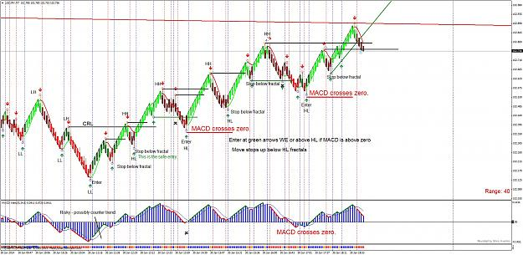
When the MACD is quite deep you might consider a counter trend trade. This is shown by the risky label on the MACD.
The CRL is not too far away and a break of that means the trend is reversing so you have to judge this. Experience helps.
Once the CRL is broken it will pull back and form a WE. This is the safe entry.
It is safe because the trend has reversed and you are getting in on wave two or wave B of the Elliott Wave .
The previous entry on the green WE alert is not as risky as the first WE because the MACD is going above zero.
Now we can enter at each green WE or as the price breaks above the recent HH fractals. Essentially entering on
breakouts and HL, green WE, pullbacks.
Stops can be close to the HL pullbacks and you will get some good trades before the price stops you out.
As the MACD gets higher you will be wise not to add positions.
Now, how long you will stay in a trend depends on how well you read the MACD.
It will diverge and head back to zero or lower and give you places to locate stops. I will explain that in a later post.
Meanwhile. if you keep a large buffer on the stops below the HL, green WE, fractals, you will weather the corrections
and stay in the trend for a long while.

Wab | Jan 31, 2014 2:57am | Post# 174

2 Attachment(s)
Before I go further, I should mention the new indicator that I have added to draw attention to the MACD trends.
The MACD that we are using is a 5 34 5 exponential one so you may find the occasional discrepancy.
Set the MACD SMA alerts V4 to 5 34 5 and the line style to 2. and you will have a vertical dotted (red stay short or blue stay long) line on the chart.
Indicator and new template are both attached.
MACD_SMA_alerts_v4.mq4
ffrenko.tpl

Wab | Jan 31, 2014 3:47am | Post# 175

5 Attachment(s)
What exactly is the 5 34 5 MACD and what does it show us? I believe most people don't have a clue how a MACD works or what a MACD is.
Renko really helps clear that up quickly.
In the chart I have placed a 1MA of the high and a 1MA of the low and then I
removed the Renko bricks. This gives us a black channel that outlines the bricks.
The CRL level is shown.
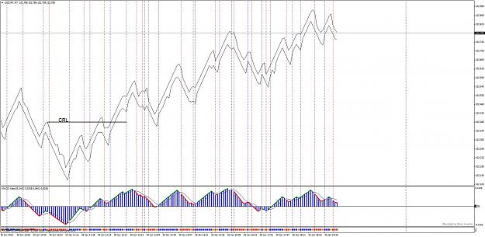
Next I have added one of the MACD moving averages. The 5 EMA of the close is a red line.
Note how it stays inside the Renko Channel.
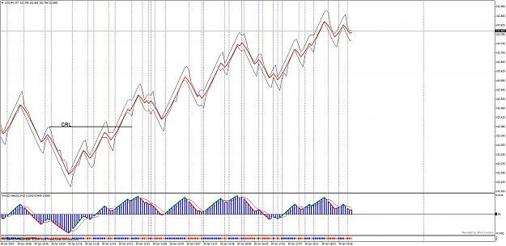
Now I have added the other moving average of the MACD, the 34 EMA of the close is the green line.
Note the places where the red line dips below the green one.
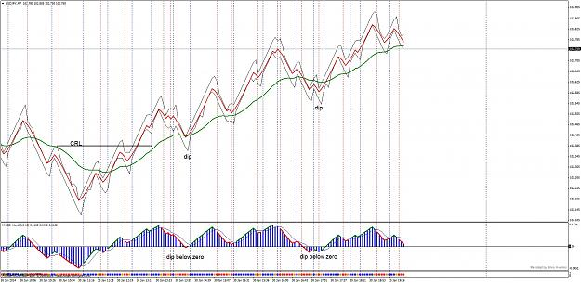
Also notice the places where the black Renko Channel has dipped below the green 34 EMA.
Now place our Renko bricks back on the chart and also examine the MACD a bit. We have a long term divergence and a short term one as well.
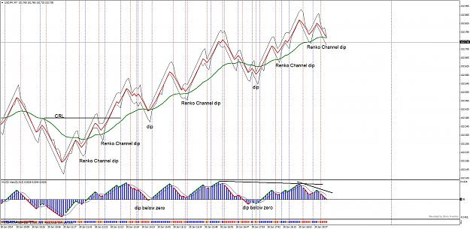
Can you see the good places to have placed your stops in a long term trade? The last Renko Channel dip has been broken and a divergence tells us to step aside now.
Look at how the MACD tells you where those good stop loss places are.
Now when we go back to our full chart display we have a pretty good idea of what the 5 34 5 MACD does for us.
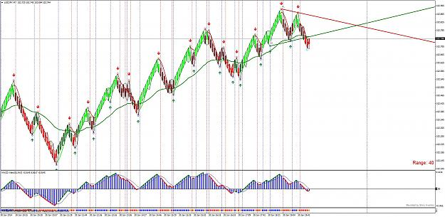
The 5 34 5 MACD is designed to match the Elliott Waves that are in the chart. We have a system that allows us to be aware of the HH HL LL LH count, the fractal breakouts, the Wick Entries and also the DMTL breakouts. All good potential places to enter trades.
We don't need to know too much about Elliott Wave to use this but I do urge anyone really interested to read Bill Williams books to further their understanding of how the 5 34 5 MACD and the Alligator and the Elliott Wave all work together.
We can use a variety of trailing stops. (If you want to use LOC you have to purchase a copy to trail the stops for you.)
You can scalp between WE alerts or try for long term trades suing the dips as above until you hit a MACD Divergence. If you want to try larger bricks you can use the same strategy to weather small brick corrections. Using a large brick and a small brick chart side by side is very powerful too.
(We will discuss that later.)
Reading the MACD and getting the HH HL LL LH count takes practice then it becomes more clear.

Wab | Jan 31, 2014 8:02am | Post# 176

3 Attachment(s)
If you like pretty charts.
Here is another little addition to make the MACD easier to see.
The MA ribbon filled Alerts colors in the space between the EMA 5 and the EMA 34
moving averages. It also makes general Buy and Sell recommendations on the bottom right.
Attachment 1359600
I used bigger blocks here, the block size does not affect the analysis,
but it does result in a lot less signals to worry about and bigger trades that carry
on for longer periods of time.
All settings are in the ffrenkoribbon template, which assumes you have all of the
previous indicators discussed so far, already installed.
MA ribbon filled_Alerts.ex4
ffrenkoribbon.tpl
 | Wab | Feb 1, 2014 12:34am | Post# 178

The MACD alerts are the dotted vertical lines that show where the trend or counter trend changes occur according to the MACD.
Check the MACD to see where they come from as it changes form green to red and so on.
A general rule would be, if the vertical line is blue only consider long trade the right of it. If you have had a green Wick Alert and you
enter long and a blue MACD alert follows that is a confirmation. Often the Wick alert will happen just before or even on the same brick
as the MACD alert occurs.
The opposite of course, red Wick Alert arrow and red dotted vertical MACD alert line for bearish trades.
Once we get the new Renko up and running - after the MT4 upgrade -I will start posting charts as they evolve.
Wab | Feb 4, 2014 9:13am | Post# 184

1 Attachment(s)
Well it is Feb 3rd and my MT4 has not forced an update yet.
I started some 16 pip brick trades last Friday and left them on for a while.
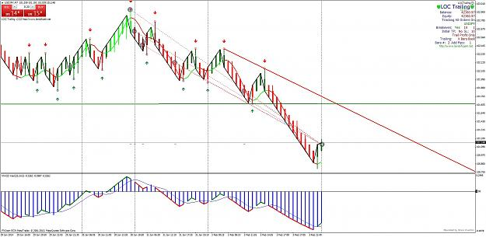
As for the best time to trade? I think the Renko approach makes timing trades
different... you can't just check every hour, or every 5 minutes because it is price that
is drawing the bars, not time.
The trade above stretched over four days, counting the weekend. If you are
using smaller bricks then you can of course be in and out a lot more quickly.
I live in the MST time zone and that makes it difficult to trade the London markets,
which open about 2:a.m. my time. I find with the Japanese open, at 5:00 p.m. my
time there is lot to trade with smaller bricks. 4 pip bricks are fast enough and make some
good moves.
I would appreciate anyone else jumping in here with advice for ducka.
Now where is that MT4 upgrade?
Wab | Feb 4, 2014 3:13pm | Post# 188

1 Attachment(s)
That's correct. Just as it is on MT4.
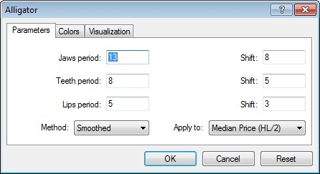
Wab | Feb 10, 2014 3:39am | Post# 207

3 Attachment(s)
A few posts back (before the new build distracted us) ducka asked about some entries that I took.
To answer his question I will use a chart and show how I combine Fibonacci with the HH HL LL LH count.
When the trend changes direction, that gives a chance to catch a third wave of some degree.
What is happening at a change in trend, is also known as a 1, 2, 3 trade or an A, B, C, D trade.
In Elliott Wave, this would generally be a new 1,2 waiting for a 3 or a new A ,B, waiting for a C.
All of the labels used in different ways makes for a lot of confusion.
The wave counting, 1,2,3 and A, B, C, D stuff is nice if you understand it, but not essential.
Let's look at the chart and relate this to HH HL LL LH.
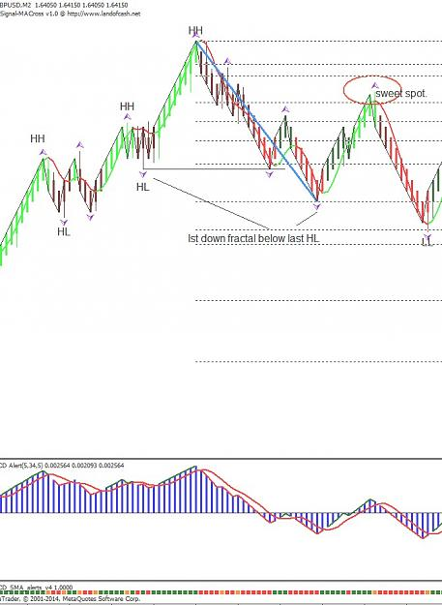
On the left we start off with HH HL count and the last HL level is broken as price drops.
Ideally, I will draw a Fib from the last HH to the first LL if I can figure out where the LL is.
A good rule of thumb is draw the Fib from the last HH to the first down fractal that forms below
the last HL and then adjust, if necessary, it as the LL LH picture becomes clear.
Of course we don't know where the LH will form, but it will form at or near a Fibonacci level, generally
between 61.8 and 78.6.. This is the Fib Retrace Sweet Spot. I have placed an ellipse over it and very
often this is where the next Wick Entry sell signal occurs.
Often, that is all you have to do to find a good entry after a reversal in the trend.
However, markets are nothing if they are not fickle.
Our next chart is a continuation of the above one and shows how we have to dance with the evolving
LL LH until it becomes clear.
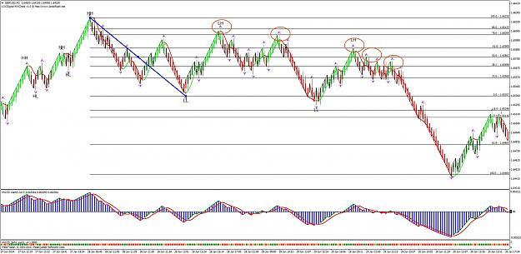
Now we can see how each of the Fib Retrace levels provides a place to be alert for WE trades.
Just look at how those WE and Fibonacci levels are right on the mark!
I am so confident with this that I can place pending or limit orders at the Fib levels. If price doesn't
retrace to one or more of those levels, no harm done.
My stop stays just above the last HH and I can let entries run with a minimum target at the 61.8 level,
shown below the 0.0 Fib level.
Of course there is also the break out trade as the price moves below the 0.0 Fib , which is of course also the LL level.
A note on the MT4 Fibonacci tool.
If you examine how I use Fibonacci, I am interested in the retrace levels from LL all that way back to the last HH.
A 100% retrace means I have to have the 100% label at the last HH. A 61.8% retrace has to follow this logic and
therefore level of 0.0 is where I break into a new wave.
My 61.8 or 161.8 targets are therefore actually entered into the Fibo properties as negative values ; -0.618 and -1.618.
All this takes practice and as I said above, when you get confident with your HH HL LL LH and draw the Fibs on the
trend changes, you get very confident that the WE will form at Fib retrace levels.
There are other ways to use the Fibs that we will explore later.
For those of you who want to set your Fibonacci Tool to match mine, here are the settings that I use.
0.0
0.236
0.382
0.5
0.618
0.786
0.86
1.0
1.618
-0.18
-0.27
-0.618
-1
-1.618
-2.0
-2.618
-4.235
And, here is how you can get the levels and prices to show on the chart.
Click on Fibo Properties and set the levels like this for each value.
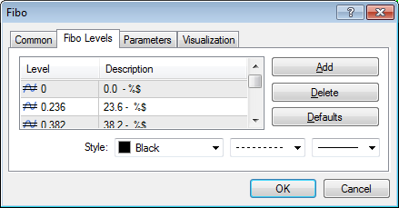
Wab | Feb 12, 2014 4:27pm | Post# 210

ducka have a look at any info on the Elliott Wave Oscillator. (Same as the 5, 34, 5 MACD.)
Some pairs (GBPUSD for example) will favor a 50% retrace on wave two. Others, the sweet spot is at 61.8 to 78.6%.
Here is a PDF that explains how to count the waves fairly well in Elliott terms. The HH HL LL LH works with this as well.
http://www.esignal.com/support/advan...manual_ch7.pdf
Wab | Mar 12, 2014 11:31am | Post# 232

One thing that works Apfelsaft is to only go long when the MACD is above zero and only short when MACD is below zero.
The exception being when a divergence occurs.
Wab | Mar 14, 2014 11:59am | Post# 237

1 Attachment(s)
Thanks Blaiserboy. An honor to be deferred to by yourself.
Apfelsaft, before you have any success with indicators in my opinion, you need to be able to read the bare chart itself.
Learn to identify the support and resistance areas. Once you master this you will throw away most of the indicators
as you will no longer need them.
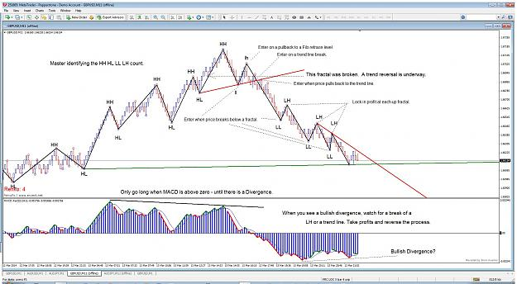
On the chart, I have identified waves, steps, zigzags, whatever you chose to call them. I have labelled them HH HL LL LH accordingly. Each label is on a Fractal.
You have to master this yourself. There is no indicator that does it properly in MT4. (At least none that I have found anyway.)
Once you can do this you will know more about a chart than any of the indicators can tell you.
Every single chart has this structure and every single trend ends like this. Once you can spot the structure and identify the components
of it, you can find great entries like the ones above and trail your stop down fractal by fractal.
You can study Elliott Wave for years and try thousands of indicators and it will not put you very far past this.
Having said that, I use a bare minimum indicators.
I like the De Mark Trend lines because it identifies the fractals and also draws the current trend lines correctly.
It is an indicator that helps identify or confirm structure that I can already see myself. Makes me feel good when
it does what I have already anticipated.
I use the 5 34 5 MACD for a variety of reasons: The main one is again that it identifies wave structure when you learn how to read it.
(That gets into Elliott Wave and Fibonacci and the Alligator and so on. Interesting stuff but all built on HH HL LL LH.)
The HH HL LL LH and trend lines alone is most of a very good system of trading. Once I understand that I found that additional indicators that
are actually useful are few and far between.
I constantly try new things but the essence of what I believe is useful in charting is in the chart above.
Wab | Mar 21, 2014 12:32pm | Post# 244

When I trade regular charts, I prefer to use H4 or even daily. The trades are slow moving and there is no hurry to jump in.
Having said that, I do a lot of research in lower time frames because you can see how things work, or don't work more quickly.
I think it is the same in Renko. Four pip bricks move fast enough that you can test out your ideas and gain experience.
What is important is to have a system that you own. It must be something that you understand as well as you can and have as much
confidence in as you can. That only comes with lots and lots of practice, research and so on. If you are reading stuff here and
on other threads, you will gather enough ideas and fit them together in a way that suites you and works for you.
I know a lady, who drives from the next town (no bank there) several times a week and moves her money back and forth between a Canadian
Dollar account and a U.S. Dollar account. That is how she trades Forex. No leverage, no charts, just what she sees on the news.
She makes close to a 100 K a year, just doing that.
Her daughter asked me to show her mother how charting works and her mother just laughed at the whole idea. She understands what she is
doing and is good at it.
I know another old fellow (that is getting to be a term I can use less and less often) who trades stocks every day. He just watches
the business News Network and is very successful. He has made a million twice. He defies my logical thinking processes but he is amazingly
successful.
I like charts. I have studied charts for along time, especially Elliott Wave and Bill Williams' ideas. That is what makes sense to me. I look at
methods other people use and if it works for them, that is perfect.
My interest in Renko has been more to find a short-term method that will compliment the long term ones that I already use. No matter what time frame
I work in, the MACD or the AO and AC and the Alligator are the best in my opinion. With Renko the Heiken Ashi Smoothed is also amazing.
As Blaiserboy says, work at it until the charts are talking to you, then be patient and wait until they do so clearly. Patience is the most important
thing. We cannot take money from the market until it clearly offers it to us.
I have been working on an idea that will perhaps help a lot with the box size issue. I will start showing some charts on that soon. As yet, I do
not have firm conclusions but I am sure some of the expertise here will help out.
Wab | May 24, 2014 8:03am | Post# 253

1 Attachment(s)
If you label your chart with the Brick Size that would help me match the chart.
I did a 5 pip brick median Renko chart and it shows some useful content so I went ahead and used it to somewhat answer your question.
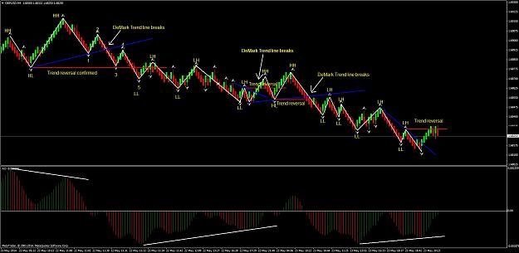
You will see that there are usually sub waves inside the larger HH HL LL LH waves that we look for. (Sometimes we cannot see then but they exist between every pair fractals. When you go to a lower time frame they are always there.)
Between the top HH and the first LL there are in fact five sub waves formed between the fractals. The fifth one is the one that
confirms a reversal in trend as it is below the last HL. However the blue De Mark trend line was broken a lot earlier and it is a good
early warning of a potential trend reversal. Each break of the blue De Mark Trend lines is a useful signal.
The overall trend is down until we get a reversal pattern -where that last LH is broken after a De Mark line is broken
The AO or a MACD gives you the direction to trade until a divergence cautions you to expect a trend reversal. If the AO is above zero
take long trades. If it is below zero take short trades. If the AO shows divergence watch the De Mark trend lines and the HH HL LL LH for
a reversal.
ab | Apr 20, 2015 3:02am | Post# 264

Reboot of Animal Farm.
It is a good idea to read over the thread, prior to this post, as there is a lot of good information in it. Many questions have already been asked and answered and it saves everyone time if you come to the discussion already informed.
When MT4 began all of the upgrades to version 600 + a lot of Renko things that I was using stopped working. It took a lot of effort to get back on track and each upgrade offered new challenges. Many of the Renko off-line generators became non-functional or unreliable. I eventually started using a commercial Renko Chart generator (Free demo at forex ovo) and found a more stable Renko Chart generator to work with.
Currently I am not up on the latest, free, Renko off-line chart generators. If anyone has a good one that they can share, I am open to using it here, so that we have consistent charts to discuss. It must show the wicks. Wicks are important.
When it comes to charts:
In a rising market they form a series of higher highs and higher lows. This eventually reverses to form a series of lower lows and lower highs in a falling market. A trader has to be able to recognize this and know how to take advantage of it.
Price action alone tells us where the trend really is, right here and now.
To me, Indicators either lag or require interpretation, which differs from person to person. Even the best of indicators are often wrong and you dont know until after the fact.
If you have an indicator that you really like, give it this test. Cover up the price data and just trade the indicator all on its own. It is an interesting experiment.
Some indicators are useful as they help identify structure and momentum in a chart, but again subjective interpretation is required.
Even price, the ultimate indicator in my opinion, requires interpretation.
The Elliott Wave is the most complex of the price interpretation methods and I have spent countless hours on Elliott Wave. Any two people can strongly disagree on Elliott Wave counts and its use becomes a very personal focussed one. Sometimes I look at what the Elliott Wave experts agree on and sometimes I disagree with their analysis. Sometimes I am right and sometimes they are right. Sometimes we are all wrong.
The HH HL LL LH sequence is the basis of Elliott Wave anyway and it does not have to be that difficult to analyze price action.
A trader has to learn how to count his sequence of HH HL LL LH. As of yet I have not seen an indicator that does this properly. If you can do this you can use it to trade nicely. If you master it, you will be well on your way to recognizing and using the most useful parts of the Elliott Wave.
The first rule is:
A new LH cannot be identified until price moves past the previous high.
A new HL cannot be identified until price moves past the previous low.
To make charts easier to interpret this, I use Bill Williams Fractals to identify the LL LH HH LH turns in the market.
Review posts 8 to 11 for more information on the use of fractals and how to identify the sequence of waves in a Renko Chart.
Some notes of interest:
My charts will usually use a 10 pip Renko Bar. I will use a consistent template and the same broker for each chart. Variations, such as price differences from broker to broker and pip size of bricks make it difficult to compare charts.
If you have a question, post your chart and state your question clearly. Post a 10 pip brick chart if you can and state the size of the bricks.
As I continue this, I am going to develop a standard template to use.
I also hope to discuss some money-management strategies, use of free Virtual Servers and what I think of as semi- automatic trading - using robots that are suitable for Renko charts. I have spent the last few months really studying the potential of trading Renko Charts with robots and I think some of it is pretty good stuff.
So why am I sharing all this? Because I can.

Wab | Apr 20, 2015 4:10am | Post# 265

1 Attachment(s)
I have tested the free Renko ea at http://www.pimpmyea.com/renko-on-build-600-solution/ and I
find that it draws charts that are essentially identical to the Fx Ovo Renko charts. I only noticed one
wick that was slightly different.
There are also instructions and videos at that site that assist in setting up the Renko off-line charts.
On the left is the fx ovo Renko and on the right the pimpmyea Renko. The only difference I could find
was with one wick. I will therefore use the fx ovo that I have been using for my charts and hope that
any differences between posted charts are not significant.
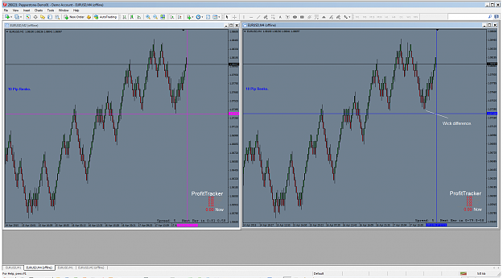
 | Wab | Apr 20, 2015 8:42am | Post# 269

2 Attachment(s)
I once took a course in organic chemistry. I had to spend many hours of my own time (over the summer) studying for an exam on chemical nomenclature. I had to pass that exam before I could take the organic chemistry course. The professor expected us to arrive ready to learn and did not have time to teach us the very basic stuff.
Consider the next few posts as an opportunity to learn about some useful tools. I wont have an exam to sort you out and see if you have done your homework.
I also don't want to answer very basic questions over and over again. Don't come to a gunfight with a knife.
*********************************** *********************************** *********************************** ******************
Have a good look at the charts on post #265. You will notice a set of pink lines (vertical and horizontal) on the left hand chart and blue ones on the right hand chart. These lines are going to be an important part of our tool kit. The pink ones are generated by a script called Get Cross and the blue ones by a script called SetCross.
Here is an exercise to introduce you to these two scripts:
Set up any two charts on the same pair, using different time frames.
Have your charts displayed side by side.
Drop GetCross on one chart and Set Cross on the other chart.
You may have to zoom out to find the pink vertical line on Get Cross. Click on it to select it, then move it to the most recent candle.
Set both charts to be about the same in terms of the number of candles displayed on each. Now move the pink vertical line from side to side and watch the blue vertical line. Do the same with the pink horizontal line.
A search of FF will reveal the source of these two wonderful scripts.
(Thanks to the Sorex for sharing. http://www.forexfactory.com/showthread.php?p=4912062)
These scripts allow you to easily find a location on two different time frames - or on two different bricks size charts.
Next, set up two Renko Charts on the same pair, with different sizes of bricks. (I recommend 10 and 30 pip bricks and will mostly be using those sizes.)
Play with these two scripts and get familiar with them. You will be seeing them a lot.
As I further develop this thread, I plan to introduce the tools and eas that I have found useful. It will be difficult for a new comer to jump in and know what is going on, so I encourage people to do their homework before they start attending the classes. I wont be inclined to answer questions that have already been dealt with. I expect people to do a bit of homework.
At this point I expect people to play with Get Cross and Set Cross and become competent users of these two scripts.
@ sx BT get cross.ex4
@ sx BT set cross.ex4
Wab | Apr 30, 2015 2:19pm | Post# 273

1 Attachment(s)
Thanks Juliuy and eurix.
If you have followed my thread this far you are familiar with the HH HL LL LH sequence of turns in a chart ... any and every chart.
These ultimately detail the Elliott Wave in a chart. EW is a tough study to gain confidence in, but let's take a shot at it in an indirect way.
You will need to open four charts:
Chart M1M2 is a M1 chart that generates an offline Renko chart that we will call M2.
Chart M1M3 is a M1 chart that generates an offline Renko Chart that we will call M3.
We will need four templates: M1M2, M1M3, M2 and M3.
Once we have these, it is easy to set up a profile. (I will use the GBPUSD in my example.)
In our profile we should have charts M1M2, M2 and M3 visible. (M1M3 is essentially the same as M1M2 so it can be minimized or hidden in the background.)
Next we put Get Cross on the M3 (30 pip bricks) chart and Set Cross on the M2 (10 pip bricks chart.)
Now we look at the M3 chart and do the HH HL LL LH analysis. We determine what the M3 chart is doing and try to establish what is in control.
On The GBPUSD Renko 30 chart we can see a reversal where price went through a LH level. Use Get Cross and Set Cross to easily identify this point on the M2 -10 pip brick chart. You can also drop the Set Cross script on the M1 chart and identify the same point there if you have enough data showing. (More on that later.)
Note:
I used the GBPUSD for this example because the M3 reversal was recent enough to be able to locate it on the M2 chart. As you do this exercise on several pairs you will find some levels are really a long way back and others are more current. In other cases (the EURUSD at the present time) the M3 is between a LL and LH but has not broken past either. Both the LL and LH are a long way back, so we note them.
For now will look for a pair with a closer critical point on the M3 30 pip brick chart.
The M3 breakouts that continue a trend are also important. We seek reversals or continuations on the 30 pip brick chart. These 30 pip brick locations are known to us well in advance of action on the 10 pip brick chart.
HH HL LL LH analysis on the 30 pip brick charts can thereby now be easily located on the 10 pip brick charts using Get Cross and Set Cross.
(On the M1 M2 Chart you can also see an indicator that displays a 10 pip brick overlaid on the one minute chart. Let's just leave that for now as there is lot to absorb here.)
So play with this a bit. Find some 30 pips turns and line them up on the 10 pip chart.
Observe what happens on a ten pip brick chart when the 30 pip chart makes a decision.
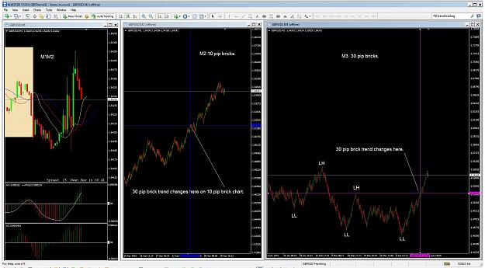
Wab | May 7, 2015 11:11am | Post# 280

Ok. Why am I so interested in comparing charts with different brick sizes?
My attempts to develop, or at least test different eas on Renko charts, have lead me to believe that pretty much everything that I have tried thus far might make a good profit in a run but then give it back in a congested market. Unless you can determine the direction of the market flow and set your ea to take trades only in that direction, the eas that I have tried lose over time.
The HH HL LL LH rule is always there in a chart and a higher Time Frame or a Bigger Brick chart can tell us what to expect for direction for some time on a Lower Time Frame or Smaller Brick chart. When a bigger brick charts such as the 30 pip brick chart makes a reversal then a 10 pip chart is going to trend in the direction of that 30 pip brick reversal for a while.
At that point we can trade in the trend direction with an ea and avoid corrections that tend to cost us pips.
We can also monitor the Lower Brick Frame (LBF) to anticipate reversals in the Higher Brick Frame (HBF.) A LBF reversal will occur inside a HBF chart and either confirm or warn us of a reversal point on the HBF. With practice, you can even use fractals on the M1 chart to identify M1 reversals. Just study those a lot before you try to use them in conjunction with Renko reversals, as a M1 chart can reverse several times inside a Renko Bar. (I mention this because it is of interest, but only useful really if you plan to trade in M1 charts.)
Next, I would like to talk a bit about money management /strategy and how I like to try and relate it to Renko. For discussion purposes, I will stay with 10 pip bricks.
The rule of 72:
If you were paying attention that day in school you would have learned that you can divide 72 by the rate of interest that your deposit pays and determine how quickly you will double your money. For example if you invest money at 10% per anum, 72 / 10 = 7.2 years until your money will double.
How many bricks will it take to double an account, if each brick is worth 2%? Yes, 31 bricks, as long as each brick is worth 2% of your account when it is closed. Is it possible to get 31 bricks in a week?
I am presently in a run that has gone 15 bricks since I entered it, another that has gone 7.
With the 7 brick run, at 2% per brick, I have 14%. With the 15 brick run I have 30%.
72 / 30 = 2.4.
72 / 14 = 5.14.
Making your bricks worth a percent of your account becomes a very good strategy.
(Anyone who finds a flaw in the calculations please advise. I try not to make errors but I know I do. Or, I could just be seeing if you are paying attention. )
Wab | May 10, 2015 2:44am | Post# 283

2 Attachment(s)
One advantage a Renko Chart has over other forms of charting is that it quantifies the data. If we set a
brick size to organize our interpretation of a chaotic environment, it allows us to set specific stops and
targets. We are not waiting on a lagging indicator to turn, or some other subjective event. We can just look
at a Renko Chart and monitor the bricks and the price of the bricks.
Have a look at this chart sample that shows three reversals:
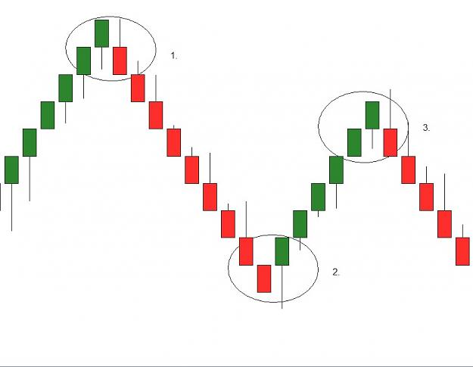
In each case a stop of three bricks and one pip is required so that the wick is contained within the stop.
(For now, I will leave the spread out of the discussion to keep things a little less complex.)
In each case the price then moves on a further 8 bricks, 5 bricks and 4 bricks respectively.
How can we set up our trading, so that each brick gained is worth a fixed percentage of our account?
Can the moves shown boost our account by a percentage even with a three bar and a pip stop?
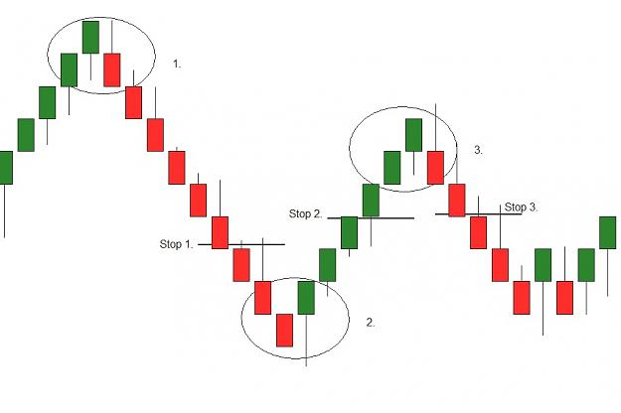
We have to take into consideration that any trade has to cover the stop (and the spread.) If our stop
was exactly three bricks our risk would be three bricks. To make each brick worth a two percent gain,
we have to think carefully about how to calculate that.
If we risk three bricks that should be 6% of our account and each subsequent brick would move one third
of that distance making its move 2% of the account. Looking at the second chart, and trailing a stop of
three bricks and pip, our first trade gives us a yield of five bricks, minus a pip and spread - somewhere
above eight and less than ten percent. The second trade gives us a yield of two bricks minus a pip and
the spread - somewhere over two percent and less than four percent. The third trade only manages to go
one brick before the three brick and a pip stop, plus spread, closes it. It makes two percent minus a pip and
the spread.
At this point I will throw this open for discussion critique etc.
Wab | May 12, 2015 2:26am | Post# 285

I am away for a few days so I won't be able top respond at length just yet.
You have indeed hit the nail on the head with your observation that a 6% stop is very large.
I agree that a ten pip brick is also hit with the spread and with slippage and that can
make up a significant percentage of a one brick move.
However, compare the ten and thirty pip charts and that six percent risk is only one brick on the 30 pip charts.
For a teaser, think of three ten pip bricks inside each thirty pip brick.
I should be back Wednesday night and will continue after that.
Wab | May 14, 2015 9:59am | Post# 288

2 Attachment(s)
They say the best way to really understand something is to try and teach it to someone else.
Two very good points have been raised:
The noise that exists (with Ten Pip bricks) and the challenge of consistent brick bagging.
To deal with these I want to refer back to the use of ten pip bricks and thirty pip bricks and my overall analysis, which looks for a reversal of the HH, HL, LL, LH, trend. I can do the analysis on either chart but I will concentrate on a 10 pip brick chart for a starting place.
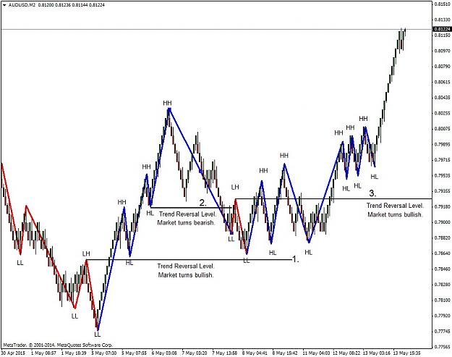
(There are many ways to enter a trade and we can go on to discuss a variety of these at a later point. For now I will use this reversal one.)
The 10 pip chart that I chose shows three places where a trend reversal has occurred. The down trend was illustrated with red lines and the uptrend with blue lines. Reversal levels are shown with horizontal black lines.
Reversal 1. occurs when a LL, LH, LL sequence is changed by a HH.
Reversal 2. occurs when a HH, HL, HH sequence is reversed with a LL.
Reversal 3. occurs when the market again swings from LL LH LL with a new HH.
This is all pretty standard stuff by now and anyone interested in this approach should have mastered identifying these reversals.
Now lets see how they relate to the 30 pip brick chart using Set Cross and Get Cross to line things up for us:
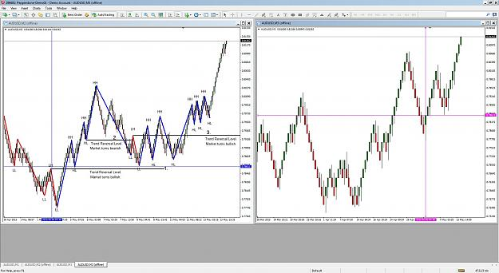
The number 1 reversal aligns with color change in the 30 pip bricks, as shown by the pink and blue crosses. When you get a 10 pip
brick LL, LH, HH, HL, reversal, which coincides with a reversal pattern on a 30 pip Renko, the stars have aligned.
Subsequent LL, LH HH, HL, reversals on the 10 pip chart fit the description of noise - if we concentrate on the 30 pip brick. They
occur inside of the 30 pip brick.
Many strategies use two different time frames to achieve a good entry level. Using different brick sizes accomplishes the same thing
in a more organized way. Big bricks are made from smaller bricks and as you examine the relationship between them, you will find that
reversal patterns in the LBF (lower brick frame) often occur within the wicks on a HBF (higher brick frame) chart. This makes for interesting
opportunities if you integrate the two wave counts.
I think that is enough for now. It may be complex at first, but with practice it becomes easier to read a set of charts like this and integrate
a LBF and a HBF strategy. I will make it easier soon (promise) but it is necessary to really get good at the analysis at this point.
Some things to try:
1. Check the relationships between HBF wicks and LBF reversal patterns.
2. Use a 6% stop on the 30 pip bricks and see how often it gets hit when you enter on the 10 pip reversal entry.
Wab | May 22, 2015 3:37am | Post# 293

3 Attachment(s)
It is a good video. Renko makes it even better.
On every chart there is a point at which the HH HL LL LH pattern reverses. You can identify these places and draw a horizontal line to the right. I call this line the E line (E for entry or Exit.) The E line occurs when price breaks above a LH or below a HL and reverses the trend.
Here is an example on a 30 pip brick chart.
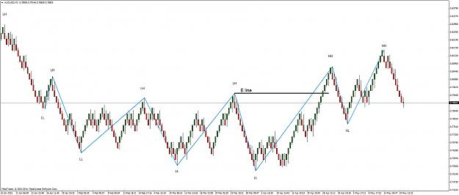
From here on you should add the E line to every chart and the potential E line, teh line at which a trend reversal will occur if price penetrates it.
Now I will add fractals to this chart.
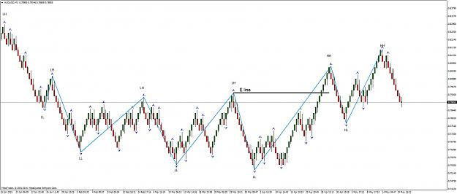
You can observe that at every HH HL LL LH there is a fractal and a wick. Also, at every other fractal there is a wick.
Now here is an important concept to understand: At every single fractal (wick) there is a reversal pattern going on, on a smaller scale. The reversal pattern is visible if you compare the 30 pip bricks to the 10 pip bricks. You can use Get Cross and Set Cross to line these up for analysis.
Locate any fractal on the 30 pip bricks then cross reference it on the 10 pip bricks. Have a good look at the HH HL LL LH sequence on the 10 pip bricks and you will just about always locate a reversal pattern and then you can locate a 10 pip brick E line. Practice this and then practice it some more.
Sometimes the E line on the ten pip bricks is quite a way from the top or bottom. This one was reasonably close and therefore presented a nice trade opportunity.
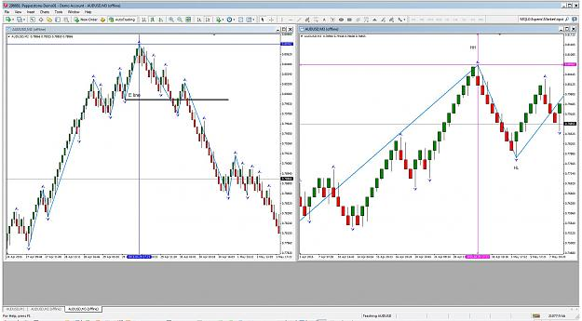
You need to be able to identify the E line on the Ten pip brick charts with a glance. That comes with practice. Once you can do this we will start into how to trade it effectively.
I am not going to be able to update for about three weeks, starting on Sunday. That will give you lots of time to master the E line search and to start placing it on all your Renko Charts. Be sure to draw a potential E line at the last LH and HL. When the price breaks those you have a reversal and pending orders at those levels tend to make you happy. (That last chart had a nice run after the E line was broken ... they often do.)
Also have a look at the relationship between a 10 pip E line and where it occurs on the 30 pip chart. You just may notice something special working it form LBF to HBF. (There is always something interesting to learn when you look hard enough.)
In later posts I will introduce a nice signal from Bill Williams book "Trading Chaos" It is often earlier than the E line and very reliable. We will also look at a way to chart the LBF and the HBF on the same chart.
Lots ahead.
Wab | Jun 30, 2015 4:15am | Post# 304

1 Attachment(s)
The EURUSD has been in the news a lot because of the Greek Crisis. Let's begin by looking at that pair and seeing if the 30 -10 brick analysis helps.
This chart has a lot on it and it is worth a lot of study because it shows the thinking that goes into a much simpler analysis that I will present in a while.
If you remember algebra there was that thing called the quadratic equation. A good math teacher would show you how it was derived and that was interesting if you were a math nerd. However you only needed to know the equation in order to solve the problems. Knowing how the equation was derived helped understand what it was you were doing with the formula, but anyone who knew the formula could solve the questions.
Let's dissect the EURUSD 30 1- combo in detail then and see if we can simplify it afterwards.
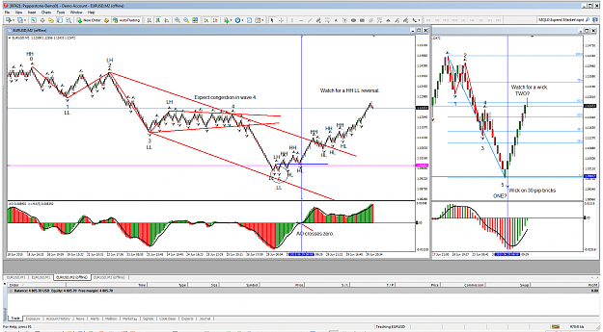
First of all check the HH LH reversal on the 10 Pip brick chart. The HH in Elliott Wave terms is the zero of a new wave. AS we add our LL LH sequence, we reveal the Elliott Wave count. Some confusion occurs at what the Elliott Wave would label as wave four. Strictly speaking it is not a LH, but the advantage in EW counting is that we expect congestion in a wave four. Also note the AO indicator pulls back to zero or above in a wave four correction. I really urge serious analysts to read Bill Williams’ books and learn how the AO works in conjunction with the EW.)
In EW theory a trend line that extends through the wave two and wave four peaks creates a useful channel when a parallel trend line is drawn from the peak of wave three. Wave Five will often form near or on the parallel trend line. I have drawn these trend lines and additional ones, that also show the wave four congestion (with red lines.)
Sure enough, as price approaches the lower red channel line we see a LL HL reversal on the 10 pip bricks as a wick forms on the 30 pip bricks. The AO confirms this and a blue horizontal E line also shows up as we follow the new HH HL in the reversal. Note how a lot of things come together here. I have drawn an ellipse to emphasize the area.
The market rallies from a five wave bearish move and moves up. EW suggests that this may be wave TWO now after a wave ONE completed, but that is just a suggestion. EW is great when you get it correct but we need evidence to support the possible map it reveals.
A wave TWO would probably top out around the 61.8% level, so we can add a fib on the 30 pip bricks and monitor that Fib level for a reversal. Look for a wick on the thirty pip bricks and a reversal of the HH HL on the 10 pip bricks.
OK that is a lot to digest. If you are not Elliott Wave savvy, does it really matter? The HH HL LL LH sequence reveals the structure. The E line gets broken and a reversal occurs. The rest is fine feathers on the bird.
AO nicely confirms that which we already know. Fibonacci is great if you can understand it. (We will use it a lot.) EW channels are useful and the EW count helps with that, but again it is the E line that tells us the most important thing. We expect it to form in the 10 pip bricks inside a 30 pip wick.
Lots to study here: I want you to study it before I make it a lot simpler.
Just like the quadratic formula is easy to use, when you don’t have to derive it each time, I will try to reduce all of this to a much simpler approach.
Understanding what the formula does is important so that you can apply it correctly.
Have fun.
If some of this is baffling don't worry. We will practice lots and it will become a lot easier when we reduce it all to a very simple system.

Wab | Jun 30, 2015 9:34am | Post# 305

2 Attachment(s)
The more simple approach:
Here is the same chart we have been looking at - just a bit further advanced.
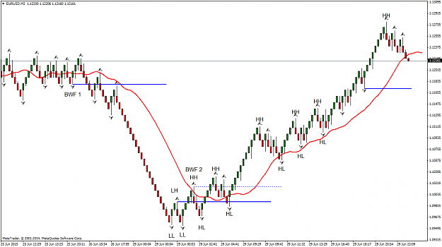
You will notice a red moving average line. This the Teeth line of the Bill Williams Alligator, an 8 smoothed MA of the median price displaced 5. (The settings are visible in the Alligator and it is the same red line that is shown in the Alligator.)
Now the Teeth line has a special relationship with certain Fractals. If you look at the fractal labelled BWF 1 (Bill Williams Fractal 1) it is the last fractal to the left of the Teeth line and below the Teeth line. When price penetrates that fractal below the Teeth line it is sell signal.
Similarly, the fractal labelled BWF 2 is the first fractal where price is above the Teeth Line. When price penetrates above that fractal it is a buy signal. (I showed that buy signal with a dotted blue line to compare it with the solid blue E line that was drawn from the first HH.)
More recently on the chart, is a third horizontal blue line. By definition it is not a LH. However, if price were to drop through the Teeth line and then penetrate this blue line it would become a BWF sell signal. Chances are that a down fractal will form first and the potential BWF sell fractal would be adjusted to the new down fractal level. That fractal will then also become a LH and also mark a potential E line.
The E line and the BWF fractal entry are often one and the same. Two methods combined to give the same signal. When they are different, one confirms the other.
Now all of the stuff that I had on the previous chart, while nice and informative, can be reduced to this simple version of the same thing. HH HL LL LH and the BWF /Teeth combination tells you a tremendous about what the market is up to.
The Teeth line has another attribute which is very powerful:
A trending market avoids it and a corrective market will correct back towards it. On the second chart, counter trend lines drawn at 1, 2, 3 and 4, present opportunities for long trades. The down fractal and interaction with the Teeth line help determine where to draw these counter trend, trend lines. A break of these lines is an entry signal, or it can be an alert that the recent HH is about to be broken as well. Both breaks are valid entry signals and lead to various trade strategies.
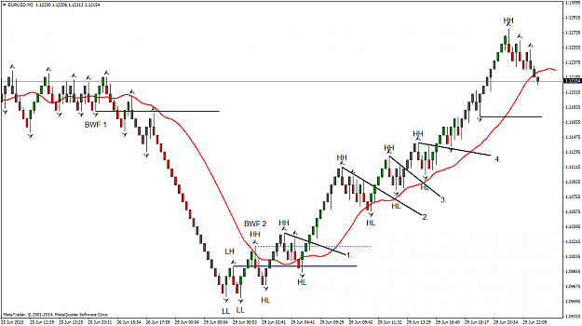
Bonus: The Teeth line also makes a great trailing stop when you give it an extra pip or so as a buffer.
I hope this is easy enough to follow. At first it may be a bit overwhelming but soon it is a matter of eyeballing a chart and knowing what is going on. Consider that this is the present EURUSD chart in the midst of a financial crisis and I let it speak for itself.
Next, I think we should look at some chart and practice this idea.

Wab | Jul 3, 2015 11:15am | Post# 306

1 Attachment(s)
Practice.
Wick on the 30 pip bricks. 10 pip brick trend reversal, BWF and then entries on counter trend, trend line breaks.
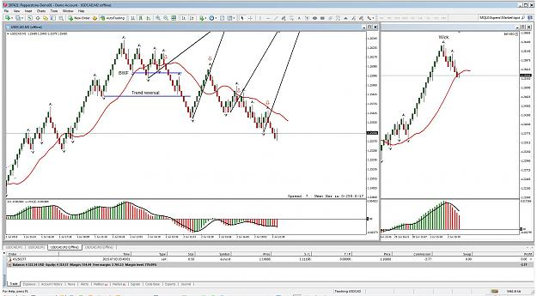
So how do we manage trades like this?
 | Wab | Jul 7, 2015 4:44am | Post# 311

1 Attachment(s)
When you finally figure something that works do you keep it to yourself or share it? How about if you have several things that work?
Well, I have shared several things here: Trend Reversal entries, Counter Trend Line Entries and the BWF signal. None of these are really my own discoveries. Nor, I suspect, is using higher and lower brick frames to try and discern the overall trend. I don't really think there is too much that has been missed by the many keen minds that have studied charts. I have to give credit to Bill Williams for his material and I wish I had run across Clive Pakenham a lot earlier (thanks for that link mor707.)
As for Bill Williams ideas being old, the Law of Gravity is pretty old too and it still works very reliably.
I do think that while many people have found many great ways to enter trades (and close them) there has not been as much attention paid to managing trades. That is where I will take this discussion next.
When the dog finally catches a car - what to do with it becomes the all-important question?
So I would now like to introduce the concept of what I call FOREX trade management.
FOREX is an acronym and it stands for Flat, Oblique, Reward, Entry and Extension.
Before I start, if anyone is familiar with similar studies please give us links to look at them. What I propose here may not be unique or even original, but it is my explanation of what I do in my own terms. I hope that you find it useful and if it is an original approach allow me to claim it, before all the hucksters jump all over it and try to sell it.
"FOREX" trade management is my methodical approach to both the identification of a trading opportunity and management of any trade taken. It is price action based and evolves from the HH HL LL LH reversals and subsequent corrections that we have already studied and drawn E lines and counter trend lines on. I hope to make it very mechanical in nature, following rules each time and thereby reducing the emotional component of taking and managing a trade.
As always, lets begin with a chart example, one that has a reversal pattern, or in this case, two reversal patterns.
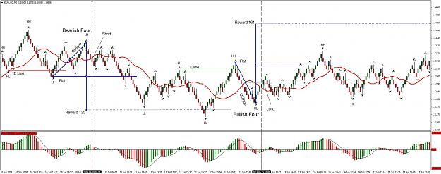
By now you should be able to identify the E lines where a HH HL LL LH trend reversal can take place and where it actually does. Entering a short trade on the Red E line is an acceptable strategy. We draw a flat (horizontal blue) line there and extend it to the right. When the LL fractal forms below the E line break we expect a LH fractal to form on what is now a count trend. We draw an oblique line (also blue) from the LL fractal to the LH fractal.
We are using Renko bars with wicks and we know a wick just about always forms on a Renko color change reversal pattern, so we can pretty much pick out that LH fractal as it forms by looking for a wick. Our oblique line joins the LL and LH fractals and while we wont always get his right until after it forms we will get good at it with practice and a little help from the AO.
We know indicators lag, so we need to give the AO a bit of time to catch up. (More on that in a minute.)
Next we construct the vertical component of the figure four. This is done by dropping a vertical line from the LH end of the Oblique line through the flat line. This is the reward line. The middle of the Reward Line must be on the Flat line as shown. This will graphically locate the reward that we hope to gain from this structure. (In this case the reward was 135 pips when the price target at the end of the reward line was hit.)
Now, back to the problem of the lagging AO, if we wait to enter our trade at the midpoint of the Oblique line, the AO has changed color. This is a confirmation of our strategy if you give credence to indicators.
By the time price has moved to the middle of the Oblique Line we have our Entry. A brick reversal pattern formed earlier and we enter at the 50% level as the AO confirms momentum. I left the Oblique line selected to show its midpoint and placed a dotted red line to the right of the midpoint, to show where the entry is achieved.
A stop is placed just above the top of the oblique LH fractal. (More Bill Williams stuff.)
The whole thing is done by drawing three lines on the chart, at the correct places, to make a figure four.
Orders, stops and take profit levels are intuitive after that.
We have a Flat an Oblique a Reward an Entry and an eXtension. (I have not discussed the extension yet. This is already a pretty big post.)
"FOREX."
Further to the right on the chart the process is repeated with a bullish trend reversal. Here we have an inverted figure four. Reward this time is 161 pips at the end of the vertical reward line. The price level was hit off the right hand side of the chart but I did not compress the chart to show this.
For now, there is a lot to digest here. Do some homework. Try it out on a lot of charts and see how it works. Strategy is next and coming up there is also a very neat dynamic tool to do this with.
Have fun.
Wab | Jul 8, 2015 12:16am | Post# 315

1 Attachment(s)
I just moved you to top of the class eurix. Same trade that I took and it has nearly reached the target now.
The AO on the 30 brick chart is still red, so it still has a good chance of forming an up fractal on the 10
pip bricks and going all the way to it.
This is also actually a good example to use the Teeth line for a trailing stop.
Isn't it nice when theory and practice actually cooperate? You made my day. Good work!
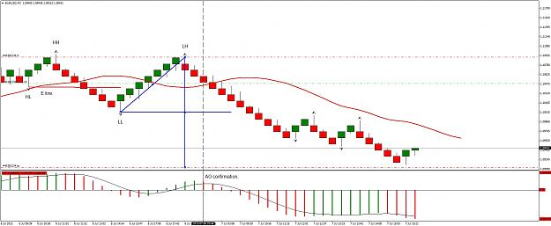

Wab | Jul 8, 2015 5:59am | Post# 316

1 Attachment(s)
... and this is how that trade finished ...
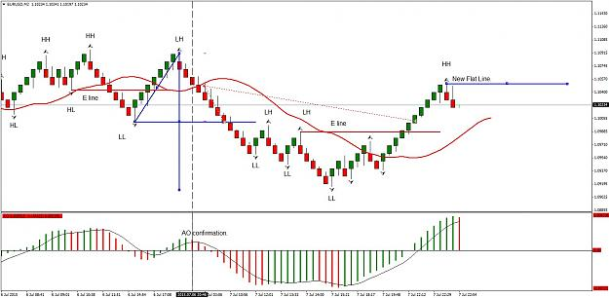
Price just about hit the Reward level then pulled back. I took two lots, closing one at the Flat line to guarantee a profit.
I moved my stop to the Flat line for the second lot, locking it a profit on that lot. I mentioned that the Teeth line was a
good place to move a trailing type stop when nervous, but I didn't do it on this trade. If I had also been watching this trade,
I would have see a new E line form and that would definitely had me close the second lot. As it was I was not able to monitor
it and have to be satisfied with two lots closed at the Flat line.
A bullish, new, Flat line is shown with an HH fractal. Now we watch for the Oblique line to end on a down fractal draw an inverted
Four and repeat.
Wab | Jul 9, 2015 2:53am | Post# 318

1 Attachment(s)
Here is how I played the inverted four; which was the next reversal trade.
Once again you nailed it with your inverted Four eurix. Good job.
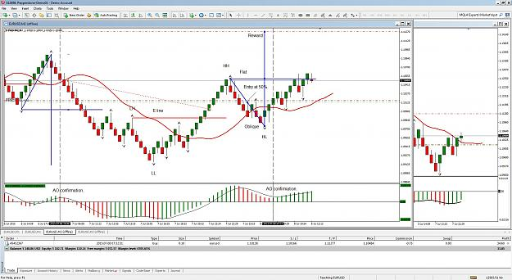
When price hit the Flat line it closed my first lot. I Moved the stop on the second lot up to protect it from losses and at that
point left it to its own devices. A one win, no loss possible, situation. As it turned out, that is what I got. One win at the Flat
line and a stop loss hit just above the 50% level.
In both of these trades, I was looking for a trend reversal. As we go along we will learn how to use the Four in other places.
Bear with me on the Teeth line and you will see how I use it. In both of the trades so far the Teeth line has not really been that useful.
It will make sense as we go along.
As for brick size, it works on any chart, not just Renko Charts. Renko is a lot easier though. A 10 pip brick size is my preference here as it
moves along at a nice pace for teaching purposes. With smaller brick sizes you will get Fours that give very small Flat line targets. As we
get into the extension aspect you will find that smaller Fours have their appeal. The basic FOREX trade is there but how it is used will depend
on each trader.
Think of a 1,2,3 or an A B C D or a Ross Hook or an Elliott Wave trader. They all basically trade the same thing based on different understanding
of the same chart. My Four is an attempt to make the trading process very visual and achieve comparable results to other proven methods. Is it
different, or does it overlap those other methods? Yes to both questions.
You will find your own comfort level and adapt how you use this.
Here are some order strategies to consider:
Early entry when the bricks change color this has the advantage of a small stop loss, but will be difficult to catch if the correction has more than one wave in it. It is best to avoid this depending on your risk aversion. If you are wrong, a smaller Four will result which can still be profitable but may get stopped out.
Enter at the 50% level of the Oblique - often has the advantage of a confirmation from the AO. Sometimes this entry is actually only slightly beyond the color change of a brick reversal in a very tight four. I prefer to see a bit of separation there but that is a matter of preference.
Enter at a 61.8% level instead of a 50% level. (Or enter at both if you are really aggressive.) The 61.8% entry is built in to the Extension tool. Along with the extended target, X, at 161.8%
Logic behind taking multiple trades:
Always T.P. on one lot at the Flat then move your stop up to the entry level plus a pip or two. This covers costs and generates a secured profit. This makes the second lot a free trade and guarantees a profit if the Reward Target is not reached. This is a very important strategy. The object is to take a profit and protect your account first and then try for the larger profit if/when the market reaches the Reward level.
Set your target just a bit before the Reward level. If a lot of people ate looking for a double it is good psychology to exit just before the rush.
If price action is a concern trail a stop a pip or so above the Teeth line. Anytime you get into a trade with a small four and price is quite well removed from the Teeth line, it can move along way before it moves back into the Teeth line.
As for success rate, you will just about always hit the Flat line if you have read the trend correctly and trade the trend reversal patterns, however there iare more situations that we have yet to discuss, where the four can be applied.
In my next post I am going to give you a neat little tool that really makes the study of Fours a bit easier - as if it wasn't easy enough already.

Wab | Jul 9, 2015 6:03am | Post# 319

1 Attachment(s)
Okay, as promised:
There is a neat little tool that already exists in MT4, the Fibonacci Expansion Tool. Just change the settings like this.
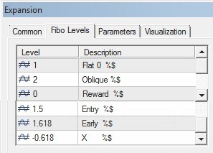
Now you can use the Extension Tool to draw a Four, or an inverted Four, on a chart. It does have the advantage of displaying a 61.8%
early entry level and the 1.618 Extension - the X of the FOREX acronym.
Personally, I find the Four easy enough to draw with trend lines but most traders enjoy any shortcuts that are available
and this displays the labels and prices that are important.

Wab | Jul 9, 2015 11:42am | Post# 320

1 Attachment(s)
Some examples of Fours that are not based on trend reversals:
I call these Correctional Fours. These are based on corrections against the trend. The price crosses the
Teeth line and forms a fractal. As long as the AO is below the zero line these work well.
(Of course you reverse that rule for Bullish Fours, where you will want the AO above the zero line.)
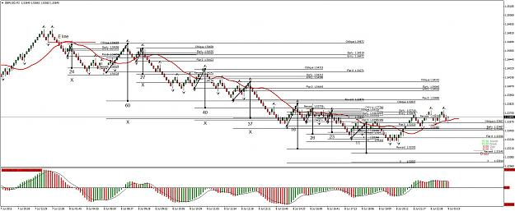
Each Four shows the pips it wins on one lot, with all calculations from the 50% level. Trades that have an
X are ones that went to the extension level at 161.8%
Each trade at least made the Flat line.
Look for a trend reversal. trade it and then trade the counter trends that come along. Keep adjusting the
potential E line and then go the other way.
Wab | Jul 9, 2015 4:00pm | Post# 321

1 Attachment(s)
In regards to different brick sizes or even time based charts. Here is one I just traded on the USDCAD M5.
I let both lots run to nearly the Reward level and manually closed them. I liked the chart so I did not take profit on
one lot at the Flat, I just let it move along to the Reward. 22 pips thank you.
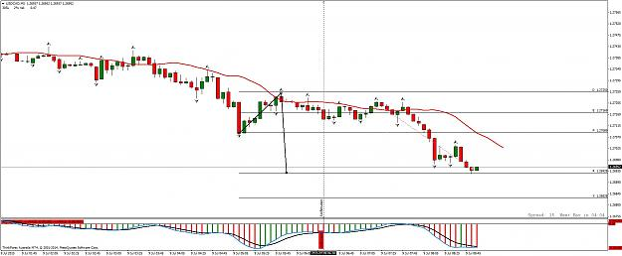

Wab | Jul 10, 2015 3:44am | Post# 322

1 Attachment(s)
And how has the EURUSD been doing? Some trades made the Reward level, all made the Flat level.
Pip returns at the Flat and at the Reward are shown. Present Four Trade is still in progress with profit
taken on the first lot, stop needs to be moved now.
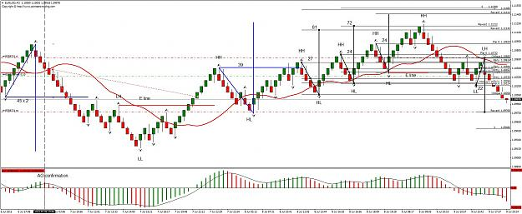
Wab | Jul 11, 2015 5:37am | Post# 324

1 Attachment(s)
Hi eurix.
Some good questions that will help illustrate some important points. I have been at this for along time and I also have a strong Elliott Wave background, so I tend to not emphasize some things that are not as readily accessible to other people.
Here is your first chart re-visited:
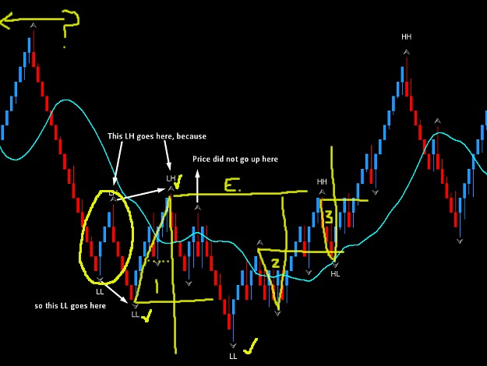
First of all, always zoom way out to get the big picture before you attempt analysis. The HH HL LL LH structure will be more apparent that way. I do not know what happened to the left (yellow line with ? on the top left) so, that leaves me at a disadvantage. The left contains information that is needed for the analysis in the present. Once you can get the big picture, you become better at identifying internal waves inside the large ones.
I have put yellow check marks on what is likely the correct "larger" LL LH count. If you go back and do the HH HL LL LH count on the chart you will soon see that there are little waves inside the big ones, They will will show up and confuse, as happened here. It takes practice until you get a better feel for it. Waves within waves is always a tricky thing and I don't always get it right either.
Inside the yellow circle you identify a LL LH which could have been traded short for a Flat Line profit. Price corrects and rises towards the Teeth line and forms a fractal. However, price did not rise above the Teeth line. It is a more reliable trade when that happens. The second time it corrects price goes above the Teeth line. I placed a yellow Four there ( numbered 1) and it is a good trade to the flat line. As long as you are in synch with the trend, these generally give you at least a Flat Line profit.
We then get two inverted Four patterns, numbered 2 and 3. Price rallies then corrects below the Teeth Line. Both of these are good trades, but I have not told you how to identify these yet as they occur before we get an E line break. I will cover how to find these when I talk about the BF Fork, at a future date.
Do not despair. The HH HL LL LH count takes time to master and is tough to do as it evolves. The HBF chart and the AO help sort out where you are and the Teeth line is really great. After a while you will read it more easily.
If you send me info on which pair and what brick size this first chart was, I will try to build a better picture for you.
In your second two charts, I think that both situations will become more clear as we discuss the BF fork, which is a very good way of predicting and or confirming a trend reversal. Let me know which chart number 1 was and I will do an extensive review of it, before I go on to the BF fork. I hope that will help.
Learning how to do trade from a discussion thread is a bit like learning how to swim, by reading a bunch of instructions and looking at a lot of pictures of people swimming. Not easy when you are actually in deep water.
Good questions.

Wab | Jul 11, 2015 6:31am | Post# 325

3 Attachment(s)
I have attached some indicators that may be of assistance with the HH HL LL LH thing.
Use with caution.
One is a fractal zigzag which can be helpful.
The other two are also zigzag indicators. The latter two show a higher degree HH HL LL LH and a lower degree HH HL LL LH which occurs inside the larger waves.
As you study these you will see that there are times when they are wrong. That is why I don't really depend on them. However they may be useful to help understand the whole concept of smaller degree HH HL LL LH within larger degree HH HL LL LH counts.
Using the HBF 30 pip bricks is an attempt to do the same thing.
My advice is to learn how to do it yourself. Indicators like this are not that useful, unless you understand what they are attempting to tell you.
Once you understand that, you don't need them anyway.
Kind of like training wheels on a bicycle - who needs those after you learn to ride?
Degree Low.ex4
Degree High.ex4
ZIGZAG-FRACTALS.ex4
Wab | Jul 11, 2015 12:01pm | Post# 327

1 Attachment(s)
This is getting very Elliott Wave. Sorry about that, but that is actually how the market works and my FOREX approach is just an attempt to simplify it.
OK here we go - GBPAUD 10 pip bricks
First of all, I like to zoom way out and eyeball the chart. Then I add the waves that I can see. Waves join extreme highs and lows and lows and highs. After a bit of practice this gets easy enough to do. On the chart I used purple lines to show the larger structure.
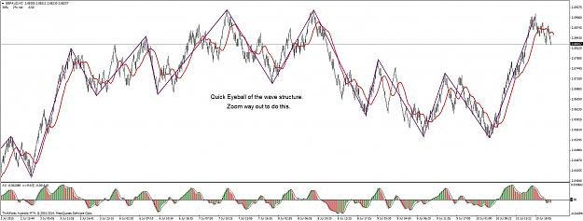

Wab | Jul 11, 2015 12:09pm | Post# 328

1 Attachment(s)
Next, I add my HH HL LL LH labels on the purple lines. I can see these pretty easily on historical part of the chart.
I identify the E line for the purple structure. That big E line tells me a lot about what to expect after price moves up through it.
It could move up to a big HH. We won't know for sure until it does. It could become a big LH , but that doesn't matter for now.
We are after trades that will occur on the way,
(Note: I should have added a purple LL on that last down move.)
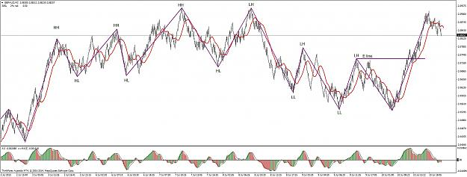

Wab | Jul 11, 2015 12:24pm | Post# 329

1 Attachment(s)
Now we start to focus in on the current wave structure. We have a good idea of what the larger waves are doing and we now get ready to analyze the waves inside of the more recent ones. We can eyeball the HH HL LL LH structure or use fractals to draw this in.
A very sharp eye will notice that there are smaller HH HL LL LH structures in between the fractals. (Hint look just to the left of the last LL.)
If you used smaller bricks on a separate chart, this would show up and be easy to see. That is why I like both a HBF chart and a LBF chart
work with.
We are going to look for trades on this smaller scale but always keep an eye on that bigger E line. It is very powerful.
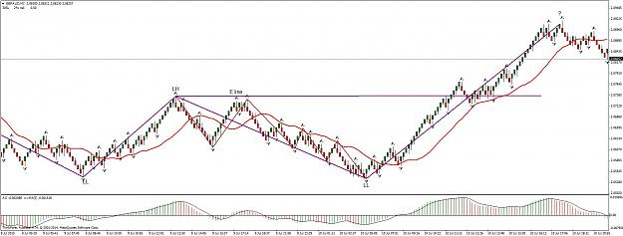

Wab | Jul 11, 2015 12:40pm | Post# 330

1 Attachment(s)
Now we do our detailed analysis:
This reveals the places that we can trade a Four on this particular structure. Our reversals become easy to find because we
know where to look for them. The red E lines and the Bill Williams Fractals show up and alert us to trend changes. Once we know
the trend direction we look for counter trends that (preferably) cross the Teeth line. Drawing a Four follows.
All market charts do this.
[On one occasion, several years back, I did this exact analysis on the OEX and refined it further and further down until I was right in the M1 charts.
I caught a turn on M1 that evolved all the way up with each wave degree until I was up over $20k in a few hours, on call options. It was a thrilling ride.]
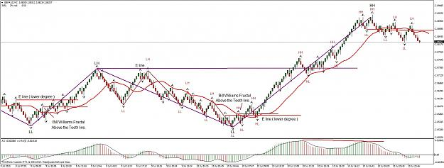
Now, see how many trades you could have done here from the counter trends, just drawing a Figure Four.
Bill Williams uses break out trades as price moves past the latest fractal in the trend. By using Four on the counter trends, we can gain on that by an extra 50% to 61.8% per trade.
I hope all this analysis of the GBPAUD clears up some of the confusion. I still haven't got to the BW Fork. It will help further.
One more thing:
The divergence on the AO tells me that GBPAUD is at the end of wave three and now in wave four. The market is always choppy in a wave four. I expect a trend reversal to the upside will be the next good trading opportunity.
Wab | Jul 11, 2015 2:46pm | Post# 333

Basically the dots are fractals. An up fractal is formed when the two bars before it have lower highs and the two bars after have lower highs.
It looks like your hand, with the middle finger as the peak. A down fractal is the opposite. By their very nature, a fractal appears to re-paint
as it forms. Once it has formed with all five bars it will not repaint.
At present I am not using the Demark indicator but it will soon be in use again, when I introduce the BW fork.

Wab | Jul 16, 2015 6:47pm | Post# 334

I had to search for some videos that explain what I am leading up to.
(Since I still have traces of a South African Accent, I enjoyed this. If/when I make a video of my own,
it will not have as strong an accent - though people tell me I have a sort of Canadian accent these days, eh.)
I found two videos that I like: (One I have had uploaded to my computer for several years and was delighted to find it is still on line.)
Both of these are worth uploading and keeping in your resources for future reference. Another that I uploaded is no
longer available anywhere. I guess I need to make a video of my own to explain some things, then I don' have to worry about finding
one, that sort of does what I need.
Anyhow, the first gets us started nicely and I urge you to look for the HH HL LL LH price reversal, explained
here in a slightly different manner. It soon becomes a very recognizable pattern. No matter what we call this or
how we decide to trade it, it is pure market behavior and occurs over and over again. Yes, on Renko Charts too.
The second video will follow once you have had a chance to digest this one a bit.
Inserted Video
 | Wab | Jul 22, 2015 3:34am | Post# 342

I have been working on some really neat stuff so it has been a while since I posted.
Today I would like to link to a video that really nails the whole concept of trend reversal.
Pay close attention to the trend line and how it relates to the HH HL LL LH sequence.
That trend line is similar to the De Mark trend line and also part of what I call the BW Hook.
This video also introduces Fibonacci into the mix and that in turn is very powerful. We will cover
Fibonacci in due course.
Now be sure to be alert to see where the E line fits into this.
A lot comes together here. It is an excellent video and leads to many good points of HH HL LL LH.
Enjoy.
Inserted Video
Wab | Jul 29, 2015 2:54am | Post# 350

1 Attachment(s)
The BF Fork.
The BF Fork is a combination of the E line or the first fractal level past the red Teeth Line and a trend line. You may recall that the E line and the BW Fractal line may often occur on the same fractal. Either way we extend a horizontal line from the E Line Fractal or the BW Fractal to the right. We know that when the price breaks either of those levels, or both, that a trend reversal has occurred.
The HH HL LL LH count confirms this with the E line and the BW Fractal line can give an early warning or be used by itself.
Now if we look at the last two significant fractals and use the Tom De Mark method of drawing a trend line, using those two fractals, we find the trend line is the handle of a fork and the E line or BW Fractal Line is the tine.
Let’s look at a chart to see this:
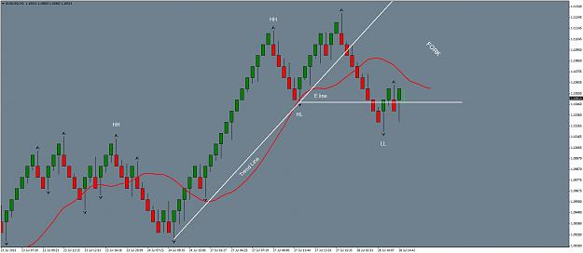
This is the current EURUSD 10 pip Renko chart, forming a Fork as I write this. The Trend line has been broken, the E line has also been broken. The two of them form a fork which I call the BW fork. (B for my last initial and W for William. A little vanity there.)
The BW Fork is a powerful visual indicator. If price goes back above the tine (trend line) of the fork then the reversal becomes suspect. Price most often breaks below the E line or BW Fractal Line (They are the same in this example, but can be different as we know.) Then price most often moves back up into the BW Fork area. Once it is back in the fork it often forms a fractal and that is the fractal that Elliott calls wave two. (Note it may not form a fractal all of the time, but looking at a LBF or a LTF chart will reveal that there is always one there.)
So how to trade it?
The safest method is to open a trade as it crosses the E line again. That puts us in a third wave and Fibonacci comes into play.
Let us see how this one works out.

Wab | Jul 30, 2015 12:49am | Post# 351

1 Attachment(s)
Here is another example that where I am presently trading a figure four.
The game begins with a trend reversal and a Fork displayed in white lines. Note how the E line (in yellow) was later to the party than the Fork.
I missed a reversal trade there however, I then located a Four (shown in yellow lines) and traded it for 110.2 pips from the 50% entry level to
the Reward level.
A second four, shown by a diagonal black line joining the wick to wick of two opposing fractals was not traded because I was already in a trade.
It was also a good potential trade, in case you had missed the first one.
Then I took another four, this time with white lines and I am presently near the reward level on that one. In fact. I just checked and it closed for another 111.5 pips, so I updated the chart to show it. Not often I post just as a trade is concluding like this. Nice when it happens.
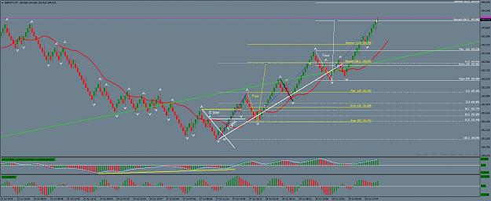
Did I use any indicators? I did look at the divergence on the AO and the Teeth line for the BW fractal.
Study this chart. It is good example of a BW Fork, an E line trend reversal and three figure four trades. Best of all it is an example of theory and practice
working together perfectly.
having said that, there was a trade that I missed. I missed it because I arrived late but we will get to that type of trade in a bit. Check the purple Fibonacci
line with its dotted white Fibonacci levels and see if you can spot it. After the new HH we get a LH at the 61.8% level. A trade taken there would currently
be up 269 pips. It can be done. Has been done many times.
Now that we have dealt with HH HL LL LH, E lines, BW Forks and Figure Fours, we are ready for Fibonacci. Stay tuned.

Wab | Jul 30, 2015 1:28am | Post# 352

1 Attachment(s)
I might as well just carry on with the Fibonacci material as this is such a good example.
I cleaned up the chart to illustrate the concept more clearly. When you get a trend reversal, there is an opportunity to draw a Fib
on the first HH and see at what Fib level the first LH will form. This one was at the 61.8% pullback level. The sweet spot is around
61.8% with a fractal, although a fractal may not always form on the pullback. This time one did.
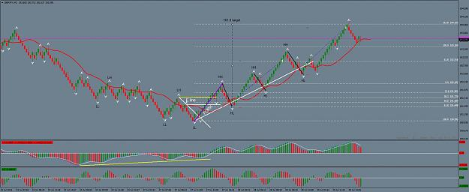
The pullback gives us a wick to wick line for a Figure Four trade. I placed the first black line there to illustrate it.
The Fibonacci is drawn in purple. With a 61.8% pullback, it gives us an entry at the 61.8% level and a target at the 161.8% level. You
can see how that worked out. A Fibonacci constructed in this manner is very powerful. Even though I missed it I was confident with the
figure four trades that followed because the reward level for each was inside of the 161.8 Fibonacci target.
So there you have it - Fibonacci Reversal Trades and Figure Four Trades. Priceless.

Wab | Jul 30, 2015 11:14am | Post# 353

1 Attachment(s)
So how about the EURUSD trade started yesterday?
I took a 0.1 lot trade on each of the Fibonacci levels. The trick now is to know when to exit.
The Alligator is wide open, so I am looking at the 100% target though the 61.8% target is just about there.
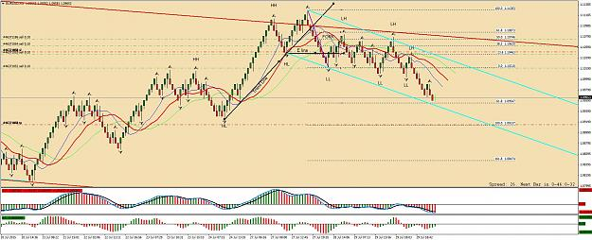
I will have to decide in a few hours, as I am away tomorrow and will not be able to monitor the trade further.

Wab | Jul 30, 2015 9:47pm | Post# 354

1 Attachment(s)
EURUSD Trade Closed.
Good enough. I have to head out of town in a couple of hours and won't be back until Monday night.
The blue channel seems to be holding for now so I won't stay in.
This move was corrective in nature with all the overlapping waves. Hoping to get to a 100% level is too risky for me at this point.
The AO has three green bars and AC has a buy signal. Maybe it will challenge the upper, red trend line and break out higher next.
Locate the potential E line, keep an eye on the BW fractal in relation to the Teeth Line and see what Fibonacci tells us, when a
trend reversal and a BW Fork comes along.
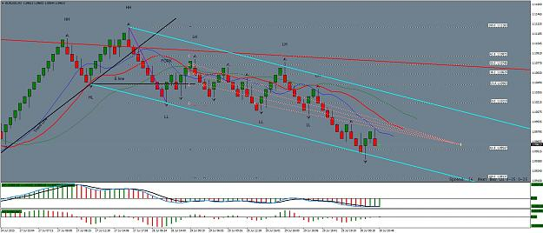
Take the cash and let the credit go. 72. 54. 34. and 27 pips banked.
Wab | Aug 5, 2015 2:24am | Post# 367

1 Attachment(s)
When I trade I have an indicator that changes the background color. It is more for auto trading, enabling me to tell at a glance which direction my robot has taken a trade. I will discontinue its use here, as we do not need it.
I will also just stick with only the 8 shift 5, smoothed median moving average (the red line in the Alligator), fractals and the AO. The main indicator is always going to be price, with the HH HL LL LH analysis revealing a potential E line. The current trend line that works with the BW fractal or the E line to form a BW Fork. Usually this matches with divergence on the AO.
I realize that I have referred to other indicators:
The MACD 5 34 5 which is nearly identical to the AO.
De Mark lines, which you can basically determine yourself without the messy indicator cluttering up the chart.
The Alligator, from which we only use the red Teeth line from. (8 shift 5, smoothed, median moving average.)
I will keep charts white with only the AO, fractals and the Teeth moving average. I will be adding Fibonacci extension and retracement lines and explaining a lot more about those in due course.
Trend lines are also essential in illustrating the E line, the BW hook and figure four trades.
In the next chart, I have shown the last trade that I took before I was out of town. I closed it off at the 61.8% level because I could not be there to manage it.
As you can see it would have easily made the 100.00% level. As we go along I will show you how to get the best out of a trade like that, instead of a mere 61.8%
The chart shows divergence on the AO, a BW Fork and A Fib retracement. I also have the HH HL LL LH analysis as it was at the time.
So here is some homework:
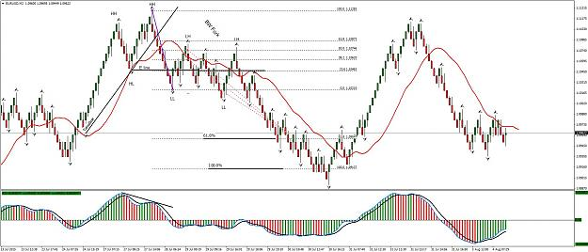
Continue the HH HL LL LH analysis and determine the next two trend reversals with BW Fork analysis.
Check the AO carefully as you go for any divergence.
By the way, the two moving average lines on the AO are a dodger blue 1 SMA and a black 5 EMA of the AO. You can add those if you like, but they are not essential.
Do not worry about posting any solutions, I will do that and you can compare your efforts with mine. Please do the analysis before you look at the answers.

Wab | Aug 5, 2015 2:56am | Post# 368

1 Attachment(s)
Answers:
Make sure you have tried to find the HH HL LL LH trend reversals and BW Forks in the previous chart before you go further.
Scroll down.
Answers are below.
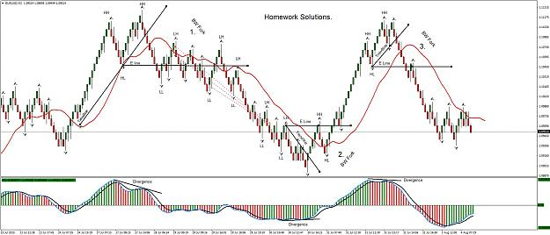

Wab | Aug 5, 2015 3:17am | Post# 369

1 Attachment(s)
I hope that I have managed to answer most of the questions asked so far. I did not really refer to the HBF chart a lot, but I will get back to that.
For now, I want to concentrate on the HH HL LL LH trend reversals and how to trade them. Eventually, I will combine the 10 pip bricks and the 30 pip bricks on one chart and provide a nice audio alert in the process.
I have attached a template for the 10 pip Renko chart that should keep it simple, as requested by one or two people.
M2Teaching.tpl

Wab | Aug 5, 2015 8:59am | Post# 370

1 Attachment(s)
Meanwhile, don't forget the Figure Four Trades.
Here are some that were available and the one that I am currently in.
I colored the potential trades A, B, C, and D and left the current one (E) in black.
I didn't take any of the earlier ones as I was traveling. I also entered this one late
but I figured it is good for some pips as it broke belwo the last fractal.
So far, it is on its way to the Reward level, up 47 pips with 22 locked in.
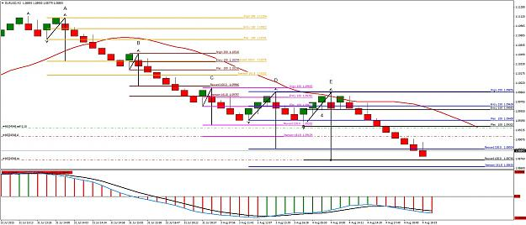

Wab | Aug 5, 2015 11:48am | Post# 371

1 Attachment(s)
Trade closed at the Reward Level.
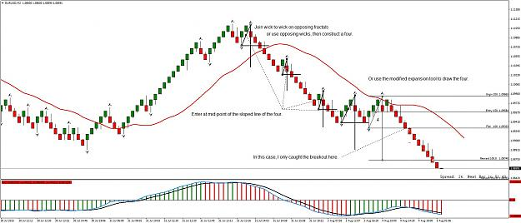
The diagonal line of each Four can be drawn from fractal to opposing fractal, wick to opposing fractal or occasionally from wick to wick.
Renko Bricks are great for this.
The trade I just took was taken late, I like to enter at the midpoint of the Four Diagonal fifty percent level on the Fib Expansion Tool as
shown. However, a late entry can still be taken with confidence, as you have a good idea where themarket will go and can decide accordingly.
I could also have gone for the extension target but I had to leave the trade to its own devices as I was busy doing other things. Being able
to place a pending order and a predefined stop and stop loss are great when you have more things to do than just trade.
When I cover the trailing stop opportunities in this type of trading you will see that there are ways to handle those situations, but we
will continue to take little steps and master each before we move on. A trailing stop on the Teeth line would be very good here but I
will leave that until later. I will come back and talk about that as this chart develops.
You will have noticed that I do live trades here. If your teacher does not show you live trades and the rational behind them as
they develop... move on. Hind-sight is easy. Doing it in real time is what separates the nuggets from the gravel.
Wab | Aug 6, 2015 3:51am | Post# 373

I like to enter on the 50% of the diagonal of the Four. However, as you have noticed, that is often not possible in smaller Fours. So you ask a very good question.
If you use a fractal to fractal diagonal for the Four they are generally bigger. As the wick forms on the opposing fractal you get an advance clue. I place a pending order on the 50% level and adjust it as the diagonal of the Four develops. Start at the wick and adjust as the next wick in the opposite direction forms.
On small Fours the 50% level can be hit with one brick, before you can actually place the trade there.
(You can see on the last trade that I missed the 50% entry and still made money by trading the break out past the fractal as there was a good Reward Level to try for. So even with a missed 50% entry there is still a trade to be had.)
We also have a one minute chart to look at. To date, I have not really talked about the M1 chart a lot. I will soon get around to explaining how I use it to time entries.
Your question is a very good one and I will answer it in detail after I add two brick sizes to one chart. Let me do that next and then I promise to really open it up with some M1 discussion.

Wab | Aug 6, 2015 4:24am | Post# 374

3 Attachment(s)
OK. It is time to really ramp this up a notch (again.) I hope that this actually makes things more simple - though at first it may be confusing.
I am going to show you how to add a second layer to any Renko Chart and also to the M1 chart. I hope this will start to answer Calcue's question and some previous questions about the 30 pip brick chart and its relationship to the 10 pip brick chart.
Here is where they become one chart.
I have attached a zip file with the Renko Shade 3 indicator and its sound files. You will have to find the sounds folder in your MT4 and copy the NBU and NBD wav files into it.
Add the RenkoShade3 indicator to your M2 chart (the 10 pip brick chart) with these settings:
Attachment 1727118
Your chart should look like this.
Attachment 1727130
I have a trade going so you can check that out too. The divergence on the AO tells me we are changing direction
I am not sure how this one will go so I will be cautions and maybe just take profit at the Flat level.
I can't post for a while now as I have other things to do, so have some fun and see what a 30 on a 10 tells you.
Don't forget to zoom way out. Also experiment with turning the 10 pip chart off by setting it to line display with no color in the lines display properties.
Believe me, this combination of 30 and 10 on one chart is powerful. When we involve the M1 it is even more so.
Renko Shade 3 with sounds.rar
 | Wab | Aug 7, 2015 2:12am | Post# 384

2 Attachment(s)
I want to remind everyone on the importance of the big picture.
Too often we can get focused on an immediate trade and have no idea on how it fits in with the larger trends.
Here is a way to deal with that. First of all, go to properties and set the line graph color to none.
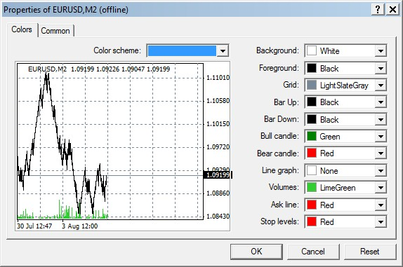
Then set your Renko Shade 3 to show 30 pip bricks on the 10 pip brick chart. Zoom out as far as you can and then display a line graph.
(The template that I made available a few posts back is set up for this.)
You should now get a chart that looks like this ... of course you have to add the HH HL LL LH labels.
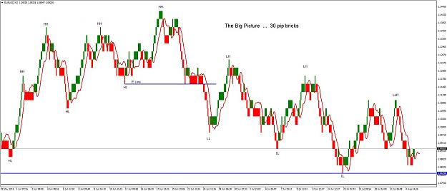
You now have the Big Picture and know well ahead of time where to expect the market to give you some great action.
Look where price would break below the last LL and confirm the LH?
Now turn the candles back on and you can play the 10 pip bricks within the 30 pip brick structure.
One other thing, note the crossover of the Teeth line when the bricks change color. That alone is a really powerful and useful feature.
Wab | Aug 8, 2015 2:24am | Post# 386

Good observation Batavier. The Renko Shade actually reveals the time it takes for a Renko Brick to form.
We use Renko to get away form time but there it is anyway.
Now here is a hint: Also put the Renko Shade on the M1 chart that you use to generate the Renko 10 pip
brick chart. Set it to a Ten pip Brick size. Now you can see how the M1 and the 10 pip Renko chart interact.
You will note how long it takes for a brick to form and how that shows a sideways market or a trending market.
The same principle of HH HL LL LH applies in the M1 chart (use fractals.) When you get a wick developing on
the 10 pip bricks, the M1 HH HL LL LH gives a microscopic view of what is happening inside that wick.
I will see about some M1 chart examples later on.
The Renko Shade 3 also gives you a nice voice alert when a new brick forms. I Love voice alerts. A series of
"new brick up" (or "down") messages coming close together is very exciting -especially if you are in the trade in
the correct direction. I particularly enjoy hearing my computer telling me I just made another ten pips, while
doing some other activity. My wife calls it the talking cash register.
Wab | Aug 11, 2015 2:45am | Post# 391

1 Attachment(s)
Thanks for fielding the Renko Shade question Bat. It is good to see the thread developing with
people helping each other.
I am going to be away for three or four days tomorrow (going prospecting.)
Meanwhile, here is my take on the 10 pip AUDUSD:
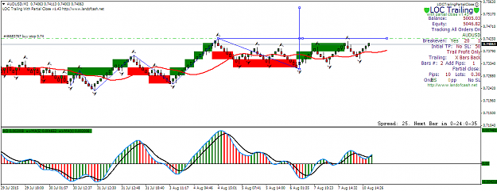
I have a buy stop at the level which is basically the neck line of an inverted head and shoulders.
I will let LOC manage the trade.
(LOC is a commercial product which I use. I am not affiliated with it at all, just a happy user.)

