Volli 5.555
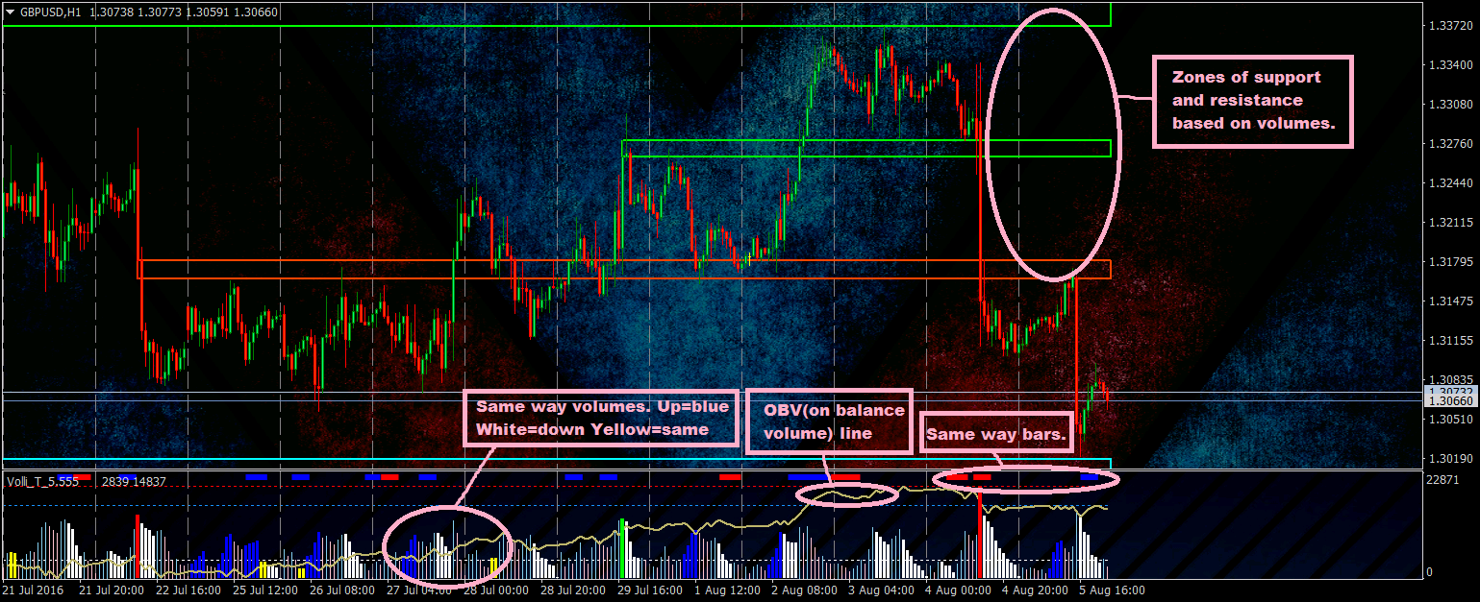
//////////////////////////Volumes window settings//////////////////////////
identify_one_way_volumes = show up or down or flat volumes in a raw
allowable_indent_same_volumes_identified = allowable indent for flat volumes
min_numb_same_way_volumes_identified = min number of volumes in a raw to show they
show_OBV_line = OnBalanceVolume in indicator window.

//////////////////////////Highest Volume settings/////////////////////////
use_highest_volume = show highest volumes
TF_chek = periods to fined highest volumes
periods_highest_vol =number of periods
use_vol_zones = show zones on chart
use_double_volume_chek = check not 1 bar with volume but sum of 2 bars.
show_current_zone = show zone from current period
start_draw_from_volume_bar = start draw zone from bar where was highest volume or from start of period
periods_vol_zones = number of zones showed on chart
Min_vol_level_perc = minimum percents(relatively to indicator window) of highest volume to draw zone
use_lines_or_zones = draw zones or lines
zone_shift = shift in bars of start drawing zone
Zone_right_side_shift_bars = shift in bars of right side of zone
Zone_left_side_shift_bars = shift in bars of left side of zone
…
show_normalC_zones = show zones based on way of candle
show_opositeC_zones = show zones based on start of way of candle
…

//////////////////////////Same way bars settings//////////////////////////
show_same_way_bars =show bars that goes in a raw
min_same_way_bars = minimum bars in a raw to show them
same_way_bar_on_top = show same way bars on top of indicator window or on top of volumes
…

//////////////////////////Volume speed settings//////////////////////////
show_vol_speed = show speed of volumes
interval_seconds = interval of seconds to count speed of volumes
…

extern string li_ = "//////////////////////////Lines in indicator window//////////////////////////";
show_lines =show lines/zones in indicator window witch divided on overbought(Sold) zones
draw_colored_zones = draw line of zones or colored they
…

extern string al = "//////////////////////////Alerts on volumes change way settings//////////////////////////";
…

