02 Feb, 2016

OK Traders: Lets get one thing straight. The SAR DOES NOT REPAINT. But what does repaint is the DB. You are trading on one scenario alone without seeking the big picture which is "in the moment". What have I said about the DB in TREND? It will move in trend from bar to bar. And what is the 1 and 2 hour charts in right now. TREND. You are in a consolidated trend which means (whichever trend of up or down); will not go that far. The SAR is attached with the DB and has no choice but to follow the rules. Just like last night. The SAR remain exactly where it was at from the top; and stayed there until it hit its target on the low side and attached with the DB. And when it did; what was the big picture?????
My friend Daniel had it right but no-one else did. The 4 horsemen on both charts was set for the race downstairs.
But; once the 1 hour had ended its trend then you start all over again. Those traders were in - you have your 40 stop. This is the reason for the 40 - from mistakes in not seeing the big picture.
And here is the big picture:
This 1 hour is showing nothing but a very strong trend down. But also the Fibo flip is holding back the trend from bar to bar. Until finally it bumped lower. Can anyone remember what I have posted about the bumps with a Fibo flip??????
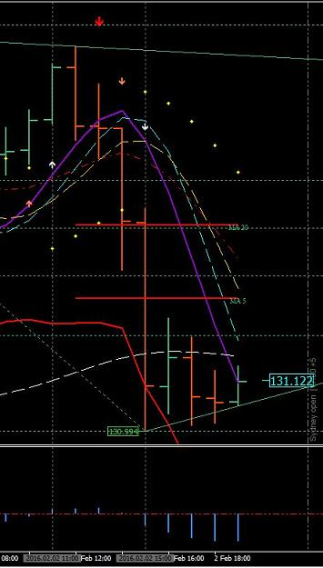
http://www.forexfactory.com/attachment.php?attachmentid=1846042&d=1454446672

Quoting Pandakker
new high/low can be bumped up a few times
That is exactly right.

A Fibo constitutes the VERY HIGH and the VERY LOW of a swing. The DB will display this with a Lime Green tag and the high will be tagged with the Magenta.

Quoting whoareyou
{quote} Is there a way to be sure the rectangular boxes with the price in them at swing highs and lows will remain at that high or low and not move higher or lower? I, as well as many others here, were under the impression that when the zig line attached and a rectangle appeared with the price and that bar closed that that high or low was supposed to be concrete and not move. Could you clarify, please?
I never said that - I said once the Fibo flips with with the DB; either a new high or low that it can bump up a little higher - or lower - depending on the flip because of market pressure. But on the other hand - it cal also turn on the next candle and keep right on going. When I position trade on those new highs and lows I always use a 60 stop and never had one take me out with the E/J.

Quoting Forex Lion
{quote} yes right, but it belong to the screen size, if I put it on my laptop, I see different fibo lines because of the size of the screen
One thing I have always recommended: NEVER use a laptop for trading.

Traders - if you do not trade in the moment you will never see what is happening at that time. You have to see the WHOLE PICTURE before making any trade decisions. If you depend entirely on one thing the other will surely disrupt what you are depending on. And I don't care how you trade - it still remains the same. You have to see the big picture. This is one reason why traders fail is because they never see it.

I believe the in most part some of you have been focusing on position trading. I'm not discouraging anyone from position trading - but it is not consistent with intraday trading. Positioning is a total different way of trading.
Looking at this screen-shot of the 2 hour you have the SAR swinging for the low. And the Reason is because the DB is on top and the DB next target is the Low. From this point on with both the SAR and DB attached; the DB will be making the decisions for the new low. And ROMAR as support you can visually see various swings getting into that new low and once the DB had created its new low the Fibo will flip with a Lime Green price box
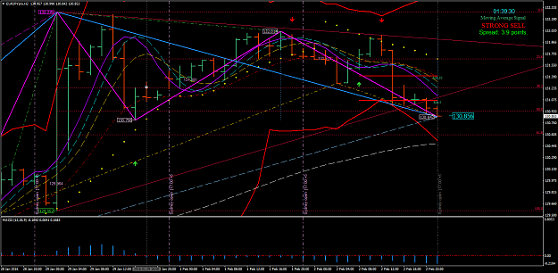
http://www.forexfactory.com/attachment.php?attachmentid=1846099&d=1454452412

You traders are anticipating in what is not there. You now have the 1 hour crossing EMA. which places the 1 hour ROMAR as Resistance. The 2 hour is in a strong downtrend. And with the two hour staying in trend will bring its ROMAR in position for crossing EMA. You have BOTH SAR and DB attached to the downtrend candle which means this could very well keep going from one bar to the next. The SAR now belongs to the DB. And will follow the rules with the DB. Your focus is on the 2 hour trend.

When you anticipate there is way too much confusion. You have to stay in the moment and not worry about what could happen but what WILL happen.

I'm going to try and explain SAR and DB again:
The SAR is the swings in between the high and low of the Fibo (Lime Green; low and Magenta; high). The DB is your long term swing in trend and will change the Fibo at the higher/high and/or lower/low. There are times the Fibo will flip on a Swing. But is still an entry with the flip.
The DB can and will mix with the SAR - as it is now. Once the DB and SAR are attached with the same bar then the DB has the control. In trend the DB will move from bar to bar in trend with the SAR following. And at times the DB is on top of the SAR where the SAR is not showing. And you will see this happening. But once the SAR breaks out from the DB it is then projecting its own swing once again.
Lest say the trend is down. The SAR leaves DB and reaches for the top of a candle. That is entry back into the DB trend and vice versa. And then reattaches with the DB.
Any questions?

Here is an example with the SAR and DB together with the SAR under the DB:
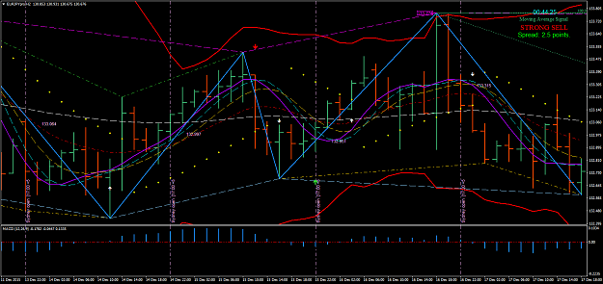
http://www.forexfactory.com/attachment.php?attachmentid=1846228&d=1454462220

Here a great example of the DB went from the top to the bottom to create a new swing going UP:
From the top was DB first attaching to the bottom - then on the way up in trend the SAR attached to the bottom of a candle from the top and placed you into the trend. And then reconnected with DB to end the Swing. But notice on both points for entry and exit of the SAR the next candle tried it best to get lower/low for the entry and higher/high after the exit. But could not do it.
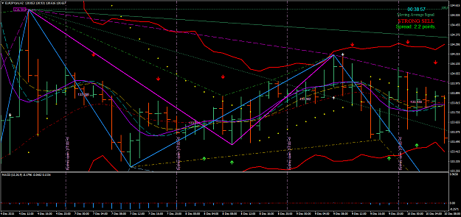
http://www.forexfactory.com/attachment.php?attachmentid=1846239&d=1454462901

As I have said - this is a very highly volatile pair. If you do not trade by the rules you will get burnt. The Daily ROMAR is resistance. The 1 hour ROMAR is resistance. And the 2 hour ROMAR is support but in the downtrend. White crossing Purple on the 2 hour will stop the downtrend for consolidating; but if Smooth does not cross then the trend is still down. Those are the rules. In consolidation the objective is taking a hit off resistance back into the trend - such as EMA as one trader had done to ROMAR. If you make up your own rules then the story is sad.
I made a post last night in regards with the Fibo of when it will flip. I stated it all depends on the 2 hour trend. It could flip at the 61.8 if the 2 hour White crosses to stop the trend for consolidation; or it will continue from bar to bar in creating a new lower/low. And as you can see it created a new lower/low and it is not finished yet. Smooth/EMA are still in the downtrend.
I have been trying to figure out why so many problems with traders MT4. After thinking about it; if you do not have your toolbars showing I want you to go to "View" - "Toolbars" and then click on "Charts".
You have an automatic scroll button and to the right another button which is shifting your chart from the right. BOTH of those buttons must be turned on. If not; then do so and see what happens from there.

Traders - when you make your plan be sure you take a very good look where the 2 hour EMA is located.
Some of you are reading EMA wrong in trend against ROMAR - which means - EMA crossing purple for the down; EMA is RESISTANCE and not support with ROMAR going up. Just like the 4 horsemen are resistance with the trend down, and vice-versa. EMA is your secondary trend according with the crossings of Purple.

The Dove - Forex Trainer

