Jan 24, 2016

Traders today begins a new week and a new trading day. Which means what happened last week is obsolete within The Paradox? We are also in consolidation with the Daily ROMAR down; the 1 and 2 hour ROMARs up.
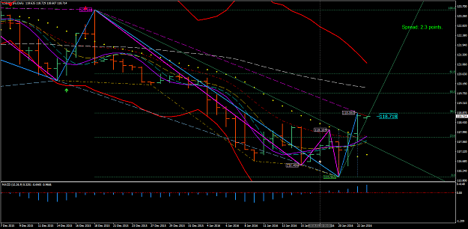
http://www.forexfactory.com/attachment.php?attachmentid=1838039&d=1453673212
The name ROMAR is a considering doctrine but to simplify it means: Reference Open Market At Reversal. And the market reverses when ROMAR crosses EMA.
To move on: We have the Daily EMA crossing of Purple for a reversal. Smooth had slid under Purple for the trend up and the Parabolic had flipped Friday. So the Daily is up with ROMAR holding resistance at 120.086..
This statement above is on my daily trading plan. So now you understand why a trading plan is imperative. Without a trading plan you would not have noticed what the Daily chart is telling you. So towards the end of the week we will get more into trading plans. The only problem with the Daily portion of the trading plan with MT4 is the time table. The Daily does not switch over to a new candle until 22:00 GMT on my chart after Sunday's opening. That is one of many reason I dislike the MT4. You cannot program it for your time zone. And for traders like myself; all timeframes needs to be set at 17:00 EST for the end of day. And there is nothing I can do about it; unless one of you gurus knows of a way.
The Daily chart is pretty much a standalone. So it can be traded as a position for long term traders. For those who know nothing about position trading it consist of a 100 pip stop from top of the last high candle on the Daily for the down; and vice-versa. And you let the trade run for days, or even weeks if you get into a long period swing trend. There is a lot more to position trading but that is the basics. As for me it is like robbing the piggy-bank to add more funding with each swings of the trend.
Which means; what I had lost on the SAR reverse swings is regain within the trend swing. And I do not mean hedging; but only with the trend itself.
And there are times I will do the same with intraday long trends. If I see the trend is holding, then on the retraces I will add more money; but never more than my safety margin.
The 1 and 2 hour charts do have visuals with the 17:00 EST Sidney opening with the Session Indicator. Provided you have it set up properly.
What most traders do not realize is the main Forex Computer which brokers use to feed off of; is set with the New York Stock Exchange for ending of the day. Trading volume is then concentrated at the beginning and end of the day; which is exactly at 17:00 EST for both beginning and ending within the Forex. This also includes the reason why your brokers spread widens just before the 17:00 mark because of volume. The end of day data is crucial for all that had happened during the previous 24 hours as regards with currency exchange. The previous data is then obsolete as the new day data being reset. This means the news release is a forest which is never accurate because of the new data. Have you ever wondered why the MT4 platform does not offer the H2 chart? The reason is because prop traders uses the 2 hour chart. The data on the 2 hour is very accurate.
One thing I had learned in becoming a trader and that is trading is defiantly a mind game. The more knowledge you gain gives you a greater opportunity of being successful as a trader.
For todays opening I like for everyone to spend the time concentrating in watching the System; especially in how support and resistance works within the Paradox. You may have questions as the market is moving so please post your questions and I will answer. Tomorrows opening we will get more into detail of how support and resistance works in the moment, and not the "whys".

[quote=diamonddbw;8708968]
.......... To move on: We have the Daily EMA crossing of Purple for a reversal. ++++++++++++++++++++++++++++++++ Did not understand this from post #103. EMA appears to be a considerable distance from purple. What am I missing?
OK - I see where I stated a confusion because I was thinking as I would trade. But the correct statement is:
"The Daily EMA is under the Daily Candle and heading for Purple for the crossing".
I'm sorry about that -- I been trading this system for so long I already know what is to happen before it happens.

Quoting rcbarlow
On the H1, it looks like purple is crossing the white indicator. On H1, what will that mean? Pullback to EMA perhaps?
The White crossing Purple is indicating a beginning of consolidation. Provided it does make a clean crossing and not slide on top of purple. As you can see the market is retracing for the consolidation and the White arrow had shown indicating the MACD crossing zero.
The market is now in consolidation for 1; reversal or 2; a slider for the continuance of the uptrend. And only time will tell which of the two it will do.
Take note with the 1 hour EMA holding SUPPORT. The 2 hour has a ways for the EMA support.
You had the Red and White arrows indicating a sell. As learning this system you have to learn about the support/resistance of the Parabolic and judging the Pips to the Parabolic. You have a minimum of the 20 pips to the Parabolic then it is a safe trade. If not -- then don't even try it.
Traders - at this time the 1 hour is in consolidation for a reversal. But that reversal will not happen until you have the four horsemen on the other side of Purple with the 1 hour chart.

Quoting rcbarlow
Based on the 2 hr chart and the fact that price has not hit the SAR on the H1, we are still in a retracement and trend will continue up. If the price hits the SAR on the H1 then I would close my long trade. Is this about right?
The SAR is not even showing yet which means the trend is still up and could very well consolidate back into the trend. The Parabolic is a deadly stopper. Just remember that.
Quoting diamonddbw
{quote} ++++++++++++++++++++++++++++++++ Good rule to note. Also came with my first audible alert: SELL signal at Ask=118.53
The alert is how you judge for accumulating the pips to the Parabolic. So if your late on entry for the Parabolic then just wait - there will be plenty more to trade.

Quoting rcbarlow
Based on the 2 hr chart and the fact that price has not hit the SAR on the H1, we are still in a retracement and trend will continue up. If the price hits the SAR on the H1 then I would close my long trade. Is this about right?
You always close your trade with the White/Purple crossing. That trade is finished. You then wait for the next indication of an entry - either with the reversal or the slider.

The Red Arrow was the alert for the market crossing EMA. It hit the Parabolic and retraced back above the signal indicator and disappeared. In the data the signal is still there. But will show again on the next market crossing of EMA. The White Arrow is for the MACD zero crossing and will reappear on the opposite direction pointing up. This is known as trading in the moment. Also take note of the Parabolic stopping the market on the down.
Through all this process with the 1 hour take note on the 2 hour holding Smooth support.
The 2 hour chart is still in the up trend. Until White crosses Purple it remains in the trend.
On the next 1 hour candle the Parabolic will be at EMA for the hit of the LR for the flip. Which sets up the 2 hour for your trades. Once the flip on the 1 hour Parabolic takes place - we then will go from there.
One thing you have to realize is EMA. That is the indicator that will make the choice of changing a chart trend. At this moment White/Purple is now resistance. And on the next candle if Smooth cross Purple then you are the first stage of a reversal. And then EMA and Parabolic will follow. But --- you cannot anticipate this all will happen. For one - Smooth can slide under Purple to keep the trend up: Or - EMA slides under Purple to keep the trend up. Consolidation is a reckoning for reversals or sliders.
So what I am saying - gain the virtue of patience because consolidation can reckon with you.
OK traders - this consolidation can very well turn into many hours. The 2 hour chart is on the verge of consolidating - but not there yet. So I am calling it a night. Pretty exhausted from all the posting this week-end. So I will return tomorrow and we will move on. Take care and God bless us all.

Good night.

Jan 25, 2016

OK traders - let's begin with ROMAR:
As I have stated when ROMAR is in sync with all three charts the trend is down and I do not recommend counter-trades. But - if one or more of the ROMAR is out of sync you are in consolidation and you can trade BOTH ways. All you have to remember is ROMAR is both support and resistance and you have the 40 pips before hitting ROMAR in the counter-trade.
I hope this clears up the confusion.
I also stated this system is not for everyone. The reason is you are looking at a 6 month period of learning to trade this system with great profitability. If you do not have the heart or the patience then it will be difficult for you.
OK - for one do not entirely depend on the 1 hour for entries. This will get you into trouble. You also have to depend on the 2 hour for the reference on your entry. Right now the 2 hour is still up with the Parabolic and is in a slider with EMA going under purple. Look at the big picture just not a portion. The actual entry for the long was when the market hit the lower BB this morning on the 1 hour; which was in trend with the 1 hour ROMAR.
Quoting shinny
{quote} If we get conditions for a buy on 2 hour, we could buy a pullback to 1 hour ema?
Yes you can - EMA then becomes support. PROVIDED EMA is support with both Smooth and EMA had crossed Purple.
Quoting shinny
{quote} Would the pullback need to be all the way to the ema or can we buy if a bar is in the 4 horsemen channel?
What I believe I am hearing is you are looking for short-cuts? There are no short-cuts with this system. The system is attached with the rules.
Quoting shinny
{quote} No not at all, just clarifying that point
The 4 horsemen channel is the trend. If the trend is up the 4 are support; if the trend is down then the 4 are resistance. Once the variation with one of the horsemen crossing Purple, you are in consolidation with the chart and trading is both ways.

Traders - as you notice on your charts the bar before the 17:00 the market created a new high at 118.869 - and from that point; the market went into consolidation.

During consolidation the 2 hour Smooth had crossed Purple and stayed above Purple during the consolidation for the change of trend. You had the 2 hour Parabolic flipped and EMA had slightly crossed Purple. and heading to cross Smooth. Until EMA crosses Purple you are still in consolidation. EMA/Purple crossing is the breakout. Until then do not anticipate.
I have said it once and will say it again: 80% of the market is totally about consolidation.
It is fair to say across the globe there are brokers that compromise the MT4 with their demo accounts. It is sad but true. The only way you can get the correct data is with a brokers live account. This is not say that some brokers will even compromise there live account MT4. This is why it is highly recommended to use an honest broker. And the reason they never get caught because, percentage wise; there are much more losers then winners.

Lets take a look at the moment and tell what you see as for support and resistance:

The Daily;
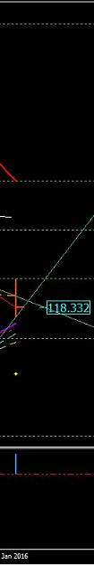
http://www.forexfactory.com/attachment.php?attachmentid=1838974&d=1453762503

The 2 Hour:
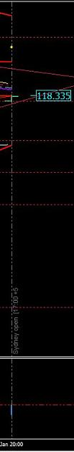
http://www.forexfactory.com/attachment.php?attachmentid=1838976&d=1453762529

The 1 Hour:
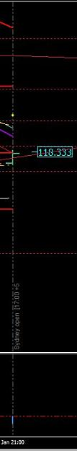
http://www.forexfactory.com/attachment.php?attachmentid=1838977&d=1453762557
Quoting L1ndgren
{quote} Daily has started a retrace at least, H2 and H1 could be meeting resistance at the 4 horsemen and coming back down. H2 and H1 are in sync but Daily is not. So we are looking at a swing in consolidation on the H2/H1?
You are the closes of being right. But this is where and how your trading plan is created.
We are looking at a developing Daily candle it is showing an uptrend with EMA as support and ROMAR as resistance. The market is above the 4 horsemen which places the 4 as support.

On the 2 hour you have the market below the 4 horsemen as resistance and ROMAR as support.
On the 1 hour you have same for the 2 hour: the 4 horsemen as resistance and ROMAR as support.
So think about this for a moment - without anticipating - and see if you can come up with the right entry.

Quoting L1ndgren
{quote} On H1/H2, I would put a sell order at the top of the current/next candle and take profit near ROMAR. Then a buy order if it touches ROMAR because that would be resistance on the daily. 40 pip SL on hourly, 100 pip SL on daily.
What makes you ANTICIPATE the market will not break the 1 hour ROMAR?

Quoting L1ndgren
{quote} I was thinking it might break H1 ROMAR, but not the H2 ROMAR. H2 ROMAR is almost the Daily EMA figure.
Very good - that is correct. It will break the 1 hour heading for the 2 hour in a trend with both.

Just keep in mind that the Daily does have EMA crossing Purple. But there is one major problem - and that is the Daily EMA has not crossed Smooth for a full blown uptrend. This means consolidation is still on going.
So what this means is the Daily EMA is still in consolidation for EMA to slide over Purple/Smooth for the trend down on the next Daily candle. And this is possible with the 1 and 2 hour in sync for the down.
The entry for this down was the SAR hit at 118.644 on the 1 hour:- Since the candle was developing at the time the SAR was attached to the candle - the entry was right at the Parabolic. And there were 4 - 1 hour candles with the Parabolic hit.
Just remember what I had said about the Parabolic hit and that is on any chart. You take entry with the hit and there are times you will have a great visual with the SAR.
Right here we have an ABC Triangle. A for beginning; B for the top; and C for the finishing.
What this means it could very well keep going to break the pattern by getting below the "A". On the other hand - it could retrace from the "C" and continue up and down until it reverses or break the "A" of the pattern. This is only for future reference.
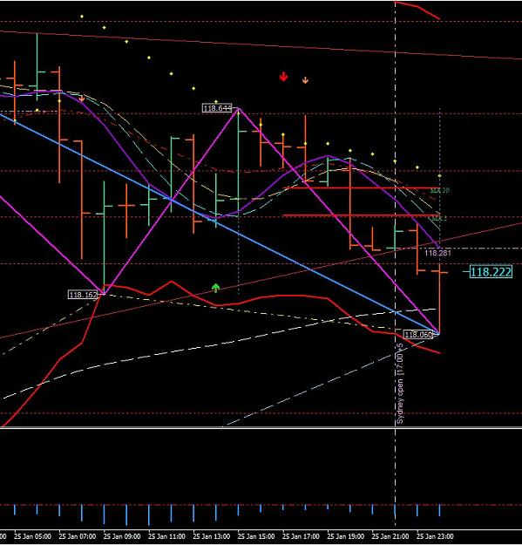
http://www.forexfactory.com/attachment.php?attachmentid=1839023&d=1453768640
And by the way - the pattern had been broken on the LOW of the "C".

Well - it is time to call it a night - be back tomorrow.
God bless us all.

Jan 26, 2016
There are some of you that are learning and others are not. For those who are having problems - all you need to do is study, study, and study. Eventually a light bulb will go on. It is like going to college working for a masters degree. It does not happen over night. It takes time.
On your Daily chart take note
Last week it had created a new low with the Fibo flipping for the up. The Fibo is a very good source of information for entries and targets. This up had hit the 38.2 resistance of the Fibo and bounced and did so again yesterday; and continue down for the Smooth support and also the 23.6 support of the Fibo and bounced again.
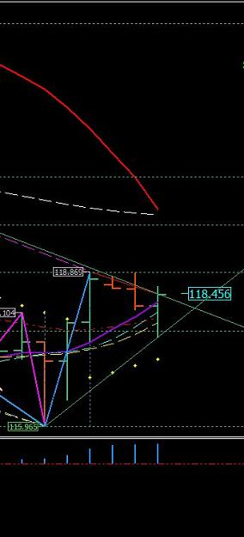
http://www.forexfactory.com/attachment.php?attachmentid=1839791&d=1453826476
On the 1 hour it got below the ROMAR support and became resistance. It then created a new low and turned. But also take note of ROMAR sliding just under EMA. It did not cross EMA so the trend is still up. With this new low there were three entries going up. 20 - 40 pips depending on entry.
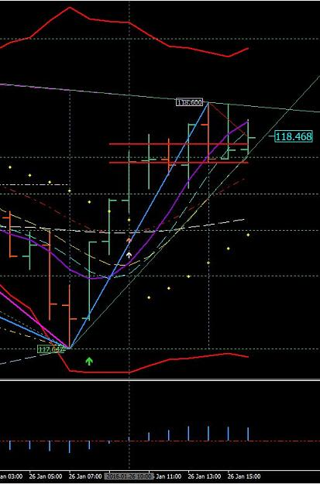
http://www.forexfactory.com/attachment.php?attachmentid=1839793&d=1453826505

The 2 hour is still under EMA for the uptrend which means that 2 hour candle had broken the rule and must return back to trend on retrace; or on the next candle.
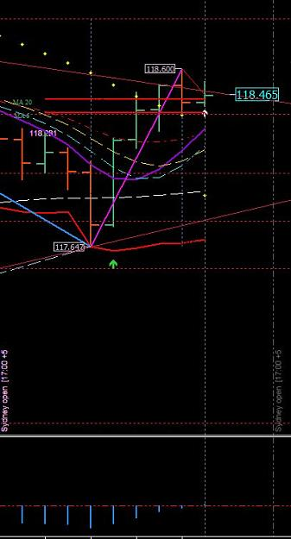
http://www.forexfactory.com/attachment.php?attachmentid=1839797&d=1453826529

Also note the hit on the lower BB of the 2 hour.

OK Traders - let me give scenarios with the ROMAR vs EMA. And the 2 hour chart is the TREND CHART. Not the 1 hour. The 1 hour is your trading chart for the entries. Support and Resistance determines your entries between the two charts:
These scenarios are with the 2 hour chart and you use the 2 hour chart to determine what is happening with the trend. This picture below is showing the market getting above the ROMAR DOWNTREND. This means ROMAR is above EMA for the down and the trend is down. This scenario is showing ROMAR sliding over EMA and the entry was at the OPEN candle below EMA.
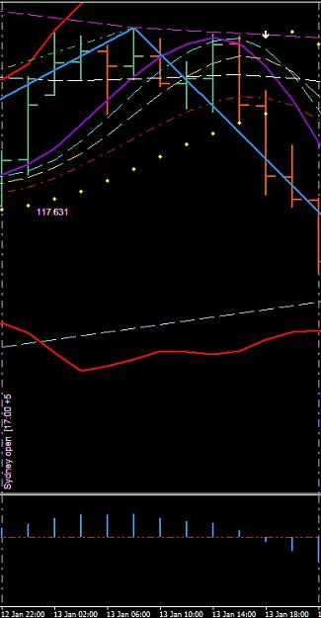
http://www.forexfactory.com/attachment.php?attachmentid=1839895&d=1453832656

On this scenario is the same as the one above. ROMAR sliding over EMA for the down and the OPEN candle below EMA is entry for the downtrend.
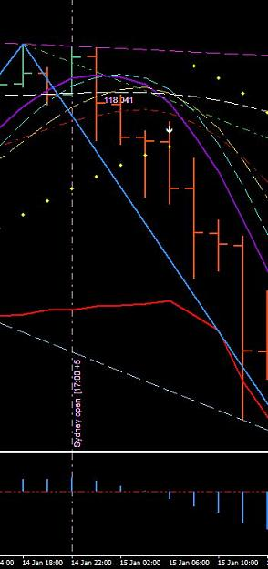
http://www.forexfactory.com/attachment.php?attachmentid=1839896&d=1453832797

On this scenario you have the same situation but ROMAR is at the crossing and just sliding over EMA for the down. Take note of two things.
You have 1; Purple/Whit crossing and 2; with an open candle below SMOOTH showing the crossing of Purple. And that is not anticipating because it is showing the crossing before it even happens.
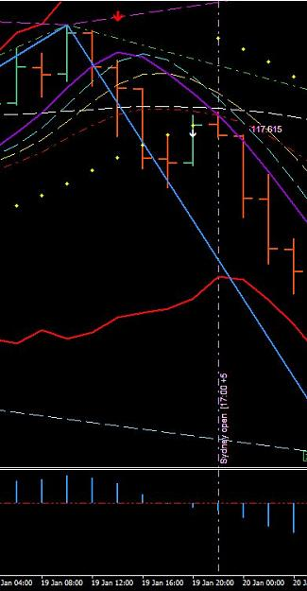
http://www.forexfactory.com/attachment.php?attachmentid=1839901&d=1453833287

On this scenario it is showing the change of trend from the down to the up with ROMAR. Notice ROMAR at the PURPLE WITH the 4 horsemen in the uptrend. The entry was with the open candle showing ROMAR at Purple.
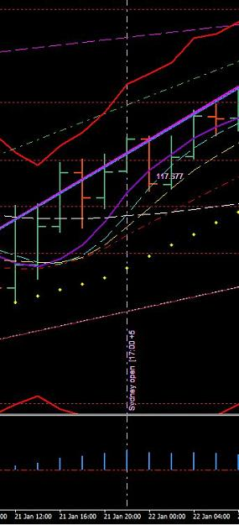
http://www.forexfactory.com/attachment.php?attachmentid=1839903&d=1453833554

The variables with this system for entries are countless. And those variables relate with support and resistance. So try not in getting emotionally depress because you are not seeing it. And those who are trying to make a fast buck with their live account is on the track of disaster. You are letting subjectively control your intellect of learning.

To understand completely - you cannot trade the 1 hour without the 2 hour TREND. If you are trading the 1 hour trend and the 2 hour is not in the same trend - then you are counter-trading.
Example - 1 hour chart:
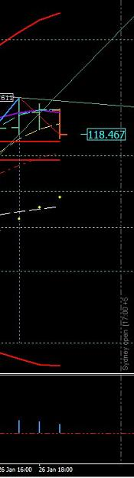
http://www.forexfactory.com/attachment.php?attachmentid=1839953&d=1453837241

Example - 2 hour chart:
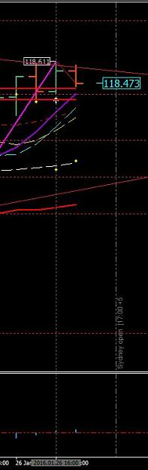
http://www.forexfactory.com/attachment.php?attachmentid=1839954&d=1453837314

The 1 hour is turning for consolidation and the 2 hour is in the uptrend. That means your trades are from support and not resistance on the 1 hour to be in trend with the 2 hour.

Quoting SirViver
Do you mean you would be looking for retracements on the 1hr for buy opportunities, so as to be in sync with the 2 hr trend correct?
In consolidations is pretty much what it means. Your trading from support to resistance and vise-versa. When both the 1 and 2 hour are in trend then you trade strictly the trend.

Quoting j0si
{quote} Dear Dove, what about this question? Im wondering too. Is there any posibility to place pending orders?
NOT in consolidation. Your pending order can very well go against you for a lost.

Quoting aazishhunain
Hello Dove sir, I usually wake up late in morning but from the day I subscribed this thread, I'm trying to wake up early in morning to get you online as I'm in GMT+5 zone. I'm continuously reading your thread from start since the first day to get a better understanding. Not being bored I just want to request you that please tell me the hierarchy I should follow to see charts when I open my mt4. Still now, I open daily chart to see longer term trend by seeing Romar and EMA relation and see where market can get support and resistance, then I move...
For those who are outside of the 17:00 EST closing/opening and can not witness it - then you go back to the 17:00 when you open your charts and follow the movements of the charts to the moment. And as you do this you write notes as to what support and/or resistance is being hit to the moment so in your mind; you know exactly what the market is doing - and make your plan from there.

Quoting GDayMates
{quote} jOsi & Forex Lion, The way I see it, once you understand the system, the most you could have to checkthe charts is at the close of each hourly bar for less than one minute. Even then you will get a feel for if it will be several hours for the possibility of the next setup. Once you have a trade on, you set your SL & TP. So taking this into account it seems a great system for someone who cannot or does not want to watch charts all day. Best regards,
This is very true. You are trading a 2 hour trend chart; which means you have 2 hours in finding a trade. If you check the 2 hour bar at opening and you see no opportunity at that time; then you leave and go do something else and come back to your charts about 5 minutes before opening of the next bar - and you just may see an opportunity at that time when you scan both 1 and 2 hour charts.

You have to remember traders - you are after 40 pips a day and that is it. And there are thousands of pips running every 24 hour. If you really think about - 40 a day is squat in comparable of how many are running.
While I am thinking about it - in consolidation there are 1; or possibly 2 trades in a 24 hour period. And if the trend is up then the trade is off support. If the trend is down then the trade is off resistance. Just like today. The only opportunity was off the 2 hour ROMAR with the open candle below ROMAR support. That is way it works in consolidation. And remember - the market is 80% consolidation.
In trends with all three charts is a different story (which is 10% of the market). In a downtrend you can get in a trade many times with hits off the 4 horsemen resistance. In the uptrend is the same - off the 4 horsemen support.
This why traders go broke because they have never learned how to trade in an 80% consolidated market.
And I have never heard another trader, on any forum, teach this very fact; especially for beginners so they can recognize just what they are getting into.

Quoting GDayMates
Mr. Dove, Currently, we are in consolidation, as all three charts are not in alignment. As such, we are trading off of support and resistance. This being the case, would a bounce off the upper 2 hour Bolinger Band be a valid trade? It would be a short and H1 and H2 indicators would be stacked up. However D1 is still in down trend. If I understand this correctly, we would take the short trade, provided we had 20/40 pips back to support (2H EMA) Is this correct? Thank you.
In reality yes. But waiting on the BB hit could be a long wait and much can happen between now and the BB hit. Trading in the moment from bar to bar is the objective. This way you are trading what is happening in the moment and not waiting on something else. The Daily ROMAR is down for the Daily. But you have the 4 horsemen are in trend waiting on the EMA crossing Smooth. So that means ROMAR is the Resistance for the Daily and the 4 horsemen are working for the Resistance. But that too can change from day to day depending on Purple/White.
I hope this answers your question.

Quoting ForexSamsam
I use on H1 the touch of the Psar and the parabolic as entry pont for a long. The H2 is always in uptrend and the pair goes below the ema support {image}
This was a very good thoughtful and insightful entry. The reason is because he tagged the 1 hour Parabolic and also the 2 hour EMA being tagged in the uptrend. The 1 hour is also still in the uptrend with EMA below Purple. Will he get 20 or +?. The possibility is not great but probability is a consideration. And the reason is because the 2 hour market is below Purple working on a consolidating situation.
If his entry was in a volatile situation then yes -- the probability was great for 20+
But the main objective for his trade is because his entry was right on.

I have a ministry that keeps me busy with marriages in crises. So there are times I'm on the phone longer then I wish to be.
But anyway - each pair has its own structure according to the pairs and also the market. Some pairs are highly volatile and others are not. And the UJ is one that is not. But for training purposes it is the choice because the pair lacks the volatility and gives more time for the visuals. So next week we will train with the EJ. It is my pair that I trade with and very volatile. And the structure with the EJ is not the same as the UJ.
Basically the trading is the same but the volatility can really put a squeeze on the way you think in terms as a trader. Your thinking has to be recondition in such a term as being "objectively" with support and resistance. If you are subjective with volatility then it can cause a major confusion. And the reason is because your entries are BEFORE the fact with the EJ. Which means you will be looking into the future. And we will get more into that fact next week.
OK - it is time to call it a night. My days are long and be back tomorrow. Everyone take care and God bless us all.

The Dove - Forex Trainer

