I will warn you that this is a theory that requires a lot of thinking and attention to detail. To trade it properly requires first learning some or all of the patterns and what they mean and then ensuring that the pattern is the pattern. I also say that I believe I have about 70% of it figured out, so that is why I call it a theory. The last 30% I haven't figured out is riding trades through small reversals....it doesn't hurt me but makes for more work during a trade.
The good news is that there are some easy basic patterns that I will explain first that are very easy to see...you can even see some of these stone cold drunk (not that I recommend trading that way). The easy patterns don't come up too often so knowing how to trade all the patterns will certainly enhance both entry and exit success. However, if an easy pattern appears...might as well trade it, eh!
I'll get us started in the easy patterns and this will allow you to look at the patterns yourselves.
The Stochastic Thread Theory was first formed from expanding Escalator to Pips. The theory was that if 4 time frames lined up, then what would happen with 18 stochastic lines on a single time frame?
For this we trade on only one chart. I recommend the 1H or 4H because we want to take advantage of the greater pip moves over time. I prefer the 1H as it fits my patience level better. I suggest starting out on the 4H because you will have more time to study the threads at close. The 30M and shorter time frames will be hard to trade because they don't leave much time for thought.
To set this up we need a 1H chart and 18 stochastic %K lines from 6 to 24...so 6,7,8,9,10,11,12,13,14,15,16,17,18, 19,20,21,22,23,24 all in one indicator window. (So each stoch is 6,3,3; 7,3,3 and so on)
Colour 6 to 13 thin blue - these are our lower time frame stochastcis and will be called LTFS (Lower Time Frame Stochastics).
Colour 14 thick red - 14 plays an important role and you'll probably see why I switched to 14,3,3 after you see this. This is our Base Stochastic and is called naturally the BS line. So when it let's us done we can say, "That dang BS line messed me up!" with all honesty.
Colour 15-24 are thin red lines and are called HTFS (Higher Time Frame Stochastics)
Just in case you are wondering, this is MTF stochastics it is just not using different price charts but different stochastic periods.
What you should have is a nice rainbow on your chart like the one below.
Attached Image
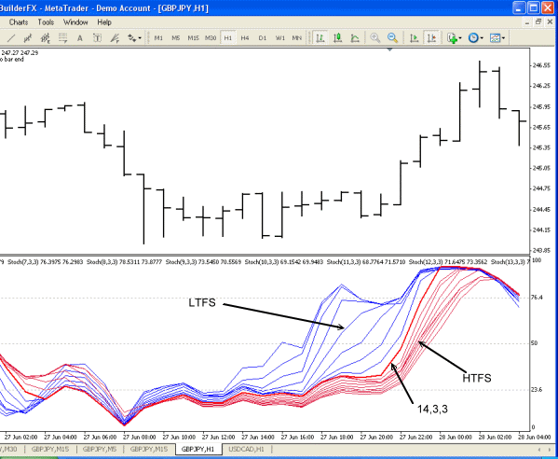
- Post 2
- I know what you are thinking...that it looks like an MA Rainbow. Ok, get that out of your mind right now....because we need to think threads and ropes not pretty coloured rainbows.
As we all know a rope is made up of lots of thinner ropes that are made up of even thinner ropes and so on until the threads make up the string that makes up the rope....gawd it sounds like a Barney song!
Well if it takes a purple Dinosaur to remind you we are talking about threads and ropes so be it. Just don't not think of the other think that is in the sky and has many colours.
The reason we talk about threads and ropes is because our trading will be centered around when the rope splits into threads and the threads converge into a rope. Interestingly enough when the rope detangles and the threads get loose is a sign of chaos just like we expect when threads come loose and get all tangled up. Once the threads get straightened up we have a really nice trade window.
If we look at the previous chart I posted we can see the rope fray but the threads stay nice and "combed" (split apart and in order) while the price climbs.

I promised easy..so here it is. Like I said we can trade these in a drunken stuper and should make some pips.
It is easy..trade the rope. When all the stochastics converge together we'll see one thick line and that is when we trade.
See the chart below, enter after we see the "peak". Usually we'll have only one peak and usually it will be in the over sold or over bought area... but the peaks all look pretty much the same.
Then we just follow the trade until our rope begins to unravel.
That's the simplest of all patterns and also the best to trade...go figure trading can be so easy.
Attached Image
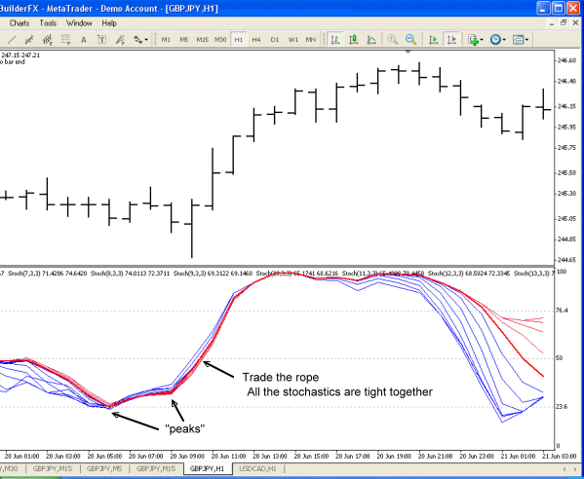
Just in case you are wondering why you are about to be inundated with threads, ropes, combs and fishnets for terms let me explain that my family has a long line of sea captains and fishermen (I'm neither but I am starting to build custom classic wooden boats as a hobby/business for the enjoyment/challenge/frustration of doing it).
Ahh...can't be this easy. Well a few things to watch will keep us on track.
Combs and Fishnets
When a rope unravels it either unravels in a nice uniform of threads and we simply take a comb and comb the threads out to keep the threads from tangling so that we can put them back into a rope. By doing this our rope naturally keeps going and isn't a tangled mess.
On the other hand if the rope unravels and the threads get tangled we start to get a fishnet of threads and these spell chaos as we can't untangle them with a comb and our rope usually has to be cut.
So, if we have a nice "combed" effect we can stay in our trade and if we start to see a "fishnet" we better get out of the trade. See chart below.
Now astute traders as we all are we can see that entering after a "peak" is going to get us some pips and waiting too long is not. So watch for those "peaks" and best if you get in on the first peak, not the second one.
Attached Image
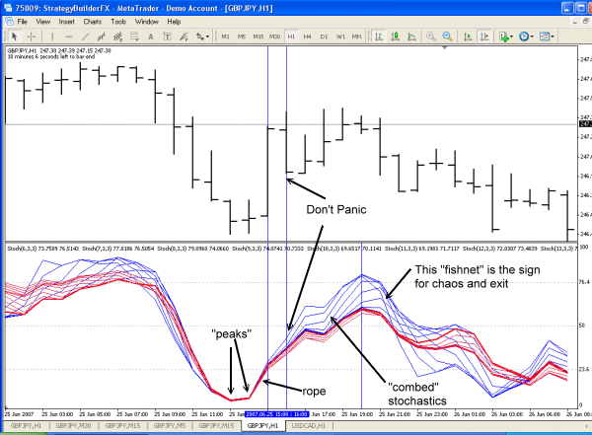
Remember why this is a theory...that dreaded 30% I haven't figured out yet.
When we go from comb threads to a new rope usually something is going to happen. That usual thing is a price reversal. So don't wait for a peak if you see a new rope...trade when all (all) the stochastics converge.
Sometimes we just can't have a reason for a change in direction like on this chart. Having said that, if we stuck with the trade until the fishnet occurred we wouldn't have lost much if anything.
Like I said, this starts to take some thinking and studying and paying attention to all those threads. It gets way way way more interesting but I think for now I'll leave you with this to mull over for a while, it is a good start.
Attached Image
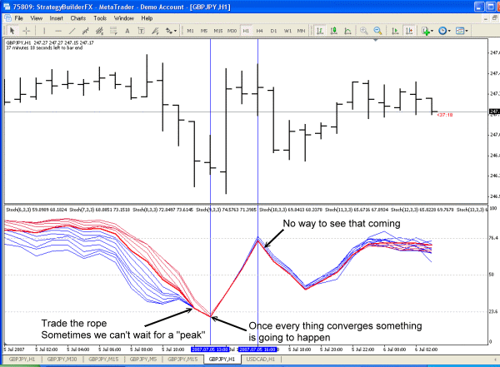
Below is a 1H chart with multiple thread patterns. Each area is explained in detail.
1. Notice how as the stochastics reach a peak and turn all the other stochastics start to converge and when they hit this convergence they simply are wrapped into the rope. I call this a "clam shell". That is because we almost always have combed stochastics prior to this phenomenon happening and it looks like a piece of clam shell.
2. From "1" the consolidation into a rope is quick and then the threads are combed again. Now the big problem with this trade is that we had a large upward spike right after the rope formed. However, if we followed the theory and stayed in the trade we would have been alright to the end. This illustrates the importance of following a trade to the end as use the stochastic patterns as your guide. If we are studying the stochastics we should be thinking of an entry right after the peak and price spike. We have a nicely combed stochastic after the peak to follow down.
3. We can see the clam shell pattern better here. Notice how all the stochastics hit the rope and converge. Look closely and see that each successive higher stochastic is converging into the upward move of the lesser time frame stochastics.
4. Here is where the theory may seem to be in trouble but again if we follow the rules of the theory and stick in the trade because the stochastics remained combed then we should come out ahead at the end or at least break-even.
5. This is the end. It is a fishnet and first sign of the fishnet we should be seriously thinking of getting out. If we have entered our trade too early from "1" and too late from "4" and stayed until the fishnet showed, we would have had very little in losses. If we were trying to catch some fixed TP, we probably made it if we kept it between 5-20 pips. The reality is that not every trade is going to gain us pips so we want to make sure that our losses are small. This is the strength of this theory, losses are small if we follow the rules of the theory. Small losses 30% of the time and 70% wins will make us a nice pile of pips.
6. Is the end of the fishnet. Notice that the lesser time frame stochastics have all converged and cannot even be seen. This is a good early entry opportunity.
7. The conservative approach is wait for the rope and here is where we definitely enter the short trade. Keep in mind that we still want to keep the 80/20 rules in use especially for ropes. Albeit we are not necessarily looking for the entire rope to follow the 80/20 rules but when we see a picture like "6" and "7" we know we can probably follow this into an over sold position if the pattern holds together and does not clam shell or fishnet on us.
This is a lot tougher to see and understand at first glance. However, the important thing to notice here is how the stochastics react when they turn and converge (in "1" and "3")...it is like the line hits a brick wall....talk about a wall of resistance
Attached Image
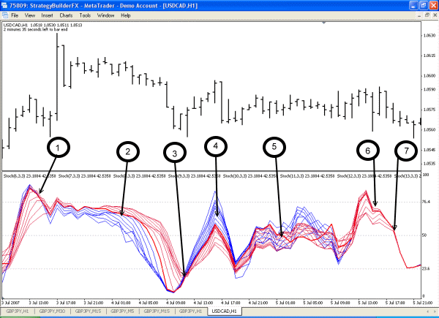
are all lined up in order from 6 to 24 as they are split apart.
Price always follows the shortest stochastic movement....to some degree. This "some degree" is the tricky part because it may be 1 pip or it may be 20 pips or more. A sustained trend is created when each successively longer stochastics follows the lowest stochastic. So 6 turns first, followed by 7, then 8, then 9, and so on.
As these stochastics turn they converge and create what I call the "wall". Nothing gets past the wall (or very far past it).
Now, look at the chart below. See how the wall forms up on the 14 stochastic. That is no coincidence. You may think I looked high and low for a 14 wall, but take a look and you will see the 14 become the wall, the rope and basically what the Forex universe revolves around. Ok, I admit not every wall is this clear but they are darn close.
The question is where do we start to conclude we have a wall and not the creation of a fishnet starting. Well, there is really no definitive answer. We know that as stochastics converge they form a rope and we want to trade the rope. So, we need to make a rule that fits our risk profile. I generally look for at least all the LTFS (lower time frame stochastics - the blue lines) to converge and then watch what happens to the 14 as my trade develops....if everything converges like this, I love my trade. Sometimes I'll only wait for 3 LTFS to converge and turn.
The other thing to watch out for is anything sneaking past our wall. Our wall can't stand up forever and will eventually break down, so any break in the wall is a get out of the trade move.
Notice too in this chart how the LTFS flip around. At first they create the wall then they stay inside the wall on the left side as our red wall sticks together. The bue stochastics from left to right are 6,7,8 and 9...in other words our leading indicators for a climb are stuck on the inside of the wall which means until they break through the wall our price will keep climbing.
Again notice how we reach the price peaks as the blue lines again cross through our red wall in the over bought area. The leading indicators 6,7,8,9 have all broken through our wall and price can now be lead to drop. This of course takes us back to "what degree" will the price drop.
This wall created a 120 pip move so playing the game like me, we'd get out at any sign of a LTFS break through of our red wall. So our pip gain would only depend on where we entered.
We could be braver and ride the red rope but always remember that it will be the LTFS that lead the price move....to some degree.
Attached Image
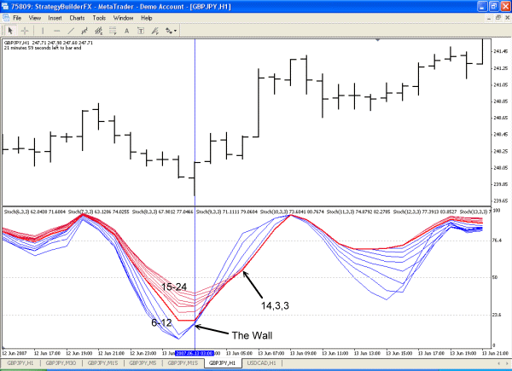
- Joined Jan 2007 | Status: MTF Stochastics and Volume/Price | 1,127 Posts
So this leads us to a rule we should fix in our mind because this rule is as solid as gravity.
The LTFS Inside Wall Rule
If we have a climbing red wall (the red line HTFS) and the blue line LTFS are to the left (inside) of this red wall, then price will go up to some degree so long as this remains true.
If we have a falling red wall (the red line HTFS) and the blue line LTFS are to the left (inside) of this red wall, then price will go down to some degree so long as this remains true.
Always exit when ANY blue line emerges on the outside of the red wall.
Exit when blue lines converge or start creating a new wall.
Attached Image
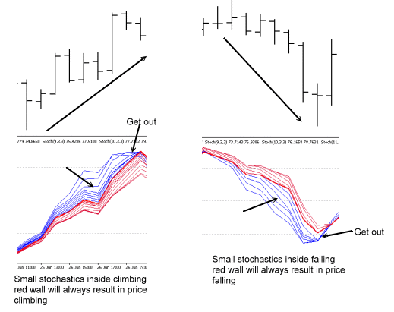
Mike
Spudfyre is derived from Spitfire...when I first joined the Internet many many years ago my nic was Spitfire wherever I was....of course as the Internet grew, Spitfire was well used and so it became Spudfyre (something no one would pick). I'm a Spitfire buff (it's a plane for all those not into historic aviation).
Think of everything presented by me as a tool. Nothing replaces anything, all the tools are designed to help and be selected to optimize our trading. Each of us will like some tools better than others and use them more. However, all the tools do use the same foundation that is explained early on in MTF Stochastics.
You are getting a littel ahead of me as I'm just starting with the basics of threads. However, from what we know so far I'll explain the chart you posted.
The first short entry is pretty basic with the LTFS (blue) on the inside wall and falling. The exit has 2 options. Use the LTFS inside wall rule or wait for the 1H 14,3,3 stoch (not shown) to cross back over 20. For the sake of keeping consistent with thread theory we are out when the LTFS crossed the wall.
The second entry is a loser. We would have stopped out based only on what we know of the thread theory so far. However, give me time and I will show us how to work around that one.
The third entry is again basic and the exit leads us to a break even point under thread theory alone. Again, we have tools in MTF Stochastics that will help us and one is following the 1H stochastic (14,3,3) until it recrosses the 76.4 level.
Again, this is ahead of where we are, so bear with me as I get all the info out there.
Attached Image (click to enlarge)
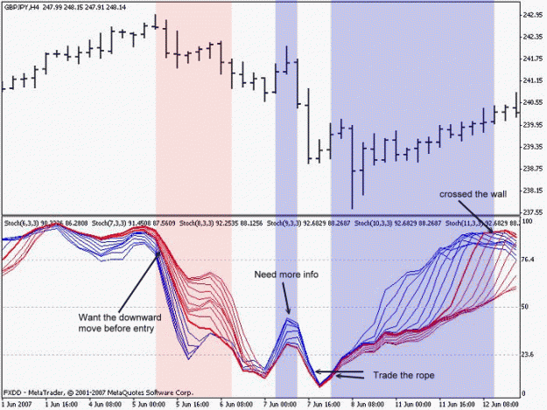
--
Peaks and Trends
During a trend a peak occurring in the over bought or over sold regions generally translates into:
1. Over sold peak/upward trend = lowest low close
2. Over sold peak/downward trend = highest high close
Now when I write "lowest low close" or "highest lhigh close" it is a general statement that means looking at say an upward trend it will be a low point in that trend from that point upwards. It may not be exactly the lowest point but definitely one of the lowest points.
Below is a 4H chart showing an upward trend and a downward trend. These trends we are looking at are over a long period but quickly finding the peaks we can find the lowest lows and highest highs. Don't worry about the details, just look to see that the peaks are in the over bought, over sold zones and the price trend direction.
Attached Image
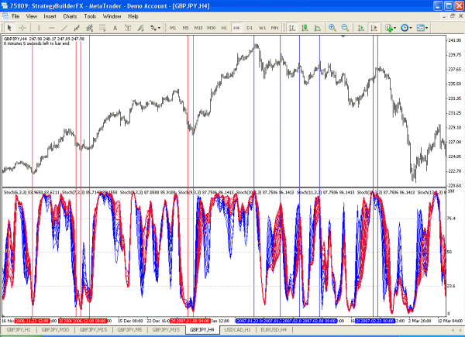
Joined Jan 2007 | Status: MTF Stochastics and Volume/Price | 1,127 Posts
So we know the general theory of peaks and trends but the secret is in our attention to detail. This is going to be a rather lengthy subject but I think we can see by the previous post the importance of peaks and trends.
Find The Trend
Obviously the longer the trend the easier it is to see the trend. To find a trend starting live is a little tricky and can be a frustrating experience of whipsaws if one is not careful. Here is my take on trend finding.
Take a step back a zoom as far out of the chart as possible. Don't worry about specific details....just look for where the price is at and what the trend was before it. In this chart the price is quite high and we are in an obvious upward trend. Draw a trend line from the low point upwards to the latest low point. We must have a stochastic peak at each low point! A peak is has to be in the over sold zone of an upward trend.
Ok, so this is our current price trend. Our next trade will either be long when we have another peak in the over sold zone or we will be looking for a trend change.
Attached Image
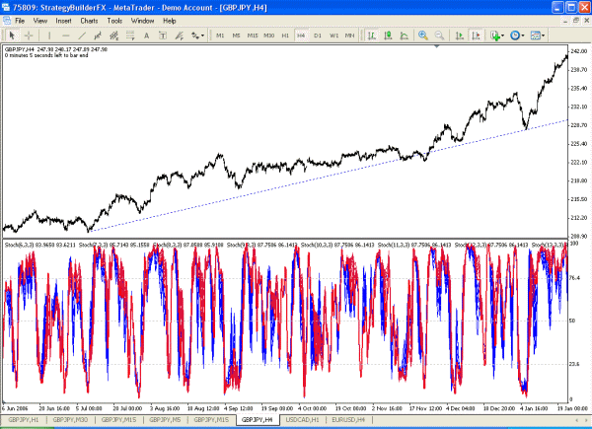
- Joined Jan 2007 | Status: MTF Stochastics and Volume/Price | 1,127 Posts
We come to our first peak in the over sold area of our upward trend. Remember we only care about the over sold peaks in an upward trend and are not interested in the over bought peaks.
I have zoomed in on our price chart so we can still see the trend line.
When we get this peak we buy long. We won't see the peak until the close of the candle so we are buying long at the close.
Notice the trend line is below the price.
Notice that our peak has all the stochastics.
Attached Image
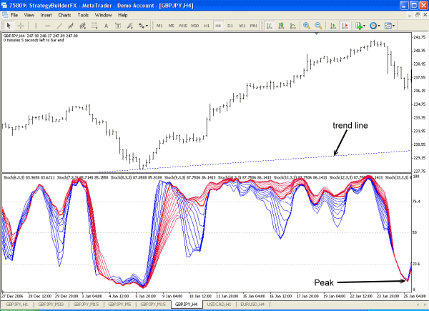
- Joined Jan 2007 | Status: MTF Stochastics and Volume/Price | 1,127 Posts
So we made our entry now how do we exit.
The chart below gives us a few pointers. The most important one is that we are up 95 pips before we have any hint to exit. So having any hint to exit after being up 95 pips is as good a reason for me to exit.
The hints to exit are:
1. We are up 95 pips.
2. The vertical red line marks the star of the rope.
3. The horizontal red line is the close of where the rope started.
4. The LTFS (lesser time frame stochastics) have reached 76.4 and are starting to turn and create a wall.
The formation of the wall is our strongest indicator to leave the trade. We might want to ride the wall a bit but in the case of being up 95 pips without any prior hint to exit, let us just take our bounty and run.
If you are wondering, the draw down on this trade was about 26 pips plus spread.
Attached Image
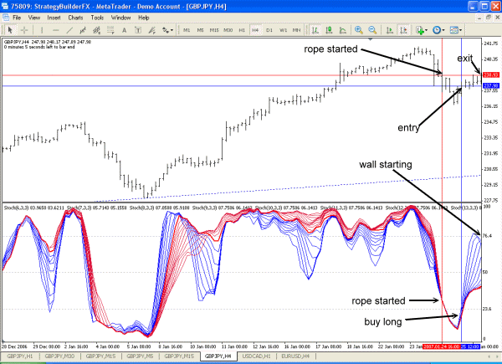
- Joined Jan 2007 | Status: MTF Stochastics and Volume/Price | 1,127 Posts
Things get a little tricky when we are in an upward trend and a downward trend starts to form. As long as price remains above our first upward trend line we still consider ourselves to be in an upward trend.
However, now we can see a downward trend starting. Notice how the stochastics have peaked in the over bought zone and the high points of the price react (the second peak created a lower high price point). We draw a trend line here and this becomes our second trend line. We now have a trend within a trend.
There are two courses of action we can take. The first is that we continue trading only the upward trend and watch the downward trend. We have to keep in mind that this downward trend may result in small upward price actions. The second choice is to trade both trend lines. There is the third choice of only trading the new downward trend but that is risky when we are in an upward trend.
My personal choice is to trade both trend lines with a high degree of caution. We will try and grab a few pips until we get a single clear trend line again.
The last choice is not to trade at all and wait, but eh! We are traders..we wait for nothing!
This is where attention to detail is so important. Missing this 2nd trend formation robs us of valuable information. Don't get tunnel vision and if necessary use the zoom function and keep looking at the overall price action. We really need to catch these trends. Again this is best done on the 1H and 4H charts as we have time to think and look. You are far better to make a trend error and think you have a trend than not notice a second trend at all. You can correct any trend recognition errors but you cannot correct a bad trade made from missing a trend line. So, if in doubt believe you have a second trend line.
Attached Image
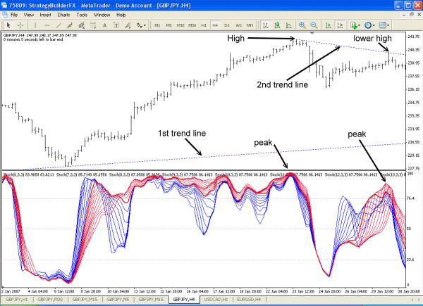
- Joined Jan 2007 | Status: MTF Stochastics and Volume/Price | 1,127 Posts
Before I go into our next trade opportunity I should talk about peaks a bit more.
A peak only occurs above 76.4 or below 23.6
We don't consider a peak, a peak only made up of only LTFS (blue lines).
We want at least the "14" to peak but prefer all the HTFS (red lines) to be in the peak. This becomes a bit of discretionary decision making here. We might have some red lines and all the blue lines in the peak zone and consider that a peak. What we ideally want is all the stochastics in the peak so our discretionary decision making will always be how close we are to the ideal.
Just remember that a "24" peaking is much better than a "6" peaking. SO consider each stochastic value as a weight in your decision making.
Contrary to that is that the "6" will always lead the move before the "24".
If we score our peaks...so let us say all the stochastics are in the peak, this gives us a score of 6+7+8+9....+23+24=285 So a perfect score is 285.
If we only have some stochastics in our peak and our score is say...84..than our peak score is only about 29% (84/285).
If we had a score of say 175 with some stochastics then our peak score is 61%.
So to me...61% is much better than 29%.
We can trade all the peaks and figure the score so we can think about how strong the peak is in our trade and what we look for as a sign to exit.
How you want to rate your peaks is discretionary. I prefer to trade off strength rather than weakness, I find it much safer. I have not done a study on peak strengths but I am sure some one will at some point or I will and then we will have some statistics to follow. If anyone is into indicator making...a peak strength meter would be a great help.
Ok, so let's move on to the next trade.
--So we need to back track a little to where we first dicovered our trend within a trend. We have a peak in the over bought to trade and a downward trend.
The peak in this case is what looks to be the end of a fishnet so not as defined as we would normally like. However it is the HTFS (red lines) defining our peak and creating a wall and the blue lines are moving inside the wall, so a short trade seems like a good idea here.
Attached Image
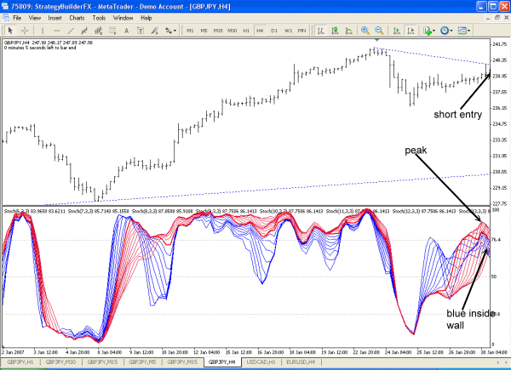
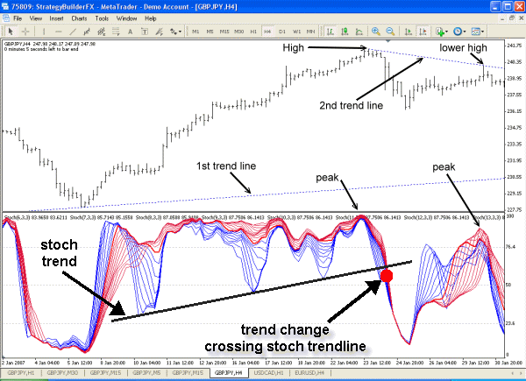
The exit here is simple and nets us about 200 pips before there is any hint to exit. So, if 200 pips and a hint appears to exit and you don't exit then you need to have Dr. Forex examine your head.
In this trade we simply follow the nicely combed stochastics down and when the first blue stochastic turns in and starts a wall we are out, done and gone.
The draw down by the way was about 15 pips.
As we can see the cardinal rule for exits to weigh risk against pip earnings. If we are making a good handful of pips and we get any hint to exit...then for gawd sakes man, exit! Don't stand there and explain to us how you will ride the price and take what the market will give you just friggin exit already.
Attached Image


