The ATM Machine

The system is used the trend following to determine the direction of the market.
There are 2 trends that provide the informations ready to trade:
1) The trend D1 determines by the fast THV MTF TRIX in D1 ( Prevailing trend)
2) The trend H4 determines by the fast THV MTF TRIX in H4 ( Counter trend)
The ATM Machine uses only M15 (for the safe trade).
Indicators :
- Synergy or Heiken Ashi candle
- RenkoStreet_Trend
- TMA Line
- THV MTF TRIX
- Entry Signal Stop
-Renko channel
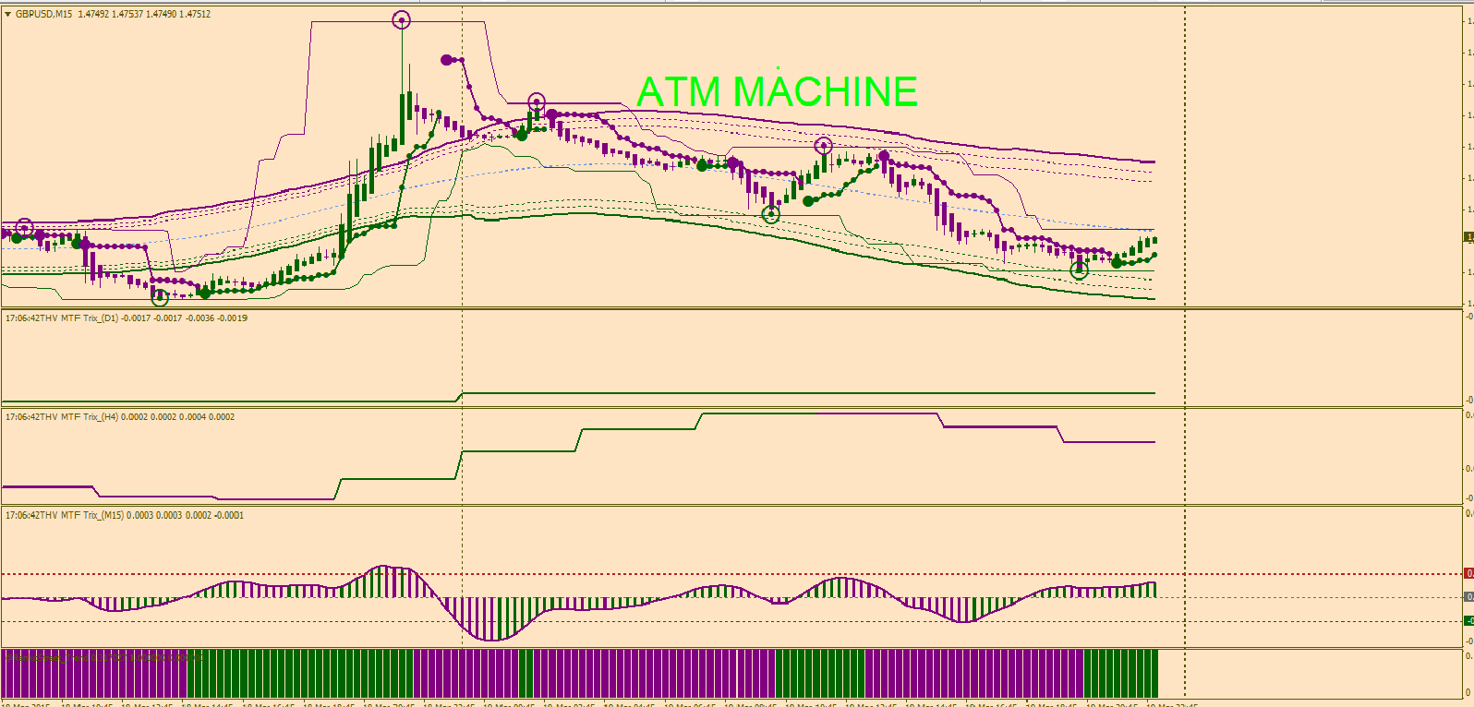

Enter a trade –M15--

Short Trade : Above the middle channel or around the upper channel (To validate the signal)

Step1) Purple Circle touched the purple resistance line (Renko channel)
Step2) THV MTF TRIX painted purple (Trend D1 or Trend H4 or both, or at least one of them)
Step3) First big dot painted purple confirmed by :
Step3_i) THV MTF TRIX’s histogram painted purple and above the zero line (to validate the signal) important
Step3_ii) RenkoStreet_Trend painted purple


