How to Setup :
- Download all data.ex goes in to script folder (Files > Open Data Folder > MQL4 > Scripts)
- Rest of all files goes in to Indicators Folder (Files > Open Data Folder > MQL4 > Indicators)
- Open MT4 > Tools > Options > Graphics > Max bar’s on the chart above 10000
- Open M1 chart - Run Download All Data script as shown on the Picture
- (If any alerts or errors you have please contact with me from skype id: Rma.mt)
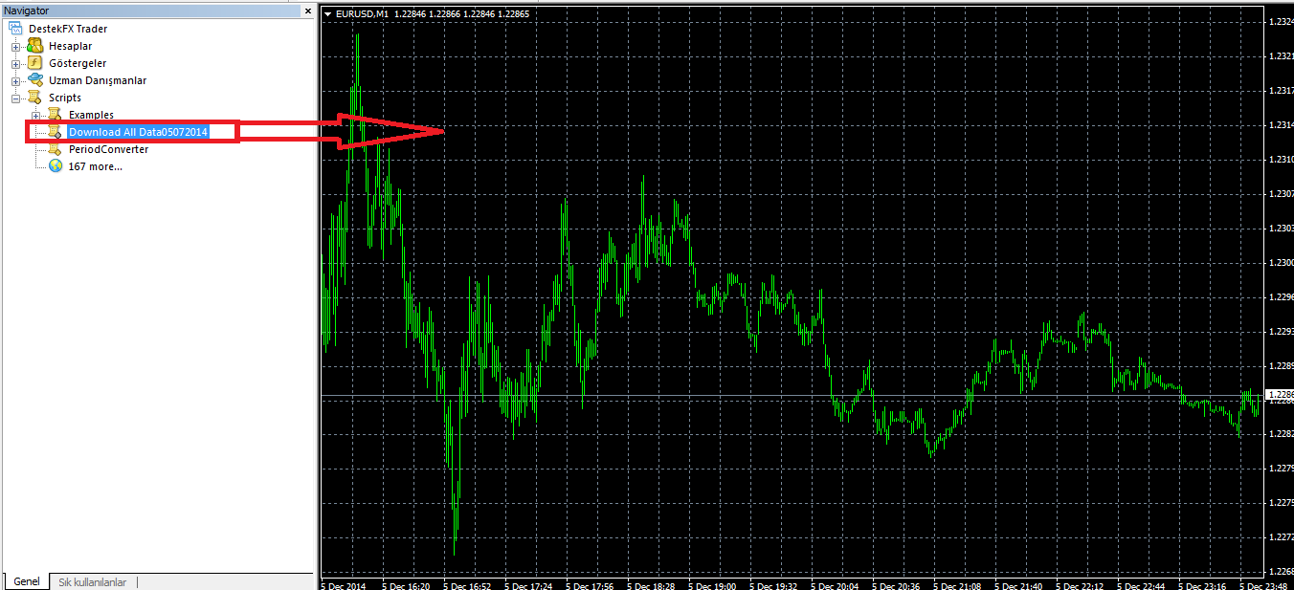

- After download complete open M1 Chart which is Not JPY pairs to run dashboard Drag Breakout.ex in to the chart
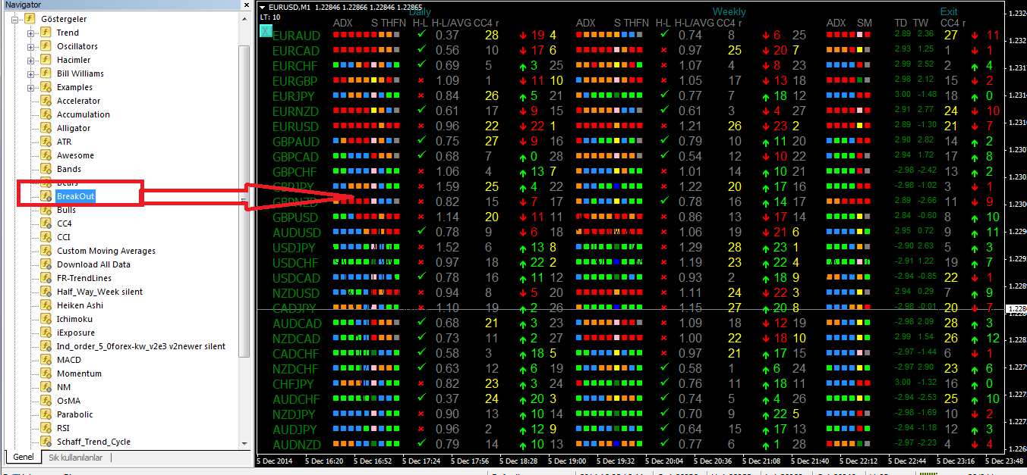

Dashboard Information and How to Use
-This dashboard designed to give extra information to trader about current market profile
-You can watch current situation of all 28 currency
-Power for different time frames, Weakest and strongest pairs.
-How many rooms left on weekly and daily avarage.
-Spread vs Avarage to see if its worth to trade.

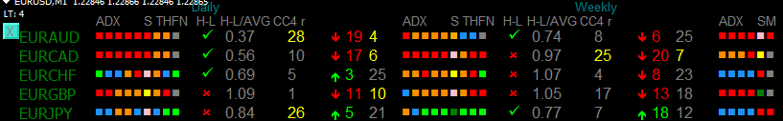
Daily part of dashboard :
-Based on M30 Time Frame (Adx periods)
-Based on Half Daily (H-L Avarage)

Weekly part of dashboard :
-Based on H1 Time Frame (Adx Periods)
-Based on Half Weekly (H-L Avarage)

Exit part of dashboard :
-Based on M15 Time Frame (Adx Periods)

Adx = 5 Box. (5 Different Periods)
All Red = Strong down move ,
All Green = Strong up move
Orange = Direction Down No Power
Blue = Direction Up No Power
S = Schaff TrendCycle
Do not focus on colours here , Its feeding Total Points to get more predictive results.
T= Trend Indicator.
Red Box = Strong Sell ,
Green Box = Strong Buy
Orange = Direction Down No power
Blue = Direction Up No Power
H= Half Daily Indicator
Orange : Price Below Daily open and dont make breakout yet.
Blue : Price Above Daily open and dont make breakout yet.
Red : Price Below Daily open and made breakout
Green: Price Above Daily open and made Breakout
F= FR-Trend Lines
Red: Below Trend Lines short direction
Green : Above Trend lines Long direction
CC4R= Currency Strength Rank
Yellow Number Strong Direction of Move and High Ranks which is Closer number to 28 is stronger.

H-L Part explenation

This is Half daily lines shown on the Picture. When price get closer to White Line
H-L Part on dashboard turns in to RED X To tell you there is no more room left and you have to be careful.

Example Daily : IF price movement avarage is 100 pips for day and EURUSD Moved 80 pips (%80 OF THE avarage ) H-L Part will turn in to X on dashboard 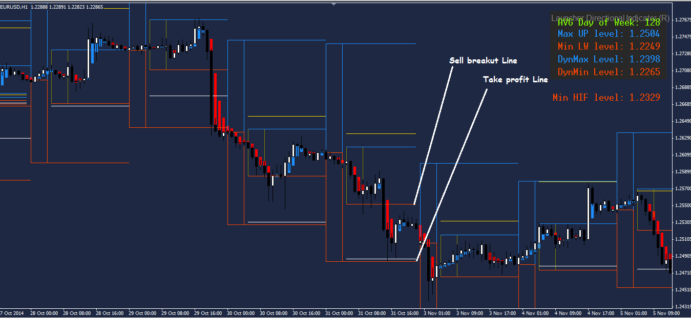

Example Weekly : IF price movement avarage is 300 pips for week and EURUSD Moved 240 pips (%80 OF THE avarage ) H-L Part will turn in to X on dashboard
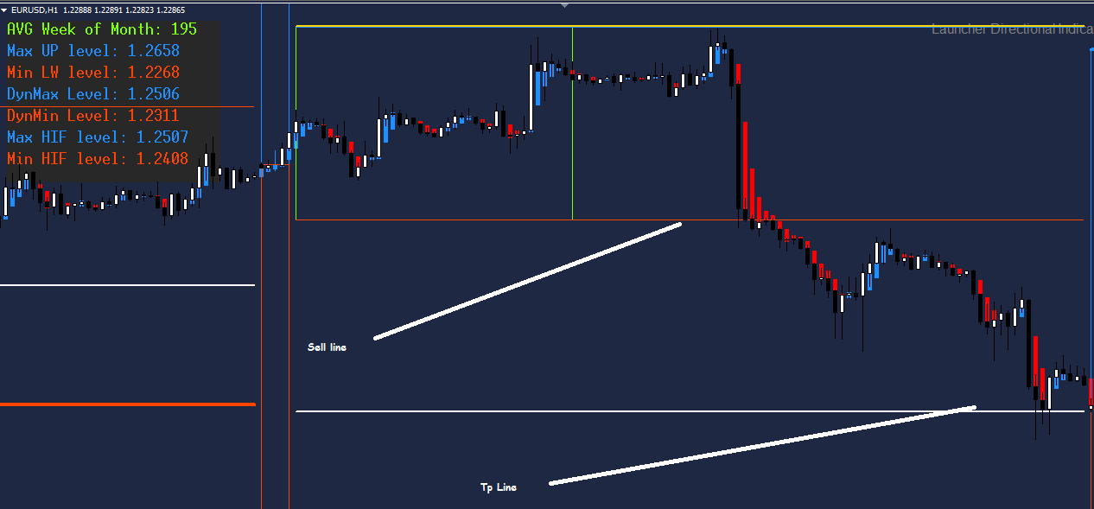

TOTAL POINTS AND RANKING
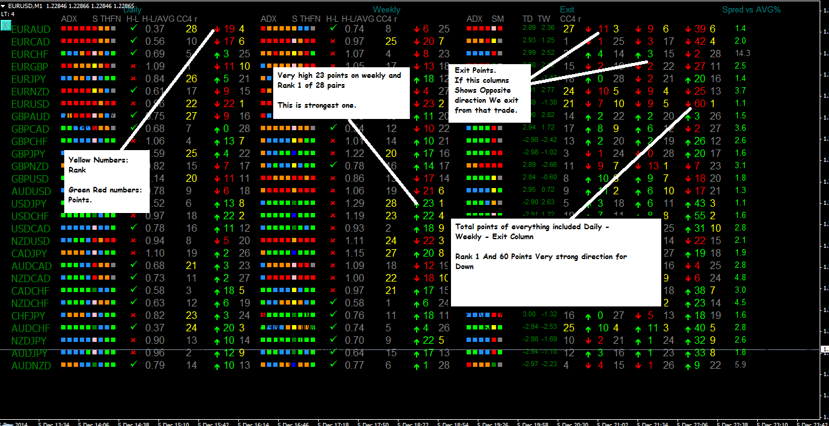

TD-TW Part Of dashboard Shows Trend Distance
For Daily and Weekly Colums (m30 + h1)

Roman Vigovski

