LAST CANDLE CLOSED

1. At the level in direction of movement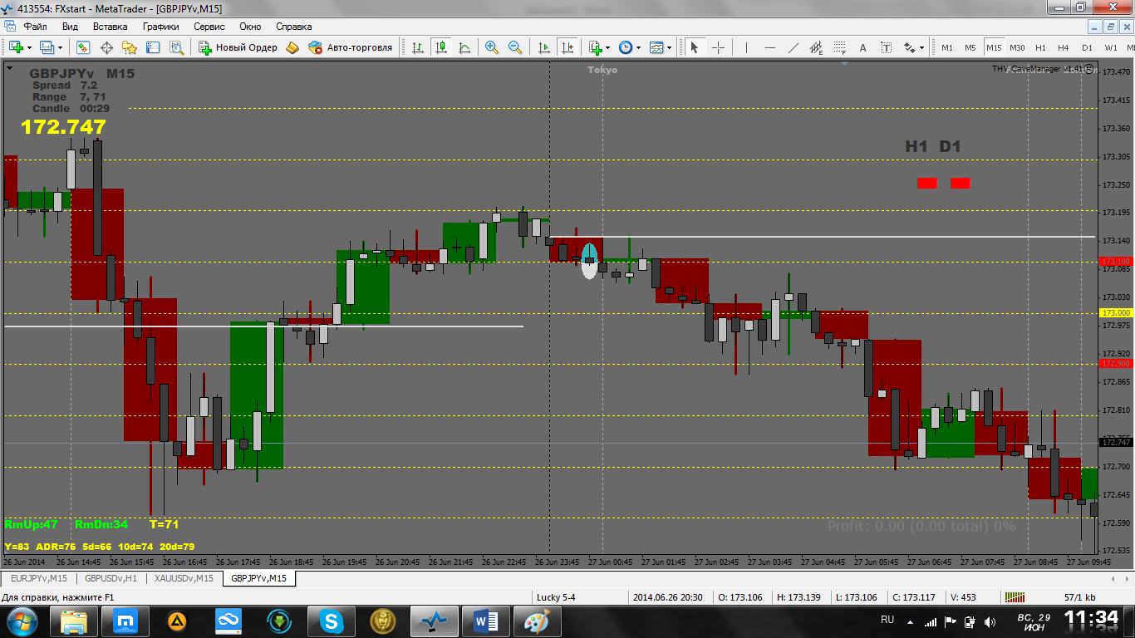

Pending order in direction movement at this level.

2. Behind level against the movement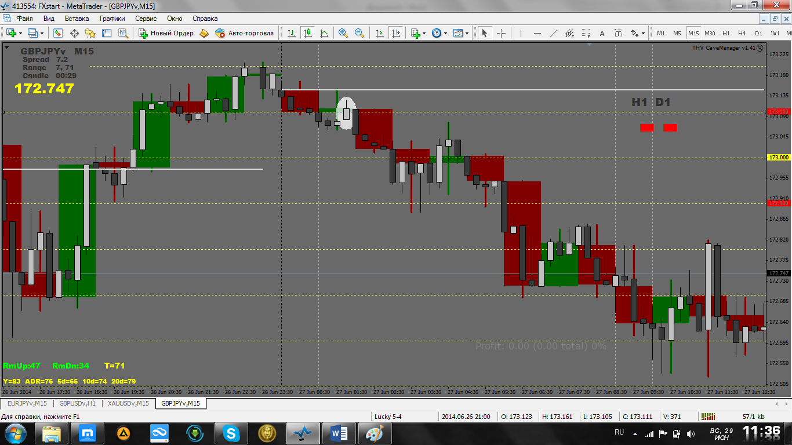

Pending order in direction movement at this level.

3. Not reaching the level (near) direction of motion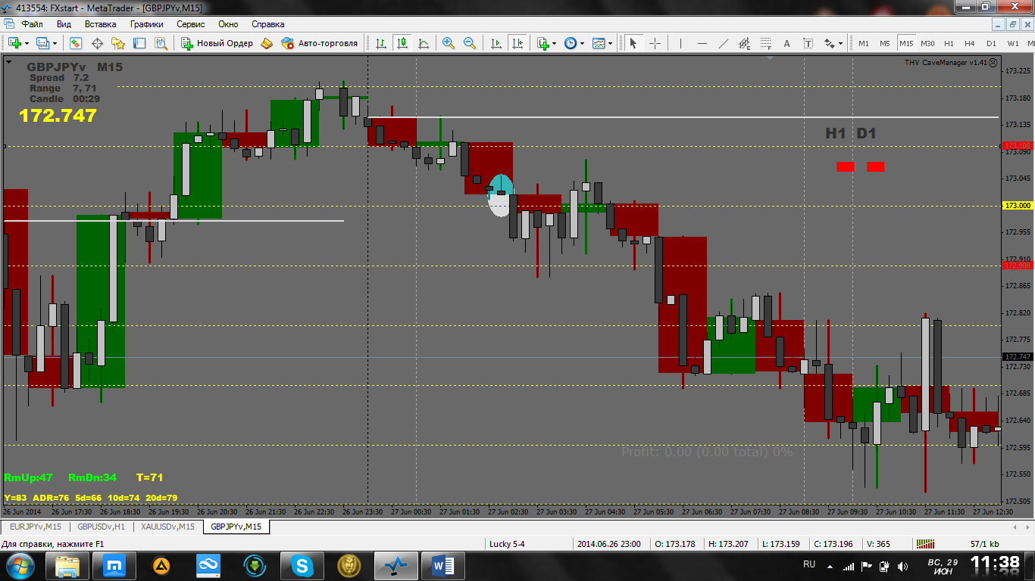

Pending order in direction movement at this level.

4. Not reaching the level against the movement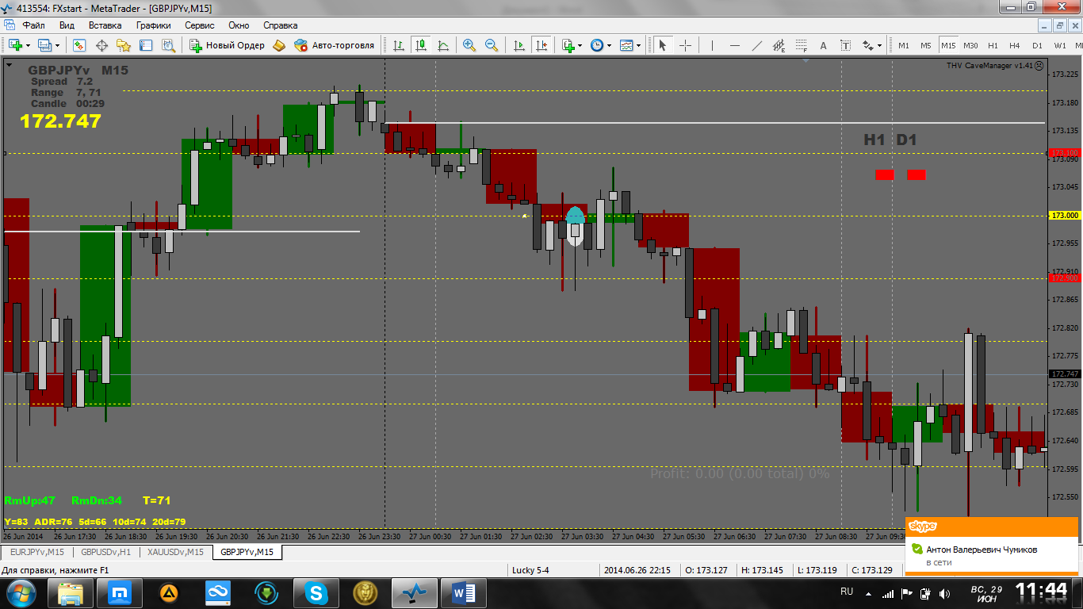

Do nothing or against the movement at your own risk. Can limit order in direction movement.

5. In the middle of the range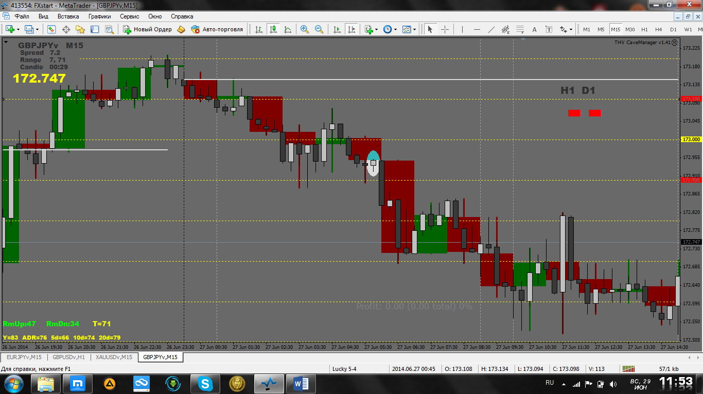

Pending order in direction movement at this level.
Setups 1, 3 and 5 can be combined into one - closing the candle in half of the range in direction of motion – pending order at this level (to which have not reached or touched) in direction of motion.
6. Behind the level of motion in the direction (the first half of range)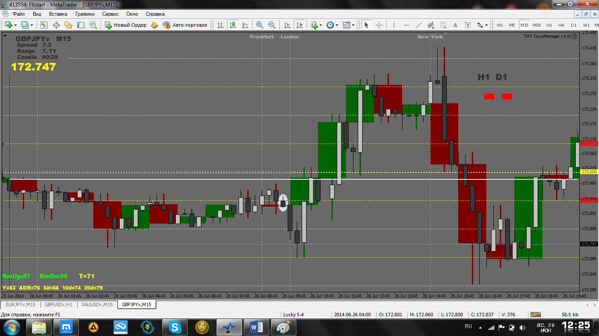

Better to do nothing. It is not known how much the price has goes. And so at your own risk.

MOVEMENT - direction daily candle. In the area of ​​Open Line work in any direction.
And, of course, watch the big picture.

