2c: News Worth Worrying about

A lot of news will affect short term price very little news will effect main trend and have a real effect.
The best news service is at Forex Factory. But it gives all the news
Diag. A has all the news on it important and other wise. How do we get the news that matters?
Diag. B lick on filter - Purple circles - have an info box open
Diag. C clicks and checks on the red and white boxes – Blue Circle
See here the two only events to care about in Green Circle on this day,
Diag. A - 8 news events in Diag. C – one white (a holiday) one red (major issue)
Check only -the red and white boxes - if you want to trade only the market (4 hours and up)
Only this stuff will move the market and not just price.
The news releases that have the biggest effects are interest rate decisions/statements and NFP
News often moves price against trend and can be a the catalyst for a retracement or
The is the nitro to push price to next level fast
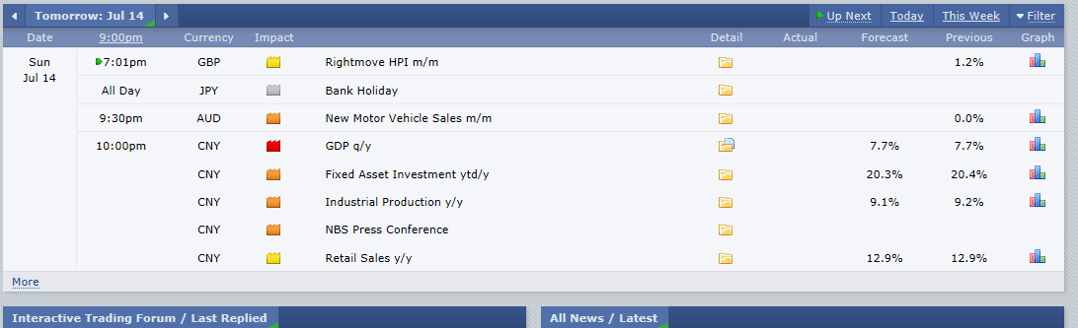Diag. A 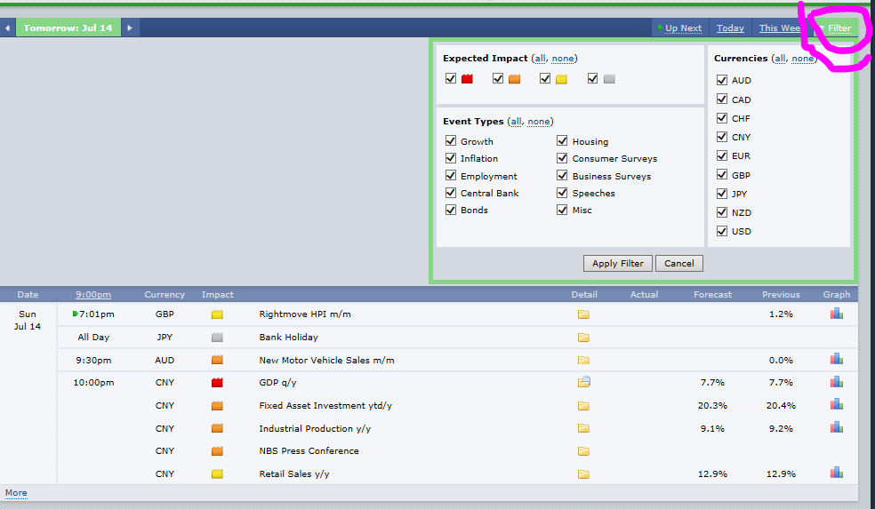 Diag. B
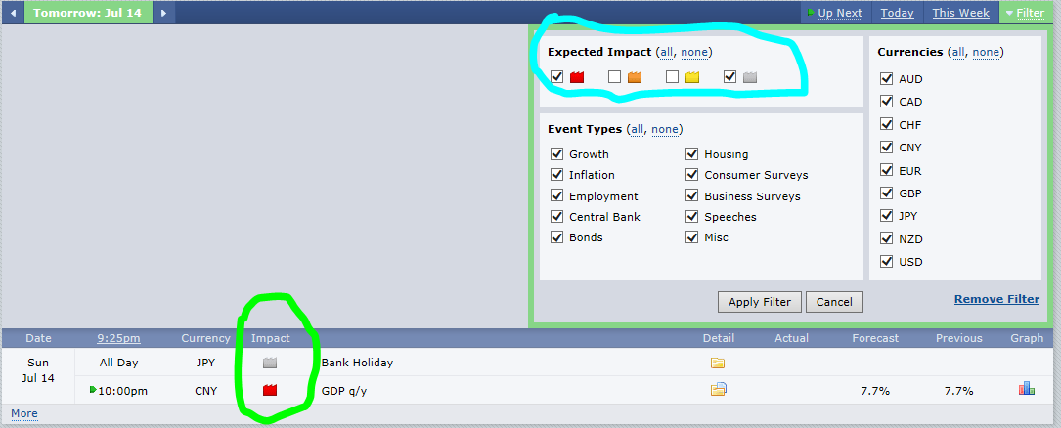Diag. C

