DCASTFX ADVANCE PATTERNS RULES OF ENGAGEMENT (R.O.E)

ABCD Pattern:
- Tools
  - Fibonacci Retracements: Primary used 61.8%.
  - Fibonacci Extensions: Primary used 127.2% & 161.8%.
- Timeframes
  - The ABCD Pattern was designed as a day / swing trading strategy. It can be identified on any timeframe and can be seen in formation of other advanced patterns.
- Tactics
  - The tactics for the ABCD Pattern are very similar to other well known advanced patterns. We seek to identify 3 market moves and 2 major Fibonacci zones. The combination of these moves forms the 4 points (A,B,C,D) that fulfill the pattern.
Rules of Engagement: Criteria 1
The ABCD Pattern begins with a market movement / impulse leg that establish our A and B points.
Once the A and B points have been identified, we then look for our first criteria.
Criteria 1: The market forms the (C) completion point by fulfilling at least a 61.8% retracement of the AB leg.
Note: The BC move remains valid as long as there is at least a 61.8% retracement of AB and there is not a candle close beyond the 78.6% retracement of AB.
Note: The C completion point (candle wick) can extend beyond the 61.8% retracement of AB as long as the candle does not close beyond the 78.6% retracement of AB. An example of this is presented below.
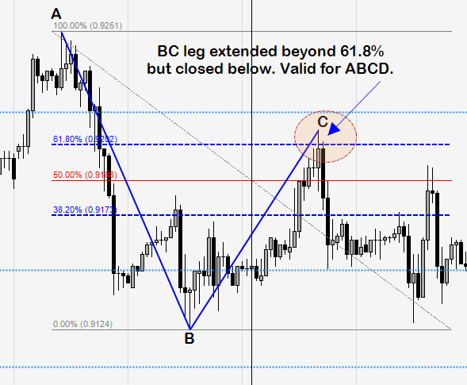
Rules of Engagement: Criteria 2
If criteria 1 has been met, then look for criteria 2.
Criteria 2: The market forms the (D) completion point by fulfilling at least a one to one harmonic move of the AB leg coming in at a 127.2% extension of AB. For ratio confluence confirmation a measurement of the BC may be taken and the extension should come in at around a 138.2% to a 161.8%.
Note: The D point remains valid as long as there is at least a 127.2% extension of AB there is not a candle close beyond the 161.8% of AB.
Note: In a valid CD move, there must be at least a 127.2%. Failure to achieve a 127.2% invalidates the pattern. An example of this is presented below.
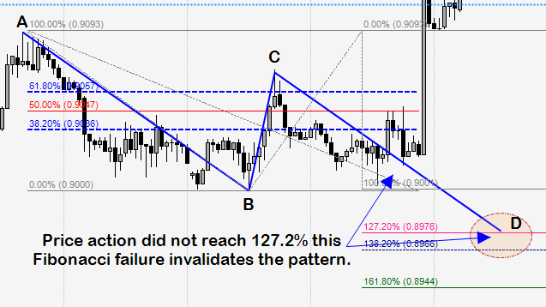
Trade management: Entry, Stops, & Targets
Simple Rules
Entry: Limit order placed at the D completion point (127.2% of AB).
Stop Placement: 10 pips +/- 161.8% extension of AB.
If long entry, stop goes 10 pips below the 161.8% extension of AB.
If short entry, stop goes 10 pips above the 161.8% extension of AB.
Target 1: 38.2% retracement of AD move. When attained, move stops to breakeven.
Target 2: 61.8% retracement of AD move. When attained, trail stop to structure +/- 10 pips.
Here is an example of an ABCD Pattern with entry, stops, & targets:

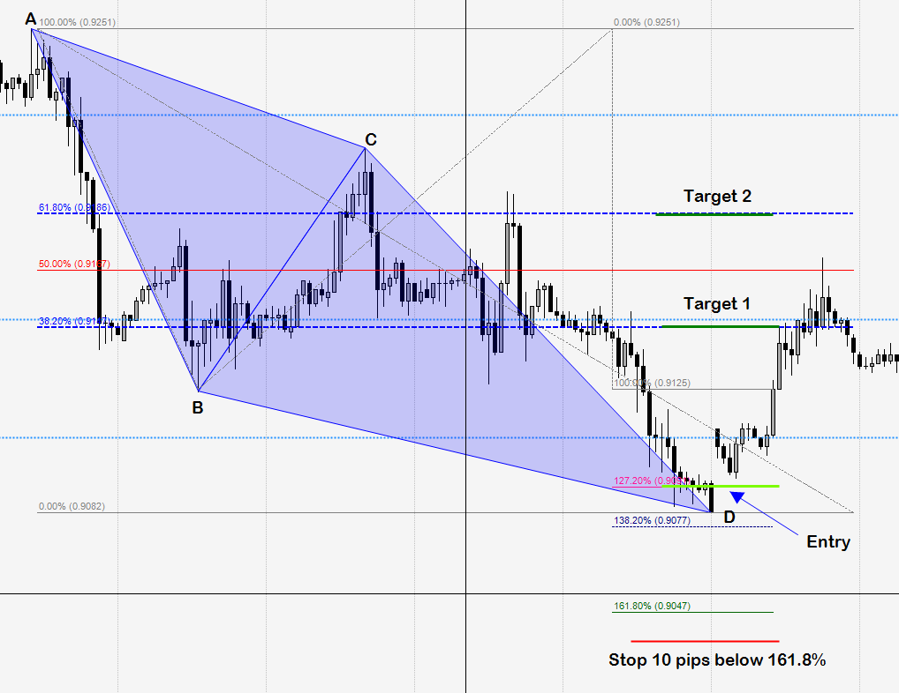

Aggressive C Buys/Sells
Entry: If price closes between the 61.8% and 78.6% Fib of point C, then take a long or short position at market in the direction of order flow.
Note: Taking an entry against order flow offers a lower probability trade and exposes you to greater risk. Price cannot close above the 78.6% or close below the 61.8% as this invalidates the setup.

Trade management: Stops, & Targets
Simple Rules
Stop Placement: 10 pips +/- of A.
If long entry, stop goes 10 pips below A.
If short entry, stop goes 10 pips above A.
Target 1: 38.2% retracement of BC move. When attained, move stops to breakeven.
Target 2: Is at the pattern completion point D or the 127.2% Fib extension. When attained, close trade and look for reversal or trail stop to structure +/- 10 pips.
Here is an example of the aggressive C buy/sell with entry, stops, & targets:



