Getting Started
BT_14-v1 Basket EA

It is assumed that before you start here you have placed all the files located in the zip file in their respective folders.

This EA will only run on an H1 Offline chart, it is hard coded for this time frame.

There are 2 files listed by each instruction, the first one is if you want to setup a 14 pair basket trade, the one in () is if you want to set up a 5 pair basket trade.

You can create your own basket with other indicators found on different forums if you like, just make sure the pairs that are in the “Offline” basket chart are the same ones you are using in the EA, you can use from 2 to 14 pairs in the EA.

- Start up your MT4 platform
- Open a M1 chart of USDJPY
- Attach the Basketv6 (Basket_05_indy) indicator to this chart.
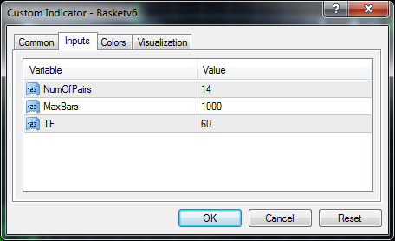

- Go to the “File” tab of MT4 and pull it down and click on “Open Offline”
- From the window that then opens, double click the “#kos#14,H1” (#kos#05,H1)chart.
- A new “Offline Chart” should now open on your screen.
- Attach the “bt_14_14p.tpl” (bt_14_5p.tpl) template to this chart. Your offline chart should now look like the following. 14 pair (5 pair)
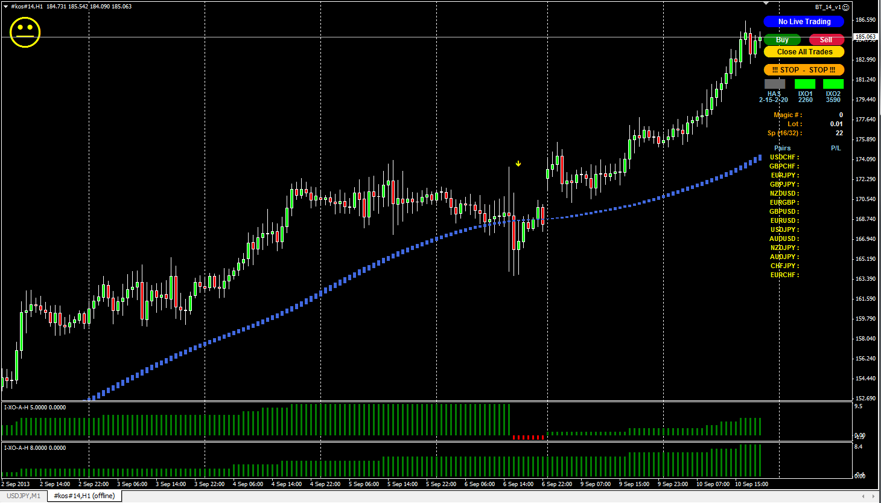
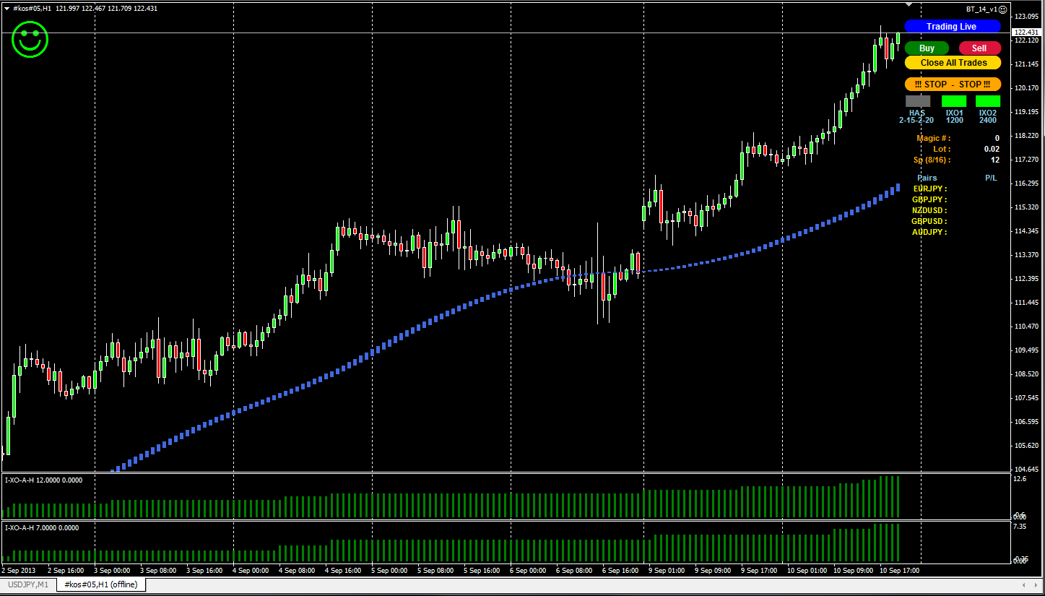
- Click the Blue “No Live Trading” button to start the EA looking for trades. The “Smiley” will start to smile and change to green. If you want the EA to not take any trades just click the Blue “Trading Live” button to stop it. The smiley will then change back to yellow.
- If you want to change any properties of the EA, you must first stop the EA by clicking the “!!! STOP _ STOP !!!” button, the smiley will change to Red. Even if you don’t make any changes when the properties window is open you must click “OK” to get a Yellow smiley again, if you just click “Cancel” the smiley will stay Red and the EA will not be running.
- If you want to open a manual trade just click the “Buy” or “Sell” buttons.
- To close all open trades click the “Close All Trades” button.
- The smiley will be Red when the EA is stopped, Yellow when the EA is running but will not take any trades, and Green when the EA is running and looking for a trade to enter.

