http://www.forexfactory.com/showthread.php?t=14630&page=1304
Post# 26,081
NAUSTINGFX
Phillip Nel’s trading Lens!
Eur/Usd: 5th August, 2013/ GMT+3

THE POWER OF 1HOUR EARLY ENTRY STRATEGY

I WAS ABOUT 50 PIPS BEFORE THE 4HOUR CANDLE ACTUALLY CLOSED...

PARTIAL PROFIT TAKEN ALREADY @ FIBONACCI 161.8

DETAILS ARE MADE CLEAR IN MY CHART...

PHIL. 4:13
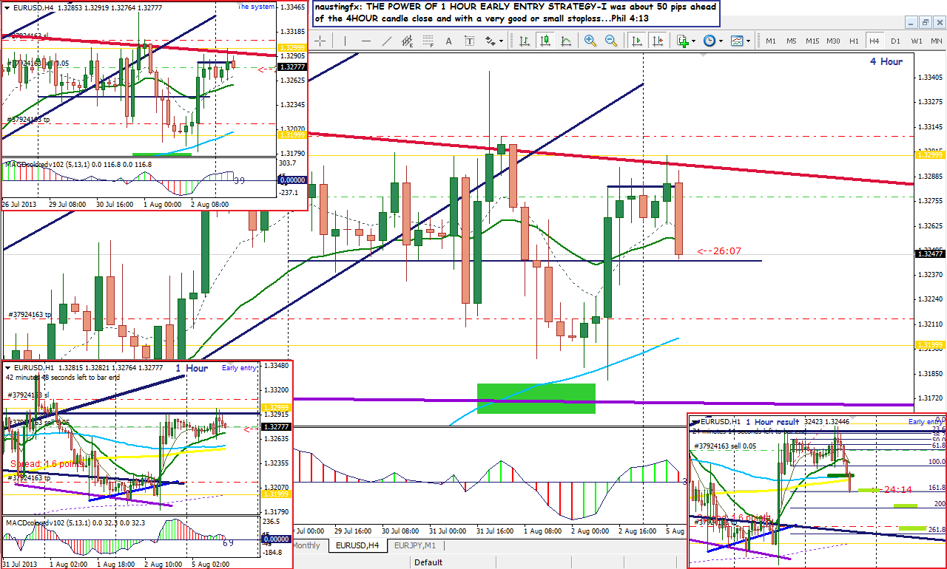
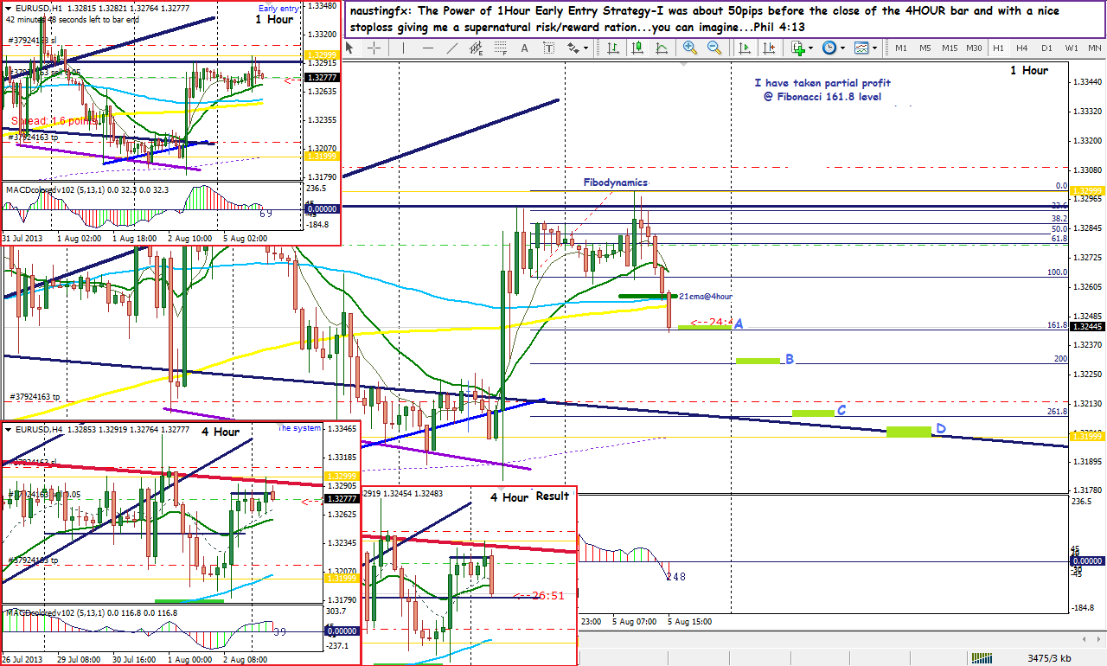
There is no limit to what God can do! God has opened my eyes to see where the pips are in this ever dynamic market. I pray for you today who is reading or studying this electronic parcel to surrender to Jesus and allow him to lead you to the place of success not only in this business but in every department of your life. I pray that the Holy Spirit will empower you to the reality of the power of Salvation in Christ Jesus! Amen!
Please do not quit from trading, but assuming you have actually put in your best and yet you seem to be sinking, you can just send me an email or a private message through the one that Forex factory offers here. Just click on my name (naustingfx), that takes you to my profile and look below and read the information and you will see a link from where you can send me private message as well as an email link. I have adjusted my settings so that I can receive emails from people.
Below are some of my cherished posts presenting my success in this system in my LIVE trading account. Please do take some time not to just read, but to study and meditate upon them:
(I tried as well to answer some questions from the forum which I have promised to give)
Answers to questions and trades:
The Essence of applying the Phillips 1HOUR early entry strategy: I hope we all know that JUST A(ONE) 4Hour candle or bar is made up of 4 candle sticks or bars of the 1hr; this means that 1,2,3,4 candles of the 1hr chart is HIDDEN JUST IN A SINCLE 4HOUR BAR! So what is happening inherently in the 4hr bar can be exposed when a trader switches to the 1hr. And analysing purely on the 1hr with respect to the 4hr rhythm will give a trader insight on the larger or overall situation of the market with the contest of the 4hr even the daily, and good insight gives birth to good decision which in turn produces pips.
Another reason is that it gives a trader the opportunity to enter trades with very nice or small stop loss but a very high reward. You will find a lot of trades you can enter with 20 or 25 or 30 pips with rewards up to 180 or 150 or 100 or 85..pips. For me this is very excellent. And you can now feel relaxed the more when you take early profit which the 1HOUR early entry technique will definitely give you. While other traders are still struggling to enter at the close of the 4HOUR candle and facing the trouble of big or very large stops and considering whether the risk reward ratio will suit them or not, and even panting when they have taken the deal....you as a 1hr early entry guy has taken your initial profit of about 30 to 40 pips, happily adjusting your stop loss and then set your other profit targets for the remaining of your positions...and you can now log out and go look for something else to do. And when you keeping making money this way, it becomes a very successful trading habit, and one day you will just log in to check to your other running trades and you will see that you can just go straight to the bank, make a huge withdrawal and begin another life transforming project for yourself, your family and the society at large!!!
I decided not to post anything since I became a member of this forum until I actually begin to make good pips. And below is my very first post.
EurUsd-April 9TH,2011-1Hour Early Entry Strategy applied:
SEE FOR YOURSELF THE CHART BELOW
http://www.forexfactory.com/showthread.php?t=14630&page=1204
- Post# 24,064
Just follow from this particular page or post down you will see the hand work of God in my trading career. You can also just click on my name and at my profile page click to below my avarta-the focused huge lion that I got there where is says “...all posts...” then look into all I have posted...from that 2011 April till now I have been trading using the 1HOUR EARLY ENTRY STRATEGY...I THINK IT IS NOT EVEN UP TO 10 TRADES OUT OF HUNDREDS OF TRADES I HAVE SUCCESSFULLY TAKEN I USED PURELY THE 4HOUR BAR...
SEE MY CHART BELWO
APRIL 2011
(You will see how small the stop loss was and the profits made from those trades)
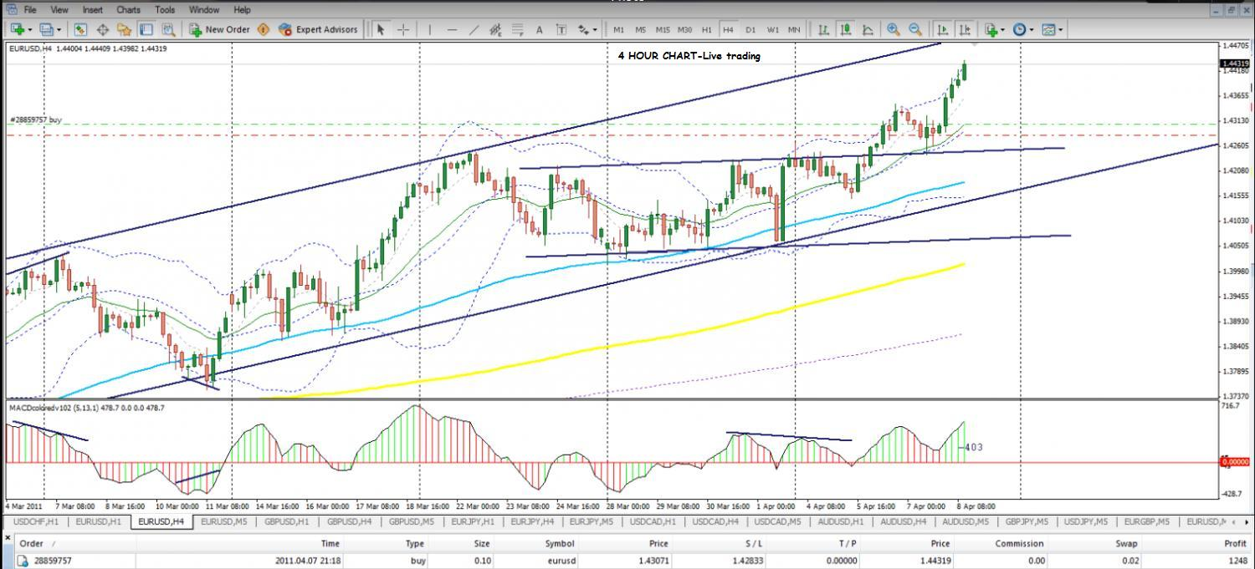

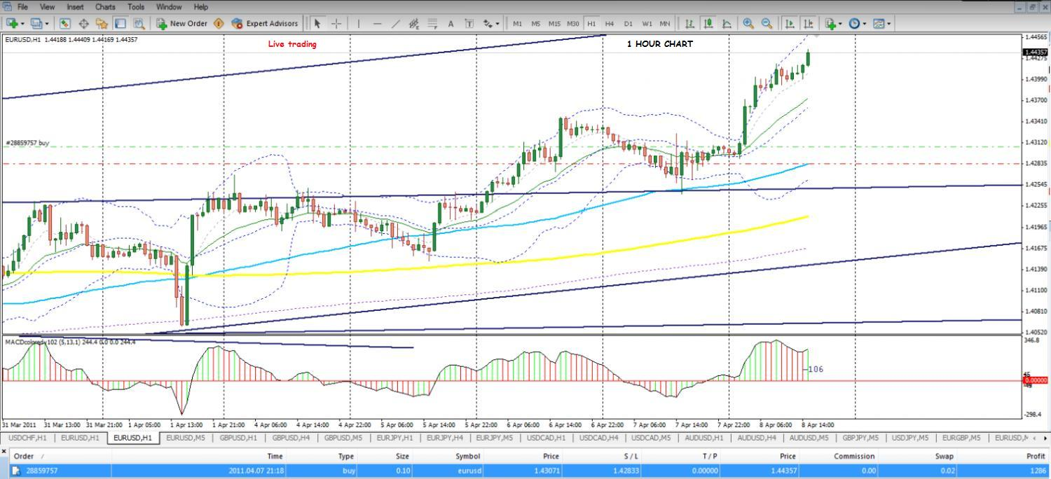
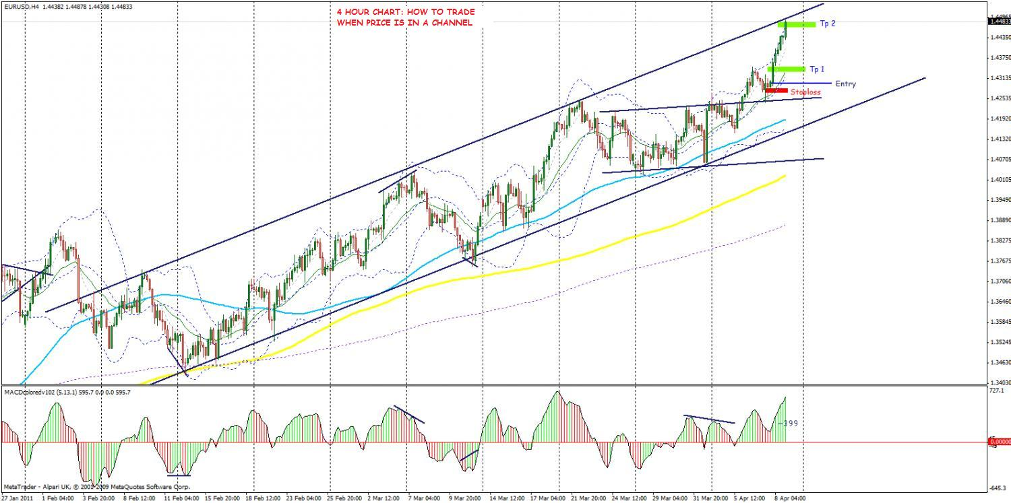
Feel free to make your comments
Peace of the Lord be with your soul!

