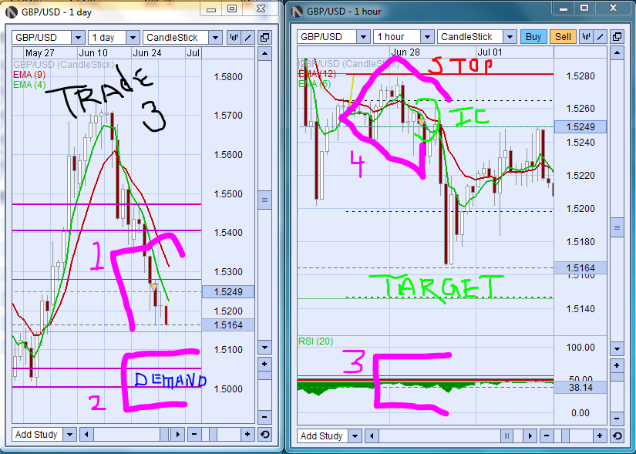 bb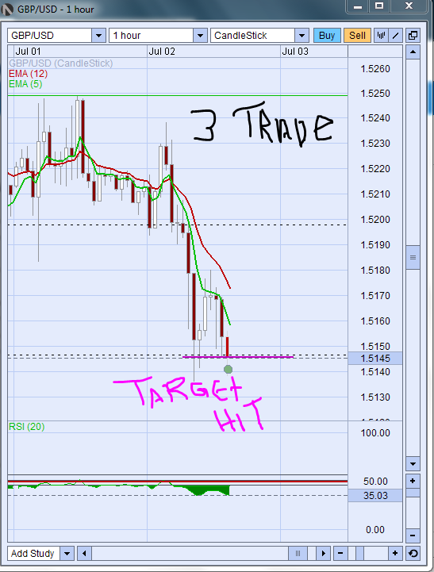

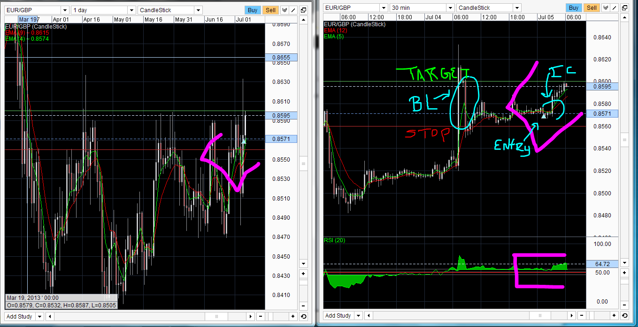
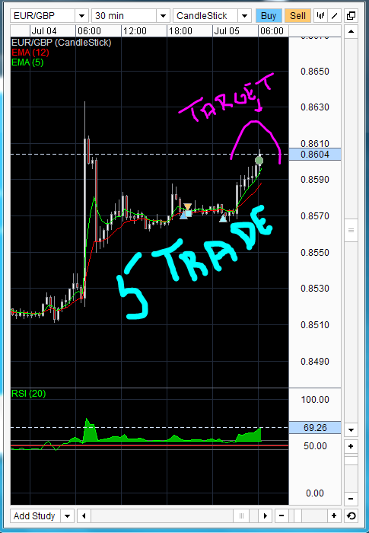
.
Trades Closed 5  FOREX | Wins 3 | Loses 2 | Win% 60% | Cash + $594.83
Good trade- No mistakes (GT-NM) Bad trade- mistakes (BT-M) 50% 50% entry (50%) ________________________________________________________________________________________
1st trade (GT-NM) 3 to1 RRR - The SL was large as it was a OC normal entry
2nd trade (GT-NM) 3 to1 RRR - IC normal entry
3rd trade (GT-NM) 3 to1 RRR - IC normal entry
4th trade (GT-NM) 3 to1 RRR – PC – Was far from EMA cross – next day USA holiday- Stop should’ve been Pin
5th trade (GT-NM) 3 to1 RRR - BL as support

