Money Management
Purpose: Opening equal positions no matter the working TF or the SL size of each position is. Protecting the account balance by the possible losses which might exceed the maximum risk procentage assumed Trading with the same risk regardless the balance size (if the balance increases, the position size increases and vice versa. Constant risk regardless the SL size chosen per position (item). If the RiskReward (RR) is pretermined, the risk and the profit remains equal regardless of the SL, the TF or the instrument from which the position is released . It ensures the validity or the invalidity of a long term working strategy.

1. It sets the size of the working lots.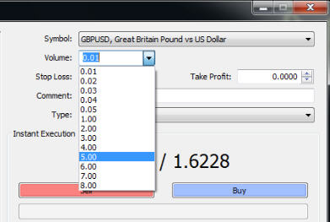.
2. It reads the current balance.
3. It sets the maximum risk from the balance (The trader can set the value) Ex 2-3-4-5%.
4. It splits the maximum risk on 5 working positions (5 available orders) - The maximum number of positions can be setted by the trader.
5. It displays permanently in the working window the maximum available SL corresponding the opening of the position with a minimum lot . I already have an indicator built for this, but you need to figure out how can it be adapted
6. It calculates based on the allocated SL to each position the number of lots per that position. The result is down rounded.
7. It reads the number of launched positions (number of launched orders).
Warning messages:
1. The established risk doesn't permit opening positions--- it is dislpayed when the established risk doesn't allow opening positions on that instrument.
2. Exceeded risk level !------------------------------------- when the number of the launched position is exceeded.
3. Not enough money for this position !--------------- when a position is launched and it has an SL which exceeds the risk per working position
4. Incorrect parameter order !----------------------------------- when there are introduced incorrect parameters for the order
Regarding the warning messages there might be issues which need to be solved with the programmer.

This is how this should look like in the end :
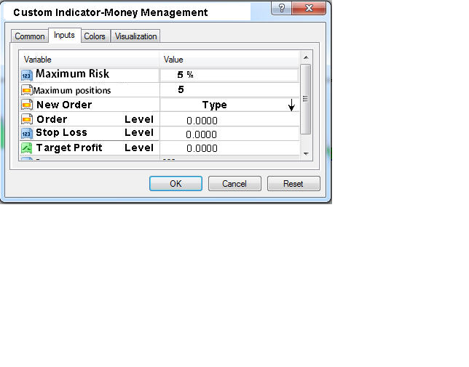

It has to work on 4 decimals brokers and 5 decimals brokers. When you put it in MT4 and compile for the first time, it should allow you to set what number of decimals will be used.
For example, to work in sequence 1 for 4 decimals brokers or in sequence 2 for 5 decimals brokers.
This is how I see it, for being easy to do the settings even for a trader who doesn't know much about programming.

