Murrey Math Trading System "5 Areas of Conflict"

"5 Areas of Conflict" (see figure E.)

If you turn to any chart, that is set with the "Square in Time," you will see a set of 5 circles, spaced equidistant, inside, a square, (looks like a square).

Look at Figure H. (classic chart)(what you trade).

Please go the section entitled Setting up the Square in Time," and review the 3 examples, which are:

1) Volunteer Capital,
2) Columbia - H.CA.,
3) Dollar General,

and follow the same logic, of how to set up your vertical (time lines), and your horizontal (price lines) to form a square, (there's no sense going any further, into this, if you haven't learned yet, how to set the square).
************************************************
Now, if you go back to the section entitled Practice Sheet: Prove the Law of Exact Proportion within your own Mind. (after you have read this, a second time, you should have seen it by looking at the 3 figures that set up the "Square in Time," for Volunteer Capital, Dollar General, and Columbia - H.C.A., and you will see the "5 Areas of conflict."

Look at Volunteer Capital: chart # 303, 304, 305, 306,307,308.
Look at Columbia - H.C.A.: chart # 107, 108, 109, 110,111,112.
Look at Dollar General Stores: chart # 280, 281, 282, 283,284,285, 286, 287, 288,289,290,291.

So, we are able to make some basic inferences, as what to expect, when a stock moves near, inside, or around, one of these 5 circles, as it moves through time, into the future.

Common sense dictates that:

1) the center of anything, constitutes the greatest area of confusion, and instability, and the greatest reaction, if it runs into it, and everyone's life is confused by at least 4 other extraneous factors that we must deal with on a daily basis, which are:

- habit (survival), (center of confusion),
- news (we assume it is correct),
- knowledge (true from repetitions of success),
- risk avoidance (don't walk in traffic),
- desire for good life (close to greed),

(Look at charts # 116., 143A., 120., 125.,147., 315).

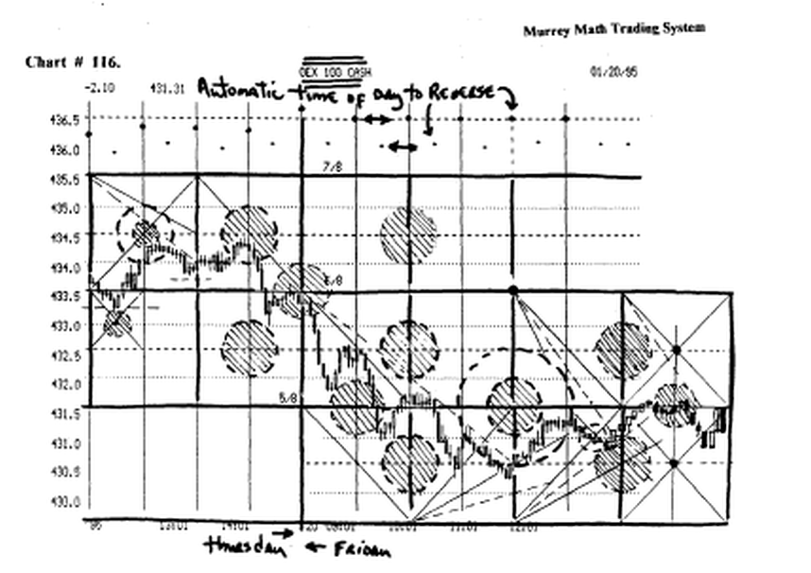

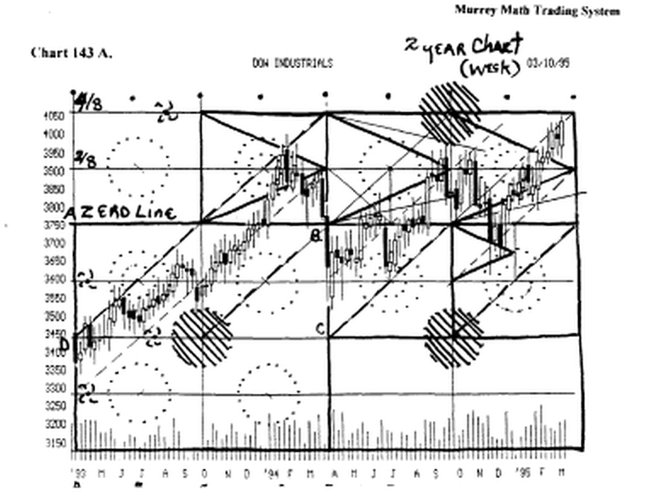
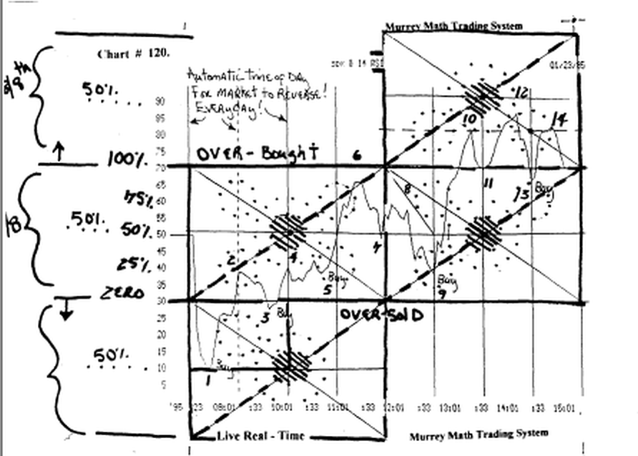

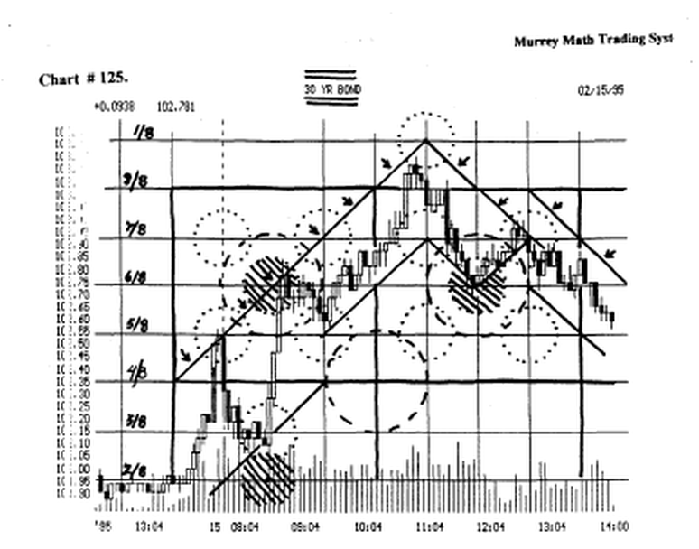

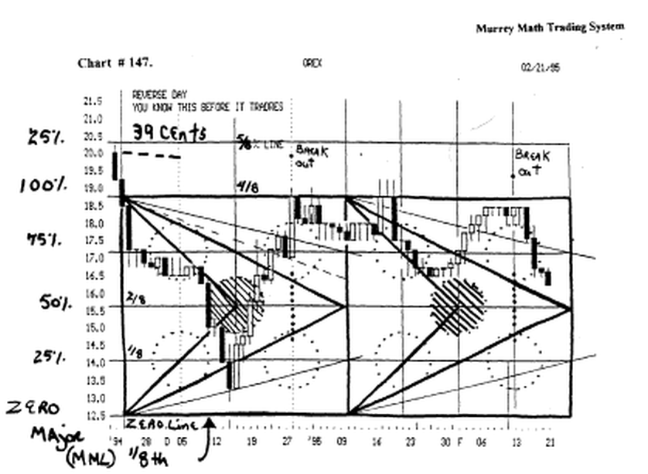

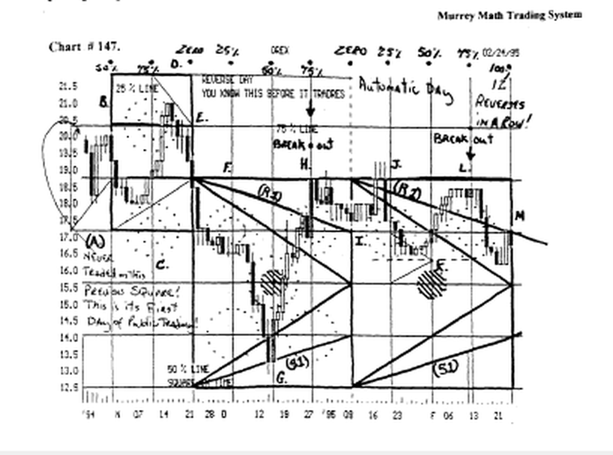

2) every circle consists of 2 levels or depth of penetration, or diameters, (50 % and 25 %).

Again, common sense states that most stocks would want to stop, and reverse, at the outer circle of resistance, when it traded down to it, the first time,

(Look at charts # 141, 130, 116., 103.,100 E., 315).

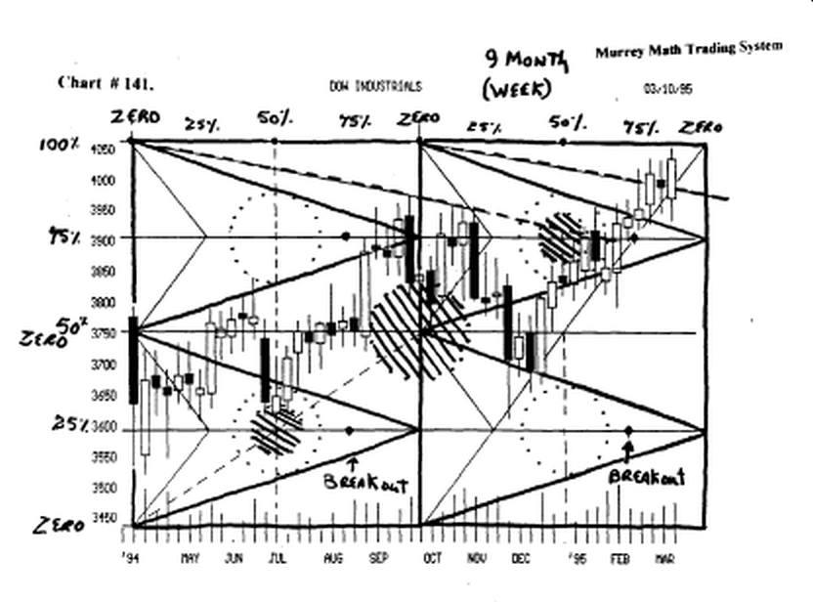

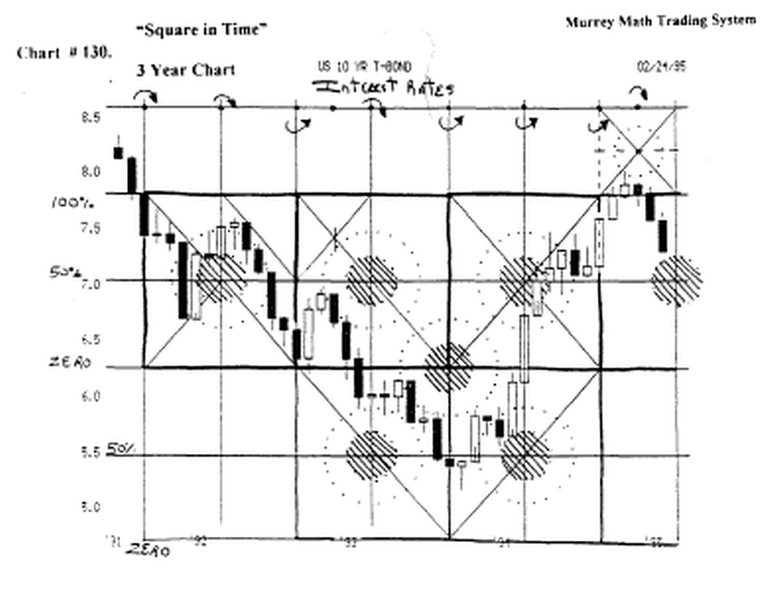

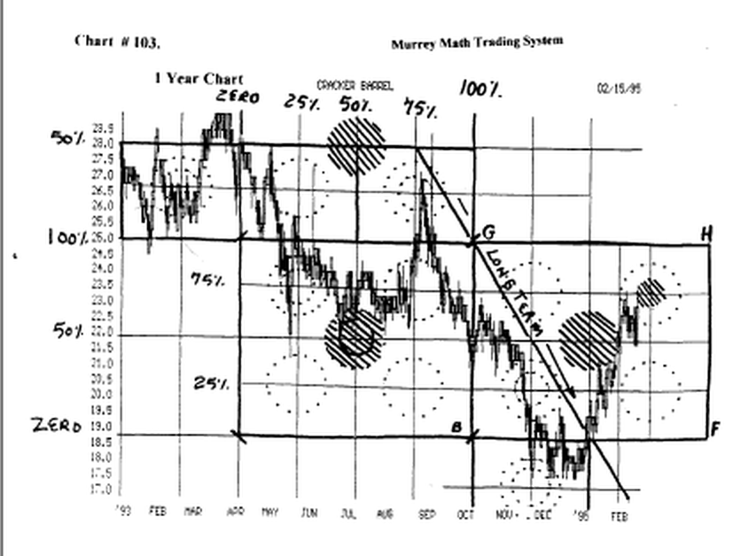
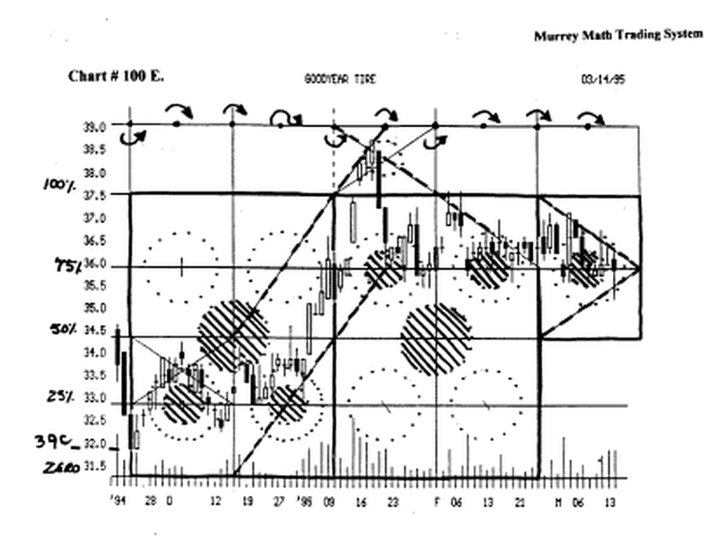

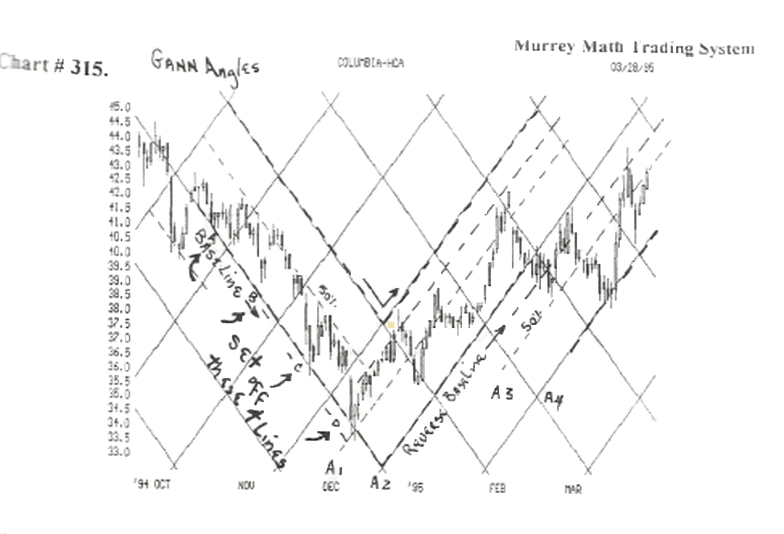

3) we must be ready to go with the direction, it spits it out, if it goes into the center circle of conflict,

Look at charts # 294, 295, 315.

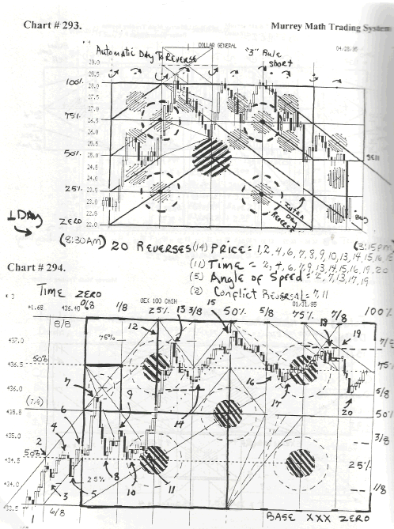

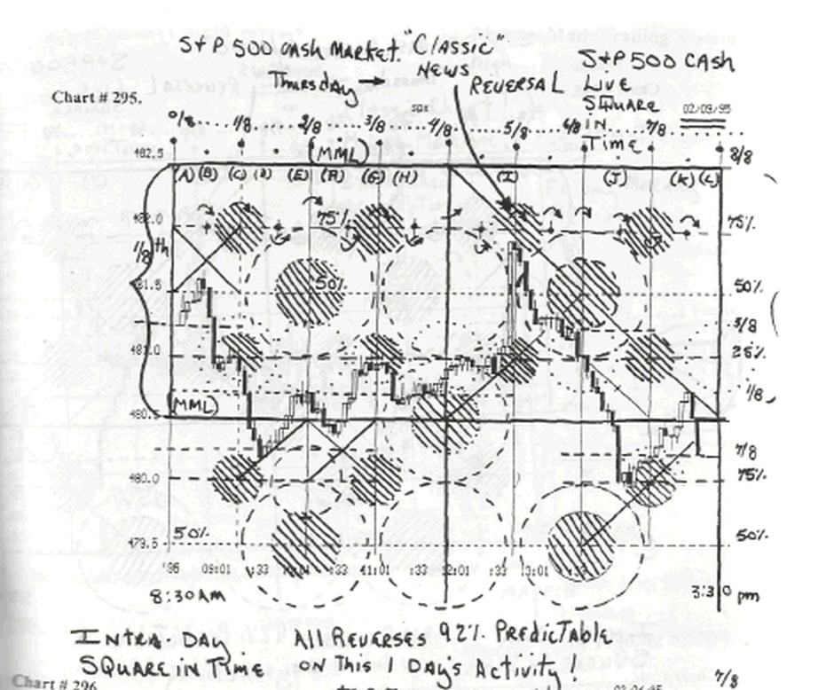

4) the "natural tendency " is for the price action, to want to slow down, and drift around the outer circle of resistance, then continue, in the same direction, that it was heading presently. (chart # 143 A.).

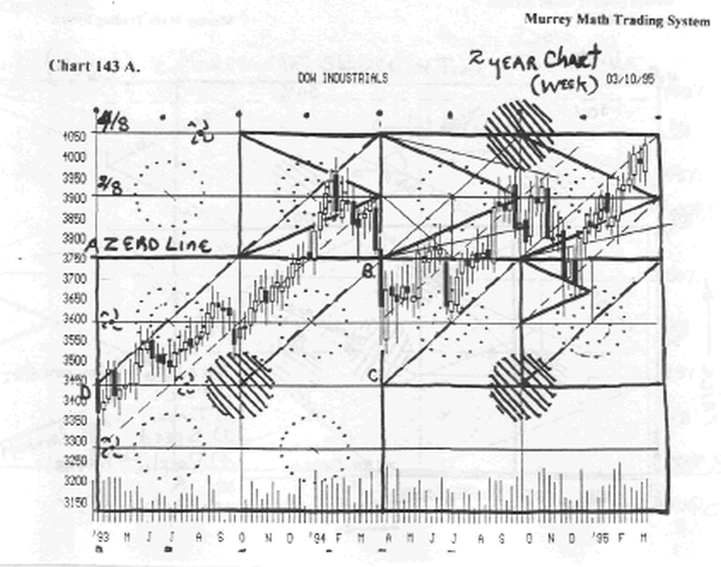

5) fast rising, or falling stocks, don't want to move slowly around the outer circle, so we must pay close attention to the closing price, and if it is parallel to, or just above, or below, the next adjacent circle. (for if it
stalls, just above or below, it will continue on, or reverse, out fast, in the opposite direction, (chart # 315, 278, 311).

