USDJPY
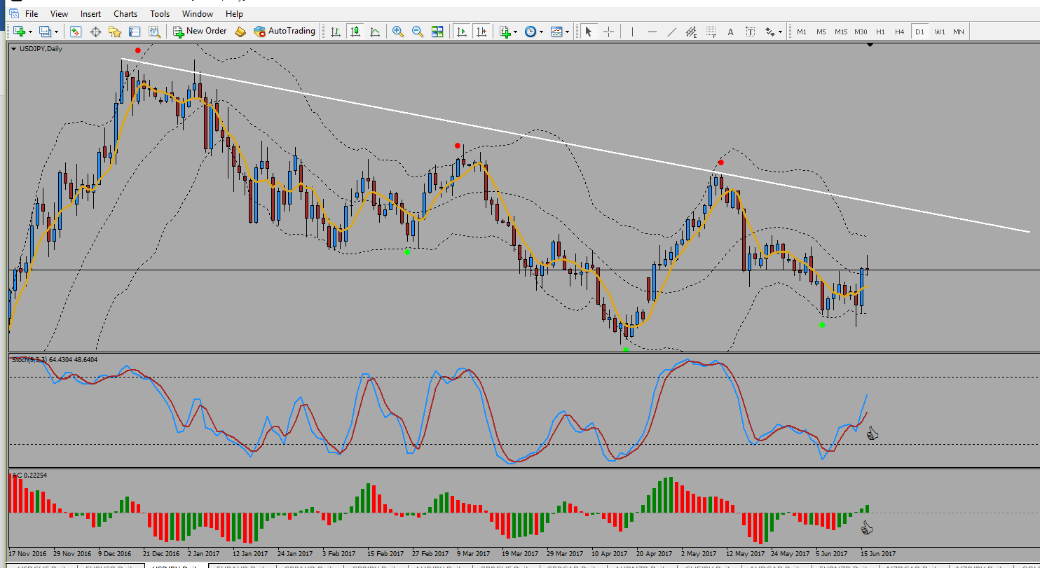

All criteria met. Running with some profits.
NzdUsd
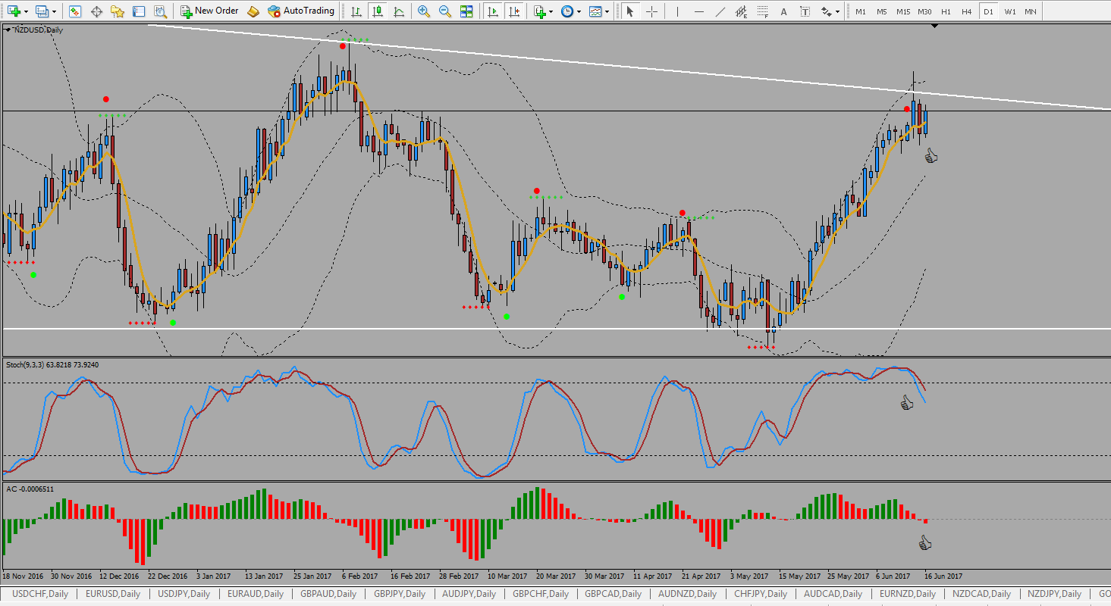
- Inside Bar & other criteria met. Retracing

NzdUsd - Weekly
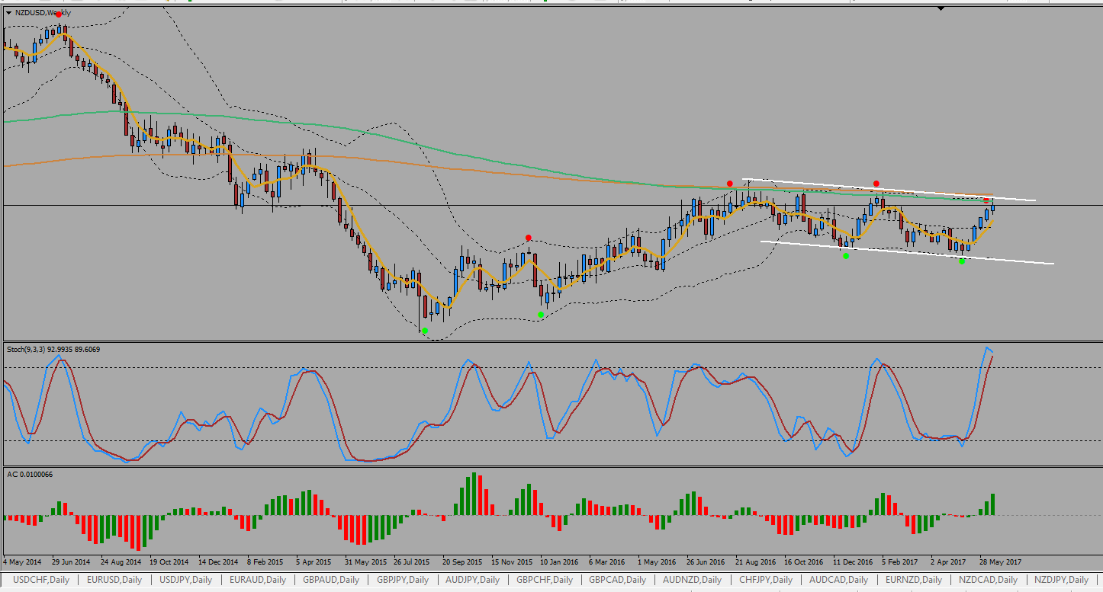

- In a channel

UsdCad
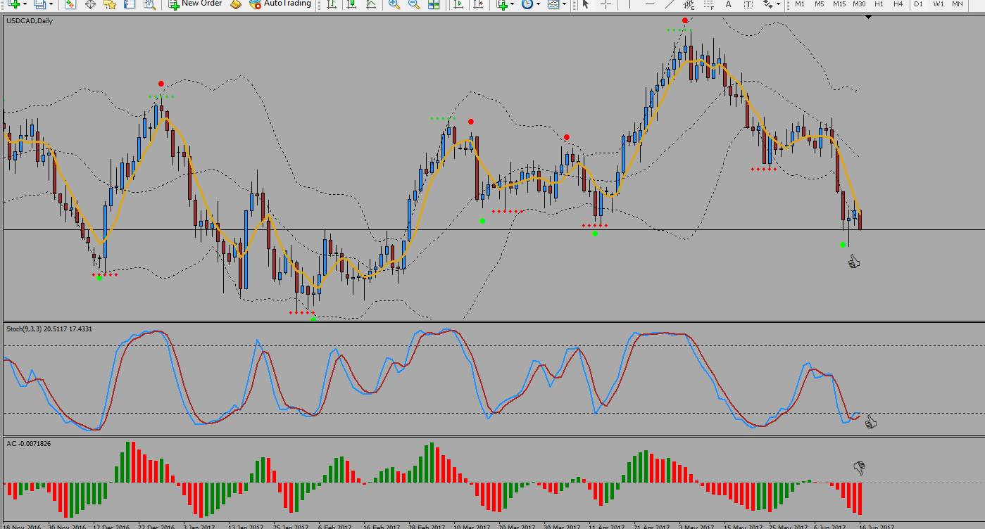

- AC not aligned yet.

